To find your way to the meeting place of the Expert Groups 14,15,17,18 November
The meeting place of the Expert Groups is at:
VEGA PARK
Confindustria Venezia
Room Oro
Parco della Industria, 19
30175 Venezia Marghera
www.confindustria.venezia.it
This location is outside the Venice island, on the mainland (other side of the bridge/dike). Lunches will be on your own expenses.

To get to the meeting room of the Expert Groups?
From the Venice bus stop located in Piazzale Roma you should take bus nr 2, 4, 6 or 7 to VEGA PARK (bus stop VEGA PARK). It takes you about 10 minutes (considering walking to the venue). Get to the entrance of Confindustria and ask your way around.
Check for bus time table at www.atvo.it

The Piazzala Roma busterminal:
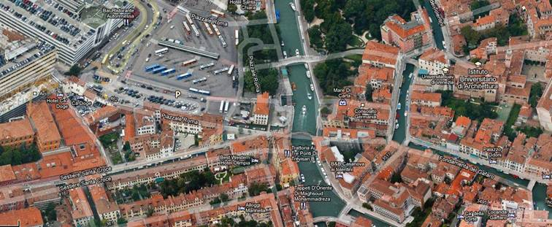
You can buy your bustickets at the busterminal.

Where to book your hotel?
In Venice, many hotels are available. If you have booked a hotel around the San Marco square, you need about 25 minute walking (by ferry/vaporetto about 15 minutes) to get to the Piazzale Roma. You can also book close to the Piazzale Roma. Palazzo Doni (http://www.palazzoodoni.it/) or Hotel Olimpia (http://www.hotel-olimpia.com) are among the many possible hotel options.

To find your way to the meeting room for the Common Issues meeting:
The Common Issues meeting will be held at the Venice Port Authority:
Spazioporto
Ex church Santa Marta
Area Portuale
30123 Venezia

To get the meeting room of the RIS Common Issues meeting.
You can walk, depending on where you stay, the weather etc. and/or take public transportation:
From the piazzale ROME a ferry (Vaporetto) can take you close to the Port Authority (about 14 minutes 9 route Trochetto – Lido de Venetia). From the San Marco square you can take the same line but opposite direction (to Trochetta - about 10 minutes). We have not been able to obtain the specific information where to disembark, yet.

The organisors of the meeting are neither responsible for your hotel arrangements neither the information provided here.

© 31 October 2011

