MODULE 1: SAMPLE ACTIVITY
Name of Student: PATRICK JASON L. TORRES
Contact of Student: 0912344567121 | patrickjasontorres@chcc.edu.ph
Program, Section, Subject: BSCS1A – CSP101
Sem & School Year: 1st Sem SY 2026-2027
CHCC STUDENT ANNOUNCEMENTS: A CAMPUS BULLETIN BOARD APPLICATION
1. Introduction
CHCC Student Announcements is a mobile application built with Flutter that acts as the digital campus bulletin board of Concepcion Holy Cross College, Inc. Instead of paper notices pinned to a cork board in the hallway, students and offices can pin digital notes about events, exams, assignments, and holidays, and read them anywhere from their phones.
The look of the app is inspired by the real campus notice board at night: cream paper notes are pinned to a deep navy board, taped down with coloured washi tape, tilted at tiny hand-pinned angles, and stamped red when they are urgent. The official seal of Concepcion Holy Cross College, Inc. sits in the header beside the wordmark.
2. Objectives
- To give students a single place to see all school announcements, wherever they are.
- To let authorized users pin new announcements with a category, an urgency flag, and an event schedule.
- To let students keep (bookmark) the announcements they do not want to forget.
- To make time-sensitive notices easy to notice through a red urgent stamp and a live countdown.
- To keep the board available offline by storing the data locally on the device.
- To practice Flutter development: widget design, custom painting, local JSON storage, and automated testing.
3. Features of the Application
3.1 Main screens
- Board (home) - the CHCC crest and wordmark in the app bar, bunting strung underneath, filter tabs cut from tape, and a feed of paper notes that drop onto the board one after another.
- The note (detail) - the full sheet on the navy board, with a hand-drawn underline, pin metadata, and a bottom bar for sharing or saving.
- Pin a new note (create) - a fresh sheet of paper with the category taped across the top; validation, categories, an optional urgent stamp, and a date and time picker for the event.

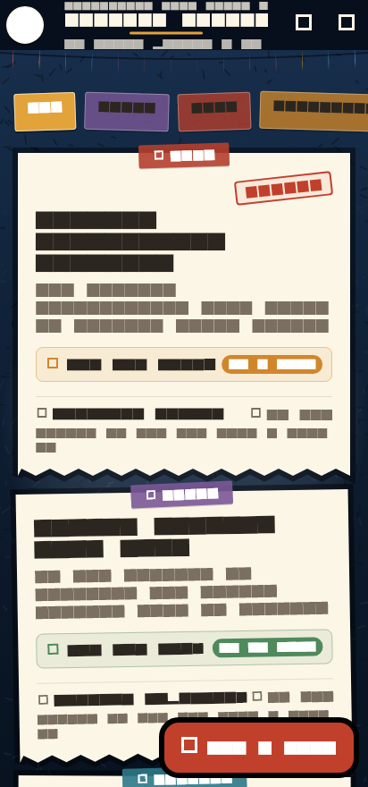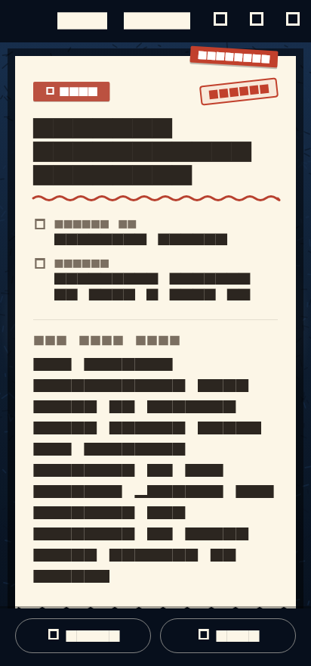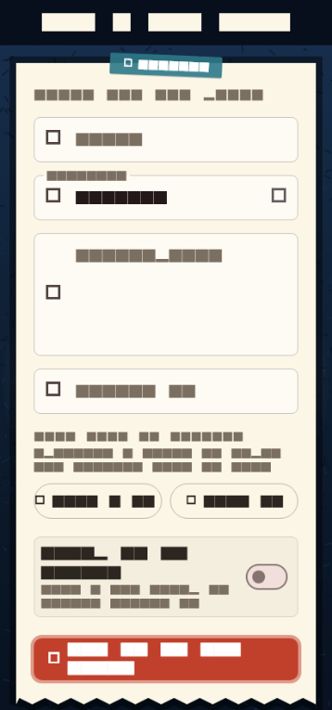
Figure 1. The board, the note, and the pin-a-note screens (golden test snapshots).
3.2 Core functions
- Create - the "Pin a note" button opens the form; a title, details, and who posted it are required, and the category, urgent stamp, and event date/time are optional.
- Edit - the pencil icon on the sheet reopens the form pre-filled; "Save changes" keeps the original posted date and id.
- Delete - swiping a note left on the board (or tapping the trash icon on the sheet) asks for confirmation first, then shows UNDO in the snack bar if the student changes their mind.
- Search - the magnifier in the app bar drops down a search box that matches the title, the details, and who posted the note, on top of the category tabs.
- Saved notes - the bookmark on the sheet files a note into the student's pocket; the bookmark in the app bar filters the board to saved notes only, and the header counts them.
- Categories - notes are filed under General, Event, Exam, Assignment, or Holiday, each with its own colour and icon; the tape tabs on the board filter by category.
- Dates - every note carries a "date posted" stamp, and notes with an event show a tinted strip with the exact date and time plus a countdown pill (Today, Tomorrow, In 5 days, 3 days ago). The pill turns red within two days, amber within a week, and green after that.
- Persistence - the whole board is written to shared_preferences as JSON, so notes added, edited, saved, or deleted today are still there tomorrow.
- Web deep links - opening the web build with ?screen=detail or ?screen=compose opens that screen directly, which is handy for sharing a link and for taking screenshots.
4. Technology and Tools Used
- Framework: Flutter with Material Design 3, written in the Dart programming language (Dart SDK 3.0.0 or newer).
- Packages: shared_preferences (local storage) and cupertino_icons; dev packages flutter_test and flutter_lints.
- App version: 1.0.1+2, application id com.example.student_announcements.
- Target platforms: Android, and also iOS, Web, Windows, macOS, and Linux builds from the same codebase.
- No backend or database is used - all data lives locally on the device, so the app works fully offline.
- IDE / SDK: Android Studio or Visual Studio Code with the Flutter SDK installed.
5. Project Structure
- lib/main.dart - the whole application: theme and palette, the Announcement data model, helper functions, the custom painters, and the three screens.
- assets/chcc_seal.jpg - the official CHCC seal used as the header crest, the empty-board mark, the favicon/PWA icon, and the Android launcher icon.
- test/widget_test.dart - 8 smoke tests covering rendering, filtering, search, compose, detail, delete with undo, saved notes, and editing.
- test/golden_test.dart and test/goldens/*.png - 3 golden snapshot tests of the board, the note, and the pin-a-note screens.
- android/, ios/, web/, windows/, macos/, linux/ - the platform folders generated by Flutter.
- pubspec.yaml - project metadata, dependencies, and asset declarations.
6. Data Model and Storage
Each announcement is an object of the Announcement class with these fields: id (unique identifier), title, description, category, datePosted, postedBy, isUrgent (red stamp), eventDate (optional - when the announcement happens or is due), and isSaved (bookmarked by the student).
The class has toJson and fromJson methods, so a note can be converted to and from a JSON map. The board is saved under the key "notes" in shared_preferences as a JSON array, and it is loaded again when the app starts. When nothing has been saved yet, the board is seeded with sample notes (for example, the Midterm Examination Schedule and the Winter Break Schedule) so the screen is never empty. Edits use the copyWith method, which keeps the original id and the original posted date.
7. Design and Visual Style
The app uses a small, fixed palette: midnight navy for the board (#12263F with lighter and darker shades), cream paper (#FCF6E7) for the notes, dark ink for the text, walnut (#070F1C) for the app bar, stamp red (#C1402C) for urgent marks, and gold (#E2A33B) for accents.
Everything on screen is drawn with Flutter's own painting API, so the app needs no extra images: CorkboardPainter paints the midnight-navy board with a top-lit gradient, speckles, and a vignette; BuntingPainter draws the flags hanging from the app bar; DeckleClipper tears the bottom edge of every sheet of paper and the shadow follows the tear; SquigglePainter draws the wavy underline on the detail sheet. Each note also sits at a tiny deterministic tilt (tiltFor) so the board looks hand-pinned.
8. Testing and Quality Assurance
The project is covered by automated tests that run with "flutter test": 8 widget (smoke) tests check that the board renders the notes and filter tabs, that filtering and searching work, that the compose screen opens, that tapping a note opens its sheet, that deleting asks first and UNDO brings the note back, that saving a note marks it and the saved filter shows it, and that editing keeps the change. The 3 golden tests compare the rendered screens against the PNG snapshots in test/goldens. After a design change, the snapshots are regenerated with "flutter test --update-goldens".
9. How to Run and Build the Application
- flutter pub get - downloads the dependencies.
- flutter run - builds and runs the app on any connected device or emulator.
- flutter test - runs the 8 widget tests and the 3 golden snapshots.
- flutter build apk --release - builds the Android installer, written to build/app/outputs/flutter-apk/app-release.apk.
The APK is copied to the phone (USB cable, Google Drive, Bluetooth, or QR file share), opened, and installed after allowing "Install unknown apps" - no Play Store account is needed. For publishing, the application id com.example.student_announcements should be changed first in android/app/build.gradle.kts, and flutter build apk --split-per-abi makes smaller per-device installers.
10. Summary
The CHCC Student Announcements app turns the campus cork board into a mobile application. Students can browse announcements filtered by category or search keyword, read the full note, save the ones that matter, and watch the countdown to events, while anyone can pin, edit, or unpin notes. All of the data is stored locally, the whole look is drawn in code, and the project ships with automated tests, which makes it a complete first release of a real school app.

