CSE101 FINAL PROJECT: CHCC STUDENT ANNOUNCEMENTS
Name of Student: PRINCESS PANGANIBAN
Contact of Student: 62372024@chcc.edu.ph
Program, Section, Subject: BSCS 3A - CSE101
Sem & School Year: 1st Sem SY 2026-2027

I. PROJECT OVERVIEW
CHCC Student Announcements is a mobile-first bulletin board application built for the students and staff of Concepcion Holy Cross College, Inc. (Concepcion, Tarlac). It replaces the hallway corkboard and the scattered group-chat notices with a single, always-current board that lives on the phone.
Every notice is pinned as a paper note on a midnight-navy board, colour-coded by category and stamped URGENT when it cannot be missed. Each note carries two dates: when the notice was posted, and when the event, exam or deadline actually happens. Notes with a schedule show a countdown pill (Today, Tomorrow, In 5 days, 3 days ago) so a student can see at a glance what is coming.
The system was developed with Flutter, a single codebase that runs on Android, the web and the desktop. The Android build is released as an installable APK, while the web build can be shared as a plain link - no installation required.
II. OBJECTIVES
General Objective
To design and develop a mobile bulletin board that keeps the CHCC community updated on school notices in one place, with clear dates on when each notice takes effect.
Specific Objectives
1. Pin an announcement with a title, details, category, poster and an optional date and time.
2. Show, for every note, when it was posted and when it happens - including a live countdown.
3. Organise notices with category tabs and a keyword search over the title, details and poster.
4. Let students bookmark notes and filter the board to their saved notes.
5. Allow notes to be added, edited and deleted safely, using a confirmation dialog and UNDO.
6. Keep the board available after the app is closed by persisting it on the device.
7. Deliver the system as an installable Android APK and as a web application.
III. FEATURES AND FUNCTIONALITIES
Feature | What it does
Bulletin board | Painted navy board with bunting, washi-tape filter tabs, and paper notes that drop in one after another.
Category filter tabs | ALL, EVENT, EXAM, ASSIGNMENT, HOLIDAY, GENERAL - one tap narrows the board.
Keyword search | The magnifier opens a search box that matches the title, the details and who posted it.
Posted date stamp | Every card carries "Posted on Oct 08, 2026 - 9:30 AM"; the detail sheet shows the full date.
Event date + countdown | Optional date and time shown as a tinted strip with a countdown pill: red within 2 days, amber within a week, green after that.
URGENT / PRIORITY stamps | Rubber-stamp marks, drawn slightly askew, so critical notices stand out.
Saved notes | Bookmark from the detail sheet; the app-bar bookmark filters the board to saved notes and the header counts them.
Add a note | Form with title, category, description, poster, date and time pickers, validation and an urgent switch.
Edit a note | The pencil icon reopens the form pre-filled; the original id and posted date are kept.
Delete with UNDO | Swipe a card left or use the trash icon; a confirmation appears first, then the snack bar offers UNDO.
Note detail sheet | Full text under a hand-drawn squiggle, with HAPPENS ON, PINNED BY and POSTED rows, plus a Share / Save bar.
Persistence | The board is written to shared_preferences as JSON after every change, so it survives a restart.
Web deep links | ?screen=detail and ?screen=compose open a screen directly.
Polish | Empty-board state, pull-to-refresh, staggered entrance animation and a hand-pinned tilt on every note.

IV. TECHNICAL SPECIFICATION
Component | Details
Framework | Flutter 3.x (Dart 3), Material 3
State management | StatefulWidget with setState, held by the board screen
Custom painting | CorkboardPainter (gradient, speckles, vignette), BuntingPainter, SquigglePainter, DeckleClipper
Local storage | shared_preferences ^2.5.6 - JSON array under the key "notes"
Other packages | cupertino_icons ^1.0.6 (no other runtime dependencies)
Platforms | Android (primary), Web, Windows, macOS, iOS scaffolds
Application id | com.example.student_announcements - must be renamed before Play Store release
Version | 1.0.1+2 (release v1.0.1)
Design assets | assets/chcc_seal.jpg - the official school seal; every other texture is painted in code
Code size | lib/main.dart - a single file holding the model, painters and the three screens

V. PROJECT STRUCTURE
Path | Purpose
lib/main.dart | The whole application: data model, painters, board, detail sheet, form, persistence
test/widget_test.dart | 8 widget tests covering board, filters, search, CRUD and saving
test/golden_test.dart | 3 golden (visual regression) snapshot tests
test/goldens/*.png | Golden images for the board, the detail sheet and the form
assets/chcc_seal.jpg | School seal used in the header, the empty state and the app icons
docs/screenshots/*.png | Figures used in this document
pubspec.yaml | Dependencies, assets and version
README.md | Feature list and installation guide
android/, web/, windows/ | Platform launchers, icons and manifests

VI. DATA MODEL
Each note is stored as an Announcement record. The list of records is serialised to a JSON array and saved under the key "notes".
Field | Type | Description
id | String | Unique identifier; kept when the note is edited
title | String | Headline of the notice
description | String | Full text of the notice
category | String | Event, Exam, Assignment, Holiday or General
datePosted | DateTime | When the notice was pinned
postedBy | String | Office, department or person who posted it
isUrgent | boolean | Shows the URGENT stamp on the card
eventDate | DateTime (optional) | Date and time when the announcement happens
isSaved | boolean | Bookmarked by the student

VII. SYSTEM SCREENS
Figure 1 shows the board: the school seal and wordmark, the category tabs, and the notes with their countdowns.
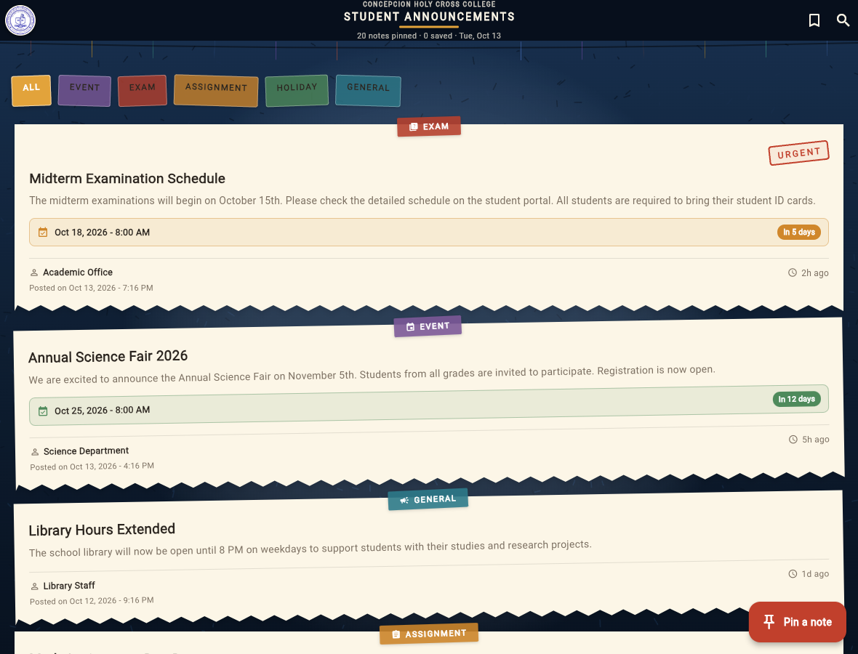
Figure 1. The bulletin board (home screen) with category tabs, the URGENT stamp and countdown pills.
Figure 2 shows a single note: when it happens, who pinned it, when it was posted, and the Share / Save bar.
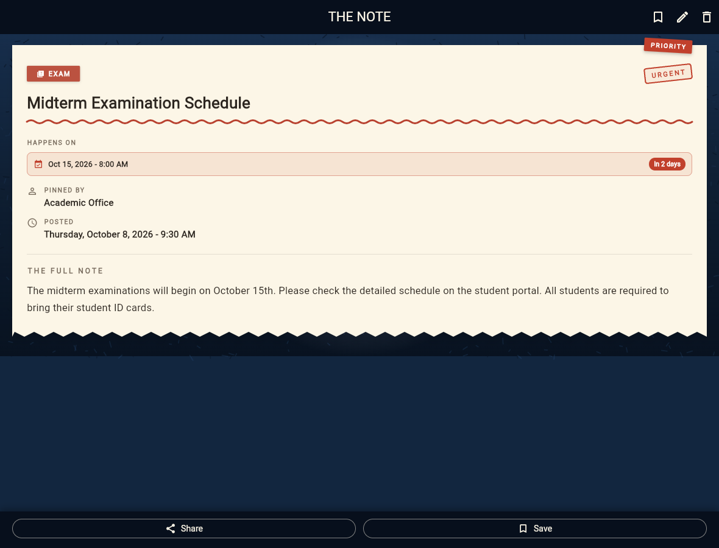
Figure 2. The note detail sheet with HAPPENS ON, PINNED BY and POSTED.
Figure 3 shows the form used to pin a new note; the pencil icon opens the same form pre-filled when editing.
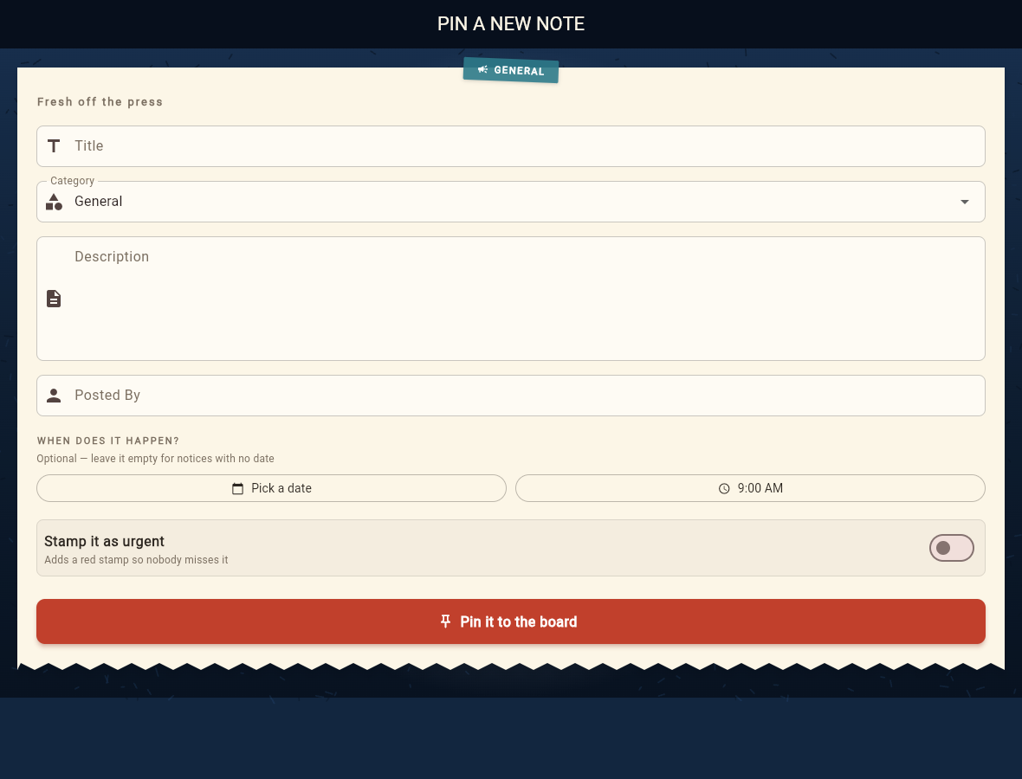
Figure 3. Pin a new note - title, category, description, poster, date, time and the urgent switch.
VIII. TESTING AND QUALITY ASSURANCE
# | Test case | Type | Result
1 | Board renders notes and filter tabs | Widget | Passed
2 | Filtering by category narrows the board | Widget | Passed
3 | Search finds notes by keyword | Widget | Passed
4 | Compose screen opens from a filtered board | Widget | Passed
5 | Tapping a note opens its sheet | Widget | Passed
6 | Deleting from the sheet unpins it and UNDO brings it back | Widget | Passed
7 | Saving a note marks it and the saved filter shows it | Widget | Passed
8 | Editing a note keeps the change | Widget | Passed
9 | Golden snapshot - board | Visual | Passed
10 | Golden snapshot - detail sheet | Visual | Passed
11 | Golden snapshot - compose form | Visual | Passed

flutter analyze - 0 issues, 0 warnings.
flutter test - 11 of 11 tests passed.
flutter build apk --release - build succeeded (49.8 MB).
Golden snapshots are regenerated with: flutter test --update-goldens
IX. INSTALLATION AND USER GUIDE
Requirements
Flutter SDK 3.x with the bundled Dart SDK.
Android SDK (only for building the APK) and a browser (for the web build).
Commands
flutter pub get
flutter run # run on a connected device or emulator
flutter build apk --release # build the Android APK
flutter test # run the test suite
Installing the APK on an Android phone
1. Download CHCC-Student-Announcements-v1.0.1.apk from the release page in Section X.
2. Copy it to the phone (USB, cloud drive or messenger).
3. Open the file and allow "Install unknown apps" when Android asks.
4. Tap Install - the school seal becomes the app icon.
Running the web build
flutter run -d web-server --web-port=8080 --web-hostname=127.0.0.1 --release
http://127.0.0.1:8080/?screen=detail # deep link to a screen
http://127.0.0.1:8080/?screen=compose # deep link to the form
X. PROJECT ARTIFACTS
Artifact | Location
Source repository | https://github.com/cesspanganiban211-spec/STUDENT_ANNOUNCEMENTS
Release page | https://github.com/cesspanganiban211-spec/STUDENT_ANNOUNCEMENTS/releases/tag/v1.0.1
APK download | https://github.com/cesspanganiban211-spec/STUDENT_ANNOUNCEMENTS/releases/download/v1.0.1/CHCC-Student-Announcements-v1.0.1.apk
APK size | 49.8 MB (release build, signed with the debug key)
Version | 1.0.1+2
Screenshots | docs/screenshots/fig1_board.png, fig2_detail.png, fig3_compose.png

XI. LIMITATIONS AND FUTURE ENHANCEMENTS
1. The application id is still com.example.student_announcements and the APK is signed with the debug key; both must be changed before publishing to the Play Store.
2. Data is stored only on the device - there is no cloud synchronisation or student login yet.
3. Notices cannot carry image attachments.
4. There are no push notifications for events that are about to happen.
5. Possible next features: real system sharing, a calendar view of event dates, a faculty-only posting mode, and rich text for the note body.
XII. CONCLUSION
CHCC Student Announcements meets its objectives: it gathers every school notice on one board, tells the student both when the notice was made and when it happens, and lets the student filter, search, bookmark, add, edit and delete notes safely. The board is kept locally so it is still there the next time the app opens, and it ships as an installable Android APK and as a web link. The test suite (11 of 11) and static analysis confirm that the delivered build is stable.

