# **2D/****3D gre CEST & 3D snapshot gre CEST**

Documentation

Version IMPI04

Developers

Moritz Zaiss

Kai Herz

Anagha Deshmane

Andrzej Liebert

**Protocol hints:**

* All shim modes for 3T are now automatic, so the following should not bother you.
  + When copying the adjustment volume, you have to make sure that the patient table mode is set on reference for all protocols (Wasabi, CEST and fieldmap). Otherwise the system will simply load the tune up shim currents… This was what was happening, whenever we copied it into the 816C version.
  + When you use automatic shimming, advanced shimming had the same issue, since advanced shimming was not available within the fieldmap sequence. This is now fixed and should work.

**Changelog: see in readme**

Contents

**2D/3D gre CEST & 3D snapshot gre CEST** 1

1. Gre CEST sequence installation 3

2. The saturation module 3

3. CEST logfiles 5

4. 3D CEST Sequence types 6

4.1. Steady-state CEST 6

4.2. Pseudo-steady-state CEST 7

4.3. Snapshot CEST 8

5. 2D CEST Sequence types 9

6. CEST evaluation 10

## Gre CEST sequence installation

The greCEST has the same source as the Siemens WIP_greCEST, which is the Siemens GRE sequence. For all parameters of the GRE sequence we refer to the documentation of Siemens. Herein only the parameters important for the CEST mode are discussed. In addition the spiral snapshot GRE mode is explained.

For installation of the sequence

* put the sequence files **("seq_filename".so and "seq_filename".dll)** in the sequence folder
* put the .txt files **"CEST_OffsetTable.txt","CEST_OffsetTable2.txt”, "CEST_Params.txt", and "CEST_TSatRecTable.txt"** directly in "\n4\x86\prod\bin" on development platform; or **"\medcom\MriCustomer\seq"** on scanner console (sometimes it is also \MrServers\MrMeasSrv\Config on development platform, test by typing "env" in IDEA console and look for MEASCONST)
* put the file **"extrf_hs.dat"** in **“MriProduct\measurement\extrf_hs.dat”** (or the one given by MEASCONST)
* To install the sequence on a pTx system please copy the "PPDconfig_dynpulse_CEST_SPINS.m" file into the **MedCom\MriProduct\PhysConfig\PPDconfig_dynpulse_CEST_SPINS.m** folder on the system.
* then in Syngo, open the Exam explorer->insert sequence->User -> "seq_filename"
* see also readme.txt

Table 1: Installation of sequence files

|  |
| --- |
| **Files for all systems** |
| %MEDHOME%\MriCustomer\seq\CEST_OffsetTable.txt %MEDHOME%\MriCustomer\seq\CEST_TSatRecTable.txt %MEDHOME%\MriCustomer\seq\CEST_Params.txt %MEDHOME%\MriCustomer\seq\gre_cest_WIP_MPI04.dll %MEDHOME%\MriCustomer\seq\libgre_cest_WIP_MPI04.so %MEDHOME%\MriProduct\measurement\extrf_hs.dat |
| **Additional files for pTX systems** |
| MedCom\MriProduct\PhysConfig\PPDconfig_dynpulse_CEST_SPINS. |

## The saturation module

In the Protocol under Sequence->Special all the self-coded features are visible. The first Checkbox activates or deactivates the whole pre-saturation block. The next selection box **“Pulse type”** allows to choose the pulse shape (Gauss, Sinc, Rect, Hypsec, AdiaSL, SATREC ..) of a single saturation pulse. Each of these pulse will be scaled by **‘B1’**, repeated by ‘number of pulses’, see below. While Gauss and Sinc pulses can be used very flexibly, please be aware that some pulses have certain restriction to yield reasonable results:

The AdiaSL, DGEp pulses require a minimum B1 of 4µT, they will lead to oscillations if used at lower power. The AdiaSL pulses only make sense if offset distribution is 0 and offset = 0 ppm (onresonant case). Also the values in CEST_Params.txt that define the Adiabatic pulses should not be changed. Same for the SATREC pulses, these are also Adiabatic half passage pulses followed by a recovery before the actual readout; the recovery times are given in CEST_TSatRecTable.txt, here also the settings must be offset distribution is 0 and offset = 0 ppm (onresonant case). If Exar file are used or Table 2 is followed carefully nothing can go wrong.

The next selection box **“B1 definition”** allows to choose different B1 normalizations (CWAE the average amplitude over the whole pulse train, CWPE, the average power over the whole pulse train, or pure FA: the average amplitude of a single pulse, which is actually the flipangle). **Definitions:**

CWAE: 

CWPE (also called B1rms) : 

B1pa or pureFA:

The next parameter **“B1”** is the B1 amplitude of the pulses according to the chosen **“B1 definition”.** The next box contains several timing parameters: **Number of pulses, pulse duration, interpulse delay,** the **recover time** before each pulse train, and the **recover time M0** which is only played out before the very first scan to make sure to scan M0 fully relaxed. The next box allows to choose different types of **spoiling** between the pulses or after the pulse train. We recommend here “Variable” or “only last”. The next parameter is actually not a CEST parameter but the “**spiral elongation”** factor of the rectangular spiral reordered readout of the snapshot mode, if spiral reordered readout is chosen this is typically 0.5 for the given FoV. For more details on the snapshot mode and spiral reordered readout see the section ‘snapshot CEST’ below. The next selection box allows to choose between different **offset distributions**: “Reverse”,” Regular”, “Alternating”, “single” and “File”. The next checkbox **“Suppressed M0”** allows to choose if the normalization image M0 also applies saturation at -300 ppm or not. If activated the exact same saturation block as for the saturated images will be played out at -300 ppm, directly after the M0 recovery time and before the readout. Example: If Suppressed M0 is checked and recover time M0 is 12s and the saturation block is 5s, the delay+sat block before the M0 acquisition will be 17s long.

The next field allows to choose the **offset range** if distribution regular, reverse, alternating is chosen; if single is chosen this value is the single offset value used. The other parameters in this field as well as the residual fields are for the CEST WIP reconstruction and are not supported yet. To finally set up the number of offsets that will be acquired, the **number of measurements** must be adjusted on the card **contrast->dynamic**. The first scan is always the M0 scan, so **measurements-1** offsets will be acquired (it must be an even number>6). If **‘File’** is chosen the offsets given in the file %MEDHOME%\MriCustomer\seq\CEST_OffsetTable.txt will be loaded, and the number of measurements will be automatically adjusted. Same for the predefined offset lists ‘APT, NOE, DGE’, fixed offsets will be loaded and repetitions will be fixed to the length of the offset list. A tooltip on the offset field can be displayed that shows the offset list that will be played out. For an ultimate check of the offset list start the sequence and check the CEST logfile, as described in the section below.

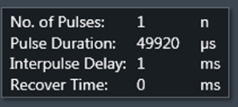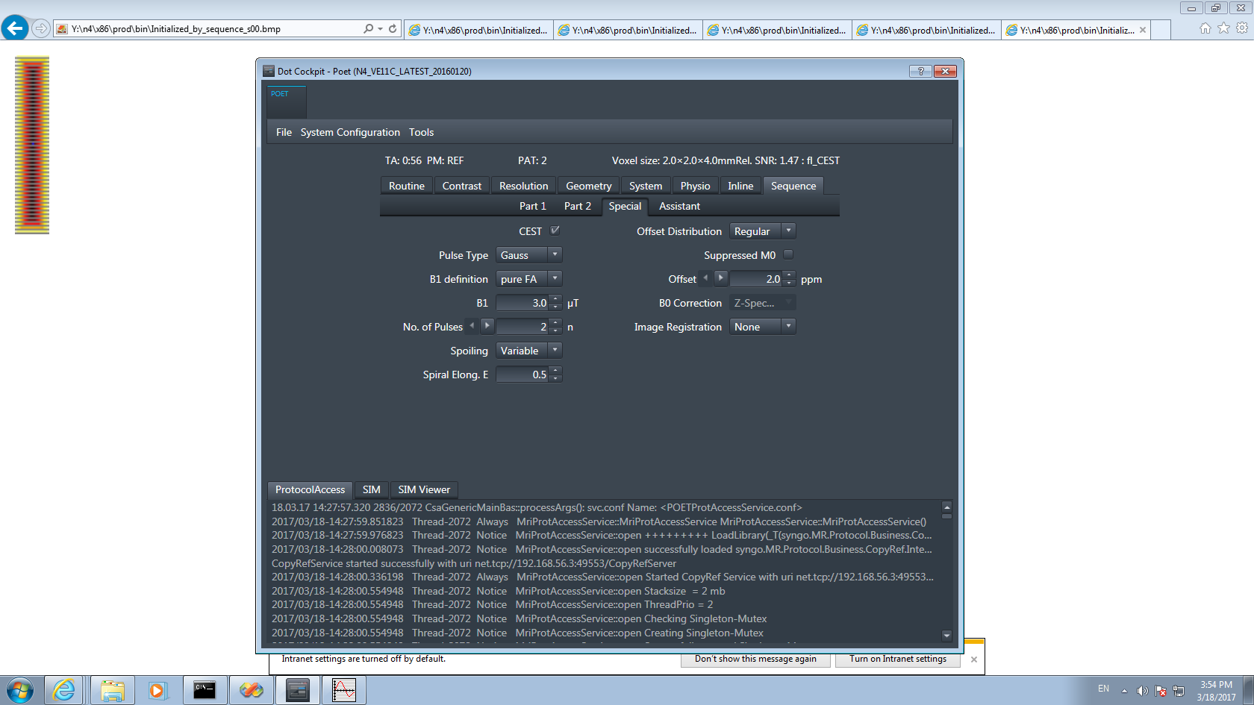

Figure 1: Sequence-Special Card for the CEST presaturation.

Table 2: Exemplary sequence parameters for different contrast using the snapshot-readout mode (see 3.3). For more standardized parameters see pulseq-cest.github.io or the .pro files.

|  |  |  |  |  |  |  |  |  |  |
| --- | --- | --- | --- | --- | --- | --- | --- | --- | --- |
| **Standard sequences** | **Pulse Type** | **B1 def.** | **B1** | **n** | **Pulse duration** | **Trec,**  **TrecM0** | **Interpulse delay Spoiling** | **Offset Distr.,**  **Offset** | **Measurements** |
| **CEST (“APT”)** | Gauss/Sinc | CWPE | 2 µT | 5-10 | 100 ms | 0-2000 ms,  12000 ms | Minimal,  Only last | Regular,  -6:6 ppm | 16-100 |
| **CEST (NOE)** | Gauss/Sinc | pure FA | 0.6 µT | 100 | 20 ms | 0-2000 ms,  12000 ms | Minimal,  Only last | Regular,  -6:6 ppm | 16-100 |
| **CEST (gluco)** | Gauss/Sinc | pure FA | 3 µT | 1-2 | 100 ms | 5000 ms,  12000 ms | Minimal,  Only last | Regular,  -3:3 ppm | 22-42 |
| **WASSR** | Gauss | pure FA | 0.2 µT | 1 | 25 ms | 2000 ms,  5000 ms | Minimal,  Only last | Regular,  -1.5:1.5 ppm | 26 |
| **WASABI** | Rect | pure FA | 3.7 µT | 1 | 5 ms | 2000 ms,  5000 ms | Minimal,  Only last | Regular,  -2:2 ppm | 32 |
| **CESL**  **(T1p onres.)** | AdiaSL  File CEST_Params.txt B1=20, mu=6, BW=1200, tp=8000, tw=1000) | Pure FA | 5 µT | 1 | 50 ms | 5000 ms,  12000 ms | Minimal,  Only last | Single,  0 ppm | 1-200  (cover dynamic) |
| **T1 satrec** | SATREC  **CEST_Params.txt:** B1=20, mu=6, BW=1200, tp=8000, tw=1000)  **CEST_TSatRecTable.txt**: 13 sat recover times [ms] | Pure FA | 5 µT | 3 | 50 ms | 0 ms,  12 000 ms | Minimal,  Variable | Single,  0 ppm | 14 |

## CEST logfiles

All special card sequence parameter important for the evaluation and analysis of CEST effects are stored in a logfile that is written during the sequence “check” routine. Thus, this is right before the “run” part of the sequence and will log all parameter exactly as they are finally applied in the presaturation block.

The logfiles can be found in the folder ../Medcom/log/CEST_log. The file name of the looks as follows:

CEST_2019-03-12_11h31m44s_B1=20_N=5_Tp=99840.txt

It has a time stamp so the log file can be associated with the CEST MRI datasets. At the end of the filename, the major saturation parameters are given to quickly distinguish the files. The file content looks for example like this:

Date and time of measurement  
12-03-2019 11:31:44  
  
**CEST PARAMETERS**  
PULSETYPE: Gauss  
SAT_B1: 2 uT  
T_PULSE: 99.84 ms  
N_PULSES: 5  
DC: 49.96 %  
SPOILING: only after last sat. pulse  
M0 SAT PULSE: FALSE  
M0-RECOVER TIME: 5000 ms  
RECOVER TIME: 5000 ms  
B0: 2.89362 T  
FREQ: 123.2 Hz  
FAT SAT: Off  
NUMBER OF MEASUREMENTS: 7  
SAMPLING: regular  
B1 definition: pure  
Saturation Offsets ppm:   
o: -300  
o: -3.6  
o: -3.5  
o: -3.4  
o: 3.4  
o: 3.5  
o: 3.6

**SEQUENCE PARAMETERS**  
TE: 2000 us  
TR: 4000 us  
RES_readout: 128  
RES_phase: 128  
SLICE THICKNESS: 5 mm  
SLICES PER SLAB: 12  
Bandwidth: 697.545 Hz/Px  
FOV_readout: 220 mm  
FOV_phase: 220 mm  
FLIPANGLE: 6  
Elongation Factor: 0.5  
iPAT not activated  
Total Scan Time: 34 s

Many parameters can also be extracted from the dicoms, but not all of them. We strongly recommend to save the logfiles with the data and use them for data evaluation. If any questions about sequence results arise, no support will be given without the log file with the correct time stamp.

## 3D CEST Sequence types

There are three types of sequences that can be realized with this sequence.

1. **Steady-state CEST** (high segmentation, few interleaved saturation pulses (~10-100ms))
2. **Pseudo-steady-state CEST** (low segmentation, more interleaved saturation pulses (~100ms -2s)
3. **Snapshot CEST** (no segmentation, arbitrary number of pulses after recover time and before readout, limited number of k-space lines)

In the following, the adjusted protocols for these three sequences are described and simulated sequences are shown.

## Steady-state CEST

To achieve a steady-state it is assumed: saturation using a single 50ms pulse followed by readout of 10 k-space lines. To realize this, first go to the special card: Protocol->Sequence->Special

Set No. of pulses n=1, Pulse duration 50 ms = 50000 µs. All other parameters as wished e.g. a Gaussian pulse of 1µT flip angle, regular offset sampling between -4:4ppm).

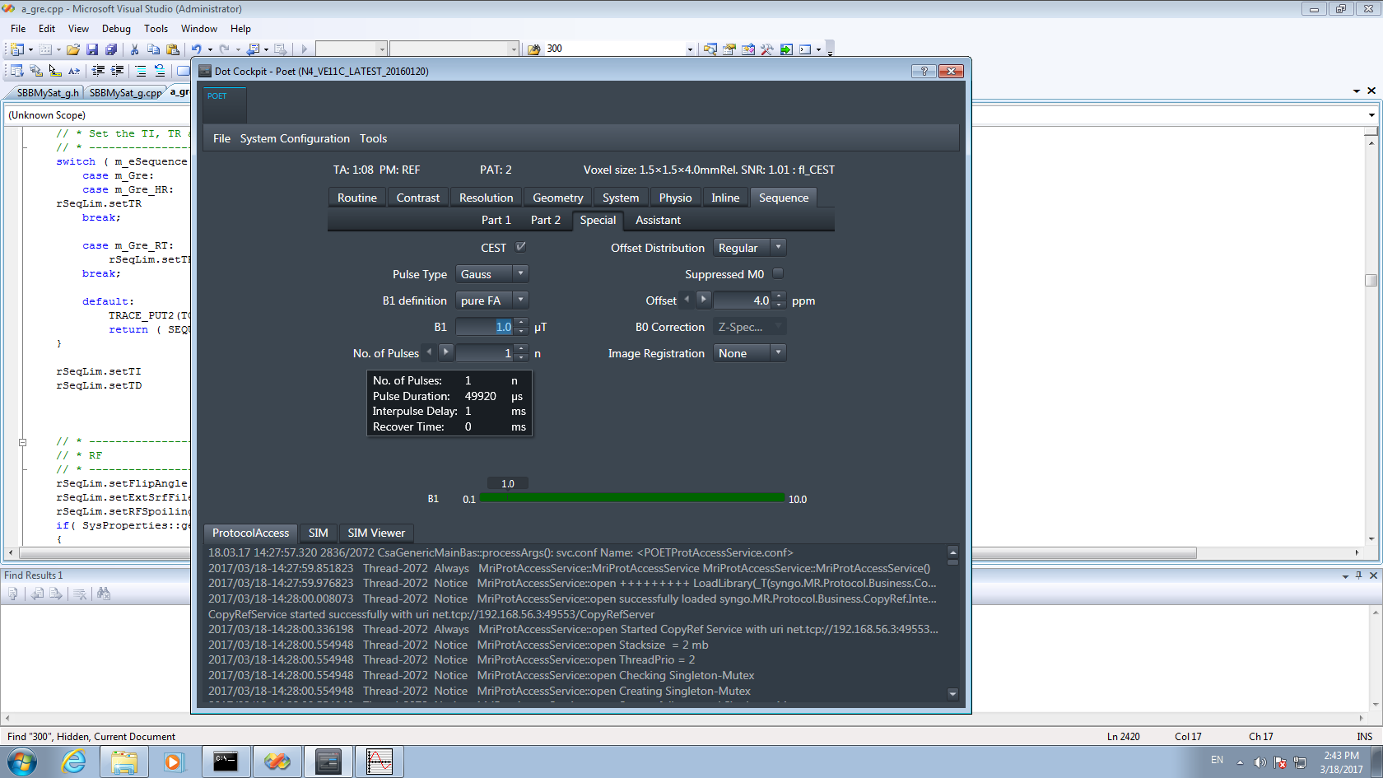 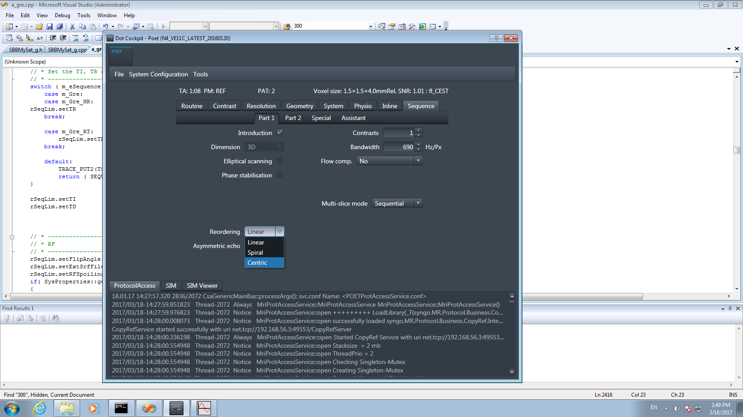

Figure 2: Steady-state sequence (a) special card (saturation), (b) reordering

Next, go to Protocol->Sequence->Part 1 and change the Dimension to 3D and the reordering scheme to centric or linear. For steady-state sequence it takes some k-space lines to approach steady-state, thus 3D makes sense and if centric or linear is chosen still the k-space is filled linearly in z-direction, thus the steady-state can build up. Spiral does not make sense here.  
Next, go to Protocol->Sequence->Part 2 and change the segments to 10. Then 10 k-space lines are acquired after each pulse (or 6 shots per slice are performed)

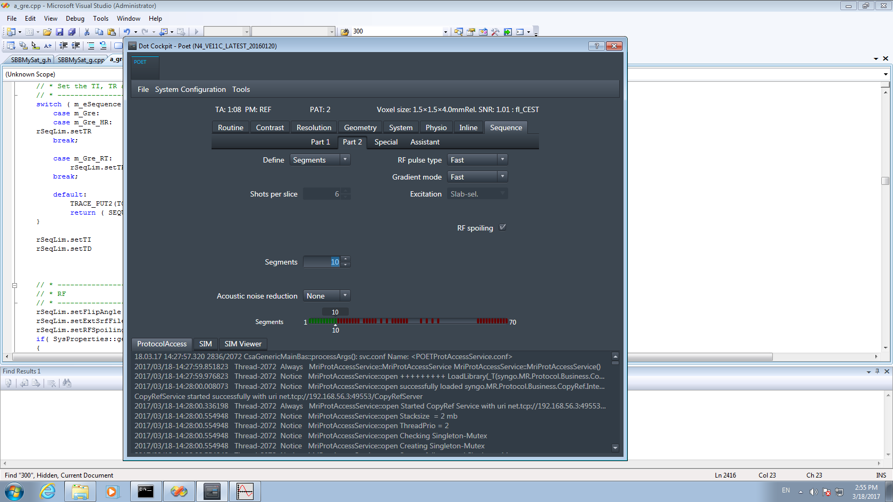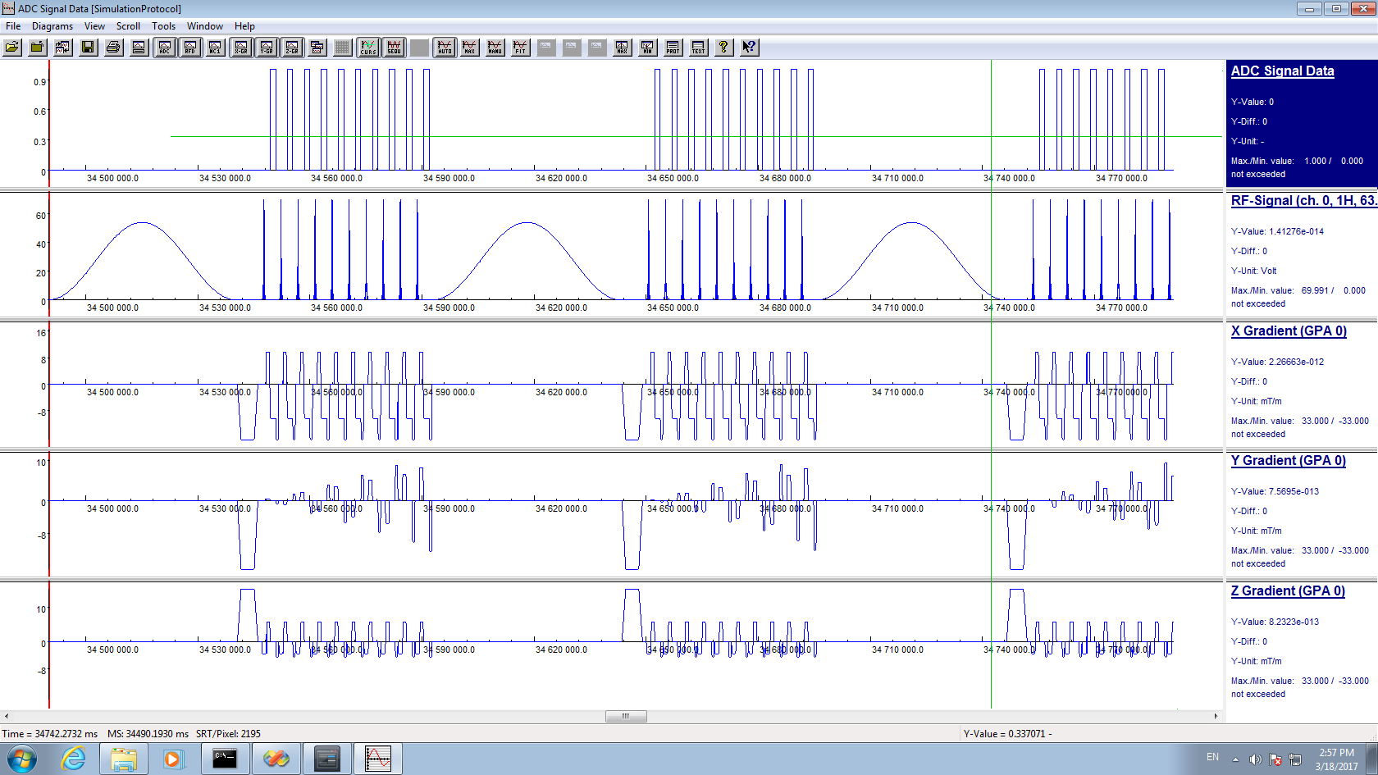 

Figure 3: Steady-state sequence (a) Segmentation, (b) simulation of steady-state sequence 50ms saturation readout of 10 k-space lines (3 shots shown), (c) reordering pattern.

## Pseudo-steady-state CEST

To achieve a Pseudo-steady-state it is assumed: saturation using 5x100ms pulses followed by readout of one 3D partition (with grappa 2/ 144 resolution / 80% phaseFOV this corresponds to 58 k-space lines). To realize this, first go to the special card: Protocol->Sequence->Special

Set No. of pulses n=5,

Pulse duration 100 ms = 100000 µs (to be able to change this, first the interpulse delay must be increased)

And all the other parameters as wished e.g. a Gaussian pulse of 1 µT flip angle, regular offset sampling between -4:4ppm) interpulse delay = 31 ms, Recover time = 500 ms.

Next go again to Part 1 and use now **Centric** reordering. Then Part 2 and Use **Segments =1.**

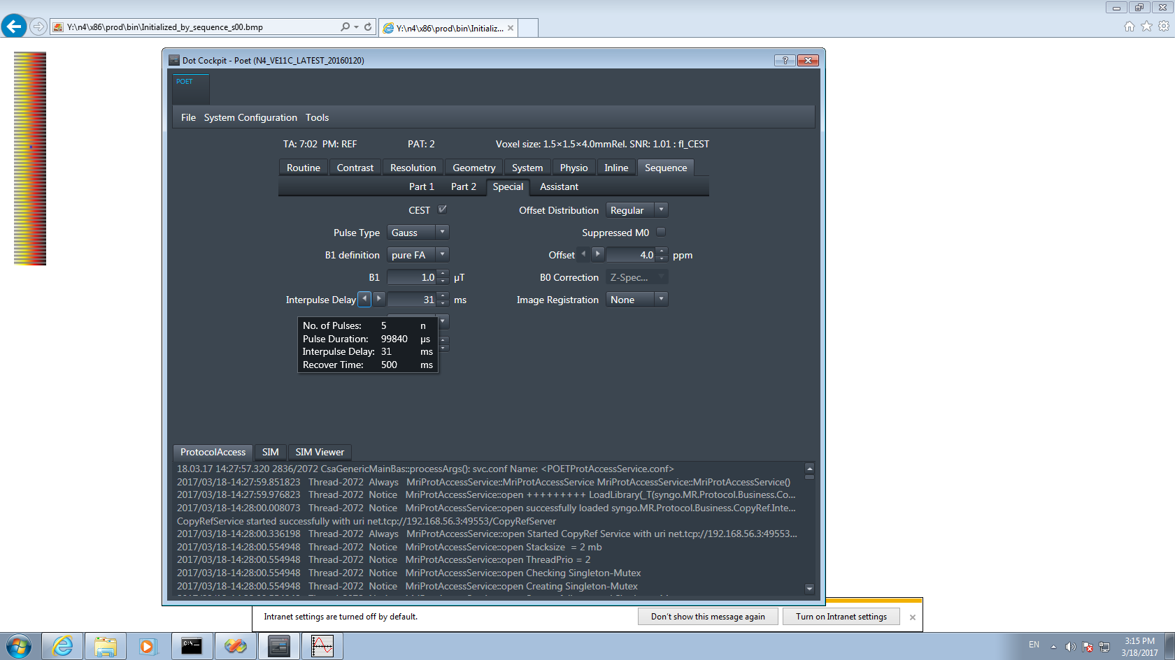 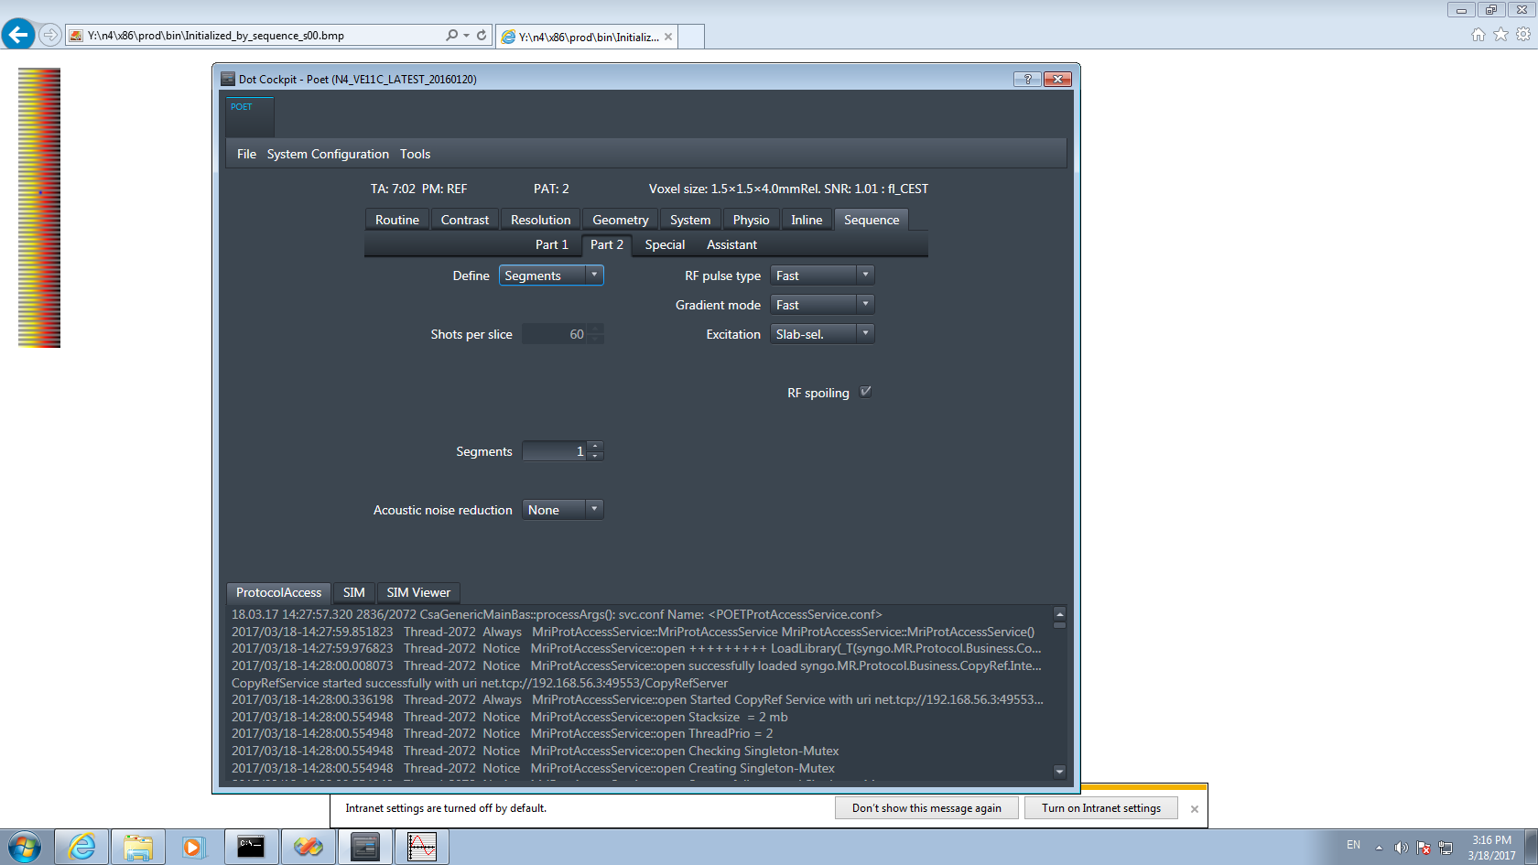

Figure 4: Pseudo-steady-state sequence (a) special card (saturation), (b) segmentation

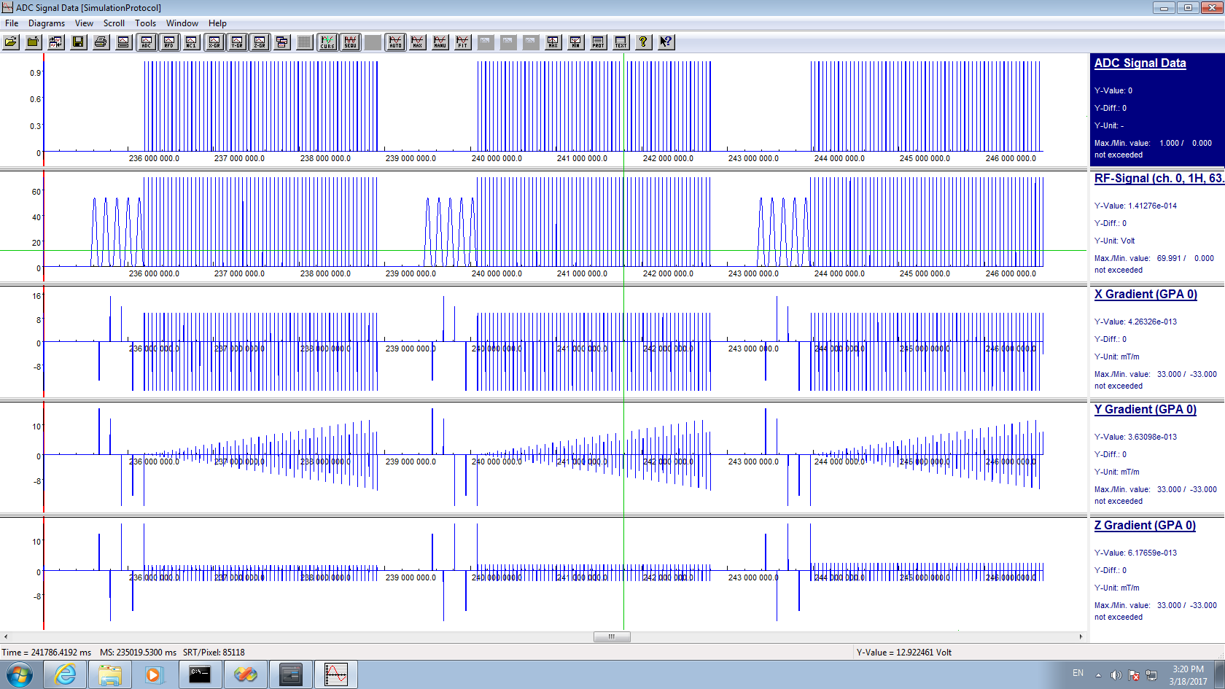

Figure 5: Pseudo-steady-state sequence simulation of three slices (3D partitions). For the full volume one block must be repeated for the number of slices, in this case 16 times.

## Snapshot CEST

In contrast to the previous methods, for snapshot CEST the number of k-space lines is limited to max. 1000. Thus the actual volume and resolution is limited. The current number of k-space lines is displayed in the tool tip of the elongation factor on the special card. We recommend for head scans at 3T transversal imaging of 16 slices, at resolution 112-144 with FOV phase=80 and phase encoding R-L, with Grappa 2 this yields around 700-900 lines. More lines than this will lead to corrupted signals, images will look great and smooth but the contrast is not reliable anymore.

Then an arbitrary saturation can be used. We assume here 2x100ms pulses followed by rectangular spiral readout of the whole 3D volume. To realize this, first go to the special card: Protocol->Sequence->Part 1 and set the **reordering to “Spiral**”, also make sure on Part 2 that Segmentation is off, i.e. **Segments=1.**

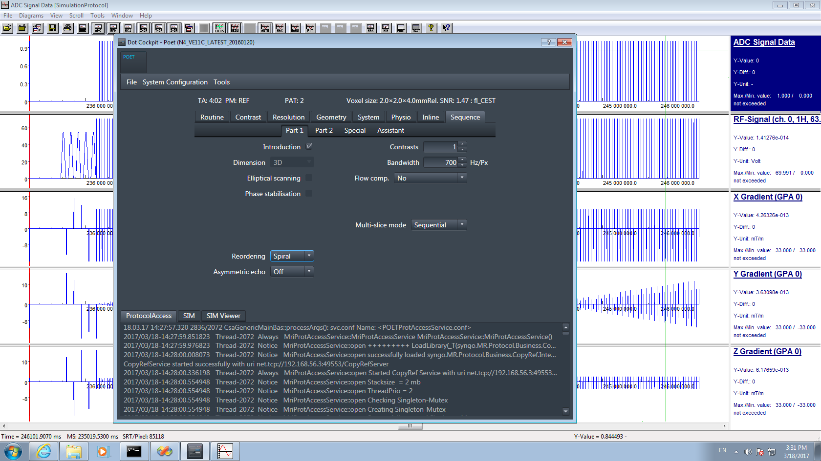 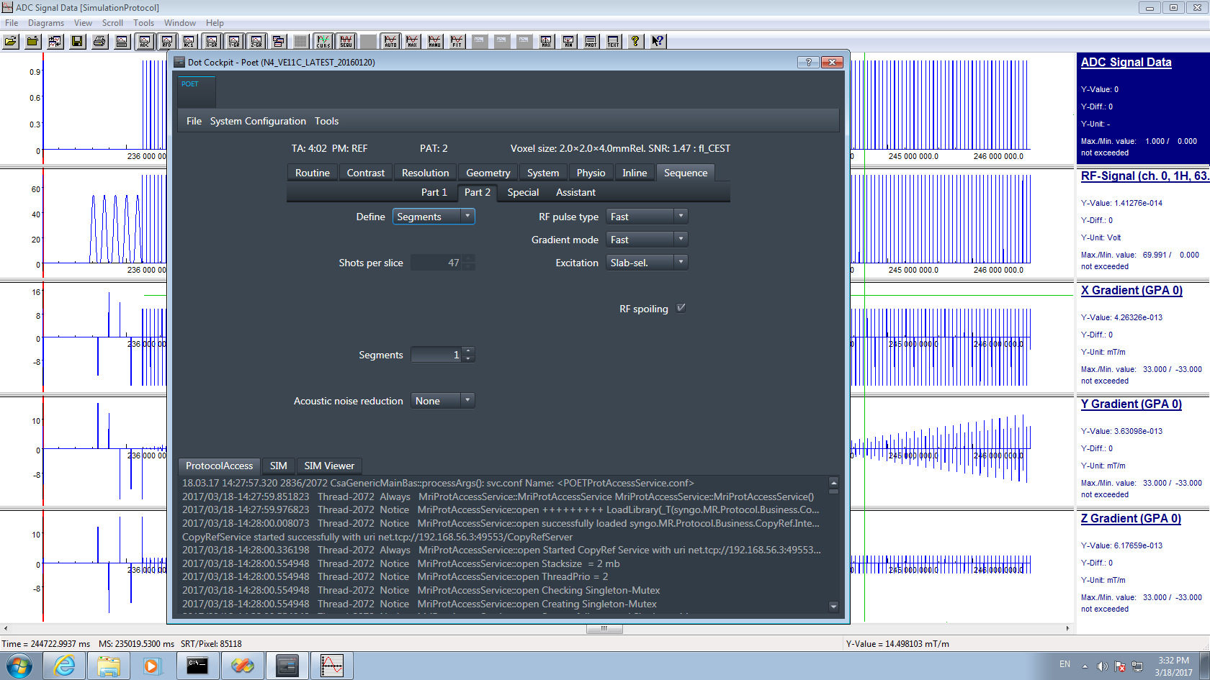

Figure 6: snapshot CEST: (a) Reordering=spiral, (b) Segmentation=off

Then go to the Special Card and set up your saturation parameters. Especially a long recover time can be used now. Also you can change the shape of the spiral reordering here. The Spiral elongation of E=0 correspnods to square spiral. E=0.5 is a rectangular spiral elongated in y direction, E=-0.5 is rectangular spiral elongated in z-direction. For the given Volume the optimal E is between 0.4 and 0.7.

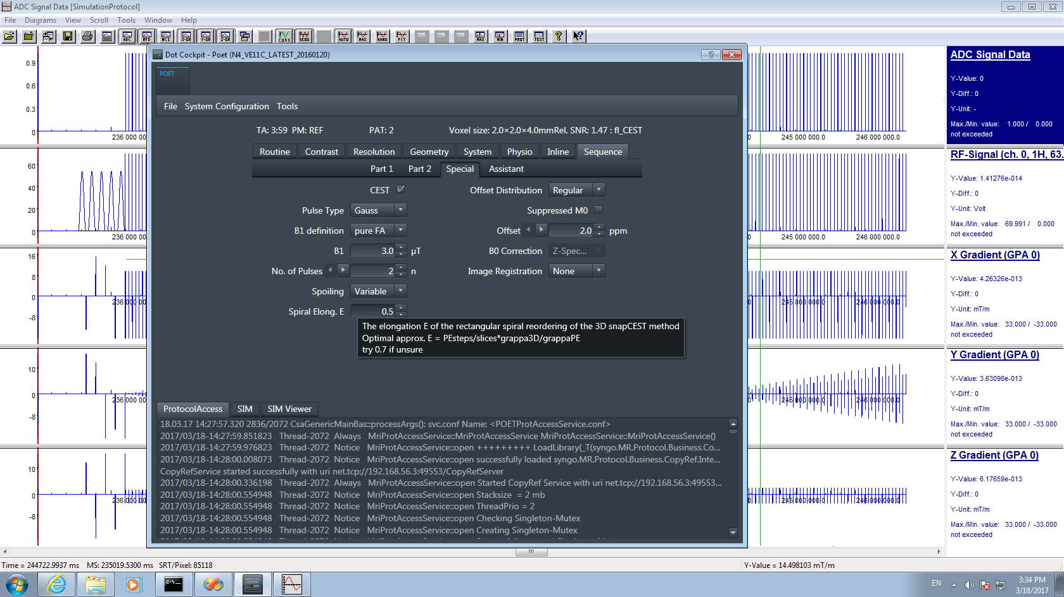

Figure 7: snapshot CEST, special card: long recovery with short but strong saturation. Spiral elongation E=0.5.

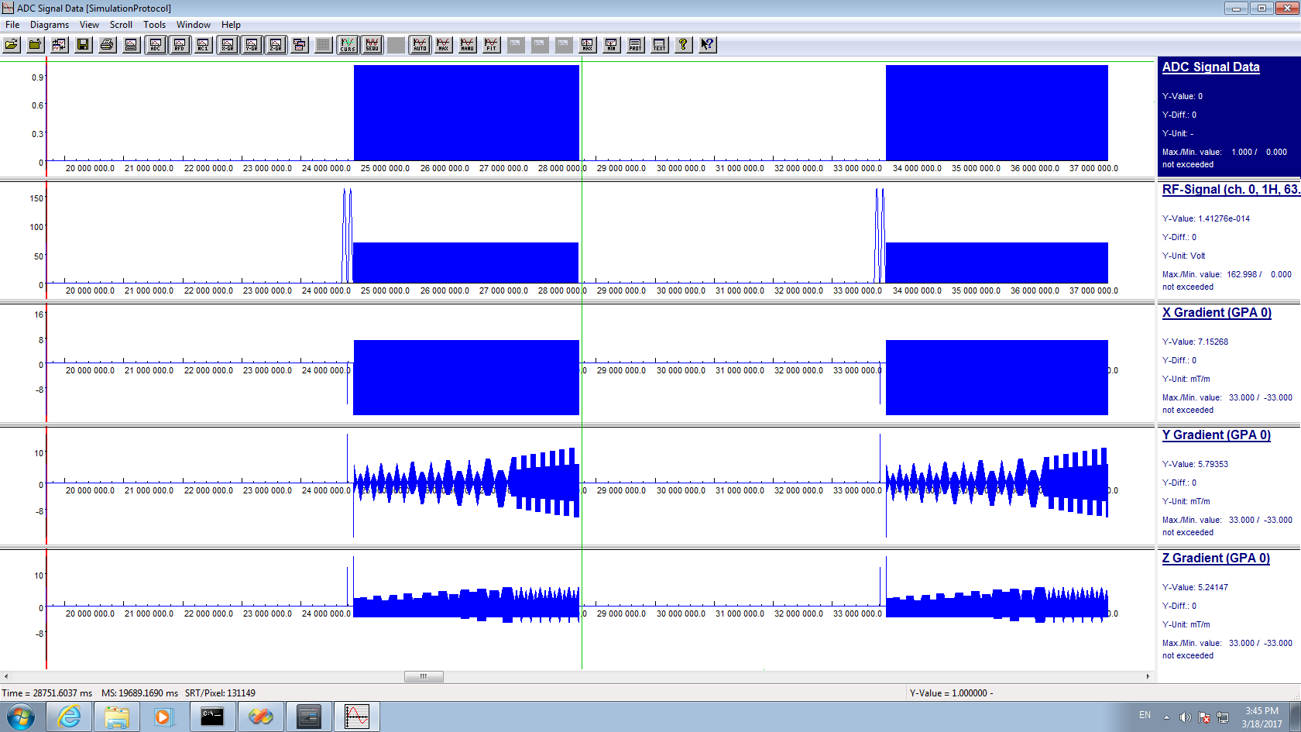     
 a b c d

Figure 8: snapshot CEST simulation (a), two 3D volumes saturated with 2 pulses at different offsets. Spiral Elongation in (a) was E=0.5 also shown in the reorder scheme (b). (c) shows the reordering for E=0 and (d) for E=0.8;

## 2D CEST Sequence types

**The 2D option is only available with CEST in the 2D single slice mode. You first have to change slices to 1 to be able to activate the CEST module.**

The sequences types of section 4 can in principle also be done in 2D single slice mode

1. **Steady-state CEST** this makes only sense when you do some averages, or go very slowly in offset domain, to really have a kind of steady state between the different CEST measurements
2. **Pseudo-steady-state CEST** and **Snapshot CEST** is actually the same in single slice mode as normally no further segmentation is performed in 2D.

We recommend in vivo to do always at least 3D snapshot mode even with fewer slice (8 with oversampling or so is possible), then 3D motion correction can be applied. However, 2D single slice can make sense for phantom experiments or animal experiments on a BRUKER system with Siemens platform.

## PTX settings – enabled only for VE12 versions an 7T

These setting are available currently only on systems with a pTx Option and were tested on Terra VE12U Software version. Suggested setup for slab selective SNAPSHOT CEST is using MIMOSA during saturation and CP excitation during readout. For WB SNAPSHOT CEST the SPINS pulse excitation is suggested in addition to MIMOSA.

In the Sequence Tab a new pTX Pulses card appears. This card allows to choose between the following options:

1. Using Only CP mode for acquisitions on a pTx System

For other options, the saturation part and the readout were divided into two parts. For saturation the following options are possible

1. Using Multiple Interleaved Mode Saturation (MIMOSA)
2. Using CP-Mode during saturation
3. Using EP-Mode during saturation

For the readout, the following two options are possible:

1. Using CP mode excitation during readout
2. Using WB SPINS pulses for the excitation during readout.

## CP only mode

For this setting the user has to ensure that **no pTX Pulse** is turned on in the pTX Pulses card. To do this the user has to press ´–´ to the right from the pTX pulse field.

## MIMOSA during saturation

For this purpose the **number of pTX pulses** has to be **set >=1**, the pulse type has to be chose **saturation** for the 1st Pulse and **trajectory** has to be set to **Spiral 3D**.

## CP mode during saturation

For this purpose the **number of pTX pulses** has to be **set >=1,** the pulse type has to be chose saturation for the 1st Pulse and **trajectory** has to be set to **Echo Planar 1D**.

## EP mode saturation

For this purpose the number of pTX pulses has to be **set >=1**, the pulse type has to be chose saturation for the 1st Pulse and **trajectory** has to be set to **Echo Planar 2D**.

## CP mode excitation during readout

For this purpose the **number of pTX pulses** has to be **set =1** and the appropriate saturation option should be chosen.

## WB SPINS pulses during readout

For this purpose the **number of pTX pulses** has to be **set =2**, the pulse type should be set to Excitation and the trajectory ‘Spiral 3D’ should be chosen.

## DICOM setting

Depending on your system, the signal range of the dicom format might not be well adjusted. This can be adjusted in the protocol on the card System/TxRx/ **ImageScale Corr.**

We set this to 5 at our site. You have to adjust at your system to make sure signals are not to small or do not clip the dicom range which is between 0 and 4096.

## CEST protocols

You find several standard protocols in the protocol folders. Some of them reflect protocols published on <https://github.com/kherz/pulseq-cest> e.g. the APTw_001 can be found in the linked library <https://github.com/kherz/pulseq-cest-library>

## CEST evaluation

Matlab tools for evaluation are available at [www.cest-sources.org](http://www.cest-sources.org).

Upon request, matching evaluation scripts for the standard protocols can be provided that are easier to use.

Licensed under GPL and as <https://en.wikipedia.org/wiki/Beerware>.

Exemplary results generated with this sequence and evaluation (for 3T) can be found in the file

**Xemplary_results_Deshmane_et_al.docx. However, with older protocols.**