# **3D snapshot gre hybrid**

Documentation

Version 1.0.0

based on snapshot readout 4.2.2

Developers

Junaid Rajput

Simon Weinmüller

Moritz Zaiss

Kai Herz

Anagha Deshmane

Andrzej Liebert

**Protocol hints:**

* All shim modes for 3T are now automatic, so the following should not bother you.
  + When copying the adjustment volume, you have to make sure that the patient table mode is set on reference for all protocols (Wasabi, CEST and fieldmap). Otherwise the system will simply load the tune up shim currents… This was what was happening, whenever we copied it into the 816C version.
  + When you use automatic shimming, advanced shimming had the same issue, since advanced shimming was not available within the fieldmap sequence. This is now fixed and should work.

**Changelog: see in readme**

Contents

**2D/3D gre CEST & 3D snapshot gre CEST** 1

1. Gre CEST sequence installation 3

2. The saturation module 3

3. CEST logfiles 5

4. 3D CEST Sequence types 6

4.1. Steady-state CEST 6

4.2. Pseudo-steady-state CEST 7

4.3. Snapshot CEST 8

5. 2D CEST Sequence types 9

6. CEST evaluation 10

## Gre CEST sequence installation

The greCEST has the same source as the Siemens WIP_greCEST, which is the Siemens GRE sequence. For all parameters of the GRE sequence we refer to the documentation of Siemens. Herein only the parameters important for the CEST mode are discussed. In addition the spiral snapshot GRE mode is explained.

For installation of the sequence

* put the sequence files **("seq_filename".so and "seq_filename".dll)** in the sequence folder
* put the iceprogram files (“ice_filename”.so, “ice_filename”.dll, “ice_filename”.ipr, “ice_filename”.evp) in the ice folder
* put the .seq file (“pulseq_filename”.seq) in the seq\pulseq\pulseq\pulseqSBB folder
* put the neural net files (“pulseq_filename”.ini and (“pulseq_filename”.nnet ) in the seq\IceDeepCEST
* then in Syngo, open the Exam explorer->insert sequence->User -> "seq_filename"
* see also readme.txt

Table 1: Installation of sequence files

|  |
| --- |
| **Files for all systems** |
| %MEDHOME%\MriCustomer\seq\pulseq\PulseqSBB\deepCEST7T_MultiPool_7T.seq %MEDHOME%\MriCustomer\seq\gre_cest_MP_04_pulseq_139_IDC01.dll  %MEDHOME%\MriCustomer\seq\libgre_cest_MP_04_pulseq_139_IDC01.so  %MEDHOME%\MriCustomer\ICE\IceProgramDeepCEST_IDC01.dll  %MEDHOME%\MriCustomer\ICE\ libIceProgramDeepCEST_IDC01.so  %MEDHOME%\MriCustomer\ICE\IceProgramDeepCEST_IDC01.evp  %MEDHOME%\MriCustomer\ICE\IceProgramDeepCEST_IDC01.ipr  %MEDHOME%\MriCustomer\seq\IceDeepCEST\deepCEST7T_MultiPool_7T.ini  %MEDHOME%\MriCustomer\seq\IceDeepCEST\deepCEST7T_MultiPool_7T.nnet |

## The special card

## – preparation

The preparation is now purely done in the Pulseq-CEST format.

<https://pulseq-cest.github.io/>

A standard seq. file is provided with the c2p-package.

## – readout parameters

The “**spiral elongation”** factor of the rectangular spiral reordered readout of the snapshot mode, if spiral reordered readout is chosen this is typically 0.5 for the given FoV. For more details on the snapshot mode and spiral reordered readout see the section ‘snapshot CEST’ below.

For an ultimate check of the offset list start the sequence and check the CEST logfile, as described in the section below.

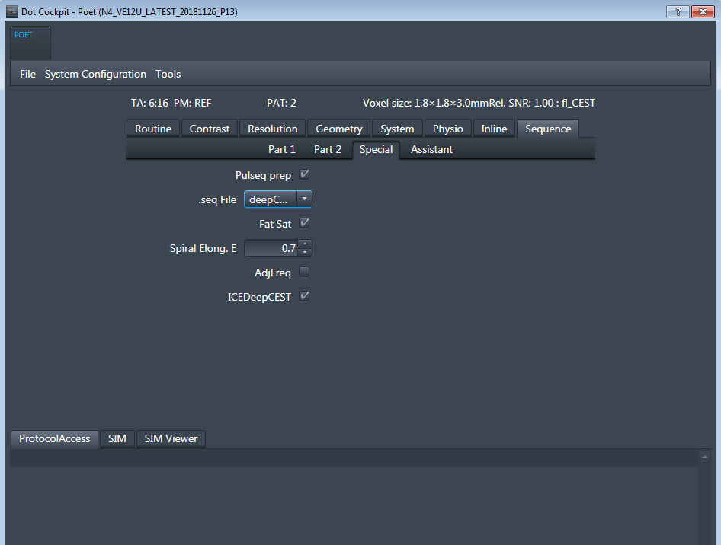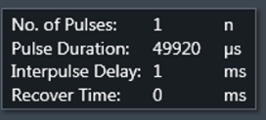

Figure 1: Sequence-Special Card for the CEST presaturation.

## 3D CEST Sequence types

1. **Snapshot CEST** (no segmentation, arbitrary preparation before readout, limited number of k-space lines)

## Snapshot CEST

In contrast to the previous methods, for snapshot CEST the number of k-space lines is limited to max. 1000. Thus the actual volume and resolution is limited. The current number of k-space lines is displayed in the tool tip of the elongation factor on the special card. We recommend for head scans at 3T transversal imaging of 16 slices, at resolution 112-144 with FOV phase=80 and phase encoding R-L, with Grappa 2 this yields around 700-900 lines. More lines than this will lead to corrupted signals, images will look great and smooth but the contrast is not reliable anymore.

Then an arbitrary saturation can be used. We assume here 2x100ms pulses followed by rectangular spiral readout of the whole 3D volume. To realize this, first go to the special card: Protocol->Sequence->Part 1 and set the **reordering to “Spiral**”, also make sure on Part 2 that Segmentation is off, i.e. **Segments=1.**

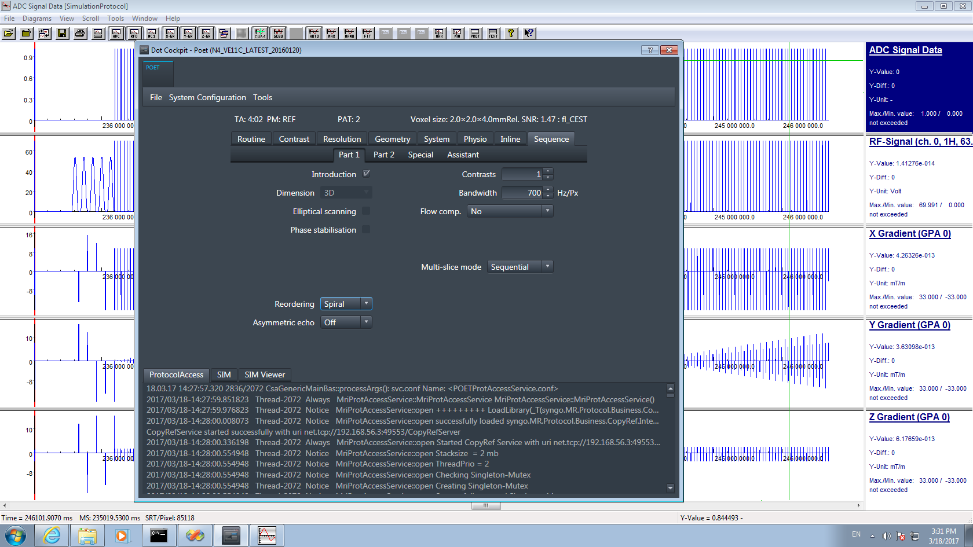 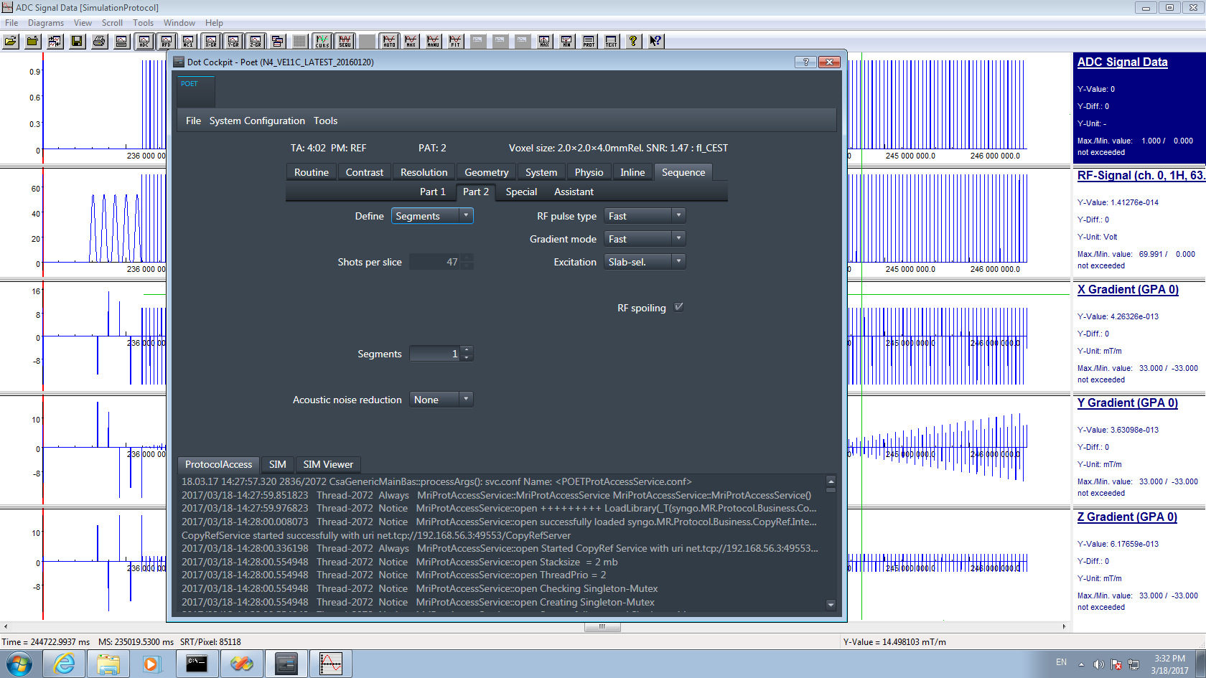

Figure 6: snapshot CEST: (a) Reordering=spiral, (b) Segmentation=off

Then go to the Special Card and set up your saturation parameters. Especially a long recover time can be used now. Also you can change the shape of the spiral reordering here. The Spiral elongation of E=0 correspnods to square spiral. E=0.5 is a rectangular spiral elongated in y direction, E=-0.5 is rectangular spiral elongated in z-direction. For the given Volume the optimal E is between 0.4 and 0.7.



Figure 7: snapshot CEST, special card: long recovery with short but strong saturation. Spiral elongation E=0.5.

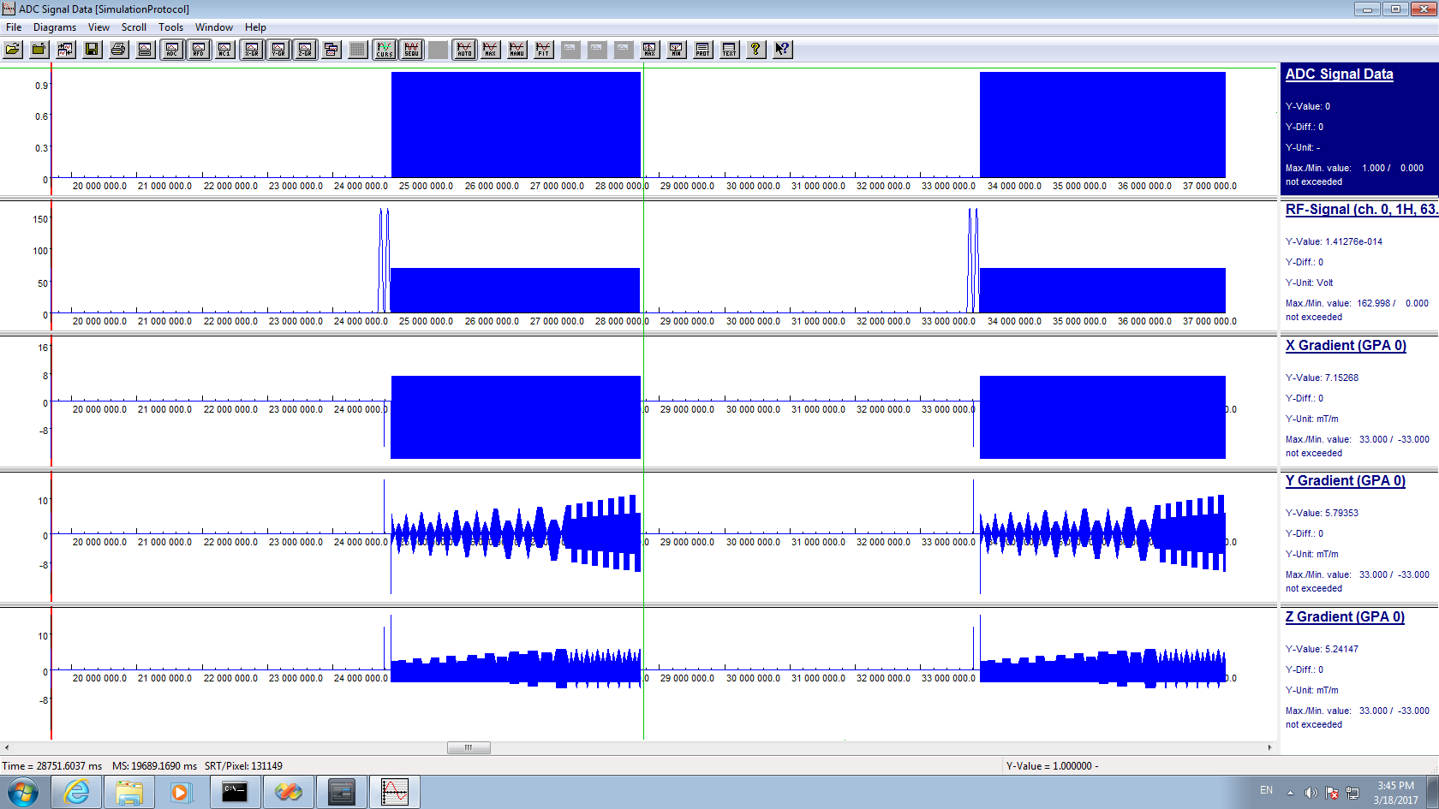     
 a b c d

Figure 8: snapshot CEST simulation (a), two 3D volumes saturated with 2 pulses at different offsets. Spiral Elongation in (a) was E=0.5 also shown in the reorder scheme (b). (c) shows the reordering for E=0 and (d) for E=0.8;

## PTX settings – enabled only for VE12 versions an 7T

If you want to run work-in-progress pTx-Pulseq files you have to switch on System->adjustments->B1 shim mode->Patienst specidifc

## Preparation Module:

Makes use of a Pulseq extension:

<https://gitlab.cs.fau.de/mrzero/pypulseq_rfshim>

## Readout:

The readout will be on one static rf shim. Either after set to patient specific:

* do nothing: the system will B1 shim the region, this shim is used for the readout pulses
* load a specific shim before scanning in global Adjustments card, either EP or CP.  
  We recommend this option with CP mode.

## DICOM setting

Depending on your system, the signal range of the dicom format might not be well adjusted. This can be adjusted in the protocol on the card System/TxRx/ **ImageScale Corr.**

We set this to 5 at our site. You have to adjust at your system to make sure signals are not to small or do not clip the dicom range which is between 0 and 4096.

## CEST protocols

You find several standard protocols in the protocol folders. Some of them reflect protocols published on <https://github.com/kherz/pulseq-cest> e.g. the APTw_001 can be found in the linked library <https://github.com/kherz/pulseq-cest-library>

For pTx-Pulseq-Extension look here: <https://gitlab.cs.fau.de/mrzero/pypulseq_rfshim>

## CEST evaluation

Matlab tools for evaluation are available at [www.cest-sources.org](http://www.cest-sources.org) and <https://github.com/kherz/pulseq-cest-library>

Upon request, matching evaluation scripts for the standard protocols can be provided that are easier to use.

Licensed under GPL and as <https://en.wikipedia.org/wiki/Beerware>.

1. Output files

* APT

* Amine

* B0

* NOE

* MT

* Uncertainty

* B1 CP

* B1 EP

* B1 MIMOSA

1. B1 maps scaling for dicom

* scaling factor 2000.

* divide B1 CP, B1 EP, and B1 MIMOSA with 2000.0 to obtain unscaled B1 maps

1. NN contrast scaling for dicom

* scale [20000, 20000, 1000, 10000, 5000]

* bias [ 0., 0., 2048., 0., 0.]

* To obtain unscaled maps use following formulation

(cest_maps_s/scale) - bias_b0

* scaling factor for uncertainty dicom 2000.0

* divide uncertainty by 2000.0 to obtain unscaled uncertainty