Class 4 R Intro
Yushi Wang
Jan 15, 2026
x <- 1:50
plot(x,sin(x))
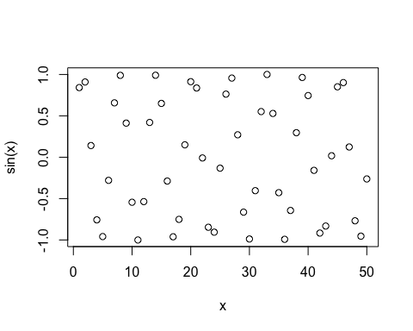
plot(x,sin(x), typ="l")
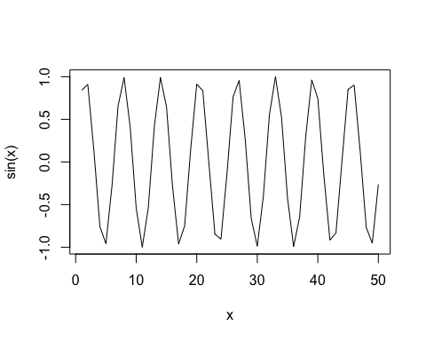
plot(x,sin(x), typ="l",col="pink", lwd=3)
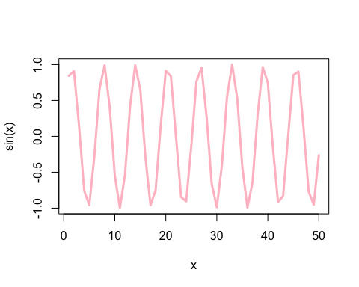
log(10,base=10)
## [1] 1

