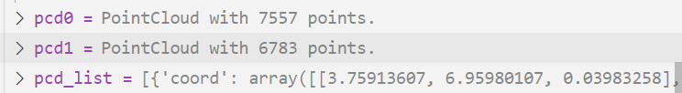

[[0, 239], [1, 325], [2, 253], [3, 258], [4, 259], [5, 259], [6, 232], [7, 237], [8, 334], [9, 336], [10, 336], [11, 335], [12, 475], [13, 332], [14, 332], [15, 335], [16, 466], [17, 319], [18, 319], [19, 330], [20, 330], [21, 255], [22, 315], [23, 315], [24, 462], [25, 318], [26, 387], [27, 389], [28, 381], [29, 382], [30, 385], [31, 351], [32, 363], [33, 364], [34, 362], [35, 374], [36, 347], [37, 347], [38, 379], [39, 379], [40, 380], [41, 380], [42, 374], [43, 374], [44, 395], [45, 417], [46, 417], [47, 455], [48, 413], [49, 417], [50, 399], [51, 419], [52, 419], [53, 416], [54, 416], [55, 395], [56, 418], [57, 396], [58, 399], ...]

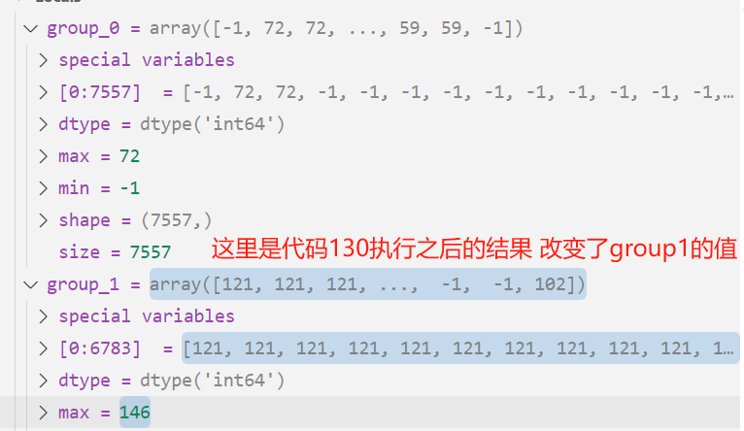

这是第一次的匹配结果

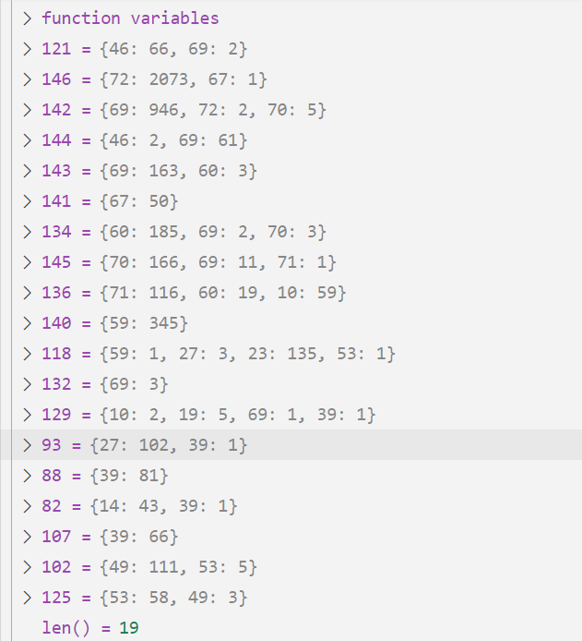

更新之后pcd1的值

[46, 46, 46, 46, 46, 46, 46, 46, 46, 46, 46, 46, 46, 46, 46, 46, 46, 46, 46, 46, 46, 46, 46, 46, 46, 46, 72, 72, 72, 72, 72, 69, 69, 69, 69, -1, -1, 69, 72, 72, 72, 72, -1, -1, 69, 72, 72, 72, 72, 72, 69, 69, 69, 72, 72, 69, 69, 69, 69, ...]

这是反向时的match_inds

[[204, 1], [205, 2], [214, 21], [220, 6], [221, 6], [229, 9], [230, 14], [231, 6], [232, 6], [233, 14], [234, 13], [235, 6], [236, 13], [237, 7], [238, 2], [239, 0], [240, 18], [241, 17], [245, 25], [246, 18], [247, 24], [249, 25], [251, 24], [252, 25], [253, 1], [254, 21], [255, 21], [257, 22], [258, 3], [259, 5], [262, 29], [263, 29], [264, 29], [265, 29], [266, 73], [267, 73], [270, 27], [281, 31], [282, 32], [287, 32], [294, 46], [295, 46], [299, 35], [300, 42], [301, 60], [312, 35], [313, 33], [314, 35], [315, 22], [316, 25], [317, 24], [318, 25], [319, 17], [320, 17], [322, 18], [323, 25], [325, 1], [326, 18], [327, 18], ...]

这次是根据pcd1的值更新pcd0的分组id pcd0的分组id会首先被偏移一下

这是第二次的匹配结果

