- Question
In a deck of strange cards, there are 947 cards. Each card has an image and a color. The amounts are shown in the table below.
  - What is the probability a random card is pink given it is a tree?
  - What is the probability a random card is a gem given it is yellow?
  - What is the probability a random card is a gem?
  - What is the probability a random card is either a gem or yellow (or both)?
  - What is the probability a random card is orange?
  - What is the probability a random card is both a dog and pink?
- Question
In a deck of strange cards, each card has an image and a color. The chance of drawing a shovel is 17.3%. If a shovel is drawn, there is a 45.8% chance that it is blue. If a card that is not a shovel is drawn, there is a 62.5% chance that it is blue.
Now, someone draws a random card and reveals it is not blue. What is the chance the card is a shovel?
Solution
I’d recommend making a tree. Remember, on the first branch, we put simple probabilities. On the second branches we put conditional probabilites. The results (products) are joint probabilities.
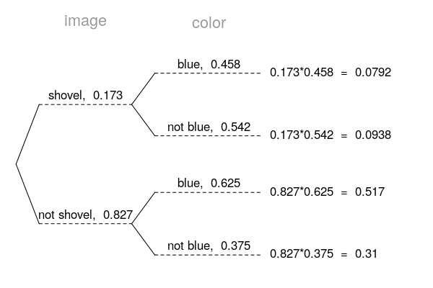
Determine the appropriate conditional probability.

- Question
In a very large pile of toothpicks, the mean length is 63.63 millimeters and the standard deviation is 1.48 millimeters. If you randomly sample 225 toothpicks, what is the chance the sample mean is between 63.58 and 63.69 millimeters?
Solution
Label the given information.

Find the standard error.

Describe the sampling distribution.

Draw a sketch.
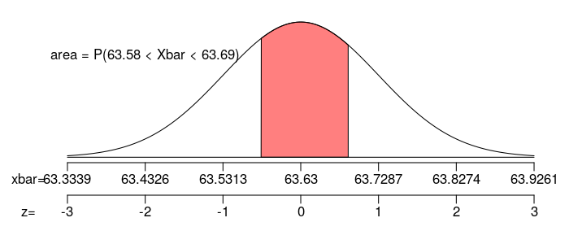
Calculate a scores.

Determine the probability.

- Question
In a game, there is a 91% chance to win a round. You will play 184 rounds.
  - What is the probability of winning exactly 164 rounds?
  - What is the probability of winning at least 161 but at most 167 rounds?
- Question
As an ornithologist, you wish to determine the average body mass of Archilochus colubris. You randomly sample 36 adults of Archilochus colubris, resulting in a sample mean of 3.38 grams and a sample standard deviation of 0.791 grams. Determine a 80% confidence interval of the true population mean.
Solution
We are given the sample size, sample mean, sample standard deviation, and confidence level.

Determine the degrees of freedom (because we don’t know and we are doing inference so we need to use the distribution).

Determine the critical value, , such that .

Calculate the standard error.

We want to make an inference about the population mean.

Determine the bounds.

We are 80% confident that the population mean is between 3.21 and 3.55.
- Question
A treatment group of size 16 has a mean of 1.11 and standard deviation of 0.124. A control group of size 21 has a mean of 1.01 and standard deviation of 0.138. If you decided to use a signficance level of 0.05, is there sufficient evidence to conclude the treatment causes an effect?
By using the Welch-Satterthwaite equation, I’ve calculated the degrees of freedom should be 33.
  - State the null hypothesis.
  - State the alternative hypothesis.
  - Evaluate the critical value. (The critical value is either or . Determine its value.)
  - Determine the standard error of the relevant sampling distribution.
  - Evaluate the absolute value of the test statistic. (The test statistic is either or . Determine its absolute value.)
  - If possible, evaluate the -value. Otherwise, describe an interval containing the -value.
  - Do we reject or retain the null?
- Question
From a very large population, a random sample of 6300 individuals was taken. In that sample, 79.4% were golden. Determine a 95% confidence interval of the population proportion.
  - Find the lower bound of the confidence interval.
  - Find the upper bound of the condifence interval.
- Question
An experiment is run with a treatment group of size 113 and a control group of size 149. The results are summarized in the table below.
Using a significance level of 0.005, determine whether the treatment causes an effect on the proportion of cases that are special.
  - State the null hypothesis.
  - State the alternative hypothesis.
  - Evaluate the critical value. (The critical value is either or . Determine its value.)
  - Determine the standard error of the relevant sampling distribution.
  - Evaluate the absolute value of the test statistic. (The test statistic is either or . Determine its absolute value.)
  - If possible, evaluate the -value. Otherwise, describe an interval containing the -value.
  - Do we reject or retain the null?

