- Question
In a deck of strange cards, there are 1394 cards. Each card has an image and a color. The amounts are shown in the table below.
  - What is the probability a random card is a tree?
  - What is the probability a random card is a shovel given it is orange?
  - What is the probability a random card is both a cat and violet?
  - What is the probability a random card is red?
  - What is the probability a random card is red given it is a gem?
  - What is the probability a random card is either a shovel or blue (or both)?
- Question
In a deck of strange cards, each card has an image and a color. The chance of drawing a dog is 38.3%. If a dog is drawn, there is a 24% chance that it is yellow. If a card that is not a dog is drawn, there is a 80.2% chance that it is yellow.
Now, someone draws a random card and reveals it is not yellow. What is the chance the card is not a dog?
Solution
I’d recommend making a tree. Remember, on the first branch, we put simple probabilities. On the second branches we put conditional probabilites. The results (products) are joint probabilities.
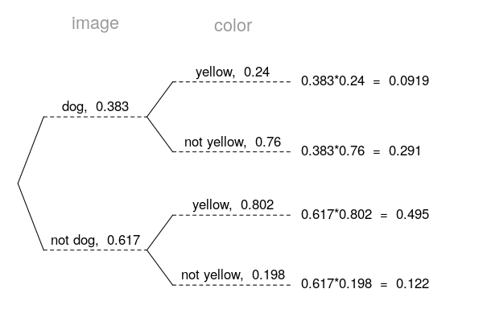
Determine the appropriate conditional probability.

- Question
In a very large pile of toothpicks, the mean length is 62.41 millimeters and the standard deviation is 3.64 millimeters. If you randomly sample 200 toothpicks, what is the chance the sample mean is between 62.22 and 62.54 millimeters?
Solution
Label the given information.

Find the standard error.

Describe the sampling distribution.

Draw a sketch.
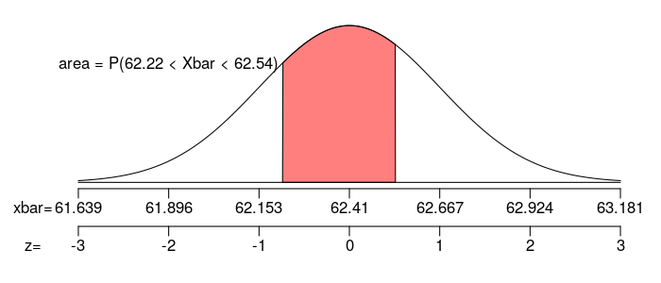
Calculate a scores.

Determine the probability.

- Question
In a game, there is a 27% chance to win a round. You will play 61 rounds.
  - What is the probability of winning exactly 17 rounds?
  - What is the probability of winning at least 12 but at most 21 rounds?
- Question
As an ornithologist, you wish to determine the average body mass of Zonotrichia albicollis. You randomly sample 27 adults of Zonotrichia albicollis, resulting in a sample mean of 23.78 grams and a sample standard deviation of 1.95 grams. Determine a 95% confidence interval of the true population mean.
Solution
We are given the sample size, sample mean, sample standard deviation, and confidence level.

Determine the degrees of freedom (because we don’t know and we are doing inference so we need to use the distribution).

Determine the critical value, , such that .

Calculate the standard error.

We want to make an inference about the population mean.

Determine the bounds.

We are 95% confident that the population mean is between 23 and 24.6.
- Question
A treatment group of size 22 has a mean of 11.2 and standard deviation of 1.76. A control group of size 24 has a mean of 10 and standard deviation of 1.96. If you decided to use a signficance level of 0.05, is there sufficient evidence to conclude the treatment causes an effect?
By using the Welch-Satterthwaite equation, I’ve calculated the degrees of freedom should be 43.
  - State the null hypothesis.
  - State the alternative hypothesis.
  - Evaluate the critical value. (The critical value is either or . Determine its value.)
  - Determine the standard error of the relevant sampling distribution.
  - Evaluate the absolute value of the test statistic. (The test statistic is either or . Determine its absolute value.)
  - If possible, evaluate the -value. Otherwise, describe an interval containing the -value.
  - Do we reject or retain the null?
- Question
From a very large population, a random sample of 51000 individuals was taken. In that sample, 38% were purple. Determine a 99.5% confidence interval of the population proportion.
  - Find the lower bound of the confidence interval.
  - Find the upper bound of the condifence interval.
- Question
An experiment is run with a treatment group of size 212 and a control group of size 229. The results are summarized in the table below.
Using a significance level of 0.04, determine whether the treatment causes an effect on the proportion of cases that are omnivorous.
  - State the null hypothesis.
  - State the alternative hypothesis.
  - Evaluate the critical value. (The critical value is either or . Determine its value.)
  - Determine the standard error of the relevant sampling distribution.
  - Evaluate the absolute value of the test statistic. (The test statistic is either or . Determine its absolute value.)
  - If possible, evaluate the -value. Otherwise, describe an interval containing the -value.
  - Do we reject or retain the null?

