- Question
In a deck of strange cards, there are 713 cards. Each card has an image and a color. The amounts are shown in the table below.
  - What is the probability a random card is both a shovel and pink?
  - What is the probability a random card is a cat?
  - What is the probability a random card is a flower given it is pink?
  - What is the probability a random card is pink?
  - What is the probability a random card is either a cat or indigo (or both)?
  - What is the probability a random card is pink given it is a bike?
- Question
In a deck of strange cards, each card has an image and a color. The chance of drawing a horn is 44.6%. If a horn is drawn, there is a 34.6% chance that it is yellow. If a card that is not a horn is drawn, there is a 79.7% chance that it is yellow.
Now, someone draws a random card and reveals it is not yellow. What is the chance the card is not a horn?
Solution
I’d recommend making a tree. Remember, on the first branch, we put simple probabilities. On the second branches we put conditional probabilites. The results (products) are joint probabilities.
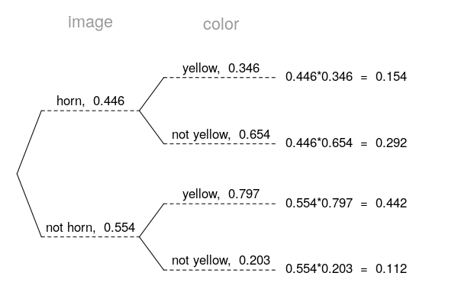
Determine the appropriate conditional probability.

- Question
In a very large pile of toothpicks, the mean length is 71.7 millimeters and the standard deviation is 3.58 millimeters. If you randomly sample 225 toothpicks, what is the chance the sample mean is between 71.43 and 71.88 millimeters?
Solution
Label the given information.

Find the standard error.

Describe the sampling distribution.

Draw a sketch.
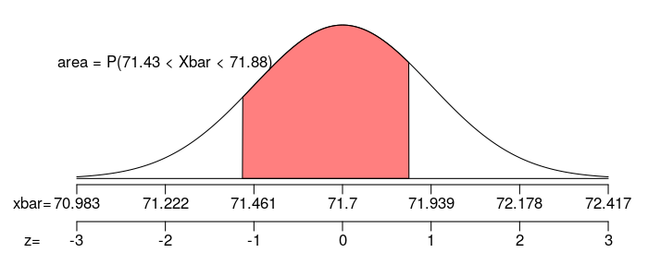
Calculate a scores.

Determine the probability.

- Question
In a game, there is a 56% chance to win a round. You will play 193 rounds.
  - What is the probability of winning exactly 102 rounds?
  - What is the probability of winning at least 109 but at most 118 rounds?
- Question
As an ornithologist, you wish to determine the average body mass of Catharus minimus. You randomly sample 20 adults of Catharus minimus, resulting in a sample mean of 32.09 grams and a sample standard deviation of 6.08 grams. Determine a 95% confidence interval of the true population mean.
Solution
We are given the sample size, sample mean, sample standard deviation, and confidence level.

Determine the degrees of freedom (because we don’t know and we are doing inference so we need to use the distribution).

Determine the critical value, , such that .

Calculate the standard error.

We want to make an inference about the population mean.

Determine the bounds.

We are 95% confident that the population mean is between 29.2 and 34.9.
- Question
A treatment group of size 31 has a mean of 96.5 and standard deviation of 17.1. A control group of size 28 has a mean of 106 and standard deviation of 18.2. If you decided to use a signficance level of 0.05, is there sufficient evidence to conclude the treatment causes an effect?
By using the Welch-Satterthwaite equation, I’ve calculated the degrees of freedom should be 55.
  - State the null hypothesis.
  - State the alternative hypothesis.
  - Evaluate the critical value. (The critical value is either or . Determine its value.)
  - Determine the standard error of the relevant sampling distribution.
  - Evaluate the absolute value of the test statistic. (The test statistic is either or . Determine its absolute value.)
  - If possible, evaluate the -value. Otherwise, describe an interval containing the -value.
  - Do we reject or retain the null?
- Question
From a very large population, a random sample of 99000 individuals was taken. In that sample, 65.1% were glowing. Determine a 95% confidence interval of the population proportion.
  - Find the lower bound of the confidence interval.
  - Find the upper bound of the condifence interval.
- Question
An experiment is run with a treatment group of size 89 and a control group of size 53. The results are summarized in the table below.
Using a significance level of 0.05, determine whether the treatment causes an effect on the proportion of cases that are abysmal.
  - State the null hypothesis.
  - State the alternative hypothesis.
  - Evaluate the critical value. (The critical value is either or . Determine its value.)
  - Determine the standard error of the relevant sampling distribution.
  - Evaluate the absolute value of the test statistic. (The test statistic is either or . Determine its absolute value.)
  - If possible, evaluate the -value. Otherwise, describe an interval containing the -value.
  - Do we reject or retain the null?

