1. **Question**  
   In a deck of strange cards, there are 1118 cards. Each card has an image and a color. The amounts are shown in the table below.

|  |  |  |  |  |  |
| --- | --- | --- | --- | --- | --- |
|  | * black | * green | * pink | * red | * violet |
| * bike | * 53 | * 70 | * 16 | * 69 | * 21 |
| * cat | * 91 | * 66 | * 17 | * 74 | * 71 |
| * pig | * 37 | * 20 | * 64 | * 60 | * 43 |
| * shovel | * 65 | * 62 | * 90 | * 89 | * 40 |

* 1. What is the probability a random card is either a shovel or red (or both)?
  2. What is the probability a random card is violet given it is a cat?
  3. What is the probability a random card is both a shovel and green?
  4. What is the probability a random card is black?
  5. What is the probability a random card is a bike?
  6. What is the probability a random card is a shovel given it is black?
* **Solution**

$P(shovel or red)$ $=\frac{65+62+90+89+40+69+74+60+89−89}{1118}=0.491$

$P(violet given cat)$ $=\frac{71}{91+66+17+74+71}=0.223$

$P(shovel and green)$ $=\frac{62}{1118}=0.0555$

$P(black)$ $=\frac{53+91+37+65}{1118}=0.22$

$P(bike)$ $=\frac{53+70+16+69+21}{1118}=0.205$

$P(shovel given black)$ $=\frac{65}{53+91+37+65}=0.264$

1. **Question**  
   In a deck of strange cards, each card has an image and a color. The chance of drawing a bike is 43.5%. If a bike is drawn, there is a 12.1% chance that it is pink. If a card that is not a bike is drawn, there is a 24.3% chance that it is pink.

* Now, someone draws a random card and reveals it is not pink. What is the chance the card is not a bike?
* **Solution**  
  I’d recommend making a tree. Remember, on the first branch, we put simple probabilities. On the second branches we put conditional probabilites. The results (products) are joint probabilities.
* 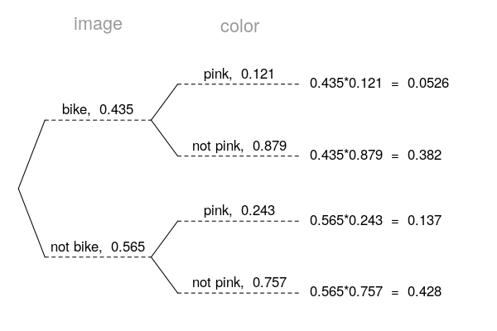
* Determine the appropriate conditional probability.

$$P("not bike" given "not pink")=\frac{0.428}{0.428+0.382}=0.528$$

1. **Question**  
   In a very large pile of toothpicks, the mean length is 64.12 millimeters and the standard deviation is 1.41 millimeters. If you randomly sample 200 toothpicks, what is the chance the sample mean is between 63.87 and 64.23 millimeters?

* **Solution**  
  Label the given information.
$$\begin{matrix}μ & =64.12 \\ σ & =1.41 \\ n & =200 \\ {\overline{x}}_{lower} & =63.87 \\ {\overline{x}}_{upper} & =64.23\end{matrix}$$

* Find the standard error.
$$SE=\frac{σ}{\sqrt{n}}=\frac{1.41}{\sqrt{200}}=0.0997$$

* Describe the sampling distribution.
$$\overline{X}∼N(64.12, 0.0997)$$

* Draw a sketch.  
  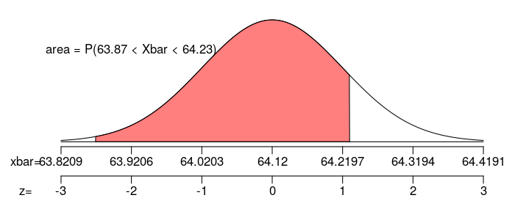
* Calculate a $z$ scores.
$$z_{lower}=\frac{x_{lower}−μ}{SE}=\frac{63.87−64.12}{0.0997}=−2.51$$

$$z_{upper}=\frac{x_{upper}−μ}{SE}=\frac{64.23−64.12}{0.0997}=1.1$$

* Determine the probability.

$$\begin{matrix}P(63.87<X<64.23) & =Φ(z_{upper})−Φ(z_{lower}) \\ & =Φ(1.1)−Φ(−2.51) \\ & =0.8583\end{matrix}$$

1. **Question**  
   In a game, there is a 73% chance to win a round. You will play 116 rounds.
   1. What is the probability of winning exactly 87 rounds?
   2. What is the probability of winning at least 79 but at most 95 rounds?

* **Solution**  
  We use the formula for binomial probabilities.
$$P(X=k)=\left({n \atop k}\right)(p)^{k}(1−p)^{n−k}$$

$$P(X=87)=\left({116 \atop 87}\right)(0.73)^{87}(1−0.73)^{116−87}$$

$$P(X=87)=\left({116 \atop 87}\right)(0.73)^{87}(0.27)^{29}$$

$$P(X=87)=0.0757$$

* Find the mean.
$$μ=np=(116)(0.73)=84.68$$

* Find the standard deviation.
$$σ=\sqrt{np(1−p)}=\sqrt{(116)(0.73)(1−0.73)}=4.7816$$

* Make a sketch, specifically try to picture whether you need to add or subtract 0.5 for the continuity correction.
* 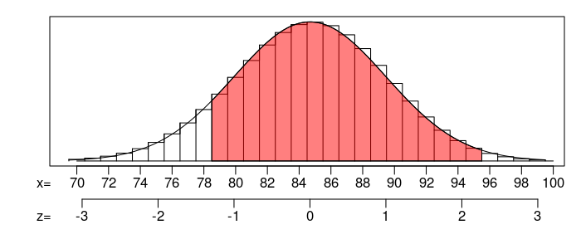 Find the $z$ scores.
$$z_{1}=\frac{78.5−84.68}{4.7816}=−1.29$$

$$z_{2}=\frac{95.5−84.68}{4.7816}=2.26$$

* Calculate the probability.

$$P(79≤X≤95)=Φ(2.26)−Φ(−1.29)=0.8896$$

$P(X=87)=0.0757$

$P(79≤X≤95)=0.8896$

1. **Question**  
   As an ornithologist, you wish to determine the average body mass of *Helmitheros vermivorus*. You randomly sample 27 adults of *Helmitheros vermivorus*, resulting in a sample mean of 16.03 grams and a sample standard deviation of 2.29 grams. Determine a 95% confidence interval of the true population mean.

* **Solution**  
  We are given the sample size, sample mean, sample standard deviation, and confidence level.
$$\begin{matrix}n & =27 \\ \overline{x} & =16.03 \\ s & =2.29 \\ CL & =0.95\end{matrix}$$

* Determine the degrees of freedom (because we don’t know $σ$ and we are doing inference so we need to use the $t$ distribution).
$$df=n−1=26$$

* Determine the critical $t$ value, $t^{⋆}$, such that $P(|T|<t^{⋆})=0.95$.
$$t^{⋆}=2.06$$

* Calculate the standard error.
$$SE=\frac{s}{\sqrt{n}}=\frac{2.29}{\sqrt{27}}=0.441$$

* We want to make an inference about the population mean.
$$μ ≈ \overline{x}±t^{⋆}SE$$

* Determine the bounds.
$$\begin{matrix}CI & =(\overline{x}−t^{⋆}SE, \overline{x}+t^{⋆}SE) \\ & =(16.03−2.06×0.441, 16.03+2.06×0.441) \\ & =(15.1, 16.9)\end{matrix}$$

* We are 95% confident that the population mean is between 15.1 and 16.9.

1. **Question**  
   A treatment group of size 30 has a mean of 0.974 and standard deviation of 0.222. A control group of size 34 has a mean of 1.13 and standard deviation of 0.218. If you decided to use a signficance level of 0.01, is there sufficient evidence to conclude the treatment causes an effect?

* By using the Welch-Satterthwaite equation, I’ve calculated the degrees of freedom should be 60.
  1. State the null hypothesis.
  2. State the alternative hypothesis.
  3. Evaluate the critical value. (The critical value is either or . Determine its value.)
  4. Determine the standard error of the relevant sampling distribution.
  5. Evaluate the absolute value of the test statistic. (The test statistic is either or . Determine its absolute value.)
  6. If possible, evaluate the $p$-value. Otherwise, describe an interval containing the $p$-value.
  7. Do we reject or retain the null?
* **Solution**  
  We are given unpaired data. We are considering a difference of means. Label the given information.
$$\begin{matrix}n_{1} & =30 \\ {\overline{x}}_{1} & =0.974 \\ s_{1} & =0.222 \\ n_{2} & =34 \\ {\overline{x}}_{2} & =1.13 \\ s_{2} & =0.218 \\ α & =0.01 \\ df & =60\end{matrix}$$

* State the hypotheses.
$$H_{0}: μ_{2}−μ_{1}=0$$

$$H_{A}: μ_{2}−μ_{1}≠0$$

* We are using a two-tail test. Find $t^{⋆}$ such that $P(|T|>t^{⋆})=0.01$ by using a $t$ table.
$$t^{⋆}=2.66$$

* Calculate the standard error.
$$\begin{matrix}SE & =\sqrt{\frac{(s_{1})^{2}}{n_{1}}+\frac{(s_{2})^{2}}{n_{2}}} \\ & =\sqrt{\frac{(0.222)^{2}}{30}+\frac{(0.218)^{2}}{34}} \\ & =0.055\end{matrix}$$

* Determine the test statistic.
$$\begin{matrix}t_{obs} & =\frac{({\overline{x}}_{2}−{\overline{x}}_{1})−(μ_{2}−μ_{1})_{0}}{SE} \\ & =\frac{(1.13−0.974)−(0)}{0.055} \\ & =2.83\end{matrix}$$

* Compare $|t_{obs}|$ and $t^{⋆}$.
$$|t_{obs}|>t^{⋆}$$

* We can determine an interval for the $p$-value using the $t$ table.
$$0.005<p-value<0.01$$

* Compare $p$-value and $α$.
$$p-value<α$$

* We conclude that we should reject the null hypothesis.
 $H_{0}: μ_{2}−μ_{1}=0$

 $H_{A}: μ_{2}−μ_{1}≠0$

$t^{⋆}=2.66$

$SE=0.055$

$|t_{obs}|=2.83$

$0.005<p-value<0.01$

1. reject the null

1. **Question**  
   From a very large population, a random sample of 7200 individuals was taken. In that sample, 36.3% were floating. Determine a 90% confidence interval of the population proportion.
   1. Find the lower bound of the confidence interval.
   2. Find the upper bound of the condifence interval.

* **Solution**  
  Determine $z^{⋆}$ such that $P(|Z|<z^{⋆})=0.9$.
$$z^{⋆}=1.64$$

* Calculate the standard error.
$$SE=\sqrt{\frac{\overset{̂}{p}(1−\overset{̂}{p})}{n}}=\sqrt{\frac{(0.363)(1−0.363)}{7200}}=0.00567$$

* Calculate the margin of error.
$$ME=z^{⋆}SE=(1.64)(0.00567)=0.0093$$

* To find the confidence interval’s bounds, find the sample proportion plus or minus the margin of error.
$$p ≈ \overset{̂}{p}±ME$$

* Determine the interval.
$$(0.354 , 0.372)$$

* We are 90% confident that the true population proportion is between 35.4% and 37.2%.
  1. The lower bound = 0.354, which can also be expressed as 35.4%.
  2. The upper bound = 0.372, which can also be expressed as 37.2%.

1. **Question**  
   An experiment is run with a treatment group of size 233 and a control group of size 242. The results are summarized in the table below.

|  |  |  |
| --- | --- | --- |
|  | * treatment | * control |
| * angry | * 67 | * 85 |
| * not angry | * 166 | * 157 |

* Using a significance level of 0.2, determine whether the treatment causes an effect on the proportion of cases that are angry.
  1. State the null hypothesis.
  2. State the alternative hypothesis.
  3. Evaluate the critical value. (The critical value is either or . Determine its value.)
  4. Determine the standard error of the relevant sampling distribution.
  5. Evaluate the absolute value of the test statistic. (The test statistic is either or . Determine its absolute value.)
  6. If possible, evaluate the $p$-value. Otherwise, describe an interval containing the $p$-value.
  7. Do we reject or retain the null?
* **Solution**  
  State the hypotheses.
$$H_{0}: p_{2}−p_{1}=0$$

$$H_{A}: p_{2}−p_{1}≠0$$

* Find $z^{⋆}$ such that $P(|Z|>z^{⋆})=0.2$.
$$z^{⋆}=Φ^{−1}\left(1−\frac{α}{2}\right)=1.28$$

* Determine the sample proportions.
$${\overset{̂}{p}}_{1}=\frac{67}{233}=0.288$$

$${\overset{̂}{p}}_{2}=\frac{85}{242}=0.351$$

* Determine the difference of sample proportions.
$${\overset{̂}{p}}_{2}−{\overset{̂}{p}}_{1}=0.351−0.288=0.063$$

* Determine the pooled proportion (because the null assumes the population proportions are equal).
$$\overset{̂}{p}=\frac{67+85}{233+242}=0.32$$

* Determine the standard error.
$$\begin{matrix}SE & =\sqrt{\frac{\overset{̂}{p}(1−\overset{̂}{p})}{n_{1}}+\frac{\overset{̂}{p}(1−\overset{̂}{p})}{n_{2}}} \\ & =\sqrt{\frac{(0.32)(0.68)}{233}+\frac{(0.32)(0.68)}{242}} \\ & =0.0428\end{matrix}$$

* We can be more specific about what the null hypothesis claims.
$$H_{0}: {\overset{̂}{P}}_{2}−{\overset{̂}{P}}_{1} ∼ N(0, 0.0428)$$

* We want to describe how unusual our observation is under the null by finding the $p$-value. To do so, first find the $z$ score.
$$\begin{matrix}z & =\frac{({\overset{̂}{p}}_{2}−{\overset{̂}{p}}_{1})−(p_{2}−p_{1})_{0}}{SE} \\ & =\frac{(0.351−0.288)−0}{0.0428} \\ & =1.47\end{matrix}$$

* Determine the $p$-value.
$$\begin{matrix}p-value & =2⋅Φ(−|z|) \\ & =2⋅Φ(−1.47) \\ & =0.1416\end{matrix}$$

* Compare the $p$-value to the signficance level.
$$p-value<α$$

* So, we reject the null hypothesis. Thus the difference in proportions is significant.
 $H_{0}: p_{2}−p_{1}=0$

 $H_{A}: p_{2}−p_{1}≠0$

$z^{⋆}=1.28$

$SE=0.0428$

$|z_{obs}|=1.47$

$p-value=0.1416$

1. reject the null