1. **Question**  
   In a deck of strange cards, there are 893 cards. Each card has an image and a color. The amounts are shown in the table below.

|  |  |  |  |  |  |
| --- | --- | --- | --- | --- | --- |
|  | * gray | * green | * orange | * red | * white |
| * dog | * 26 | * 79 | * 43 | * 18 | * 99 |
| * tree | * 37 | * 73 | * 76 | * 32 | * 60 |
| * wheel | * 91 | * 81 | * 49 | * 68 | * 61 |

* 1. What is the probability a random card is green given it is a tree?
  2. What is the probability a random card is either a wheel or red (or both)?
  3. What is the probability a random card is both a wheel and orange?
  4. What is the probability a random card is green?
  5. What is the probability a random card is a tree given it is white?
  6. What is the probability a random card is a dog?
* **Solution**

$P(green given tree)$ $=\frac{73}{37+73+76+32+60}=0.263$

$P(wheel or red)$ $=\frac{91+81+49+68+61+18+32+68−68}{893}=0.448$

$P(wheel and orange)$ $=\frac{49}{893}=0.0549$

$P(green)$ $=\frac{79+73+81}{893}=0.261$

$P(tree given white)$ $=\frac{60}{99+60+61}=0.273$

$P(dog)$ $=\frac{26+79+43+18+99}{893}=0.297$

1. **Question**  
   In a deck of strange cards, each card has an image and a color. The chance of drawing a horn is 18.2%. If a horn is drawn, there is a 44.6% chance that it is gray. If a card that is not a horn is drawn, there is a 84.2% chance that it is gray.

* Now, someone draws a random card and reveals it is gray. What is the chance the card is not a horn?
* **Solution**  
  I’d recommend making a tree. Remember, on the first branch, we put simple probabilities. On the second branches we put conditional probabilites. The results (products) are joint probabilities.
* 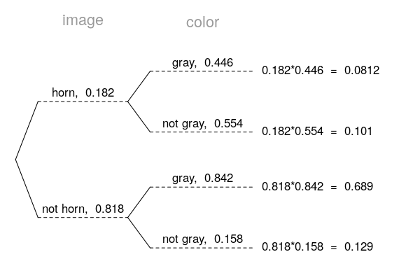
* Determine the appropriate conditional probability.

$$P("not horn" given "gray")=\frac{0.689}{0.689+0.0812}=0.895$$

1. **Question**  
   In a very large pile of toothpicks, the mean length is 73.42 millimeters and the standard deviation is 2.83 millimeters. If you randomly sample 121 toothpicks, what is the chance the sample mean is between 72.86 and 73.72 millimeters?

* **Solution**  
  Label the given information.
$$\begin{matrix}μ & =73.42 \\ σ & =2.83 \\ n & =121 \\ {\overline{x}}_{lower} & =72.86 \\ {\overline{x}}_{upper} & =73.72\end{matrix}$$

* Find the standard error.
$$SE=\frac{σ}{\sqrt{n}}=\frac{2.83}{\sqrt{121}}=0.257$$

* Describe the sampling distribution.
$$\overline{X}∼N(73.42, 0.257)$$

* Draw a sketch.  
  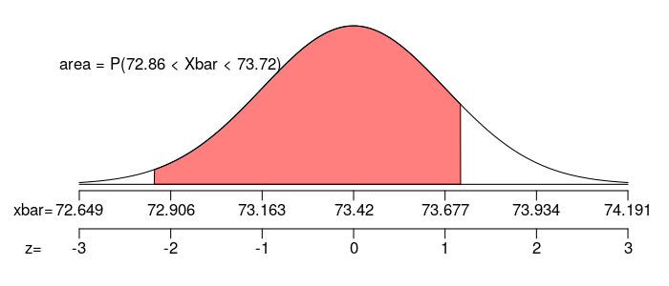
* Calculate a $z$ scores.
$$z_{lower}=\frac{x_{lower}−μ}{SE}=\frac{72.86−73.42}{0.257}=−2.18$$

$$z_{upper}=\frac{x_{upper}−μ}{SE}=\frac{73.72−73.42}{0.257}=1.17$$

* Determine the probability.

$$\begin{matrix}P(72.86<X<73.72) & =Φ(z_{upper})−Φ(z_{lower}) \\ & =Φ(1.17)−Φ(−2.18) \\ & =0.8644\end{matrix}$$

1. **Question**  
   In a game, there is a 48% chance to win a round. You will play 108 rounds.
   1. What is the probability of winning exactly 56 rounds?
   2. What is the probability of winning at least 48 but at most 57 rounds?

* **Solution**  
  We use the formula for binomial probabilities.
$$P(X=k)=\left({n \atop k}\right)(p)^{k}(1−p)^{n−k}$$

$$P(X=56)=\left({108 \atop 56}\right)(0.48)^{56}(1−0.48)^{108−56}$$

$$P(X=56)=\left({108 \atop 56}\right)(0.48)^{56}(0.52)^{52}$$

$$P(X=56)=0.0556$$

* Find the mean.
$$μ=np=(108)(0.48)=51.84$$

* Find the standard deviation.
$$σ=\sqrt{np(1−p)}=\sqrt{(108)(0.48)(1−0.48)}=5.192$$

* Make a sketch, specifically try to picture whether you need to add or subtract 0.5 for the continuity correction.
* 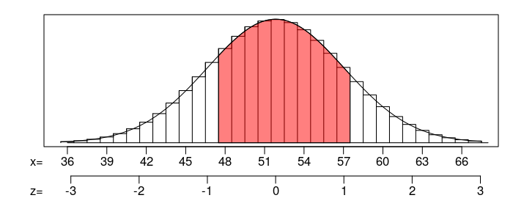 Find the $z$ scores.
$$z_{1}=\frac{47.5−51.84}{5.192}=−0.84$$

$$z_{2}=\frac{57.5−51.84}{5.192}=1.09$$

* Calculate the probability.

$$P(48≤X≤57)=Φ(1.09)−Φ(−0.84)=0.6616$$

$P(X=56)=0.0556$

$P(48≤X≤57)=0.6616$

1. **Question**  
   As an ornithologist, you wish to determine the average body mass of *Dendroica castanea*. You randomly sample 17 adults of *Dendroica castanea*, resulting in a sample mean of 14.94 grams and a sample standard deviation of 1.13 grams. Determine a 99.5% confidence interval of the true population mean.

* **Solution**  
  We are given the sample size, sample mean, sample standard deviation, and confidence level.
$$\begin{matrix}n & =17 \\ \overline{x} & =14.94 \\ s & =1.13 \\ CL & =0.995\end{matrix}$$

* Determine the degrees of freedom (because we don’t know $σ$ and we are doing inference so we need to use the $t$ distribution).
$$df=n−1=16$$

* Determine the critical $t$ value, $t^{⋆}$, such that $P(|T|<t^{⋆})=0.995$.
$$t^{⋆}=3.25$$

* Calculate the standard error.
$$SE=\frac{s}{\sqrt{n}}=\frac{1.13}{\sqrt{17}}=0.274$$

* We want to make an inference about the population mean.
$$μ ≈ \overline{x}±t^{⋆}SE$$

* Determine the bounds.
$$\begin{matrix}CI & =(\overline{x}−t^{⋆}SE, \overline{x}+t^{⋆}SE) \\ & =(14.94−3.25×0.274, 14.94+3.25×0.274) \\ & =(14, 15.8)\end{matrix}$$

* We are 99.5% confident that the population mean is between 14 and 15.8.

1. **Question**  
   A treatment group of size 20 has a mean of 105 and standard deviation of 7.31. A control group of size 20 has a mean of 98.6 and standard deviation of 8.9. If you decided to use a signficance level of 0.02, is there sufficient evidence to conclude the treatment causes an effect?

* By using the Welch-Satterthwaite equation, I’ve calculated the degrees of freedom should be 36.
  1. State the null hypothesis.
  2. State the alternative hypothesis.
  3. Evaluate the critical value. (The critical value is either or . Determine its value.)
  4. Determine the standard error of the relevant sampling distribution.
  5. Evaluate the absolute value of the test statistic. (The test statistic is either or . Determine its absolute value.)
  6. If possible, evaluate the $p$-value. Otherwise, describe an interval containing the $p$-value.
  7. Do we reject or retain the null?
* **Solution**  
  We are given unpaired data. We are considering a difference of means. Label the given information.
$$\begin{matrix}n_{1} & =20 \\ {\overline{x}}_{1} & =105 \\ s_{1} & =7.31 \\ n_{2} & =20 \\ {\overline{x}}_{2} & =98.6 \\ s_{2} & =8.9 \\ α & =0.02 \\ df & =36\end{matrix}$$

* State the hypotheses.
$$H_{0}: μ_{2}−μ_{1}=0$$

$$H_{A}: μ_{2}−μ_{1}≠0$$

* We are using a two-tail test. Find $t^{⋆}$ such that $P(|T|>t^{⋆})=0.02$ by using a $t$ table.
$$t^{⋆}=2.43$$

* Calculate the standard error.
$$\begin{matrix}SE & =\sqrt{\frac{(s_{1})^{2}}{n_{1}}+\frac{(s_{2})^{2}}{n_{2}}} \\ & =\sqrt{\frac{(7.31)^{2}}{20}+\frac{(8.9)^{2}}{20}} \\ & =2.575\end{matrix}$$

* Determine the test statistic.
$$\begin{matrix}t_{obs} & =\frac{({\overline{x}}_{2}−{\overline{x}}_{1})−(μ_{2}−μ_{1})_{0}}{SE} \\ & =\frac{(98.6−105)−(0)}{2.575} \\ & =−2.49\end{matrix}$$

* Compare $|t_{obs}|$ and $t^{⋆}$.
$$|t_{obs}|>t^{⋆}$$

* We can determine an interval for the $p$-value using the $t$ table.
$$0.01<p-value<0.02$$

* Compare $p$-value and $α$.
$$p-value<α$$

* We conclude that we should reject the null hypothesis.
 $H_{0}: μ_{2}−μ_{1}=0$

 $H_{A}: μ_{2}−μ_{1}≠0$

$t^{⋆}=2.43$

$SE=2.575$

$|t_{obs}|=2.49$

$0.01<p-value<0.02$

1. reject the null

1. **Question**  
   From a very large population, a random sample of 290 individuals was taken. In that sample, 57.2% were purple. Determine a 90% confidence interval of the population proportion.
   1. Find the lower bound of the confidence interval.
   2. Find the upper bound of the condifence interval.

* **Solution**  
  Determine $z^{⋆}$ such that $P(|Z|<z^{⋆})=0.9$.
$$z^{⋆}=1.64$$

* Calculate the standard error.
$$SE=\sqrt{\frac{\overset{̂}{p}(1−\overset{̂}{p})}{n}}=\sqrt{\frac{(0.572)(1−0.572)}{290}}=0.0291$$

* Calculate the margin of error.
$$ME=z^{⋆}SE=(1.64)(0.0291)=0.0477$$

* To find the confidence interval’s bounds, find the sample proportion plus or minus the margin of error.
$$p ≈ \overset{̂}{p}±ME$$

* Determine the interval.
$$(0.524 , 0.62)$$

* We are 90% confident that the true population proportion is between 52.4% and 62%.
  1. The lower bound = 0.524, which can also be expressed as 52.4%.
  2. The upper bound = 0.62, which can also be expressed as 62%.

1. **Question**  
   An experiment is run with a treatment group of size 64 and a control group of size 52. The results are summarized in the table below.

|  |  |  |
| --- | --- | --- |
|  | * treatment | * control |
| * special | * 41 | * 41 |
| * not special | * 23 | * 11 |

* Using a significance level of 0.1, determine whether the treatment causes an effect on the proportion of cases that are special.
  1. State the null hypothesis.
  2. State the alternative hypothesis.
  3. Evaluate the critical value. (The critical value is either or . Determine its value.)
  4. Determine the standard error of the relevant sampling distribution.
  5. Evaluate the absolute value of the test statistic. (The test statistic is either or . Determine its absolute value.)
  6. If possible, evaluate the $p$-value. Otherwise, describe an interval containing the $p$-value.
  7. Do we reject or retain the null?
* **Solution**  
  State the hypotheses.
$$H_{0}: p_{2}−p_{1}=0$$

$$H_{A}: p_{2}−p_{1}≠0$$

* Find $z^{⋆}$ such that $P(|Z|>z^{⋆})=0.1$.
$$z^{⋆}=Φ^{−1}\left(1−\frac{α}{2}\right)=1.64$$

* Determine the sample proportions.
$${\overset{̂}{p}}_{1}=\frac{41}{64}=0.641$$

$${\overset{̂}{p}}_{2}=\frac{41}{52}=0.788$$

* Determine the difference of sample proportions.
$${\overset{̂}{p}}_{2}−{\overset{̂}{p}}_{1}=0.788−0.641=0.147$$

* Determine the pooled proportion (because the null assumes the population proportions are equal).
$$\overset{̂}{p}=\frac{41+41}{64+52}=0.707$$

* Determine the standard error.
$$\begin{matrix}SE & =\sqrt{\frac{\overset{̂}{p}(1−\overset{̂}{p})}{n_{1}}+\frac{\overset{̂}{p}(1−\overset{̂}{p})}{n_{2}}} \\ & =\sqrt{\frac{(0.707)(0.293)}{64}+\frac{(0.707)(0.293)}{52}} \\ & =0.085\end{matrix}$$

* We can be more specific about what the null hypothesis claims.
$$H_{0}: {\overset{̂}{P}}_{2}−{\overset{̂}{P}}_{1} ∼ N(0, 0.085)$$

* We want to describe how unusual our observation is under the null by finding the $p$-value. To do so, first find the $z$ score.
$$\begin{matrix}z & =\frac{({\overset{̂}{p}}_{2}−{\overset{̂}{p}}_{1})−(p_{2}−p_{1})_{0}}{SE} \\ & =\frac{(0.788−0.641)−0}{0.085} \\ & =1.73\end{matrix}$$

* Determine the $p$-value.
$$\begin{matrix}p-value & =2⋅Φ(−|z|) \\ & =2⋅Φ(−1.73) \\ & =0.0836\end{matrix}$$

* Compare the $p$-value to the signficance level.
$$p-value<α$$

* So, we reject the null hypothesis. Thus the difference in proportions is significant.
 $H_{0}: p_{2}−p_{1}=0$

 $H_{A}: p_{2}−p_{1}≠0$

$z^{⋆}=1.64$

$SE=0.085$

$|z_{obs}|=1.73$

$p-value=0.0836$

1. reject the null