- Question
A sample was gathered.

You can download the data as a CSV file.
Determine , the sample mean. Your answer can be rounded to the nearest tenth.
Solution
(ANS=79.8508333)
video
You need to sum the values (, see summation) and divide by the sample size ().

You can round to the nearest tenth: 79.9.
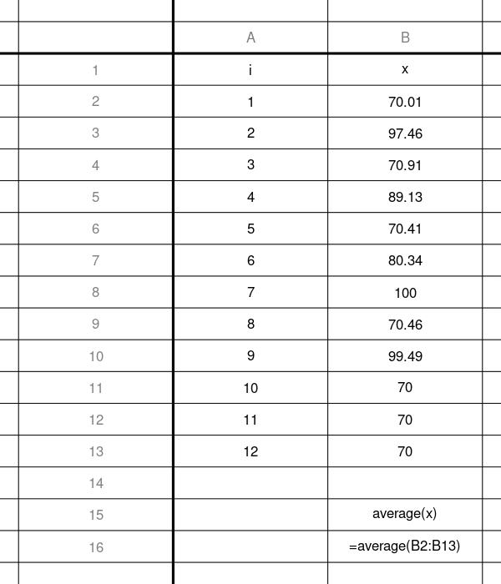
In a spreadsheet, you can use the AVERAGE function. You can see a solution spreadsheet here.
In R, you can use the MEAN function.
# First, get the csv into the working directory... then...
data = read.csv("get_mean.csv")
x = data$x
xbar = mean(x)
round(xbar,1)
## [1] 79.9
- Question
A sample was gathered.

You can download the data as a CSV file.
Determine the sample median. Please enter an exact answer.
Solution
video
(ANS=58.45)
To determine the median by hand, you first sort the sample.

If the sample size is odd, just find the number in the middle number (the th value). If the sample size is even, determine the mean of the middle two numbers (the th and th values).
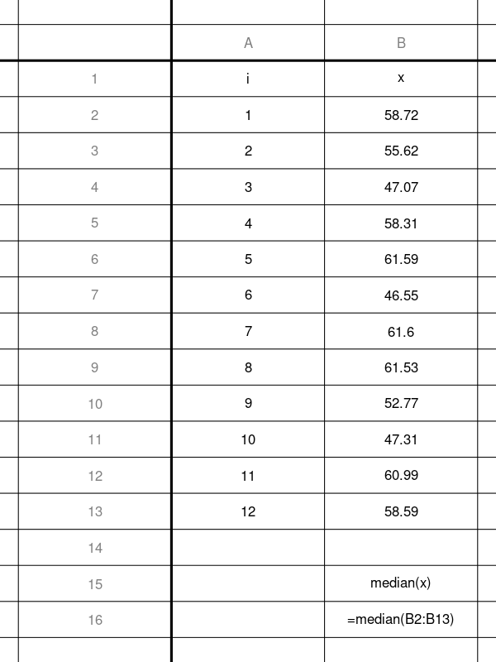
In a spreadsheet, you can use the MEDIAN function. You can see a solution spreadsheet here.
In R, you can use the MEDIAN function.
# First, get the csv into the working directory... then...
data = read.csv("get_median.csv")
x = data$x
median(x)
## [1] 58.45
- Question
Depending on the type of distribution, we can make a strong claim regarding the mean and median.
  - Symmetric (bell, uniform, bimodal)

  - Skew-right

  - Skew-left

A sample was gathered and visualized with a histogram.
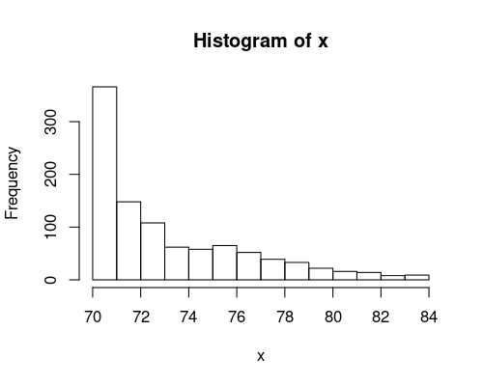
What claim can you make regarding the mean and median?

Solution
video
The distribution is skew-right, so .
  - FALSE
  - TRUE
  - FALSE
- Question
A sample was gathered (from a Bernoulli random variable).

You can download the data as a CSV file.
Determine , the sample mean. Actually, in this special case of 0s and 1s, the sample mean is called the sample proportion (=“p hat”).

So, determine the sample proportion. Your answer can be rounded to the nearest hundredth.
Solution
(ANS=0.7272727)
video
You need to sum the values (, see summation) and divide by the sample size ().

In the context of 0s and 1s, it is more appropriate to use .

Notice: the mean of 0s and 1s is the proportion of 1s. This is a good reason to use 0 for FALSE/“fail” and 1 for TRUE/“success”.
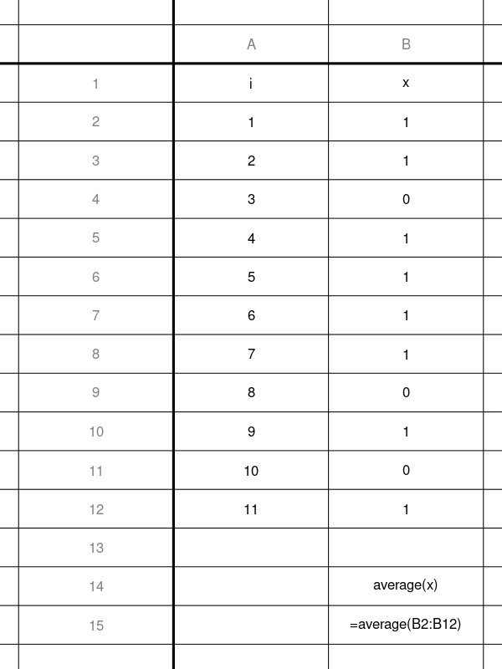
In a spreadsheet, you can use the AVERAGE function. You can see a solution spreadsheet here.
In R, you can use the MEAN function.
# First, get the csv into the working directory... then...
data = read.csv("get_phat.csv")
x = data$x
xbar = mean(x)
phat = xbar #because data is 0s and 1s
round(phat,2)
## [1] 0.73

