- Question
A sample was gathered.

You can download the data as a CSV file.
Determine the sample range. Please enter an exact answer.
Solution
(ANS=8.07)
video
To determine the range by hand, you subtract the minimum value from the maximum value. You could first sort all the data.

Determine the minimum.

Determine the maximum.

Take the difference.

Spreadsheet
In a spreadsheet, you can use the MIN function and MAX function.
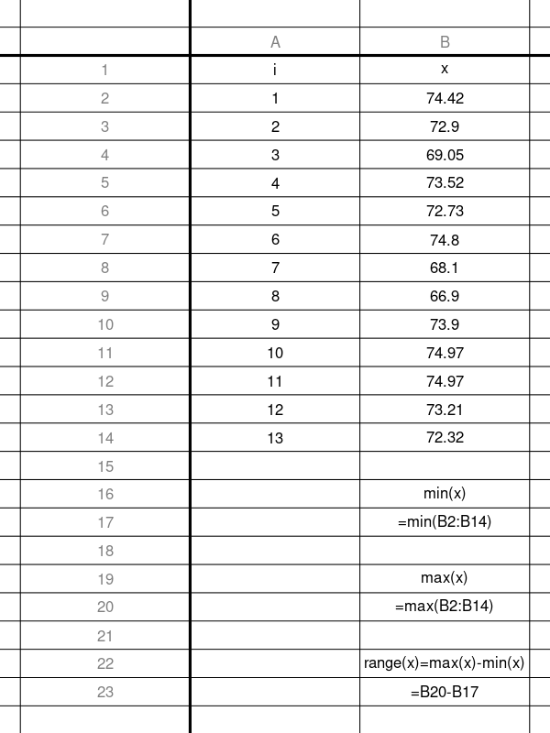
You can see a solution spreadsheet here.

R
In R, you can use the MIN and MAX functions.
# First, get the csv into the working directory... then...
data = read.csv("get_range.csv")
x = data$x
range = max(x)-min(x)
print(range)
## [1] 8.07
- Question
A sample was gathered.

You can download the data as a CSV file.
Determine the sample’s mean absolute deviation (MAD) around the mean. You can round your answer to the hundredths place.
Solution
(ANS=8.9345455)
video
First, determine the mean of the sample.

Determine the absolute deviations (distances from ).

deviations =
AbsDev =
1
65.01
-9.26
9.26
2
65.00
-9.27
9.27
3
68.36
-5.91
5.91
4
84.71
10.44
10.44
5
67.38
-6.89
6.89
6
84.89
10.62
10.62
7
82.72
8.45
8.45
8
65.01
-9.26
9.26
9
84.98
10.71
10.71
10
65.72
-8.55
8.55
11
83.19
8.92
8.92
Now, take the mean of the absolute deviations.

spreadsheet
You can do this with a spreadsheet.
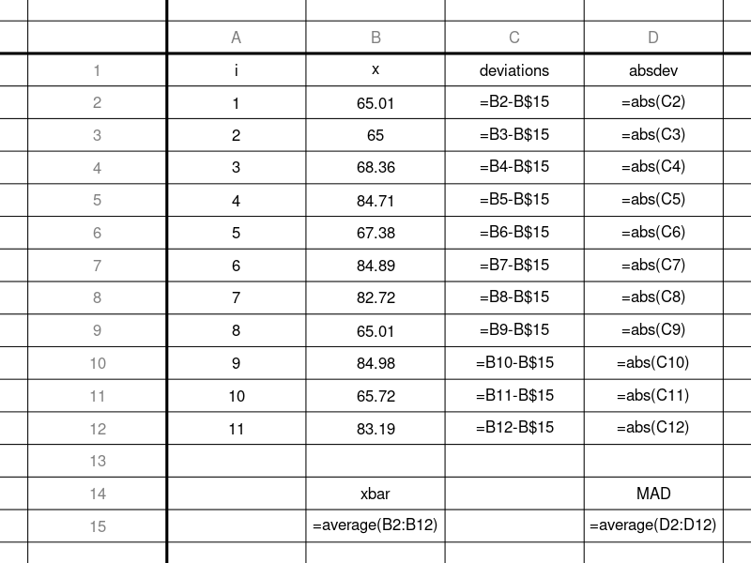

R
You can do this with R
x = read.csv("get_MAD.csv")$x
xbar = mean(x)
deviations = x-xbar
AbsDev = abs(deviations)
MAD = mean(AbsDev)
x
## [1] 65.01 65.00 68.36 84.71 67.38 84.89 82.72 65.01
## [9] 84.98 65.72 83.19
xbar
## [1] 74.27
deviations
## [1] -9.26 -9.27 -5.91 10.44 -6.89 10.62 8.45 -9.26
## [9] 10.71 -8.55 8.92
AbsDev
## [1] 9.26 9.27 5.91 10.44 6.89 10.62 8.45 9.26
## [9] 10.71 8.55 8.92
MAD
## [1] 8.934545
- Question
A sample was gathered.

You can download the data as a CSV file.
Determine the biased sample variance (without Bessel correction). You can round your answer to the hundredths place.
Solution
(ANS=28.0276889)
video
First, determine the mean of the sample.

Determine the squared deviations (squared distances from ).

deviations =
SqrDev =
1
65.77
-0.18
0.0324
2
64.87
-1.08
1.1664
3
63.55
-2.40
5.7600
4
70.77
4.82
23.2324
5
72.72
6.77
45.8329
6
65.91
-0.04
0.0016
7
73.50
7.55
57.0025
8
58.34
-7.61
57.9121
9
58.12
-7.83
61.3089
Now, take the mean of the squared deviations.

spreadsheet
You can do this with a spreadsheet.
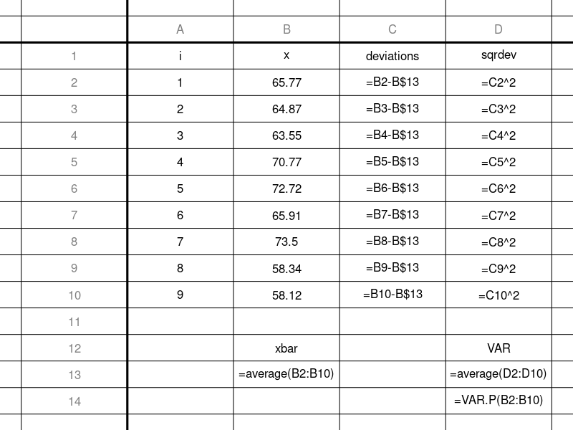
And, actually, you can skip a lot of work by using the VAR.P function. Using the population variance formula is equivalent to using the biased sample variance formula.

R
You can do this with R
x = read.csv("get_VAR.csv")$x
xbar = mean(x)
deviations = x-xbar
sqrdev = deviations^2
VAR = mean(sqrdev)
x
## [1] 65.77 64.87 63.55 70.77 72.72 65.91 73.50 58.34 58.12
xbar
## [1] 65.95
deviations
## [1] -0.18 -1.08 -2.40 4.82 6.77 -0.04 7.55 -7.61 -7.83
sqrdev
## [1] 0.0324 1.1664 5.7600 23.2324 45.8329 0.0016
## [7] 57.0025 57.9121 61.3089
VAR
## [1] 28.02769
# The built-in var() function almost works, but it is too fancy, and makes a Bessel correction. To use it, we need to undo the Bessel correction.
n = length(x)
var(x)*(n-1)/(n)
## [1] 28.02769
- Question
A sample was gathered.

You can download the data as a CSV file.
Determine the unbiased sample variance (with Bessel correction). You can round your answer to the hundredths place.
You probably wonder why you would make the Bessel correction. The reason is important. We will see that the main goal of statistics is to infer the underlying probability distribution of a collection of empirical observations. In other words, we have a lottery machine filled with many balls (population), but we only see a small sample of those balls, and our goal is to guess what the population looks like based on a small sample (see statistical inference).
It turns out that when guessing the population’s variance from a small sample, your guess is better after making the Bessel correction.
Solution
(ANS=2.5762)
video
First, determine the mean of the sample.

Determine the squared deviations (squared distances from ).

deviations =
SqrDev =
1
69.89
1.72
2.9584
2
65.23
-2.94
8.6436
3
69.67
1.50
2.2500
4
68.94
0.77
0.5929
5
68.26
0.09
0.0081
6
65.05
-3.12
9.7344
7
66.96
-1.21
1.4641
8
68.47
0.30
0.0900
9
69.75
1.58
2.4964
10
67.59
-0.58
0.3364
11
69.64
1.47
2.1609
12
67.60
-0.57
0.3249
13
67.68
-0.49
0.2401
14
69.65
1.48
2.1904
Determine the unbiased sample variance by summing the squared deviations and dividing the sum by .

spreadsheet
You can do this with a spreadsheet.
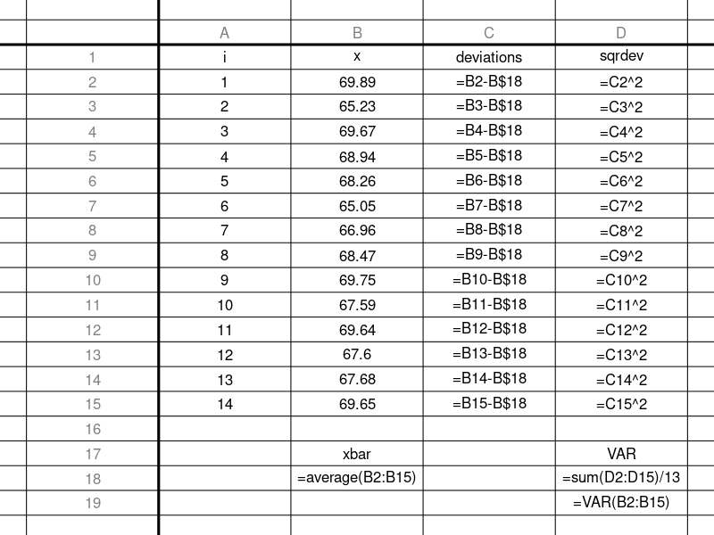
And, actually, you can skip a lot of work by using the VAR function.

R
You can do this with R
x = read.csv("get_VAR.csv")$x
var(x)
## [1] 2.5762
You could also do it the long way.
x = read.csv("get_VAR.csv")$x
n = length(x)
xbar = mean(x)
deviations = x-xbar
sqrdev = deviations^2
VAR = sum(sqrdev)/(n-1)
VAR
## [1] 2.5762
- Question
A sample was gathered.

You can download the data as a CSV file.
Determine the uncorrected sample standard deviation (without Bessel correction, biased).

You can round your answer to the hundredths place.
Solution
(ANS=3.0708549)
video
Determine the mean of the sample.

Determine the squared deviations (squared distances from ).

deviations =
SqrDev =
1
76.72
0.65
0.4225
2
73.83
-2.24
5.0176
3
77.22
1.15
1.3225
4
78.33
2.26
5.1076
5
82.99
6.92
47.8864
6
78.68
2.61
6.8121
7
73.82
-2.25
5.0625
8
77.22
1.15
1.3225
9
75.25
-0.82
0.6724
10
72.59
-3.48
12.1104
11
75.30
-0.77
0.5929
12
70.89
-5.18
26.8324
Find the mean of the squared deviations.

Take the square root of the variance.

spreadsheet
You can do this with a spreadsheet.
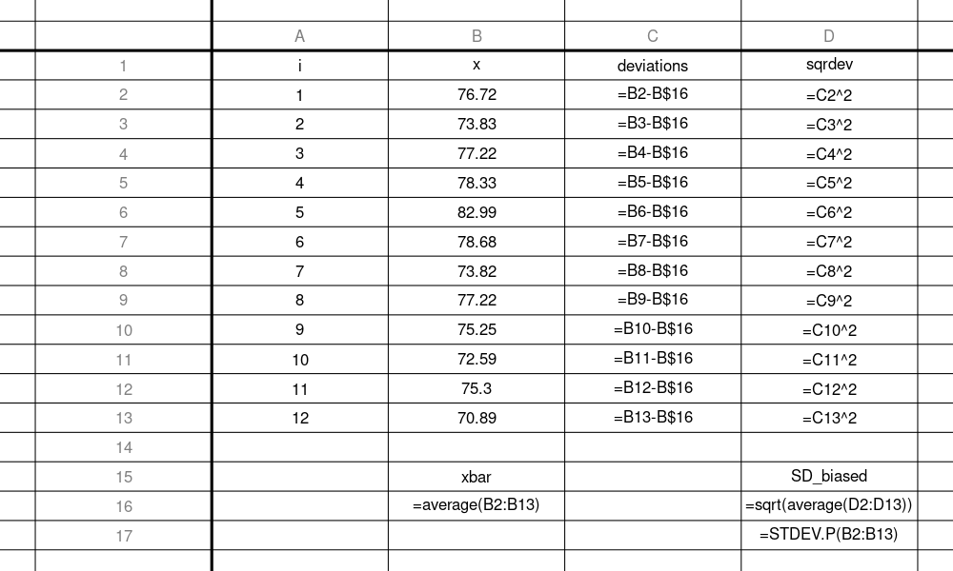
And, actually, you can skip a lot of work by using the STDEV.P function. Using the population standard deviation formula is equivalent to using the biased sample standard deviation formula.

R
You can do this with R
x = read.csv("get_SD.csv")$x
xbar = mean(x)
deviations = x-xbar
sqrdev = deviations^2
VAR_biased = mean(sqrdev)
SD_biased = sqrt(VAR_biased)
SD_biased
## [1] 3.070855
# This could also be done with a one-liner
x = read.csv("get_SD.csv")$x
SD_biased2 = sqrt(mean((x-mean(x))^2))
SD_biased2
## [1] 3.070855
# The built-in sd() function almost works, but it is too fancy, and makes a Bessel correction. To use it, we need to undo the Bessel correction.
x = read.csv("get_SD.csv")$x
n = length(x)
SD_biased3 = sd(x)*sqrt((n-1)/(n))
SD_biased3
## [1] 3.070855
- Question
A sample was gathered.

You can download the data as a CSV file.
Determine the corrected sample standard deviation (with Bessel correction). You can round your answer to the hundredths place.
You probably wonder why you would make the Bessel correction. The reason is important. We will see that the main goal of statistics is to infer the underlying probability distribution of a collection of empirical observations. In other words, we have a lottery machine filled with many balls (population), but we only see a small sample of those balls, and our goal is to guess what the population looks like based on a small sample (see statistical inference).
It turns out that when guessing the population’s standard deviation from a small sample, your guess is better after making the Bessel correction.
Solution
(ANS=3.681787)
video
First, determine the mean of the sample.

Determine the squared deviations (squared distances from ).

deviations =
SqrDev =
1
37
10
100
2
26
-1
1
3
27
0
0
4
25
-2
4
5
25
-2
4
6
25
-2
4
7
25
-2
4
8
27
0
0
9
28
1
1
10
25
-2
4
Determine the unbiased sample variance by summing the squared deviations and dividing the sum by .

Determine the corrected sample standard deviation by taking the square root of the unbiased sample variance.

spreadsheet
You can do this with a spreadsheet.
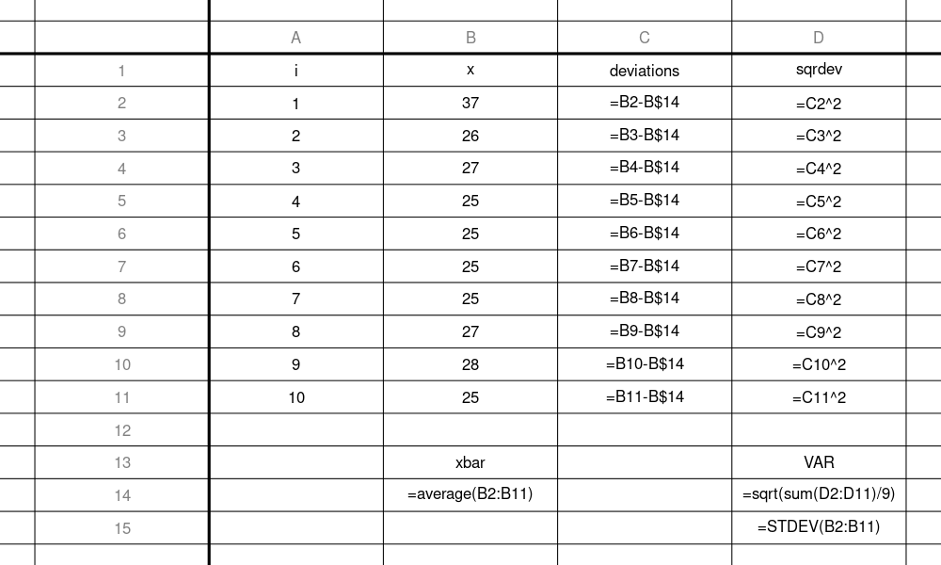
And, actually, you can skip a lot of work by using the STDEV function.

R
You can do this with R
x = read.csv("get_SD.csv")$x
sd(x)
## [1] 3.681787
You could also do it the long way.
x = read.csv("get_SD.csv")$x
n = length(x)
xbar = mean(x)
deviations = x-xbar
sqrdev = deviations^2
VAR = sum(sqrdev)/(n-1)
SD = sqrt(VAR)
SD
## [1] 3.681787
- Question
A large sample () was gathered and visualized with a histogram.
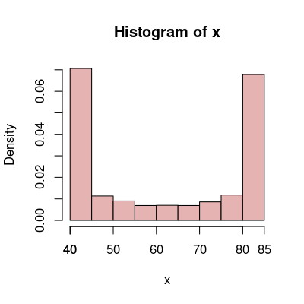
When a symmetric distribution is sampled thoroughly (), you can use the following rules of thumb to estimate the mean and standard deviation.
  - Estimate the mean of the sample. (Please use the given formula.)
  - Estimate the standard deviation of the sample. (Please use the given formula.)
Solution
video
Notice the bell has the smallest standard deviation for a given range. This is because many measurements are near the mean, and just a few are near the edges.
The bimodal has the largest standard deviation for a given range. This is because many measurements are near the edges, and just a few are near the mean.
The uniform distribution has about equal numbers of measurements near the mean and near the edges, so it has a standard deviation between the two other shapes (for a given range).
You’ll notice the bimodal estimate is probably the worst estimate. The estimate would be more accurate if none of the values were near the mean, and all the values were near the edge.
  - By using the given formula, you’ll get an estimate of 62.5 for the mean. The actual mean is 62.2097527.
  - By using the formula, you’ll get an estimate of 22.5 for the standard deviation. The actual standard deviation is 19.0537463.
- Question
Three large samples were taken from three different populations. Their distributions are shown as histograms.
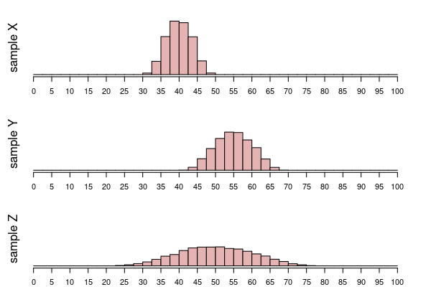
  - Which sample has the smallest mean? ##ANSWER1##
  - Which sample has the largest mean? ##ANSWER2##
  - Which sample has the smallest standard deviation? ##ANSWER3##
  - Which sample has the largest standard deviation? ##ANSWER4##
  - X / Y / Z
  - X / Y / Z
  - X / Y / Z
  - X / Y / Z
Solution
video
All three distributions look like they have similar bell shape, but their centers and spreads are all different.
  - The distribution with its center sitting furthest left has the smallest mean. / . / .
  - The distribution with its center sitting furthest right has the largest mean. / . / .
  - The least wide distribution has the smallest standard deviation. It is this simple because all distributions have the same shape. / . / .
  - The most wide distribution has the largest standard deviation. It is this simple because all distributions have the same shape. / . / .
- Question
Three large samples were taken from three different populations. Their distributions are shown as histograms.
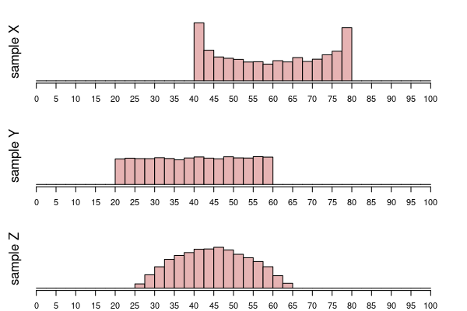
  - Which sample has the smallest mean? ##ANSWER1##
  - Which sample has the largest mean? ##ANSWER2##
  - Which sample has the smallest standard deviation? ##ANSWER3##
  - Which sample has the largest standard deviation? ##ANSWER4##
  - X / Y / Z
  - X / Y / Z
  - X / Y / Z
  - X / Y / Z
Solution
video
All three distributions look like they have similar ranges (widths), but different shapes. So, we will use the fact that for a given range, bell shape has the smallest standard deviation and bimodal has the largest standard deviation. This is because a bell shape has many measurements near the middle, whereas the bimodal shape has many measurements near the edges of its interval.
  - The distribution with its center sitting furthest left has the smallest mean. / . / .
  - The distribution with its center sitting furthest right has the largest mean. / . / .
  - The bell shape has the smallest standard deviation. It is this simple because all the distributions have the same range, but the bell has a higher fraction near its mean. / . / .
  - The bimodal shape has the largest standard deviation. It is this simple because all the distributions have the same range, but the bimodal shape has a higher fraction far from its mean. / . / .
- Question

Background
Sometimes a population is well characterized, meaning we know its mean and standard deviation. We use greek letters (“mu”) and (“sigma”) when describing the population (instead of the (“xbar”) and used for sample mean and sample standard deviation).

When measuring individuals from a population, we expect most measurements to be within the interval of typical measurements. We will define the interval of typical measurements (using interval notation):

In other words, we expect most measurements to be between two bounds.

Actual Question
A population of lizards has a mean length of cm and a standard deviation of cm. Determine the interval of typical measurements.
  - Determine the lower bound of the interval of typical measurements.
  - Determine the upper bound of the interval of typical measurements.
Solution
video
You need to use the formulas. Remember your order of operations!
  - (ANS=29) Use the formula.
  - (ANS=37.8) Use the formula.
- Question
The following spinner has a population mean and a population standard deviation . We can think of a spinner as an infinite population from which we can take as many independent measurements from as we want.
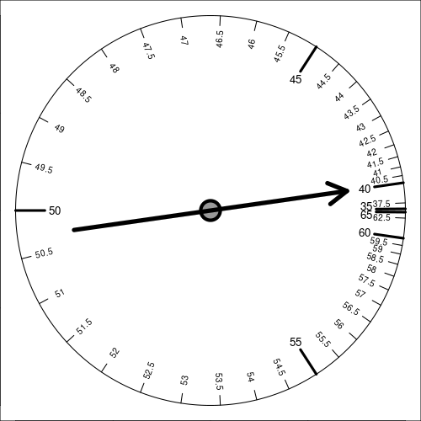
A sample (200 measurements) was taken.
41.9578, 49.0355, 56.9273, 47.3177, 37.7403, 49.5462, 57.6886, 50.7143, 43.8452, 49.1986,
47.6301, 50.8326, 47.6134, 50.0902, 43.2208, 50.3685, 48.8845, 47.8500, 53.0015, 55.3558,
56.9120, 52.3216, 41.2037, 44.9557, 46.8478, 46.1813, 50.0315, 54.3321, 48.3583, 51.8473,
55.8336, 52.9779, 50.7251, 45.8660, 48.9565, 48.6453, 50.1976, 45.2616, 49.9742, 57.2772,
53.7346, 42.9364, 49.5639, 46.2590, 43.0242, 41.1574, 44.9911, 55.6235, 57.2356, 55.6652,
49.5705, 55.0161, 48.9661, 49.4570, 48.8382, 44.4941, 51.6068, 46.5257, 60.8438, 56.8951,
51.1218, 49.6395, 56.0449, 57.1646, 37.2805, 45.7092, 45.4234, 45.0833, 49.1795, 43.0251,
46.9435, 48.7134, 53.9170, 57.4060, 53.0443, 54.0329, 43.2752, 45.5161, 38.2734, 49.9903,
52.5236, 47.7567, 48.0851, 44.2091, 46.9550, 51.0249, 50.2391, 55.5746, 45.7335, 51.7641,
42.9976, 46.4138, 48.7993, 49.5921, 50.0083, 50.0127, 57.7193, 58.0607, 46.8947, 53.7868,
54.9602, 35.8583, 47.8342, 50.0815, 47.0878, 50.7625, 44.5313, 48.4341, 47.9105, 46.6971,
44.4390, 55.3265, 47.7596, 40.5672, 50.8505, 45.9485, 50.4121, 50.7165, 41.5384, 44.7209,
48.1417, 40.7224, 50.9009, 59.1669, 46.8133, 48.7844, 45.0290, 46.6463, 47.5955, 50.2842,
47.6346, 52.5709, 46.4055, 56.5358, 48.1800, 47.7605, 46.8948, 58.1063, 46.7617, 50.4355,
56.3558, 45.9042, 46.7758, 55.0881, 49.3544, 57.6193, 48.8567, 44.3830, 34.4626, 54.0018,
53.8527, 50.4341, 48.7889, 48.1870, 58.4461, 47.5801, 52.3814, 48.5955, 58.6376, 49.9523,
49.8204, 49.2269, 50.7274, 45.8606, 56.1665, 44.5078, 49.0517, 51.3163, 56.9645, 52.8436,
40.5179, 47.4533, 51.1810, 45.6197, 47.2182, 49.9574, 62.6988, 56.4424, 51.1976, 54.1160,
50.7429, 57.1022, 43.7818, 41.8565, 49.3828, 47.7829, 49.5453, 45.3147, 44.3789, 51.2464,
52.9110, 57.2151, 47.0315, 48.4350, 56.5272, 50.9659, 51.8340, 44.1722, 49.7097, 55.7096
You can download the data as a CSV file.

Actual question
What proportion of the 200 measurements are outside the interval of typical measurements?
Solution
(ANS=0.035)
video
First, determine the interval of typical measurements.

Now, determine how many measurements (and divide by 200 for what proportion) are either less than 40 or more than 60. You’ll want to use a computer.

R
x = read.csv("check_interval_typical_measurements.csv")$x
n = length(x)
count_outside = sum(x<40 | x>60)
prop_outside = count_outside/n
print(prop_outside)
## [1] 0.035
In R, the “” operator means “or”.
You could also write the equality as an absolute deviation from the mean. Any measurement more than 10 units from 50 (in either direction) would be outside the interval.
x = read.csv("check_interval_typical_measurements.csv")$x
n = length(x)
count_outside = sum( abs(x-50)>10 )
prop_outside = count_outside/n
print(prop_outside)
## [1] 0.035

Spreadsheet
In a spreadsheet you can use the IF function along with the OR function to determine which measurements are under 40 or over 60. You then use the SUM function to count the 1s.
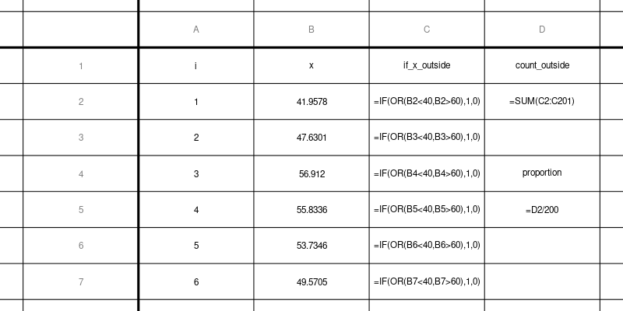
You can download this solution CSV.
Another (simpler?) way is to use the COUNTIF function with the ABS function.
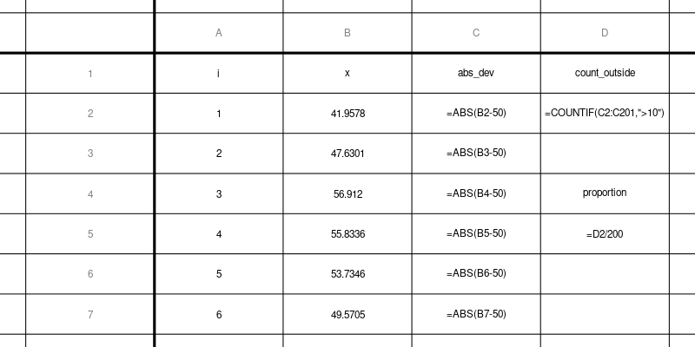
You can download this second solution CSV.
- Question
A sample was gathered.

You can download the data as a CSV file.
Determine the sample interquartile range (IQR).
Warning: various definitions of IQR exist, based on arbitrary decisions made in defining the quantile function or other definitions of quartiles. I will make the answer’s tolerance large enough to accept most (hopefully all) methods.
Solution
video
(ANS = any of [3.56, 3.72, 3.76, 3.7733333, 3.88, 3.96])

Method 1: method of medians
This method is described in the wikipedia page on IQR.
This method relies on first determining the size of each half.
  - If the sample size () is even, divide the sample size by 2.
  - If the sample size () is odd, first subtract 1, then divide the result by 2.
You determine the medians of the lowest half of the values and the highest half of the values. The IQR is the difference of those medians.
In this case, , so is the median of the lowest 6 numbers and is the median of the highest 6 numbers.

Method 1 by hand
Method 1 is easiest to do by hand.

Because there are 12 values, the first quartile is the median of the lowest 6 values and the third quartile is the median of the highest 6 values.

The IQR is the difference between and .

Method 1 with spreadsheet
Unfortunately, the built-in QUARTILE function does not use the method of medians (more about this in Method 2).
We sort the data, determine the median of the lowest 6 values, determine the median of the highest 6 values, and take a difference.
You can see a solution spreadsheet.
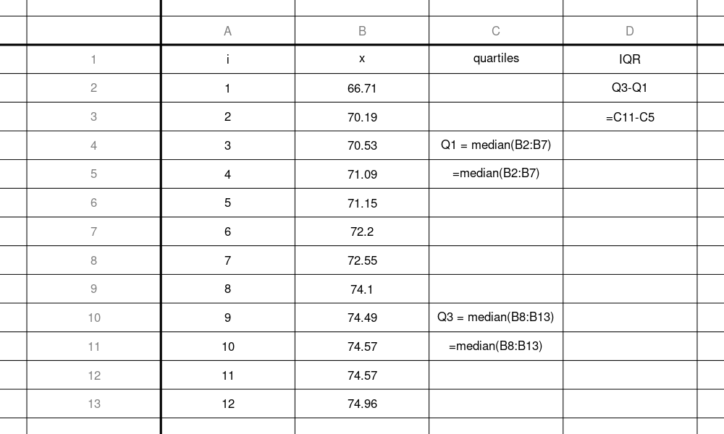

Method 1 with R
Again, the built-in function does not follow the method of medians. So, Method 1 is actually kind of difficult with R. The following code should be relatively easy to understand… but it uses floor rounding, subsetting and the colon operator.
data = read.csv("get_IQR.csv")
x = data$x
n = length(x)
x_sorted = sort(x)
halfsize = floor(n/2)
Q1 = median(x_sorted[1:halfsize])
Q3 = median(x_sorted[(n-halfsize+1):n])
iqr = Q3-Q1
print(iqr)
## [1] 3.72

Method 2: built-in functions

Method 2 with spreadsheet
We can find the quartiles with built-in functions of a spreadsheet.
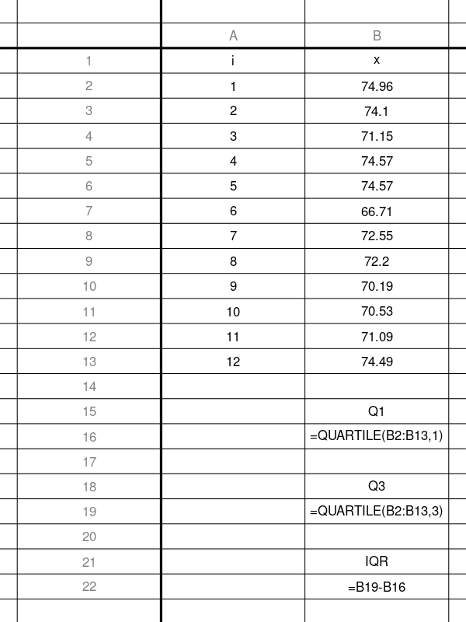
Download this solution
You’ll notice this gives a different answer than Method 1.

Method 2 with R
There are 9 different built-in methods in R.
# Personally, I like the 5th option... the default is 7... some smart researchers suggest 8...
x = read.csv("get_IQR.csv")$x
IQR1 = IQR(x,type=1)
IQR2 = IQR(x,type=2)
IQR3 = IQR(x,type=3)
IQR4 = IQR(x,type=4)
IQR5 = IQR(x,type=5)
IQR6 = IQR(x,type=6)
IQR7 = IQR(x,type=7)
IQR8 = IQR(x,type=8)
IQR9 = IQR(x,type=9)
cat(c(IQR1,IQR2,IQR3,IQR4,IQR5,IQR6,IQR7,IQR8,IQR9))
## 3.96 3.72 3.96 3.96 3.72 3.88 3.56 3.773333 3.76
#The default is type 7...
x = read.csv("get_IQR.csv")$x
IQR_default = IQR(x)
IQR_default
## [1] 3.56

TMI
To really understand what is happening, I think it helps to visualize the quantile functions. Let’s use types 1, 5, and 7. Also, remember the sorted sample:
## 66.71 70.19 70.53 71.09 71.15 72.2 72.55 74.1 74.49 74.57 74.57 74.96
Type 1 is based on the empirical cumululative distribution.
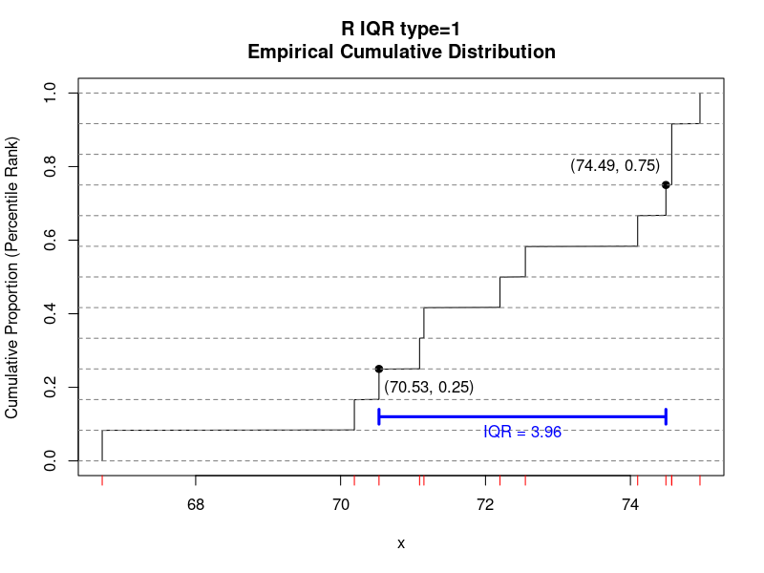
Types 5 and 7 are based on continuous versions of the empirical cumulative distribution.
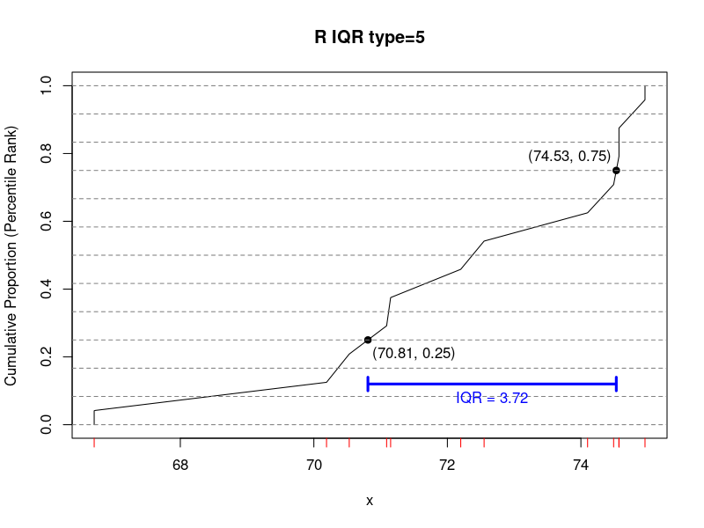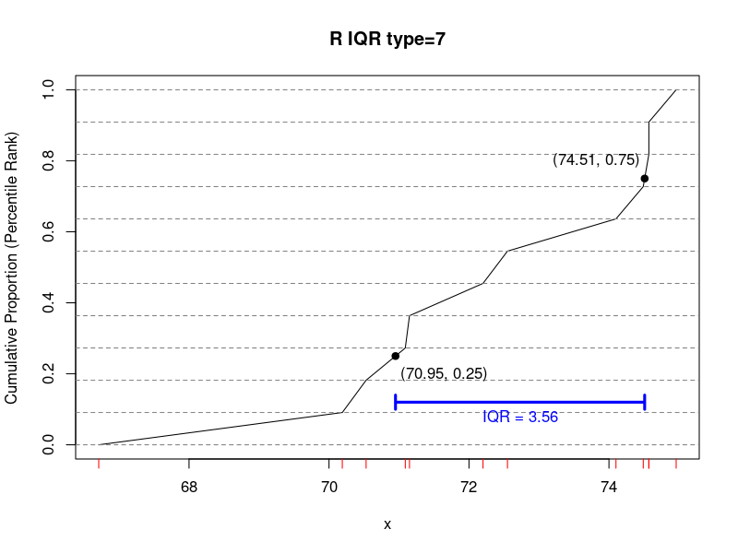

TL;DR
Any of the following answers are accepted:
## 3.72 3.72 3.96 3.72 3.96 3.96 3.72 3.88 3.56 3.773333 3.76
- Question
A sample was gathered.

You can download the data as a CSV file.
Determine the sample’s mean absolute deviation (MAD) around the sample proportion. You can round your answer to the hundredths place.
Solution
(ANS=0.375)
First, determine the sample proportion (mean of 0s and 1s).

Determine the absolute deviations (distances from ).

deviations =
AbsDev =
1
0
-0.75
0.75
2
1
0.25
0.25
3
1
0.25
0.25
4
1
0.25
0.25
5
0
-0.75
0.75
6
1
0.25
0.25
7
1
0.25
0.25
8
1
0.25
0.25
Now, take the mean of the absolute deviations.

spreadsheet
You can do this with a spreadsheet.
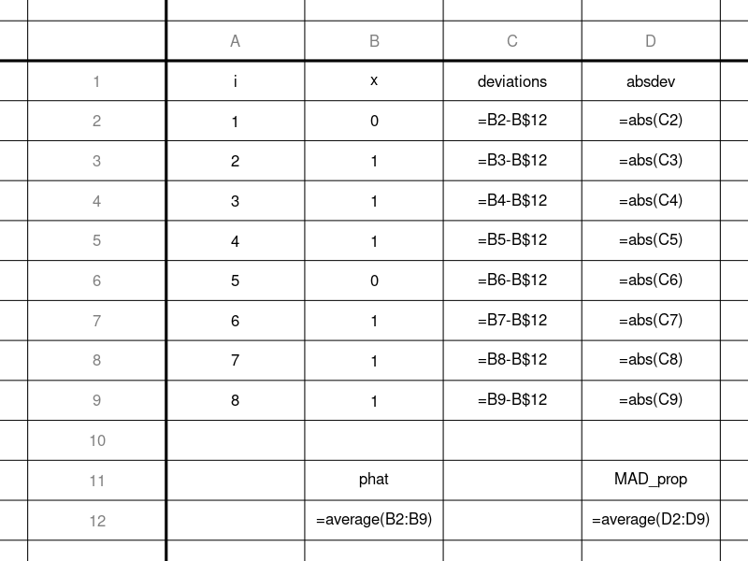

R
You can do this with R
x = read.csv("get_MAD.csv")$x
phat = mean(x)
deviations = x-phat
AbsDev = abs(deviations)
MAD = mean(AbsDev)
x
## [1] 0 1 1 1 0 1 1 1
phat
## [1] 0.75
deviations
## [1] -0.75 0.25 0.25 0.25 -0.75 0.25 0.25 0.25
AbsDev
## [1] 0.75 0.25 0.25 0.25 0.75 0.25 0.25 0.25
MAD
## [1] 0.375

Algebra
With a little bit of algebra, we can simplify the formula for . (I’ve not shown the algebra…)

In other words, if is the number of 0s and is the number of 1s, then

So, in this case:

- Question
A sample was gathered.

You can download the data as a CSV file.
Determine the variance of the sample. You can round your final answer to the hundredths place.
Solution
(ANS=0.234375)
video
First, determine the mean of the sample. Remember, if a sample is all 0s and 1s, then the sample’s mean is the same as the sample proportion ().

Determine the squared deviations (squared distances from ).

deviations =
SqrDev =
1
0
-0.375
0.140625
2
1
0.625
0.390625
3
0
-0.375
0.140625
4
0
-0.375
0.140625
5
1
0.625
0.390625
6
1
0.625
0.390625
7
0
-0.375
0.140625
8
0
-0.375
0.140625
Now, take the mean of the squared deviations to determine the variance.

IMPORTANT NOTE (notation and central limit theorem):
I will usually use (not conventional) to represent raw data of 0s and 1s (instead of ), because in the context of 0s and 1s, usually implies the number of successes in trials.

When represents a count of successes in (independent) trials, a large sample of counts () follows a binomial distribution, which is a special case of more general distributions of sums or means, which tend to be normally distributed.
The Central Limit Theorem states that random averages (means) and random sums follow normal probability distributions. The expected value and standard deviation of the sampling distribution is either calculated from the underlying distribution’s parameters or guessed from a sample’s statistics.
Notice, when dealing with binomial distributions, the underlying Bernoulli distribution is rarely discussed, and even when it is, “” is not used. So, this notation is not conventional. The conventional notation for is , where the hat denotes “estimated”, because sample proportion is an estimate of the underlying population proportion .

spreadsheet
You can do this with a spreadsheet.
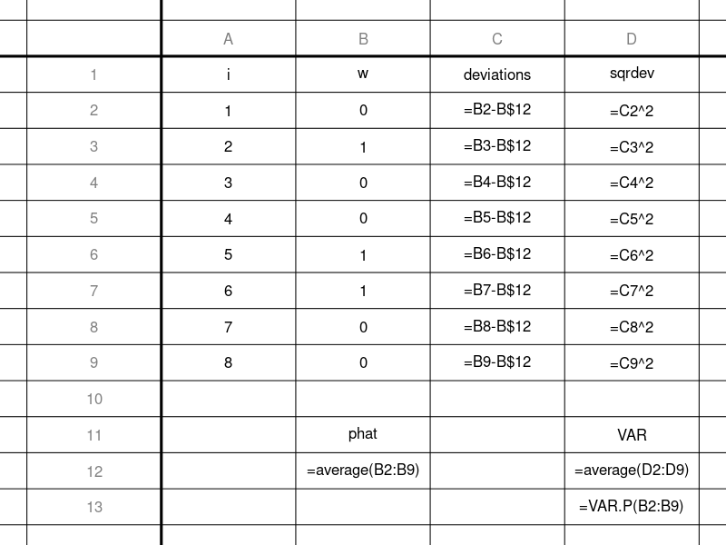
And, actually, you can skip a lot of work by using the VAR.P function. Notice, you use the population function even though the data is a sample. This is because, with proportions, the mean and variance are intrinsically linked (not independent).
In fact, we will see that the sample variance of 0s and 1s can be calculated from the sample proportion.

R
You can do this with R
w = read.csv("get_VAR.csv")$w
phat = mean(w)
deviations = w-phat
sqrdev = deviations^2
VAR = mean(sqrdev)
w
## [1] 0 1 0 0 1 1 0 0
phat
## [1] 0.375
deviations
## [1] -0.375 0.625 -0.375 -0.375 0.625 0.625 -0.375
## [8] -0.375
sqrdev
## [1] 0.140625 0.390625 0.140625 0.140625 0.390625 0.390625
## [7] 0.140625 0.140625
VAR
## [1] 0.234375
# The built-in var() function almost works, but it is too fancy, and makes a Bessel correction. To use it, we need to undo the Bessel correction.
n = length(w)
var(w)*(n-1)/(n)
## [1] 0.234375

Algebra
As mentioned earlier, there is an intrinsic link between (the mean of 0s and 1s) and (the variance of 0s and 1s).
Let represent the number of 0s and represent the number of ones.

We can find a simple formula for variance (when data is 0s and 1s [Bernoulli]).

So, you could have just found .

Then used the formula.

- Question
A sample was gathered.

You can download the data as a CSV file.
Determine the standard deviation of the sample. Because the data are all 0s and 1s, you would never make Bessel’s correction (even if guessing the population’s standard deviation), because the mean and standard deviation are not independent parameters. You can round your final answer to the hundredths place.
Solution
(ANS=0.4898979)
video
First, determine the mean of the sample. Remember, if a sample is all 0s and 1s, then the sample’s mean is the same as the sample proportion ().

Determine the squared deviations (squared distances from ).

deviations =
SqrDev =
1
0
-0.4
0.16
2
1
0.6
0.36
3
0
-0.4
0.16
4
0
-0.4
0.16
5
1
0.6
0.36
6
1
0.6
0.36
7
0
-0.4
0.16
8
0
-0.4
0.16
9
0
-0.4
0.16
10
1
0.6
0.36
Now, take the mean of the squared deviations to determine the variance.

The standard deviation is the square root of the variance.

IMPORTANT NOTE (notation and central limit theorem):
I will usually use (not conventional) to represent raw data of 0s and 1s (instead of ), because in the context of 0s and 1s, usually implies the number of successes in trials.

When represents a count of successes in (independent) trials, a large sample of counts () follows a binomial distribution, which is a special case of more general distributions of sums or means, which tend to be normally distributed.
The Central Limit Theorem states that random averages (means) and random sums follow normal probability distributions. The expected value and standard deviation of the sampling distribution is either calculated from the underlying distribution’s parameters or guessed from a sample’s statistics.
Notice, when dealing with binomial distributions, the underlying Bernoulli distribution is rarely discussed, and even when it is, “” is not used. So, this notation is not conventional. The conventional notation for is , where the hat denotes “estimated”, because sample proportion is an estimate of the underlying population proportion .

spreadsheet
You can do this with a spreadsheet.
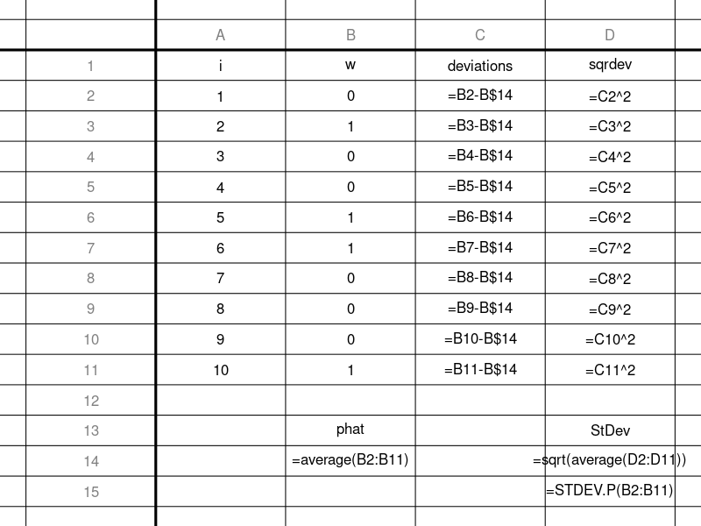
And, actually, you can skip a lot of work by using the STDEV.P function. Notice, you use the population function even though the data is a sample. This is because, with proportions, the mean and standard deviation are intrinsically linked (not independent).
In fact, we will see that the sample standard deviation of 0s and 1s can be calculated from the sample proportion.

R
You can do this with R
w = read.csv("get_SD.csv")$w
phat = mean(w)
deviations = w-phat
sqrdev = deviations^2
VAR = mean(sqrdev)
SD = sqrt(VAR)
w
## [1] 0 1 0 0 1 1 0 0 0 1
phat
## [1] 0.4
deviations
## [1] -0.4 0.6 -0.4 -0.4 0.6 0.6 -0.4 -0.4 -0.4 0.6
sqrdev
## [1] 0.16 0.36 0.16 0.16 0.36 0.36 0.16 0.16 0.16 0.36
VAR
## [1] 0.24
SD
## [1] 0.4898979
# The built-in sd() function almost works, but it is too fancy, and makes a Bessel correction. To use it, we need to undo the Bessel correction.
n = length(w)
sd(w)*sqrt((n-1)/(n))
## [1] 0.4898979

Algebra
As mentioned earlier, there is an intrinsic link between (the mean of 0s and 1s) and (the variance of 0s and 1s).
Let represent the number of 0s and represent the number of ones.

We can find a simple formula for variance (when data is 0s and 1s [Bernoulli]).

So, you could have just found .

Then used the formula.

