- Question
A continuous random variable (spinner/random number generator/infinite population) can be visualized with a density curve, a spinner, and a cumulative curve.
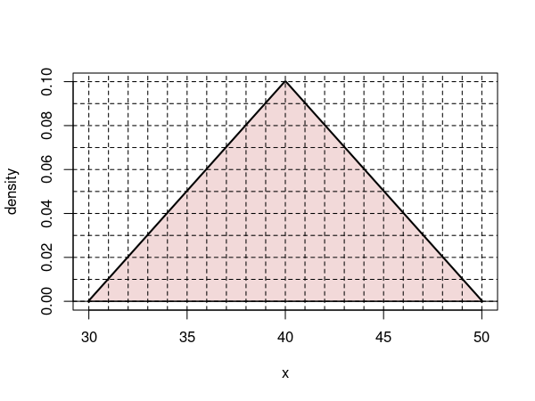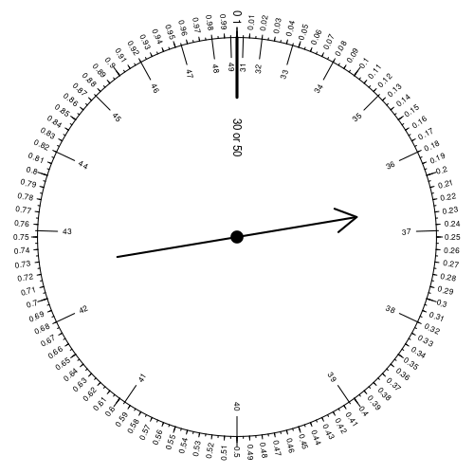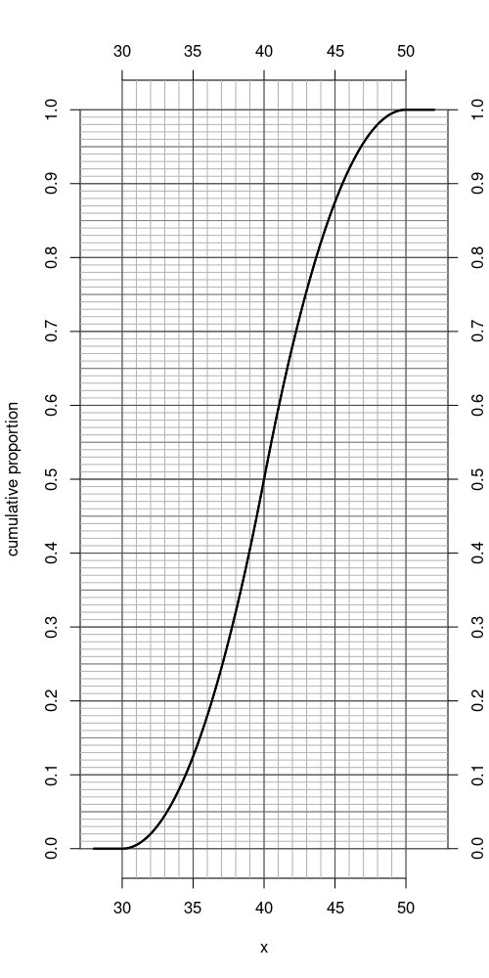
  - Evaluate
  - Evaluate
  - Evaluate
  - Determine integer such that
  - Determine integer such that
  - Determine integer such that
Solution
video
For each problem, you can use any of the visualizations. In short, the answers:
## 0.82 0.5 0.6 38 46 6
  - The answer is 0.82 because . The following visualizations show this. The density curve can be used by counting percent boxes. Each box adds 0.01 to the proportion. You may need to count half boxes, or find partial boxes that add to whole boxes. 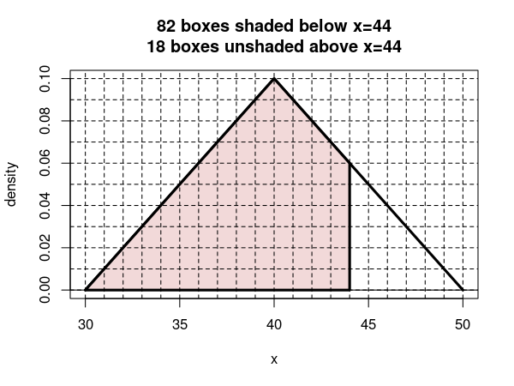 On the spinner, you can determine the size of a region by using the outside tickmarks. 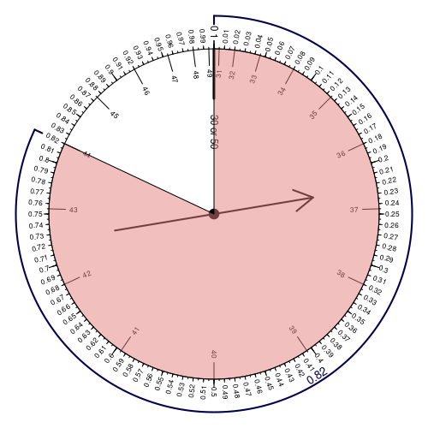 You need to read coordinates to use the cumulative curve. 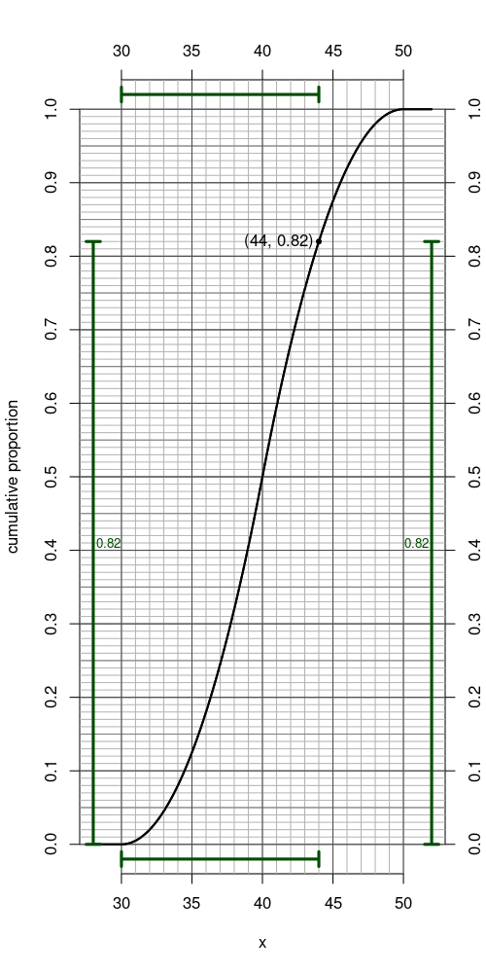
  - The answer is 0.5 because . The following visualizations show this. The density curve can be used by counting percent boxes. Each box adds 0.01 to the proportion. You may need to count half boxes, or find partial boxes that add to whole boxes. 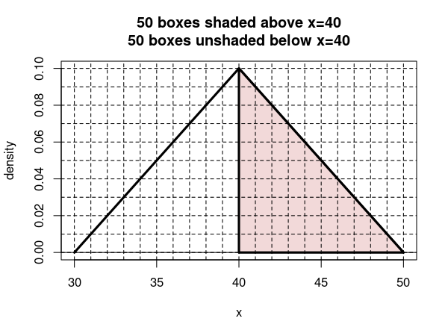 On the spinner, you can determine the size of a region by using the outside tickmarks.

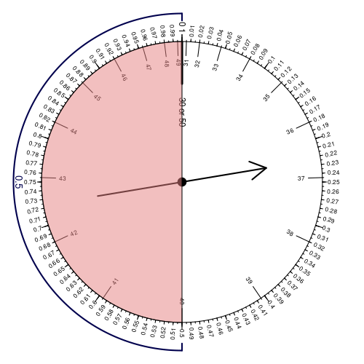 You need to read coordinates to use the cumulative curve.

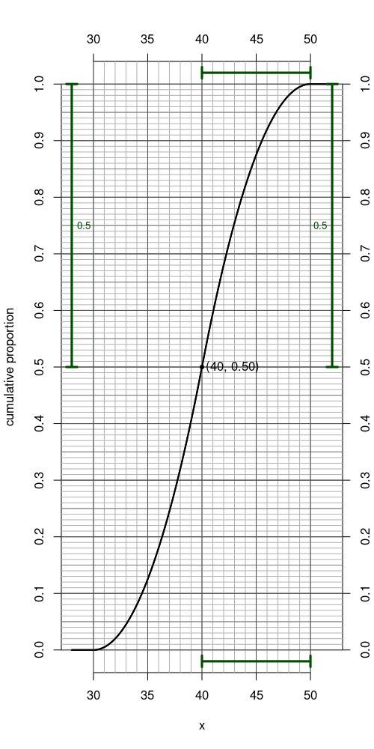
  - The answer is 0.6 because . It helps to point out this interval has a center of 38 and a radius of 4, and thus a lower bound of 34 and an upper bound of 42. The following visualizations show this. The density curve can be used by counting percent boxes. Each box adds 0.01 to the proportion. You may need to count half boxes, or find partial boxes that add to whole boxes. 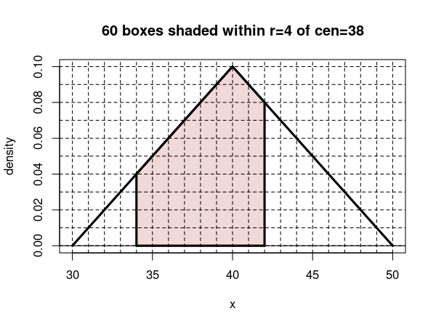 On the spinner, you can determine the size of a region by using the outside tickmarks. The lower bound is at , which corresponds to a cumulative proportion of 0.08. The upper bound is at , which corresponds to a cumulative proportion of 0.68.

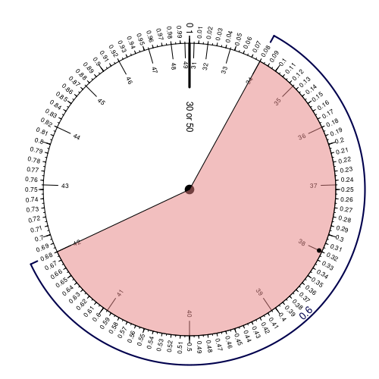 You need to read coordinates to use the cumulative curve. The lower bound is at , which corresponds to a cumulative proportion of 0.08. The upper bound is at , which corresponds to a cumulative proportion of 0.68.

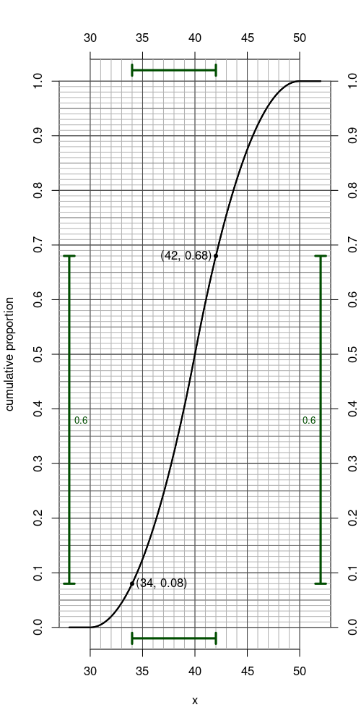
  - The answer is 38 because . The following visualizations show this. The density curve can be used by counting percent boxes. Each box adds 0.01 to the proportion. You may need to count half boxes, or find partial boxes that add to whole boxes. 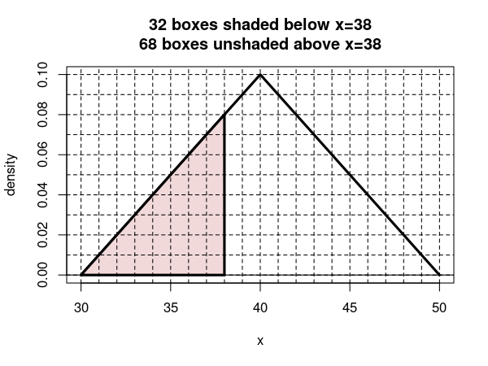 On the spinner, you can determine the size of a region by using the outside tickmarks. 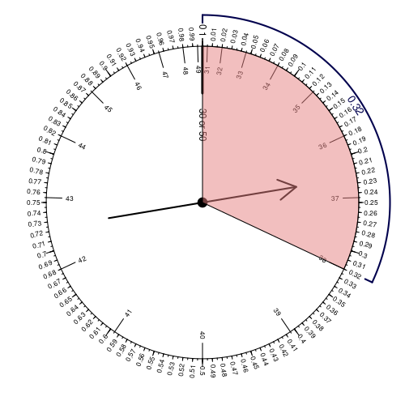 You need to read coordinates to use the cumulative curve. 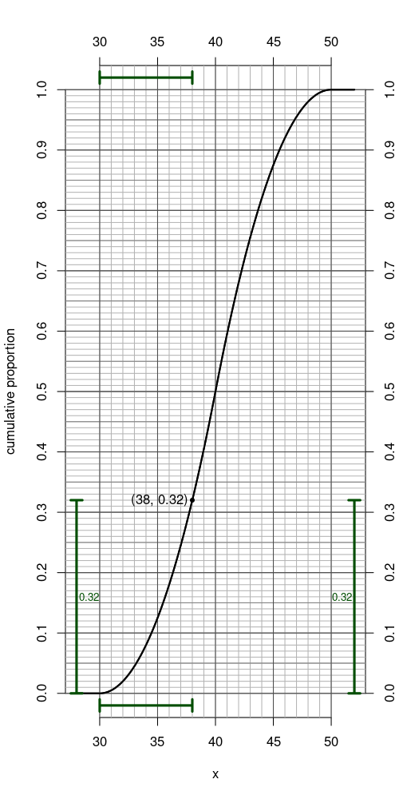
  - The answer is 46 because . The following visualizations show this. The density curve can be used by counting percent boxes. Each box adds 0.01 to the proportion. You may need to count half boxes, or find partial boxes that add to whole boxes. 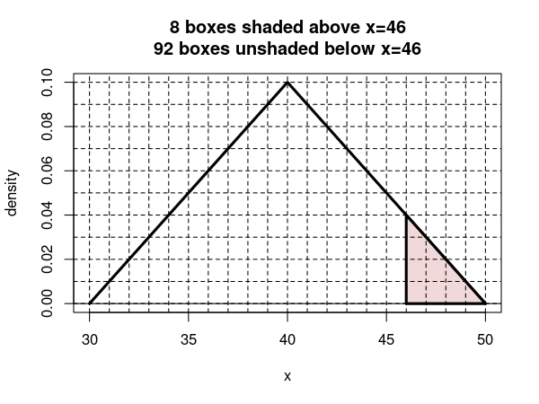 On the spinner, you can determine the size of a region by using the outside tickmarks.

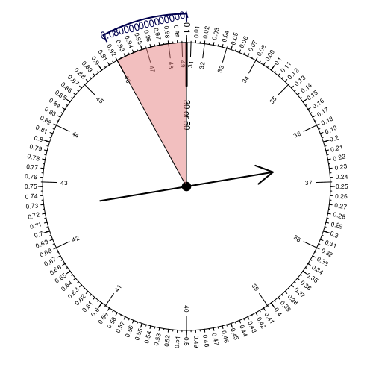 You need to read coordinates to use the cumulative curve.

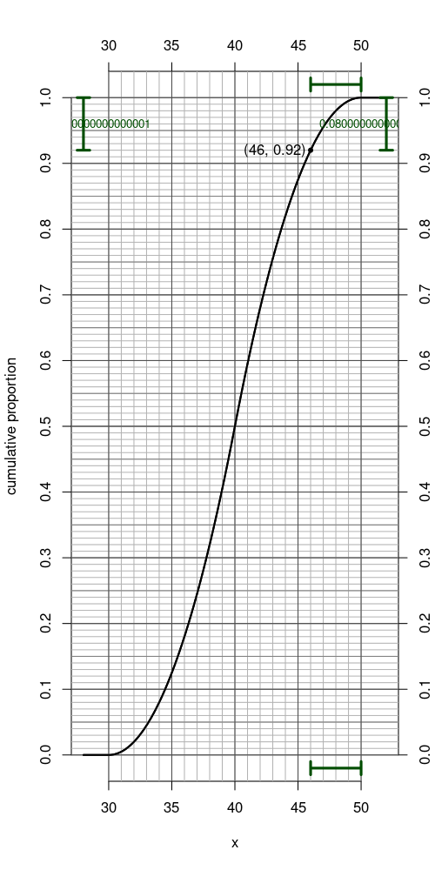
  - The answer is 6 because . You will need to guess and check to arrive at this answer. The following shows how to check after making the correct guess. This interval has a center of 42 and a radius of 6, and thus a lower bound of 36 and an upper bound of 48. The density curve can be used by counting percent boxes. Each box adds 0.01 to the proportion. You may need to count half boxes, or find partial boxes that add to whole boxes. 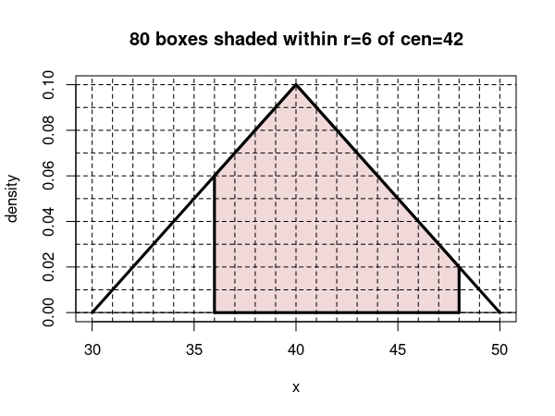 On the spinner, you can determine the size of a region by using the outside tickmarks. The lower bound is at , which corresponds to a cumulative proportion of 0.18. The upper bound is at , which corresponds to a cumulative proportion of 0.98.

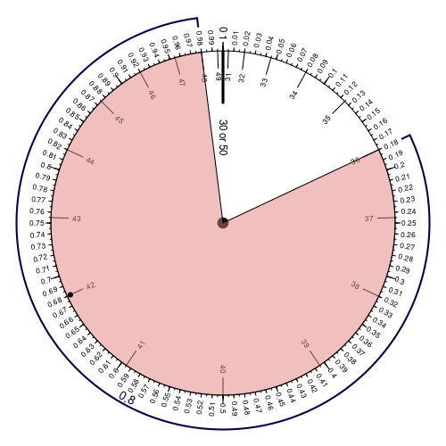 You need to read coordinates to use the cumulative curve. The lower bound is at , which corresponds to a cumulative proportion of 0.18. The upper bound is at , which corresponds to a cumulative proportion of 0.98.

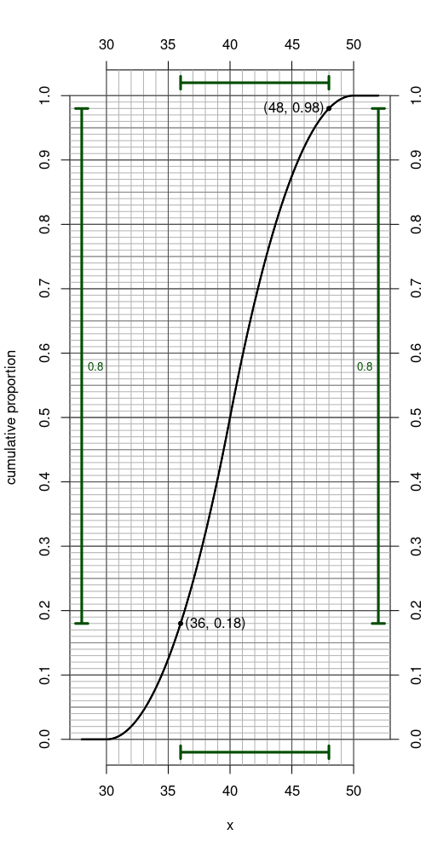
- Question

Background
In statistics, the word “normal” does not mean “typical”. Instead, “normal” refers to a very important continuous distribution: the normal distribution. Normal distributions are important because random sums and random averages are approximately normal (see central limit theorem). For example, if you repeatedly roll 100 dice, taking the sum of each 100, those sums will be normally distributed (even though single rolls are discrete-uniformly distributed).
A normal distribution has a bell-shaped density curve. The center and spread of the bell are dictated by two parameters: mean () and standard deviation (). The normal density curve is defined by the following equation:

where is the mean, is the standard deviation, is the ratio of a circle’s circumference to its diameter, and is Euler’s number.
For the first exam, we are expected to know the empirical rule. We are going to round unconventionally, so for us it could be called the “68-96-100 rule”. It implies that in a normal distribution 68% of the measurements are within 1 standard deviation of the mean, 96% of the measurements are within 2 standard deviations of the mean, and 100% of the measurements are within 3 standard deviations of the mean.
We can visualize the “68-96-100” rule with a density curve. Notice the area of each region is shown, and you can estimate the areas by counting percentage boxes.
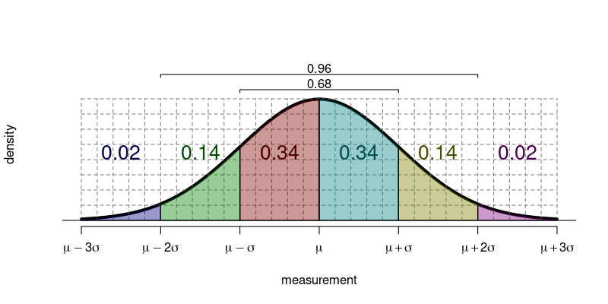
We can display our 68-96-100 rule with a spinner.
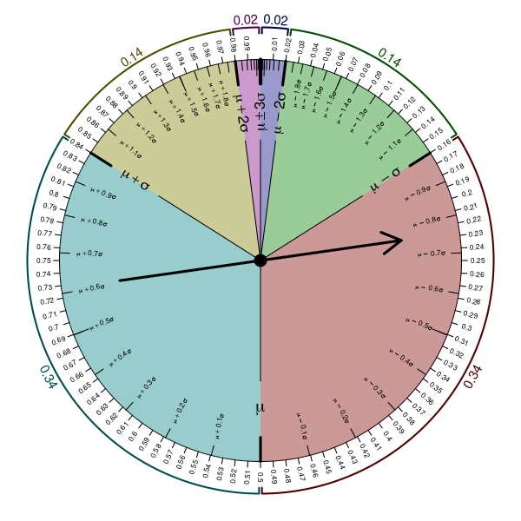
And, we can display our 68-96-100 rule with a cumulative curve. In this case, we will introduce the notation of using as the multiplier of . For example, if , then the measurement is . We call the standard score.
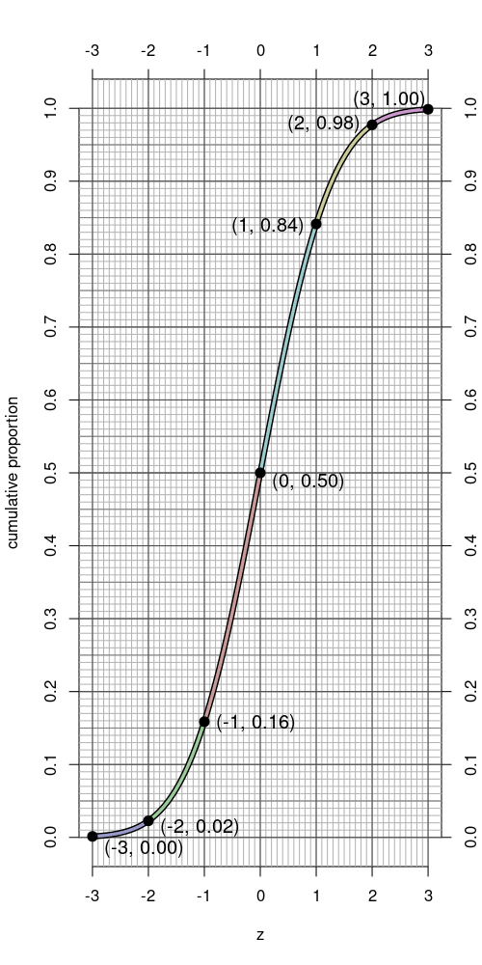

Actual Question:
Population (with infinite individuals) has measurements that are normally distributed with mean and standard deviation . Use the empirical rule (68-96-100 rule) to answer the following questions.
  - Evaluate .
  - Evaluate .
  - Evaluate .
  - Determine boundary such that .
  - Determine boundary such that .
  - Determine radius such that .
Solution
video
It helps to draw a diagram using the supplied mean () and standard deviation ().
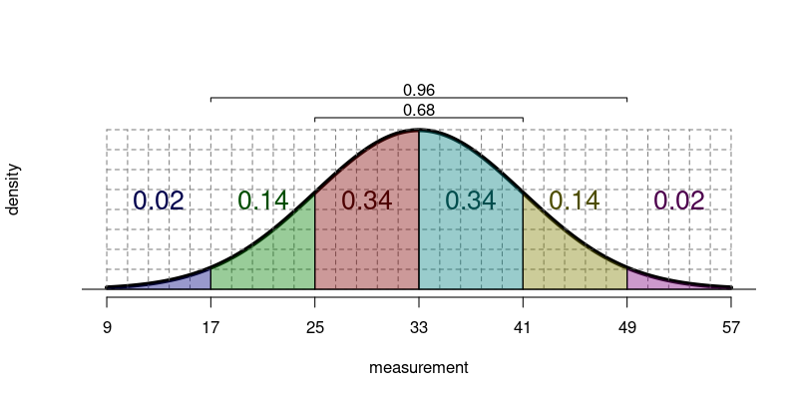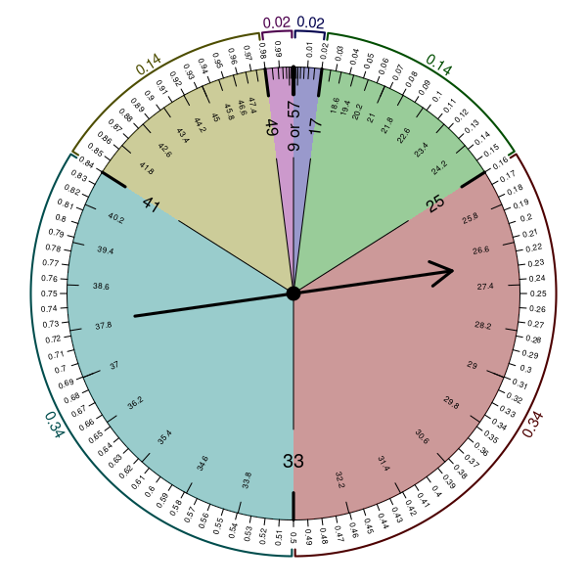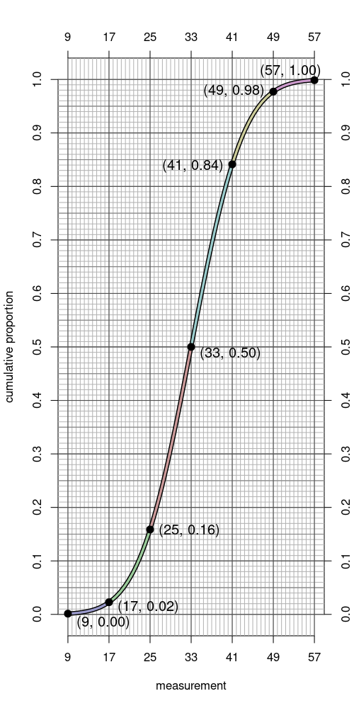
  - The answer is 0.98 because . 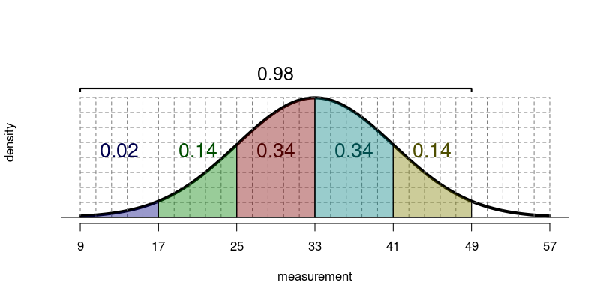 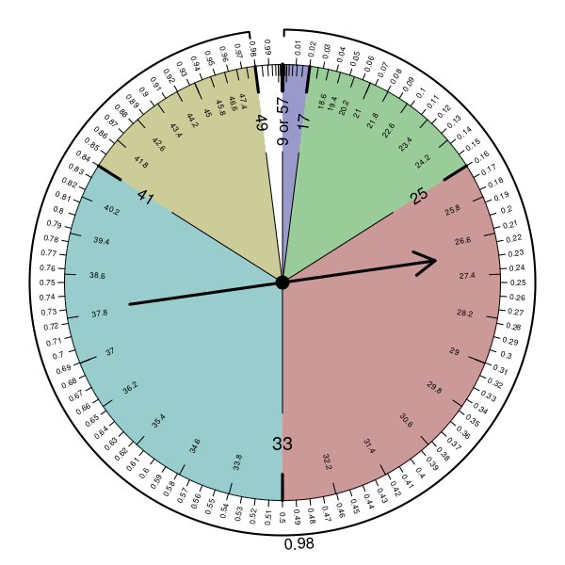 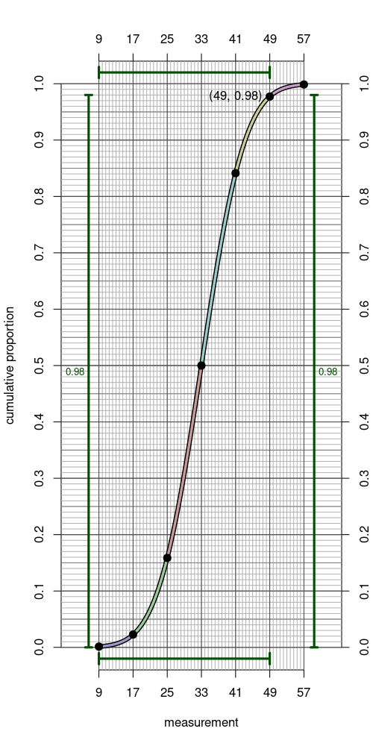
  - The answer is 0.84 because . 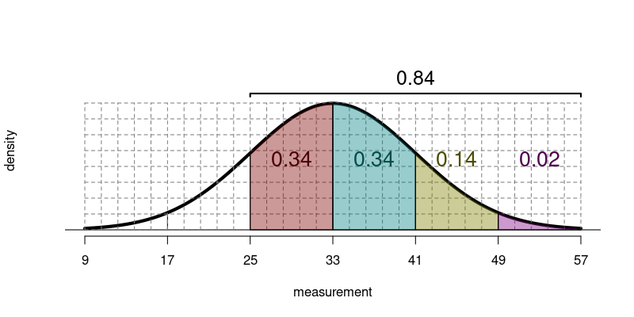 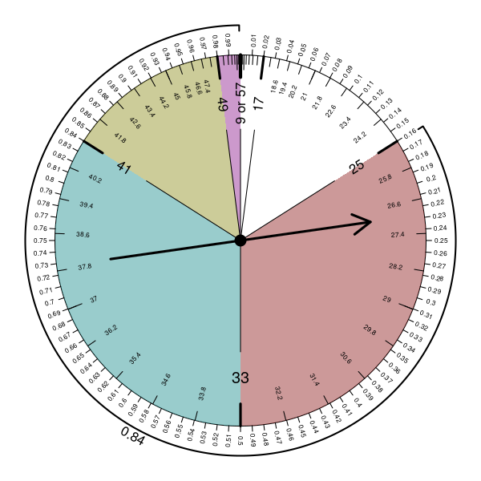 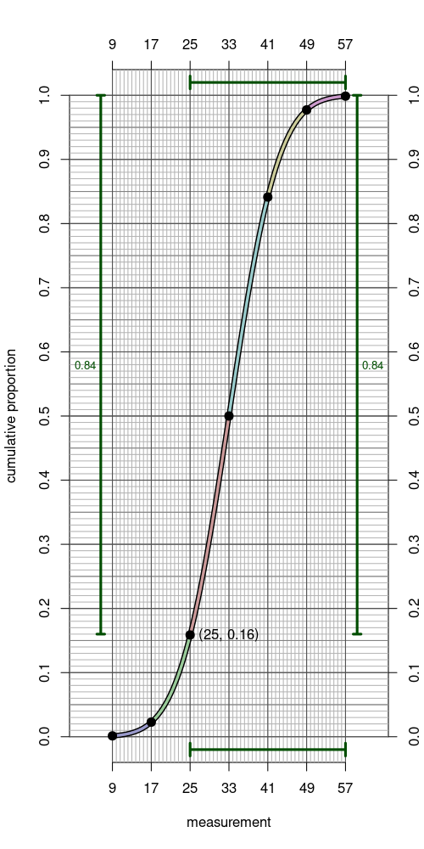
  - The answer is 0.68 because . 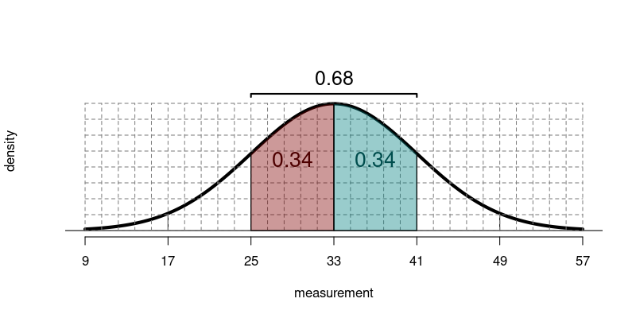 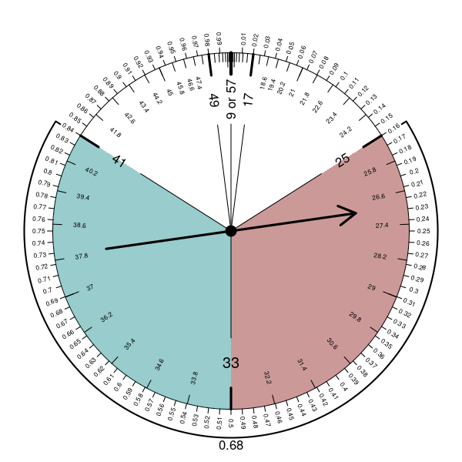 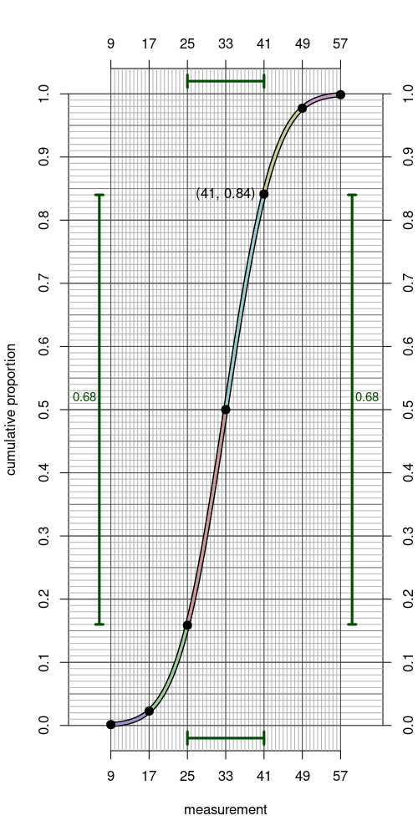
  - The answer is 33 because . 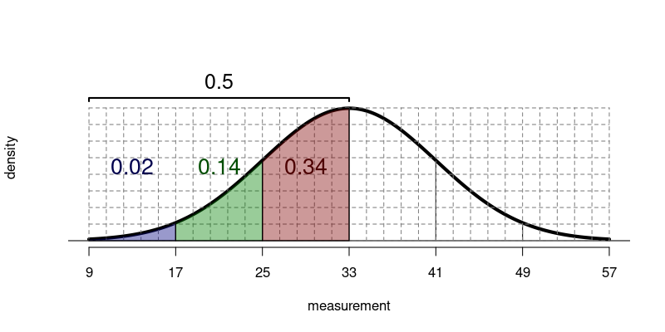 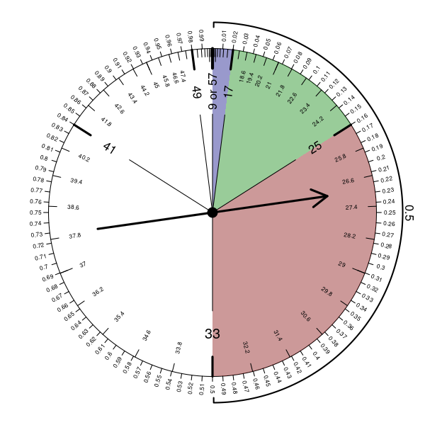 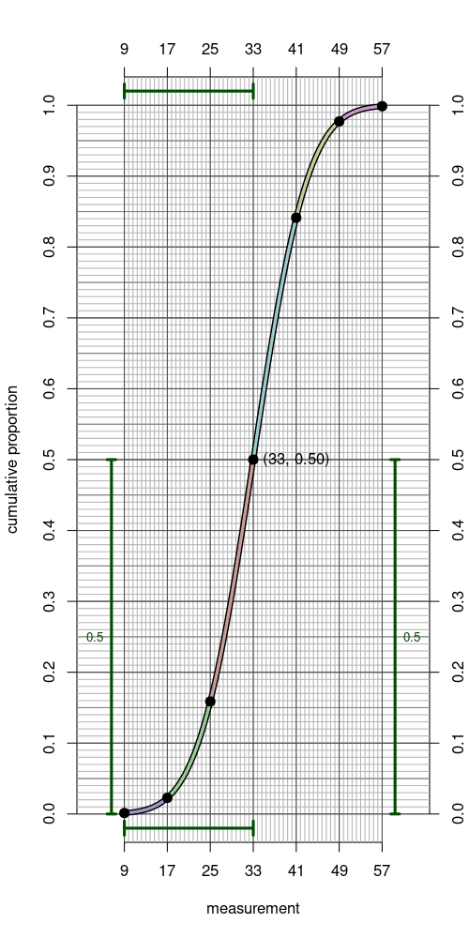
  - The answer is 41 because . 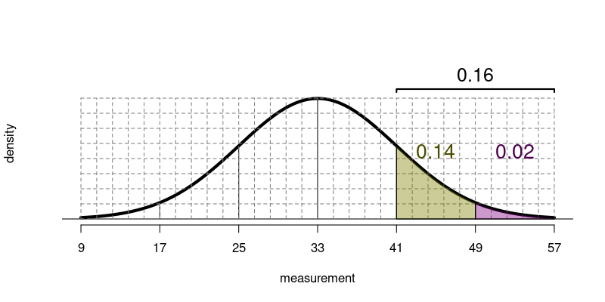 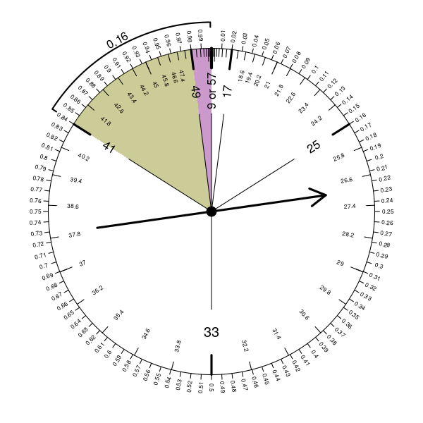 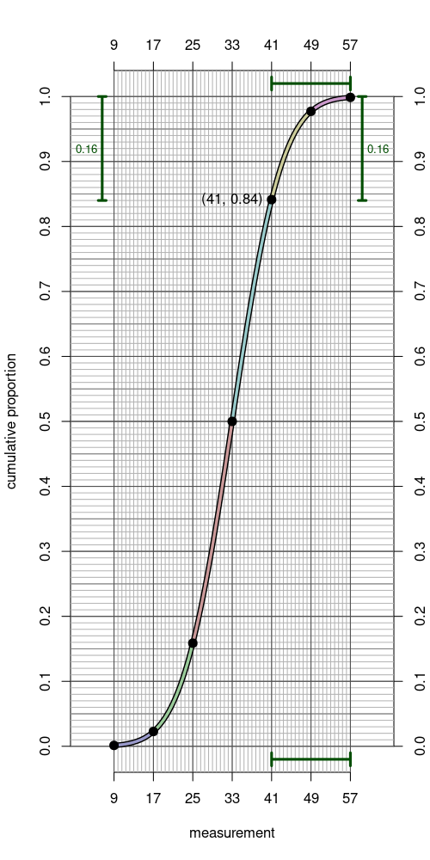
  - The answer is 16 because . 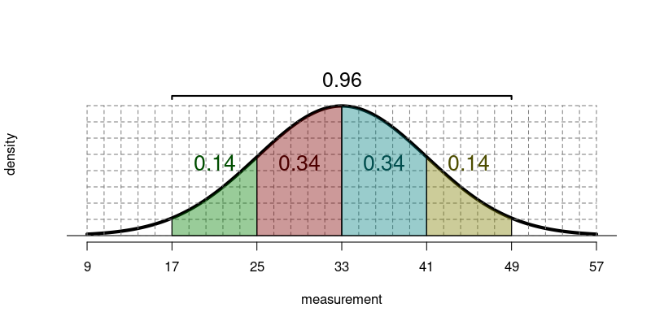 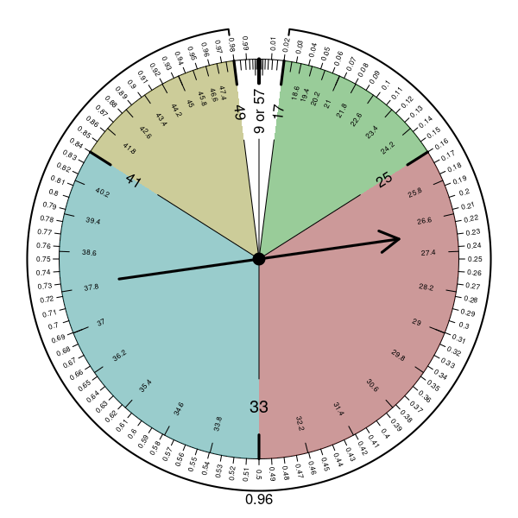 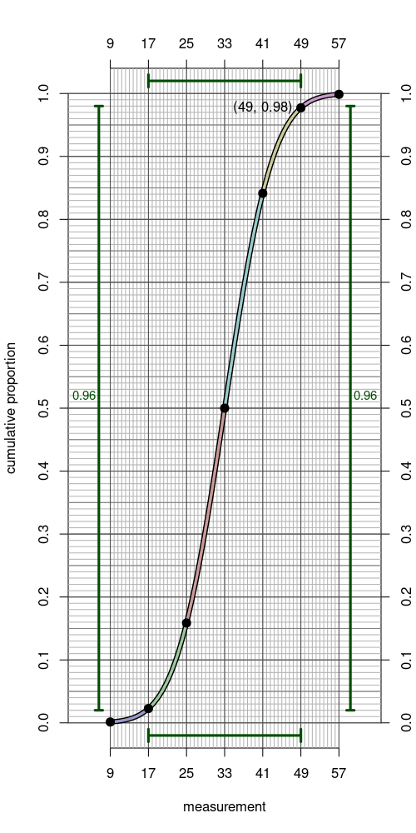
- Question

Background
A standard score () can be calculated from a measurement (), the population mean (), and the population standard deviation ().

With a little algebra, you can create another formula solved for the measurement.

Actual question
A gambler is interested in the sum of 10 rolls of 12-sided dice. The process of summing 10 rolls of 12-sided dice can be repeated infinitely many times, giving independent results each time, so those sums can be thought of as an infinitely large population. This population happens to be approximately normal (see central limit theorem).
The gambler knows how to calculate the population mean (see discrete-uniform distribution).

She also knows how to calculate the population standard deviation.

  - If the gambler rolled a sum of 77 (in other words got a measurement ), what is the standard score? (Determine ; you can round to the nearest hundredth.)
  - If the gambler got a standard score of , what is the sum? (Determine , rounding to the nearest integer.)
Solution
video
  - Use the formula.

  - Use the formula.

