- Question
Determine the probability that the standard normal variable is less than 0.99. In other words, evaluate .
Solution
(ANS=0.8389)
video
The numbers that satisfy are on the left side of a number line (toward ). The probability equals a left area under the density curve.
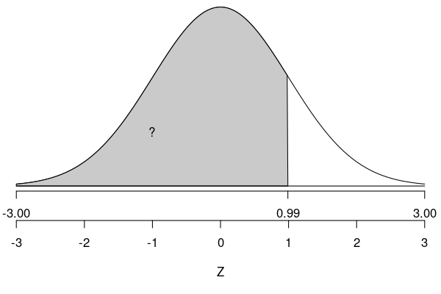
By using the z-table, we find the appropriate probability.

It might help to visualize with a spinner:
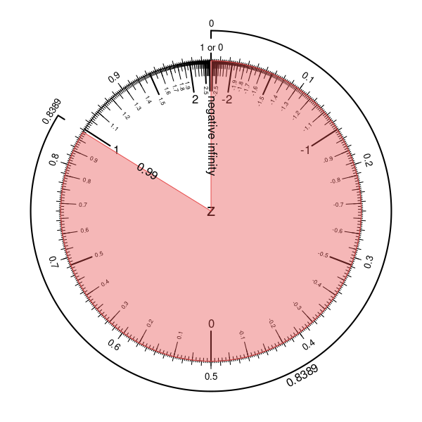
Using a spreadsheet:
=NORM.DIST(0.99,0,1,TRUE)
Using R:
pnorm(0.99)
- Question
Determine the probability that the standard normal variable is more than -0.08. In other words, evaluate .
Solution
(ANS=0.5319)
video
First, you need to identify that we are looking for a right area. This is because large values of satisfy .
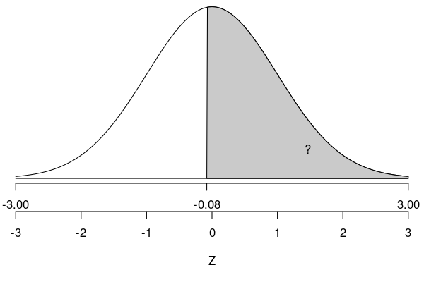
By using the z-table, we find the left area (even though we eventually want the right area).

We use the rule of compliments to determine the right area.

Method 2: You might also recognize that the normal distribution is symmetric. Thus,

Method 3: It often helps to draw a picture.
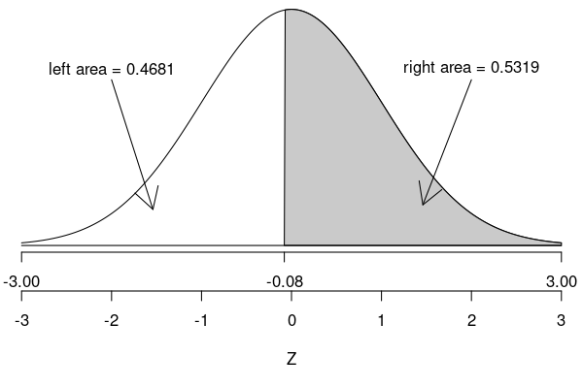
It might help to visualize with a spinner:
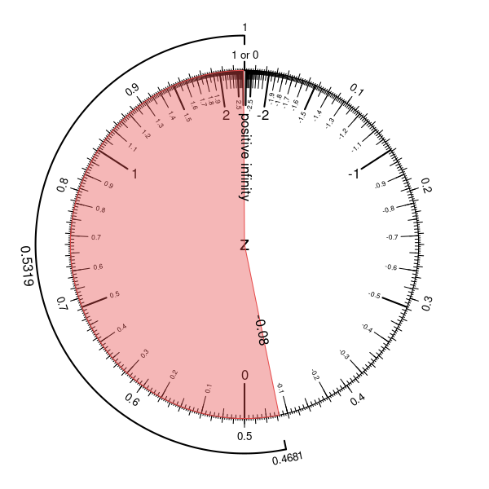
Using a spreadsheet:
=1-NORM.DIST(-0.08,0,1,TRUE)
Using R:
1-pnorm(-0.08)
- Question
Determine the probability that the absolute standard normal variable is less than 0.43. In other words, evaluate .
Solution
(ANS=0.3328)
video
First, you need to identify that we are looking for a central area. This is because -scores near 0 satisfy , while -scores far from 0 (either positive or negative) do not satisfy the inequality.
Start with a sketch.
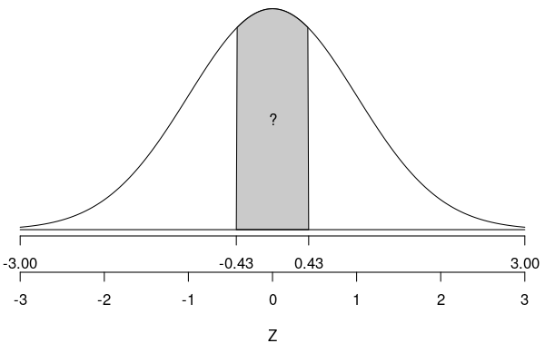
Remember, the entire area is always 1. Most z-tables only provide left areas, so three methods are shown to get the central area from a left-area (cumulative probability) table.
Method 1: First find the area of the left tail.

Recognize normal distributions are symmetric, so we also know the area of the right tail.

The three areas add to 1.

This technique can be summarized with the following formula:

assuming .
So, in our case (when ),

This method is shown graphically:
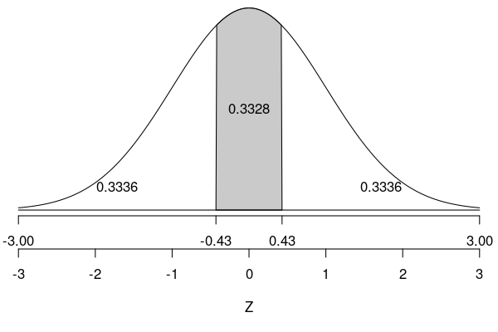
Method 2: You can also find half of the central area and then double it.

This method is shown graphically:
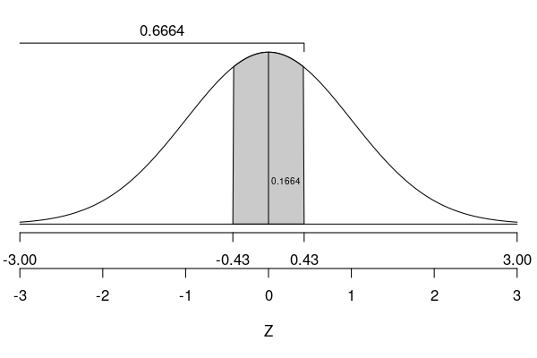
Method 3: You can also calculate the central area with a difference of two left areas.

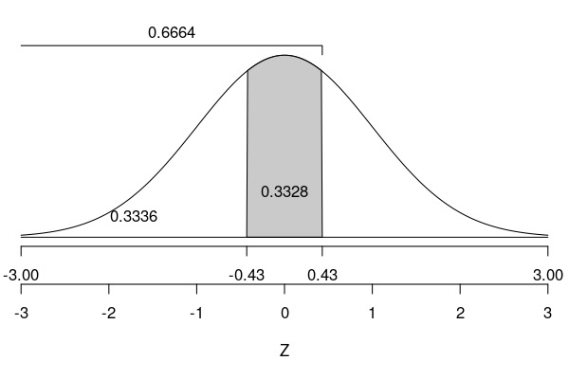
It might be helpful to visualize with a spinner.
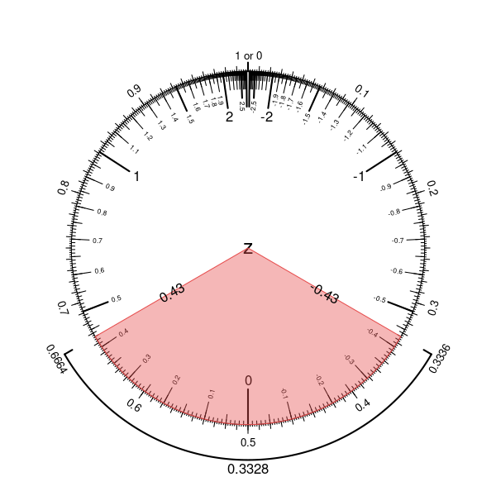
In a spreadsheet, you could use the NORM.DIST() function.
=NORM.DIST(0.43,0,1,TRUE) - NORM.DIST(-0.43,0,1,TRUE)
In R, you could use the pnorm function.
pnorm(0.43) - pnorm(-0.43)
- Question
Determine the probability that the absolute standard normal variable is more than 0.6. In other words, evaluate .
Solution
(ANS=0.5486)
video
First, you need to identify that we are looking for a two-tail area (the sum of the left and right tails). This is because -scores far from 0 satisfy , while -scores near 0 do not satisfy the inequality.
Start with a sketch.
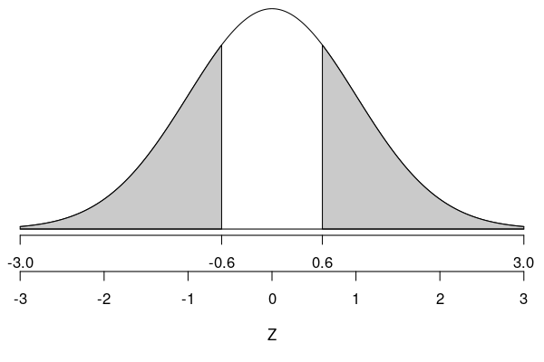
Remember, the entire area is always 1. Most z-tables only provides left areas, so three methods are shown to get the two-tail area from a left-area (cumulative probability) table.
Method 1: First find the area of the left tail.

Recognize normal distributions are symmetric, so we also know the area of the right tail.

The two areas add to our desired two-tail area.

This technique can be summarized with the following formula:

assuming .
So, in our case (when ),

This method is shown graphically:
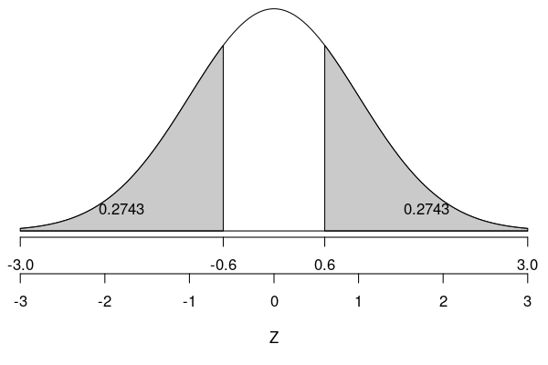
Notice we need to add both tails.
Method 2: You can achieve the same result by using the following formula:

So,

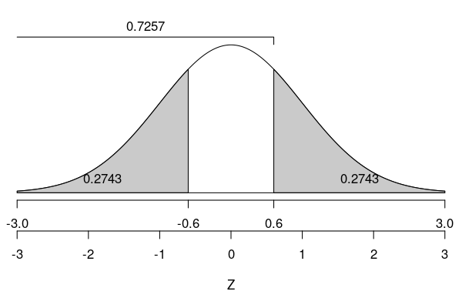
It might be helpful to visualize with a spinner.
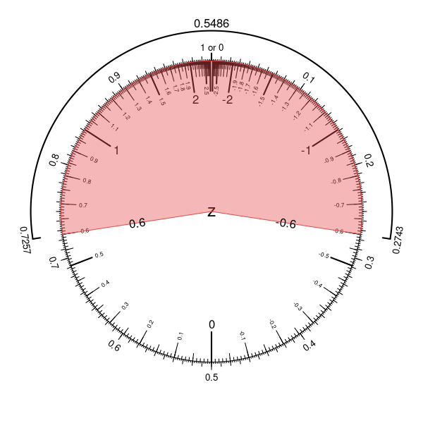
In a spreadsheet, you could use the NORM.DIST() function.
=2*NORM.DIST(-0.6,0,1,TRUE)
In R, you could use the pnorm function.
2*pnorm(-0.6)
- Question
Determine the probability that the standard normal variable is between -1.27 and 0.32. In other words, evaluate .
Solution
(ANS=0.5235)
video
Start with a sketch.
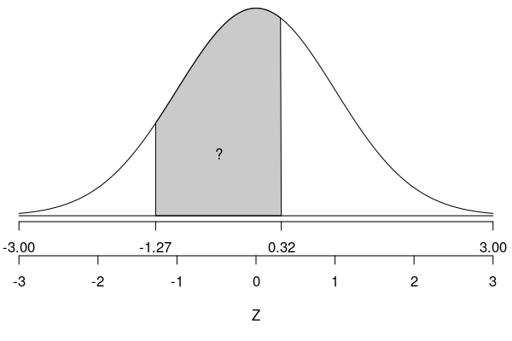
We take a difference of areas.

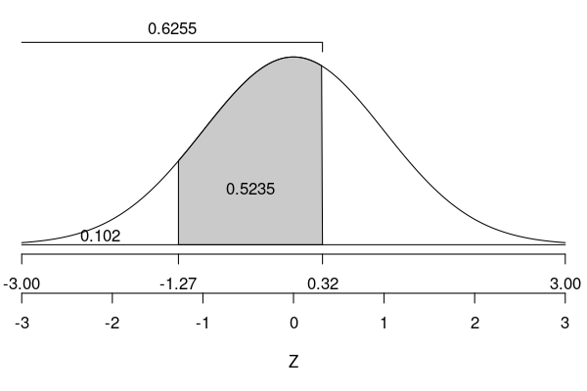
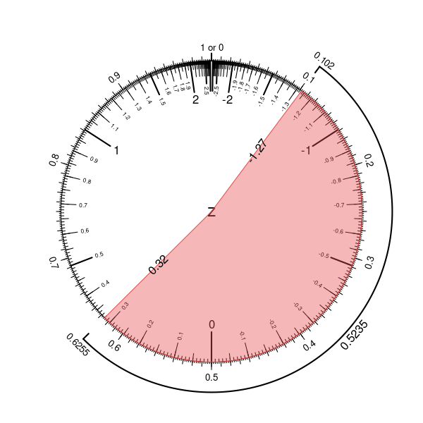
In a spreadsheet, you could use the NORM.DIST() function.
=NORM.DIST(0.32,0,1,TRUE) - NORM.DIST(-1.27,0,1,TRUE)
In R, you could use the pnorm function.
pnorm(0.32) - pnorm(-1.27)
- Question
Determine such that . In other words, what -score is greater than % of standard normal values? (Answers within 0.01 from the correct value will be marked correct.)
Solution
(ANS=-0.3853205)
video
Start with a sketch. Leftward numbers (toward ) will be less than our boundary , so we shade a left region with area 0.35.
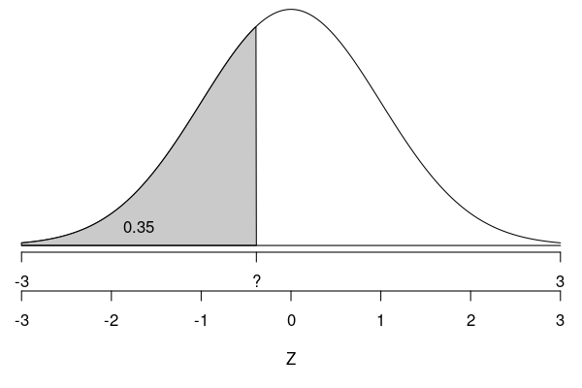
You should go to your -table and find the -score with the left area closest to 0.35.
It turns out the exact answer is , which could be found by using an inverse normal function. On a spreadsheet:
=Norm.Inv(0.35,0,1)
Using R:
qnorm(0.35)
But, the -table is accurate enough, so I will accept either -0.39 or -0.38 (anything within 0.01 of -0.3853205).
You might find it helpful to visualize with a spinner.
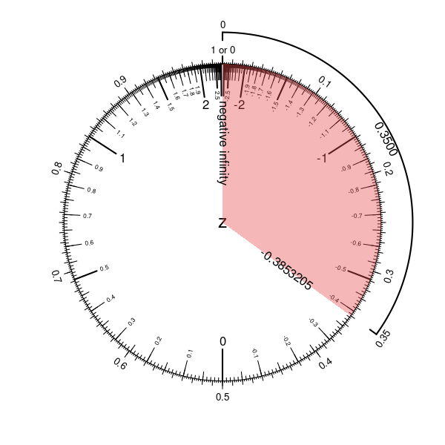
- Question
Determine such that . In other words, what -score is less than % of standard normal values? (Answers within 0.01 from the correct value will be marked correct.)
Solution
(ANS=1.475791)
video
Start with a sketch. Rightward numbers (toward ) will be more than our boundary , so we shade a rightward region with area 0.07.
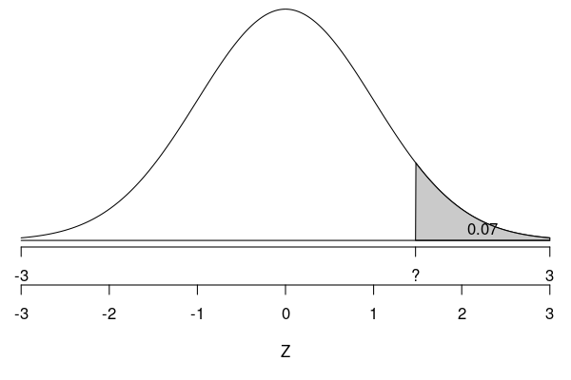
You should first find the left area.

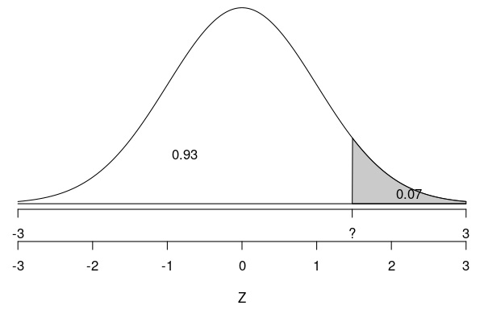
You should go to your -table and find the -score with the left area closest to 0.93.
It turns out the exact answer is , which could be found by using an inverse normal function. On a spreadsheet:
=Norm.Inv(0.93,0,1)
Using R:
rightarea = 0.07
leftarea = 1-rightarea
qnorm( leftarea )
But, the -table is accurate enough, so I will accept either 1.47 or 1.48 (anything within 0.01 of 1.475791).
You might find it helpful to visualize with a spinner.
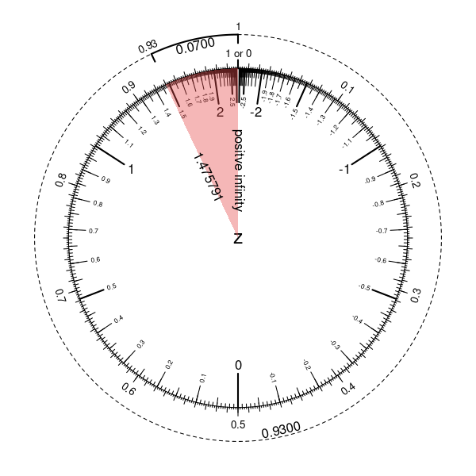
- Question
Determine such that . In other words, how far from 0 should boundaries be set such that 92% of standard normal values are between those boundaries? (Answers within 0.01 from the correct value will be marked correct.)
Solution
(ANS=1.7506861)
video
Start with a sketch.
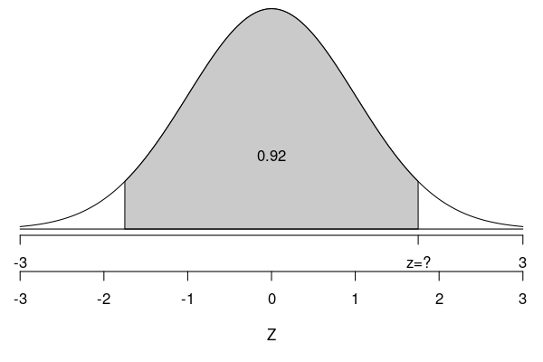
Method 1: Determine the area of each tail. Both tails have the same area, and all three areas add to 1. Thus,

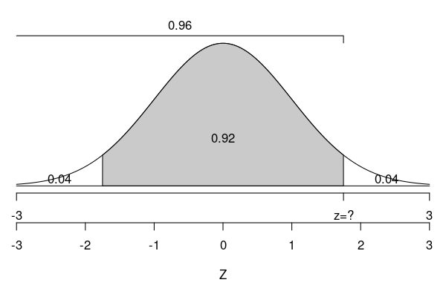

You should go to your -table and find the -score with the left area closest to 0.96.
It turns out the exact answer is , which could be found by using an inverse normal function. On a spreadsheet:
=Norm.Inv(0.96,0,1)
Using R:
centralarea = 0.92
leftarea = (1-centralarea)/2 + centralarea
qnorm( leftarea )
But, because we are using the -table, I will accept either 1.75 or 1.76. (Or, really anything within 0.01 of 1.7506861.)
Method 2: Another way to get 0.96 is by adding half of 0.92 to 0.5.

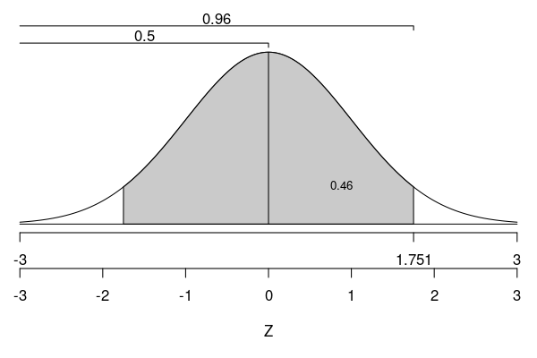
Then, use the table. Or, you could use R:
centralarea = 0.92
leftarea = 0.5 + centralarea/2
qnorm( leftarea )
It might be helpful to visualize with a spinner.
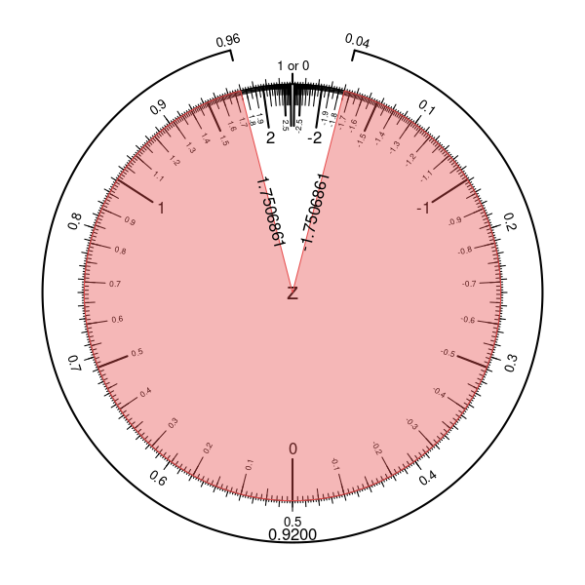
- Question
Determine such that . In other words, how far from 0 should boundaries be set such that 66% of standard normal values are outside those boundaries? (Answers within 0.01 from the correct value will be marked correct.)
Solution
(ANS=0.4399132)
video
Start with a sketch. The total two-tail area is 0.66, so each tail has half that area.
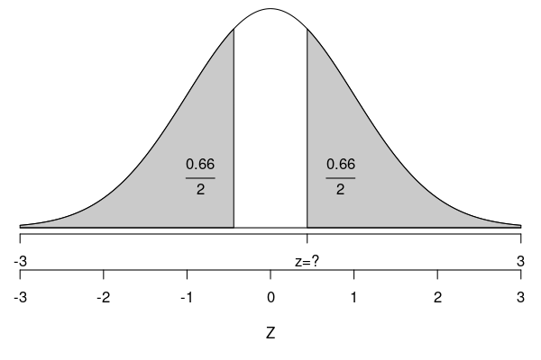
Method 1: Determine the area of each tail and the center. Both tails have the same area, and all three areas add to 1. Thus,

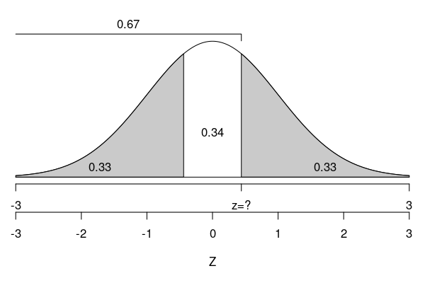
Find the left area.

You should go to your -table and find the -score with the left area closest to 0.67.
It turns out the exact answer is , which could be found by using an inverse normal function. On a spreadsheet:
=Norm.Inv(0.67,0,1)
Using R:
twotailarea = 0.66
onetailarea = twotailarea/2
centralarea = 1-twotailarea
leftarea = onetailarea + centralarea
qnorm( leftarea )
Method 2: Another way to get 0.67 is by subtracting half of 0.66 from 1.

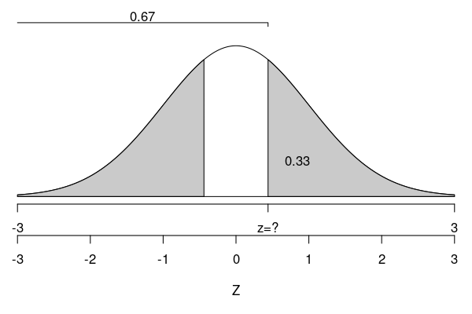
Then, use the table. Or, R:
twotailarea = 0.66
leftarea = 1 - twotailarea/2
qnorm( leftarea )
You might find a spinner visualization useful.
