- Question
A farm produces 4 types of fruit: grapefruits, kiwis, lemons, and apricots. The fruits’ masses follow normal distributions, with population parameters dependent on the type of fruit.
Type of fruit
, population mean mass in grams
, population standard deviation in grams
grapefruits
170
24
kiwis
57
4
lemons
118
11
apricots
46
6
One specimen of each type is weighed. The results are shown below.
Specimen type
, mass of specimen in grams
grapefruit
183.00
kiwi
63.40
lemon
127.90
apricot
44.92
The population parameters and specimen masses can be downloaded as a csv.
For each measurement, determine the standard score and the cumulative probability. Then determine which specimen is most unusually large, most unusually small, most typically sized, and most unusually sized.
  - ##ANSWER1##
  - ##ANSWER2##
  - ##ANSWER3##
  - ##ANSWER4##
  - ##ANSWER5##
  - ##ANSWER6##
  - ##ANSWER7##
  - ##ANSWER8##
  - Which specimen is the most unusually large? ##ANSWER9##
  - Which specimen is the most unusually small? ##ANSWER10##
  - Which specimen is most typically sized? ##ANSWER11##
  - Which specimen is most unusually sized? ##ANSWER12##
  - Calculate a score for the grapefruit specimen. (Round to the nearest hundredth.)
  - What proportion of grapefruits have less mass than the grapefruit specimen?
  - Calculate a score for the kiwi specimen. (Round to the nearest hundredth.)
  - What proportion of kiwis have less mass than the kiwi specimen?
  - Calculate a score for the lemon specimen. (Round to the nearest hundredth.)
  - What proportion of lemons have less mass than the lemon specimen?
  - Calculate a score for the apricot specimen. (Round to the nearest hundredth.)
  - What proportion of apricots have less mass than the apricot specimen?
  - The grapefruit specimen is most unusually large. / The kiwi specimen is most unusually large. / The lemon specimen is most unusually large. / The apricot specimen is most unusually large.
  - The grapefruit specimen is most unusually small. / The kiwi specimen is most unusually small. / The lemon specimen is most unusually small. / The apricot specimen is most unusually small.
  - The grapefruit specimen is most typically sized. / The kiwi specimen is most typically sized. / The lemon specimen is most typically sized. / The apricot specimen is most typically sized.
  - The grapefruit specimen is most unusually sized. / The kiwi specimen is most unusually sized. / The lemon specimen is most unusually sized. / The apricot specimen is most unusually sized.
Solution
video
The formula to determine the -score of a measurement is the ratio with numerator the difference between measurement and population mean and denominator the population standard deviation.

The highest -score (furthest right on number line) corresponds to the most unusually large measurement.
The smallest -score (furthest left on number line) corresponds to the most unusually small measurement.
The smallest absolute -score corresponds to the most usually sized measurement.
The largest absolute -score corresponds to the most unusually sized measurement.
  - We use the formula for calculating the grapefruit specimen’s score.

  - Use the table to find the cumulative probability

  - We use the formula for calculating the kiwi specimen’s score.

  - Use the table to find the cumulative probability

  - We use the formula for calculating the lemon specimen’s score.

  - Use the table to find the cumulative probability

  - We use the formula for calculating the apricot specimen’s score.

  - Use the table to find the cumulative probability

  - We determine the maximum score is , which belongs to the kiwi. / . / . / .
  - We determine the minimum score is , which belongs to the apricot. / . / . / .
  - We determine the minimum absolute score is , which belongs to the apricot. / . / . / .
  - We determine the maximum absolute score is , which belongs to the kiwi. / . / . / .
- Question
Random variable is normally distributed with mean and standard deviation .

Evaluate .
Solution
video (using z-table)
video (using app): the app
First, draw a sketch. We can label the axis by adding integer multiples of 20 to 390. We know to shade toward the left because small values of satisfy the condition .
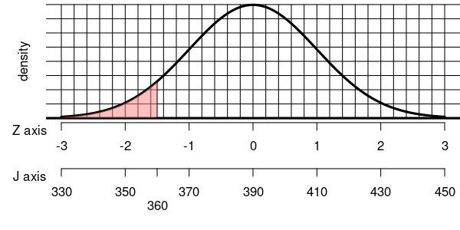
We are given a specific value as a boundary. (Remember, for random variables we use uppercase letters, but for specific values we use lowercase.)

We calculate the value of the boundary.

We have rephrased our problem into a standard normal probability problem, because

So, we just need to evaluate . To do this, you just need a -table.
Thus, we find our answer.

- Question
Random variable is normally distributed with mean and standard deviation .

Evaluate .
Solution
video (using z-table)
video (using app): the app
First, draw a sketch. We can label the axis by adding integer multiples of 6 to 69. We know to shade toward the right because large values of satisfy the condition .
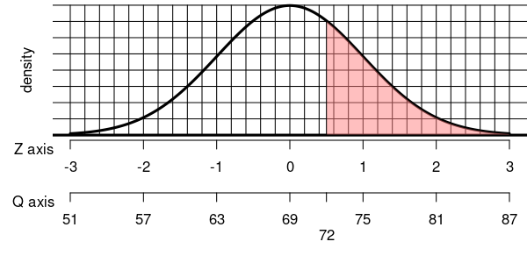
We are given a specific value as a boundary. (Remember, for random variables we use uppercase letters, but for specific values we use lowercase.)

We calculate the value of the boundary.

We have rephrased our problem into a standard normal probability problem, because

So, we just need to evaluate .
To do this, you need to remember that right-area events are complementary to left-area events.

You can use a -table.
Thus, we find our answer.

- Question
Random variable is normally distributed with mean and standard deviation .

Evaluate . In other words, what is the probability that is within units from the mean?
Solution
video (using z-table)
video (using app): the app
First, draw a sketch. We can label the axis by adding integer multiples of 50 to 190. We know to shade the center because values near 190 satisfy the condition . We draw the boundaries at and because those are the solutions to . We can also rephrase the probability.

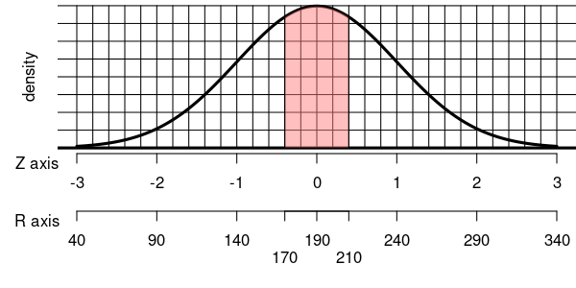
We calculate the values of the boundaries. Left boundary:

Right boundary:

We have rephrased our problem into a standard normal probability problem, because

So, we just need to evaluate . I will also point out that . In general, if is normally distributed, then:

From here we have a formula that lets us use the table. (We practiced this part before.)

- Question
Random variable is normally distributed with mean and standard deviation .

Evaluate . In other words, what is the probability that is outside units from the mean?
Solution
video (using z-table)
video (using app): the app
First, draw a sketch. We can label the axis by adding integer multiples of 5 to 69. We know to shade the two tails because values far from 69 satisfy the condition . We draw the boundaries at and because those are the solutions to . We can also rephrase the probability.

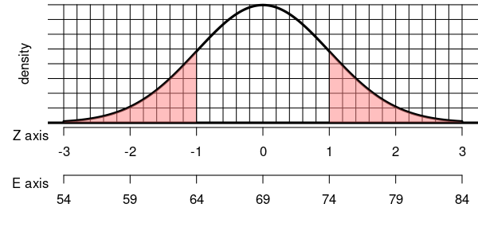
We calculate the values of the boundaries. Left boundary:

Right boundary:

We have rephrased our problem into a standard normal probability problem, because

So, we just need to evaluate . I will also point out that . In general, if is normally distributed, then:

From here we have a formula that lets us use the table. (We practiced this part before.)

- Question
Random variable is normally distributed with mean and standard deviation .

Evaluate . In other words, what is the probability that is between and ?
Solution
video (using z-table)
video (using app): the app
First, draw a sketch. We can label the axis by adding integer multiples of 2 to 27. We know to shade the between and because those values satisfy the condition .
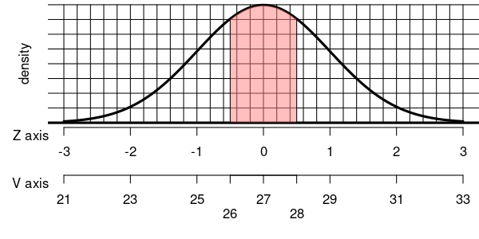
We calculate the values of the boundaries. Left boundary:

Right boundary:

We rephrase our problem into a standard normal probability problem:

So, we just need to evaluate .
From here we have a formula that lets us use the table. (We practiced this part before.)

- Question
Random variable is normally distributed with mean and standard deviation .

Evaluate such that . In other words, determine an upper boundary such that a normal spinner with mean 70 and standard deviation 20 lands below that boundary 83% of the time.
Solution
video (using z-table)
video (using app): the app
First, draw a sketch. We can label the axis by adding integer multiples of 20 to 70. We know to shade the left because low values of satisfy the condition (regardless of the exact value of ). We don’t know exactly where to place the boundary, but we know the left area is 0.83.
It is helpful to know the following approximations:
So, we know the -score is between 0 and 1. Remember, and always refer to the standard normal variable.
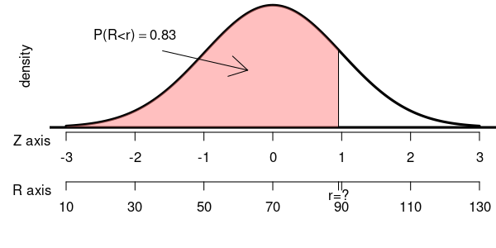
By using the table we can determine more precisely.
Either 0.95 or 0.96 is a good estimation of , and either value will lead you to an acceptable answer. Using other tools, a more accurate value can be found. I will show the work with a more accurate value.

We now convert the score into a score.

We can also visualize this with a spinner.
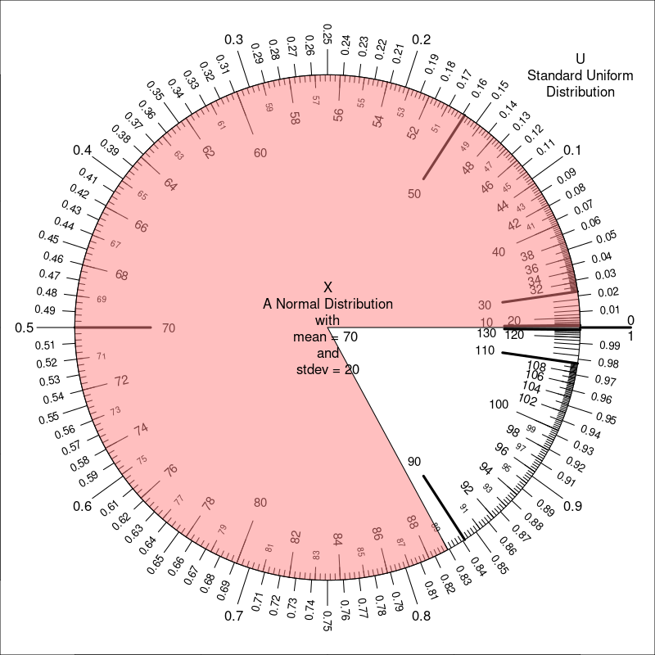
The tolerance for an acceptable answer was from 89.0833051. So, anything between 88.0833051 and 90.0833051 was accepted.
- Question
Random variable is normally distributed with mean and standard deviation .

Evaluate such that . In other words, determine an lower boundary such that a normal spinner with mean 66 and standard deviation 20 lands over that boundary 32% of the time.
Solution
video (using z-table)
video (using app): the app
First, draw a sketch. We can label the axis by adding integer multiples of 20 to 66. We know to shade the right because high values of satisfy the condition (regardless of the exact value of ). We don’t know exactly where to place the boundary, but we know the right area is 0.32.
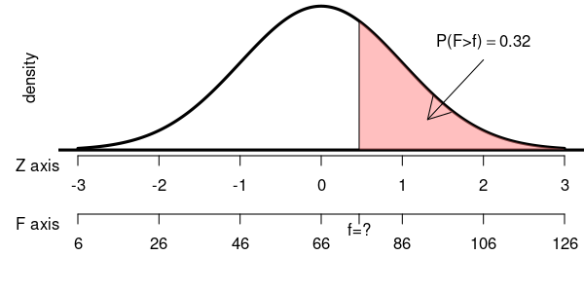
We know how to find the left area.

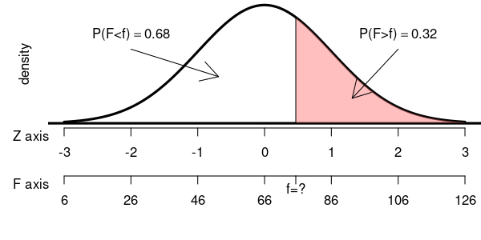
As an intermediate step, we find such that .
By using the table we can determine .
Either 0.46 or 0.47 is a good estimation of , and either value will lead you to an acceptable answer. Using other tools, a more accurate value can be found. I will show the work with a more accurate value.

We now convert the score into a score.

We can also visualize this with a spinner.
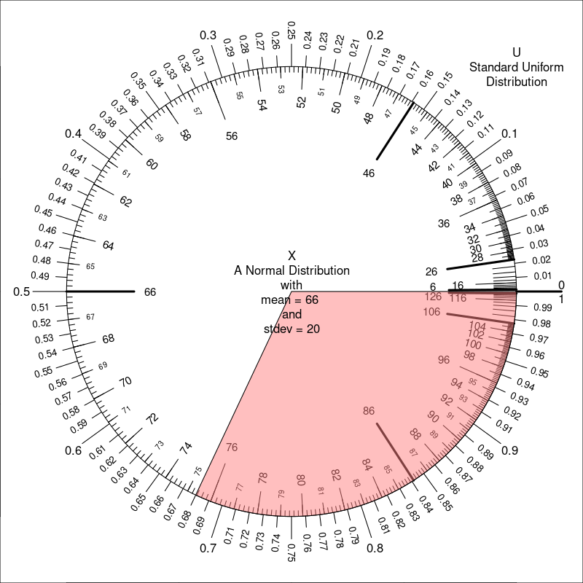
The tolerance for an acceptable answer was from 75.353976. So, anything between 74.353976 and 76.353976 was accepted.
- Question
Random variable is normally distributed with mean and standard deviation .

  - Evaluate such that . In other words, determine the distance from mean of two boundaries such that this normal spinner lands between those boundaries 56% of the time.
  - Let and , such that . Evaluate .
  - Using the definitions above, evaluate
Solution
video (using z-table)
video (using app): the app
First, draw a sketch. We can label the axis by adding integer multiples of 0.5 to 2.6. We know to shade the the middle because values near 2.6 satisfy the condition (regardless of the exact value of ). We don’t know exactly where to place the boundaries, but we know the central area is 0.56.
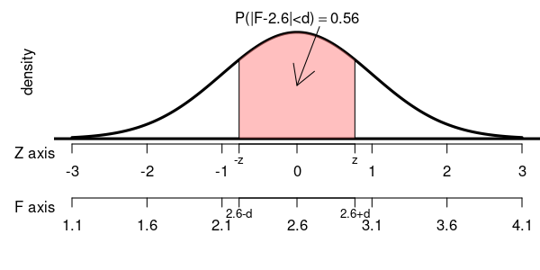
As an intermediate step, let’s find such that . First, we need to evaluate .

You could have also drawn some pictures… we know there is symmetry and all the areas should add to 1.
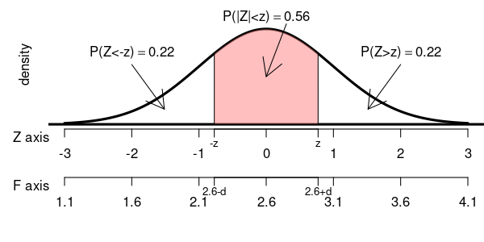
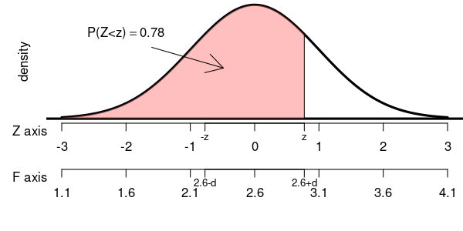
We find such that .
By using the table we can determine .
Either 0.77 or 0.78 is a good estimation of , and either value will lead you to an acceptable answer. Using other tools, a more accurate value can be found. I will show the work with a more accurate value.

We now convert the score into a score.

We can also visualize this with a spinner.
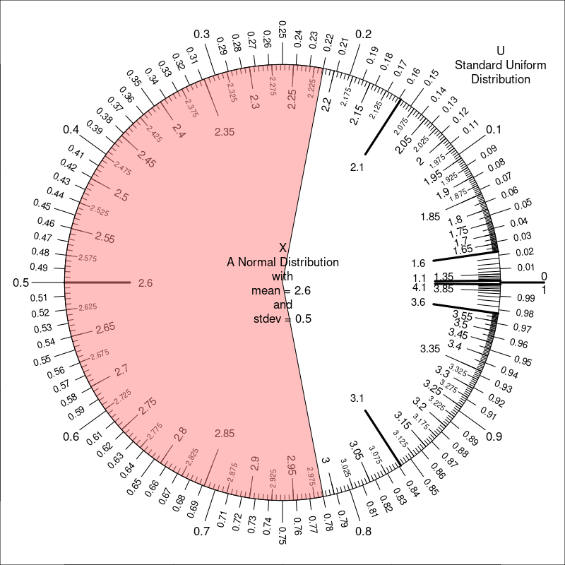
  - We determined
  - It is easy to find
  - It is easy to find
- Question
Random variable is normally distributed with mean and standard deviation .

  - Evaluate such that . In other words, determine the distance from mean of two boundaries such that this normal spinner lands outside those boundaries 24% of the time.
  - Let , such that . Evaluate .
  - Let , such that . Evaluate .
Solution
video (using z-table)
video (using app): the app
First, draw a sketch. We can label the axis by adding integer multiples of 5 to 24. We know to shade the the outsides because values far from 24 satisfy the condition (regardless of the exact value of ). We don’t know exactly where to place the boundaries, but we know the two-tail area is 0.24.
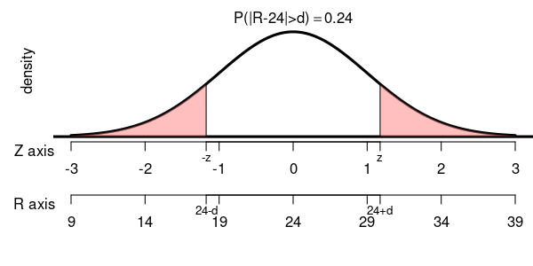
As an intermediate step, let’s find such that . First, we need to evaluate .

You could have also drawn some pictures… we know there is symmetry and all the areas should add to 1.
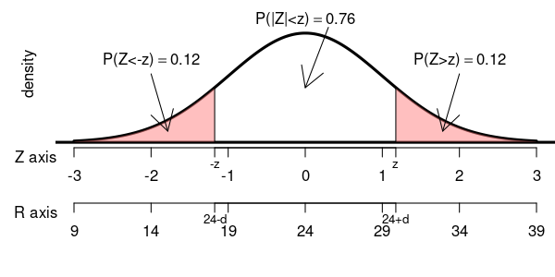
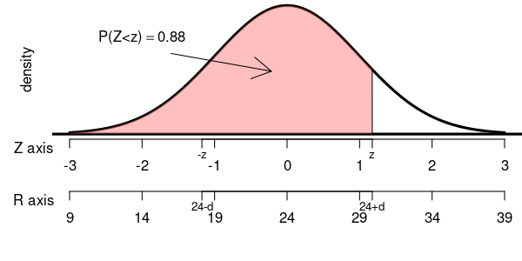
We find such that .
By using the table we can determine .
Either 1.17 or 1.18 is a good estimation of , and either value will lead you to an acceptable answer. Using other tools, a more accurate value can be found. I will show the work with a more accurate value.

We now convert the score into a score.

We can also visualize this with a spinner.
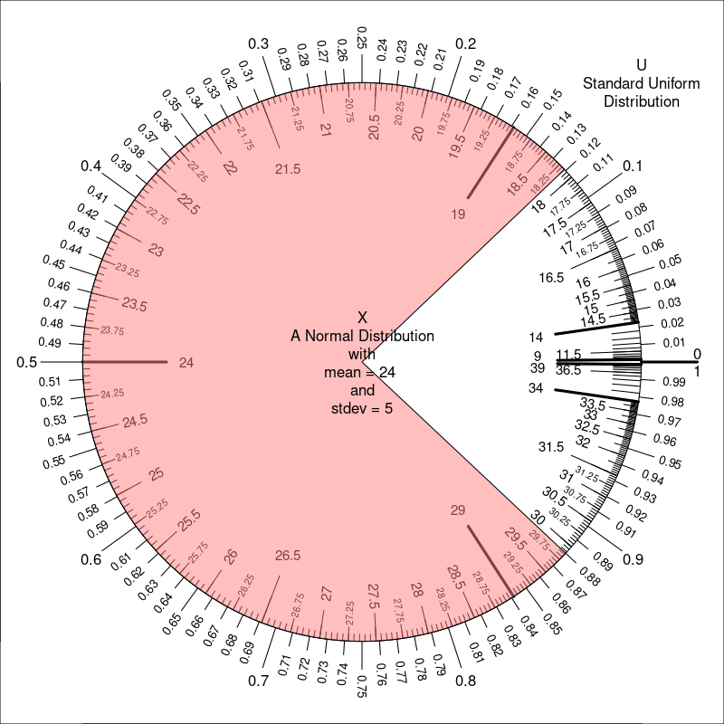
  - We determined
  - It is easy to find
  - It is easy to find

