- Question
The following questions use to refer to the standard normal variable. You will determine some probabilities and some boundaries.
  - Determine such that
  - Determine
  - Determine such that
  - Determine
  - Determine
Solution
video
To do this problem, you should practice the Standard Normal exercises.
  - 1.15
  - 0.6026
  - -1.74
  - 0.766
  - 0.6879
- Question
Let random variable be normally distributed with mean and standard deviation .
  - Determine
  - Determine such that
  - Determine
  - Determine
  - Determine such that
Solution
video
  - Identify the boundary.

Get the z score.

With -table, determine
  - Determine such that .

Calculate the boundary .

  - Identify the boundary.

Get the z score.

With -table, determine
  - Identify the boundaries.

Get the z scores.

With -table, determine
  - Determine such that .

Calculate the boundary .

- Question

Population
Random variable has mean and standard deviation .

Interval of typical measurements
Let the interval of typical measurements be defined as having lower bound and upper bound .

##ANSWER1##
##ANSWER2##

Interval of typical totals
Let the interval of typical totals be defined as having lower bound and upper bound .

For the listed values of , determine the bounds.

lower bound of typical totals
upper bound of typical totals
25
##ANSWER3##
##ANSWER4##
100
##ANSWER5##
##ANSWER6##
400
##ANSWER7##
##ANSWER8##

Interval of typical averages
Let the interval of typical averages be defined as having lower bound and upper bound .

For the listed values of , determine the bounds.

lower bound of typical averages
upper bound of typical averages
25
##ANSWER9##
##ANSWER10##
100
##ANSWER11##
##ANSWER12##
400
##ANSWER13##
##ANSWER14##
  - Calculate the lower bound of the interval of typical measurements.
  - Calculate the upper bound of the interval of typical measurements.
  - .
  - .
  - .
  - .
  - .
  - .
  - .
  - .
  - .
  - .
  - .
  - .
Solution
video

Interval of typical measurements

Interval of typical totals

lower bound of typical totals
upper bound of typical totals
25
1410
1590
100
5820
6180
400
23640
24360

Interval of typical averages

lower bound of typical averages
upper bound of typical averages
25
56.4
63.6
100
58.2
61.8
400
59.1
60.9
- Question

Population
Random variable follows a Bernoulli distribution with . In this context, each spin is often called a trial. A “0” is a “fail” and a “1” is a “success”.
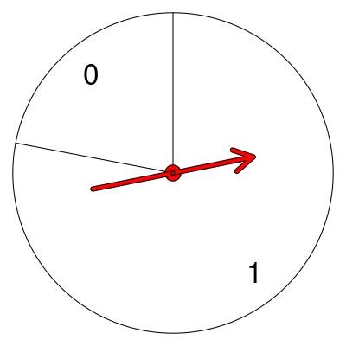
The average of a Bernoulli random variable is equal to .

##ANSWER1##
The standard deviation of a Bernoulli random variable is equal to .

##ANSWER2## (Round to thousandths place.)

Interval of typical success totals
The binomial distribution predicts how many successes there will be for a given number of trials. Let the interval of typical successes be defined as having lower bound and upper bound .

For the listed values of , determine the bounds. (Round to nearest integer.)

lower bound of typical success count
upper bound of typical success count
25
##ANSWER3##
##ANSWER4##
100
##ANSWER5##
##ANSWER6##
400
##ANSWER7##
##ANSWER8##

Interval of typical proportions
Let the interval of typical proportions be defined as having lower bound and upper bound .

For the listed values of , determine the bounds. (Round to nearest hundredth.)

lower bound of typical proportions
upper bound of typical proportions
25
##ANSWER9##
##ANSWER10##
100
##ANSWER11##
##ANSWER12##
400
##ANSWER13##
##ANSWER14##
  - Determine .
  - Determine .
  - .
  - .
  - .
  - .
  - .
  - .
  - .
  - .
  - .
  - .
  - .
  - .
Solution
video

Bernoulli

Interval of typical successes

lower bound of typical success counts
upper bound of typical success counts
25
15
24
100
70
86
400
295
329

Interval of typical proportions

lower bound of typical proportions
upper bound of typical proportions
25
0.6143015
0.9456985
100
0.6971507
0.8628493
400
0.7385754
0.8214246
- Question
A farm produces 4 types of fruit: oranges, pineapples, mangos, and persimmons. The fruits’ masses have population parameters dependent on the type of fruit. (All values are in grams.)
Type of fruit
, population mean mass in grams
, population standard deviation in grams
oranges
181
10
pineapples
1497
145
mangos
246
13
persimmons
153
9
A sample of each type is weighed. The results are shown below.
Type of fruit
, sample size
, sample mean
orange
49
182.7
pineapple
121
1489.0
mango
36
245.0
persimmon
144
152.2
The population parameters and sample statistics can be downloaded as a csv.
For each sample, determine the mean’s standard score and the mean’s cumulative probability by assuming the requirements for the central limit theorem are met. Then determine which sample mean is most unusually large, most unusually small, most typically sized, and most unusually sized.
The standard score of a sample mean:

Some people prefer to call this denominator the standard error.

So the standard score (-score) of a sample mean can also be expressed as

  - ##ANSWER1##
  - ##ANSWER2##
  - ##ANSWER3##
  - ##ANSWER4##
  - ##ANSWER5##
  - ##ANSWER6##
  - ##ANSWER7##
  - ##ANSWER8##
  - Which sample mean is most unusually large? ##ANSWER9##
  - Which sample mean is most unusually small? ##ANSWER10##
  - Which sample mean is most typically sized? ##ANSWER11##
  - Which sample mean is most unusually sized? ##ANSWER12##
  - Calculate a -score for the orange sample mean. (Round to the nearest hundredth.)
  - What proportion of orange samples of size have a smaller mean than the orange sample?
  - Calculate a -score for the pineapple sample mean. (Round to the nearest hundredth.)
  - What proportion of pineapple samples of size have a smaller mean than the pineapple sample?
  - Calculate a -score for the mango sample mean. (Round to the nearest hundredth.)
  - What proportion of mango samples of size have a smaller mean than the mango sample?
  - Calculate a -score for the persimmon sample mean. (Round to the nearest hundredth.)
  - What proportion of persimmon samples of size have a smaller mean than the persimmon sample?
  - The orange sample mean is most unusually large. / The pineapple sample mean is most unusually large. / The mango sample mean is most unusually large. / The persimmon sample mean is most unusually large.
  - The orange sample mean is most unusually small. / The pineapple sample mean is most unusually small. / The mango sample mean is most unusually small. / The persimmon sample mean is most unusually small.
  - The orange sample mean is most typically sized. / The pineapple sample mean is most typically sized. / The mango sample mean is most typically sized. / The persimmon sample mean is most typically sized.
  - The orange sample mean is most unusually sized. / The pineapple sample mean is most unusually sized. / The mango sample mean is most unusually sized. / The persimmon sample mean is most unusually sized.
Solution
video
The formula to determine the -score of a sample mean is the ratio with numerator the difference between measurement and population mean and denominator the standard error of the mean.

The highest -score (furthest right on number line) corresponds to the most unusually large sample mean.
The smallest -score (furthest left on number line) corresponds to the most unusually small sample mean.
The smallest absolute -score corresponds to the most usually sized sample mean.
The largest absolute -score corresponds to the most unusually sized sample mean.

Spreadsheet:
By using the formulas, you should get a spreadsheet like the one displayed here:
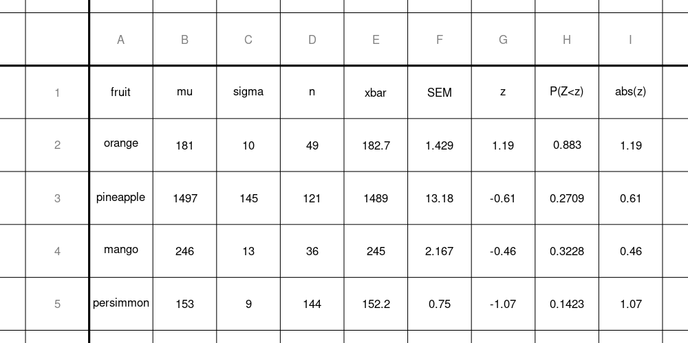

To do this in R:
data = read.csv("fruit.csv", as.is=TRUE)
fruit = data$fruit
mu = data$mu
sigma = data$sigma
n = data$n
xbar = data$xbar

SEM = sigma/sqrt(n)
z = round( (xbar-mu)/SEM ,2)
cum_prob = round( pnorm(z) ,4)
data.frame(data,SEM,z,cum_prob,abs(z))
## fruit mu sigma n xbar SEM z
## 1 orange 181 10 49 182.7 1.428571 1.19
## 2 pineapple 1497 145 121 1489.0 13.181818 -0.61
## 3 mango 246 13 36 245.0 2.166667 -0.46
## 4 persimmon 153 9 144 152.2 0.750000 -1.07
## cum_prob abs.z.
## 1 0.8830 1.19
## 2 0.2709 0.61
## 3 0.3228 0.46
## 4 0.1423 1.07
# Most unusually large
fruit[z==max(z)]
## [1] "orange"
# Most unusually small
fruit[z==min(z)]
## [1] "persimmon"
# Most typically sized
fruit[abs(z)==min(abs(z))]
## [1] "mango"
# Most unusually sized
fruit[abs(z)==max(abs(z))]
## [1] "orange"
  - We use the formula for calculating the orange sample-mean score.

  - Use the table to find the cumulative probability.

  - We use the formula for calculating the pineapple sample-mean score.

  - Use the table to find the cumulative probability.

  - We use the formula for calculating the mango sample-mean score.

  - Use the table to find the cumulative probability.

  - We use the formula for calculating the persimmon sample-mean score.

  - Use the table to find the cumulative probability.

  - We determine the maximum score is , which belongs to the orange. / . / . / .
  - We determine the minimum score is , which belongs to the persimmon. / . / . / .
  - We determine the minimum absolute score is , which belongs to the mango. / . / . / .
  - We determine the maximum absolute score is , which belongs to the orange. / . / . / .
- Question
This question provides , , , and . You will characterize the sampling distribution, calculate the standard score, determine the percentile rank (expressed as a decimal), and translate the score into a rating (see below).

Population
When Archie practices archery, each arrow has the same probability distribution (see i.i.d). This means her skill is constant, there is no hot-hand effect, and there is no maturity of chances.
Over many months, Archie has shot ten thousand arrows (their positions are shown below as dots).
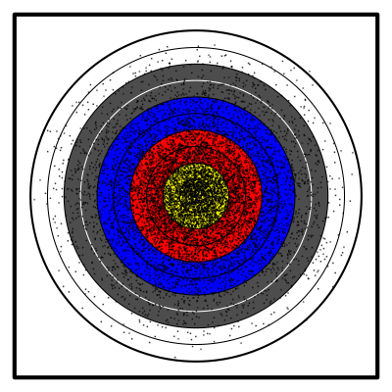
From those many arrows, Archie has determined an accurate probability distribution (of the points scored by an arrow).
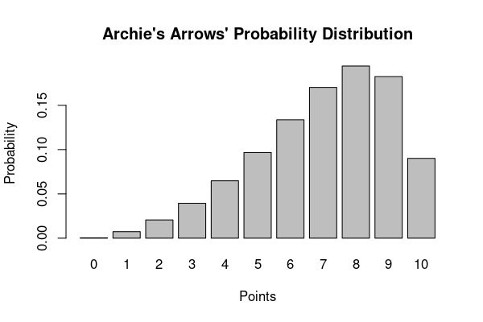
Thus, Archie can determine her population mean and population standard deviation.

Sampling distribution
Each day, Archie shoots 48 arrows () and determines that day’s total score. A total of 480 would be a perfect day. We can treat each day’s total as a random variable with its own probability distribution: a sampling distribution. We wish to characterize this sampling distribution. From the central limit theorem, we know the sampling distribution is approximately normal; however, we need to calculate the parameters.

Expected total (mean of sampling distribution)
The expected total is the product of the sample size and the population mean.

“Expected total” is a misnomer. It is not necessarily likely, or even possible, for a total to equal the expected total. However, if Archie repeatedly shot 48 arrows, we expect the totals to have a mean equal to the expected total. So, maybe “average of totals” would be better terminology.
This expected total is the average of the sampling distribution.
##ANSWER1##
(Round to the hundredths place)

Standard error (standard deviation of sampling distribution)
The standard error of a total is the product of the population standard deviation and the square root of the sample size.

This standard error is the standard deviation of the sampling distribution.
##ANSWER2##
(Round to the hundredths place)

Sample
Today, Archie’s total score is 349 points ().
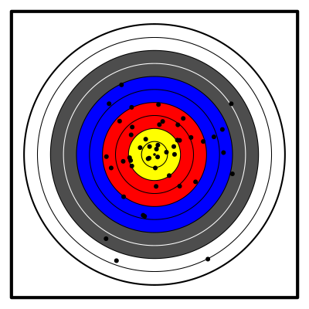

Standard score
Archie would like to know how well she did today. She wants you to calculate a standard score (a score). To calculate the standard score of a sample total, you can use the following formula.

##ANSWER3##
(Round to the hundredths place)

Cumulative probability (percentile rank)
Archie would like to know the probability that tomorrow she shoots worse than today. To estimate this, report the cumulative probability associated with the standard score you calculated. This can be done with a table, pnorm function in R, NORM.DIST function in a spreadsheet, or with other standard normal tools.
##ANSWER4##
(Round to the ten-thousandths place)

Rating
Archie would like a rating for her day’s performance. You decide to use the following scale and that if is on a boundary, Archie will be given the higher rating.
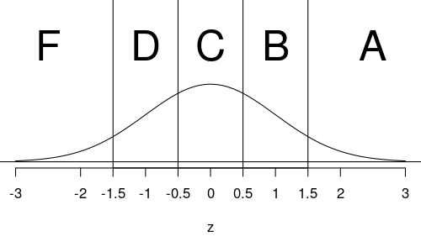
Determine Archie’s rating: ##ANSWER5##
  - Calculate the expected total:
  - Calculate the standard error:
  - Calculate the standard score:
  - Calculate , the cumulative probability:
  - A / B / C / D / F
Solution
video
The sampling distribution is approximately normal with mean 336 and standard error 14.34. The sampling distribution can be visualized, along with today’s total (349) highlighted in red. The cumulative probability is the sum of the probabilities of scores less than (or equal) 349. Thus, the area highlighted in blue represents the cumulative probability.
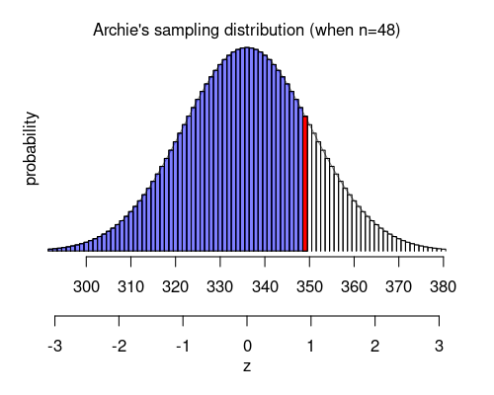
  - The expected total is
  - The standard error is
  - Use the formula to calculate
  - Use the table to find
  - The proper rating is B / The proper rating is B / The proper rating is B / The proper rating is B / The proper rating is B
- Question
Random variable is normally distributed with mean and standard deviation .

  - If , determine
  - If , determine
  - If , determine
  - Determine
  - If , determine
  - Determine
Solution
video
video (with app)
app
  - Identify the boundary.

Calculate the standard error (of mean)

Get the z score.

With -table, determine
  - Identify the boundary.

Calculate the standard error (of total)

Get the z score.

With -table, determine
  - Identify the boundary.

Calculate the standard error (of mean)

Get the z score.

With -table, determine
  - Identify the boundary.

Get the z score.

With -table, determine
  - Identify the boundary.

Calculate the standard error (of total)

Get the z score.

With -table, determine
  - Identify the boundary.

Get the z score.

With -table, determine
- Question
In some game, each trial has chance of success. In other words, is a random Bernoulli variable with parameter . To determine the following probabilities, use the de Moivre–Laplace theorem (normal approximation). I have already done the continuity correction by setting the boundaries.
  - If , what is the chance the number of successes is less than 22.5? In other words, if , determine
  - If , what is the probability that the sample proportion () is more than 0.3889? In other words, if , determine .In other words, if , determine .
  - If , what is the probability that the sample proportion () is less than 0.505? In other words, if , determine .In other words, if , determine .
  - If , what is the chance the number of successes is more than 15.5? In other words, if , determine
Solution
video
video (with spreadsheet)
video (with app… sorry, the video starts with previous question)
app
You could first determine the mean and standard deviation of the Bernoulli variable .

  - Identify the boundary.

Calculate the standard error (of total)

Get the z score.

With -table, determine
  - Identify the boundary.

Calculate the standard error (of proportion sampling)

Get the z score.

With -table, determine
  - Identify the boundary.

Calculate the standard error (of proportion sampling)

Get the z score.

With -table, determine
  - Identify the boundary.

Calculate the standard error (of total)

Get the z score.

With -table, determine

