- Question
A scientist has weighed 111 specimens of a newly discovered organism. Those weights have a sample mean of grams and a sample standard deviation of grams. The scientist hopes to construct a 95% confidence interval of the organism’s population mean ().
The scientist will later consult a statistician for a more precise method, but for now she will use a quick method to estimate the 95% confidence interval:

(You can round to nearest 0.1 grams.)
  - Determine the lower boundary of the confidence interval by using .
  - Determine the upper boundary of the confidence interval by using .
Solution
video
Plug the numbers into the expressions.
  - Lower bound =
  - Upper bound =
- Question
A scientist has grown 128 specimens under novel conditions and found that 40.62% of them survived (in other words ). The scientist hopes to construct a 95% confidence interval of the survival rate.
The scientist will later consult a statistician for a more precise method, but for now she will use a quick method to estimate the 95% confidence interval:

(You can round answers to the nearest thousandth.)
  - Determine the lower boundary of the confidence interval by using .
  - Determine the upper boundary of the confidence interval by using .
Solution
video
Plug the numbers into the expressions.
  - Lower bound =
  - Upper bound =
- Question
In trials, there were successes, so the sample proportion is . You are tasked with determining the confidence interval (of the population proportion) with confidence level .
To do this, you first determine such that . Then, evaluate to determine the boundaries of the confidence interval.
(You can round answers to the hundredths place.)
  - Determine the lower boundary of the confidence interval by using .
  - Determine the upper boundary of the confidence interval by using .
Solution
video
First, determine such that . It can help to draw a sketch.
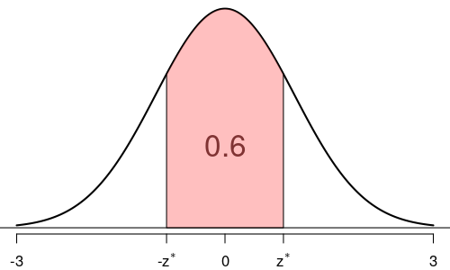
The entire area under the density curve is 1. Thus, we can determine the areas of the tails (using symmetry).

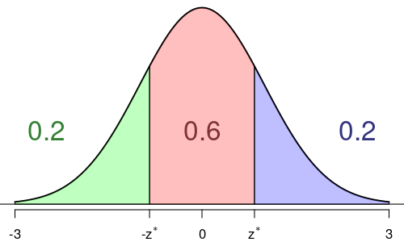
Determine a leftward area with boundary .

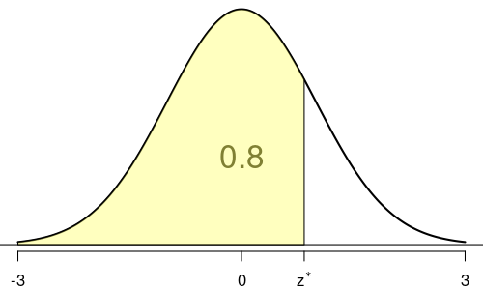
We rephrase the puzzle. We wish to determine such that . This is easy to determine using a -table, qnorm in R, norm.inv in spreadsheets, or other methods for evaluating the quantile function.
## Using R's qnorm:
qnorm(0.8)
## [1] 0.8416212

In the original phrasing,

So, . Now, use the given expressions to evaluate the boundaries.
  - Lower bound =
  - Upper bound =
- Question
A population’s mean () is unknown, but its standard deviation is known: . A sample of size is taken, and the sample mean is calculated: . You are tasked with determining a confidence interval using a given confidence level: .
To do this, you need to first determine such that . Then, the boundaries are determined by evaluating .
(You can round to the nearest hundredth and the boundaries to the nearest tenth.)
  - Determine the lower boundary of the confidence interval by using .
  - Determine the upper boundary of the confidence interval by using .
Solution
video
First, determine such that . It can help to draw a sketch.
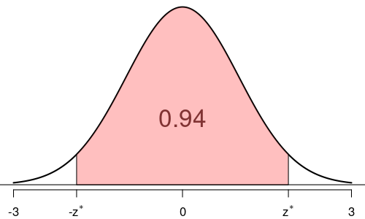
The entire area under the density curve is 1. Thus, we can determine the areas of the tails (using symmetry).

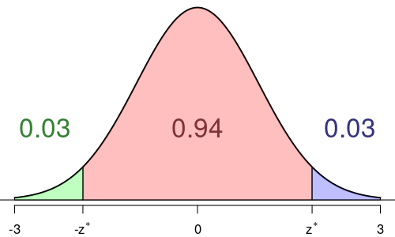
Determine a leftward area with boundary .

It should be mentioned the expression can be simplified.

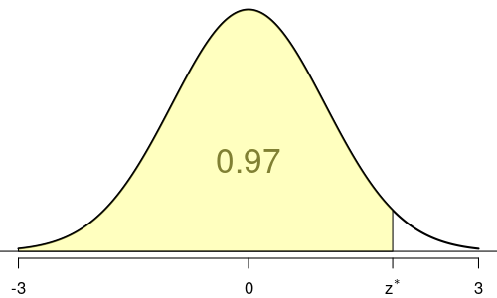
We rephrase the puzzle. We wish to determine such that . This is easy to determine using a -table, qnorm in R, norm.inv in spreadsheets, or other methods for evaluating the quantile function.

In the original phrasing,

So, . Now, use the given expressions.

Spreadsheet
A spreadsheet can use the confidence.norm function. It takes three arguments:
  - Alpha () is the two-tail area,
  - Population standard deviation,
  - Sample size,
The function returns the margin of error.

So, in this case, if in a spreadsheet you typed =confidence.norm(1-0.94,5.7,287), the result would be the margin of error, 0.6328125. You then add/subtract the margin of error to/from the sample mean.

You can do this with a spreadsheet.
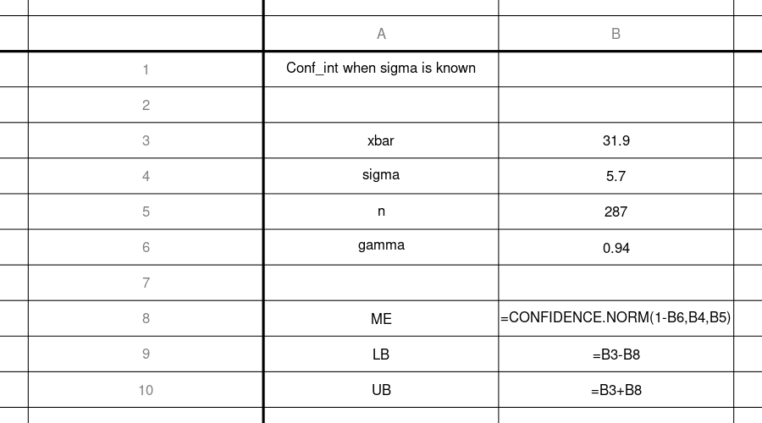

R
xbar = 31.9
sigma = 5.7
n = 287
gamma = 0.94
zstar = qnorm(gamma+(1-gamma)/2)
ME = zstar*sigma/sqrt(n)
LB = xbar-ME
UB = xbar+ME
cat(sprintf("The lower bound: %.4f\nThe upper bound: %.4f",LB,UB))
## The lower bound: 31.2672
## The upper bound: 32.5328
  - Lower bound =
  - Upper bound =
- Question
A population’s mean () and standard deviation () are unknown, but the population is approximately normal. A sample of size is taken, and the sample mean is calculated: . The sample standard deviation is also calculated: . You are tasked with determining a confidence interval using a given confidence level: .
To do this, you need to first determine such that . Then, the boundaries are determined by evaluating .
(You can round to the nearest hundredth and the boundaries to the nearest tenth.)
  - Determine the lower boundary of the confidence interval by using .
  - Determine the upper boundary of the confidence interval by using .
Solution
video
First, determine such that . It can help to draw a sketch.
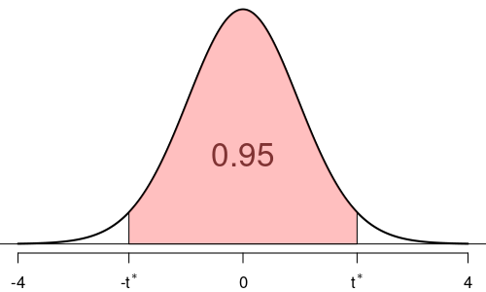
The entire area under the density curve is 1. Thus, we can determine the areas of the tails (using symmetry).

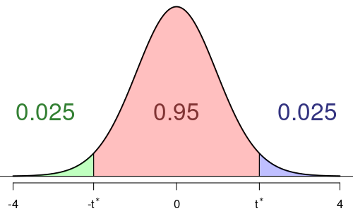
Thus, we determine a left area.

It should be mentioned the expression can be simplified.

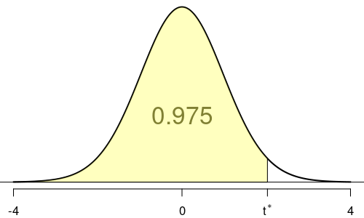
We rephrase the puzzle. We wish to determine such that . This is easy to determine using a -table, qt in R, t.inv in spreadsheets, or other methods for evaluating the quantile function.
Because , then .

In the original phrasing,

So, . Now, use the given expressions.

Spreadsheet
A spreadsheet can use the confidence.t function. It takes three arguments:
  - Alpha () is the two-tail area,
  - sample standard deviation,
  - Sample size,
The function returns the margin of error.

So, in this case, if in a spreadsheet you typed =confidence.t(1-0.95,10.8,37), the result would be the margin of error, 3.6008993. You then add/subtract the margin of error to/from the sample mean.

You can do this with a spreadsheet.
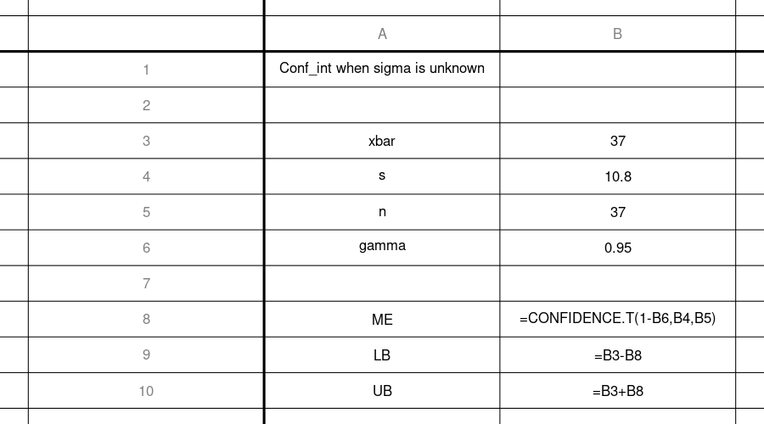

R
xbar = 37
s = 10.8
n = 37
gamma = 0.95
df = n-1 # df is the degrees of freedom
tstar = qt(0.5+gamma/2, df)
ME = tstar*s/sqrt(n)
LB = xbar-ME
UB = xbar+ME
cat(sprintf("The lower bound: %.4f\nThe upper bound: %.4f",LB,UB))
## The lower bound: 33.3991
## The upper bound: 40.6009
  - Lower bound =
  - Upper bound =
- Question
A sample was taken from a population. The measurements are shown below and can be downloaded as a csv.
814, 760, 724, 749, 728, 790, 783, 694, 815, 734, 838, 711, 823, 758, 751, 841, 733, 758, 788, 693, 757, 750, 762, 811, 723, 807, 743, 740, 753, 782, 697, 766, 761, 763, 752, 738, 765
You are tasked with determining the confidence interval (of the population mean) with the confidence level of .
  - Determine , the sample size.
  - Determine , the sample mean.
  - Determine , the sample standard deviation (with Bessel correction).
  - Calculate , the estimated standard error.
  - Determine such that . Remember, .
  - Calculate , the estimated margin of error.
  - Calculate , the lower boundary of the 99% confidence interval.
  - Calculate , the upper boundary of the 99% confidence interval.
Solution
video

Spreadsheet
You can download a solution spreadsheet. The top 13 rows are shown below:
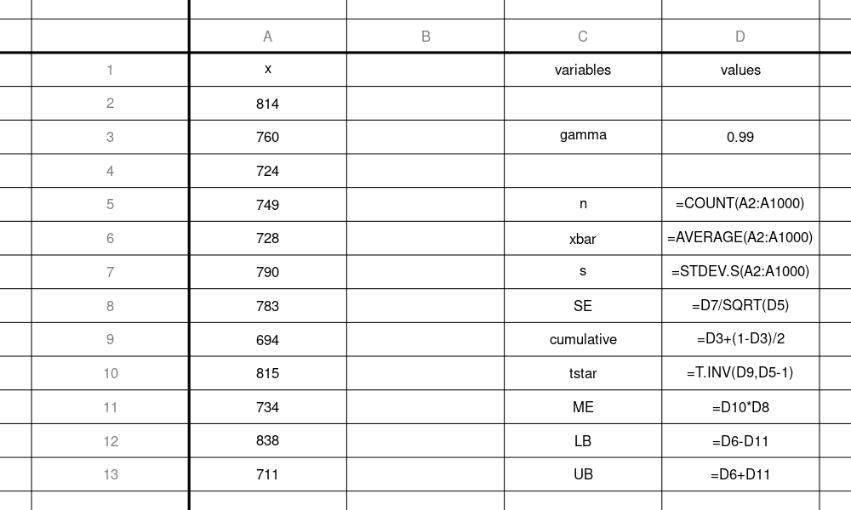

R
x = c(814, 760, 724, 749, 728, 790, 783, 694, 815, 734, 838, 711, 823, 758, 751, 841, 733, 758, 788, 693, 757, 750, 762, 811, 723, 807, 743, 740, 753, 782, 697, 766, 761, 763, 752, 738, 765)
n = length(x)
xbar = mean(x)
s = sd(x)
SE = s/sqrt(n)
gamma = 0.99 # Probability T is between -tstar and tstar
cumulative = gamma+(1-gamma)/2 # Probability T is less than tstar
tstar = qt(cumulative, n-1)
ME = tstar*s/sqrt(n)
LB = xbar-ME
UB = xbar+ME
print(data.frame(n,xbar,s,SE,tstar,ME,LB,UB,row.names=""))
n xbar s SE tstar ME LB
37 760.9459 38.01239 6.249198 2.719485 16.9946 743.9513
UB
777.9405
  - The sample size .
  - The sample mean .
  - The sample standard deviation .
  - The estimated standard error .
  - You can show, when , then , and , so the boundary .
  - The estimated margin of error .
  - The lower boundary of the confidence interval .
  - The upper boundary of the confidence interval .
- Question
When Archie shoots archery, she records the horizontal position () and vertical position () of every arrow (in millimeters), using the bullseye as the origin.
From years of shooting, Archie has determined that and are roughly bell-shaped with population standard deviations and mm. However, Archie has a new sight, so her current population means ( and ) are unknown. (She hopes both are zero.)
Archie wants to get confidence intervals for and , using a sample size and a confidence level . Whether or not a confidence interval straddles 0 will determine whether Archie adjusts that aspect of her sight.

Critical value
##ANSWER1##

Margins of error.
The margin of error represents how much variation we expect in sample means.

##ANSWER2##
##ANSWER3##

Sample
Archie shoots arrows.
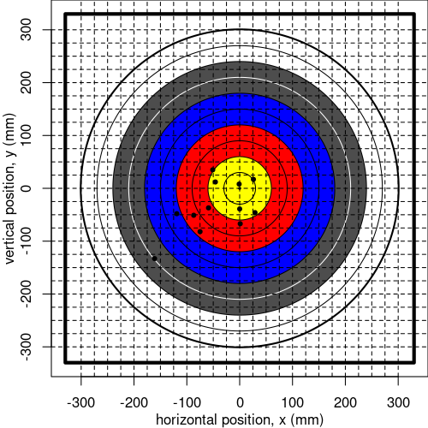
The exact positions can be downloaded as a csv.

Sample means
##ANSWER4##
##ANSWER5##

Confidence intervals
Calculate the 96% confidence interval of by using .
##ANSWER6##
##ANSWER7##
Calculate the 96% confidence interval of by using .
##ANSWER8##
##ANSWER9##

Inference
If a confidence interval straddles 0, Archie will leave that aspect alone. If a confidence interval does not straddle 0, Archie will adjust that aspect on the sight.
Does Archie adjust the horizontal aspect of her sight? ##ANSWER10##
Does Archie adjust the vertical aspect of her sight? ##ANSWER11##
  - Determine the boundary such that :
  - Calculate , the margin of error when sampling :
  - Calculate , the margin of error for sampling :
  - Calculate , the horizontal sample mean:
  - Calculate , the vertical sample mean:
  - Calculate the lower boundary:
  - Calculate the upper boundary:
  - Calculate the lower boundary:
  - Calculate the upper boundary:
  - Yes / No
  - Yes / No
Solution
video
  - 2.05
  - 27.3
  - 21.9
  - -45.2
  - -35.9
  - -72.5
  - -18
  - -57.9
  - -14
  - The confidence interval of does not contain 0. So Archie does adjust the horizontal aspect of her sight. / .
  - The confidence interval of does not contain 0. So Archie does adjust the vertical aspect of her sight. / .
- Question
A basketball player has decided to estimate her probability to score a freethrow. To do this, she shoots freethrows. If she scores, she records a “1”. If she misses, she records a “0”.
The results are shown below and can be downloaded as a csv.
0, 0, 1, 1, 0, 1, 0, 1, 0, 0, 1, 1, 0, 0, 1, 1, 1, 1, 1, 1, 1, 1, 0, 0, 0, 0, 0, 0, 1, 0, 0, 1, 1, 0, 1, 0, 0, 1, 1, 1, 0, 0, 0, 1, 1, 1, 1, 0, 1, 1, 0, 1, 0, 1, 0, 0, 1, 0, 0, 0, 1, 1, 1, 0, 1, 0, 0, 1, 0, 0, 1, 0, 1, 0, 0, 0, 1, 0, 0, 0, 1, 1, 1, 1, 0, 1, 1, 0, 0, 0, 1, 1, 1, 0, 1, 1, 0, 0, 1, 1, 0, 1, 1, 1, 1, 1, 1, 0, 1, 1, 1, 1, 0, 1, 1, 1, 0, 1, 0, 0, 0, 0, 0, 1, 0, 0, 0, 0, 1, 0, 1, 0, 0, 1, 1, 0, 0, 0, 1, 1, 1, 0, 0, 1, 0, 0, 1, 1, 1, 0, 1, 1, 1, 1, 0, 1, 0, 1, 1, 0, 0, 0, 1, 1, 1, 0, 1, 0, 0, 0, 0, 0, 1, 1, 1, 0, 1, 1, 1, 0, 0, 1, 0, 0, 1, 0, 0, 1, 1, 0, 0, 1, 0, 1, 0, 1, 0, 1, 0, 0, 1, 0, 0, 1, 0, 0, 1, 0, 1, 1, 0, 0, 1, 0, 1, 0, 1, 1, 0, 0, 0, 0, 0, 1, 1
You are asked to determine a confidence interval using a given confidence level: . To do this, you determine such that . You also calculate the sample size and sample proportion. Then, you use the following formulas:

  - Determine the lower boundary of the confidence interval
  - Determine the upper boundary of the confidence interval
Solution
video
You should be able to determine that , so . Using a spreadsheet or R, you should determine that and . Then, use the given formulas.

R
gamma = 0.96
zstar = qnorm(0.5+gamma/2)
x = c(0, 0, 1, 1, 0, 1, 0, 1, 0, 0, 1, 1, 0, 0, 1, 1, 1, 1, 1, 1, 1, 1, 0, 0, 0, 0, 0, 0, 1, 0, 0, 1, 1, 0, 1, 0, 0, 1, 1, 1, 0, 0, 0, 1, 1, 1, 1, 0, 1, 1, 0, 1, 0, 1, 0, 0, 1, 0, 0, 0, 1, 1, 1, 0, 1, 0, 0, 1, 0, 0, 1, 0, 1, 0, 0, 0, 1, 0, 0, 0, 1, 1, 1, 1, 0, 1, 1, 0, 0, 0, 1, 1, 1, 0, 1, 1, 0, 0, 1, 1, 0, 1, 1, 1, 1, 1, 1, 0, 1, 1, 1, 1, 0, 1, 1, 1, 0, 1, 0, 0, 0, 0, 0, 1, 0, 0, 0, 0, 1, 0, 1, 0, 0, 1, 1, 0, 0, 0, 1, 1, 1, 0, 0, 1, 0, 0, 1, 1, 1, 0, 1, 1, 1, 1, 0, 1, 0, 1, 1, 0, 0, 0, 1, 1, 1, 0, 1, 0, 0, 0, 0, 0, 1, 1, 1, 0, 1, 1, 1, 0, 0, 1, 0, 0, 1, 0, 0, 1, 1, 0, 0, 1, 0, 1, 0, 1, 0, 1, 0, 0, 1, 0, 0, 1, 0, 0, 1, 0, 1, 1, 0, 0, 1, 0, 1, 0, 1, 1, 0, 0, 0, 0, 0, 1, 1)
n = length(x)
phat = mean(x)
LB = phat-zstar*sqrt(phat*(1-phat)/n)
UB = phat+zstar*sqrt(phat*(1-phat)/n)
print(data.frame(LB,UB,row.names=""))
## LB UB
## 0.4337646 0.5706798

Spreadsheet
You can download a solution spreadsheet.
The first 10 lines are shown here:
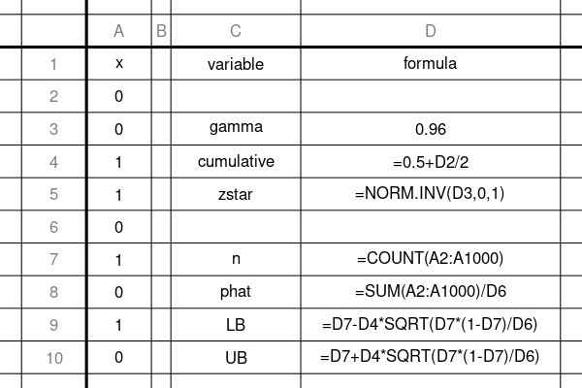
  - The lower boundary:

  - The upper boundary:

- Question
We can approximate a 95% confidence interval (where the 95% refers to the confidence level: how frequently these intervals straddle the population mean) by using .

where is the sample mean, is the sample standard deviation, and is the sample size. The 2 comes from the fact that 95% of normal measurements land within 2 standard deviations from the mean.
The quantity that we subtract from or add to the sample mean is called the margin of error.

When using a confidence level of 0.95, knowing will be approximately 0.62, and wanting the margin of error to be approximately 0.014, how large does the sample size need to be?
You can round your answer to two significant digits.
Solution
video
Do some algebra.

Multiply both sides by .

Divide both sides by .

Square both sides.

Plug in numbers.

Evaluate.

The tolerance is , so you can round to 2 significant digits, giving .
- Question
We can approximate a 95% confidence interval of a proportion (where the 95% refers to how frequently these intervals straddle the population proportion) by using .

where is the sample proportion and is the sample size. The 2 comes from the fact that 95% of normal measurements land within 2 standard deviations from the mean.
The quantity that we subtract from or add to the sample proportion is called the margin of error.

If we know will be approximately 0.69, and we want the margin of error to be approximately 0.016, then how large does the sample size need to be?
You can round your answer to two significant digits.
Solution
video
Do some algebra.

Multiply both sides by .

Divide both sides by .

Square both sides.

Simplify.

Plug in numbers.

Evaluate.

The tolerance is , so you can round to 2 significant digits, giving .

