- Question
A scientist is investigating whether a chemical may effect the growth of an organism. Under the control conditions (no chemical), the organism grows to a mean mass of grams with a standard deviation of grams. These values are known precisely because the organism has been grown under control conditions many many times.
The scientist has only grown the organism under experimental conditions (with chemical) times. In that sample, the masses have a mean .
The scientist wonders if this sample mean is significantly different from . To investigate this, the scientist will determine the -value. The -value represents the probability of getting a sample mean as far (or farther) from due to chance alone.

It is common to compare the -value to 0.05.
  - If then “significant”
  - If then “not significant”
  - ##ANSWER1##
  - Is the difference significant? ##ANSWER2##
  - Determine the -value.
  - The difference is significant; the chemical seems to alter the growth of the organism. / The difference is not significant; we don’t know whether the chemical alters the growth of the organism.
Solution
video
We need to calculate the -value.

Of course you could have rounded the score. Either of the following will also get credit.

The difference is significant; the chemical seems to alter the growth of the organism.
  - 0.0128027
  - TRUE / FALSE
- Question
A scientist is investigating whether a chemical may effect the survival rate of an organism. Under the control conditions (no chemical), the organism has a survival rate of . This value is known precisely because the organism has been grown under control conditions many many times.
The scientist has only grown the organism under experimental conditions (with chemical) times. In that sample, the survival rate is .
The scientist wonders if this survival rate is significantly different from . To investigate this, the scientist will determine the -value. The -value represents the probability of getting a sample proportion as far (or farther) from due to chance alone.

It is common to compare the -value to 0.05.
  - If then “significant”
  - If then “not significant”
  - ##ANSWER1##
  - Is the difference significant? ##ANSWER2##
  - Determine the -value.
  - The difference is significant. The chemical seems to alter the growth of the organism. / The difference is not significant. We don’t know whether the chemical alters the growth of the organism.
Solution
video
We need to calculate the -value.

Of course you could have rounded the score. Either of the following will also get credit.

The difference is not significant; we don’t know whether the chemical alters the growth of the organism.
  - 0.076922
  - FALSE / TRUE
- Question
Archie worries the horizontal aspect of her sight may be off. She decides to run a one-sample t test on the values of her next 24 arrows. She will use a significance level of . If the result has statistical significance, Archie will adjust her sight.

Result
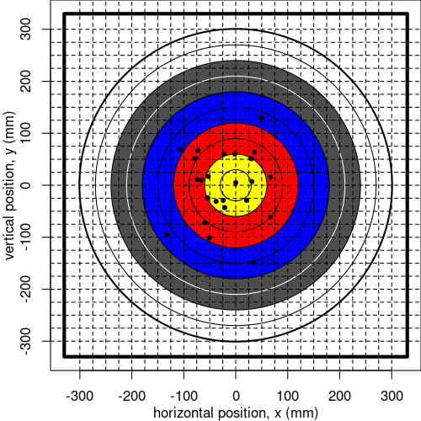
The horizontal positions are shown below and can be downloaded as a csv.
-51, -74, 49, 31, 0, -2, -106, 67, -38, -79, -21, -133, -54, 34, 21, 36, -60, -24, -53, -66, 67, -23, 30, -73

Analysis
To get the -value:

In this situation, the null population mean is zero.

In other words, the null hypothesis claims the sight is correct and the difference between and 0 is just due to chance. The alternative hypothesis claims the sight needs to be adjusted: the difference between and 0 is partly because the sight is off.
##ANSWER1##
Archie will adjust her sight if the -value is less than 0.05, because this indicates there is statistical significance. Does Archie adjust her sight? ##ANSWER2##
  - Determine the -value.
  - Yes. / No.
Solution
(ANS=0.0658909. No; Archie does not adjust her sight.)
video
Determine the sample statistics ( and ). I would recommend using a spreadsheet or R (or another computer-based method).

Evaluate the statistic.

Restate the -value.

Remember, the degree of freedom is one less than the sample size.

At this point, there are various ways to determine the -value. The least accurate way is to use the -table. Go to the row with .
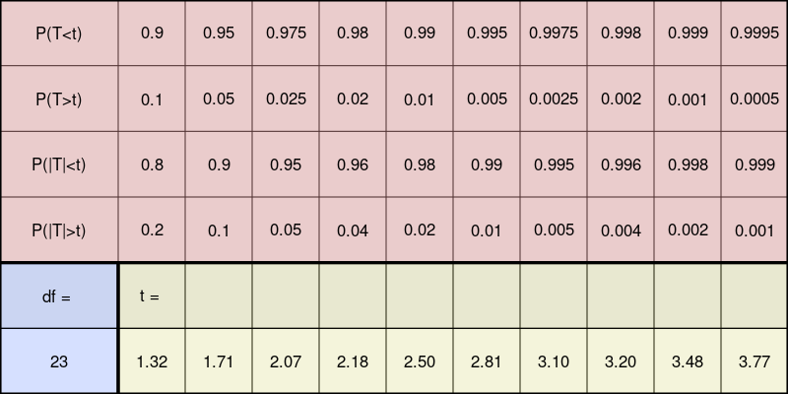
If we go to the row with df=23, we can see that our calculated , 1.93, is between 1.71 and 2.07. Thus, we know is between 0.05 and 0.1. You could get pretty close by using linear interpolation.

The more accurate -value is 0.0658909. This can be calculated using a computer; for example, you can use this web app (for full accuracy, you’ll need the more precise value of ). You can also use a spreadsheet or R.

Spreadsheet
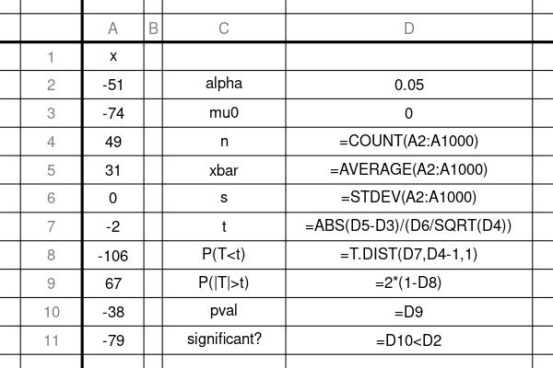

R
You can do this problem VERY quickly with R.
x = c(-51,-74,49,31,0,-2,-106,67,-38,-79,-21,-133,-54,34,21,36,-60,-24,-53,-66,67,-23,30,-73)
t.test(x)
##
## One Sample t-test
##
## data: x
## t = -1.9311, df = 23, p-value = 0.06589
## alternative hypothesis: true mean is not equal to 0
## 95 percent confidence interval:
## -45.049698 1.549698
## sample estimates:
## mean of x
## -21.75
- Question
Connie suspects a coin may be unfair when spun on its edge on a table. She decides to record some spins, using “0” for tails and “1” for heads. After those spins, she will run a one-proportion hypothesis test using a significance level .
The data is shown below, and can be downloaded as a csv.
1, 1, 1, 1, 0, 1, 1, 1, 1, 1, 0, 1, 0, 1, 1, 1, 1, 1, 1, 0, 0, 1, 1, 0, 1, 1, 1, 0, 1, 0, 1, 0, 0, 1, 1, 0, 1, 0, 1, 0, 0, 1, 0, 0, 0, 0, 0, 1, 0, 0, 1, 0, 0, 0, 0, 0, 0, 1, 0, 1, 1, 1, 0, 1, 1, 1, 0, 0, 0, 0, 1, 0, 1, 1, 1, 1, 1, 0, 0, 1, 0, 1, 1, 0, 1, 1, 0, 1, 0, 1, 1, 0, 0, 1, 0, 1, 1, 0, 1, 0, 0, 1, 1, 1, 0, 1, 1, 1, 0, 1, 0, 1, 0, 0, 1, 0, 0, 0, 1, 1, 1, 1, 1, 0, 1, 1, 0, 1, 0, 0, 0, 0, 1, 1, 0, 1, 1, 1, 0, 1, 1, 1, 1, 1, 0, 0, 1, 1, 1, 1, 1, 0, 1, 0, 1, 1, 1, 0, 1, 1, 1, 1, 0, 0, 1, 0, 1, 0, 1, 0, 0, 1, 1, 1, 1, 1, 1, 0, 1, 1, 1, 1, 1, 0, 1, 1, 1, 1, 0, 1, 0, 0, 0
The null hypothesis states the coin is fair and any deviation between the sample proportion and 0.5 is merely due to chance and natural variation. Thus, the null population proportion is .
The alternative hypothesis states the coin is unfair, so the deviation between the sample proportion and 0.5 is at least partly due to the unfairness of the coin.
The -value will indicate the probability that a fair coin produces a sample mean as extreme (or more extreme) in its deviation from 0.5. An approximate formula, using a normal approximation of the proportion sampling and not using a continuity correction, is given:

If you want to make a continuity correction, your -value is more accurate (and larger, more conservative).

And, if you want to be exactly correct, you need a computer (or a lot of time) to use the binomial distribution formulas.

For this problem, you can use any of those three strategies.
##ANSWER1##
Connie compares the -value to the significance level, . If the -value is less than 0.05, Connie concludes the coin is unfair. Otherwise, Connie will conclude the coin MIGHT be fair but future measurements may still show the coin is unfair.
Does Connie conclude the coin is unfair?
##ANSWER2##
  - Determine the -value.
  - Yes, the sample proportion is significantly far from 0.5, so Connie thinks the coin is unfair. / No, the sample proportion is NOT significantly far from 0.5, so Connie retains the belief that the coin MIGHT be fair.
Solution
(ANS=[0.011757,0.0143902, or 0.0141788]. Yes, the coin is unfair.)
video
First, I apologize for the notation, but for some reason this notation is ubiquitous. We have 4 different “p” variables.

You need to determine the sample size () and sample proportion ().

You then calculate a -score. For simplicity, we will not make the continuity correction if we are doing this by hand.

Restate the -value.

You can use a table to determine the cumulative probability of .

To calculate the -value, you need to remember how to determine a two-tail probability from a cumulative (leftward) probability.

Spreadsheet
You can use any of the three methods shown in the spreadsheet:
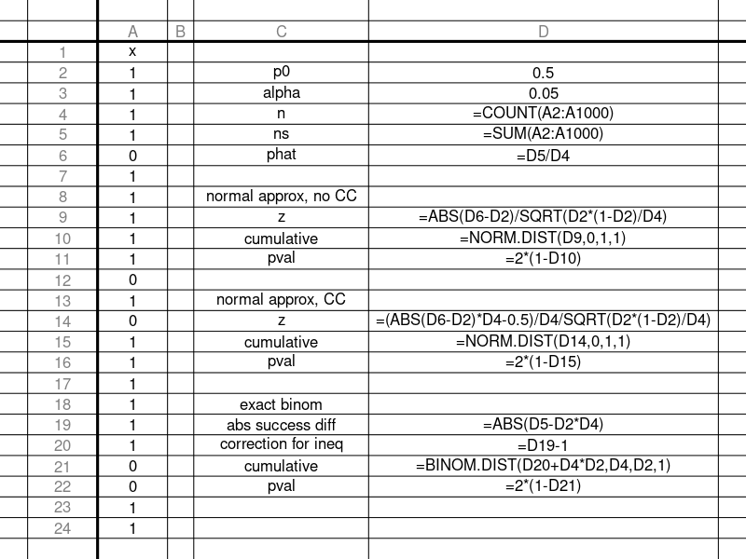
You can download a solution spreadsheet.

R
All three methods can be done easily in R:
x = c(1,1,1,1,0,1,1,1,1,1,0,1,0,1,1,1,1,1,1,0,0,1,1,0,1,1,1,0,1,0,1,0,0,1,1,0,1,0,1,0,0,1,0,0,0,0,0,1,0,0,1,0,0,0,0,0,0,1,0,1,1,1,0,1,1,1,0,0,0,0,1,0,1,1,1,1,1,0,0,1,0,1,1,0,1,1,0,1,0,1,1,0,0,1,0,1,1,0,1,0,0,1,1,1,0,1,1,1,0,1,0,1,0,0,1,0,0,0,1,1,1,1,1,0,1,1,0,1,0,0,0,0,1,1,0,1,1,1,0,1,1,1,1,1,0,0,1,1,1,1,1,0,1,0,1,1,1,0,1,1,1,1,0,0,1,0,1,0,1,0,0,1,1,1,1,1,1,0,1,1,1,1,1,0,1,1,1,1,0,1,0,0,0)
prop.test(sum(x),length(x),0.5,correct=F)
##
## 1-sample proportions test without continuity
## correction
##
## data: sum(x) out of length(x), null probability 0.5
## X-squared = 6.3472, df = 1, p-value = 0.01176
## alternative hypothesis: true p is not equal to 0.5
## 95 percent confidence interval:
## 0.5201905 0.6576176
## sample estimates:
## p
## 0.5906736
prop.test(sum(x),length(x),0.5)
##
## 1-sample proportions test with continuity
## correction
##
## data: sum(x) out of length(x), null probability 0.5
## X-squared = 5.9896, df = 1, p-value = 0.01439
## alternative hypothesis: true p is not equal to 0.5
## 95 percent confidence interval:
## 0.5175859 0.6600913
## sample estimates:
## p
## 0.5906736
binom.test(sum(x),length(x),0.5)
##
## Exact binomial test
##
## data: sum(x) and length(x)
## number of successes = 114, number of trials = 193,
## p-value = 0.01418
## alternative hypothesis: true probability of success is not equal to 0.5
## 95 percent confidence interval:
## 0.5177609 0.6607564
## sample estimates:
## probability of success
## 0.5906736

