- Question
A study asked individuals to time a mile run (in seconds). After a month, the same individuals timed another mile run. You are asked to perform a paired-data test to investigate whether fitness changed.
name
x1
x2
Alexandro
311
392
Ashton
431
437
Austin
413
408
Bentley
1135
1165
Daniel
301
306
Edward
320
350
Elaine
408
499
Fletcher
723
704
Harley
727
770
Kareem
355
404
Leonardo
617
710
Lucas
743
813
Lun
669
709
Makayla
1004
988
Makiyah
425
436
Sophie
825
861
Zahra
942
892
(download as run_times.csv)
To do this, first determine the list of differences. For each individual, , determine their difference .

Then, determine the mean () and standard deviation () of the differences. The score is then calculated to determine the -value.

The null hypothesis predicts there is no change in fitness, so . The alternative hypothesis predicts a change in fitness. The degree of freedom is one less than the number of individuals.
##ANSWER1##
Using a significance level of , is there a significant change in run times?
##ANSWER2##
  - Calculate the -value.
  - Yes / No
Solution
video
You first need to determine a list of differences.
name
x1
x2
d = x2-x1
Alexandro
311
392
81
Ashton
431
437
6
Austin
413
408
-5
Bentley
1135
1165
30
Daniel
301
306
5
Edward
320
350
30
Elaine
408
499
91
Fletcher
723
704
-19
Harley
727
770
43
Kareem
355
404
49
Leonardo
617
710
93
Lucas
743
813
70
Lun
669
709
40
Makayla
1004
988
-16
Makiyah
425
436
11
Sophie
825
861
36
Zahra
942
892
-50
Determine the sample size and degrees of freedom.

Determine the sample mean of the differences.

Determine the standard deviation of the differences. You probably do not want to do this by hand.

Calculate the -score.

Restate the -value.

I would recommend using a computer program to determine this -value, like a spreadsheet or R.

The -value is less than 0.05, so the result is significant.

spreadsheet
The solution spreadsheet can be downloaded as a csv. The first 10 rows are shown below.
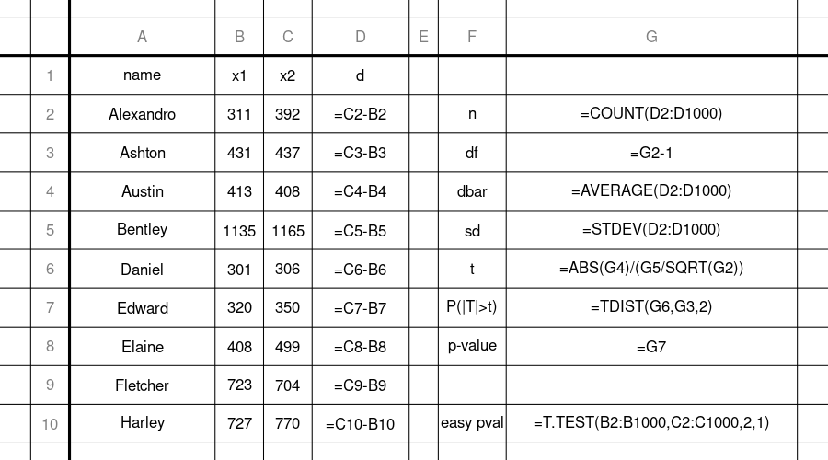
If your spreadsheet does not have the TDIST function, you can try T.DIST.2T(G6,G3,1). Also, notice that T.TEST does everything for you, so you can just use that.

R
Make/use a directory (folder) for this problem (paired-data test), and set the working directory accordingly. Save run_times.csv to your working directory. I would recommend saving the following script as paired_data_hypothesis_test.r, in the same directory.
table = read.csv("run_times.csv")
x1 = table[['x1']]
x2 = table[['x2']]
t.test(x1,x2,paired=T)
##
## Paired t-test
##
## data: x1 and x2
## t = -2.9641, df = 16, p-value = 0.009138
## alternative hypothesis: true difference in means is not equal to 0
## 95 percent confidence interval:
## -49.942319 -8.292975
## sample estimates:
## mean of the differences
## -29.11765
Or, if you wanted to do it the long way:
table = read.csv("run_times.csv")
x1 = table[["x1"]]
x2 = table[["x2"]]
d = x2-x1
n = length(d)
t = abs(mean(d))/(sd(d)/sqrt(n))
cumulative = pt(t,n-1)
pvalue = 2*(1-cumulative)
pvalue
## [1] 0.009138093
- Question
A doctor runs a controlled experiment. The participants are randomly assigned to two groups: control and treatment. The participants in the control group are given a placebo. The participants in the treatment group are given a drug.
After a month, each participant’s triglyceride level (in mg/dL) is measured. Those measurements are shown below. They can also be downloaded as a csv.
## Control: 526.1, 643.3, 558.2, 520.2, 486.3, 487, 489.1, 475.7, 550.8, 574.1, 460, 587.2, 487.2, 558.6, 543.6, 502.6, 534.1, 504.4, 605.9, 554.8, 540.5, 597.7, 577.4, 461.4, 561.6, 473.3, 562.1, 539.8, 533.4, 511.1, 596.8, 581.3, 479.8, 503.9, 603.3
##
## Treatment: 552.7, 468, 589, 535, 524.6, 476.3, 522.3, 487, 517.9, 420.5, 477.1, 594.5, 561.8, 474.2, 514.7, 468.3, 344, 468.7, 477.2, 518.9, 420.8, 482.7, 507.4, 466.8, 432.4, 583.6, 524.8, 459.8, 570.5, 552.3, 606.6, 550.5, 468.3
You are asked to perform a two-tail two-sample Welch’s test to determine whether there is a significant difference of means in the two samples.
To do this by hand, you would first determine the absolute score as defined here.

You’d also need to calculate the degrees of freedom.

And then, the -value:

However, this problem is easy when using a spreadsheet or R, so I would recommend using one of those tools.
In a spreadsheet, you can use T.TEST with mode=2 for a two-tail test and type=3 for Welch’s test.
In R, you can use t.test with the default settings.
##ANSWER1##
Is the difference of means significant (using a significance level of 0.05)?
##ANSWER2##
  - Determine the -value.
  - Yes, the drug causes a difference in average triglyceride level. / No, we don’t know whether the drug causes a difference.
Solution
video
To do this by hand, you first calculate the sample statistics.

You will get quite close if you round df down (floor).
Then, using a computer application or a table, you should be able to determine the following probabilities (using interpolation to estimate if using table).

Spreadsheet
You just need to use T.TEST with the proper settings. You can download the solution as a csv.
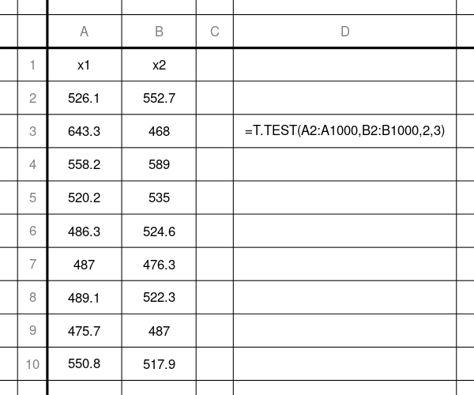

R
You just use t.test with the default settings. The hardest part is getting the data imported. You can do this in 2 ways: copy/paste or read.csv.

copy/paste
x1 = c(526.1,643.3,558.2,520.2,486.3,487,489.1,475.7,550.8,574.1,460,587.2,487.2,558.6,543.6,502.6,534.1,504.4,605.9,554.8,540.5,597.7,577.4,461.4,561.6,473.3,562.1,539.8,533.4,511.1,596.8,581.3,479.8,503.9,603.3)
x2 = c(552.7,468,589,535,524.6,476.3,522.3,487,517.9,420.5,477.1,594.5,561.8,474.2,514.7,468.3,344,468.7,477.2,518.9,420.8,482.7,507.4,466.8,432.4,583.6,524.8,459.8,570.5,552.3,606.6,550.5,468.3)
t.test(x1,x2)
##
## Welch Two Sample t-test
##
## data: x1 and x2
## t = 2.5588, df = 61.769, p-value = 0.01297
## alternative hypothesis: true difference in means is not equal to 0
## 95 percent confidence interval:
## 7.162867 58.332891
## sample estimates:
## mean of x mean of y
## 536.3600 503.6121

read.csv
Download media/supplements1/exercise2/triglyceride.csv and move it to a directory (folder). Make a script, welchttest.r, and put it in the same directory. Set the working directory to this directory. Then, run the script.
### welchttest.r
data = read.csv("triglyceride.csv")
x1 = data$x1
x2 = data$x2
t.test(x1,x2)
##
## Welch Two Sample t-test
##
## data: x1 and x2
## t = 2.5588, df = 61.769, p-value = 0.01297
## alternative hypothesis: true difference in means is not equal to 0
## 95 percent confidence interval:
## 7.162867 58.332891
## sample estimates:
## mean of x mean of y
## 536.3600 503.6121
- Question
A doctor runs a controlled experiment. The sick patients are randomly assigned to two groups: control and treatment. The patients in the control group are given a placebo. The patients in the treatment group are given a drug.
After a month, each patient was checked for whether they recovered from the sickness. A “0” means no recovery while a “1” means recovery. This data can also be downloaded as a csv.
## Control: 0, 0, 1, 1, 1, 0, 0, 0, 0, 1, 1, 0, 1, 0, 0, 1, 0, 0, 0, 1, 1, 0, 0, 1, 0, 0, 0, 1, 1, 1, 0, 1, 0, 1, 0, 0, 0, 1, 0, 1, 0, 1, 0, 0, 1, 1, 1, 1, 1, 0, 0
##
## Treatment: 0, 0, 1, 0, 0, 0, 0, 0, 0, 0, 1, 0, 0, 1, 1, 0, 0, 0, 0, 0, 0, 1, 0, 0, 0, 1, 0, 0, 0, 0, 0, 0, 0, 0, 0, 0, 0, 0, 1, 0, 1, 0, 1, 0, 0, 1, 0, 0, 1, 0, 0, 0, 1, 0, 0, 0, 0, 0, 1, 1, 0, 0, 0
You are asked to perform a two-tailed two-proportion test. You can do a two-proportions test (which is equivalent to a 2x2 test [chi squared test]). You will get credit whether or not you apply a continuity correction, but please pool data for the standard error estimation.
Just for completeness, you would also get credit for using Fisher’s exact test.
##ANSWER1##
Is the difference of means significant (using a significance level of 0.05)?
##ANSWER2##
  - Determine the -value.
  - Yes, the drug causes a difference in recovery. / No, we don’t know whether the drug causes a difference.
Solution
video
There are many ways to do this problem. I will show the following:
  - “By hand”
  - Use a spreadsheet’s chisq.test function on 2x2 contingency table
  - Use R’s prop.test and fisher.test functions.

“By hand”
First, somehow you need to determine the sample sizes ( and ) and the sample totals (numbers of recovery), and . You could count… but a computer is probably helpful.

It can be helpful to organize these summary statistics into a contingency table.
Recover
Not_recover
TOTAL
Control
23
28
51
Treatment
14
28
63
TOTAL
37
56
114
Calculate the proportions.

Determine the absolute score.

Using a table or an online standard-normal probability tool, determine the appropriate probabilities.

This -value did not use the continuity correction.

Spreadsheet
Solution download.
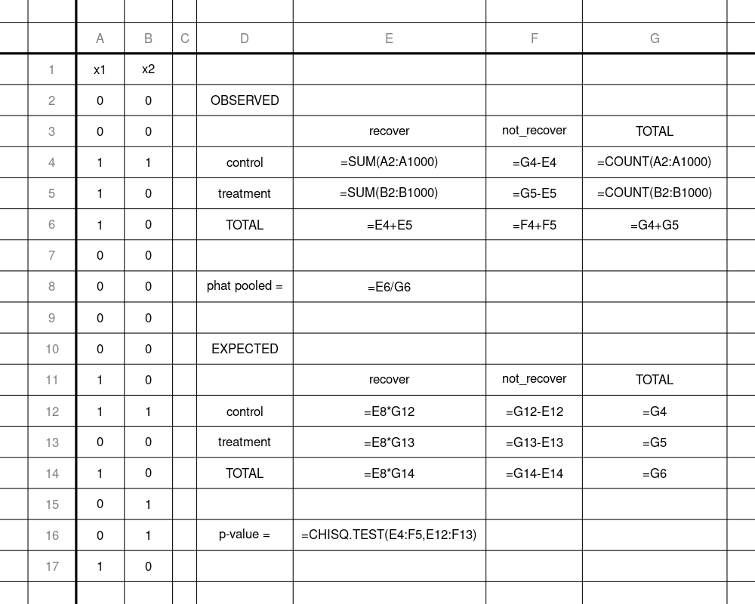
If you wanted to make Yates’ continuity correction, you would need to calculate the EXPECTED table the same, but then make another table, where the observed values are all 0.5 closer to the expected values. Then, you would use =CHISQ.TEST on these new values (as the “observed”) and the expected values.
It looks challenging to do a Fisher exact test in a spreadsheet.

R
x1 = c(0,0,1,1,1,0,0,0,0,1,1,0,1,0,0,1,0,0,0,1,1,0,0,1,0,0,0,1,1,1,0,1,0,1,0,0,0,1,0,1,0,1,0,0,1,1,1,1,1,0,0)
x2 = c(0,0,1,0,0,0,0,0,0,0,1,0,0,1,1,0,0,0,0,0,0,1,0,0,0,1,0,0,0,0,0,0,0,0,0,0,0,0,1,0,1,0,1,0,0,1,0,0,1,0,0,0,1,0,0,0,0,0,1,1,0,0,0)
n1 = length(x1)
n2 = length(x2)
ns1 = sum(x1) #number of successes in sample 1
ns2 = sum(x2)
prop.test(c(ns1,ns2),c(n1,n2))
##
## 2-sample test for equality of proportions with
## continuity correction
##
## data: c(ns1, ns2) out of c(n1, n2)
## X-squared = 5.7248, df = 1, p-value = 0.01673
## alternative hypothesis: two.sided
## 95 percent confidence interval:
## 0.04017083 0.41734551
## sample estimates:
## prop 1 prop 2
## 0.4509804 0.2222222
prop.test(c(ns1,ns2),c(n1,n2),correct=F)
##
## 2-sample test for equality of proportions without
## continuity correction
##
## data: c(ns1, ns2) out of c(n1, n2)
## X-squared = 6.7279, df = 1, p-value = 0.009492
## alternative hypothesis: two.sided
## 95 percent confidence interval:
## 0.05791126 0.39960508
## sample estimates:
## prop 1 prop 2
## 0.4509804 0.2222222
nf1 = n1-ns1
nf2 = n2-ns2
conttab = matrix(c(ns1,nf1,ns2,nf2),nrow=2)
fisher.test(conttab)
##
## Fisher's Exact Test for Count Data
##
## data: conttab
## p-value = 0.01523
## alternative hypothesis: true odds ratio is not equal to 1
## 95 percent confidence interval:
## 1.188405 7.041969
## sample estimates:
## odds ratio
## 2.847371

