- Question
An automatic bottle filler is supposed to average 500.00 ml of fluid in each bottle. You sampled some random bottles, recording their volumes:
497.33, 498.21, 501.35, 499.72, 500.49, 498.25, 498.75, 497.69, 496.57, 500.39,
499.61, 500.26, 497.25, 498.57, 498.75, 504.54, 500.13, 500.03, 499.82, 499.79,
500.20, 501.87, 498.14, 500.19, 498.90, 501.20, 503.23, 500.81, 499.17, 499.16,
499.74, 499.12, 500.87, 500.14, 499.95, 498.94, 499.12, 497.94, 500.14, 499.51
Download data.
You are asked to determine a 95% confidence interval, calculate an appropriate -value (using two-tail test), and state whether the filler needs adjustment using a significance level of 0.05.
##ANSWER1##
##ANSWER2##
##ANSWER3##
Does the filler need adjustment?
##ANSWER4##
  - Determine the lower boundary of the confidence interval.
  - Determine the upper boundary of the confidence interval.
  - Determine the -value.
  - Yes / No
Solution

  - 499.1558034
  - 500.1361966
  - 0.1521066
  - The p-value is more than 0.05, so the difference is NOT significant. /
- Question
A scratch-off lottery has a stated chance of 0.7 to win. You sampled some tickets, marking a win as “1” and a loss as “0”.
1, 1, 1, 1, 1, 1, 0, 1, 1, 0, 0, 1, 1, 0, 1, 1, 1, 1, 1, 1,
1, 1, 0, 1, 1, 0, 1, 1, 1, 0, 1, 1, 0, 1, 1, 1, 1, 1, 1, 1,
1, 1, 1, 1, 1, 0, 0, 1, 1, 1, 1, 1, 1, 0, 1, 1, 0, 1, 1, 0,
1, 1, 1, 1, 1, 1, 1, 1, 1, 1, 0, 1, 1, 1, 1, 1, 1, 0, 1, 1,
1, 1, 1, 1, 1, 1, 0
Download data.
Please determine a 95% confidence interval, calculate an appropriate -value, and state whether the sample proportion is significantly different than the stated chance (using a significance level of 0.05).
For the confidence interval, you can use a normal approximation interval, a Wilson score interval, a Wilson score interval with continuity correction, or the exact Clopper-Pearson interval (see descriptions here).
For the -value, you can use similarly use a test, a test (with or without continuity correction), or an exact test.
##ANSWER1##
##ANSWER2##
##ANSWER3##
Using a significance level of 0.05, is the sample proportion significantly different from the stated chance?
##ANSWER4##
  - Determine the lower boundary of the confidence interval.
  - Determine the upper boundary of the confidence interval.
  - Determine the -value.
  - Yes / No
Solution
By hand, this is easiest to do with a normal approximation without the continuity correction.

  - Normal approx: . Wilson: . Wilson with CC: . Exact Clopper-Pearson: .
  - Normal approx: . Wilson: . Wilson with CC: . Exact Clopper-Pearson: .
  - Normal approx: . Chi squared: . Chi squared with CC: . Exact: .
  - The p-value is less than 0.05, so the difference is significant. /
- Question
A study asked individuals to time a mile run (in seconds). After a month, the same individuals timed another mile run. You are asked to perform a paired-data test to investigate whether fitness changed.
name
x1
x2
Cataleya
704
709
Colbie
579
534
Daliah
333
312
Dayanara
505
494
Essa
384
377
Gabriella
532
511
Gustavo
353
348
Jolene
372
382
Kameron
505
508
Kristina
305
305
Miranda
281
299
Nickson
369
325
Nori
318
327
Ruby
576
571
Rylie
502
482
Sephora
292
261
Zahra
363
333
(download as run_times.csv)
Please run a paired -test to check whether there was a significant change in running times.
##ANSWER1##
Using a significance level of , is there a significant change in run times?
##ANSWER2##
  - Calculate the -value.
  - Yes / No
Solution
You first need to determine a list of differences.
name
x1
x2
d = x2-x1
Cataleya
704
709
5
Colbie
579
534
-45
Daliah
333
312
-21
Dayanara
505
494
-11
Essa
384
377
-7
Gabriella
532
511
-21
Gustavo
353
348
-5
Jolene
372
382
10
Kameron
505
508
3
Kristina
305
305
0
Miranda
281
299
18
Nickson
369
325
-44
Nori
318
327
9
Ruby
576
571
-5
Rylie
502
482
-20
Sephora
292
261
-31
Zahra
363
333
-30
Determine the sample size and degrees of freedom.

Determine the sample mean of the differences.

Determine the standard deviation of the differences. You probably do not want to do this by hand.

Calculate the -score.

Restate the -value.

I would recommend using a computer program to determine this -value, like a spreadsheet or R.

The -value is less than 0.05, so the result is significant.

spreadsheet
The solution spreadsheet can be downloaded as a csv. The first 10 rows are shown below.
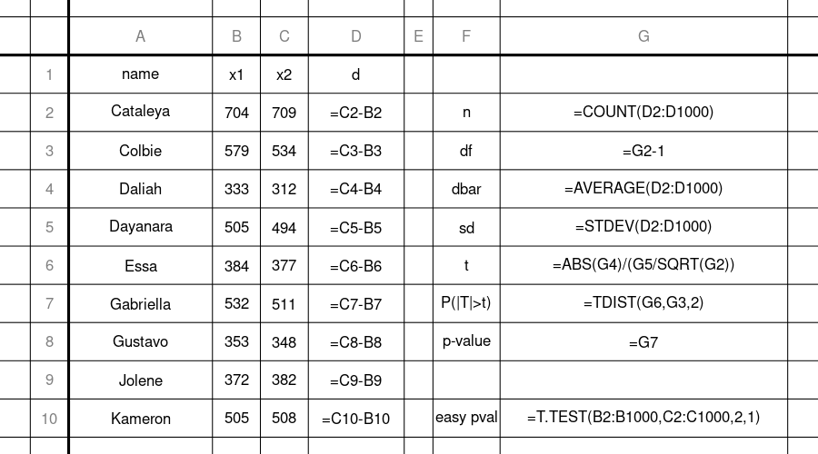
If your spreadsheet does not have the TDIST function, you can try T.DIST.2T(G6,G3,1). Also, notice that T.TEST does everything for you, so you can just use that.

R
Make/use a directory (folder) for this problem (paired-data test), and set the working directory accordingly. Save run_times.csv to your working directory. I would recommend saving the following script as paired_data_hypothesis_test.r, in the same directory.
table = read.csv("run_times.csv")
x1 = table[['x1']]
x2 = table[['x2']]
t.test(x1,x2,paired=T)
##
## Paired t-test
##
## data: x1 and x2
## t = 2.5221, df = 16, p-value = 0.02264
## alternative hypothesis: true difference in means is not equal to 0
## 95 percent confidence interval:
## 1.829169 21.112007
## sample estimates:
## mean of the differences
## 11.47059
Or, if you wanted to do it the long way:
table = read.csv("run_times.csv")
x1 = table[["x1"]]
x2 = table[["x2"]]
d = x2-x1
n = length(d)
t = abs(mean(d))/(sd(d)/sqrt(n))
cumulative = pt(t,n-1)
pvalue = 2*(1-cumulative)
pvalue
## [1] 0.02264385
- Question
A doctor runs a controlled experiment. The participants are randomly assigned to two groups: control and treatment. The participants in the control group are given a placebo. The participants in the treatment group are given a drug.
After a month, each participant’s triglyceride level (in mg/dL) is measured. Those measurements are shown below. They can also be downloaded as a csv.
## Control: 321.5, 319.7, 321, 328, 297.5, 326.4, 346.5, 336.5, 345.5, 344.6
##
## Treatment: 328.8, 336.2, 315.1, 307.9, 302.8, 303.8, 296.3, 294.3, 299.9, 316.1, 323.1, 297.6, 301.7, 324.6, 320
You are asked to perform a two-tail two-sample Welch’s test to determine whether there is a significant difference of means in the two samples.
##ANSWER1##
Is the difference of means significant (using a significance level of 0.05)?
##ANSWER2##
  - Determine the -value.
  - Yes, the drug causes a difference in average triglyceride level. / No, we don’t know whether the drug causes a difference.
Solution
To do this by hand, you first calculate the sample statistics.

You will get quite close if you round df down (floor).
Then, using a computer application or a table, you should be able to determine the following probabilities (using interpolation to estimate if using table).

The -value is less than 0.05, so the result is significant.

Spreadsheet
You just need to use T.TEST with the proper settings. You can download the solution as a csv.
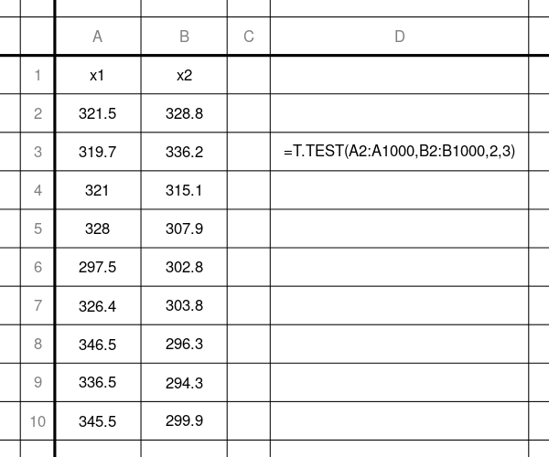

R
You just use t.test with the default settings. The hardest part is getting the data imported. You can do this in 2 ways: copy/paste or read.csv.

copy/paste
x1 = c(321.5,319.7,321,328,297.5,326.4,346.5,336.5,345.5,344.6)
x2 = c(328.8,336.2,315.1,307.9,302.8,303.8,296.3,294.3,299.9,316.1,323.1,297.6,301.7,324.6,320)
t.test(x1,x2)
##
## Welch Two Sample t-test
##
## data: x1 and x2
## t = 2.9729, df = 17.412, p-value = 0.008369
## alternative hypothesis: true difference in means is not equal to 0
## 95 percent confidence interval:
## 5.104934 29.908399
## sample estimates:
## mean of x mean of y
## 328.7200 311.2133

read.csv
Download media/supplements1/exercise4/triglyceride.csv and move it to a directory (folder). Make a script, welchttest.r, and put it in the same directory. Set the working directory to this directory. Then, run the script.
### welchttest.r
data = read.csv("triglyceride.csv")
x1 = data$x1
x2 = data$x2
t.test(x1,x2)
##
## Welch Two Sample t-test
##
## data: x1 and x2
## t = 2.9729, df = 17.412, p-value = 0.008369
## alternative hypothesis: true difference in means is not equal to 0
## 95 percent confidence interval:
## 5.104934 29.908399
## sample estimates:
## mean of x mean of y
## 328.7200 311.2133
- Question
A doctor runs a controlled experiment. The sick patients are randomly assigned to two groups: control and treatment. The patients in the control group are given a placebo. The patients in the treatment group are given a drug.
After a month, each patient was checked for whether they recovered from the sickness. A “0” means no recovery while a “1” means recovery. This data can also be downloaded as a csv.
## Control: 1, 0, 1, 0, 0, 0, 1, 1, 1, 0, 1, 0, 1, 0, 0, 1, 0, 1, 0, 1, 1, 1, 0, 1, 0, 1, 0, 1, 1, 0, 1, 0, 1, 1, 0, 1, 0, 0, 0, 0, 0, 0, 1, 1, 0, 0, 1, 0, 1
##
## Treatment: 0, 0, 0, 0, 0, 0, 1, 0, 0, 0, 0, 0, 1, 0, 0, 0, 1, 1, 0, 1, 1, 0, 0, 0, 0, 0, 1, 1, 1, 0, 0, 0, 0, 0, 0, 0, 0, 0, 0, 0, 0, 0, 1, 1, 0, 1, 0, 0, 0, 0
You are asked to perform a two-tailed two-proportion test. You can do a two-proportions test (which is equivalent to a 2x2 test [chi squared test]). You will get credit whether or not you apply a continuity correction, but please pool data for the standard error estimation.
Just for completeness, you can also get credit for using Fisher’s exact test.
##ANSWER1##
Is the difference of means significant (using a significance level of 0.05)?
##ANSWER2##
  - Determine the -value.
  - Yes, the drug causes a difference in recovery. / No, we don’t know whether the drug causes a difference.
Solution
There are many ways to do this problem. I will show the following:
  - “By hand”
  - Use a spreadsheet’s chisq.test function on 2x2 contingency table
  - Use R’s prop.test and fisher.test functions.

“By hand”
First, somehow you need to determine the sample sizes ( and ) and the sample totals (numbers of recovery), and . You could count… but a computer is probably helpful.

It can be helpful to organize these summary statistics into a contingency table.
Recover
Not_recover
TOTAL
Control
24
25
49
Treatment
12
25
50
TOTAL
36
50
99
Calculate the proportions.

Determine the absolute score.

Using a table or an online standard-normal probability tool, determine the appropriate probabilities.

This -value did not use the continuity correction.
The -value is less than 0.05, so the result is significant.

Spreadsheet
Solution download.
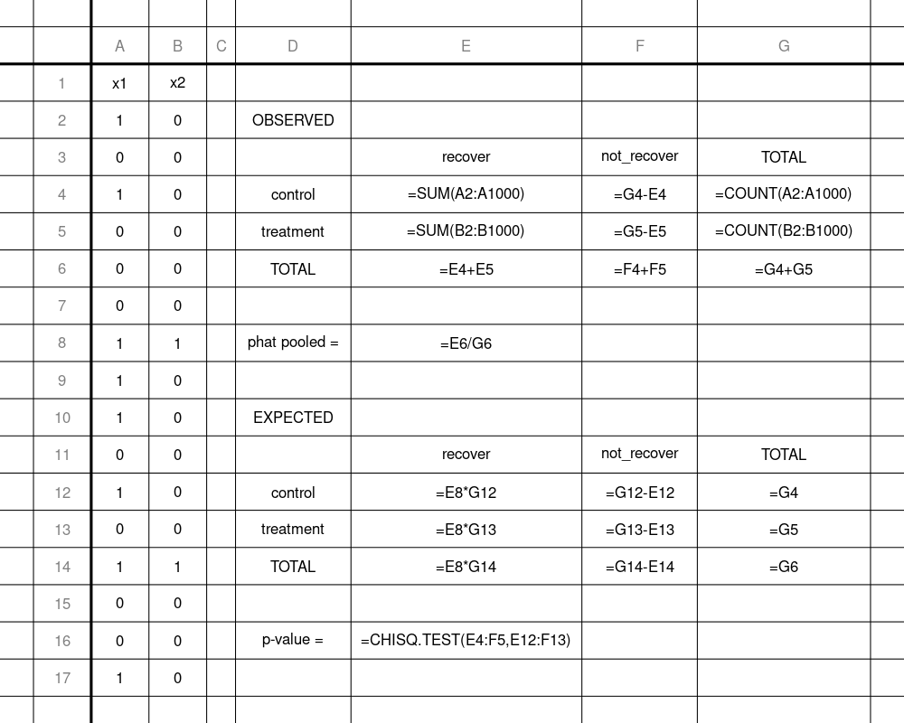
If you wanted to make Yates’ continuity correction, you would need to calculate the EXPECTED table the same, but then make another table, where the observed values are all 0.5 closer to the expected values. Then, you would use =CHISQ.TEST on these new values (as the “observed”) and the expected values.
It looks challenging to do a Fisher exact test in a spreadsheet.

R
x1 = c(1,0,1,0,0,0,1,1,1,0,1,0,1,0,0,1,0,1,0,1,1,1,0,1,0,1,0,1,1,0,1,0,1,1,0,1,0,0,0,0,0,0,1,1,0,0,1,0,1)
x2 = c(0,0,0,0,0,0,1,0,0,0,0,0,1,0,0,0,1,1,0,1,1,0,0,0,0,0,1,1,1,0,0,0,0,0,0,0,0,0,0,0,0,0,1,1,0,1,0,0,0,0)
n1 = length(x1)
n2 = length(x2)
ns1 = sum(x1) #number of successes in sample 1
ns2 = sum(x2)
prop.test(c(ns1,ns2),c(n1,n2))
##
## 2-sample test for equality of proportions with
## continuity correction
##
## data: c(ns1, ns2) out of c(n1, n2)
## X-squared = 5.6373, df = 1, p-value = 0.01758
## alternative hypothesis: two.sided
## 95 percent confidence interval:
## 0.04627583 0.45331601
## sample estimates:
## prop 1 prop 2
## 0.4897959 0.2400000
prop.test(c(ns1,ns2),c(n1,n2),correct=F)
##
## 2-sample test for equality of proportions without
## continuity correction
##
## data: c(ns1, ns2) out of c(n1, n2)
## X-squared = 6.6731, df = 1, p-value = 0.009788
## alternative hypothesis: two.sided
## 95 percent confidence interval:
## 0.06647991 0.43311193
## sample estimates:
## prop 1 prop 2
## 0.4897959 0.2400000
nf1 = n1-ns1
nf2 = n2-ns2
conttab = matrix(c(ns1,nf1,ns2,nf2),nrow=2)
fisher.test(conttab)
##
## Fisher's Exact Test for Count Data
##
## data: conttab
## p-value = 0.01243
## alternative hypothesis: true odds ratio is not equal to 1
## 95 percent confidence interval:
## 1.193429 7.902711
## sample estimates:
## odds ratio
## 3.004639

