- Question
A random procedure generated the following sample (sequence of measurements):

You can download the data as a CSV file (for importing into a spreadsheet or R): media/supplements1/exercise1/list_counting_basic_data.csv
  - How many of the measurements are less than 66? In other words, determine .
  - How many of the measurements are less than or equal to 67? In other words, determine .
  - How many of the measurements are greater than 64? In other words, determine .
  - How many of the measurements are greater than or equal to 67? In other words, determine .
  - If 9 of the measurements are less than , and is a measurement from sample , then what is ? In other words, determine a measurement from sequence such that .
  - If 5 of the measurements are less than or equal to , and is a measurement from sample , then what is ? In other words, determine a measurement from sequence such that .
  - If 8 of the measurements are greater than , and is a measurement from sample , then what is ? In other words, determine a measurement from sequence such that .
  - If 4 of the measurements are greater than or equal to , and is a measurement from sample , then what is ? In other words, determine a measurement from sequence such that .
Solution
First, it helps to sort the data.

Spreadsheet
You could use a spreadsheet to sort the data. Import the table into a spreadsheet. Then, highlight the column of measurements and use Sort function.
Video of similar problem done with spreadsheet

R
You could use R to sort the data:
sort(c(67,66,63,67,69,65,61,61,64,67))
## [1] 61 61 63 64 65 66 67 67 67 69
Video of similar problem done with R
  - (ANS=5) There are 5 measurements less than 66.
  - (ANS=9) There are 9 measurements less than or equal to 67.
  - (ANS=6) There are 6 measurements greater than 64.
  - (ANS=4) There are 4 measurements greater than or equal to 67.
  - (ANS=69) Measurement value 69 has 9 measurements less than it, so . In other words, .
  - (ANS=65) Measurement value 65 has 5 measurements less than or equal to it, so . In other words, .
  - (ANS=61) Measurement value 61 has 8 measurements greater than it, so . In other words, .
  - (ANS=67) Measurement value 67 has 4 measurements greater than or equal to it, so . In other words, .
- Question
A random procedure generated the following sample (sequence of measurements):

You can download the data as a CSV file (for importing into a spreadsheet or R): media/supplements1/exercise2/list_counting_between_data.csv
  - How many of the measurements are inside 75.5 to 76.5? In other words, determine . In other words, determine .
  - How many of the measurements are outside 72.5 to 79.5? In other words, determine . In other words, determine .
  - How many of the measurements are closer than 0.5 units from 77? In other words, determine .
  - How many of the measurements are farther than 0.5 units from 71? In other words, determine .
  - Determine a half-integer radius of an interval with center 75 such that .
  - Determine an integer radius of an interval with center 73.5 such that .
Solution
First, it helps to sort the data.

R
You could use R to sort the data:
sort(c(73,79,74,76,75,74,76,78,77,72))
## [1] 72 73 74 74 75 76 76 77 78 79
Video of a similar problem solved with R

Spreadsheet
You could also use a spreadsheet. Import the table into a spreadsheet. Then, highlight the column of measurements and use Sort function.
Video of a similar problem solved with a spreadsheet.
  - (ANS=2) There are 2 measurements between 75.5 and 76.5.

  - (ANS=1) There are 1 measurements outside 72.5 and 79.5.

  - (ANS=1) There are 1 measurements closer than 0.5 units from 77. It might help to rephrase the problem as finding how many measurements are between 76.5 and 77.5. These boundaries are found by subtracting 0.5 from 77 and adding 0.5 to 77.

  - (ANS=10) There are 10 measurements farther than 0.5 units from 71. It might help to rephrase the problem as finding how many measurements are outside 70.5 and 71.5. These boundaries are found by subtracting 0.5 from 71 and adding 0.5 to 71.

  - (ANS=2.5) You can guess and check until you find a half-integer that satisfies the equation. It turns out that satisfies the equation, because . Notice the boundaries are 72.5 and 77.5, which are found by adding/subtracting 2.5 to/from 75.

  - (ANS=3) You can guess and check until you find an integer that satisfies the equation. It turns out that satisfies the equation, because . Notice the boundaries are 70.5 and 76.5, which are found by adding/subtracting 3 to/from 73.5.

- Question
A random procedure generated many measurements: media/supplements1/exercise3/list_counting_large_data.csv
52.91, 56.74, 56.44, 56.42, 55.27, 56.48, 55.05, 59.06, 55.16, 50.51, 56.63, 59.57, 50.97, 58.43, 50.77, 59.46, 56.65, 57.51, 58.16, 55.37, 50.44, 52.37, 57.13, 58.09, 50.09, 54.42, 51.97, 56.58, 53.59, 59.97, 51.44, 57.75, 58.30, 59.48, 55.26, 50.01, 59.34, 55.50, 57.27, 58.60, 51.72, 53.72, 55.34, 55.19, 59.95, 54.40, 51.73, 59.05, 57.57, 57.18, 54.66, 55.95, 53.26, 58.42, 55.10, 55.94, 53.87, 52.40, 53.28, 54.91, 56.31, 58.22, 53.13, 59.39, 52.81, 56.61, 51.12, 58.82, 52.08, 58.50, 52.62, 56.61, 52.18, 54.17, 53.22, 57.32, 55.23, 53.32, 59.24, 52.24, 58.85, 55.38, 57.40, 56.65, 57.24, 54.70, 50.42, 56.41, 54.72, 54.19
  - How many measurements are in the sample? In other words, determine . In the future, we will use to denote the number of measurements in the sample.
  - How many of the measurements are less than 54.7? In other words, determine .
  - How many of the measurements are greater than 57.1? In other words, determine .
  - How many of the measurements are closer than 4 units from 54.1? In other words, determine .
  - How many of the measurements are farther than 1.5 units from 52.8? In other words, determine .
Solution
You will want to use a computer to answer these questions.

Spreadsheet
video
You need to learn about references and formulas: https://wiki.openoffice.org/wiki/Documentation/OOo3_User_Guides/Calc_Guide/Creating_formulas
You need to learn about the IF function: https://wiki.openoffice.org/wiki/Documentation/How_Tos/Calc:_IF_function
You need to learn about the SUM function: https://wiki.openoffice.org/wiki/Documentation/How_Tos/Calc:_SUM_function
If you used a spreadsheet, you should end up with this solution csv. You can also see the solution spreadsheet here (with the middle rows removed).
A
B
C
D
E
F
1
i
x
x<54.7
x>57.1
abs(x-54.1)<4
abs(x-52.8)>1.5
2
1
52.91
=IF(B2<54.7,1,0)
=IF(B2>57.1,1,0)
=IF(ABS(B2-54.1)<4,1,0)
=IF(ABS(B2-52.8)>1.5,1,0)
3
2
56.74
=IF(B3<54.7,1,0)
=IF(B3>57.1,1,0)
=IF(ABS(B3-54.1)<4,1,0)
=IF(ABS(B3-52.8)>1.5,1,0)
4
3
56.44
=IF(B4<54.7,1,0)
=IF(B4>57.1,1,0)
=IF(ABS(B4-54.1)<4,1,0)
=IF(ABS(B4-52.8)>1.5,1,0)
5
4
56.42
=IF(B5<54.7,1,0)
=IF(B5>57.1,1,0)
=IF(ABS(B5-54.1)<4,1,0)
=IF(ABS(B5-52.8)>1.5,1,0)
89
88
56.41
=IF(B89<54.7,1,0)
=IF(B89>57.1,1,0)
=IF(ABS(B89-54.1)<4,1,0)
=IF(ABS(B89-52.8)>1.5,1,0)
90
89
54.72
=IF(B90<54.7,1,0)
=IF(B90>57.1,1,0)
=IF(ABS(B90-54.1)<4,1,0)
=IF(ABS(B90-52.8)>1.5,1,0)
91
90
54.19
=IF(B91<54.7,1,0)
=IF(B91>57.1,1,0)
=IF(ABS(B91-54.1)<4,1,0)
=IF(ABS(B91-52.8)>1.5,1,0)
92
=SUM(C2:C91)
=SUM(D2:D91)
=SUM(E2:E91)
=SUM(F2:F91)
If you have the solution spreadsheet open in a spreadsheet program, you can display the functions by simultaneously pressing ctrl and ~ and then return to the outputs by pressing ctrl and ~ again. If you see ###, you can expand the cell-width until there is enough room to display the functions.

R
video
To use R, the following commands would answer the questions.
x = c(52.91,56.74,56.44,56.42,55.27,56.48,55.05,59.06,55.16,50.51,56.63,59.57,50.97,58.43,50.77,59.46,56.65,57.51,58.16,55.37,50.44,52.37,57.13,58.09,50.09,54.42,51.97,56.58,53.59,59.97,51.44,57.75,58.3,59.48,55.26,50.01,59.34,55.5,57.27,58.6,51.72,53.72,55.34,55.19,59.95,54.4,51.73,59.05,57.57,57.18,54.66,55.95,53.26,58.42,55.1,55.94,53.87,52.4,53.28,54.91,56.31,58.22,53.13,59.39,52.81,56.61,51.12,58.82,52.08,58.5,52.62,56.61,52.18,54.17,53.22,57.32,55.23,53.32,59.24,52.24,58.85,55.38,57.4,56.65,57.24,54.7,50.42,56.41,54.72,54.19)
length(x)
## [1] 90
sum(x<54.7)
## [1] 33
sum(x>57.1)
## [1] 29
sum(abs(x-54.1)<4)
## [1] 69
sum(abs(x-52.8)>1.5)
## [1] 68
Notice that the standard output in R starts with “##” and then [1]. For now, just ignore these. If the [1] really bothers you, you could use the cat function.
  - (ANS=90) There are 90 measurements.
  - (ANS=33) There are 33 measurements less than 54.7.
  - (ANS=29) There are 29 measurements greater than 57.1.
  - (ANS=69) There are 69 measurements closer than 4 units from 54.1. You could also say there are 69 measurements inside 50.1 to 58.1.
  - (ANS=68) There are 68 measurements farther than 1.5 units from 52.8. You could also say there are 68 measurements outside 51.3 to 54.3.
- Question
A random procedure generated many measurements: download data
Please complete the frequency distribution using breaks 30, 35, 40, 45:
interval
frequency
30 to 35
##ANSWER1##
35 to 40
##ANSWER2##
40 to 45
##ANSWER3##
Solution
You will want to use a computer to answer these questions.

Spreadsheet
video (using a spreadsheet)
In a spreadsheet, open the data, add the breaks as a column; then, use the FREQUENCY function.

R
video (using R)
In R, open the data and use the hist function. You supply the breaks and read the counts:
mydata = read.csv("make_freq_dist.csv")
x = mydata$x
myhist = hist(x,breaks=c(30,35,40,45))
myhist$counts
## [1] 30 9 31
interval
frequency
30 to 35
30
35 to 40
9
40 to 45
31
  - 30
  - 9
  - 31
- Question
A random procedure generated 75 measurements, which were organized into the frequency distribution shown below. You can assume the measurements are of a continuous random variable, such that every measurement is in one of the intervals (and not on a break).
interval
frequency
40 — 42
9
42 — 44
17
44 — 46
19
46 — 48
13
48 — 50
17
  - Evaluate .
  - Evaluate .
  - Evaluate .
  - Evaluate .
  - Find boundary such that .
  - Find boundary such that .
  - Find radius such that .
  - Find radius such that .
Solution
video
The first 4 questions involve adding up frequencies of the indicated intervals. The last 4 questions can be done by guessing and checking until something works.
  - (ANS=45) There are 45 measurements less than 46. So, .
  - (ANS=66) There are 66 measurements more than 42. So, .
  - (ANS=36) There are 36 measurements closer than 2 units from 44. So, .
  - (ANS=26) There are 26 measurements further than 3 units from 45. So, .
  - (ANS=48) A boundary at has 58 measurements less than it. So, .
  - (ANS=46) A boundary at has 30 measurements more than it. So, .
  - (ANS=1) An interval with radius around center 45 contains 19 measurements. So, .
  - (ANS=3) An interval with radius around center 45 excludes 26 measurements. So, .
- Question
A random procedure generated 110 measurements, which were organized into the histogram shown below. You can assume the measurements are of a continuous variable, such that every measurement is in one of the intervals (and not on a break).
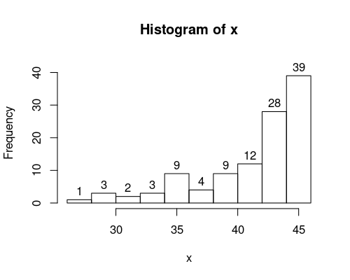
  - Evaluate .
  - Evaluate .
  - Evaluate .
  - Evaluate .
  - Find boundary such that .
  - Find boundary such that .
  - Find radius such that .
  - Find radius such that .
Solution
video
The first 4 questions involve adding up frequencies of the indicated intervals. The last 4 questions can be done by guessing and checking until something works.
  - (ANS=9) There are 9 measurements less than 34. So, .
  - (ANS=92) There are 92 measurements more than 36. So, .
  - (ANS=3) There are 3 measurements closer than 1 units from 33. So, .
  - (ANS=98) There are 98 measurements further than 1 units from 41. So, .
  - (ANS=40) A boundary at has 31 measurements less than it. So, .
  - (ANS=42) A boundary at has 67 measurements more than it. So, .
  - (ANS=7) An interval with radius around center 37 contains 67 measurements. So, .
  - (ANS=6) An interval with radius around center 38 excludes 45 measurements. So, .
- Question
A standard eight-sided die was rolled 60 times, and the results were organized into the histogram shown below.
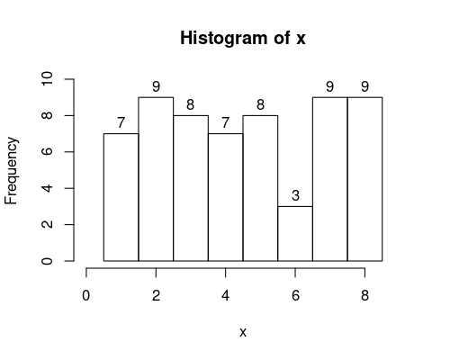
  - Evaluate .
  - Evaluate .
  - Evaluate .
  - Evaluate .
  - Evaluate half-integer boundary such that .
  - Evaluate half-integer boundary such that .
  - Evaluate integer radius such that .
  - Evaluate integer radius such that .
Solution
video
The first 4 questions involve adding up frequencies of the indicated intervals. The last 4 questions can be done by guessing and checking until something works.
  - (ANS=39) There are 39 measurements less than 5.5. So, .
  - (ANS=18) There are 18 measurements more than 6.5. So, .
  - (ANS=3) There are 3 measurements closer than 0.5 units from 6. So, .
  - (ANS=28) There are 28 measurements further than 2 units from 3.5. So, .
  - (ANS=6.5) A boundary at has 42 measurements less than it. So, .
  - (ANS=1.5) A boundary at has 53 measurements more than it. So, .
  - (ANS=1) An interval with radius around center 3.5 contains 15 measurements. So, .
  - (ANS=2) An interval with radius around center 5.5 excludes 33 measurements. So, .
- Question
A standard six-sided die was rolled 100 times, and the results were organized into the pie chart shown below.
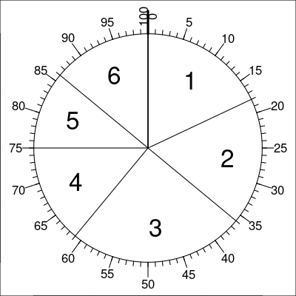
  - Evaluate .
  - Evaluate .
  - Evaluate .
  - Evaluate .
  - Evaluate half-integer boundary such that .
  - Evaluate half-integer boundary such that .
  - Evaluate half-integer radius such that .
  - Evaluate integer radius such that .
Solution
video
The first 4 questions involve adding up frequencies of the indicated intervals. The last 4 questions can be done by guessing and checking until something works.
  - (ANS=61) There are 61 measurements less than 3.5. So, .
  - (ANS=64) There are 64 measurements more than 2.5. So, .
  - (ANS=39) There are 39 measurements closer than 1 units from 3.5. So, .
  - (ANS=32) There are 32 measurements further than 2 units from 3.5. So, .
  - (ANS=4.5) A boundary at has 75 measurements less than it. So, .
  - (ANS=1.5) A boundary at has 82 measurements more than it. So, .
  - (ANS=0.5) An interval with radius around center 3 contains 25 measurements. So, .
  - (ANS=1) An interval with radius around center 3.5 excludes 61 measurements. So, .

