- Question
A random procedure generated the following sample (sequence of measurements):

You can download the data as a CSV file (for importing into a spreadsheet or R): media/supplements1/exercise1/list_proportion_basic_data.csv
  - What proportion of the measurements are less than 44? In other words, determine .
  - What proportion of the measurements are less than or equal to 45? In other words, determine .
  - What proportion of the measurements are greater than 41? In other words, determine .
  - What proportion of the measurements are greater than or equal to 47? In other words, determine .
  - If the proportion of measurements less than is 0.3, and is a measurement from sample , then what is ? In other words, determine a measurement from sequence such that .
  - If the proportion of measurements less than or equal to is 1, and is a measurement from sample , then what is ? In other words, determine a measurement from sequence such that .
  - If the proportion of measurements greater than is 0.8, and is a measurement from sample , then what is ? In other words, determine a measurement from sequence such that .
  - If the proportion of measurements greater than or equal to is 0.3, and is a measurement from sample , then what is ? In other words, determine a measurement from sequence such that .
Solution
video
First, it helps to sort the data.

You could use R to sort the data:
sort(c(42,44,41,46,47,44,47,44,41,45))
## [1] 41 41 42 44 44 44 45 46 47 47
You could also use a spreadsheet. Import the table into a spreadsheet. Then, highlight the column of measurements and use Sort function.
  - (ANS=0.3) The proportion of measurements less than 44 is 0.3.

  - (ANS=0.7) The proportion of measurements less than or equal to 45 is 0.7.

  - (ANS=0.8) The proportion of measurements greater than 41 is 0.8.

  - (ANS=0.2) The proportion of measurements greater than or equal to 47 is 0.2.

  - (ANS=44) The proportion of measurements less than 44 is 0.3.

  - (ANS=47) The proportion of measurements less than or equal to 47 is 1.

  - (ANS=41) The proportion of measurements greater than 41 is 0.8.

  - (ANS=46) The proportion of measurements greater than or equal to 46 is 0.3.

- Question
The lengths (in centimeters) of 10 lizards were recorded.

You can download the data as a CSV file (for importing into a spreadsheet or R): media/supplements1/exercise2/lizard_data.csv
  - What proportion of the measurements are inside 34.5 cm to 39.5 cm? In other words, determine . In other words, determine .
  - What proportion of the measurements are outside 32.5 cm to 35.5 cm? In other words, determine . In other words, determine .
  - What proportion of the measurements are closer than 0.5 cm from 31 cm? In other words, determine .
  - What proportion of the measurements are farther than 1 cm from 34.5 cm? In other words, determine .
  - Determine an integer radius of an interval with center 35.5 cm such that .
  - Determine an integer radius of an interval with center 36.5 cm such that .
Solution
video
First, it helps to sort the data.

You could use R to sort the data:
sort(c(35,35,36,36,32,34,33,33,31,34))
## [1] 31 32 33 33 34 34 35 35 36 36
You could also use a spreadsheet. Import the table into a spreadsheet. Then, highlight the column of measurements and use Sort function.
  - (ANS=0.4) The proportion of measurements between 34.5 and 39.5 is 0.4.

  - (ANS=0.4) The proportion of measurements outside 32.5 and 35.5 is 0.4.

  - (ANS=0.1) The proportion of measurements closer than 0.5 cm from 31 cm is 0.1.

  - (ANS=0.6) The proportion of measurements farther than 1 cm from 34.5 cm is 0.6.

  - (ANS=4) You can guess and check until you find an integer that satisfies the equation. It turns out that satisfies the equation, because

  - (ANS=2) You can guess and check until you find an integer that satisfies the equation. It turns out that satisfies the equation, because

- Question
Jordan is practicing free throws. She has recorded the results of many free throws.
Miss Hit Miss Miss Hit Miss Hit Hit Miss Miss Miss Miss Hit Miss Miss Miss Hit Miss Miss Hit Miss Miss Miss Miss Miss Hit Miss Hit Miss Miss Miss Miss Miss Miss Hit Hit Hit Miss Miss Miss Miss Miss Miss Miss Hit Miss Miss Hit Miss Miss Hit Miss Miss Miss Miss Miss Hit Miss Hit Hit Miss Miss Hit Miss Miss Hit Miss Hit Hit Hit Hit Miss Miss Miss Miss Miss Miss Miss Miss Miss Hit Hit Miss Hit Hit Miss Miss Miss Hit Hit Miss Miss Miss Miss Miss Hit Hit Hit Miss Miss Miss Miss Miss Miss Miss Miss Miss Miss Miss Hit Miss Miss Miss Miss Miss Hit Miss Miss Miss Hit Miss Miss Miss Miss Miss Miss Miss Miss Hit Miss Miss Miss Miss Miss Miss Miss Miss Miss Miss Miss Miss Miss Miss Miss Miss Miss Miss Miss
You can download the data as a csv: media/supplements1/exercise3/basketball_proportion.csv. The header and first four rows are shown below.
i
hit_or_miss
1
Miss
2
Hit
3
Miss
4
Miss

  - How many shots did Jordan attempt? (Evaluate .)
  - How many shots were successful? (Evaluate .)
  - How many shots were failures? (Evaluate .)
  - What proportion of Jordan’s shots were successful? (Evaluate .)
  - What proportion of Jordan’s shots were failures? (Evaluate .)
Solution
video
I recommend using either R or a spreadsheet.

Using R
First, download the csv. Also, write the following script, and save it as basketball_proportion.r. Put both files in the same directory (folder). Run the script.
mydata = read.csv("basketball_proportion.csv")
x = mydata$hit_or_miss
n = length(x)
ns = sum(x=="Hit")
nf = sum(x=="Miss")
phat = ns/n
qhat = nf/n
mydata = data.frame(n,ns,nf,phat,qhat)
print(mydata,row.names=F)
## n ns nf phat qhat
## 148 37 111 0.25 0.75
If you are using Rstudio, you may need to click Session, Set Working Directory, Source File Location while the script (basketball_proportion.r) is the open tab.

Using a spreadsheet
First, if you scroll down, it should be clear there are 148 rows of data, because the last row has . In column C use IF(B2="Hit",1,0) and in column D use IF(B2="Miss",1,0), and extend the formulas down, to get columns of 0s and 1s, then use SUM(C2:C148) and SUM(D2:D148) to get and . You can divide these by to determine and .
You can see a solution CSV: media/supplements1/exercise3/proportion_solution.csv. Remember, you can hit ctrl+~ to see the formulas. You may need to enlarge a cell if it shows ###.
  - (ANS=148)
  - (ANS=37) This is simply the number of times “Hit” is in the list.
  - (ANS=111) This is simply the number of times “Miss” is in the list.
  - (ANS=)
  - (ANS=)
- Question
A random procedure generated measurements: download data
I’ve already determined the frequencies. Please determine the relative frequencies and the densities. A brief description of relative frequency and density can be found here.
Interval
Frequency
Relative_frequency
Density
25 to 30
1
##ANSWER1##
##ANSWER2##
30 to 35
2
##ANSWER3##
##ANSWER4##
35 to 40
9
##ANSWER5##
##ANSWER6##
40 to 45
8
##ANSWER7##
##ANSWER8##
45 to 50
55
##ANSWER9##
##ANSWER10##
Solution
video
To determine the relative frequencies, just divide each frequency by 75 (because ). To determine the densities, divide the relative frequencies by the width of the interval, which in this case is the same for each interval ().
Interval
Frequency
Relative_frequency
Density
25 to 30
1
0.01333
0.002667
30 to 35
2
0.02667
0.005333
35 to 40
9
0.12000
0.024000
40 to 45
8
0.10670
0.021330
45 to 50
55
0.73330
0.146700
- Question
A random procedure generated 80 measurements, which were organized into the frequency distribution shown below. You can assume the measurements are of a continuous random variable, such that every measurement is in one of the intervals (and not on a break).
Interval
Frequency
Relative_frequency
Density
21 to 22
1
0.0125
0.0125
22 to 23
9
0.1125
0.1125
23 to 24
11
0.1375
0.1375
24 to 25
14
0.1750
0.1750
25 to 26
17
0.2125
0.2125
26 to 27
21
0.2625
0.2625
27 to 28
5
0.0625
0.0625
28 to 29
1
0.0125
0.0125
29 to 30
1
0.0125
0.0125
  - Evaluate .
  - Evaluate .
  - Evaluate .
  - Evaluate .
  - Evaluate boundary such that .
  - Evaluate boundary such that .
  - Evaluate radius such that .
  - Evaluate radius such that .
Solution
video
The first 4 questions involve adding up relative frequencies of the indicated intervals. The last 4 questions can be done by guessing and checking until something works.
  - (ANS=0.975 0.01) There are 78 measurements less than 28. So, .
  - (ANS=0.35 0.01) There are 28 measurements more than 26. So, .
  - (ANS=0.8625 0.01) There are 69 measurements closer than 3 units from 26. So, .
  - (ANS=0.2875 0.01) There are 23 measurements further than 2 units from 26. So, .
  - (ANS=24) First, . A boundary at has 21 measurements less than it. So, .
  - (ANS=26) First, . A boundary at has 28 measurements more than it. So, .
  - (ANS=2.5) First, . An interval with radius around center 24.5 contains 72 measurements. So, .
  - (ANS=1.5) First, . An interval with radius around center 23.5 excludes 46 measurements. So, .
- Question
A random procedure generated 500 measurements, which were organized into the histogram shown below. You can assume the measurements are of a continuous variable, such that every measurement is in one of the intervals (and not on a break).
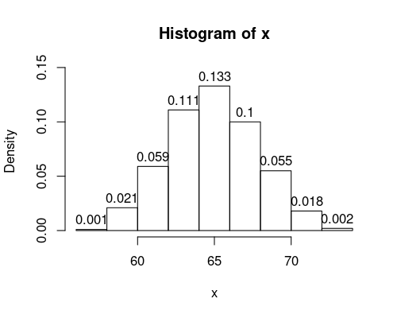
  - Evaluate .
  - Evaluate .
  - Evaluate .
  - Evaluate .
  - Evaluate boundary such that .
  - Evaluate boundary such that .
  - Evaluate radius such that .
  - Evaluate radius such that .
Solution
video
You may find it helpful to convert the densities to frequencies by multiplying each density by both the total sample size () and the width of the bar (2).
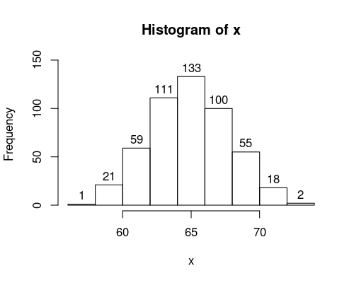
The first 4 questions involve adding up frequencies of the indicated intervals. The last 4 questions can be done by guessing and checking until something works.
  - (ANS=0.96) There are 480 measurements less than 70. So, .
  - (ANS=0.956) There are 478 measurements more than 60. So, .
  - (ANS=0.31) There are 155 measurements closer than 2 units from 68. So, .
  - (ANS=0.388) There are 194 measurements further than 4 units from 68. So, .
  - (ANS=72) A boundary at has 498 measurements less than it. So, .
  - (ANS=64) A boundary at has 308 measurements more than it. So, .
  - (ANS=2) An interval with radius around center 66 contains 233 measurements. So, .
  - (ANS=5) An interval with radius around center 65 excludes 42 measurements. So, .
- Question
A standard eight-sided die was rolled 500 times, and the results were organized into the histogram shown below.
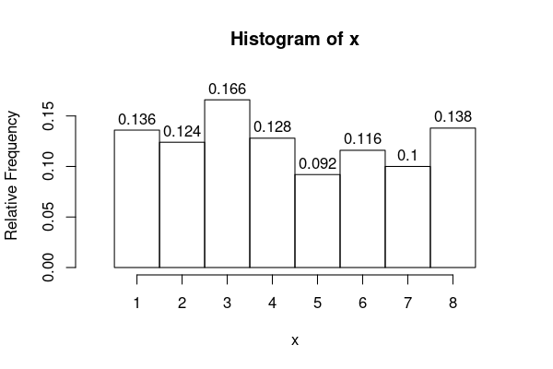
  - Evaluate .
  - Evaluate .
  - Evaluate .
  - Evaluate .
  - Evaluate half-integer boundary such that .
  - Evaluate half-integer boundary such that .
  - Evaluate half-integer radius such that .
  - Evaluate half-integer radius such that .
Solution
video
The first 4 questions involve adding up relative frequencies of the indicated intervals. The last 4 questions can be done by guessing and checking until something works.
You may also find it is helpful to determine frequencies (counts). You do this by multiplying each relative frequency by the total number of measurements.
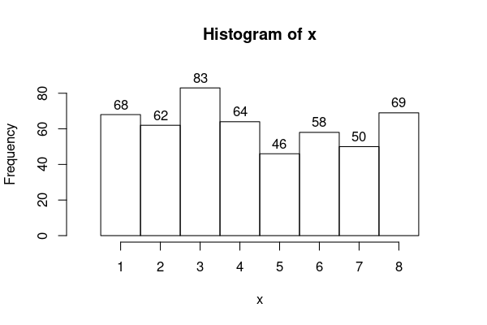
  - (ANS=0.554) There are 277 measurements less than 4.5. So, .
  - (ANS=0.354) There are 177 measurements more than 5.5. So, .
  - (ANS=0.208) There are 104 measurements closer than 1 units from 5.5. So, .
  - (ANS=0.692) There are 346 measurements further than 1.5 units from 6. So, .
  - (ANS=5.5) First, convert the proportion into a count. . A boundary at has 323 measurements less than it. So, .
  - (ANS=3.5) First, convert the proportion into a count. . A boundary at has 287 measurements more than it. So, .
  - (ANS=1.5) An interval with radius around center 5 contains 168 measurements. So, .
  - (ANS=0.5) An interval with radius around center 7 excludes 450 measurements. So, .
- Question
A standard eight-sided die was rolled 20 times, and the results were organized into the pie chart shown below. The marks outside of the circle indicate the cumulative proportion.
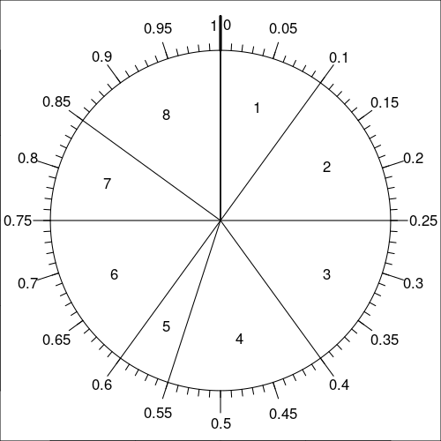
  - Evaluate .
  - Evaluate .
  - Evaluate .
  - Evaluate .
  - Evaluate half-integer boundary such that .
  - Evaluate half-integer boundary such that .
  - Evaluate integer radius such that .
  - Evaluate half-integer radius such that .
Solution
video
The first 4 questions involve adding up relative frequencies of the indicated intervals. The last 4 questions can be done by guessing and checking until something works.
  - (ANS=0.75) The proportion of measurements less than 6.5 is 0.75.

  - (ANS=0.45) The proportion of measurements more than 4.5 is 0.45.

  - (ANS=0.65) The proportion of measurements closer than 2.5 units from 4 is 0.65.

  - (ANS=0.85) The proportion of measurements farther than 0.5 units from 2 is 0.85.

  - (ANS=2.5) The proportion of measurements less than 2.5 is 0.25.

  - (ANS=1.5) The proportion of measurements more than 1.5 is 0.9.

  - (ANS=2) The proportion of measurements closer than 2 units from 5.5 is 0.45.

  - (ANS=0.5) The proportion of measurements farther than 0.5 units from 3 is 0.85.

