- Question
Match the five histograms with their appropriate description.
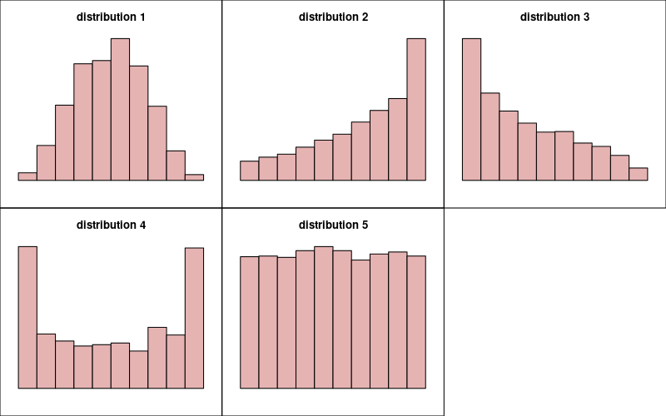
  - Right-skew (Enter an integer between 1 and 5)
  - Uniform (Enter an integer between 1 and 5)
  - Bell (Enter an integer between 1 and 5)
  - Left-skew (Enter an integer between 1 and 5)
  - Bimodal (Enter an integer between 1 and 5)
Solution
video
This is definitional.
  - 3
  - 5
  - 1
  - 2
  - 4
- Question
A sample of size was taken from an unknown population.
4.39, 2.09, 3.66, 0.64, 6.49, 8.31, 0.37, 1.75, 7.33, 2.96,
2.24, 7.42, 2.61, 5.19, 7.01, 8.84, 3.18, 0.36, 3.85, 9.78,
2.07, 2.41, 2.06, 8.16, 2.02, 3.65, 3.86, 7.43, 5.57, 6.01,
3.80, 5.53, 9.52, 1.24, 6.63, 8.10, 1.71, 4.06, 3.89, 5.13,
6.71, 3.51, 8.12, 1.92, 3.62, 6.50, 1.32, 3.87, 2.85, 8.98,
9.25, 5.15, 3.70, 3.79, 2.13, 6.39, 8.65, 5.15, 3.00, 2.43,
1.93, 9.97, 5.88, 1.60, 4.45, 0.02, 6.62, 0.69, 4.96, 8.78,
1.62, 4.04, 5.95, 5.55, 7.45, 6.48, 9.66, 3.12,10.00, 0.99,
8.62, 0.38, 6.60, 8.44, 9.88, 2.18, 6.41, 6.04, 8.66, 7.58,
7.64, 2.02, 9.62, 0.43, 4.36, 1.23, 1.26, 8.36, 8.57, 9.57,
3.83, 1.86, 8.78, 3.98, 8.72, 2.90, 2.08, 6.14, 5.39, 0.47,
8.39, 4.64, 3.36, 5.92, 4.67, 7.63, 1.93, 1.76, 9.07, 2.16,
9.46, 3.76, 3.50, 1.68, 7.13, 1.26, 6.32, 2.79, 1.84, 6.69,
5.75, 9.96, 6.79, 2.75, 5.80, 6.63, 7.75, 3.96, 0.62, 6.76,
9.02, 1.13, 5.81, 1.90, 6.00, 9.53, 6.41, 1.31, 2.01, 4.52,
7.03, 2.32, 4.57, 2.85, 3.94, 2.61, 4.17, 3.17, 7.05, 3.34,
1.80, 9.92, 6.48, 0.82, 5.88, 1.83, 7.82, 7.42, 2.12, 8.71,
8.48, 9.80, 9.20, 6.95, 4.09, 1.05, 5.14, 0.52, 3.04, 4.11,
6.81, 7.67, 7.22, 1.19, 0.82, 1.75, 7.57, 1.98, 9.58, 4.42,
8.23, 5.94, 6.77, 4.73, 9.20, 0.69, 0.07, 0.78, 4.90, 7.01
You can download the data as a CSV. Determine which histogram visualizes the data, and describe the shape of the data.
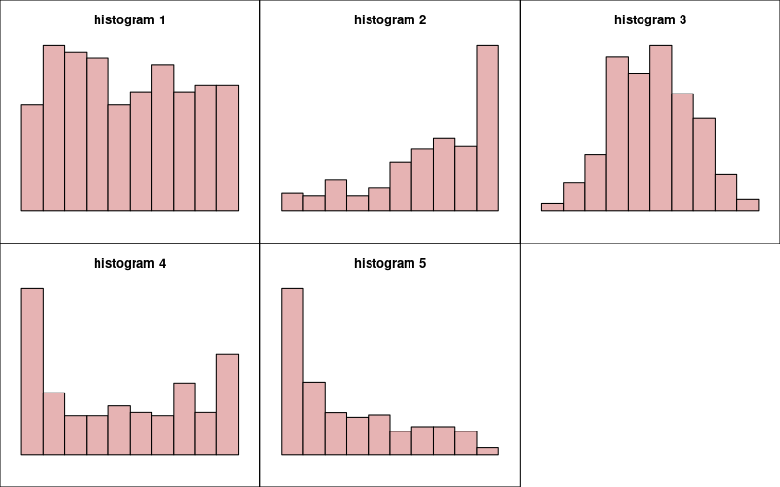
  - Which histogram is appropriate? ##ANSWER1##
  - Which shape description is appropriate? ##ANSWER2##
  - histogram 1 / histogram 2 / histogram 3 / histogram 4 / histogram 5
  - Bell / Uniform / Bimodal / Right-skew / Left-skew
Solution
video
You should make a histogram. This is easy in R.
x = read.csv("make_hist.csv")$x
hist(x)
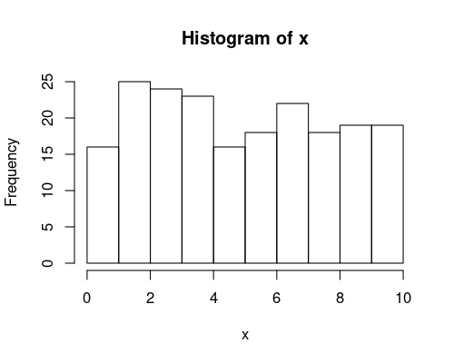
Using a spreadsheet is way more work. But, you could use the FREQUENCY function.
The correct histogram is number 1. The correct description is Uniform.
  - TRUE / FALSE / FALSE / FALSE / FALSE
  - FALSE / TRUE / FALSE / FALSE / FALSE

