- Question
A sample was taken from an unknown population. The values were organized into a boxplot.
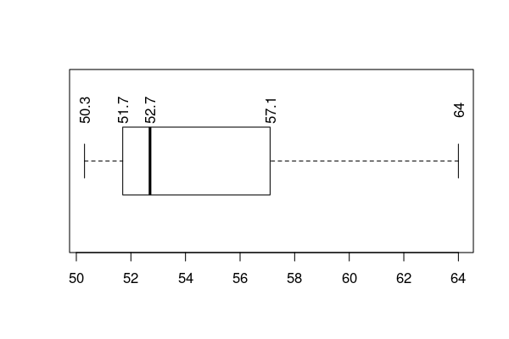
For simplicity, assume no measurements lie on the hinges, median, or whisker tips (so we do not worry about inclusive vs. exclusive boundaries). This assumption is approximately true with a very large sample from a continuous distribution.
  - What proportion of measurements are below 57.1?

  - What proportion of measurements are above 51.7?

  - What proportion of measurements are between 52.7 and 57.1?

  - What proportion of measurements are closer than 2.2 units from 54.9?

  - Determine boundary such that .
  - Determine boundary such that .
  - What is the range?
  - What is the interquartile range (IQR)?
  - What is the median?
Solution
video
You need to know that each region (whisker or half-box) contains 25% of the measurements.
  - 0.75
  - 0.75
  - 0.25
  - 0.25
  - 57.1
  - 52.7
  - 13.7. Subtract min from max.

  - 5.4. Subtract from .

  - 52.7
- Question
Five different populations were sampled, and the measurements were visualized as five boxplots. (Note: typical boxplots indicate outliers with dots. For simplicity, these boxplots include all outliers in the whiskers.)
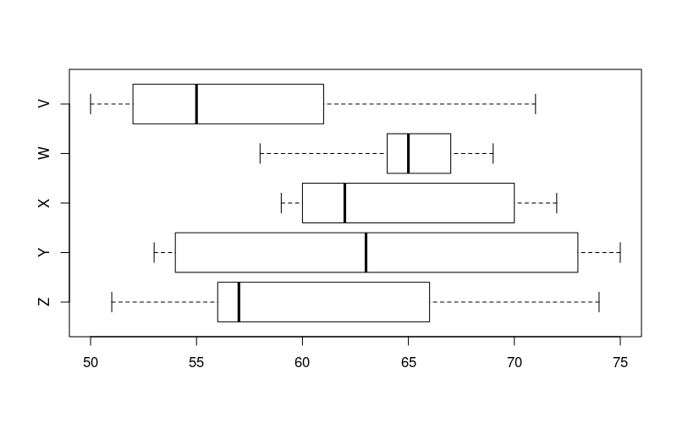
  - Which sample contains the largest value? ##ANSWER1##
  - Which sample contains the smallest value? ##ANSWER2##
  - Which sample has the largest median? ##ANSWER3##
  - Which sample has the smallest median? ##ANSWER4##
  - Which sample has the largest IQR? ##ANSWER5##
  - Which sample has the smallest IQR? ##ANSWER6##
  - V / W / X / Y / Z
  - V / W / X / Y / Z
  - V / W / X / Y / Z
  - V / W / X / Y / Z
  - V / W / X / Y / Z
  - V / W / X / Y / Z
Solution
video
  - Y. You find the sample with a whisker that goes furthest to the right.
  - V. You find the sample with a whisker that goes furthest to the left.
  - W. You find the sample with the median (thick line in middle of box) furthest to the right.
  - V. You find the sample with the median (thick line in middle of box) furthest to the left.
  - Y. You find the sample with the widest box.
  - W. You find the sample with the narrowest box.
- Question
Match the five boxplots with their appropriate description.
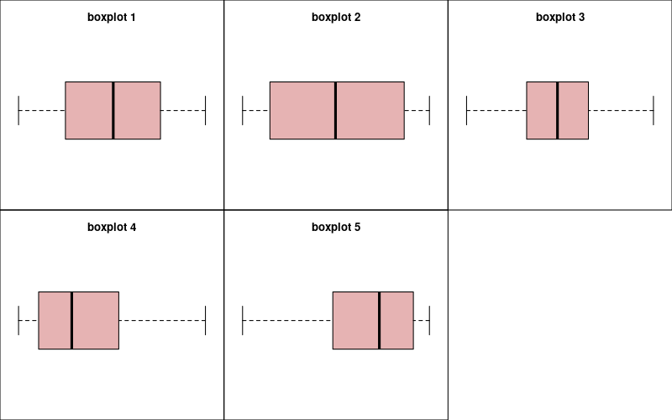
  - Uniform (Enter an integer between 1 and 5)
  - Right-skew (Enter an integer between 1 and 5)
  - Bimodal (Enter an integer between 1 and 5)
  - Left-skew (Enter an integer between 1 and 5)
  - Bell (Enter an integer between 1 and 5)
Solution
video
  - The bell shape has many measurements near the median and some measurements far, so its box is small but whiskers long.
  - The uniform shape has 4 approximately equal regions (left whisker, left side of box, right side of box, and right whisker).
  - The bimodal distribution has few measurements near the median and many far from it, so its box is large and whiskers small.
  - The right-skew distribution has a few measurements much higher than the median, so its right whisker is long.
  - The left-skew distribution has a few measurements much lower than the median, so its left whisker is long.
  - 1
  - 4
  - 2
  - 5
  - 3

