- Question
A sample’s statistic typically approaches its corresponding population parameter, but with a small sample size there is regularly error. Let’s explore this idea with an example.
A geometric distribution is a well-studied discrete population. The spinner below represents a geometric distribution with the following population parameters.

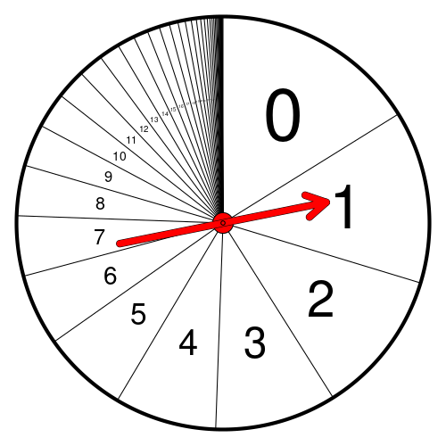
That spinner was spun many times. The raw data is displayed below and can be downloaded as a CSV.
0, 16, 7, 14, 1, 3, 3, 2, 2, 7, 5, 13, 2, 1, 7, 0, 3, 1, 3, 3, 0, 1, 1, 5, 4, 15, 3, 4, 17, 6, 3, 3, 6, 10, 4, 6
Please calculate the following sample statistics.
  - What is the sample size? (Determine .)
  - What is the sample mean? (Determine . You can round to nearest hundredth.)
  - What is the absolute difference between the sample mean and population mean? (Calculate . You can round to nearest hundredth.)
  - What is the sample median?
  - What is the sample variance? (Determine . Use Bessel’s correction. You can round to nearest hundredth.)
  - What is the sample standard deviation? (Determine . Use Bessel’s correction. You can round to nearest hundredth.)
  - What is the absolute difference between the sample standard deviation and population standard deviation? (Calculate . You can round to nearest hundredth.)
Solution
Notice the sample mean and sample standard deviation do not match the population mean and population standard deviation exactly.
  - 36
  - 5.0277778
  - 0.1622222
  - 3
  - 21.9134921
  - 4.6811849
  - 0.9888151
- Question
A normal distribution is a well-studied continuous population. The spinner below represents a normal distribution with the following population parameters.

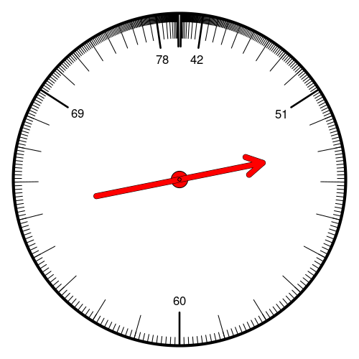
That spinner was spun many times. The raw data is displayed below and can be downloaded as a CSV.
67.4371, 56.3106, 61.3391, 61.1526, 68.2392, 59.6406, 63.7812, 74.4878, 59.8167, 54.7681, 81.4433, 61.4576, 69.0663, 60.2432, 50.0677, 44.4206, 67.1076, 54.7011, 63.8357, 83.122, 63.2327, 62.4968, 51.8068, 47.6723, 46.7319, 41.1746, 60.9347, 53.6657, 69.2807, 59.3245, 51.6598, 50.754, 68.5222, 59.7632, 61.0823, 71.6002, 72.6268, 50.6607, 59.244, 69.8136, 70.3261, 74.843, 57.4301, 55.447, 42.638, 73.2516, 58.8032, 62.7881, 59.084, 71.5408, 53.8271, 47.4346, 53.1795, 49.1614, 50.8525, 57.1755, 64.6353, 63.6885, 66.2577, 50.8121, 52.6661, 64.9483, 56.9247, 66.118, 51.2642, 42.1623, 60.248, 57.6894, 79.0052, 55.3029, 45.014, 59.1809, 54.7421, 65.3082, 58.9057, 61.7132, 42.0594, 66.4479, 52.1702, 65.8832, 34.5637, 54.1693
Please calculate the following sample proportions. (All answers can be rounded to nearest hundredth.)
  - Calculate .
  - Calculate .
  - Calculate .
  - Calculate .
Solution
  - 0.6341463
  - 0.3658537
  - 0.4268293
  - 0.804878
- Question
A standard eight-sided die was rolled many times, and the results were organized into the histogram shown below.
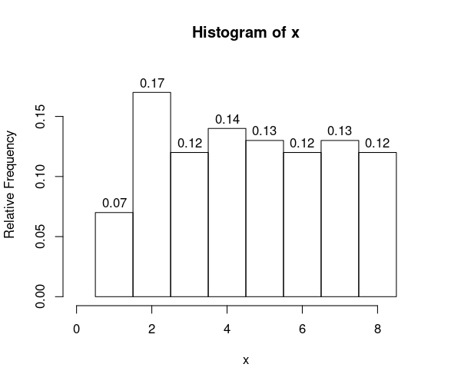
  - Evaluate .
  - Evaluate .
  - Evaluate .
  - Evaluate .
  - Evaluate half-integer boundary such that .
  - Evaluate half-integer boundary such that .
  - Evaluate integer radius such that .
  - Evaluate half-integer radius such that .
Solution
  - The answer is 0.24 because .
  - The answer is 0.37 because .
  - The answer is 0.64 because .
  - The answer is 0.32 because .
  - The answer is 3.5 because .
  - The answer is 5.5 because .
  - The answer is 2 because .
  - The answer is 1.5 because .
- Question
Three large samples were taken from three different populations. Their distributions are shown as histograms.
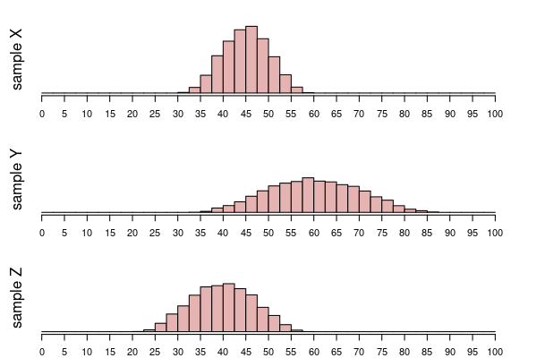
  - Which sample has the smallest mean? ##ANSWER1##
  - Which sample has the largest mean? ##ANSWER2##
  - Which sample has the smallest standard deviation? ##ANSWER3##
  - Which sample has the largest standard deviation? ##ANSWER4##
  - X / Y / Z
  - X / Y / Z
  - X / Y / Z
  - X / Y / Z
Solution
All three distributions look like they have similar bell shape, but their centers and spreads are all different.
  - The distribution with its center sitting furthest left has the smallest mean. / . / .
  - The distribution with its center sitting furthest right has the largest mean. / . / .
  - The least wide distribution has the smallest standard deviation. It is this simple because all distributions have the same shape. / . / .
  - The most wide distribution has the largest standard deviation. It is this simple because all distributions have the same shape. / . / .
- Question
Three large samples were taken from three different populations. Their distributions are shown as histograms.
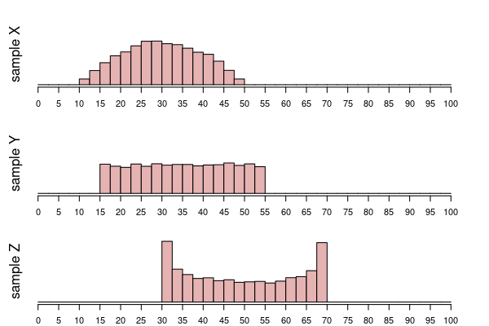
  - Which sample has the smallest mean? ##ANSWER1##
  - Which sample has the largest mean? ##ANSWER2##
  - Which sample has the smallest standard deviation? ##ANSWER3##
  - Which sample has the largest standard deviation? ##ANSWER4##
  - X / Y / Z
  - X / Y / Z
  - X / Y / Z
  - X / Y / Z
Solution
All three distributions look like they have similar ranges (widths), but different shapes. So, we will use the fact that for a given range, bell shape has the smallest standard deviation and bimodal has the largest standard deviation. This is because a bell shape has many measurements near the middle, whereas the bimodal shape has many measurements near the edges of its interval.
  - The distribution with its center sitting furthest left has the smallest mean. / . / .
  - The distribution with its center sitting furthest right has the largest mean. / . / .
  - The bell shape has the smallest standard deviation. It is this simple because all the distributions have the same range, but the bell has a higher fraction near its mean. / . / .
  - The bimodal shape has the largest standard deviation. It is this simple because all the distributions have the same range, but the bimodal shape has a higher fraction far from its mean. / . / .
- Question
Five different populations were sampled, and the measurements were visualized as five boxplots. (Note: typical boxplots indicate outliers with dots. For simplicity, these boxplots include all outliers in the whiskers.)
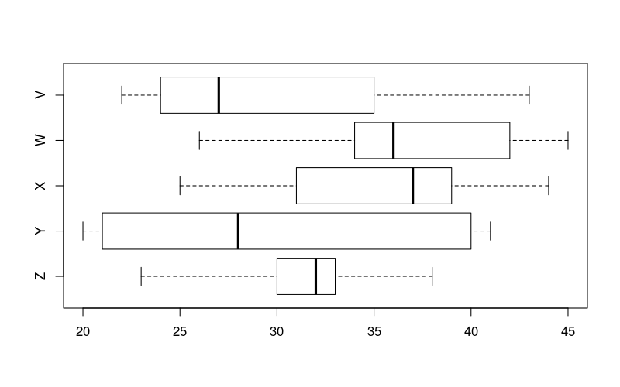
  - Which sample contains the largest value? ##ANSWER1##
  - Which sample contains the smallest value? ##ANSWER2##
  - Which sample has the largest median? ##ANSWER3##
  - Which sample has the smallest median? ##ANSWER4##
  - Which sample has the largest IQR? ##ANSWER5##
  - Which sample has the smallest IQR? ##ANSWER6##
  - V / W / X / Y / Z
  - V / W / X / Y / Z
  - V / W / X / Y / Z
  - V / W / X / Y / Z
  - V / W / X / Y / Z
  - V / W / X / Y / Z
Solution
video
  - W. You find the sample with a whisker that goes furthest to the right.
  - Y. You find the sample with a whisker that goes furthest to the left.
  - X. You find the sample with the median (thick line in middle of box) furthest to the right.
  - V. You find the sample with the median (thick line in middle of box) furthest to the left.
  - Y. You find the sample with the widest box.
  - Z. You find the sample with the narrowest box.
- Question
When measuring individuals from a population, we expect most measurements to be within the interval of typical measurements. We will define the interval of typical measurements (using interval notation):

In other words, we expect we expect most measurements to be between two bounds.

Actual Question
A population of lizards has a mean length of cm and a standard deviation of cm. Determine the interval of typical measurements.
  - Determine the lower bound of the interval of typical measurements.
  - Determine the upper bound of the interval of typical measurements.
Solution
You need to use the formulas. Remember your order of operations!
  - Use the formula.
  - Use the formula.
- Question
We can visualize the “68-96-100” rule with a density curve. Notice the area of each region is shown, and you can estimate the areas by counting percentage boxes.
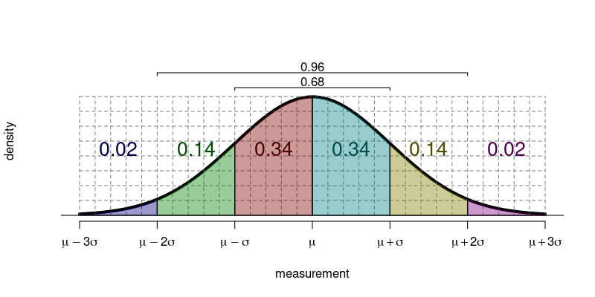
Population has measurements that are normally distributed with mean and standard deviation . Use the empirical rule (68-96-100 rule) to answer the following questions.
  - Evaluate .
  - Evaluate .
  - Evaluate .
  - Determine boundary such that .
  - Determine boundary such that .
  - Determine radius such that .
Solution
It helps to draw a diagram using the supplied mean () and standard deviation ().
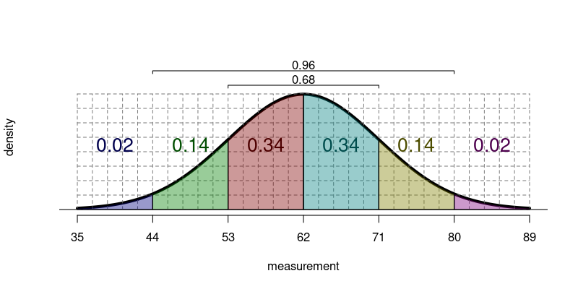
  - The answer is 0.02 because .
  - The answer is 0.84 because .
  - The answer is 0.68 because .
  - The answer is 62 because .
  - The answer is 80 because .
  - The answer is 18 because .
- Question
A standard score () can be calculated from a measurement (), the population mean (), and the population standard deviation ().

The following (normal) spinner has population mean and population standard deviation .
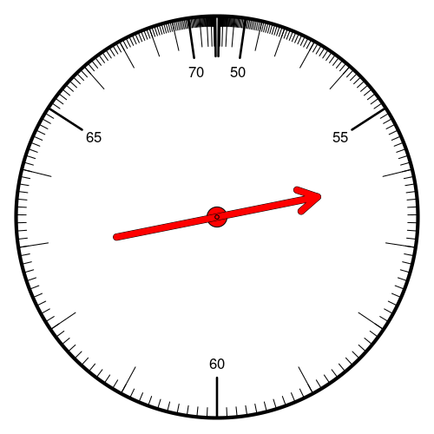
  - If a spin has a measurement , what is the standard score ()?
  - If a spin has a standard score , what is the measurement ()?
Solution
  - Use the formula.

  - Use the formula.

- Question
A sample of size was taken from an unknown population.
7.81, 7.58, 4.92,10.00, 8.35,10.00, 4.44, 4.42, 8.10, 4.02,
8.76, 9.94, 9.80, 7.01, 9.49, 8.55, 8.54, 9.81, 5.11, 4.45,
6.26, 9.78, 9.80, 9.74, 8.93, 9.84, 4.57, 8.60, 2.06, 4.23,
9.01, 8.62, 2.96, 5.20, 9.76, 5.24, 7.65, 5.95, 7.42, 5.23,
3.61, 9.69, 7.07,10.00, 4.38, 4.57, 7.71, 6.29, 6.93, 8.32,
3.64, 7.02, 2.24, 5.62, 9.72, 5.20, 4.09, 5.60, 8.57, 6.78,
9.58, 5.68, 1.25, 3.29, 4.30, 8.89, 2.91, 9.98, 9.01, 2.76,
7.21,10.00, 5.29, 6.54, 9.99, 3.52, 8.46, 6.50, 3.19, 1.37,
9.64, 7.69, 4.02, 9.20, 9.28, 6.76, 9.96, 9.89, 9.82, 2.00,
2.61, 9.02, 8.12, 2.47, 9.61, 5.72, 7.39, 2.50, 8.71,10.00,
4.17, 8.74, 9.12, 3.50, 5.67, 1.62, 9.03, 9.92, 6.72, 9.98,
9.85, 9.52, 8.62, 7.96, 8.79,10.00, 5.69, 8.98, 9.95, 2.04,
8.02, 9.68, 4.48, 8.54, 8.55, 7.60, 7.32, 6.35, 3.00, 2.73,
5.31, 9.61, 8.33, 8.25, 4.97, 9.69, 6.56, 8.20, 5.01, 3.77,
1.30, 8.85, 9.52, 7.30, 7.93, 4.77, 9.80, 9.05, 5.61, 3.93,
8.98, 9.61, 7.16, 9.28, 8.31, 4.76, 3.92, 4.66, 8.33, 9.74,
3.41, 2.26, 8.43, 1.42, 8.36, 6.43, 5.00, 7.88, 2.53, 2.31,
9.90, 8.60, 5.34, 6.51, 9.73, 8.91, 3.41, 8.89, 7.79, 8.93,
7.03,10.00, 9.83, 6.27, 5.80, 4.67, 6.48, 6.88, 9.87, 9.65,
9.76, 8.96, 4.48, 4.16, 4.49, 8.77, 9.07, 4.41, 5.95, 8.95
You can download the data as a CSV. Determine which histogram visualizes the data, and describe the shape of the data.
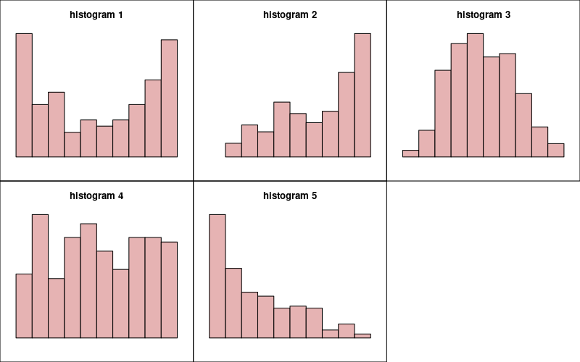
  - Which histogram is appropriate? ##ANSWER1##
  - Which shape description is appropriate? ##ANSWER2##
  - histogram 1 / histogram 2 / histogram 3 / histogram 4 / histogram 5
  - Bell / Uniform / Bimodal / Right-skew / Left-skew
Solution
video
You should make a histogram. This is easy in R.
x = read.csv("make_hist.csv")$x
hist(x)
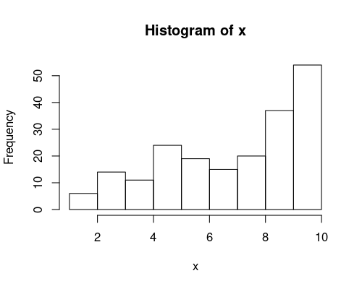
Using a spreadsheet is way more work. But, you could use the FREQUENCY function.
The correct histogram is number 2. The correct description is Left-skew.
  - FALSE / TRUE / FALSE / FALSE / FALSE
  - FALSE / FALSE / FALSE / FALSE / TRUE

