- Question
In a deck of strange cards, there are 471 cards. Each card has an image and a color. The amounts are shown in the table below and can be downloaded as a csv.
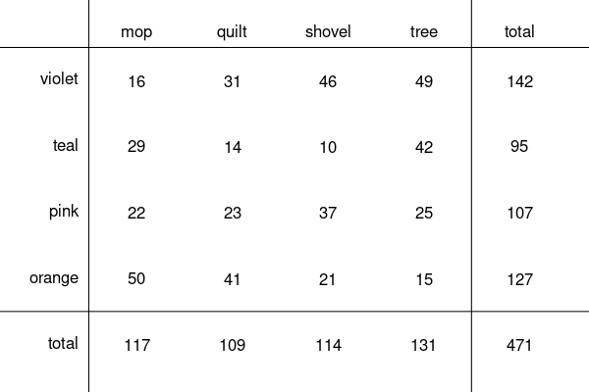
(Answers can be rounded to nearest hundredth.)
  - ##ANSWER1##
  - ##ANSWER2##
  - ##ANSWER3##
  - Between a quilt and a shovel, which is more likely to be a orange? ##ANSWER4##
  - ##ANSWER5##
  - ##ANSWER6##
  - ##ANSWER7##
  - What is the probability a random card is either a mop or orange (or both)?
  - What is the probability a random card is a shovel?
  - What is the probability a random card is a tree given it is pink?
  - A quilt. / A shovel.
  - What is the probability a random card is both a quilt and orange?
  - What is the probability a random card is teal given it is a tree?
  - What is the probability a random card is teal?
Solution
video
The key logical terms are “and”, “or”, and “given”. Notice that I am using “given” as a shorter version of “under the condition”.

  - and , so a quilt is more likely to be orange than a shovel is. / .

- Question
A spinner was constructed:
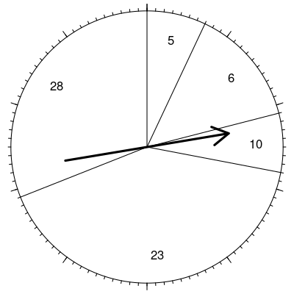
The spinner’s probability distribution is shown below.

5
0.07
6
0.14
10
0.07
23
0.41
28
0.31
It can also be downloaded as a csv.
  - What is the probability of spinning 6? In other words, what is ?
  - What is the probability of spinning 5 or 28? In other words, what is ?
  - If spinning twice, what is the probability of first spinning 5 and then spinning 28? In other words, what is ?
  - What is the probability of spinning at most 23? In other words, what is ?
  - Determine the mean of the probability distribution by using .
  - Determine the standard deviation of the probability distribution by using .
Solution
video
Make a table (for parts mean and standard deviation).

5
0.07
0.35
-15
225
15.75
6
0.14
0.84
-14
196
27.44
10
0.07
0.7
-10
100
7
23
0.41
9.43
3
9
3.69
28
0.31
8.68
8
64
19.84

  - 0.14
  - = 0.38
  - = 0.0217
  - 0.69

- Question
How many unique ways can the letters in “AAAAABBBBBBBBBBBBBBBBB” be rearranged? (There are 5 As and 17 Bs.)
Solution
video
This scenario describes a combinations problem (order does not matter). We are considering the subsets of size 5 from a set of size 22.

- Question
A committee is judging the performances of 20 different acrobats. The committee needs to assign 1st prize and 2nd prize. How many ways could the committee assign the prizes?
Solution
video
This scenario describes a permutations problem (order matters). We are considering the nonrepeating sequences of size 2 from a set of size 20.

- Question
In some situation, each trial has 0.47 probability of success. There will be 7 trials. (Thus the number of successes will follow a binomial distribution.)
  - What is the probability of getting exactly 4 successes? In other words, determine .
  - What is the probability of getting exactly 2 successes? In other words, determine .
  - What is the probability of getting more than 2 successes? In other words, determine .
  - What is the probability of getting at least 2 successes? In other words, determine .
  - What is the probability of getting less than 2 successes? In other words, determine .
  - What is the probability of getting at most 2 successes? In other words, determine .
  - Determine the mean number of successes.
  - Determine the standard deviation of successes.
Solution
video
This is a binomial distribution, so use the appropriate formulas.

where is the probability of success on each trial, is a specific number of successes, is the number of trials, and is the combinations operator (so that ). Some people prefer to also use as the probability of failure, such that .

You will also need to add mutually exclusive probabilities (when multiple -values satisfy the probability’s condition). It is also helpful to be aware of the complement rule.

  - Because this is a binomial distribution, , so
  - Because this is a binomial distribution, , so
- Question
Bob has a 0.51 chance of winning a game. If Bob wins, he has a 0.45 chance of being happy after the game. If Bob loses, he has a 0.11 chance of being happy after the game.
After the game, you notice Bob is happy. What is the probability that Bob won his game? (Do not answer as a percentage; answer as a decimal.)
Solution
(ANS=0.8098095)
video
Use the definition of conditional probability.

We can first determine all the joint probabilities.

Notice there are two disjoint ways Bob could be happy.

So, back to the conditional probability.

- Question
Cindy has two games today. Each game she will either win or lose. She has a 0.31 chance of winning the first game and a 0.79 chance of winning the second game.
  - What is the chance Cindy wins both games?
  - What is the chance Cindy loses both games?
  - What is the chance Cindy wins once and loses once (in either order)?
Solution
video

  - Win,win: 0.31 * 0.79 = 0.2449
  - Lose,lose: (1-0.31) * (1-0.79) = 0.1449
  - WL or LW: 1-0.2449-0.1449 = 0.6102

