- Question
This question provides , , , and . You will characterize the sampling distribution, calculate the standard score, determine the percentile rank (expressed as a decimal), and translate the score into a rating (see below).

Population
When Archie practices archery, each arrow has the same probability distribution (see i.i.d). This means her skill is constant, there is no hot-hand effect, and there is no maturity of chances.
Over many months, Archie has shot ten thousand arrows (their positions are shown below as dots).
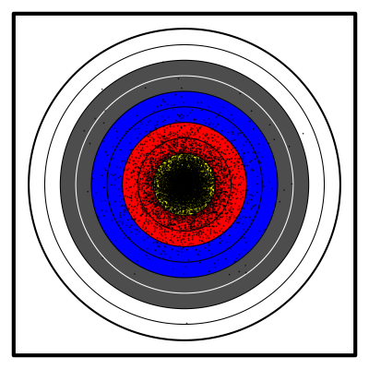
From those many arrows, Archie has determined an accurate probability distribution (of the points scored by an arrow).
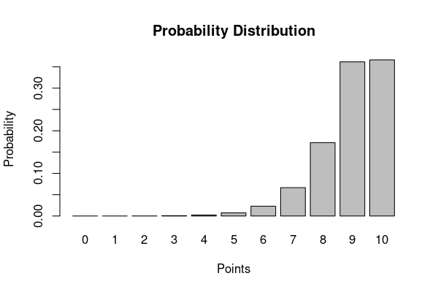
Thus, Archie can determine her population mean and population standard deviation.

Sampling distribution
Each day, Archie shoots 120 arrows () and determines that day’s mean score. A mean of 10 would be a perfect day. We can treat each day’s mean as a random variable with its own probability distribution: a sampling distribution. We wish to characterize this sampling distribution. From the central limit theorem, we know the sampling distribution is approximately normal; however, we need to calculate the parameters.

Expected mean (mean of sampling distribution)
The expected mean is simply the population mean.

“Expected mean” is a misnomer. It is not necessarily likely, or even possible, for a mean to equal the expected mean. However, if Archie repeatedly shot 120 arrows, we expect the means to have a average equal to the expected mean. So, maybe “average of means” would be better terminology.
This expected mean is the average of the sampling distribution.
##ANSWER1##
(Round to the hundredths place)

Standard error (standard deviation of sampling distribution)
The standard error of a mean is the quotient of the population standard deviation and the square root of the sample size.

This standard error is the standard deviation of the sampling distribution.
##ANSWER2##
(Round to the thousandths place)

Sample
Today, Archie’s mean score is 8.983 points ().
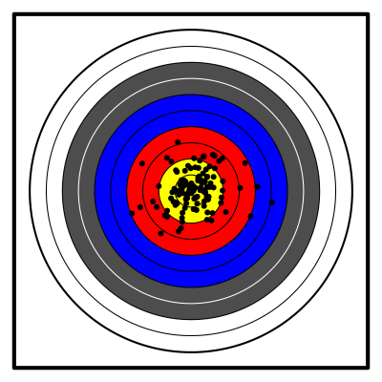

Standard score
Archie would like to know how well she did today. She wants you to calculate a standard score (a score). To calculate the standard score of a sample mean, you can use the following formula.

##ANSWER3##
(Round to the hundredths place)

Cumulative probability (percentile rank)
Archie would like to know the probability that tomorrow she shoots worse than today. To estimate this, report the cumulative probability associated with the -score you calculated. This can be done with a table, pnorm function in R, NORM.DIST function in a spreadsheet, or with other standard normal tools.
##ANSWER4##
(Round to the ten-thousandths place)

Rating
Archie would like a rating for her day’s performance. You decide to use the following scale and that if is on a boundary, Archie will be given the higher rating.
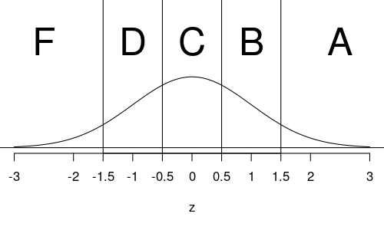
Determine Archie’s rating: ##ANSWER5##
  - Determine the expected mean:
  - Calculate the standard error:
  - Calculate the standard score:
  - Calculate , the cumulative probability:
  - A / B / C / D / F
Solution
video
The sampling distribution is approximately normal with mean 8.95 and standard error 0.1. The sampling distribution can be visualized, along with today’s mean (8.983) highlighted in red. The cumulative probability is the sum of the probabilities of scores less than (or equal) 8.983. Thus, the area highlighted in blue represents the cumulative probability.
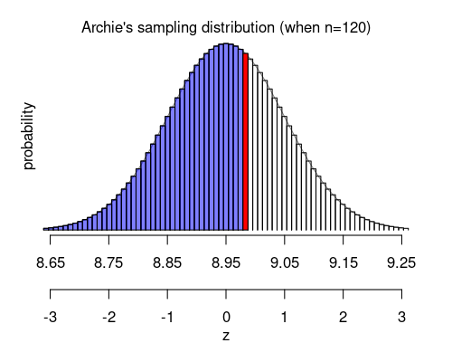
  - The expected mean is
  - The standard error is
  - Use the formula to calculate
  - Use the table to find
  - The proper rating is C / The proper rating is C / The proper rating is C / The proper rating is C / The proper rating is C
- Question
This question provides , , , and . You will characterize the sampling distribution, calculate the standard score, determine the percentile rank (expressed as a decimal), and translate the score into a rating (see below).

Population
When Archie practices archery, each arrow has the same probability distribution (see i.i.d). This means her skill is constant, there is no hot-hand effect, and there is no maturity of chances.
Over many months, Archie has shot ten thousand arrows (their positions are shown below as dots).
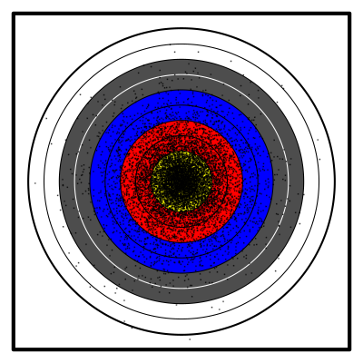
From those many arrows, Archie has determined an accurate probability distribution (of the points scored by an arrow).
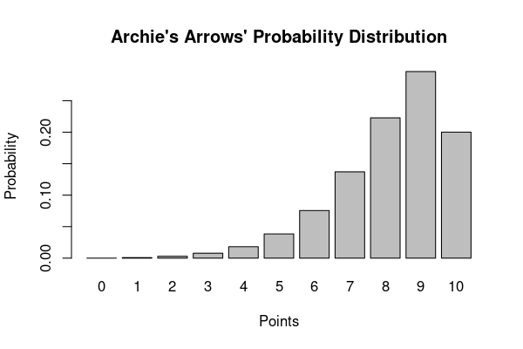
Thus, Archie can determine her population mean and population standard deviation.

Sampling distribution
Each day, Archie shoots 48 arrows () and determines that day’s total score. A total of 480 would be a perfect day. We can treat each day’s total as a random variable with its own probability distribution: a sampling distribution. We wish to characterize this sampling distribution. From the central limit theorem, we know the sampling distribution is approximately normal; however, we need to calculate the parameters.

Expected total (mean of sampling distribution)
The expected total is the product of the sample size and the population mean.

“Expected total” is a misnomer. It is not necessarily likely, or even possible, for a total to equal the expected total. However, if Archie repeatedly shot 48 arrows, we expect the totals to have a mean equal to the expected total. So, maybe “average of totals” would be better terminology.
This expected total is the average of the sampling distribution.
##ANSWER1##
(Round to the hundredths place)

Standard error (standard deviation of sampling distribution)
The standard error of a total is the product of the population standard deviation and the square root of the sample size.

This standard error is the standard deviation of the sampling distribution.
##ANSWER2##
(Round to the hundredths place)

Sample
Today, Archie’s total score is 395 points ().
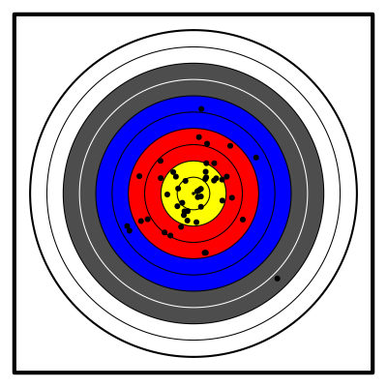

Standard score
Archie would like to know how well she did today. She wants you to calculate a standard score (a score). To calculate the standard score of a sample total, you can use the following formula.

##ANSWER3##
(Round to the hundredths place)

Cumulative probability (percentile rank)
Archie would like to know the probability that tomorrow she shoots worse than today. To estimate this, report the cumulative probability associated with the standard score you calculated. This can be done with a table, pnorm function in R, NORM.DIST function in a spreadsheet, or with other standard normal tools.
##ANSWER4##
(Round to the ten-thousandths place)

Rating
Archie would like a rating for her day’s performance. You decide to use the following scale and that if is on a boundary, Archie will be given the higher rating.
Determine Archie’s rating: ##ANSWER5##
  - Calculate the expected total:
  - Calculate the standard error:
  - Calculate the standard score:
  - Calculate , the cumulative probability:
  - A / B / C / D / F
Solution
video
The sampling distribution is approximately normal with mean 391.68 and standard error 10.95. The sampling distribution can be visualized, along with today’s total (395) highlighted in red. The cumulative probability is the sum of the probabilities of scores less than (or equal) 395. Thus, the area highlighted in blue represents the cumulative probability.
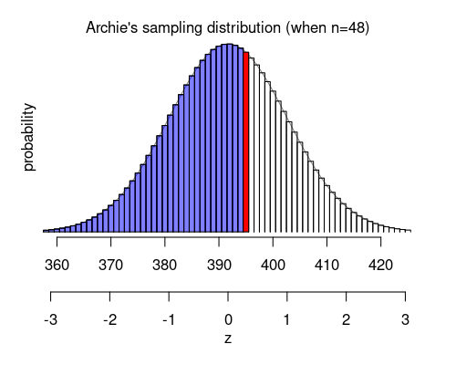
  - The expected total is
  - The standard error is
  - Use the formula to calculate
  - Use the table to find
  - The proper rating is C / The proper rating is C / The proper rating is C / The proper rating is C / The proper rating is C
- Question
A farm produces 4 types of fruit: kiwis, watermelons, plums, and lemons. The fruits’ masses have population parameters dependent on the type of fruit. (All values are in grams.)
Type of fruit
, population mean mass in grams
, population standard deviation in grams
kiwis
95
5
watermelons
9844
564
plums
98
5
lemons
111
14
A sample of each type is weighed. The results are shown below.
Type of fruit
, sample size
, sample mean
kiwi
121
95.13
watermelon
81
9834.00
plum
144
98.18
lemon
100
113.40
The population parameters and sample statistics can be downloaded as a csv.
For each sample, determine the mean’s standard score and the mean’s cumulative probability by assuming the requirements for the central limit theorem are met. Then determine which sample mean is most unusually large, most unusually small, most typically sized, and most unusually sized.
The standard score of a sample mean:

Some people prefer to call this denominator the standard error.

So the standard score (-score) of a sample mean can also be expressed as

  - ##ANSWER1##
  - ##ANSWER2##
  - ##ANSWER3##
  - ##ANSWER4##
  - ##ANSWER5##
  - ##ANSWER6##
  - ##ANSWER7##
  - ##ANSWER8##
  - Which sample mean is most unusually large? ##ANSWER9##
  - Which sample mean is most unusually small? ##ANSWER10##
  - Which sample mean is most typically sized? ##ANSWER11##
  - Which sample mean is most unusually sized? ##ANSWER12##
  - Calculate a -score for the kiwi sample mean. (Round to the nearest hundredth.)
  - What proportion of kiwi samples of size have a smaller mean than the kiwi sample?
  - Calculate a -score for the watermelon sample mean. (Round to the nearest hundredth.)
  - What proportion of watermelon samples of size have a smaller mean than the watermelon sample?
  - Calculate a -score for the plum sample mean. (Round to the nearest hundredth.)
  - What proportion of plum samples of size have a smaller mean than the plum sample?
  - Calculate a -score for the lemon sample mean. (Round to the nearest hundredth.)
  - What proportion of lemon samples of size have a smaller mean than the lemon sample?
  - The kiwi sample mean is most unusually large. / The watermelon sample mean is most unusually large. / The plum sample mean is most unusually large. / The lemon sample mean is most unusually large.
  - The kiwi sample mean is most unusually small. / The watermelon sample mean is most unusually small. / The plum sample mean is most unusually small. / The lemon sample mean is most unusually small.
  - The kiwi sample mean is most typically sized. / The watermelon sample mean is most typically sized. / The plum sample mean is most typically sized. / The lemon sample mean is most typically sized.
  - The kiwi sample mean is most unusually sized. / The watermelon sample mean is most unusually sized. / The plum sample mean is most unusually sized. / The lemon sample mean is most unusually sized.
Solution
video
The formula to determine the -score of a sample mean is the ratio with numerator the difference between measurement and population mean and denominator the standard error of the mean.

The highest -score (furthest right on number line) corresponds to the most unusually large sample mean.
The smallest -score (furthest left on number line) corresponds to the most unusually small sample mean.
The smallest absolute -score corresponds to the most usually sized sample mean.
The largest absolute -score corresponds to the most unusually sized sample mean.

Spreadsheet:
By using the formulas, you should get a spreadsheet like the one displayed here:
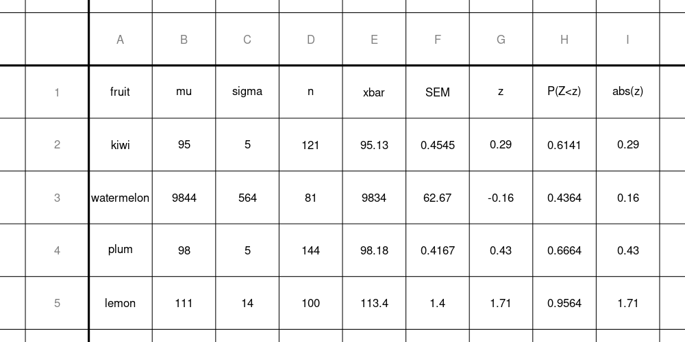

To do this in R:
data = read.csv("fruit.csv", as.is=TRUE)
fruit = data$fruit
mu = data$mu
sigma = data$sigma
n = data$n
xbar = data$xbar

SEM = sigma/sqrt(n)
z = round( (xbar-mu)/SEM ,2)
cum_prob = round( pnorm(z) ,4)
data.frame(data,SEM,z,cum_prob,abs(z))
## fruit mu sigma n xbar SEM z
## 1 kiwi 95 5 121 95.13 0.4545455 0.29
## 2 watermelon 9844 564 81 9834.00 62.6666667 -0.16
## 3 plum 98 5 144 98.18 0.4166667 0.43
## 4 lemon 111 14 100 113.40 1.4000000 1.71
## cum_prob abs.z.
## 1 0.6141 0.29
## 2 0.4364 0.16
## 3 0.6664 0.43
## 4 0.9564 1.71
# Most unusually large
fruit[z==max(z)]
## [1] "lemon"
# Most unusually small
fruit[z==min(z)]
## [1] "watermelon"
# Most typically sized
fruit[abs(z)==min(abs(z))]
## [1] "watermelon"
# Most unusually sized
fruit[abs(z)==max(abs(z))]
## [1] "lemon"
  - We use the formula for calculating the kiwi sample-mean score.

  - Use the table to find the cumulative probability.

  - We use the formula for calculating the watermelon sample-mean score.

  - Use the table to find the cumulative probability.

  - We use the formula for calculating the plum sample-mean score.

  - Use the table to find the cumulative probability.

  - We use the formula for calculating the lemon sample-mean score.

  - Use the table to find the cumulative probability.

  - We determine the maximum score is , which belongs to the lemon. / . / . / .
  - We determine the minimum score is , which belongs to the watermelon. / . / . / .
  - We determine the minimum absolute score is , which belongs to the watermelon. / . / . / .
  - We determine the maximum absolute score is , which belongs to the lemon. / . / . / .
- Question
The continuous random variable follows the distribution shown by the density curve and spinner below. It has a mean of and standard deviation of .
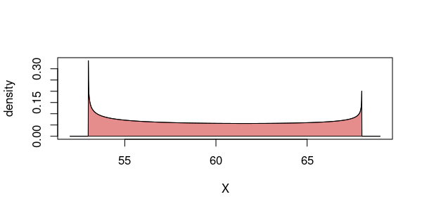
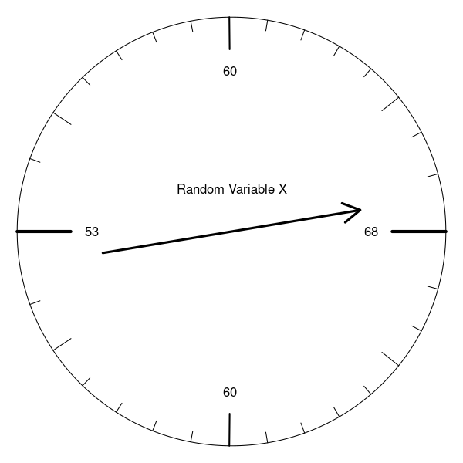
That spinner () will be fairly spun 889 times, and the sample mean of the spins will be recorded. Determine the probability that the random sample mean is less than 60.28.

(Even though single spins are not normally distributed, the random means will be normally distributed. See central limit theorem.)
Solution
video
We use the central limit formulas for a random mean.

So, we think the random mean is normally distributed with a mean of 60.21 and a standard deviation of 0.1569622.

Calculate a -score for the boundary.

You can round that to or . Any of the following probabilities will get credit.

Let’s draw a sketch.
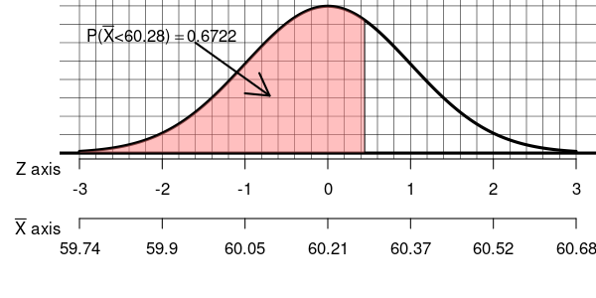
- Question
The continuous random variable follows the distribution shown by the density curve and spinner below. It has a mean of and standard deviation of .
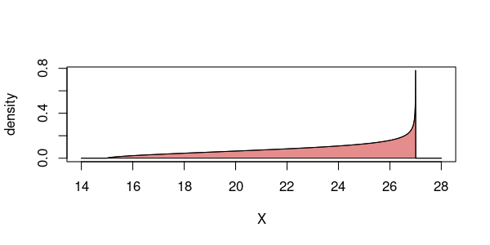
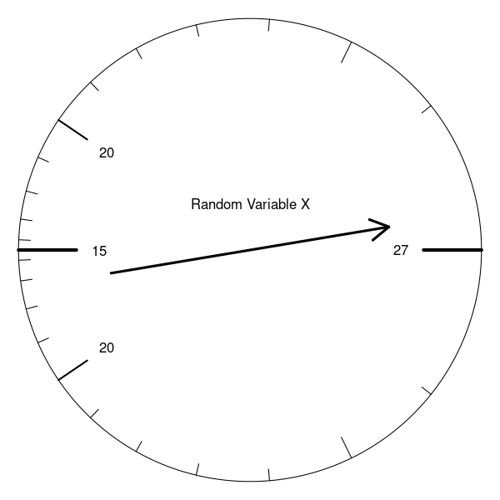
That spinner () will be fairly spun 275 times, and the sample mean of the spins will be recorded. Determine the probability that the random sample mean is more than 23.02.

(Even though single spins are not normally distributed, the random means will be normally distributed. See central limit theorem.)
Solution
video
We use the central limit formulas for a random mean.

So, we think the random mean is normally distributed with a mean of 23.09 and a standard deviation of 0.185731.

Calculate a -score for the boundary.

You can round that to or . Any of the following probabilities will get credit.

Let’s draw a sketch.
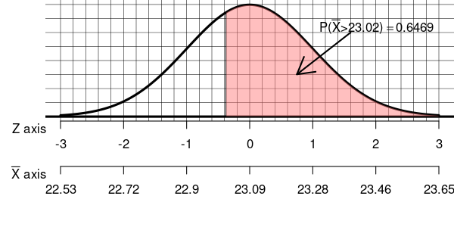
- Question
The continuous random variable follows the distribution shown by the density curve and spinner below. It has a mean of and standard deviation of .
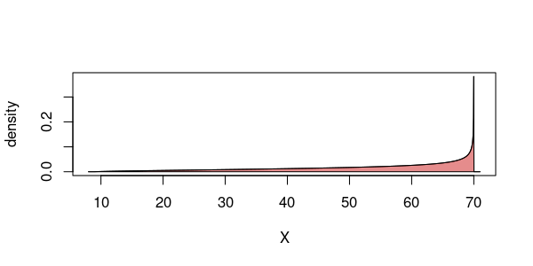
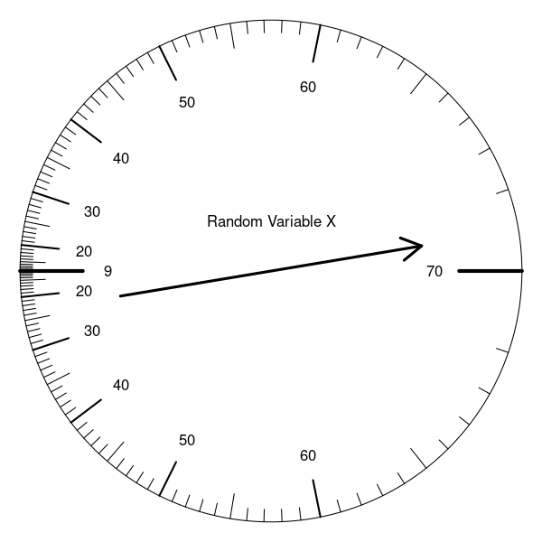
That spinner () will be fairly spun 44 times, and the sample mean of the spins will be recorded. Determine the probability that the random sample mean is within units from .

(Even though single spins are not normally distributed, the random means will be normally distributed. See central limit theorem.)
Solution
video
We use the central limit formulas for a random mean.

So, we think the random mean is normally distributed with a mean of 53.16 and a standard deviation of 2.2628426.

Calculate a -score for the boundary.

You can round that to or . Any of the following probabilities will get credit.

Let’s draw a sketch.
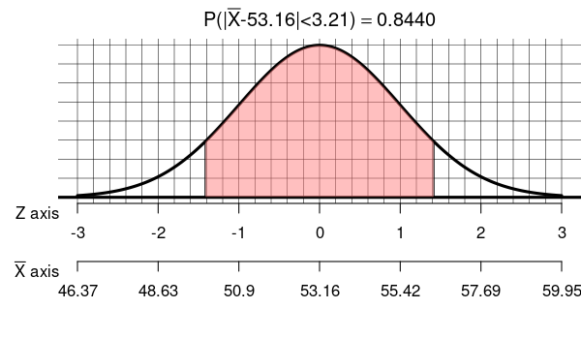
- Question
The continuous random variable follows the distribution shown by the density curve and spinner below. It has a mean of and standard deviation of .
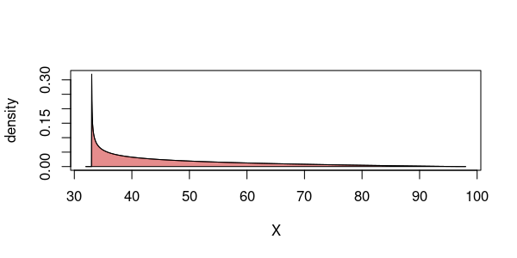
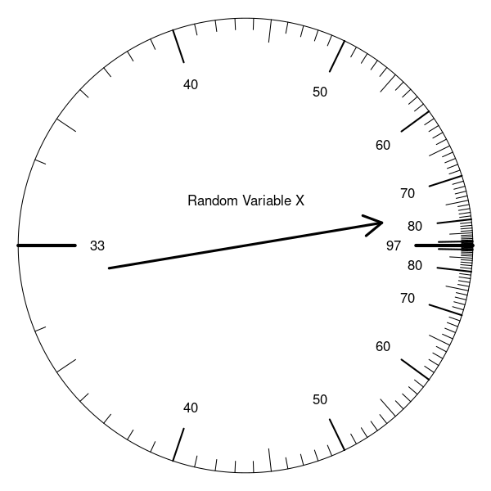
That spinner () will be fairly spun 73 times, and the sample mean of the spins will be recorded. Determine the probability that the random sample mean is farther than units from .

(Even though single spins are not normally distributed, the random means will be normally distributed. See central limit theorem.)
Solution
video
We use the central limit formulas for a random mean.

So, we think the random mean is normally distributed with a mean of 48 and a standard deviation of 1.6619843.

Calculate a -score for the boundary.

You can round that to or . Any of the following probabilities will get credit.

Let’s draw a sketch.
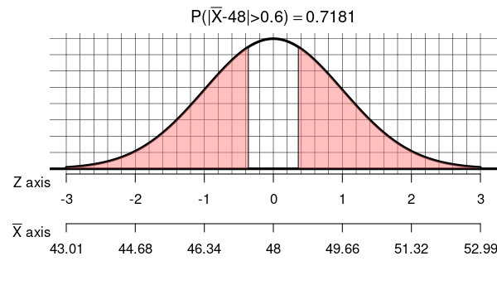
- Question
A fair 12-sided die (with sides numbered 1 through 12) will be rolled 324 times, and the sum (total) of those rolls will be recorded. What is the probability that the sum is less than 2057.5?

To help you along, I will calculate the mean and standard deviation of single rolls. The formulas for an -sided die can be derived from the formulas for discrete uniform distribution.

(Even though single rolls are not normally distributed, the random totals will be normally distributed. See central limit theorem.)
Solution
video
We calculate the mean and standard deviation of the random sum using the formulas from the central limit theorem.

The central limit theorem tells us that the random sum is approximately normal with the parameters calculated above.

In other words, we can approximate the summing of 324 rolls of 12-sided dice with a single spin of the following spinner.
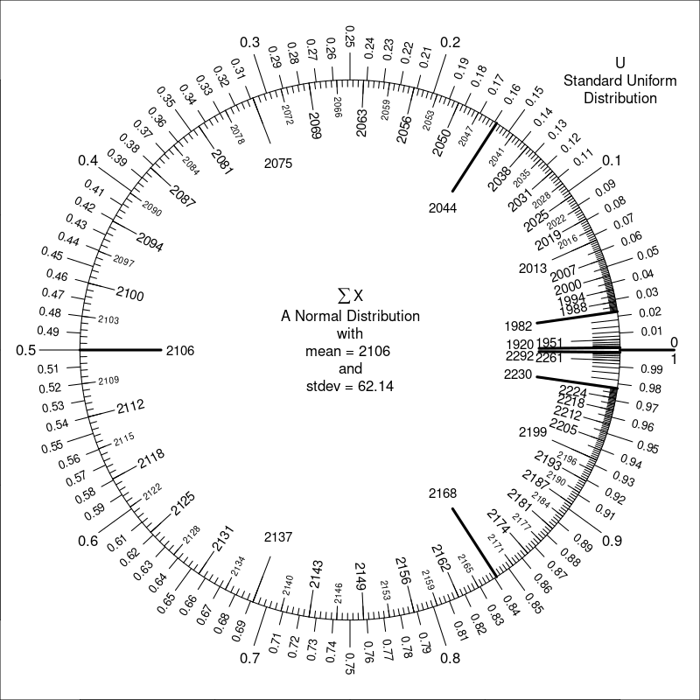
Find the appropriate score.

You can round this to either -0.79 or -0.78. I will continue with the unrounded score. We now rephrase the question as a standard normal probability.

You can use the table to find the probability.

We can sketch the density curve and shade the appropriate region.
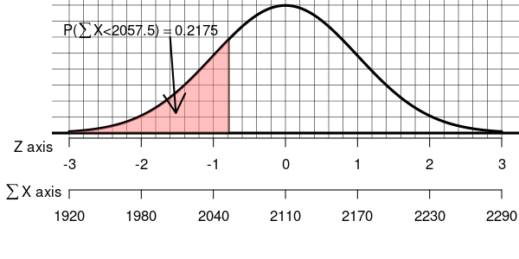
- Question
The continuous random variable follows the distribution shown by the density curve and spinner below. It has a mean of and standard deviation of .
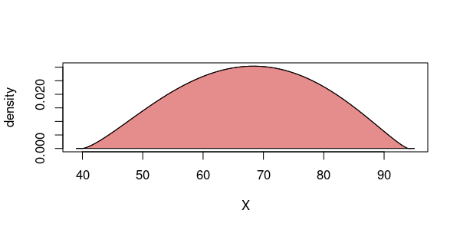
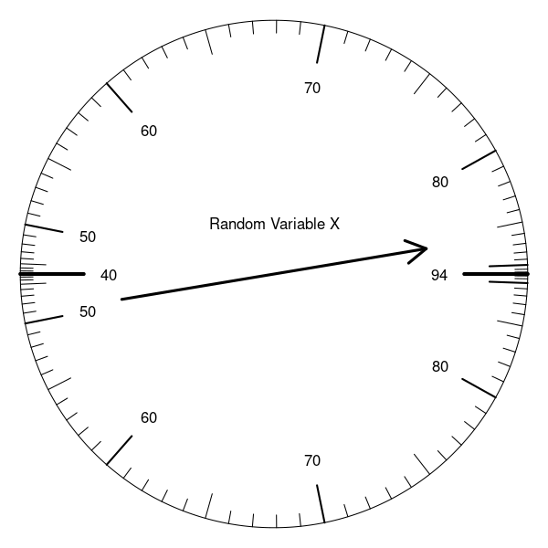
That spinner () will be fairly spun 175 times, and the total of the spins will be recorded. Determine the probability that the random total is more than 11900.

(Even though single spins are not normally distributed, the random totals will be normally distributed. See central limit theorem.)
Solution
video
We use the central limit formulas for a random total.

So, we think the random total is normally distributed with a mean of 11861.5 and a standard deviation of 149.6172366.

Calculate a -score for the boundary.

You can round that to or . Any of the following probabilities will get credit.

Let’s draw a sketch.
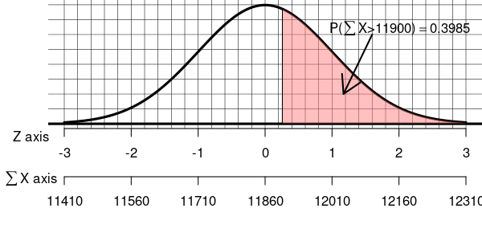
- Question
The continuous random variable follows the distribution shown by the density curve and spinner below. It has a mean of and standard deviation of .
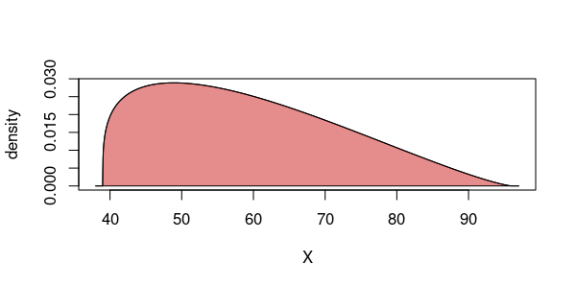
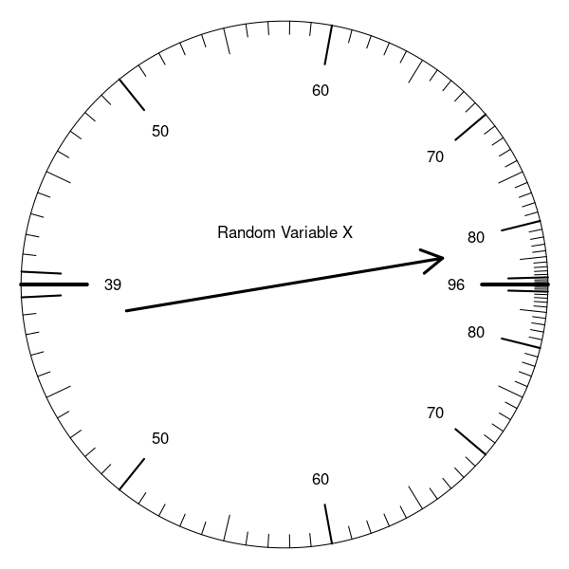
That spinner () will be fairly spun 195 times, and the total of the spins will be recorded. Determine the probability that the random total is within 215.05 units from .

(Even though single spins are not normally distributed, the random totals will be normally distributed. See central limit theorem.)
Solution
video
We use the central limit formulas for a random total.

So, we think the random total is normally distributed with a mean of 11584.95 and a standard deviation of 179.1611998.

Calculate a -score for the boundary.

You can round that to or . Any of the following probabilities will get credit.

Let’s draw a sketch.
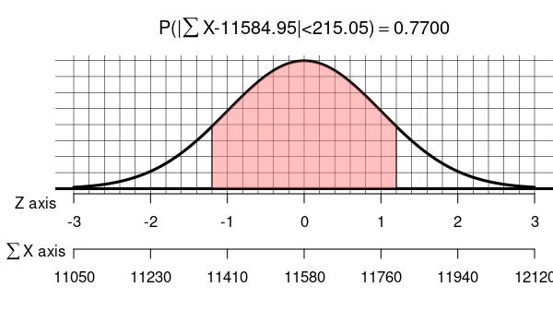
- Question
The continuous random variable follows the distribution shown by the density curve and spinner below. It has a mean of and standard deviation of .
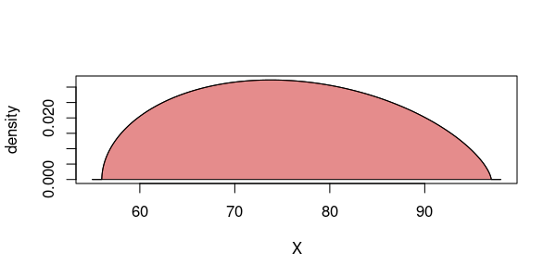
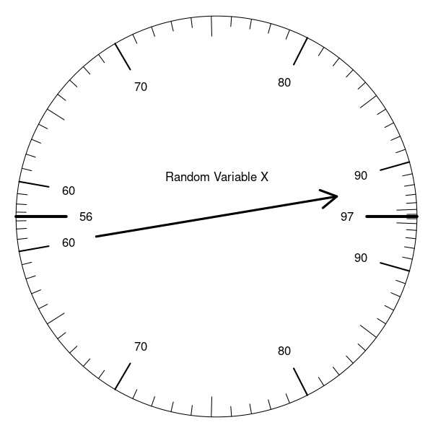
That spinner () will be fairly spun 127 times, and the total of the spins will be recorded. Determine the probability that the random total is farther than 192.77 units from .

(Even though single spins are not normally distributed, the random totals will be normally distributed. See central limit theorem.)
Solution
video
We use the central limit formulas for a random total.

So, we think the random total is normally distributed with a mean of 9587.23 and a standard deviation of 112.806971.

Calculate a -score for the boundary.

You can round that to or . Any of the following probabilities will get credit.

Let’s draw a sketch.
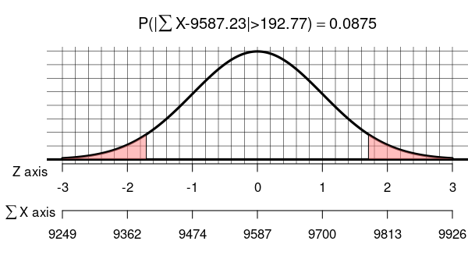
- Question
In some game, each trial has a probability of success. A player will attempt 176 trials. What is the probability that the number of successes is less than 89.5?
(Even though single trials are not normally distributed [they follow a Bernoulli distribution], the random totals will be normally distributed. See central limit theorem. Also, I have already made the continuity correction by setting the boundary to a half-integer. )
Solution
video
We determine the mean and standard deviation of the binomial distribution.

We determine a -score. (In the de Moivre-Laplace notes, I used to emphasize that a binomial variable is a sum of Bernoulli trials. Here, I will just use as the boundary for number of successes, because this is the more common notation.)

Then, find the standard normal probability.

Of course, you could have rounded , so the following will also get credit.

- Question
In some game, each trial has a probability of success. A player will attempt 42 trials. What is the probability that the number of successes is more than 16.5?
(Even though single trials are not normally distributed [they follow a Bernoulli distribution], the random totals will be normally distributed. See central limit theorem. Also, I have already made the continuity correction by setting the boundary to a half-integer. )
Solution
video
We determine the mean and standard deviation of the binomial distribution.

We determine a -score. (In the de Moivre-Laplace notes, I used to emphasize that a binomial variable is a sum of Bernoulli trials. Here, I will just use as the boundary for number of successes, because this is the more common notation.)

Then, find the standard normal probability.

Of course, you could have rounded , so the following will also get credit.

- Question
In some game, each trial has a probability of success. A player will attempt 127 trials. What is the probability that the number of successes is between 111.5 and 113.5?
(Even though single trials are not normally distributed [they follow a Bernoulli distribution], the random totals will be normally distributed. See central limit theorem. Also, I have already made the continuity correction by setting the boundary to a half-integer. )
Solution
video
We determine the mean and standard deviation of the binomial distribution.

We determine both -scores. (In the de Moivre-Laplace notes, I used to emphasize that a binomial variable is a sum of Bernoulli trials. Here, I will just use as the boundary for number of successes, because this is the more common notation.) We get the first -score.

We get the second -score.

Then, find the standard normal probability.

Of course, you could have rounded the -scores, so any of the following will also get credit.

- Question
In some game, each trial has a probability of success. A player will attempt 71 trials. What is the probability that the proportion of successes is less than 0.7676?
(Even though single trials are not normally distributed [they follow a Bernoulli distribution], the random proportion will be normally distributed. See central limit theorem. Also, I have already made the continuity correction. )
Solution
video
We determine the mean and standard deviation of the proportion sampling distribution.

We determine a -score. (The common notation is for a specific proportion.)

Then, find the standard normal probability.

Of course, you could have rounded , so the following will also get credit.

- Question
In some game, each trial has a probability of success. A player will attempt 145 trials. What is the probability that the proportion of successes is more than 0.3483?
(Even though single trials are not normally distributed [they follow a Bernoulli distribution], the random proportion will be normally distributed. See central limit theorem. Also, I have already made the continuity correction. )
Solution
video
We determine the mean and standard deviation of the proportion sampling distribution.

We determine a -score. (The common notation is for a specific proportion.)

Then, find the standard normal probability.

Of course, you could have rounded , so the following will also get credit.

- Question
In some game, each trial has a probability of success. A player will attempt 121 trials. What is the probability that the proportion of successes is between 0.8058 and 0.8471?
(Even though single trials are not normally distributed [they follow a Bernoulli distribution], the random proportion will be normally distributed. See central limit theorem. Also, I have already made the continuity correction. )
Solution
video
We determine the mean and standard deviation of the proportion sampling distribution.

We determine both -scores. We get the first -score.

We get the second -score.

Then, find the standard normal probability.

Of course, you could have rounded the -scores, so any of the following will also get credit.

