## Change History

|  |  |  |  |
| --- | --- | --- | --- |
| Version | Description | Member | Date |
| 0.0 | First draft | All members | 2/6/18 |
| 0.1 | Added first drafts of create timeline and create event use case and activity diagrams | Eric Berryhill | 2/8/18 |
| 0.2 | Added Master (top level) Use Case Diagram  Updated Working Definitions to better reflect the current concept design. | Benjimin Aaron | 2/8/18 |
| 0.3 | Updated glossary and formatting  Updated descriptions in Introduction | Brian Pecot | 2/15/18 |
| 0.4 | Added Share Timeline Use Case and Activity Diagrams  Made minor changes to formatting | Colt Wrobel | 2/20/18 |
| 0.5 | Replaced Master (top level) Use Case Diagram  Added queryTimeline Use Case image and description  Edited project description | Benjimin Aaron | 2/22/18 |
| 0.6 | Added Class Diagram Image | Daniel Caudle | 2/22/18 |
| 0.7 | Added Query Timeline Activity Diagram | Eric Berryhill | 2/26/18 |
| 0.8 | Added combineTimline Use Case and Activity | Benjimin Aaron | 2/26/18 |
| 1.0 | Final Formatting/Submit | Benjimin Aaron | 3/1/18 |

## Table of Contents

1. Introduction pg. 3

1.1 Purpose

1.2 Scope

1.3 Glossary pg. 4

2. Project Description pg. 5

3. Requirements pg. 6

3.1 Functional Requirements

3.2 Non-functional requirements

4. Competing Apps Functionality Table pg. 7

5. Diagrams

5.1 High-Level Class Diagram pg. 8

5.2 Use Case Diagrams pg. 9

5.3 Activity Diagrams pg. 19

## 1 Introduction

### 1.1 Purpose

Timeline is an Android application with the intent to provide a flexible and user-friendly interface for personal scheduling, with the functionality of time management, availability scheduling, and social/community sharing. Timeline delivers a novel solution to users for event planning and sharing that is fully integrated with their personal calendar.

### 1.2 Scope

This application fulfills the need for an application that can effectively generate a personal schedule, efficiently share and compare schedules, and provide convenient methods for the manipulation of schedules. The interface is a view based on a linear paradigm for personal calendar applications that emphasizes time availability and schedule sharing through its query and compare features.

### 1.3 Glossary

**Timeline**: a collection of Segments displayed graphically in a linear fashion from “start” to “end”, generally using a chronological ordering system of earliest date/time to most recent (or latest) date/time. Ex: a timeline with the title “Work Schedule” might contain a series of Segments which each contain Events describing a user’s work shifts.

**Event:** a data object which represents some real-world (or fictional world) occurrence. Events must maintain a collection of Identifiers which provide key information about the Events and allow the user to locate an Event using the search function.

**Identifier**: Identifiers are values entered by the user during Event creation and include: Title(r), Date(r), StartTime(r), EndTime(r), Duration(calculated), etc. These identifiers serve to distinguish the Events on the Timeline (in terms of computing) and also provide search fields for the user to locate Events.

**Tag:** a tag is a string associated by the user with an event. This is the same concept as the tags on a youtube video. The user will be provided with a text box to add tags to an event for search/query optimization. In addition to looking for an Event with a specific *title*, *date*, or *duration* (all of these are Event Identifiers which are required to create an Event) a user might wish to search for any Event with tags like “work”, “school”, “groupProject”, “birthday”, etc.

**Segment:** a segment represents a portion of time, typically shown to the user as Hours, Days, Weeks, Months, or Years; the scale of each visible segment will be determined by user settings. Segments should be represented by some type of bar/box graphic and should be clickable. A Segment on the Timeline with no currently scheduled Event within its range should display as some neutral color (ex. gray/silver). When an Event is scheduled for a time frame encompassed by the Segment, it should be displayed as some distinctive color (ex. gold) and it may be possible for the user to choose a color for an Event when it is created. If the user selects to view his/her Timeline in (Free/Busy) mode, the Segments with scheduled Events should appear in some color like Red vs. empty Segments representing Free time appearing in some color like Green.

## 

## 2 Project Description

Timeline is an android application concept intended to provide a tool to visualize and manage time, particularly where event scheduling is concerned. Timeline provides an interface for creating schedules in a linear-progression format, a departure from the typical calendar and grid style formats. Most importantly, Timeline allows users to not only share their schedules as Timeline constructs, but also to automatically mesh their Timelines into a single unit revealing intuitive relations about the combined schedules, for instance, shared free time and availability. Thus, the strongest quality of Timeline is its ability to quickly sync groups of friends or collaborators without the need to message back and forth to determine when each individual is free or busy.

## 

## 3 Requirements

### 3.1 Functional

1. Users can create a timeline.
2. Users can create events on their timeline.
3. Users can query timeline for events by Identifiers or Tags.
4. Users can share timelines with other users, contacts, social media.
5. Users can invite/share events with other users, contacts, social media.

### 3.2 Non-Functional

1. The system can import calendars and events from Google Calendar API.
2. The system can display a calendar in a linear representation (make a timeline).
3. The system can compare shared timelines and provide visual feedback.
4. The system can communicate with the database in order to pull/push user’s Timelines.

## 

## 4 Functionality/Competitor Table

|  |  |  |  |  |  |
| --- | --- | --- | --- | --- | --- |
|  | Schedule  Creation | Event Creation | Share Schedule | Event Invitation | Schedule  Compare |
| Google Calendar | ✔ | ✔ | ✔ | ✔ | X |
| Facebook | X | ✔ | ✔ | ✔ | X |
| GroupMe / Slack | X | ✔ | X | X | X |
| Outlook | ✔ | ✔ | ✔ | ✔ | X |
| TimeTree | ✔ | ✔ | X | ✔ | X |

1. Schedule creation entails creating a personal calendar or schedule. Facebook and GroupMe/Slack fail in this respect because they only offer community/group calendars.
2. Event creation entails creating singular events at a specified time.
3. Schedule sharing is allowing others to see your personal schedule or calendar or a variation of them.
4. Event invitation is sending an invitation to a specific person or group of people asking if they want to attend an event that you have created or have been granted permissions to invite others to.
5. Schedule comparison is the system performing a comparison on two or more schedules in order to solve queries or show availability.

## 5 UML Diagrams

### 5.1 High-Level Class Diagram

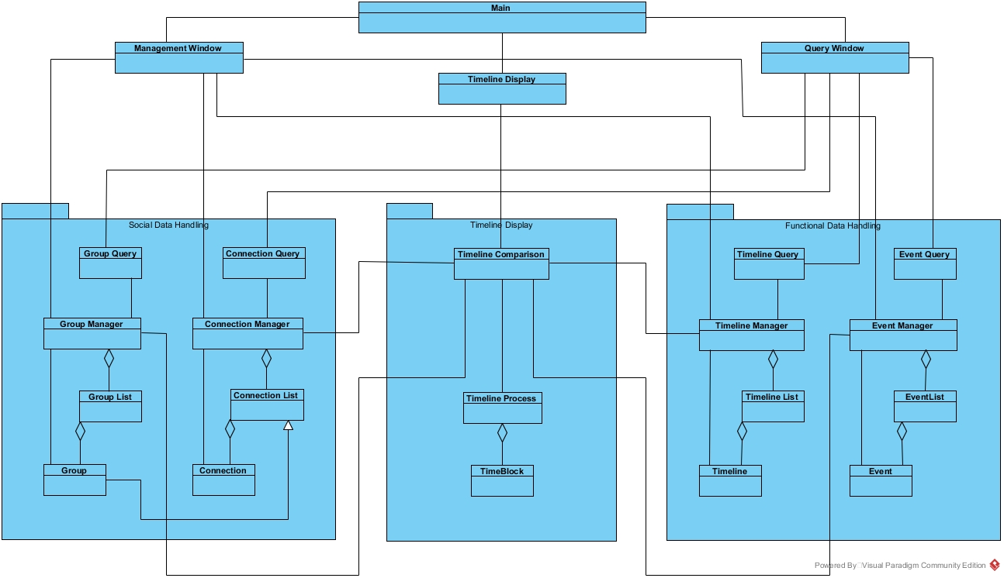

### 

### 5.2 Use Cases

#### UC0 - Master Use Case

|  |  |
| --- | --- |
| Use Case | Master Use Case |
| Description | User Interaction with Timeline App |
| Actors | General User |

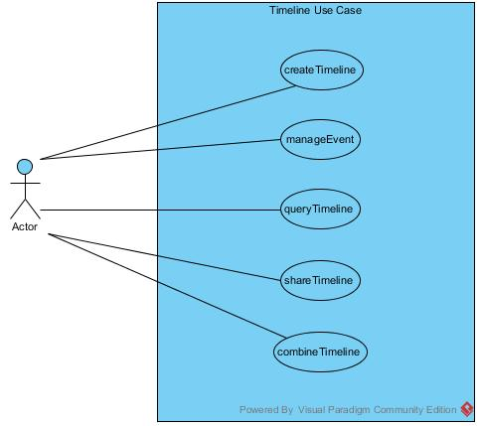

#### 

#### **UC1 - Create New Timeline**

|  |  |
| --- | --- |
| Use Case | Create a timeline |
| Description | User wants to create a new Timeline |
| Actors | general user, Timeline database |
| Activity | 1. System is prompted by the user to create a new timeline 2. The user enters a name for the new timeline 3. System communicates with database and stores a reference for the user's new timeline |
| Exceptions | 3a. Users device is not connected to the internet; creation of the new timeline fails |

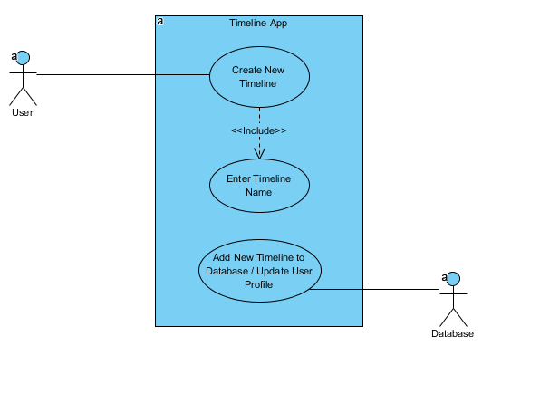

#### 

#### **UC2 - Create New Event**

|  |  |
| --- | --- |
| Use Case | Create an event |
| Description | User creates an event for a timeline |
| Actors | general user, Timeline database |
| Activity | 1. User selects a timeline in which to create the event 2. User prompts the system to create a new event to place in the chosen timeline 3. User enters details about the event in the provided fields 4. System communicates with the Timeline database and updates the user's timeline and all versions of that timeline that have been shared with other users 5. All shared users receive a notification that the original user created a new event in their timeline |
| Exceptions | 4a. Users device is not connected to the internet: creation of the new event fails |

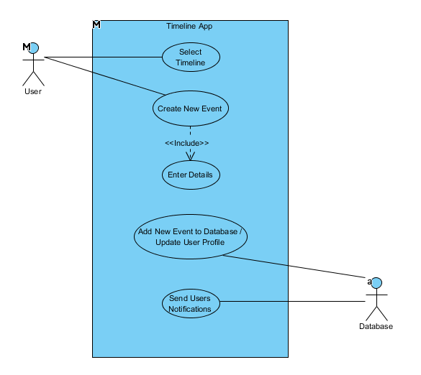

#### 

#### **UC3 - Query Timeline**

|  |  |
| --- | --- |
| Use Case | Query Timeline |
| Description | User searches for an Event, the next time Segment without an Event (Free Time), or the Segment associated with a specified time. Application changes the Timeline view according to query result. |
| Actors | general user, system |
| Activity Option 1 | 1-1. User chooses findEvent.  2-1. User enters one or all of the following: a time, identifier(s), tag(s)  3-1. System changes Timeline view to focus on the Segment containing the matching Event. |
| Activity Option 2 | 1-2. User chooses findFreeTime.  2-2. User enters contiguous duration  3-2. System changes Timeline view to focus on the first Segment of a matching span(duration of time) of unoccupied Segments. |
| Activity Option 3 | 1-3. User chooses findSpecificTime  2-3. User enters a Time value.  3-3. System changes Timeline view to focus on the matching Segment. |
| Exceptions | 2-1a. User enters invalid input, or no Event is found matching the given input(s). System prompts user for re-input.  2-2a. User enters invalid input. System prompts user for re-input.  2-3a. User enters invalid input. System prompts user for re-input. |

#### 

#### 

#### 

#### 

#### 

#### 

#### 

#### 

#### 

#### 

#### 

#### 

#### 

#### 

#### **UC4 - Share Timeline**

|  |  |
| --- | --- |
| Use Case | Share Timeline |
| Description | User adds/removes Members to share Timeline with |
| Actors | general user, Timeline database |
| Activity | 1. User selects a timeline in which to create the event 2. User selects option to Add/Remove a Member 3. User enters Member email or selects a Member, depending on whether Add or Remove option was selected. 4. System communicates with the Timeline database to update the Timeline’s members. |
| Exceptions | 4a. Users device is not connected to the internet: sharing of Timeline fails.  4b. If Add member was selected, and there is no Timeline user associated with the supplied email, the system sends and invitation email. |

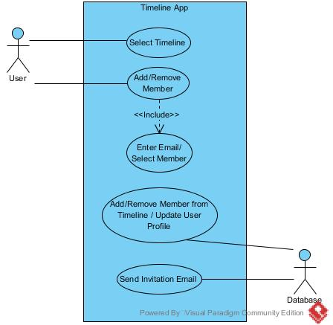

#### **UC5 - Combine Timeline**

|  |  |
| --- | --- |
| Use Case | Combine Timeline |
| Description | User chooses two or more timelines to combine into a single unit. |
| Actors | general user |
| Activity | 1. User chooses option from menu “combine timelines” 2. User chooses “combine as new timeline” option 3. User selects all desired timelines from the timelines list 4. User chooses “generate combined timeline” 5. User provides name for new timeline |
| Activity 2 | 1-2. User chooses option from menu “combine timelines”  2-2. User chooses “combine into existing timeline” option (destructive)  2-3. User selects a single timeline to be host.  2-4. User selects all desired timelines from timelines list to add to the host.  2-5. User chooses “generate combined timeline”  2-6. User may provide new name for augmented host timeline |
| Exceptions | 1a. User enters invalid name for new timeline. |

#### 

### 

### 5.3 Activity Diagrams

## 

#### **AD1 Create a New Timeline**

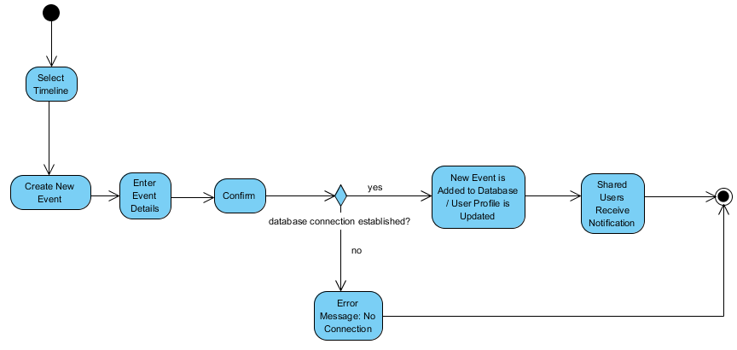

#### **AD2 Create a New Event**

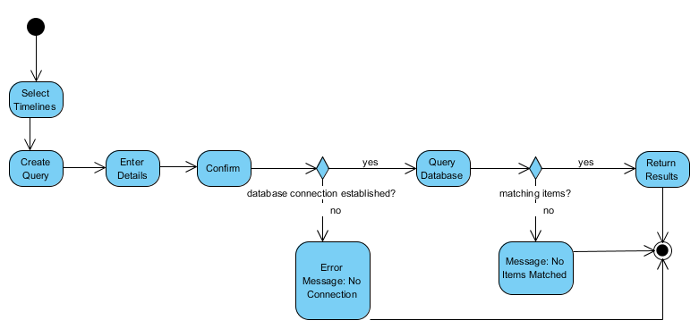

#### **AD3 Query Timeline**

## 

#### **AD4 Share Timeline**

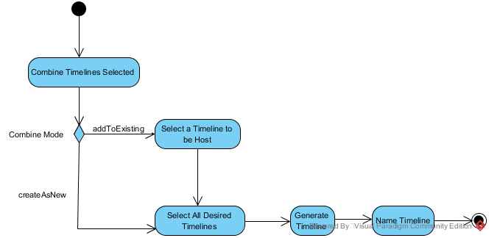

#### **AD5 Share Timeline**