13.04.2022

**SWE 585 In Class Practice #4**

**(Hello World of Networked Gaming)**

**Name, Surname: Ceyda Düzgeç**

**Group #:** 2

**Group Member Names, Surnames:**

Zeynep Ece Sarıoğlu

Ceyda Düzgeç

Mehmet Samet Taştı

Deniz Dikbıyık

Mehmet Ali Özcan

**Definition:**

In this ICP you will use Mirror Networking library to create a very basic multiplayer game setup.

**STEP 0:** Download Mirror from asset store and import it into your project. Download ParrelSync Editor extension from its github repo and import it into your project.

**STEP 1:** Open up ParrelSync tab -> Clones Manager -> Create a clone.

(Make your changes on the original project. Save your project from time to time and observe that the changes are reflected to the clone)

**STEP 2:** Create an empty game object on the scene. Name it as “Network Manager”. Add “Network Manager” and “Network Manager HUD” components.

**STEP 3:** Create a new 3D object on your scene (Can be cube, sphere, capsule etc.) Create a new material to give it a color. Make this object a prefab.

**STEP 4:** Open your prefab and add a “Network Identity” component to it.

**STEP 5:** Open the inspector for the Network Manager object. Drag your object prefab on the player prefab area. Check Fig 1 where a prefab named “Player” is attached to the Network Manager.

*Figure 1: Network Manager Component Properties*

**STEP 6:** Add a script to your prefab. In your sript:

i) include Mirror library -> add “using Mirror;”

ii) Change MonoBehaviour -> NetworkBehaviour

NetworkBehaviour is a superset of Monobehaviour.

**STEP 7:** Create a new method that moves (update transform.position based on user input)

in Update() call your new method if “isLocalPlayer” holds True.

**STEP 8:** Add component “Network Transform” to your prefab. (Check “Client Authority”

**STEP 9:** Delete your prefab from the scene (not from the assets!)

**STEP 10:** Make sure you save and have the same content on the cloned project. Run the project on both editors. Check “Host(Server+Client)” on original project and choose “Client” on the clone project.

*Figure 2: Server Configuration*

**STEP 11:** Insert below a screenshot from the host.

|  |
| --- |
| Below the host and client together screenshot added too: |

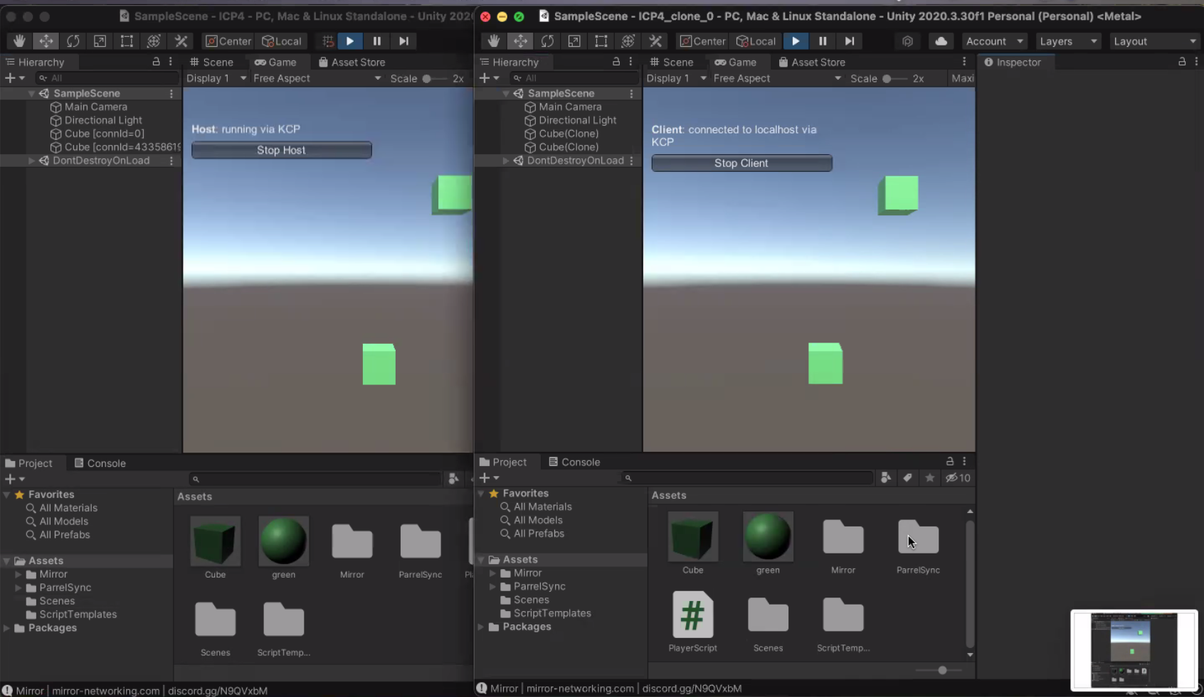

**What to submit:**

This file. (Every member should submit)

Your script.