

**EE463**

**STATIC POWER CONVERSION-I**

**Term Project Simulation Report**

Ceyhun KOÇ 2166833

Defne Nur KORKMAZ 2166858

Görkem GÜLLETUTAN 2166544

Table of Contents

Introduction 4

Project Description 4

Topology Selection 5

Ideal Simulations 5

1. Simulations of Three Phase Diode Rectifier 6

2. Simulations of Buck Converter 9

3. Simulations of Battery Part 11

4. Simulations of Whole Circuit 13

Component Selection 15

Capacitors 15

Inductor 16

Diodes 16

MOSFET 16

Shunt Resistor 17

Isolation Op-Amp 17

Digital Isolator 17

Digital Controller 18

Gate Driver 18

Power Conversion Units 19

a. 24V/12V Conversion: 19

b. 24V/3.3V Conversion 19

c. 3.3V Isolation 19

Connectors 20

Non-ideal Simulations 20

1. Simulations of Three Phase Diode Rectifier 21

2. Simulations of Buck Converter 22

3. Simulations of Battery Part 22

Schematic Design 23

a. Rectifier Unit 23

b. Converter Unit 24

c. Isolation Unit 25

d. Logic Unit 26

e. Power Unit 27

f. Connector Unit 28

Conclusion 28

REFERENCES 30

# Introduction

The fact that the energy provided by fossil fuels in the world will be exhausted has directed people to inexhaustible energy resources. That is to renewable energy sources. It is a necessity to focus on renewable energy sources to transfer natural heritage to future generations, to protect the environment and to obtain energy cheaply. For this purpose, three METU EE senior students, named Distanced Power Solutions Inc. presents AC to DC Motor Drive for the wind turbine to get renewable energy.

In this report, we included simulation results for ideal and non-ideal conditions. In the first part of the report, topology selection will be discussed. The advantages and disadvantages of the selected topology will be stated. Also, we will discuss why we selected it. Then, simulation results for ideal cases will be shown. On the other hand, as everyone knows, simulation results are not the same as real-life results. In real life, there are some non-ideal parameters. We will discuss them. In the following part, the component selection will be discussed. It will do by adding some margin to what we have measured in the ideal simulation so that the system does not fail. Then, simulation results with the non-ideal parameters of the selected components will be shown. In the PCB design part, PCB design of our circuit using Altium will be shown by taking into consideration real-life environment such as gate drivers, regulators, isolators, heatsinks & fans.

Our biggest goal from this project is to get a simple, robust, reliable, and as cheap as possible AC to DC converter. We think that this project will improve our practical skills by using theoretical knowledge of EE 463 course. As senior engineering students, this project will give chance us to improve the problem-solving skills that every engineer should have.

# Project Description

In this project, we are asked to design an AC to DC converter with the required control techniques to use in the wind turbine. Generated electricity by the turbine will be used to illuminate the road next to our department. There are some specifications and requirements for this project.

Parameters of the synchronous machine are:

* Open circuit voltage peak: 330 Vline-to-line
* Inertia: 0.00027 kg.m2
* Viscous Damping: 0.005024 N.m.s
* Poles: 2
* Voltage Constant: 110 Vl-l /krpm
* Stator Resistance: 10.58 Ohm
* Armature Inductance: 16.7 mH

Project requirements are:

* Battery capacity: 13 Ah
* Battery nominal voltage: 24 V
* Output current: 2 A
* Output current ripple: %20 of average current

# Topology Selection

In this project, we aim to develop a low cost, and compact converter in order to make our design desirable by potential customers. To do that, we have made our topology selection carefully by considering the wieldy usage and reliability of the circuit, and the cost restriction. On the other hand, we work hard for designing efficient and useful converter with this limited budget. For us, there was three different options as a topology that is used on the design.

* Three-phase Thyristor Rectifier
* PWM Rectifier
* Diode rectifier + Buck converter

At the beginning, we discussed about using thyristor diode rectifier in order to rectify the AC signal and regulate it. But in this case, we should consider the firing the gates of all the thyristor diodes in the rectifier. Therefore, we would be dealing with the firing loss, also it would make the circuit complicated instead of our simplicity desire. Also, we want to design a non-bulky hardware to be able to converge to the high class manufacturer. At the end, the thyristor rectifier did not correspond our requirements and it would not satisfy our engineering desires.

Then we considered the PWM rectifier as a topology for our project. In PWM rectifier, the important thing is the switching. Therefore, there will obviously high switching losses besides the conduction losses. Also, we should consider the harmonics of the pulses, there should be filter design in order to suppress the higher harmonics. Thus, we did not want to make our design complicated and we pass through the PWM rectifier option.

As a last and best option for us, we have considered the diode rectifier and buck converter in order to control our 3-phase voltage lines. At first, this option includes the main topics of EE463 lecture, so it will be a good practical application of learning outcomes in the lecture. Also, diode rectifier gives chance to rectify the AC waveforms with minimum amount of conduction and switching losses, we will calculate the losses in the next step of the project. Also, in our design we wanted to keep simple the application and working system. With this simplicity, we can adjust our design in variable current and voltage values as much as they stay in our components’ electrical limitations, current, voltage, slew rate etc.

As a result, we have chosen the diode rectifier and buck converter in our project in order to rectify three-phase waveforms. This topology satisfies our principles in terms of being low budget design, compatible with variable voltage and current values, and easy to control.

# Ideal Simulations

In this part of the report, simulation results by using MATLAB Simulink with ideal components will be provided. Firstly, three-phase diode rectifier schematic and simulation results will be shown. Then, the buck converter schematic and simulation results will be observed. After the buck converter, battery, and controller the last part of our system will be shown. Finally, the whole circuit schematic and input-output simulation results of the whole circuit will be provided.

## Simulations of Three Phase Diode Rectifier

As seen in Figure 1. below, in our three-phase diode rectifier circuit, we used a capacitor to filter out output voltage waveform because our input voltage which was given to us for the project is not purely sinusoidal. This simulation does not include line inductance and resistance. Also, diodes are ideal.

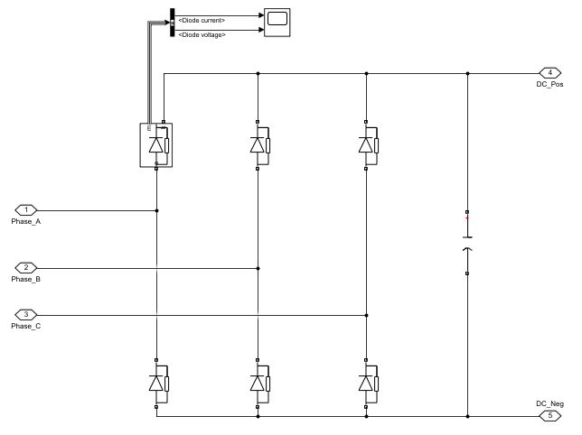

Figure 1.The circuit schematic of three phase diode rectifier

In Figure 2. below, the input line to line (a) and output voltage (b) can be seen. 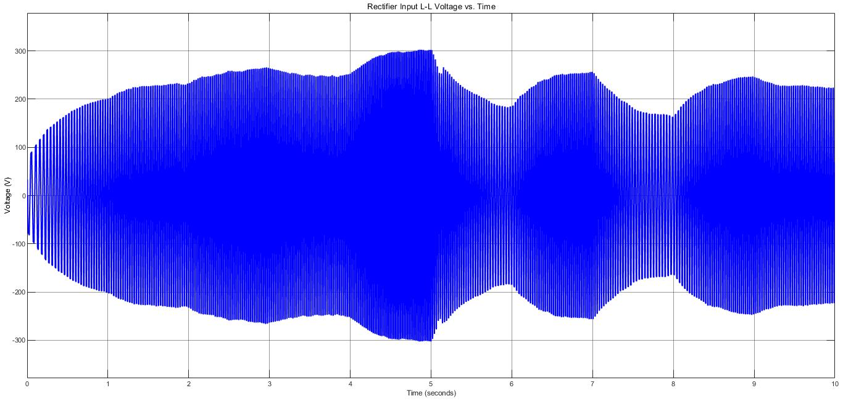

(a)

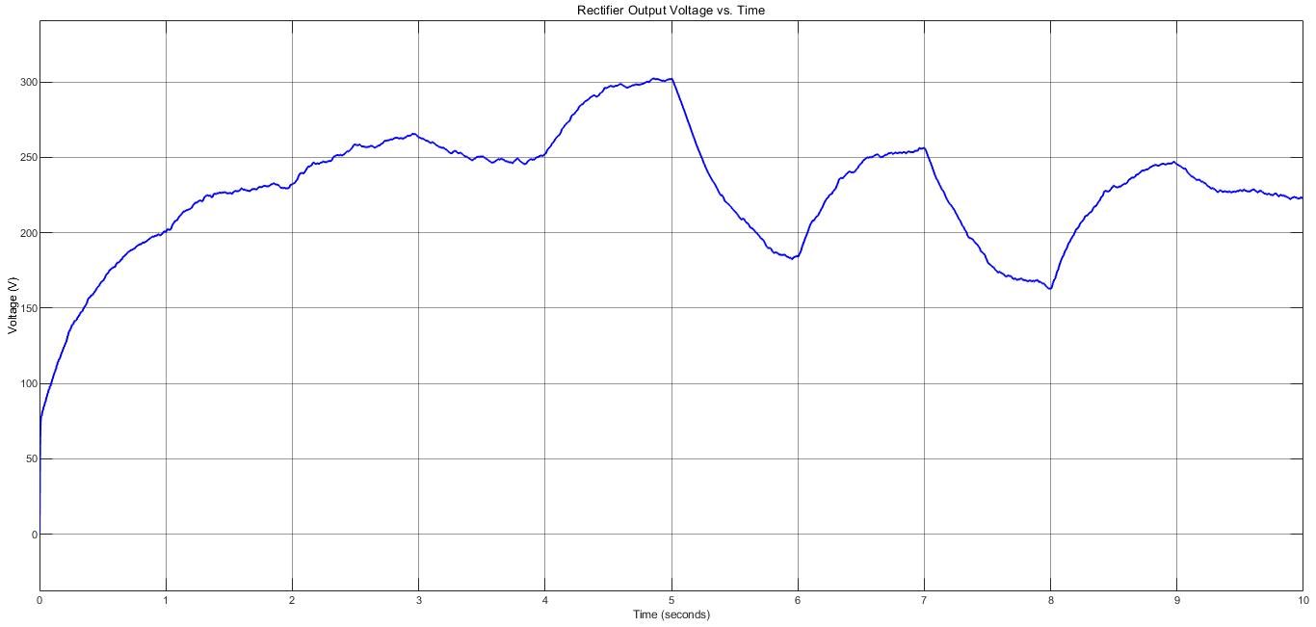

(b)

Figure 2. Rectifier input line to line voltage (a) and rectifier output voltage (b)

We used capacitance with 1 mF. If we used a larger capacitance value, we would get a waveform much closer to the DC. On the other hand, this causes to increase in the size and cost of the rectifier. Cost and size are important criteria for our company, so we used this capacitance value to get the optimum balance between efficiency, size, and cost criteria.

This topology has harmonics in the input and output current. THDs of input and output current are 80.61% and 53.66%, respectively. This is due to unwanted distortion in the input. In Figure 3. below, input and output current can be observed.

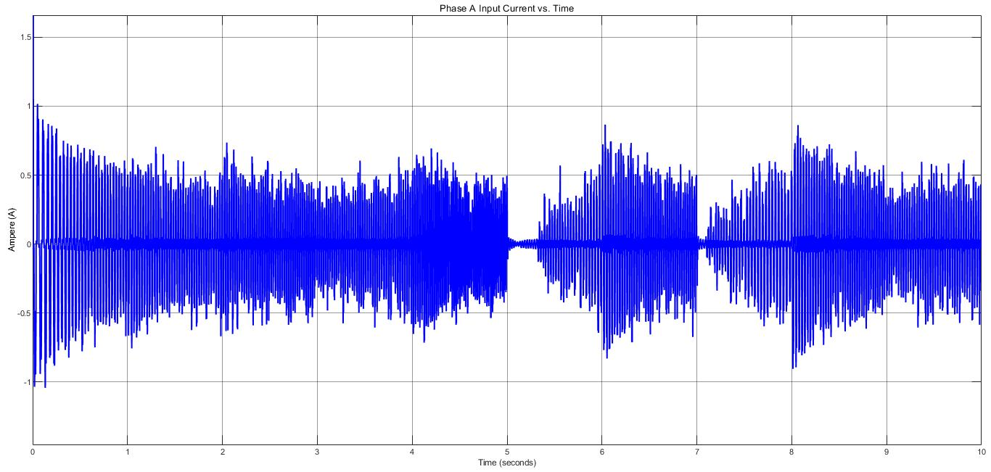

(a)

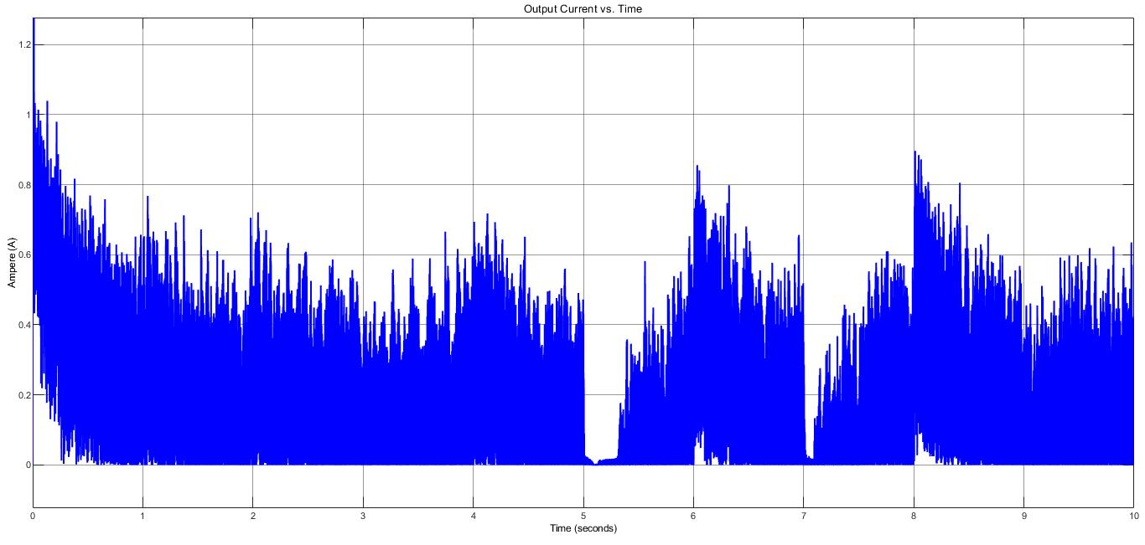

(b)

Figure 3.Rectifier Phase A Input Current (a) and Output Current (b)

Component selection for diodes is based on voltage and current ratings on the simulation waveforms. Diodes current and voltage can be observed in Figure 4. below.

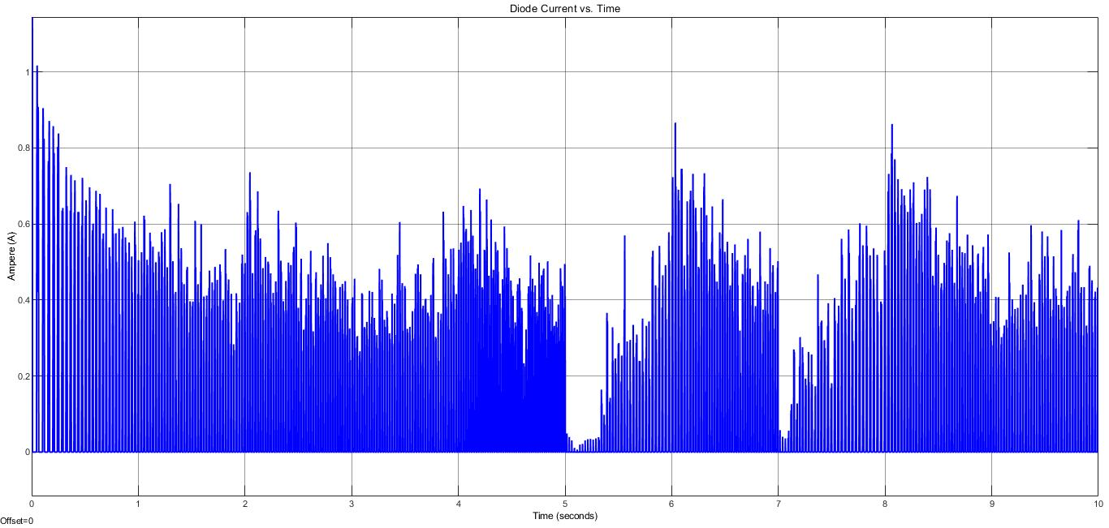

(a)

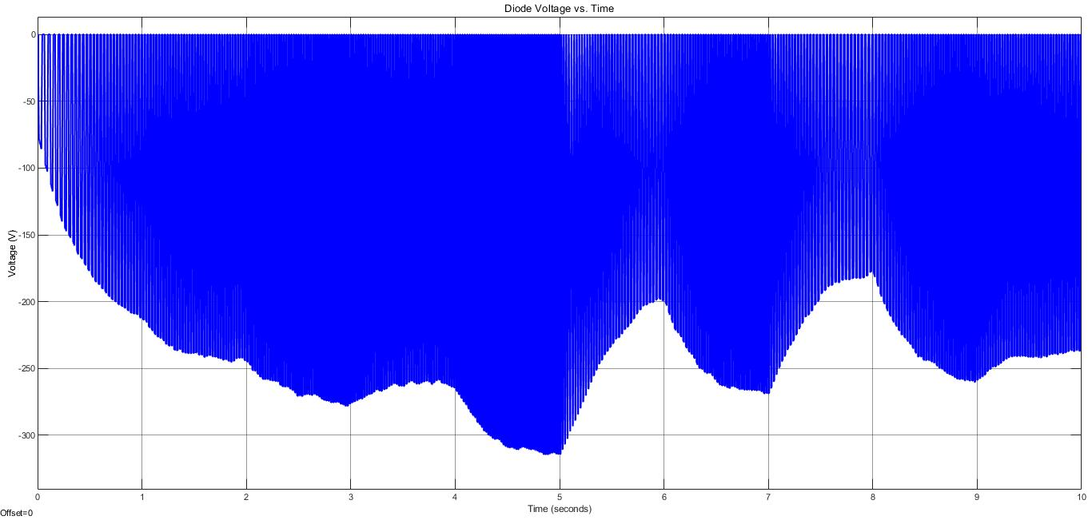

(b)

Figure 4.Diode Current (a) and Output Voltage (b)

It is obvious that the maximum current flowing through diodes is around 1A. Also, inrush current (starting current) cannot be seen from Figure 4., but it is around 10 A. Moreover, the maximum reverse voltage on the diodes is around -330 V. As we will discuss in the ‘Component Selection’ part of the report, we will take into consideration these ratings to select components.

## Simulations of Buck Converter

The circuit schematic of the buck converter can be seen in Figure 5. In this part of the report, MOSFET current and voltage simulation results, also output current and voltage simulation results can be observed. As we said before, MOSFETs are ideal.

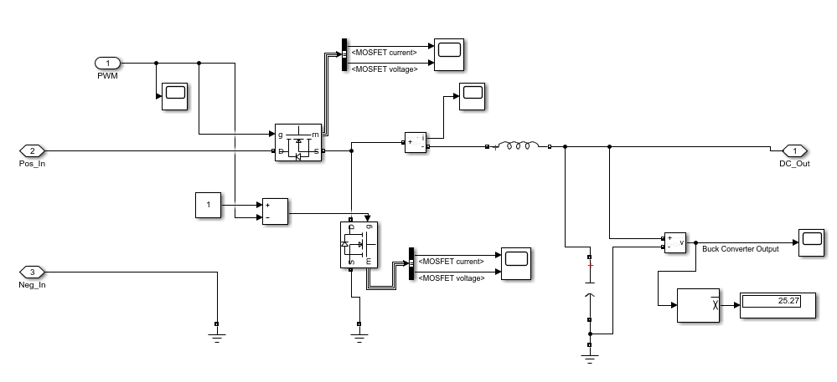

Figure 5. The circuit schematic of buck converter

Since the synchronous buck converter has lower power loss, we decided to use it. On the other hand, it has the disadvantage that it is more complex to control. MOSFET on the top is called the high side which means current flows through to the load. MOSFET on the below is called the low side which means current flows from the supply or load to the ground. We have to drive both of two MOSFETs. High side and low side MOSFETs are driven by PWMs complements of each other because when one diode is on, the other should be off, vice versa. PWM has duty cycle D. In buck converters, the output voltage is found by Equation (1):

[1]

To get 25 V output voltage, duty cycle change between 0.1 and 0.15 because rectifier output has ripple, not DC. We control the duty cycle by the voltage of a resistor at the battery side. We will discuss this in the controller section.

Also, this topology has an inductor and capacitor as every buck converter has. Firstly, we decided inductance value by Equation (2):

[2]

: desired output voltage (It is desired 25V)

Input voltage (Output voltage of the rectifier)

Switching frequency (It is chosen as 10 kHz)

Estimated inductor ripple current (We estimated it as 0.2A by linearization)

By inserting values into the equation (3), we found inductance value of 6.8 mH. In the simulation, we used 5 mH close to the value found. Also, we used a 1 mF capacitor. As seen in Equation x, as inductance and capacitance increase, the ripple at the output decreases.

[3]

On the other hand, as inductance and capacitance values increase, the size and cost increase, so we wanted an optimum balance between efficiency and them.

In Figure 6. below, buck converter output current and voltage can be observed. It is obvious that the output voltage (battery voltage) is almost 25V DC which is consistent with the requirement of the project. Ripple in current and voltage, especially in voltage is small.

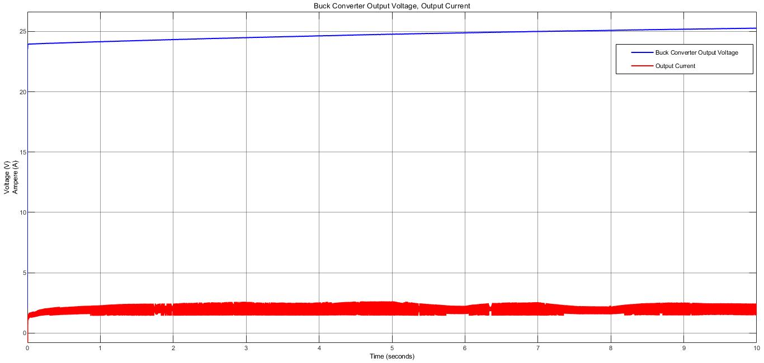

Figure 6. Buck converter output voltage and current

Figure 7. shows MOSFETs voltage and current.

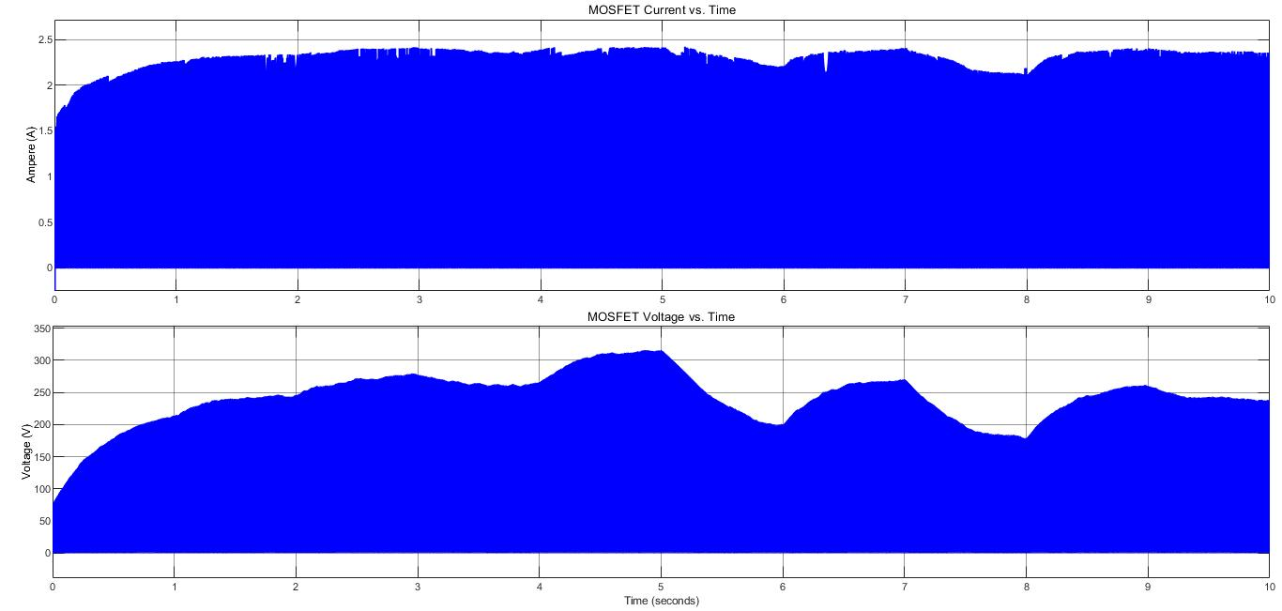

Figure 7.Buck converter MOSFETs voltage and current

## Simulations of Battery Part

The last part of our system is the battery. In this part, 25 V battery voltage and 2 A battery current (ripple is %20 of average current) are desired. We obtained almost 25 V from the previous part (buck converter). To get 2A battery current with the maximum ripple of %20 of the average current, we should use a controller. Our aim is to control the duty cycle of PWM by voltage difference through resistance 0.01 Ohm connected between battery and ground.

Firstly, we tried to implement the P controller. On the other hand, with the P controller we had a huge steady-state error not consistent with battery current requirements, it is expected because steady-state errors are seen in the P controller. For this reason, we focused on other controller types. We tried the hysteresis controller (on-off controller), we obtained less ripple than P controllers do but still it was not consistent with requirements. The on-off controller is not much efficient control way because it does not contain intermediate values. Lastly, we tried the PI controller. Since I term decreases error, we obtained a waveform consistent with the requirement. We arranged P and I values by fine-tuning.

In Figure 8. below, the battery part of our system and the controller we designed can be seen.

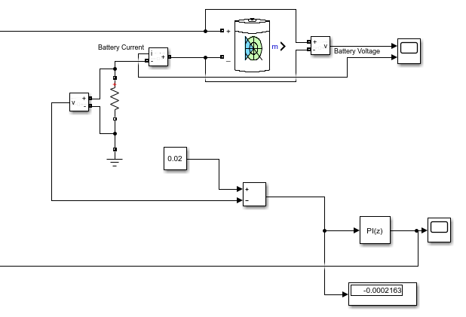

Figure 8. Battery part of our system and PI controller we designed

As seen in Figure 8., we used resistance 0.01 Ohm connected between battery and ground. The desired input current is 2 A, so the desired voltage difference on this resistor is 0.02 V. That is, the set point is 0.02 V. Also, the output is measured voltage difference on the resistor. Error is the difference of them, and our aim is to control it. We arranged P and I values by fine-tuning. The output of the controller is the duty cycle of PWM that drives high side MOSFET. Also, we have mentioned before, complements of this PWM drives low side MOSFET.

In figure 9. below, battery voltage and battery current can be observed.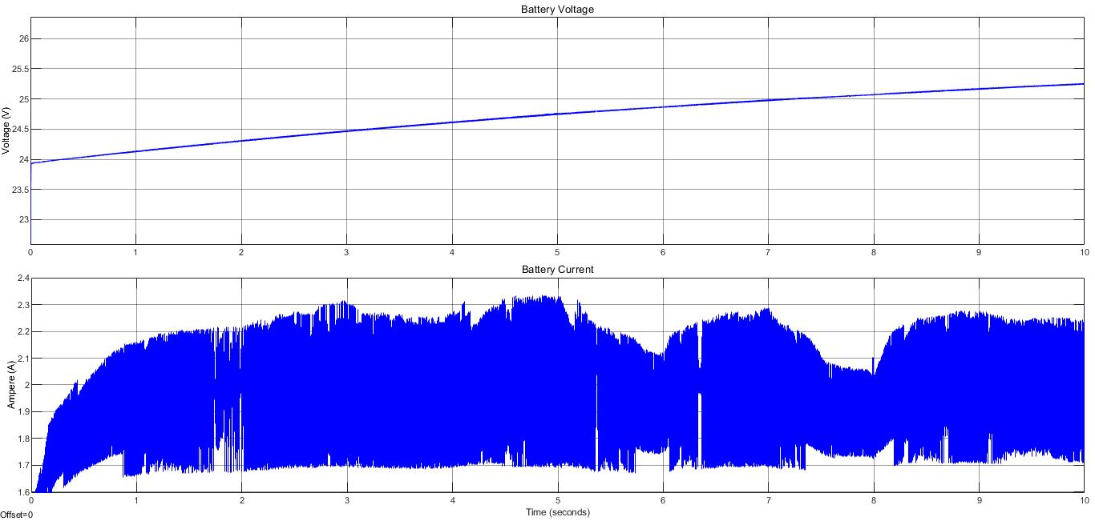

Figure 9. Battery current and voltage

As seen in Figure 9. above, battery voltage and current are consistent with the project requirements.

## Simulations of Whole Circuit

In this part of the report, the whole circuit schematic of our design and input-output simulation results of the whole circuit can be observed.

In Figure 10. below, the whole circuit schematic can be seen.

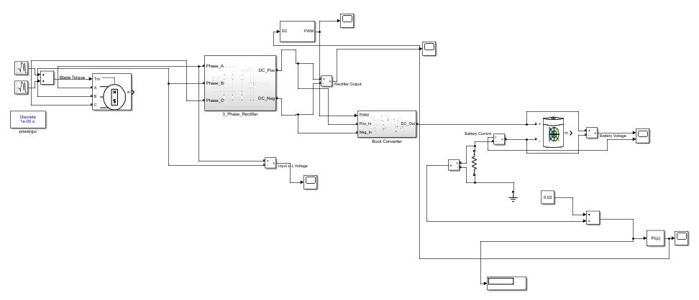

Figure 10. The whole circuit schematic of our design

Moreover, in Figure 11. below, input and output simulations of the whole circuit can be seen. The input of the system is phase line to line voltage which is given as specification of this project, and the output is battery voltage and current which are requirements of this project.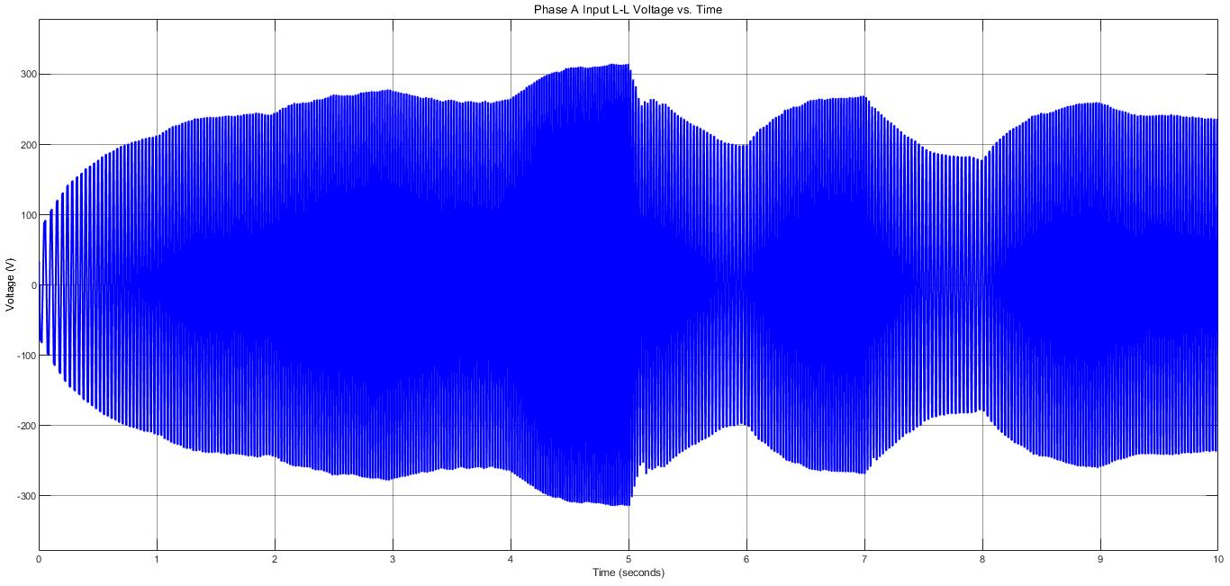

(a)

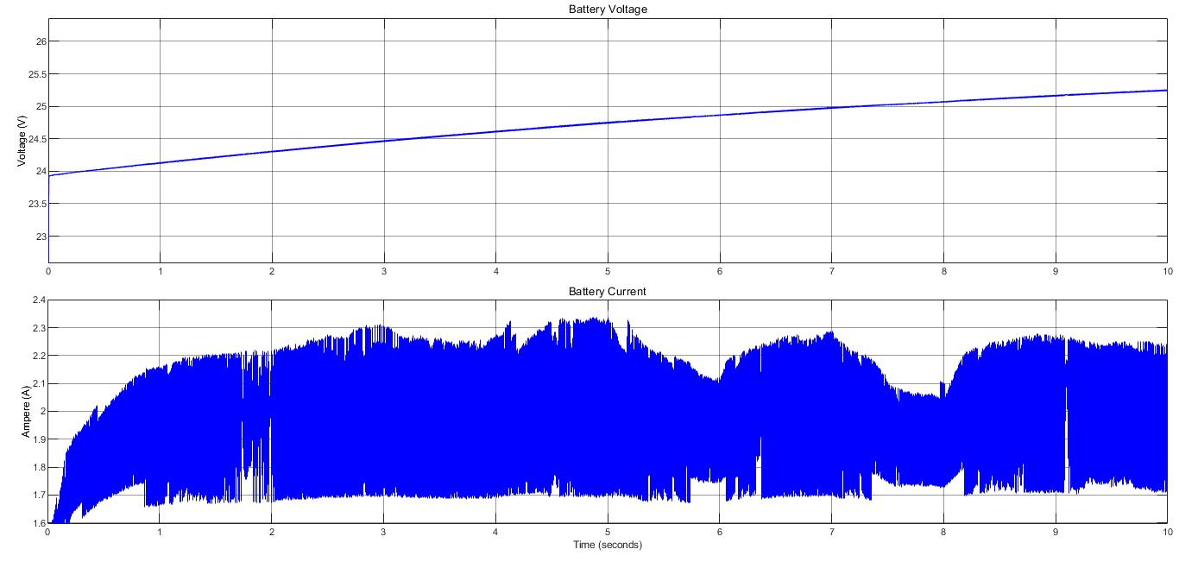

(b)

Figure 11.The simulation results of input (a) and output (b) of the whole circuit

As seen in Figure 11., the whole circuit simulation results are consistent with the results of the subsystems.

# Component Selection

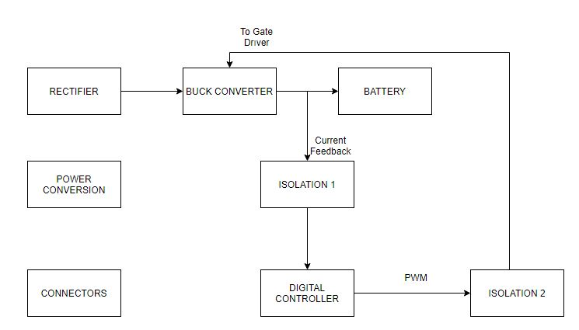

Block diagram 1

In the previous part, we have decided on what components, their values and voltage and current ratings with the Simulink simulation and formulas that we learnt in the lectures. To provide a reliable design, we considered the inrush currents and surge voltages. Therefore, we have chosen our components by considering the maximum power rating and its tolerance.

Also, in our Simulink simulation, we have 3-phase rectifier, Buck Converter, and shunt resistor in order to take feedback, however we are using PI block in order to implement control loop. In real world, we need controllers (analog/digital) to implement this loop, we need gate drivers in order to drive MOSFETs and we need isolations in order to keep logical operations in safe zone.

In this project, we will control our battery current by using a PIC microcontroller. However, these digital controllers are very sensitive and easily disturbed by a noise, so we need to isolate our topology’s analog and digital parts, with a current sensing op-amp. Moreover, we need to take the generated PWM from PIC to our analog circuit side, so we need a digital isolator. Moreover, this coming signal will not be able to drive the MOSFET gates due to low power and voltage, so we need a gate driver with our low-side and high-side MOSFET’s in Buck Converter and this driver must have a bootstrap circuit in order to drive high-side MOSFET. Lastly, we need to feed supplies of these discussed IC’s, so we need to convert battery’s 24V to desired levels, where we will select these desired levels in following sections.

## Capacitors

In this project, we will use two capacitors; one is in rectifier part in order to stabilize our output DC voltage. For the capacitor value, we have calculated them in the ideal simulation part and simulate them accordingly. In rectifier part we needed around 300V capacitor in 1 mF. To stay in safety zone, we chose the ALF20G102EJ450 capacitor, which holds for 450V.

**Link:** https://www.digikey.com/en/products/detail/kemet/ALF20G102EJ450/8681391

**Price:** 9.44 Dollars

The other capacitor is used in buck converter. For this capacitor, the rating value is around 25V and again 1 mF. We chose 108RZM035M1325 capacitor as buck converter capacitor.

**Link:** https://www.digikey.com/en/products/detail/illinois-capacitor/108RZM035M1325/5410896

**Price:** 0.33 Dollars

## Inductor

In the project, we will use inductor in buck converter, and we supposed to design the inductor by hand. However, for this step of the project we added it off the shell product. Our voltage rating is 300V, current rating is around 2A. We chose B82615B2202M001 as inductor.

**Link:** https://www.digikey.com/en/products/detail/illinois-capacitor/108RZM035M1325/5410896

**Price:** 7.50 Euros

## Diodes

In the design, we will use the diode in three different places. One is for rectifier, there will be six diodes for three-phase. The other one is for gate driver as bootstrap diode.

* For the rectifier, we chose S2GTR diode for 400V voltage rating, 2A current rating and 10A surge current.

**Link:** https://www.digikey.com/en/products/detail/smc-diode-solutions/S2GTR/6022599

**Price:** 0.04 Dollar

* As bootstrap capacitor, we chose VS-10BQ030-M3/5BT for 30V voltage rating and 1A current rating.

**Link:** https://www.mouser.com.tr/ProductDetail/Vishay-Semiconductors/VS-10BQ030-M3-5BT/?qs=nc3S1USEIbs7ZsUbhtfKYg%3D%3D

**Price:** 0.186 Euro

## MOSFET

In the circuit, we will use the MOSFET for switching to regulate the duty cycle and conduction on buck converter instead of diode. Our switching frequency is around 10kHz, voltage rating is around 300V and current rating is 2A for around 0.1 duty cycle. Thus, we chose FDD5N50NZTM as a switching MOSFET.

**Link:** https://www.mouser.com.tr/ProductDetail/ON-Semiconductor-Fairchild/FDD5N50NZTM/?qs=kDD%2FdQe9TTeBFAie%252BCBivg%3D%3D

**Price:** 0.79 Euro

## Shunt Resistor

In order to take the feedback from the battery, we should use a shunt resistor. This resistor should be low power component in order to reduce the power loss. Therefore, we chose 10m Ω, and 0402 package in order to keep our design compactness, CSS0402FT10L0.

**Link:** https://www.digikey.com/en/products/detail/stackpole-electronics-inc/CSS0402FT10L0/10719366

**Price:** 0.56 Dollar

## Isolation Op-Amp

Like in every component, we need a cheap and feasible isolation op-amp in order to isolate our Shunt Voltage from the logic side of the circuit. For this purpose, a two channel op-amp was enough for us, and while doing our research, we have found SI8920BC (Silicon Labs) model current sensing isolation op-amp. This model is one of the cheapest isolation op-amps in Mouser and has specifications that we are needed at all. SI8920 has a supply range 3.0V to 5.5V, its differential inputs are capable up to +/-200mV, it is default gain is 8.1 and in datasheet, its typical usage is for current sensing, which is our purpose.

We want all of the IC’s with 3.3V supply in our circuit, where SI8920BC is suitable, our shunt voltage will be around 20mV (with 0.01 ohm shunt resistor and the current is around 2A), and with gain, it’s output will be around 160mV, where this voltage is enough for ADC readings. As a consequence of the features that we count above, we have chosen the SI8920BC for our shunt voltage isolation.

**Link:** https://www.mouser.com.tr/ProductDetail/Silicon-Labs/SI8920BC-IP/?qs=bB7QTEcmLuN2VIVidYwh9w==

**Price (Si8920BCx1):** 2.48 Euro

## Digital Isolator

In our Buck Converter, we have two MOSFETs which are standing for high side and for low side. In order to use these MOSFETs as switches, we need PWMs, which are generated from the controller which will be discussed below. As we mentioned, our controller side will be isolated, so we need a digital isolator which will carry logic side generated PWMs into our analog side.

We will have two PWMs, and for them a two channel digital isolator will be enough for us. As we mentioned before, we are planning the supplies of ICs as 3.3V, so we need to select our digital isolator in that way. When we filtered the components with desired properties above, we have found SI8620AB (Silicon Labs). This digital isolator is a unidirectional, two-channel, 2.5V-5.5V supply range and one of the cheapest solutions. As a consequence of discussed properties, we are selected SI8620AB for our digital isolator.

**Link:** https://www.mouser.com.tr/ProductDetail/Silicon-Labs/SI8620AB-B-ISR/?qs=j6MGy4L9yX20sFXZc1kgqQ%3D%3D

**Price:** 0.85 Euro

## Digital Controller

In our topology, we are selected to control our battery current with a digital controller in order to have an adjustable, reliable, and easy setup circuit. By using a digital controller, we are getting away from complicated and fixed burden of analog controllers. If we use an analog controller, we cannot change control parameters P and I easily when there is an application error of control loop. Moreover, with digital controller, our circuit will be able to charge battery for different currents, which will make our design more desirable.

For digital controller, we wanted to use Microchip’s PIC controllers, due to their easy and useful configuration. When we looked into PIC and dsPIC microcontrollers, we have seen that dsPICs are more complicated, however we only need a Analog-to-Digital Converter and PWM generator, so we decided to move into PIC controllers. When we make a research on Microchip website for ADC and PWM modules with cheap solutions, we are ended up on PIC16F16 series controllers, because these series are specialized for PID control and math operations. While looking the cheapest solution, we have found PIC16F1613 module, which is a fourteen-pin small controller, however there is not a separated PWM module in this PIC16F1613, PWM module is connected to Compare-Capture Module, which may be problematic while initializing PWM in code, so we moved into PIC16F1614. This module has 10-bit ADC module configurable for all analog pins and a CWG (complementary waveform generator) module which is suitable for driving of a half-bridge, again this module is configurable for all digital pins.

To conclude, with 3.3V supply, 10-bit ADC, CWG, specialized for PID control and cheap price features, we are decided to use PIC16F1614 as digital controller in our circuit.

**Link:** https://www.microchip.com/wwwproducts/en/PIC16F1614

**Price:** 0.96 Dollar

## Gate Driver

In our Buck Converter, we have two MOSFETs for high side and low side which will be driven complementary, with PWMs generated from our digital controller, however these PWMs are not have enough voltage to drive our MOSFET gates, moreover for high side we need a bootstrap configuration for drive. For this purpose, we need a gate driver in our circuit.

From our simulations, we know that our high side MOSFET sees a voltage up to 300V between drain and source, so we need to select a suitable driver. Moreover, in order to prevent short circuit between drain of high side and source of low side we need a proper dead time between complementary PWMs, by considering turn-on and off delay times. When we look the datasheet of our MOSFETs in Buck Converter (FDD5N50NZ), the maximum turn-on delay time is 35ns and the maximum turn-off delay time is 65ns, so at least we need a dead time higher than 100ns.

While doing our research on Mouser, we have ended up with 2 models, which are 2ED2182S06FXUMA1 and BS2103F, with 650V and 600V high voltage purpose, respectively. Both models are suitable for our voltage range and have bootstrap application, however the first model is expensive than second. When we look further, we see that gate current of first one is up to 2.5A and the second one is 130mA. We are using MOSFETs, so we do not need a high gate current, when we examine the datasheet of the first one, we see that it is suitable for IGBT, too, due to high gate current. When we look dead times, first one has 400ns dead time and it is adjustable with R-C circuit, and second one has fixed 160ns dead time.

As we discussed above, a dead time higher than 100ns is suitable for us, and we are driving MOSFETs, we do not need high gate current, for this purpose we have selected 2nd option, which is cheaper, BS2103F. This model has supply range between 10V and 18V.

**Link:** https://www.mouser.com.tr/ProductDetail/ROHM-Semiconductor/BS2103F-E2/?qs=iaprbs8w3G9rav1d9DTYOA%3D%3D

**Price:** 0.84 Euro

## Power Conversion Units

As we mentioned above, except gate driver, we have selected all of our IC’s with 3.3V, and our gate driver has a supply range between 10V and 18V. We can select supply of gate driver as 12V, so we need to convert 24V battery voltage into 12V and 3.3V separately, and for isolated supplies, we need to convert 3.3V into isolated 3.3V, which means we need three converters which are 24V/12V, 24V/3.3V, 3.3V/Isolated 3.3V.

In following sections, we have decided our conversions with cheapest way with considering IC supply currents.

### 24V/12V Conversion:

When we look cheapest solution for 24V/12V conversion, we have ended up with UA7812CKCS, which is a linear voltage regulator with fixed 3.3V 1.5A output for 14.5V-25V input range. This will supply only gate driver, whose supply current is at most 1mA, where our converter is enough. Moreover, in this model is through hole, so we can place it vertically in our circuit for lower space.

**Link:** <https://www.mouser.com.tr/ProductDetail/Texas-Instruments/UA7812CKCS/?qs=DcvZ7Fltd5zyvhYGYzcR7A%3D%3D>

**Price:** 0.67 Euro

### 24V/3.3V Conversion

While doing our research for 24V/3.3V conversion, we have ended up in two models which are BA033CC0FP and UA78M33CKVURG3, which are LDO and Linear regulators, respectively. A LDO regulator is more power efficient, moreover our LDO regulator is 1A, however our linear regulator is cheaper but has 500mA output. When we look our ICs, we have 2 ICs with 3.3V supply and in the worst case, isolated op-amp draws 4.2mA maximum, for digital isolation that current is 1.2mA. Which means we do not need high currents, so we have selected the second one which is UA78M33CKVURG3, cheaper solution.

**Link:** https://www.mouser.com.tr/ProductDetail/Texas-Instruments/UA78M33CKVURG3/?qs=0O%2FZFlpUpJXrDg4gfD1Q2g%3D%3D

**Price:** 0.49 Euro

### 3.3V Isolation

For a non-disturbed operation, we need that isolation, however the isolation is a very expensive event. Due to this fact, we have selected the cheapest solution for 3.3V isolation. While we are doing our research, we have found R1SX-3333R, which gives isolated 3.3V with 303mA output. We have three IC’s with isolated 3.3V supply, and the worst one in worst case draws 4.2mA according to datasheet, so 303mA is enough.

**Link:** https://www.mouser.com.tr/ProductDetail/RECOM-Power/R1SX-3333-R/?qs=AQlKX63v8Rsf1yduGKaK6w%3D%3DA

**Price:** 2.46 Euro

## Connectors

We have three terminals in our circuit which are motor phases, battery terminals and in circuit serial programming (ICSP) pins. For motor phases and battery terminals we will use screw connectors, and for ICSP we will use headers.

* **Motor Connector Link:** https://www.mouser.com.tr/ProductDetail/Phoenix-Contact/5452258/?qs=iCzJi%2FIZBF77ZcTXZHmYbQ%3D%3D
* **Battery Connector Link:** https://www.mouser.com.tr/ProductDetail/CUI-Devices/TB007-508-02BE/?qs=vLWxofP3U2y6PFKAfCqKUQ%3D%3D
* **ICSP Connector Link:** https://www.mouser.com.tr/ProductDetail/Amphenol-FCI/67997-100HLF/?qs=cpLrBgdhsoH33Mp6xh%2FbyQ%3D%3D

**Total Price:** 1.87 Euro

Table . Total Budget

|  |  |  |  |  |
| --- | --- | --- | --- | --- |
| **Component** | **Manufacturer Number** | **Quantity** | **Price [$]** | **Total Price [$]** |
| Capacitor | ALF20G102EJ450 | 1 | 9.44 | 9.44 |
| Capacitor | 108RZM035M1325 | 1 | 0.33 | 0.33 |
| Inductor | B82615B2202M001 | 1 | 9.16 | 9.16 |
| Diode | S2GTR | 6 | 0.04 | 0.24 |
| Diode | VS-10BQ030-M3/5BT | 1 | 0.23 | 0.23 |
| MOSFET | FDD5N50NZTM | 2 | 0.97 | 1.94 |
| Shunt Resistor | CSS0402FT10L0 | 1 | 0.56 | 0.56 |
| Isolation Op-Amp | SI8920BC | 1 | 3.03 | 3.03 |
| Digital Isolator | SI8620AB | 1 | 1.04 | 1.04 |
| Digital Controller | PIC16F1614 | 1 | 0.96 | 0.96 |
| Gate Driver | BS2103F | 1 | 1.03 | 1.03 |
| 12V Converter | BS2103F | 1 | 0.82 | 0.82 |
| 3.3V Converter | UA78M33CKVURG3 | 1 | 0.60 | 0.60 |
| DC Isolator | R1SX-3333R | 1 | 3.01 | 3.01 |
| Connector | 5452258 | 1 | 1.64 | 1.64 |
| Connector | TB007-508-02BE | 1 | 0.54 | 0.54 |
| Connector | 67997-100HLF | 1 | 0.10 | 0.10 |
| Consumables | - | - | 1 | 1 |
| **Total** | | | | **35.67** |

# Non-ideal Simulations

In this part of the report, simulation results by using MATLAB Simulink with non-ideal cases will be provided. After component selection, we implemented the diodes and MOSFETs to Simulink with their real parameters. We observed that there is not a significant change. It may be since we cannot enter all parameters into the Simulink environment, or we carefully selected the components.

In this part, firstly, three-phase diode rectifier schematic and simulation results will be shown. Then, the buck converter schematic and simulation results will be shown. After the buck converter, the battery and controller the last part of our system will be shown. Finally, the whole circuit schematic and input-output simulation results of the whole circuit will be provided.

## Simulations of Three Phase Diode Rectifier

In Figure 12. below, the input line to line (a) and output voltage (b) with non-ideal diodes can be seen.

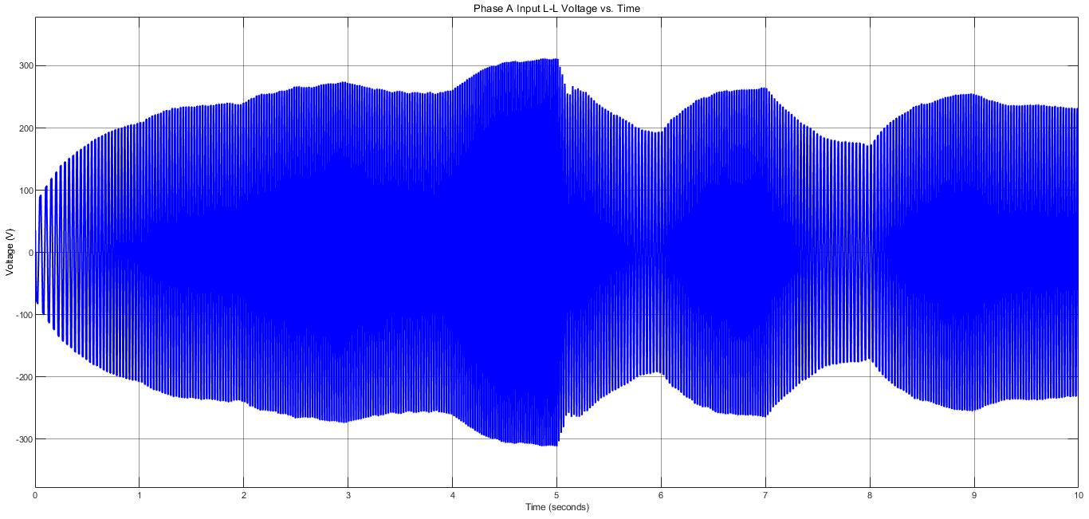

(a)

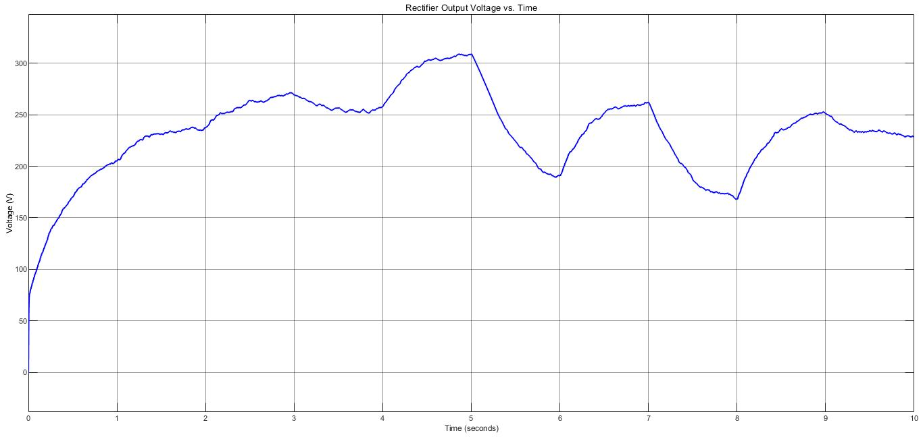

(b)

Figure 12. Rectifier input line to line voltage (a) and rectifier output voltage (b)

If Figure 12. is compared with Figure 2. it is seen that there is no significant change.

## Simulations of Buck Converter

In Figure 13. below, the buck converter output voltage and output current waveforms with non-ideal diodes can be seen.

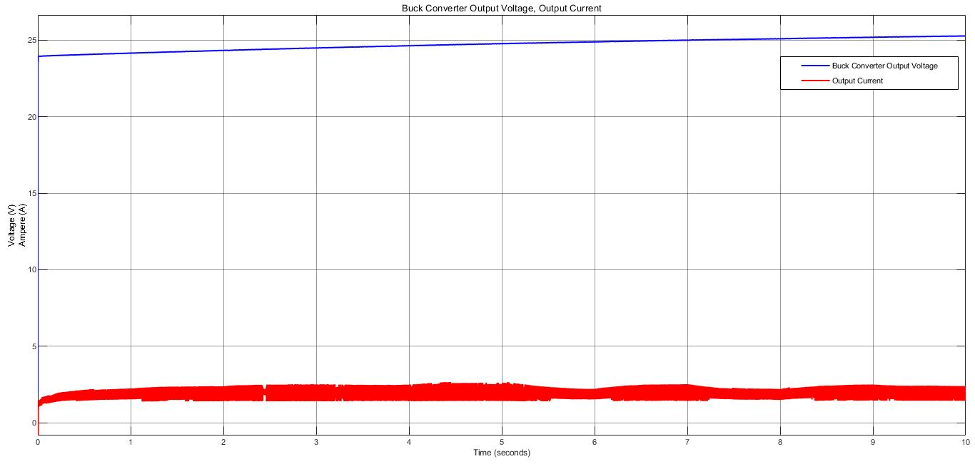

Figure 13. Buck converter output voltage and current

If Figure 13. is compared with Figure 6., it is seen that there is no significant change.

## Simulations of Battery Part

In Figure 14 below, the battery voltage and battery current can be seen.

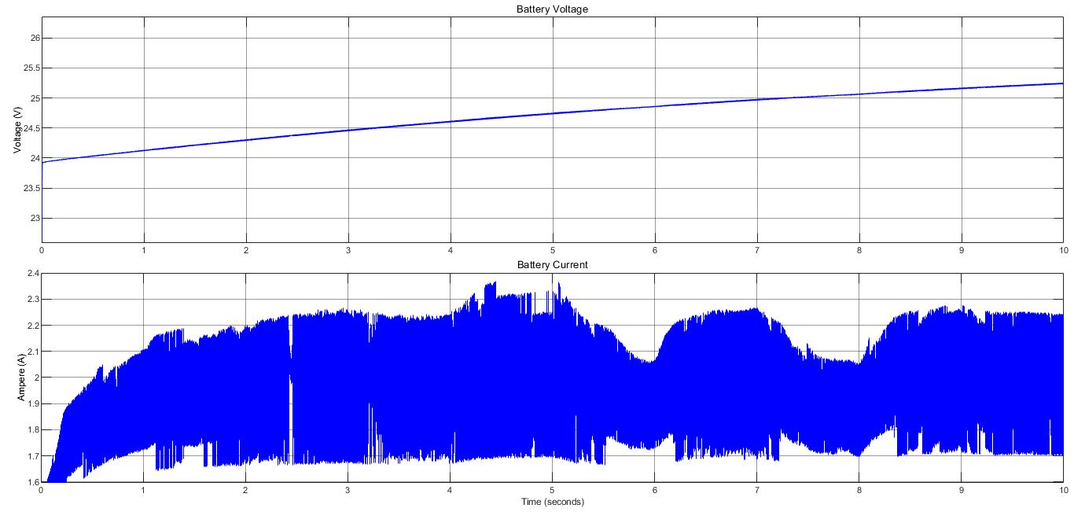

Figure 141 Battery current and voltage

If Figure 14. is compared with Figure 9., it is seen that there is no significant change.

# Schematic Design

After concluding our topology selection, ideal/non-ideal simulation results and component selection part, we moved into schematic design part. In schematic part we have used Altium Designer 20, we have worked hierarchically which have eased our design. Our subparts are rectifier unit, converter unit, isolation unit, logic unit, power unit and connector unit. Overview of hierarchy can be seen in Figure 15.

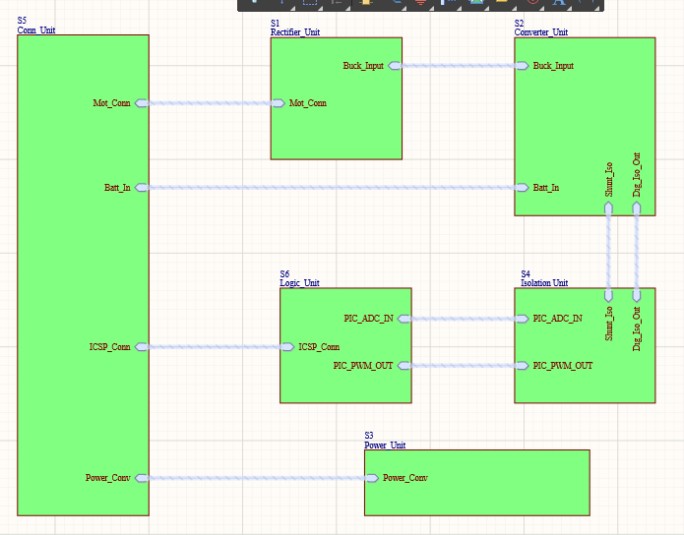

Figure 15. Overview of Hierarchical Design

## Rectifier Unit

As seen in Figure 16., in our rectifier unit we have our selected diodes and capacitor for three phase diode rectifiers, which has the same design with Simulink simulations.

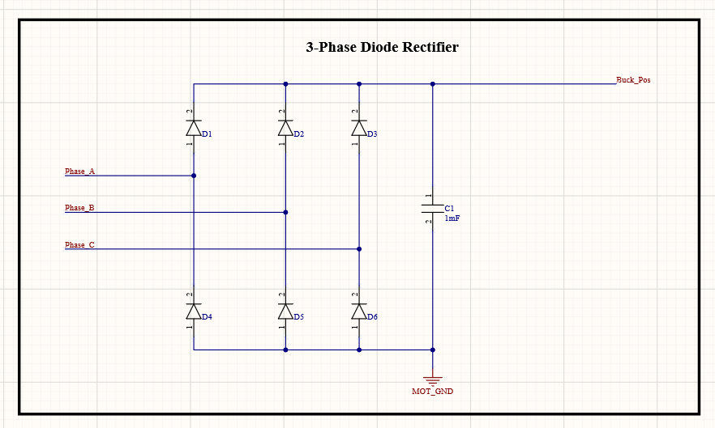

Figure 16. Three Phase Full Bridge Diode Rectifier Schematic

## Converter Unit

In converter unit, we have three parts which are buck converter, shunt resistor and gate driver. Buck converter design is same with Simulink simulations, shunt resistor is connected between negative terminal of battery and ground, which can be seen in Figure 17.

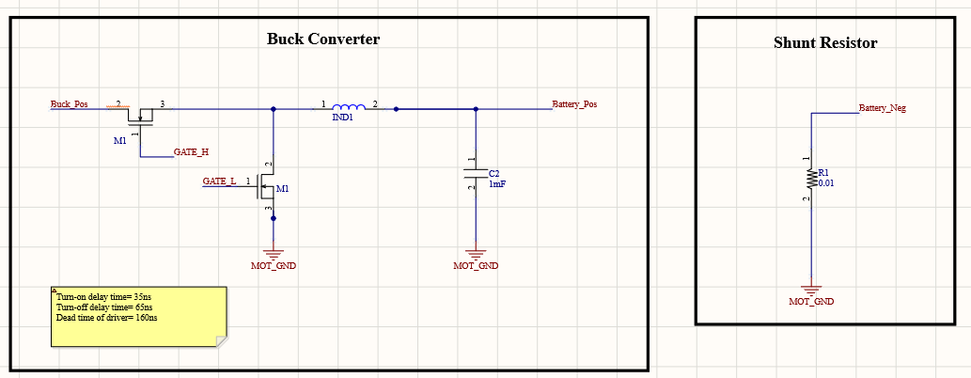

Figure 17. Buck Converter and Shunt Resistor Schematic

When we examined the selected gate driver’s datasheet, in recommended connection we are needed a 1uF bootstrap capacitor, and two times of bootstrap capacitor for supply bypass capacitance. Moreover, for bootstrap circuit, we need a diode between supply and positive terminal of bootstrap capacitor. While driving MOSFET gates, small resistances are required for current slew rate, so we added 20 ohms to gate paths. These discussed features of gate driver circuit can be examined in Figure 18.

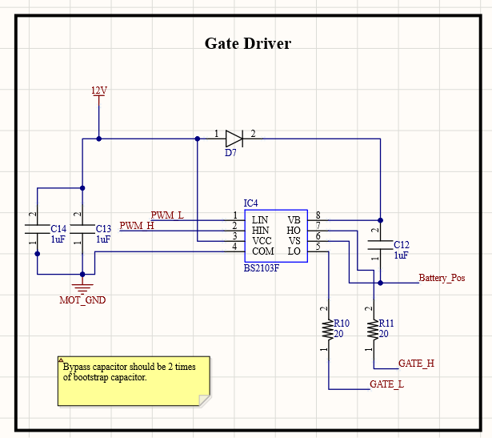

Figure 18. Gate Driver Schematic

## Isolation Unit

As we discussed in component selection part, we are needed isolation for digital side of our circuit. In our schematic, isolation unit includes two main parts which are isolating op-amp and digital isolator.

When we examine the datasheet of our selected isolating op-amp, we see that for both supplies we are needed 100nF bypass capacitors, for differential input of our op-amp we are given a recommended filtering R-C circuit constructed with 20 ohm resistors and 10nF capacitor. At the output of isolation, we need again filtering for ADC input, and the cut-off frequency is determined by user. The only information given is resistors should be bigger than 5kohms. We have assumed our PWM frequency as 30kHz and cut-off frequency as 15kHz to prevent isolation from PWM noise, we have assumed the resistors as 5.6kohms, so we have found the filtering capacitor as 1uF. Isolation op-amp circuit can be examined in Figure 19.

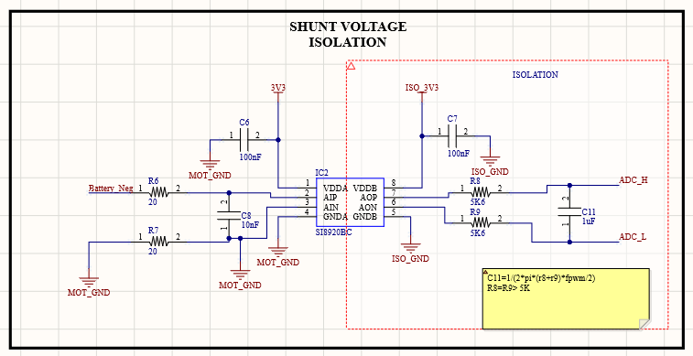

Figure 19. Isolating Op-amp Schematic

In our selected digital isolator, we only need bypass capacitors which are recommended in datasheet as 100nF. In Figure 20., digital isolator schematic can be seen.

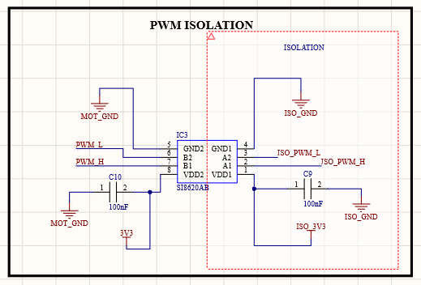

Figure 20. Digital Isolation Schematic

## Logic Unit

In logic unit, we have our selected digital controller which is PIC16F1614. In the datasheet of this controller, we need bypass capacitors 10nF and 100nF. In this microcontroller, we have pins for in circuit serial programming which are MCLR, ICSPDAT and ICSPCLK, which are connecting to PICKIT. In recommended connection, ICSPDAT and ICSPCLK have direct connection, however we are given a recommended connection for MCLR with 10kohms and 4.7kohms resistor and 100nF bypass capacitor. Moreover, in this part of schematic we have ADC inputs and PWM outputs, where PWM outputs have pull-down resistors for safe operation. Schematic of controller can be seen in Figure 21.

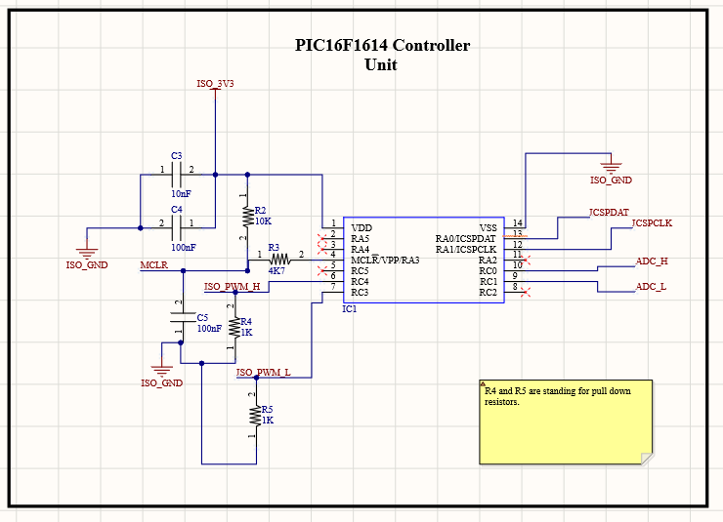

Figure 21. Controller Schematic

## Power Unit

In power unit of schematic, we have selected 24V/12V, 24V/3.3V and 3.3V Isolation equipment. In this part, we only have extra bypass capacitors that are recommended in datasheets. In Figure 22. 24V/12V and 24V/3.3V, and in Figure 23. 3V isolation schematics can be seen.

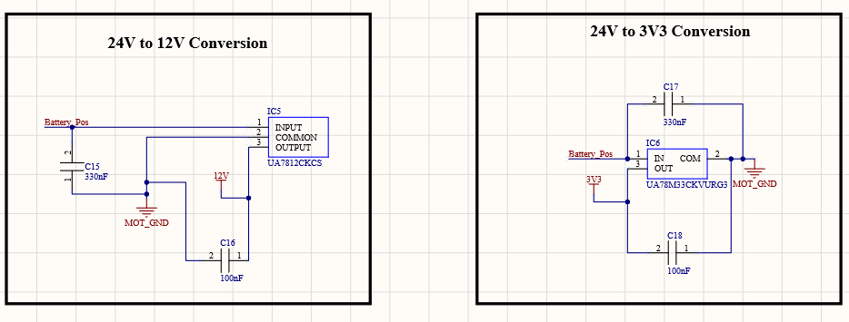

Figure 22. 24V/12V and 24V/3.3V Conversion Schematic

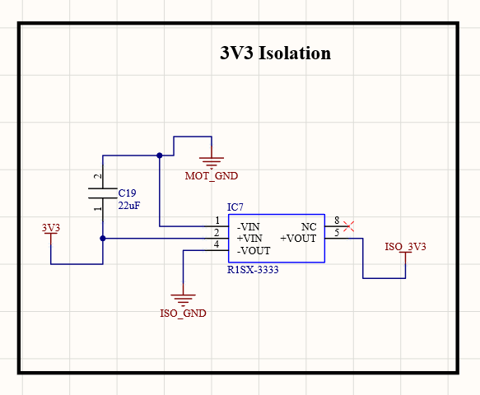

Figure 23. 3.3V Isolation Schematic

## Connector Unit

As we discussed before, we will use screw connectors and headers in order to achieve flexibility in connections. Schematic of connectors can be seen in figure 10.

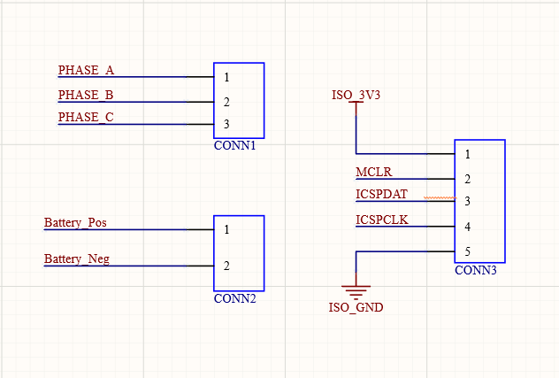

Figure 24. Connector Schematic

To sum up the schematic design, we have designed our circuit in detail by investigating and exploring all of the datasheets deeply. We have considered needed bypass capacitors, diodes, pull-down resistors, and other equipment. We will carry this detailed work into PCB works to achieve best design.

# Conclusion

In this project, the aim is showing the outcomes of the lecture in practical level. We have considered a real case, which is a rising phenomena in energy industry, the Wind Turbines.

We have made a circuit design which rectifies the three-phase AC voltage, reduces it to charge a battery in desired value and controls it with closed feedback loop. Then, we made the necessary simulation bot ideal and non-ideal case. In here the idea is, simulation is a tool for specifying the components in order to design a reliable and compact product. Therefore, after the simulations we chose the components according to our calculations and simulation results. As a last part, for this step of the project, we draw the schematics of our components and subsystems by using a design tool Altium. This is an important part in order to see the component as a circuit particle, not a simulation box.

# REFERENCES

|  |  |
| --- | --- |
| [1] | B. Hauke, «Basic Calculation of a Buck Converter's Power Stage,» Texas Instruments Inc., 2015. |
| [2] | M. Score, «Ceramic or electrolytic output capacitors in DC/DC converters—Why not both?,» *Analog Applications Journal,* pp. 16-20, 2015. |
| [3] | A. KARAFIL ve H. OZBAY, «Power Control of Single Phase Active Rectifier,» *BALKAN JOURNAL OF ELECTRICAL & COMPUTER ENGINEERING,* pp. 332-336, 2019. |