**INTRODUCTION**

The fact that the energy provided by fossil fuels in the world will be exhausted has directed people to inexhaustible energy resources. That is to renewable energy sources. It is a necessity to focus on renewable energy sources to transfer natural heritage to future generations, to protect the environment and to obtain energy cheaply. For this purpose, three METU EE senior students, named Distanced Power Solutions Inc. presents AC to DC Motor Drive for the wind turbine to get renewable energy.

In this report, we included simulation results for ideal and non-ideal conditions. In the first part of the report, topology selection will be discussed. The advantages and disadvantages of the selected topology will be stated. Also, we will discuss why we selected it. Then, simulation results for ideal cases will be shown. On the other hand, as everyone knows, simulation results are not the same as real-life results. In real life, there are some non-ideal parameters. We will discuss them. In the following part, the component selection will be discussed. It will do by adding some margin to what we have measured in the ideal simulation so that the system does not fail. Then, simulation results with the non-ideal parameters of the selected components will be shown. In the PCB design part, PCB design of our circuit using Altium will be shown by taking into consideration real-life environment such as gate drivers, regulators, isolators, heatsinks & fans.

Our biggest goal from this project is to get a simple, robust, reliable and as cheap as possible AC to DC converter. We think that this project will improve our practical skills by using theoretical knowledge of EE 463 course. As senior engineering students, this project will give chance us to improve the problem-solving skills that every engineer should have.

**PROJECT DESCRIPTION**

In this project, we are asked to design an AC to DC converter with the required control techniques to use in the wind turbine. Generated electricity by the turbine will be used to illuminate the road next to our department. There are some specifications and requirements for this project.

Parameters of the synchronous machine are:

Open circuit voltage peak: 330 Vline-to-line

Inertia: 0.00027 kg.m^2

Viscous Damping: 0.005024 N.m.s

Poles: 2

Voltage Constant: 110 Vpeak l-l/krpm

Stator Resistance: 10.58 Ohm

Armature Inductance: 16.7 mH

Project requirements are:

Battery capacity: 13 Ah

Battery nominal voltage: 24 V

Output current: 2 A

Output current ripple: %20 of average current

**IDEAL SIMULATIONS**

In this part of the report, simulation results by using MATLAB Simulink with ideal components will be provided. Firstly, three-phase diode rectifier schematic and simulation results will be shown. Then, the buck converter schematic and simulation results will be observed. After the buck converter, battery and controller the last part of our system will be shown. Finally, the whole circuit schematic and input-output simulation results of the whole circuit will be provided.

**Simulations of Three Phase Diode Rectifier**

As seen in Figure X below, in our three-phase diode rectifier circuit, we used a capacitor to filter out output voltage waveform because our input voltage which was given to us for the project is not purely sinusoidal. This simulation does not include line inductance and resistance. Also, diodes are ideal.

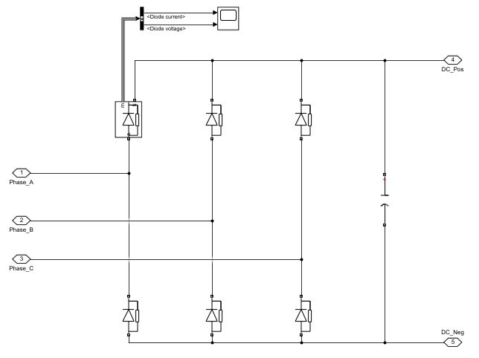

***Figure X:*** *The circuit schematic of three phase diode rectifier*

In Figure X below, the input line to line (a) and output voltage (b) can be seen.

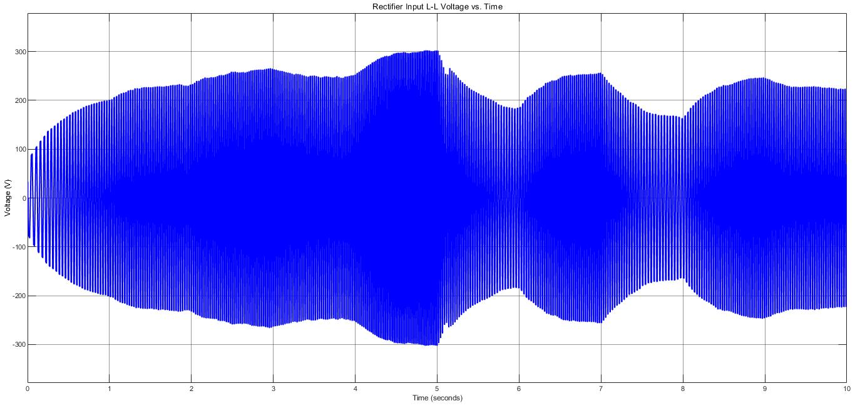

(a)

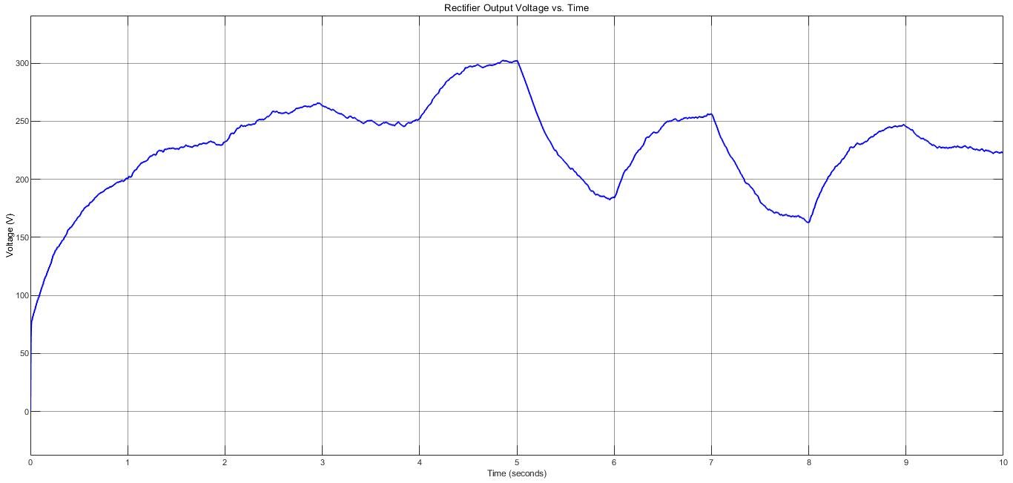

(b)

***Figure X:*** *Rectifier input line to line voltage (a) and rectifier output voltage (b)*

We used capacitance with 1 mF. If we used a larger capacitance value, we would get a waveform much closer to the DC. On the other hand, this causes to increase in the size and cost of the rectifier. Cost and size are important criteria for our company, so we used this capacitance value to get the optimum balance between efficiency, size, and cost criteria.

This topology has harmonics in the input and output current. THDs of input and output current are 80.61% and 53.66%, respectively. This is due to unwanted distortion in the input. In Figure x below, input and output current can be observed.

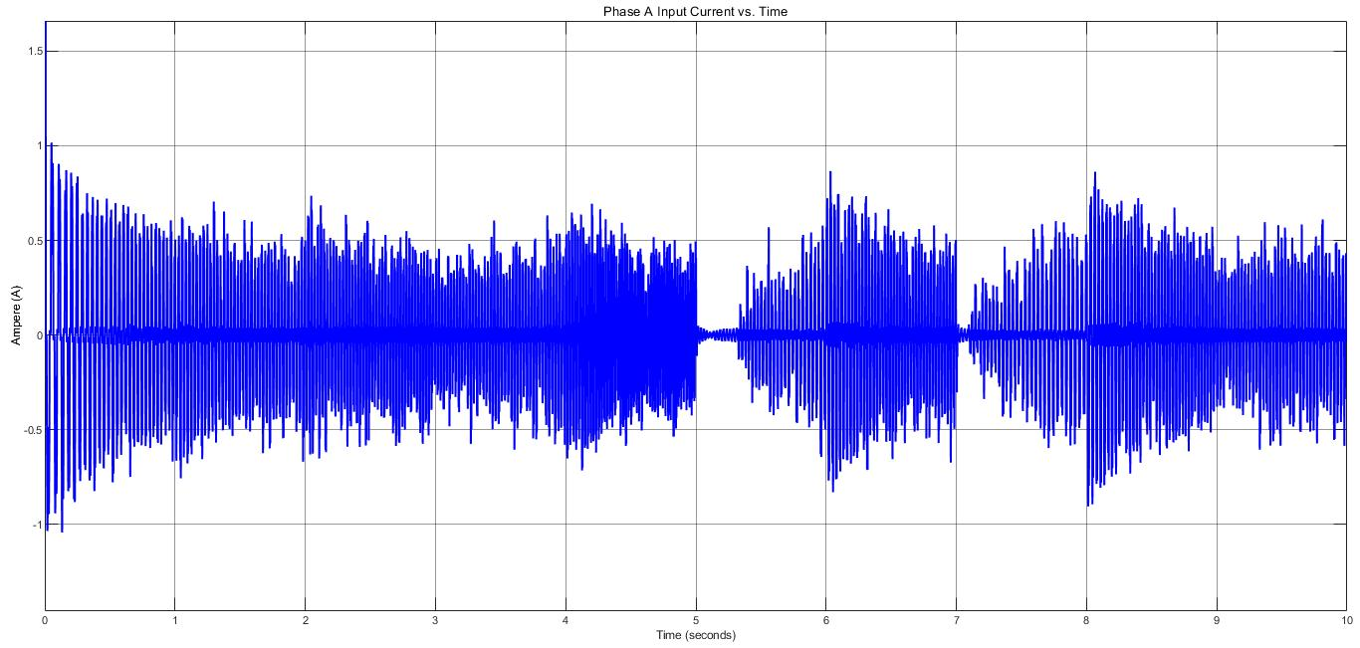

(a)

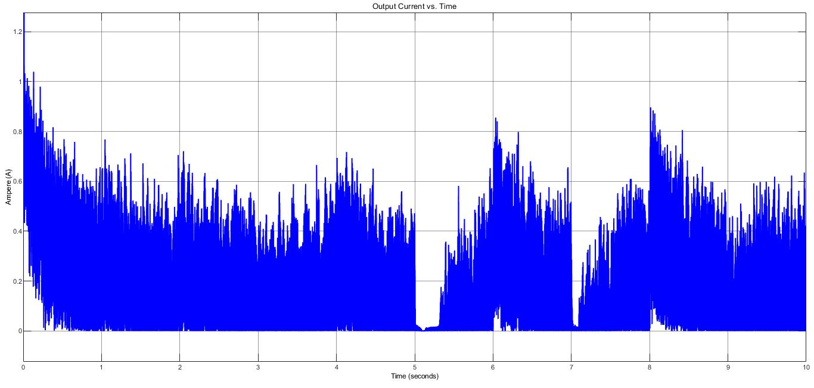

(b)

***Figure X:*** *Rectifier Phase A Input Current (a) and Output Current (b)*

Component selection for diodes is based on voltage and current ratings on the simulation waveforms. Diodes current and voltage can be observed in Figure x below.

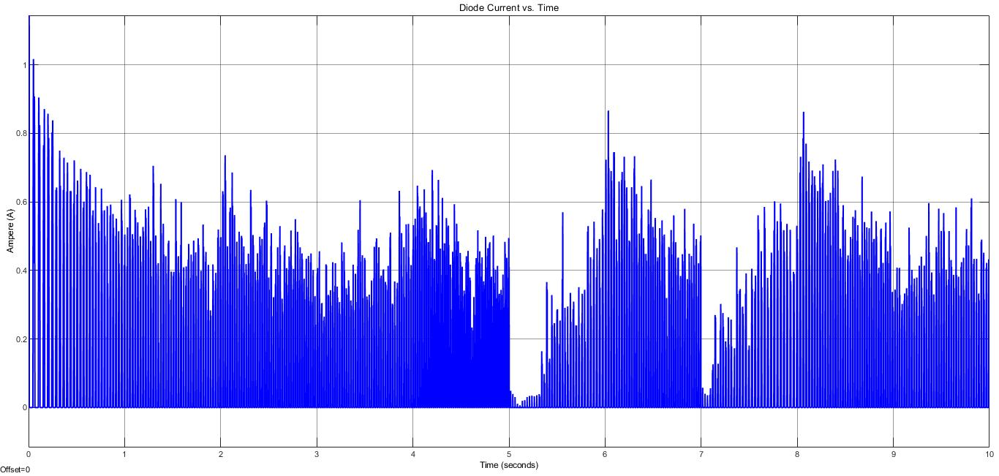

(a)

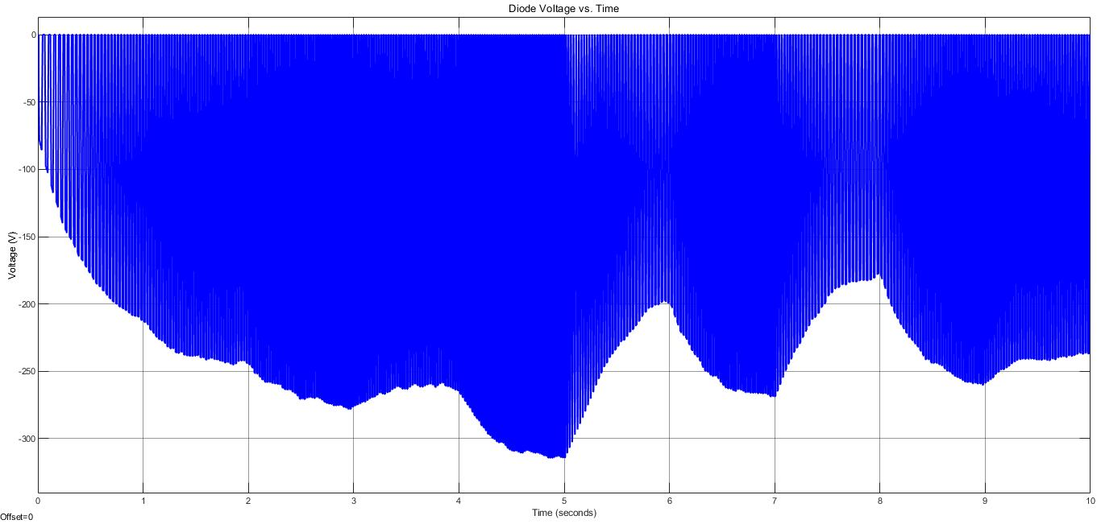

(b)

***Figure X:*** *Diode Current (a) and Output Voltage (b)*

It is obvious that the maximum current flowing through diodes is around 1A. Also, inrush current (starting current) cannot be seen from Figure X, but it is around 10 A. Moreover, the maximum reverse voltage on the diodes is around -330 V. As we will discuss in the ‘Component Selection’ part of the report, we will take into consideration these ratings to select components.

**Simulations of Buck Converter**

The circuit schematic of the buck converter can be seen in figure X. In this part of the report, MOSFET current and voltage simulation results, also output current and voltage simulation results can be observed. As we said before, MOSFETs are ideal.

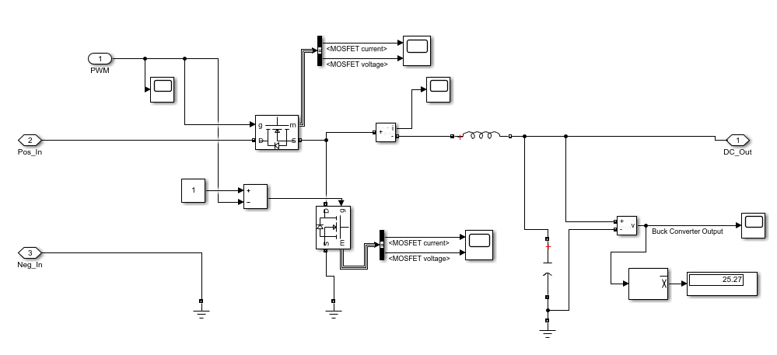

***Figure X:*** *The circuit schematic of buck converter*

Since the synchronous buck converter has lower power loss, we decided to use it. On the other hand, it has the disadvantage that it is more complex to control. MOSFET on the top is called the high side which means current flows through to the load. MOSFET on the below is called the low side which means current flows from the supply or load to the ground. We have to drive both of two MOSFETs. High side and low side MOSFETs are driven by PWMs complements of each other because when one diode is on, the other should be off, vice versa. PWM has duty cycle D. In buck converters, the output voltage is found by Equation x;

To get 25 V output voltage, duty cycle change between 0.1 and 0.15 because rectifier output has ripple, not DC. We control the duty cycle by the voltage of a resistor at the battery side. We will discuss this in the controller section.

Also, this topology has an inductor and capacitor as every buck converter has. Firstly, we decided inductance value by Equation X;

: desired output voltage (It is desired 25V)

Input voltage (Output voltage of the rectifier)

Switching frequency (It is chosen as 10 kHz)

Estimated inductor ripple current (We estimated it as 0.2A by linearization)

By inserting values into the equation x, we found inductance value of 6.8 mH. In the simulation, we used 5 mH close to the value found. Also, we used a 1 mF capacitor. As seen in Equation x, as inductance and capacitance increase, the ripple at the output decreases.

On the other hand, as inductance and capacitance values increases, the size and cost increase, so we wanted an optimum balance between efficiency and them.

In Figure X below, buck converter output current and voltage can be observed. It is obvious that the output voltage (battery voltage) is almost 25V DC which is consistent with the requirement of the project. Ripple in current and voltage, especially in voltage is small.

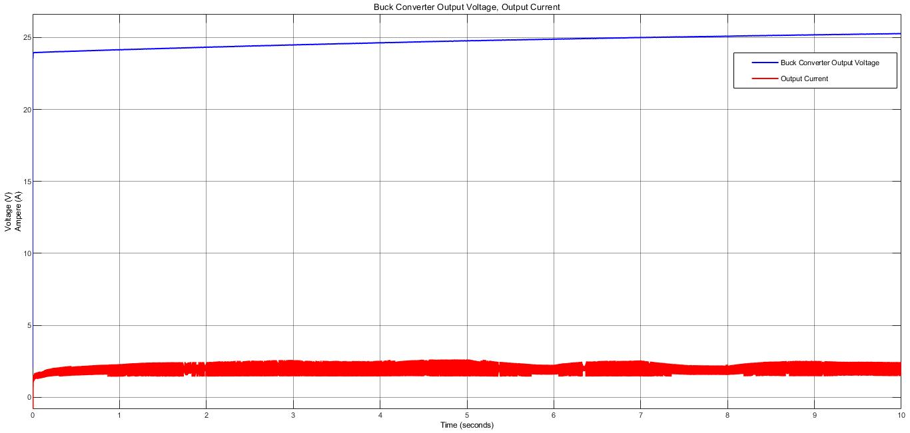

***Figure X:*** *Buck converter output voltage and current*

Figure x shows MOSFETs voltage and current.

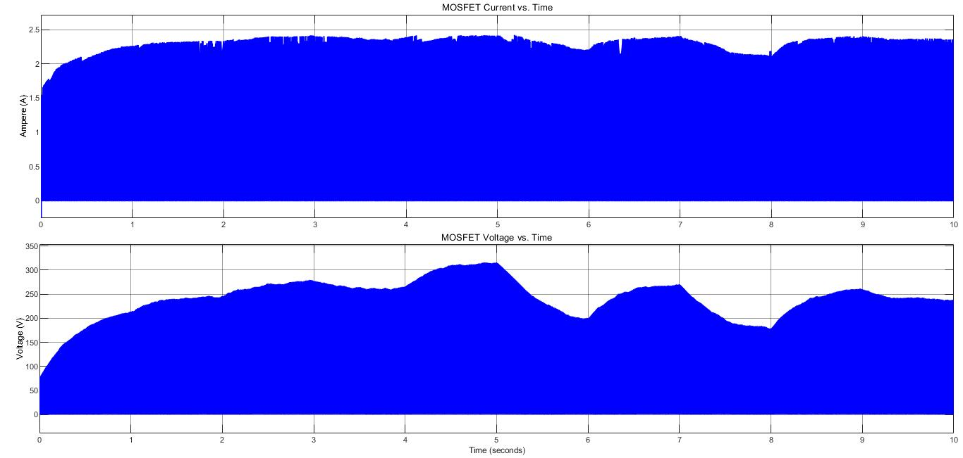

***Figure X:*** *Buck converter MOSFETs voltage and current*

**Simulations of Battery Part**

The last part of our system is the battery. In this part, 25 V battery voltage and 2 A battery current (ripple is %20 of average current) are desired. We obtained almost 25 V from the previous part (buck converter). To get 2A battery current with the maximum ripple of %20 of the average current, we have to use a controller. Our aim is to control the duty cycle of PWM by voltage difference through resistance 0.01 Ohm connected between battery and ground.

Firstly, we tried to implement the P controller. On the other hand, with the P controller we had a huge steady-state error not consistent with battery current requirements, it is expected because steady-state errors are seen in the P controller. For this reason, we focused on other controller types. We tried the hysteresis controller (on-off controller), we obtained less ripple than P controllers do but still it was not consistent with requirements. The on-off controller is not much efficient control way because it does not contain intermediate values. Lastly, we tried the PI controller. Since I term decreases error, we obtained a waveform consistent with the requirement. We arranged P and I values by fine-tuning.

In Figure x below, the battery part of our system and the controller we designed can be seen.

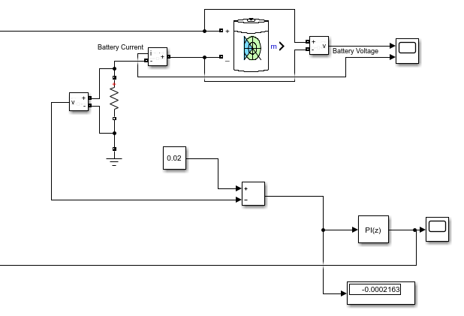

***Figure X:*** *Battery part of our system and PI controller we designed*

As seen in Figure x, we used resistance 0.01 Ohm connected between battery and ground. The desired input current is 2 A, so the desired voltage difference on this resistor is 0.02 V. That is, the set point is 0.02 V. Also, the output is measured voltage difference on the resistor. Error is the difference of them, and our aim is to control it. We arranged P and I values by fine-tuning. The output of the controller is the duty cycle of PWM that drives high side MOSFET. Also, we have mentioned before, complements of this PWM drives low side MOSFET.

In figure x below, battery voltage and battery current can be observed.

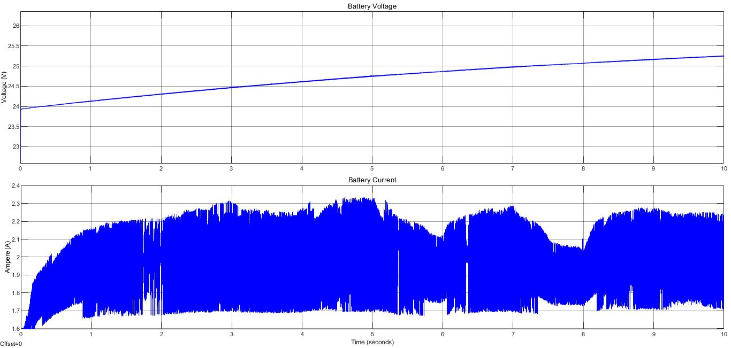

***Figure X:*** *Battery current and voltage*

As seen in Figure X above, battery voltage and current are consistent with the project requirements.

**Simulations of Whole Circuit**

In this part of the report, the whole circuit schematic of our design and input-output simulation results of the whole circuit can be observed.

In Figure x below, the whole circuit schematic can be seen.

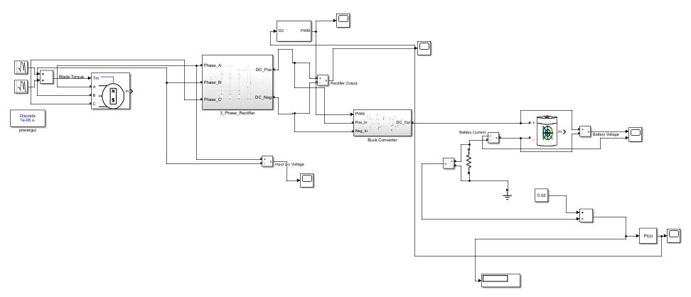

***Figure X:*** *The whole circuit schematic of our design*

Moreover, in Figure x below, input and output simulations of the whole circuit can be seen. The input of the system is phase line to line voltage which is given as specification of this project, and the output is battery voltage and current which are requirements of this project.

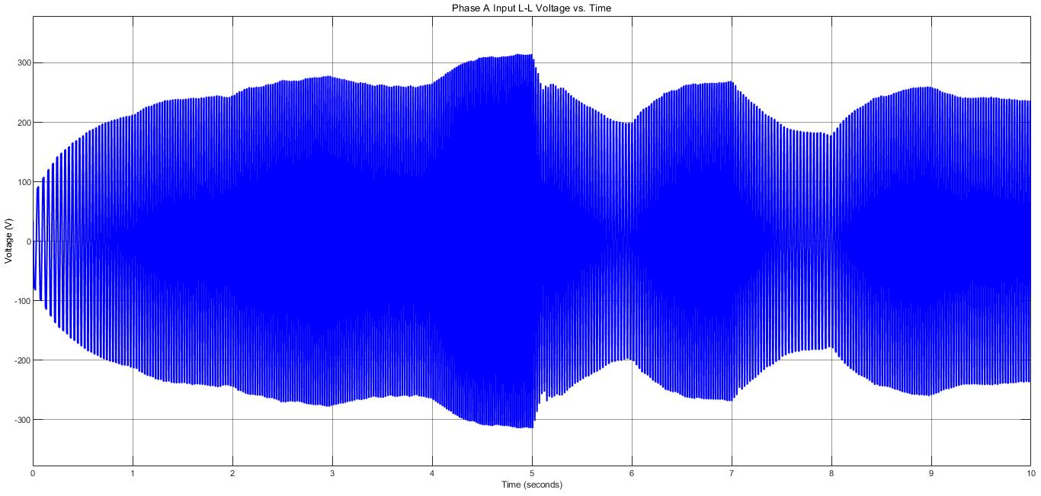

(a)

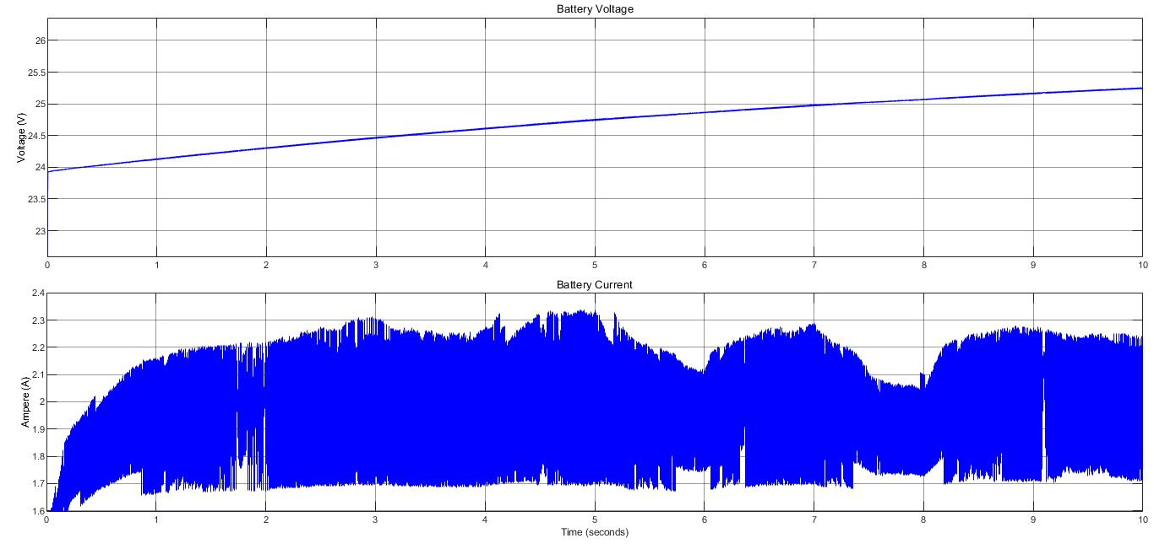

(b)

***Figure X:*** *The simulation results of input (a) and output (b) of the whole circuit*

As seen in Figure x, the whole circuit simulation results are consistent with the results of the subsystems.

**NON-IDEAL SIMULATIONS**

In this part of the report, simulation results by using MATLAB Simulink with non-ideal cases will be provided. After component selection, we implemented the diodes and MOSFETs to Simulink with their real parameters. We observed that there is not a significant change. It may be due to the fact that we cannot enter all parameters into the Simulink environment, or we carefully selected the components.

In this part, firstly, three-phase diode rectifier schematic and simulation results will be shown. Then, the buck converter schematic and simulation results will be shown. After the buck converter, the battery and controller the last part of our system will be shown. Finally, the whole circuit schematic and input-output simulation results of the whole circuit will be provided.

**Simulations of Three Phase Diode Rectifier**

In Figure X below, the input line to line (a) and output voltage (b) with non-ideal diodes can be seen.

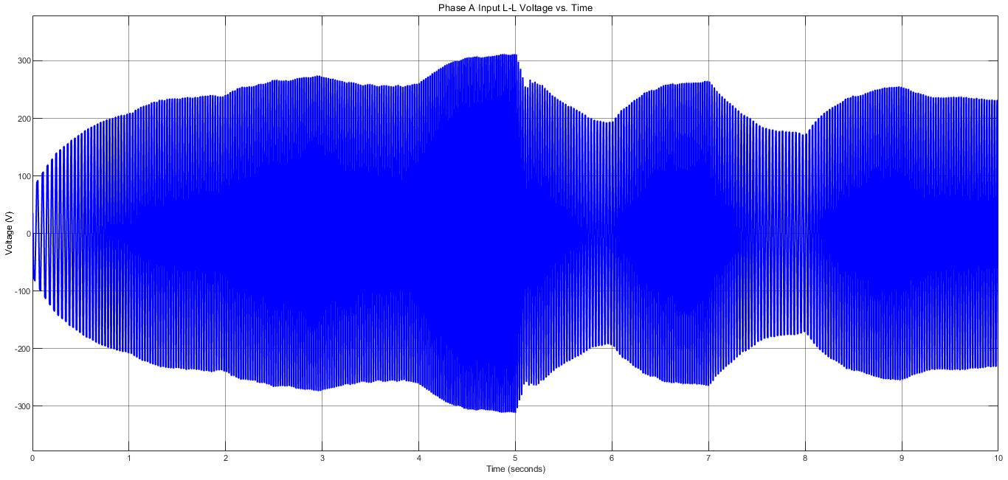

(a)

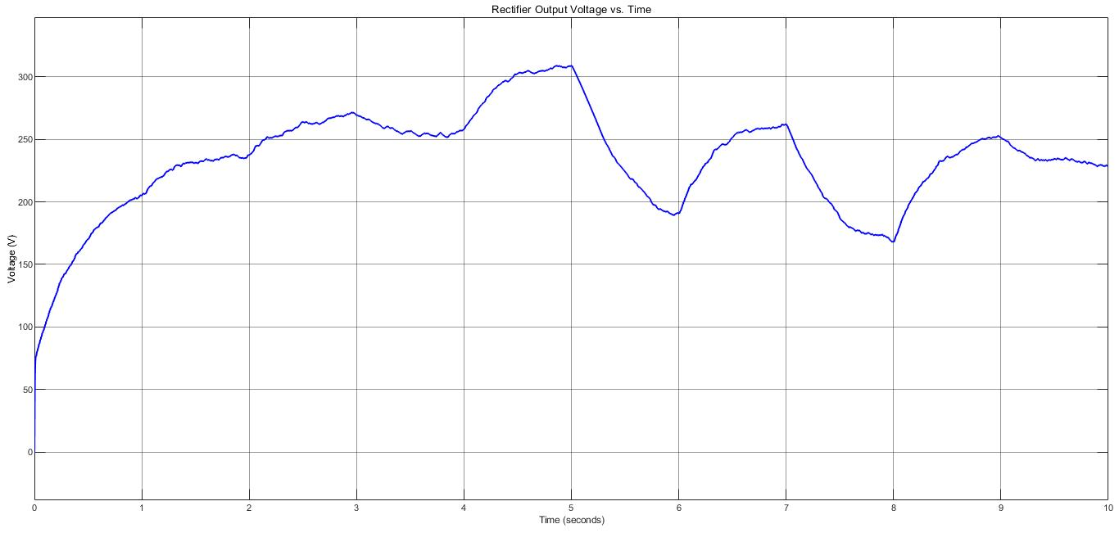

(b)

***Figure X:*** *Rectifier input line to line voltage (a) and rectifier output voltage (b)*

If Figure x is compared with Figure x, it is seen that there is no significant change.

**Simulations of Buck Converter**

In Figure X below, the buck converter output voltage and output current waveforms with non-ideal diodes can be seen.

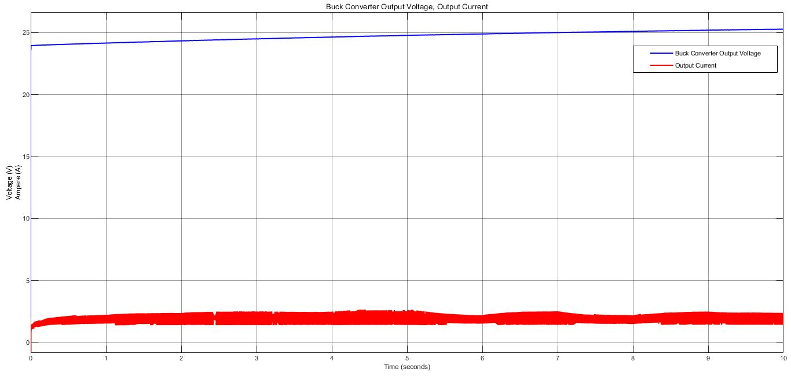

***Figure X:*** *Buck converter output voltage and current*

If Figure x is compared with Figure x, it is seen that there is no significant change.

**Simulations of Battery Part**

In Figure X below, the battery voltage and battery current can be seen.

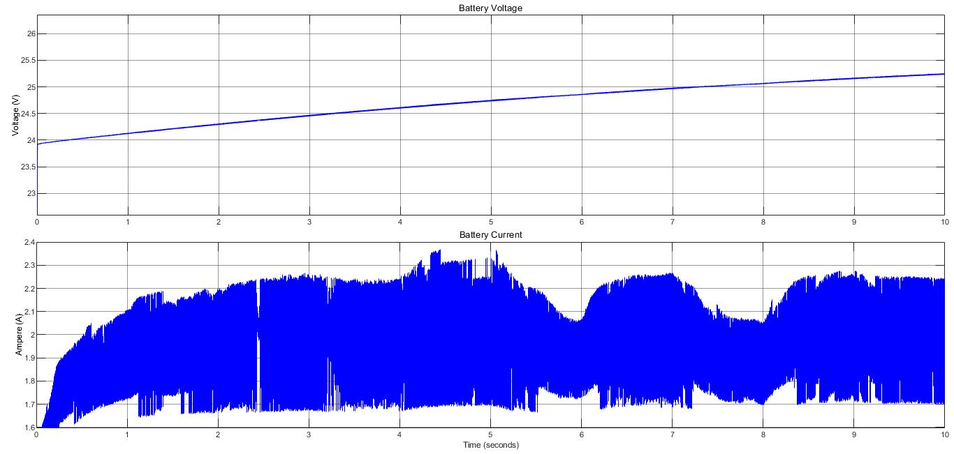

***Figure X:*** *Battery current and voltage*

If Figure x is compared with Figure x, it is seen that there is no significant change.