ELEC0144 Machine Learning for Robotics
Assignment Part I: Image Processing and Neural Networks
What-if analyses (Tasks 1 and 2) and Open Exploration: can a camera tell how hard a hand grips?
Team number: 10
Submission date: 6 November 2026
Full name | Student number | Email
Ceyhun Ozturk | 24164815 | zceeoco@ucl.ac.uk
Kairi Shukla | [student number] | [email]
Shangze Kong | 24010782 | zcemsk2@ucl.ac.uk
Yik Hui Ng | 24014096 | y.ng.24@ucl.ac.uk

Pages. Counted (6): page 1 What-if 1, page 2 What-if 2, pages 3–6 Open Exploration. Not counted: this cover, References (page 7) and Appendix A, the derivation for Task 2 (pages 8–9).
Use of AI. The code, the draft of Appendix A and drafts of this report’s text were produced with Claude Opus 5.5 [1]; each code file names the model and setting in the last line of its code map.
Code. Python. The Open Exploration uses scikit-learn [2] and OpenCV [3]; Task2.py implements SGD and ADAM [4]; all files use NumPy [5], pandas [6] and Matplotlib [7]. Files: Task1.py, Task2.py, WhatIf_Task1.py, WhatIf_Task2.py; OpenExploration/: OE1_Grips.py, OE2_SessionCheck.py, OE3_Explore.py, FinalMethod.py, OE4_Extension.py, OE5_SkinCheck.py and oe_common.py. Run commands are in README.md; each file starts with a code map.

What-if 1: darkening (Task 1)
Scenario. darkFactor is lowered from 1.0 to 0.1 in steps of 0.05 (19 settings) with mirror = True; the colour thresholds and the 7 × 7 median filter stay as submitted. Questions: (1) which fruit, if any, is lost first; (2) at which darkFactor; (3) which fruit is lost last, or is still found at 0.1. A fruit is lost when it has no box, or its box covers less than half of what is visible of it.
1. Predict (each member’s prediction and reason, written down before the run)
Ceyhun Ozturk: (1) none lost; (2) none in 1.0–0.1; (3) all three still found at 0.1. Reason: All our colour rules compare a channel with R, and brightness is taken relative to the image mean, so darkening should cancel out on both sides. The only thing that changes is rounding to whole numbers, which matters more at 0.1 because the values only go up to 26. I expect this to change a few pixels around the edges of each fruit, but not enough to lose one. The lemon will probably shrink the most, since its G > 0.75R threshold is quite close to the G/R of its lower, more orange part.
Kairi Shukla: (1) none lost; (2) none in the tested range; (3) all three still identifiable at 0.1. Reason: We do not use static thresholds, so as the brightness decreases the thresholds decrease too. The fruits stay identifiable unless there is no light, or less light than can be calculated (e.g. 0.1 × 4, which would not round well).
Shangze Kong: (1) none lost; (2) no first-loss factor in 1.0–0.1; (3) apple, capsicum and lemon all still found at 0.1. Reason: The colour rules compare channels proportionally and brightness is normalised by the image mean, so uniform darkening should largely cancel out, although 8-bit rounding may affect individual pixels.
Yik Hui Ng: (1) none lost; (2) none; (3) all three still found at 0.1. Reason: Our colour masks use relative pixel brightness (e.g. R < B), so multiplying both R and B by darkFactor cancels the darkening out.
2. Run. WhatIf_Task1.py (python WhatIf_Task1.py) runs Task1.py unchanged apart from its darkFactor line, darkening as floor(darkFactor × original + 0.5) in 8 bits. It prints Table W1 and draws Figure W1.
Table W1. Result over the 19 darkFactor settings, printed by WhatIf_Task1.py. IoU: overlap of the box with the same fruit’s box at 1.0 (1 = identical).
Fruit | Found | First lost at | At 0.10 | Smallest IoU | Region (pixels), 1.0 → 0.1
Apple | 19/19 | none | found | 0.996 | 16,774 → 16,696 (−0.5%)
Capsicum | 19/19 | none | found | 0.989 | 20,323 → 20,335 (+0.1%)
Lemon | 19/19 | none | found | 0.969 | 9,041 → 7,886 (−12.8%)
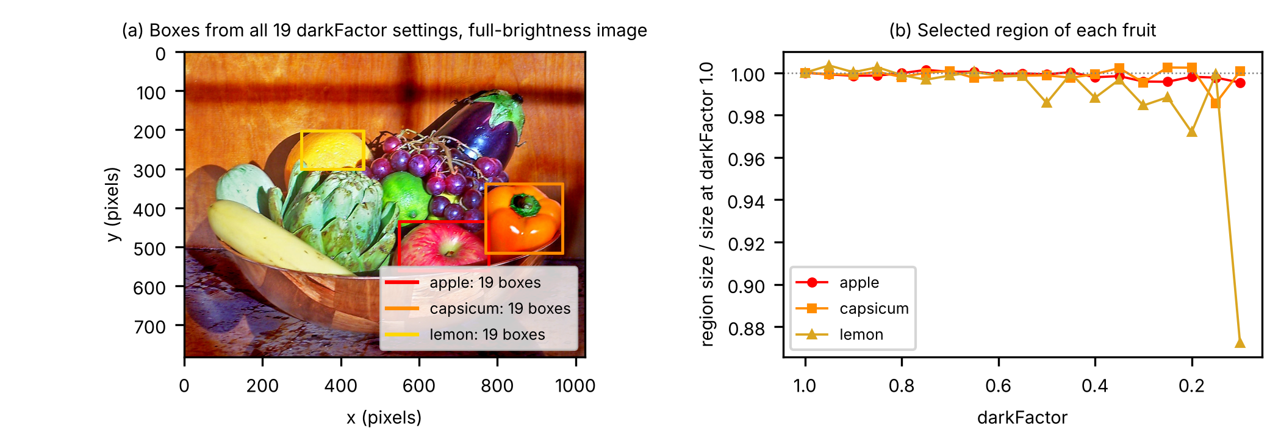
Figure W1. (a) The boxes from all 19 settings drawn on the full-brightness, mirrored image (photograph [8]); every box stays on its fruit and covers more than half of it. (b) Size of each fruit’s selected region relative to its size at darkFactor 1.0. Produced by WhatIf_Task1.py.
3. Explain. All four predictions were right, so none needs correcting. Every rule compares a channel with R (for example B < 0.05R), and brightness is each pixel’s grey level divided by the image mean. Darkening scales R, G, B and the mean by the same factor, which cancels on both sides of every rule, as all four reasons said, so the median filter and the largest-region choice see the same masks. Only 8-bit rounding changes anything: at 0.1 the channels reach only 26, so a ratio such as G/R can shift by a few hundredths and pixels near a threshold flip. The lemon has the most such pixels, because its lower part shades towards orange where G/R nears the 0.75 limit: its region shrank by 12.8% at 0.1 while the apple and capsicum changed by under 1%, as Ceyhun predicted, and its box still matched its full-brightness box (IoU 0.969). This holds for digital darkening of this image, not for real lighting changes, which also shift colour balance and add noise.

What-if 2: the forgotten derivative (Task 2)
Scenario. In the hidden delta, eq. (9) of Appendix A, the slope of tanh, 1 − a² (eq. (8); slope = 1 - a1**2 in Task2.py), is replaced by 1; the network is trained again with SGD and with ADAM, all else as in Task2.py. (1) What will the fit look like? (2) How will the final training error compare with the normal run?
1. Predict (each member’s prediction and reason, written down before the run)
Ceyhun Ozturk: (1) The fit will still be a smooth curve, but it will follow the data less closely, especially around the turning points. (2) The final training error will be higher than in the normal run for both. SGD will be affected more than ADAM. Reason: Without the 1 − a² term, the hidden-layer updates become too large whenever a node is close to saturation. For example, in the worked step at x = 0.5, hidden node 1 has a slope of only 0.07, so its update would be about 14 times bigger than it should be. With SGD the step size depends directly on the gradient, so this should hurt training more. ADAM divides by the size of recent gradients, so I think it will cancel out most of the extra size and end up closer to the normal run.
Kairi Shukla: (1) The fit may still follow the data smoothly and non-linearly but would be less accurate. (2) Would likely end higher than data, with ADAM slightly better. Reason: Weights and biases will still adapt and tanh units give a smooth basis. Tanh saturation is no longer factored in for a better gradient. ADAM may be better due to the per-weight normalising.
Shangze Kong: (1) The fit will remain smooth and nonlinear but follow the data less accurately. (2) The final training error will be higher than the normal run for both SGD and ADAM. Reason: Replacing (1 − a²) with 1 removes the attenuation of hidden-layer updates near tanh saturation. This produces incorrect gradients; ADAM may partly compensate through adaptive scaling but does not restore the missing derivative.
Yik Hui Ng: (1) The fit will no longer follow the training data for both methods. (2) Training error will be greater than normal run for both methods. Reason: The slope of tanh is used in the backpropagation steps of both SGD and ADAM, so it will affect both methods. This term affects the magnitude of change of each weight. With slope set to 1, it makes all changes to the weight huge, so that the algorithms cannot “slowly” reach the minimum.
2. Run. WhatIf_Task2.py (python WhatIf_Task2.py) runs Task2.py as it is and with the slope line changed, so both use the given weights, seed 1 and fixed settings. It prints the final training error, normal → slope = 1, SGD 0.000475 → 0.028677 (×60.37) and ADAM 0.000373 → 0.027383 (×73.50); the first epoch below 0.001, 188 and 151 normally and not reached with slope = 1; and the values below (Figure W2).
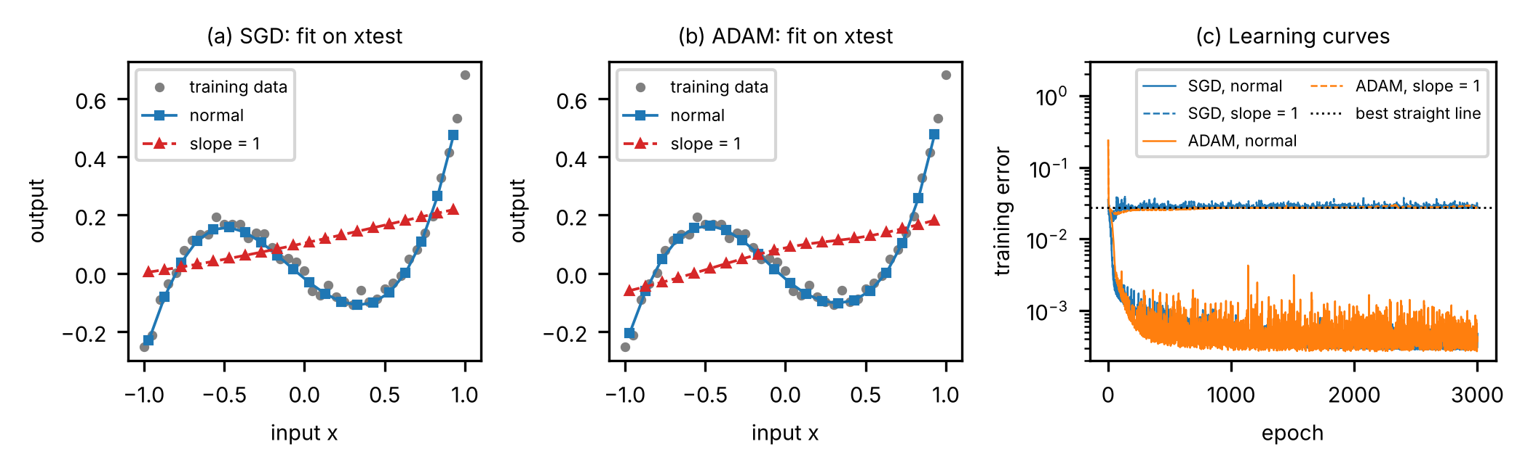
Figure W2. (a, b) Final output on the 20 xtest inputs, normal and with slope = 1, and the 41 training samples. (c) Training error of the four runs and the best straight line. Produced by WhatIf_Task2.py.
3. Explain. Without the slope the step of W_{1j} becomes η·W_{2j}·δ_{o}·x, which over an epoch adds up to about η·W_{2j}·Σδ_{o}x: the hidden layer only reacts to the part of the error that a straight line in x could remove, and loses the weighting by 1 − a_{j}², which varies with x and lets the normal run fit the turning points. The output layer keeps its true gradient and at first uses the curved nodes it starts with (the error dips to 0.018 with SGD and 0.022 with ADAM), but the hidden weights drift with no regard to curvature. By epoch 3000 the SGD hidden nodes are nearly linear and ADAM’s one strongly curved node has almost no output weight, so both errors bounce around that of the best straight line, 0.0273. Why the wrong predictions were wrong: Ceyhun, Kairi and Shangze expected a curve that still bends, treating the fault as wrongly sized steps still going downhill. Yik Hui predicted the fit, but the steps were large only where a node saturated, and neither run diverged. Ceyhun expected ADAM to cancel most of the fault and Shangze thought it might partly compensate; it did not: dividing by √v̂ cancels a constant factor on a weight’s gradient, but 1 − a² varies from sample to sample, so leaving it out changes the direction of the average step, which ADAM keeps. ADAM ended slightly below SGD (0.0274 vs 0.0287), as Kairi predicted, but at the same straight-line level and further from its normal run (73.5 vs 60.4 times). All four rightly predicted a higher error.

Open Exploration: can a camera tell how hard a hand grips?

Research question
Robots learn grasps from videos of people, but a video shows the hand and the object, not the force. We ask: from one fixed camera, can a program tell a light grip from a firm grip made by a person it has never seen, and does it rely on the object or on the hand? The second part matters for learning from demonstration: a cue that holds only for the people in the training videos would not transfer to a new demonstrator.

Hypothesis
We expect test accuracy above guessing, mostly from the sponge, because a firm grip squashes it; on the rigid cube only the hand changes, so we expect cube accuracy near guessing. We are wrong if (1) the test accuracy is inside the range guessing reaches 95% of the time (35–65% for 40 balanced grips); (2) cube grips are classified as well as sponge grips; or (3) frames with no hand in view tell the firm take from the light take about as well as the method tells the grips apart (or better), since the method could then be reading the take. The question and the three conditions were written down before any method was tried (results/00_written_before_exploring.md).

Method
Pipeline (OpenExploration/, with scikit-learn [2] and OpenCV [3]). Grips: videos are read at 15 frames/s and 320 × 180 pixels; skin-coloured pixels (HSV thresholds) give the hand area of each frame, and a grip is a stretch with the hand over 4% of the frame for at least 0.8 s; green pixels mark the cube clip (OE1_Grips.py). Measures per grip: hand area (mean, maximum, spread); visible object area (cube green, sponge yellow side) and solidity (area over convex-hull area, lower when the sponge bends), both relative to the empty scene just before the grip; movement (highest lift and rise speed of the object, frame-to-frame change). Classifier: standardisation fitted on training grips, then logistic regression; one prediction per grip.
Exploration tree (val = leave-one-member-out accuracy over the 120 training grips, OE3_Explore.py; letters = who led the node)
Question: can one fixed camera tell a light grip from a firm grip by a person it has not seen?
├─ 1 Hand area (YN): a firm grip may wrap more hand round the object; val 63% → not used alone
├─ 2 Object area, shape (CO): a squeeze should bend the sponge; val 62%, sponge 60% → ask why
│ └─ 3 One model per object (CO): cues differ by object; val 71% (sponge 93%, cube 48%) → kept
│ └─ 4 + hand area (YN): the cube does not deform; val 78% (sponge 97%, cube 60%) → kept
│ └─ 5 + movement (SK): a firm hold may lift differently; val 84% (sponge 92%, cube 77%) → kept
│ ├─ 6 + grip duration (SK): firm grips may last longer; val 84%, no gain → dropped
│ └─ 8 Own measures per object (CO): movement for the cube only; val 87% → chosen
└─ 7 Difference image + PCA (KS): let the model find its own cues; val 68% (Kairi 50%) → dropped
Check, no hand in view (KS): do takes reveal labels? Across people no (37%); within one, yes (98%)
Final method (8) on the test set (Yik Hui, 40 grips): 75% (sponge 100%, cube 50%); guessing 50%.
All four of us recorded our grips and discussed every node. What each member did:
Ceyhun Ozturk (CO): object measures, one model per object and the final method (nodes 2, 3, 8).
Kairi Shukla (KS): difference image (node 7) and the no-hand check (OE2_SessionCheck.py).
Shangze Kong (SK): movement and grip duration (nodes 5, 6).
Yik Hui Ng (YN): hand area (nodes 1, 4) and the extension ablations (OE4_Extension.py).
Final method (node 8, FinalMethod.py): one logistic regression per object, trained on that object’s 60 training grips. The cube model uses hand area, object area and shape, and movement (13 measures); the sponge model uses hand area and object area and shape (8). It outputs a firm score between 0 and 1, and a grip is called firm above 0.5 (Figure 1). It was chosen, and written down, before it was run on the test set (results/01_final_choice_before_test.md).
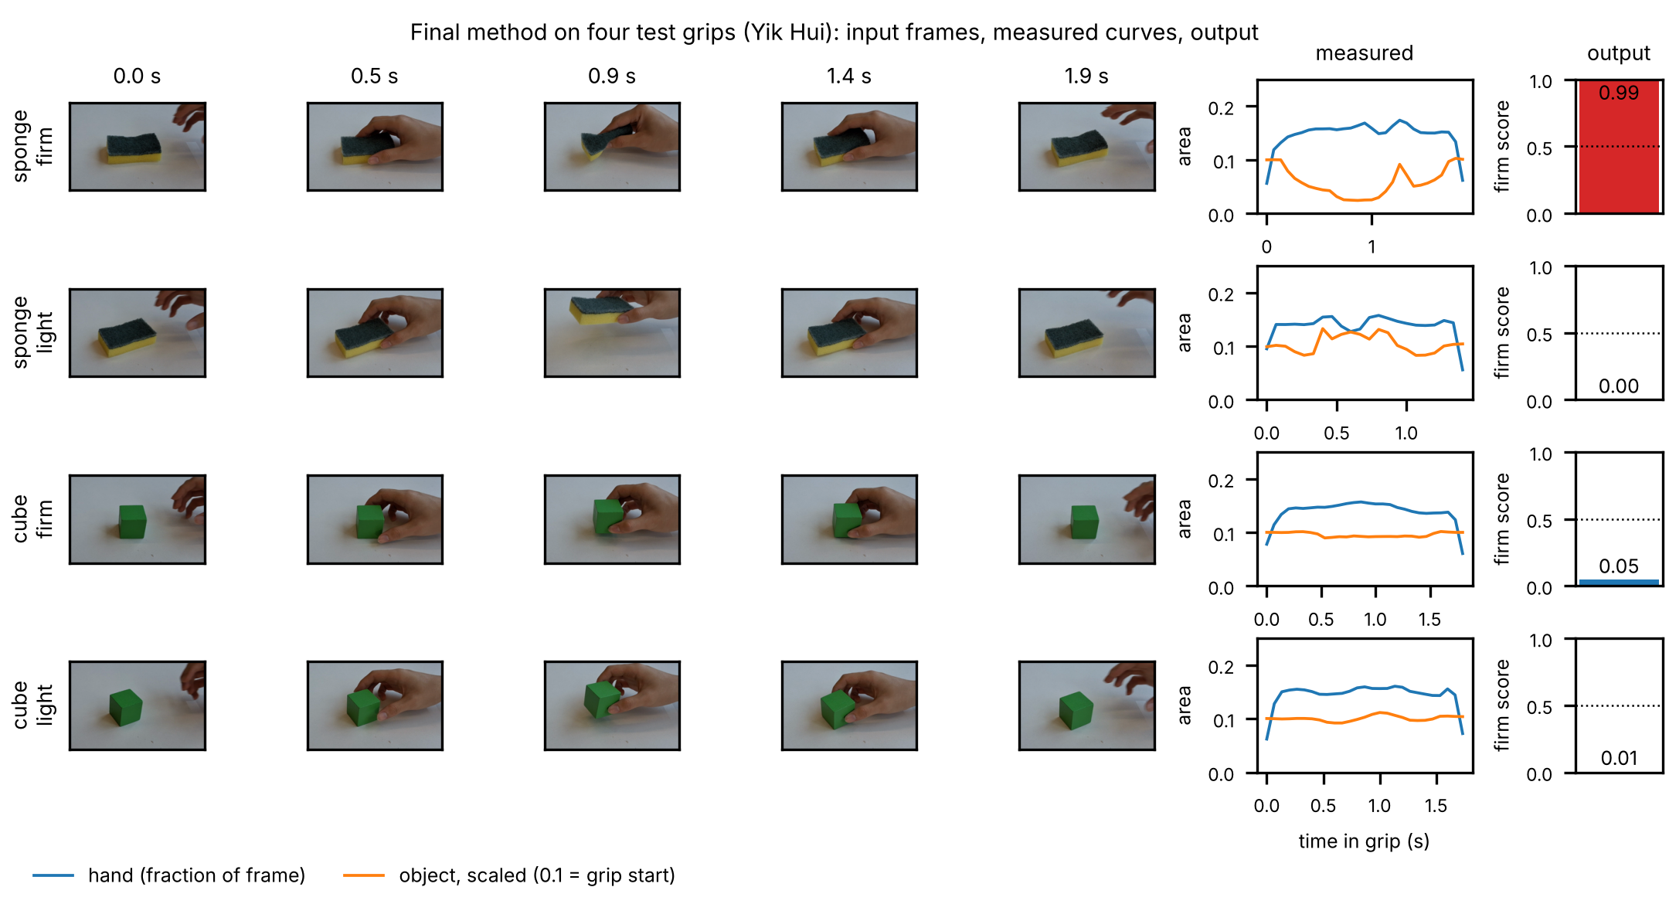
Figure 1. Input and output of the final method for four test grips (Yik Hui): five frames of each grip; hand area (fraction of the frame) and visible object area (scaled, 0.1 = grip start) over the grip; and the firm score. The firm sponge grip folds the sponge and its yellow area drops; the two cube grips look alike and both score light. Produced by FinalMethod.py.

Validation
Recordings. One iPad, fixed, with the same angle and lighting and with focus and exposure locked; the object stood on a clear-tape mark at the centre of the view, each reach started from a second mark, and no faces are in view. Objects: a wooden cube, which keeps its shape, and a kitchen sponge, which is soft. Each member filmed one firm and one light take, each a cube clip then a sponge clip of 10 grips: 8 videos and 160 grips (Table 1). The cutting found exactly 10 grips in every clip, checked by eye (fig_all_grips.png, OE1_Grips.py).
Table 1. Grips per member, object and label, and the set of each member (OE1_Grips.py, results/counts.csv).
Member | Cube firm | Cube light | Sponge firm | Sponge light | Total | Set
Ceyhun | 10 | 10 | 10 | 10 | 40 | training
Kairi | 10 | 10 | 10 | 10 | 40 | training
Shangze | 10 | 10 | 10 | 10 | 40 | training
Yik Hui | 10 | 10 | 10 | 10 | 40 | test
Total | 40 | 40 | 40 | 40 | 160

Order of grips. The grips were filmed in blocks, all firm grips in one take and all light grips in another, not in a random order, so a grip’s label is its take’s label. To test whether the takes themselves give the label away, frames between grips with no hand in view were classified as firm take or light take (OE2_SessionCheck.py). Within one person this works (98%; 96% with the object area left out): the table colour shifts by up to 7 levels of 255 between takes (results/take_differences.csv), and the object is put down near its mark rather than exactly on it. Across people it gets 37% (45% table only), and 51% on the test member (Table 2), because the differences go different ways for different people. The takes therefore do not carry the label to a new person, which is how we validate and test.
Split. Test set: all 40 grips of Yik Hui (Yikhui firm.mp4, Yikhui gentle.mp4), drawn by lot (seed 2026, OE1_Grips.py) before any method was tried; this is 25%, all from takes the method never saw. Model weights and standardisation come from training grips only, and the 0.5 threshold is fixed in advance. Validation: leave one member out over Ceyhun, Kairi and Shangze (train on two, validate on the third), giving 120 validation predictions per attempt. One grip is one row of measures, so the frames of a grip are never split between sets. The skin-colour bounds and the cutting settings (4%, 0.8 s, gaps under 0.35 s joined) were chosen from the hand-area curves of all eight videos, without labels. They do not shape the test result: Yik Hui’s clips give exactly 10 grips each under all 45 cutting settings tried (2–8%, 0.5–1.2 s, 0.2–0.6 s; results/cutting_robustness.csv), and with each skin-colour bound moved down or up, or all moved together (11 settings), the test result stays at 30 of 40 (OE5_SkinCheck.py, results/skin_check.csv).
Measure. Accuracy over grips. With 20 firm and 20 light test grips, guessing gets 50% on average and lands between 35% and 65% in 95% of cases (binomial, 40 grips). The p-value is the chance that guessing does at least as well as the method.

Results
Final method on the test set (FinalMethod.py, results/final_test_predictions.csv): 30 of 40 grips correct, 75%, above the 35–65% range that guessing reaches 95% of the time (p = 0.001). All 20 sponge grips were right. On the cube 10 of 20 were right (50%): every cube grip was called light, so the 10 light cube grips were right and the 10 firm ones wrong.
Going further B: ablations (OE4_Extension.py). Each version was trained on the 120 training grips only, run once on the 40 test grips and compared with the main result, 75% (Table 2, Figure 2a). Without movement, or with the hand hidden, nothing changes. With the object hidden the sponge falls to 50%. With hand and object both hidden (scene only) the result is 51%, so for a new person the takes do not give the label away. In every grip-based version the cube model calls all 20 of Yik Hui’s cube grips light. The 75% therefore rests on the sponge’s object measures (visible yellow area and solidity).
Table 2. Ablations on the test set (Yik Hui); every version trained on the training members only (OE4_Extension.py, results/extension_ablations.csv).
Version (measures kept) | Test | Cube | Sponge
Final method | 75% | 50% | 100%
Without movement (hand + object) | 75% | 50% | 100%
Hand hidden (object area, shape, lift) | 75% | 50% | 100%
Object hidden (hand area, scene motion) | 50% | 50% | 50%
Scene only (no-hand frames, table only; 41 gaps) | 51% | 52% | 50%

Why (Figure 2b–d). On the sponge, the smallest visible yellow area is at most 0.46 of the resting area in every firm grip and at least 0.49 in every light grip, for all four members (d). On the cube, each training member shows more hand in a firm grip than in a light one; Yik Hui does not, and Yik Hui’s hand covers less of the frame in both (largest hand area about 0.16 of the frame against 0.17–0.20, 1.9 training standard deviations below the training mean) (b). Hand area carries one of the cube model’s largest weights (+1.6), and a cube model on hand area alone also calls all 20 grips light. Lift goes opposite ways across people (c): Ceyhun and Shangze lift higher in a firm grip, Kairi and Yik Hui lower, and a lift-only cube model gets 35% on Yik Hui (results/why_cube.csv).
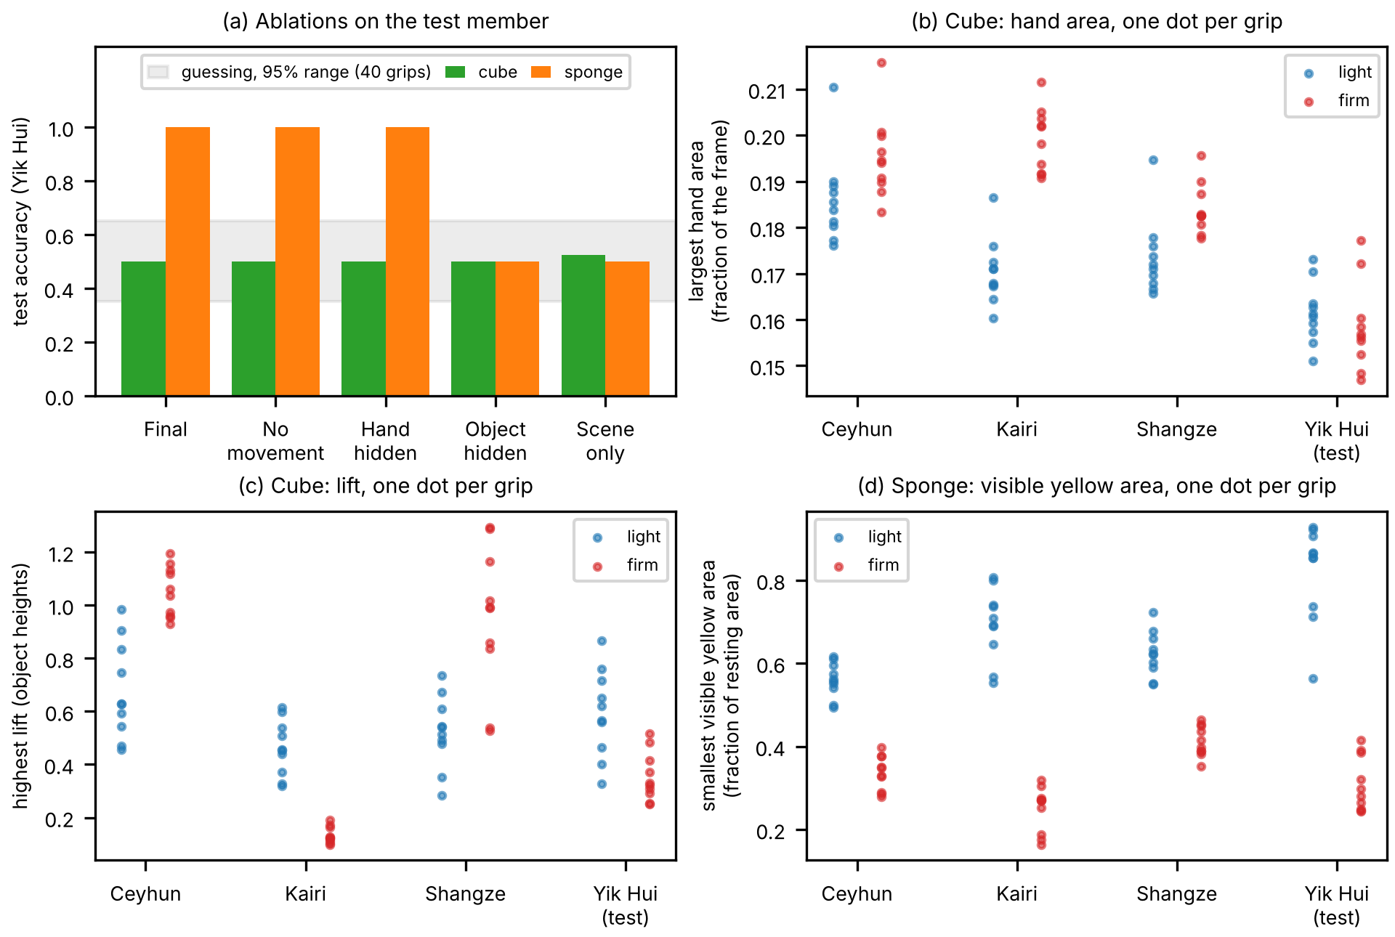
Figure 2. (a) Test accuracy of each ablation, cube and sponge, with the range guessing reaches 95% of the time. (b) Largest hand area in each cube grip. (c) Highest lift of the cube in each grip. (d) Smallest visible yellow area of the sponge in each grip, as a fraction of its resting area. Produced by OE4_Extension.py.

Discussion
What the results show. One fixed camera told firm from light sponge grips of an unseen person in all 20 test grips, and the ablations tie this to the sponge’s object measures (20 of 20 with them, 10 of 20 without). Two of the three results that would have shown the hypothesis wrong did not occur: 75% is outside the guessing range, and the cube (50%) did worse than the sponge (100%). The third did not occur for an unseen person, the setting we validated and tested in: no-hand frames give 37% across people and 51% on Yik Hui, far below 75%. Within one person, however, they reach 98%, so a method trained and tested on the same person could read the take; our result holds only for a person the method has not seen.
What they do not show. The method does not see grip force: it sees the sponge’s visible yellow area shrink and its outline bend, which a firm squeeze causes on a soft object (fingers covering more of the sponge may add to this), and on the rigid cube it is at guessing. The labels are what each person meant to do, not a measured force, and filming in blocks may have made firm takes more exaggerated than a mixed take would be. The test is one person and 40 grips, with one sponge, one camera view and one room.
What did not work, and why. Hand area (63%) and the difference image (68%, 50% on Kairi) did not carry across people: how much of the frame a hand covers differs more between people than between light and firm grips (Figure 2b). The cube model failed on exactly this. It learned that more hand means firm, which holds within each training member, but Yik Hui shows less hand overall and no more in firm grips, so every cube grip was called light. Movement raised cube validation from 60% to 77%, but lift goes opposite ways in different people (Figure 2c), so it did not transfer. With three training members each fold learns from two, so a pattern shared by two of them looks like a rule: validation overstated the cube (77% against 50% on test). Grip duration gave no gain and may reflect the pace of a take, so it was dropped.
Next step. For the cube, measure hand area relative to each person’s own hand, for example from one open-hand frame recorded before their grips, since the cube model failed on a person-level offset in hand area; and film light and firm grips in one random-order take. For the sponge, check the cue against a measurement rather than intent: stand it on a kitchen scale, display out of view, and test whether the smallest visible yellow area falls as the reading rises.

References
[1] Anthropic, “Claude Opus 5.5,” large language model, claude.ai, default settings, 2026. Used Oct.–Nov. 2026 for the code of Task1.py, Task2.py, the What-if files and the Open Exploration files, the draft of Appendix A and drafts of the report text. Accessed: Nov. 2, 2026. [Online]. Available: https://claude.ai
[2] F. Pedregosa et al., “Scikit-learn: Machine learning in Python,” J. Mach. Learn. Res., vol. 12, pp. 2825–2830, 2011.
[3] G. Bradski, “The OpenCV library,” Dr. Dobb’s J. Softw. Tools, vol. 25, no. 11, pp. 120–125, 2000.
[4] D. P. Kingma and J. Ba, “Adam: A method for stochastic optimization,” in Proc. Int. Conf. Learn. Represent. (ICLR), 2015.
[5] C. R. Harris et al., “Array programming with NumPy,” Nature, vol. 585, no. 7825, pp. 357–362, 2020.
[6] W. McKinney, “Data structures for statistical computing in Python,” in Proc. 9th Python in Science Conf. (SciPy), 2010, pp. 56–61.
[7] J. D. Hunter, “Matplotlib: A 2D graphics environment,” Comput. Sci. Eng., vol. 9, no. 3, pp. 90–95, 2007.
[8] “Fruits,” photograph, Flickr, user 53553325@N06. Accessed: Nov. 2, 2026. [Online]. Available: https://www.flickr.com/photos/53553325@N06/8543057650


