Draft for the team, delete this note before submitting. Confirm or replace the question and hypothesis (drafted before exploring: results/00_written_before_exploring.md); text taken over unchanged from AI must be referenced (IEEE, [1]).

Open Exploration: can a camera tell how hard a hand grips?

Research question
Robots learn grasps from videos of people, but a video shows the hand and the object, not the force. We ask: from one fixed camera, can a program tell a light grip from a firm grip made by a person it has never seen, and does it rely on the object or on the hand? The second part matters for learning from demonstration: a cue that only holds for the people in the training videos would not transfer to a new demonstrator.

Hypothesis
Written before any method was tried. We expect better than guessing on the held-out member, mostly from the sponge, because a firm grip squashes it; on the rigid cube only the hand can change, so we expect the cube to be close to guessing. We are wrong if (1) the test accuracy is inside the range guessing reaches 95% of the time (35% to 65% for 40 balanced grips), (2) cube grips are classified as well as sponge grips, or (3) frames with no hand in view tell the firm takes from the light takes about as well as the method does.

Method
Pipeline (code in OpenExploration/, scikit-learn [2], OpenCV [3]). Cut into grips: each video is read at 15 frames per second, 320 × 180 pixels. Skin-coloured pixels (HSV thresholds) give the hand area of every frame; a grip is a stretch with the hand covering more than 4% of the frame for at least 0.8 s, and the cube clip is told from the sponge clip by green pixels (OE1_Grips.py). Measures: hand area over the grip (mean, maximum, spread); visible object area (cube green, sponge yellow side) as a fraction of its area in the empty scene just before the grip, and its shape (solidity, area over convex hull area, lower when the sponge bends, also relative to that empty scene); movement (highest lift and rise speed in object heights from the resting position, and frame-to-frame change). Measuring the object against the scene just before each grip removes where it rests in each take; hand area and frame-to-frame change come from the grip's own frames. Classifier: features standardised on the training part, then logistic regression; one grip gives one prediction.
Exploration tree (val = leave-one-member-out accuracy on the 120 training grips, OE3_Explore.py; initials = who led the node):
Question: can one fixed camera tell a light grip from a firm grip by a person it has not seen?
└ 1 Hand area (YN): a firm grip may wrap more hand round the object; val 63% → not used alone
└ 2 Object area and shape (CO): a firm squeeze should deform the sponge; val 62%, sponge only 60% → kept, find out why
└ 3 One model per object (CO): a measure means different things for cube and sponge; val 71% (sponge 93%, cube 48%) → kept
└ 4 + hand area (YN): the cube does not deform, so it needs another cue; val 78% (cube 60%) → kept
└ 5 + movement (SK): a firm hold may lift differently; val 84% (cube 77%, sponge 92%) → kept
└ 6 + grip duration (SK): firm grips last longer; val 84%, no gain, may be the pace of a take → dropped
└ 8 Own measures per object (CO): movement helped the cube, not the sponge; val 87% → chosen
└ 7 Difference image + PCA (KS): let the model find its own cues; val 68%, Kairi 50% → dropped
└ Check, no hand in view (KS): could the takes give the label away? across people 37% (table only 45%; OE2_SessionCheck.py) → no
Final method (8) on the test set, Yik Hui's 40 grips: 75% (sponge 100%, cube 50%); guessing 50%.
All four of us recorded our grips, chose the setup and went through every node together; the initials on a node mark who led it. Code written with AI assistance [1].
Ceyhun Ozturk (CO): object area and shape, one model per object, the final method and FinalMethod.py (nodes 2, 3, 8).
Kairi Shukla (KS): difference image (node 7) and the check that the takes do not give the label away (OE2_SessionCheck.py).
Shangze Kong (SK): movement and grip duration (nodes 5, 6).
Yik Hui Ng (YN): hand area (nodes 1, 4) and the ablations of the extension (OE4_Extension.py).
Final method (attempt 8, FinalMethod.py). A grip is cut from the video and measured against the empty scene before it. The cube model uses hand area, object area and shape, and movement (13 measures); the sponge model uses hand area and object area and shape (8). Each is a logistic regression trained on the 60 training grips of its object; its output is a firm score between 0 and 1, and the grip is called firm above 0.5 (Figure 1).
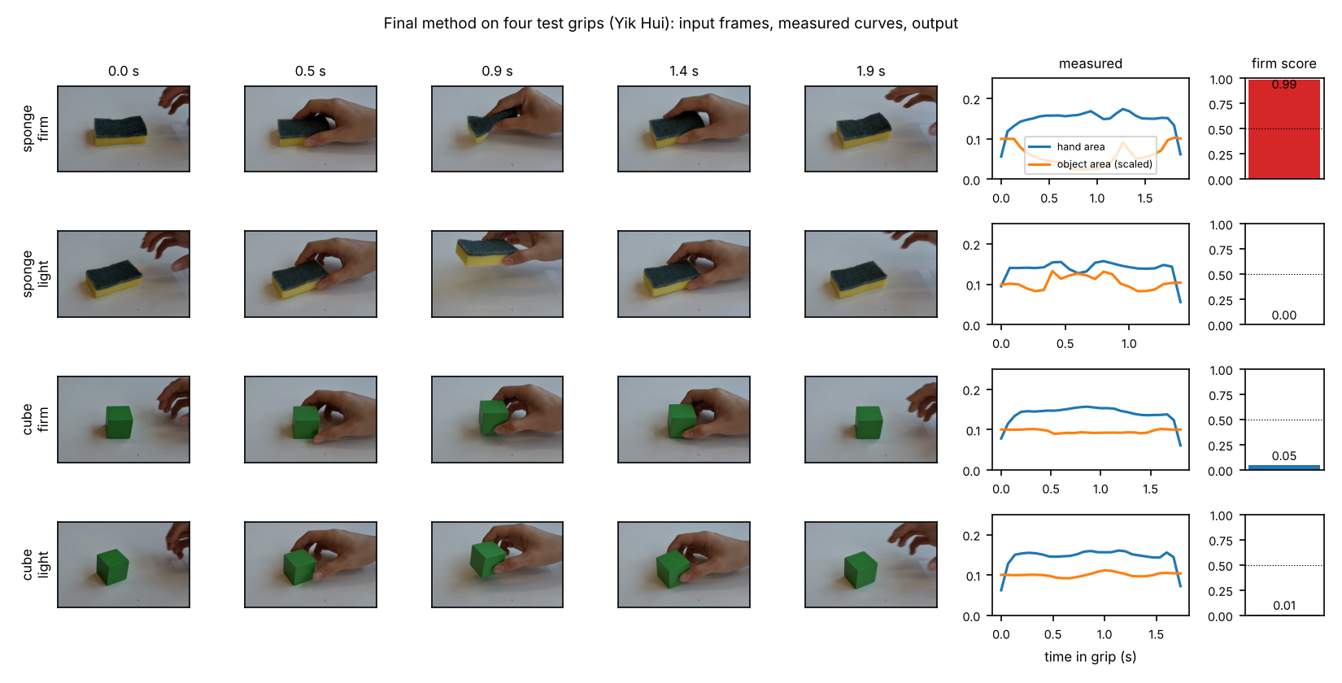
Figure 1. Input and output of the final method for four test grips (Yik Hui): five frames of each grip, the hand area and visible object area over the grip, and the firm score. The firm sponge grip folds the sponge and its yellow area drops; the two cube grips look alike and both score light. Produced by FinalMethod.py.

Validation
Recordings. One iPad in the same place for all recordings, with the same angle and lighting, and focus and exposure locked. The object was placed on a tape mark at the centre of the view and each reach started from a second mark; the tape is clear and does not show on camera. No faces are in view. Objects: a wooden cube, which keeps its shape, and a kitchen sponge, which is soft. Each member filmed one firm take and one light take; each take is a cube clip followed by a sponge clip with 10 grips each, which gives 8 videos and 160 grips (Table 1). The grip cutting found exactly 10 grips in every clip and was checked by eye (fig_all_grips.png, OE1_Grips.py); Shangze's light take starts in the middle of a cube grip, which is kept because its hold and release are recorded.
Table 1. Grips per member, object and label (OE1_Grips.py, results/counts.csv).
Member | Cube firm | Cube light | Sponge firm | Sponge light | Total | Set
Ceyhun | 10 | 10 | 10 | 10 | 40 | training
Kairi | 10 | 10 | 10 | 10 | 40 | training
Shangze | 10 | 10 | 10 | 10 | 40 | training
Yik Hui | 10 | 10 | 10 | 10 | 40 | test
Total | 40 | 40 | 40 | 40 | 160
Order of grips. The grips were filmed in blocks, all firm grips in one take and all light grips in another, not in a random order, so the label of a grip is the label of its take. To check whether the takes themselves give the label away, frames between grips with no hand in view were classified as firm take or light take (OE2_SessionCheck.py). Within one person the two takes can be told apart (98%; 96% with the object area left out): even with exposure locked, the table colour shifts by up to 7 levels out of 255 between takes (results/take_differences.csv), and after each grip the object is put down near its mark rather than exactly on it. Across people the same classifier gets 37% (45% table only), below guessing: the differences go different ways for different people (on Kairi's takes it is right only 21% of the time). On the test member it gets 51% (Table 2), so the take differences do not carry to a new member.
Split. Test set: all 40 grips of Yik Hui (Yikhui firm.mp4 and Yikhui gentle.mp4), drawn by lot (seed 2026, OE1_Grips.py) before any method was tried. With four members this is 25%, and every test grip comes from takes the method never saw. The test set was not used to fit anything: model weights, standardisation and the 0.5 decision threshold all come from training grips. Validation: leave one member out over Ceyhun, Kairi and Shangze (train on two, validate on the third, three times), which gives 120 validation predictions per attempt. One grip gives one row of measures, so the frames of a grip are never split between sets. The grip-cutting settings (skin colour, 4% hand area, 0.8 s, gaps under 0.35 s joined) were chosen by looking at the hand-area curves of all eight videos, test videos included, without labels. They do not shape the test set: Yik Hui's clips give exactly 10 grips each under all 45 of the 45 combinations tried (hand threshold 2–8%, shortest grip 0.5–1.2 s, joined gap 0.2–0.6 s; results/cutting_robustness.csv), while Ceyhun's and Shangze's clips do depend on them.
Measure. Accuracy over grips. The test set has 20 firm and 20 light grips, so guessing gets 50% on average; for 40 grips it lands between 35% and 65% 95% of the time. The p-value is the chance that guessing does at least as well as the method.

Results
Final method on the test set (FinalMethod.py): 30 of 40 grips correct, 75%, above the 35% to 65% that guessing reaches 95% of the time (p = 0.001). All 20 sponge grips were right. On the cube 10 of 20 were right (50%): every cube grip was called light. Of the 20 firm grips, 10 were called firm and 10 light; all 20 light grips were called light (results/final_test_predictions.csv).
Going further B, ablations (OE4_Extension.py). Each version was trained on the 120 training grips only and run once on the 40 test grips (Table 2, Figure 2). In all four grip-based versions the cube model calls every one of Yik Hui's 20 cube grips light, so the cube's 50% is the 10 light grips. The sponge stays at 100% whenever its area and shape are measured (final, no movement, hand hidden) and falls to 50% when the object is hidden. With hand and object both hidden it is 51%: for the new member the takes do not give the label away.
Table 2. Ablations on the test set, Yik Hui (results/extension_ablations.csv).
Version (trained on training members only) | Test | Cube | Sponge
Final method | 75% | 50% | 100%
Without movement (hand + object) | 75% | 50% | 100%
Hand hidden (object area, shape, lift) | 75% | 50% | 100%
Object hidden (hand area, scene motion) | 50% | 50% | 50%
Both hidden (no-hand frames, table only; 41 gaps) | 51% | 52% | 50%
Figure 2 shows why. On the sponge, the smallest visible yellow area of every firm grip is at most 0.46 of its resting area and of every light grip at least 0.49, for all four members (d). On the cube, each training member shows more hand in a firm grip than in a light one; Yik Hui does not, and Yik Hui's hand covers less of the frame in both (largest hand area about 0.16 of the frame against 0.17 to 0.20 for the training members, 1.9 training standard deviations below their mean) (b). Hand area is among the cube model's strongest measures (weight +1.6), and a cube model with hand area alone also calls all 20 grips light. Lift goes opposite ways across people (c): Ceyhun and Shangze lift higher in a firm grip, Kairi and Yik Hui lower, and a lift-only cube model gets 35% on Yik Hui (results/why_cube.csv).
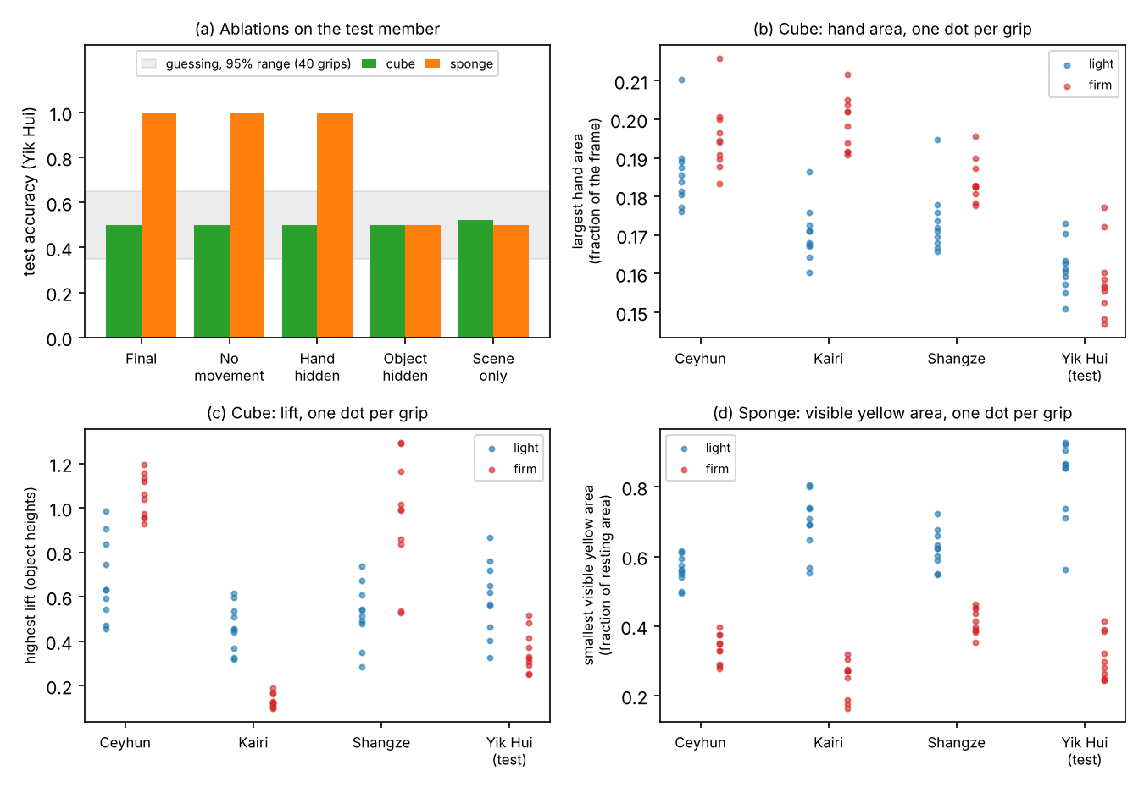
Figure 2. (a) Test accuracy of each ablation, cube and sponge, with the range guessing reaches 95% of the time. (b) Largest hand area in each cube grip. (c) Highest lift of the cube in each grip. (d) Smallest visible yellow area of the sponge in each grip, as a fraction of its resting area. Produced by OE4_Extension.py.

Discussion
What the results show. One fixed camera told firm from light sponge grips of an unseen member in all 20 test grips, and the ablations place this on the sponge's visible shape: with the object measures the sponge is 20 of 20, without them 10 of 20. Of the three results that would have shown the hypothesis wrong, the first two did not occur: 75% is outside the guessing range, and the cube (50%) was not classified as well as the sponge (100%). The third depends on the comparison. Within one person, frames with no hand tell the two takes apart (98%), so a method trained and tested on the same person could read the take; across people, which is how we validated and tested, they do not (37% and 45% in validation, 51% on Yik Hui).
What they do not show. The method does not see grip force. It sees the sponge fold, which is what force does to a soft object; on the rigid cube it is at guessing. The labels are what each person meant to do, not a measured force, and because the grips were filmed in blocks, a firm take may hold more exaggerated squeezes than a mixed take would. The test is one member and 40 grips, with one sponge, one camera view and one room.
What did not work, and why. Hand area (63%) and the difference image (68%, 50% on Kairi) did not carry across people: how much of the frame a hand covers differs more between people than between light and firm grips (Figure 2b). The cube model failed on exactly this. It learned that more hand means firm, which holds within each training member, but Yik Hui shows less hand overall and no more in firm grips, so every cube grip was called light. Movement raised cube validation from 60% to 77% but did not help on the test member; lift goes opposite ways in different people (Figure 2c). With three training members, each validation fold learns from only two, so a pattern shared by two of them looks like a rule; validation overstated the cube. Grip duration gave no gain and may reflect the pace of a take, so it was dropped.
Next step. For the cube, measure hand area relative to each person's own hand, for example from one open-hand frame recorded before their grips, since the cube model failed on a person-level offset in hand area; film light and firm grips in one random-order take. For the sponge, check the cue against a measurement rather than intent: stand it on a kitchen scale, display out of view, and test whether the smallest visible yellow area falls as the reading rises.

References
[1] Anthropic, "Claude Opus 5.5," large language model, claude.ai, used Oct. 2026 for the Open Exploration code and a draft of this text. [keep if any text is taken over unchanged]
[2] F. Pedregosa et al., "Scikit-learn: Machine learning in Python," J. Mach. Learn. Res., vol. 12, pp. 2825–2830, 2011.
[3] G. Bradski, "The OpenCV library," Dr. Dobb's J. Softw. Tools, vol. 25, no. 11, pp. 120–125, 2000.

