
blynt
COMPLETE SOURCE CODE EXPLAINER MANUAL
Architectural Deep-Dive • NestJS 11 Backend Services • Prisma Schema • Next.js 15 Web Client
Authoritative Engineering Reference • October 2026
Standalone Engineering Document
This standalone manual provides exhaustive, line-by-line explanations of every service, database constraint, API handler, security guard, calculation algorithm, and UI component across the blynt platform. It is completely independent from the master specification.
Document Ref: BLYNT-ENG-CODE-EXPLAINER-V1
System Name: blynt (Internal Code: Ledgerline)
Verified Test Suites: 26/26 Suites PASS (127/127 Active Unit & Service Tests)
Backend Framework: NestJS 11 + TypeScript 5 (apps/api)
Database Layer: PostgreSQL 16 + Prisma ORM (Prisma Client 6)
Frontend Framework: Next.js 15 (Turbopack, React 19) (apps/web)
Document Scope: Independent Standalone Code-Level Explainer
Classification: Confidential Engineering Knowledge Reference

blynt — Complete Source Code Explainer Manual
Document Classification: Engineering Architecture & Code-Level Specification
Version: 1.0 Production Readiness
Target Applications: apps/api (NestJS 11 Backend) • apps/web (Next.js 15 Frontend) • prisma/schema.prisma
Standalone Manual: This is an independent, dedicated source code reference document. It does not replace or merge with the master business and technical specification.

Table of Contents
- 1. Architectural Overview & Request Pipeline
- 2. Database Schema & Prisma ORM Deep-Dive (`schema.prisma`)
- 2.1 Enums and Tenant Boundary Architecture
- 2.2 Organizations & Membership Models
- 2.3 Chart of Accounts Nominal Model
- 2.4 Financial Years & Accounting Periods (btree_gist Constraints)
- 2.5 Double-Entry Journal Core & Database-Level Constraints
- 2.6 Subledger Models: Contacts & Contact People
- 2.7 Invoices & Billing Models
- 2.8 Append-Only Audit Logging & Database Trigger Functions
- 3. The Double-Entry Accounting Engine (`src/accounting-engine/`)
- 3.1 MoneyService: Decimal.js and Zero-Drift Fixed-Point Math
- 3.2 JournalValidationService: Complete Walkthrough of the 15 Invariants
- 3.3 JournalPostingService: Atomic Sequences and State Transitions
- 3.4 JournalReversalService: Non-Destructive GAAP Balancing Entries
- 3.5 AccountingIntegrityService: Trial Balance and Equation Equilibrium
- 4. Chart of Accounts & General Ledger (`src/accounts/` & `src/ledger/`)
- 4.1 Nominal Code Hierarchy (1000–8999) & Standard Seeding
- 4.2 Control Account Protection Mechanics
- 4.3 AccountsService: Hierarchical Trees & Validation
- 4.4 LedgerService: General Ledger Running Balances
- 5. Financial Periods & Year-End Closure (`src/financial-years/`, `src/accounting-periods/`)
- 5.1 Automated 12-Month Calendar Generation
- 5.2 Three-Tier Period Lockdown State Machine (OPEN, SOFT_LOCKED, HARD_LOCKED)
- 5.3 Overlap Prevention Algorithms & Error Codes
- 6. Contacts & Commercial Subledgers (`src/contacts/`)
- 6.1 ContactsService: Customer/Supplier Directory & Master Data
- 6.2 ContactSubledgerService: Dynamic AR/AP Derivation & Zero Cache Drift
- 6.3 Customer & Supplier Statement Generation
- 7. Sales Invoicing & Commercial Billing (`src/invoices/`)
- 7.1 Invoice Creation, Line Pricing, and UK VAT Calculation
- 7.2 The Automated General Ledger Posting Pipeline (postInvoice)
- 7.3 Invoice Voiding and Reversal Alignment (voidInvoice)
- 8. Financial Reporting Engine (`src/reports/`)
- 8.1 TrialBalanceService: Real-Time Nominal Aggregation & Export
- 8.2 ProfitAndLossService: Revenue & Expense Classification
- 8.3 BalanceSheetService: Assets, Liabilities, and Equity Verification
- 9. Security, Authentication & Multi-Tenancy (`src/auth/`, `src/roles/`, `src/organizations/`, `src/audit/`)
- 9.1 PasswordService: scrypt Hashing & Constant-Time Verification
- 9.2 AuthGuard: Bearer Token Extraction & Session Validation
- 9.3 RolesGuard: Role-Based Access Control
- 9.4 AuditService: Structured Immutable Logging
- 10. AI Document Intelligence & Safety Guardrails (`src/ai/`)
- 10.1 AccountingClassificationService: Document Code Mapping
- 10.2 TransactionDirectionService: Debit/Credit Prediction
- 10.3 AccountingSafetyService: Validation Guardrails
- 11. Common Infrastructure, Filters, Pipes & Logger (`src/common/`)
- 11.1 AllExceptionsFilter: Centralized Domain Error Envelope
- 11.2 DomainException: Standardized Error Structure
- 11.3 ValidationPipe: Class-Validator Sanitization
- 11.4 Correlation IDs and Structured JSON Logging
- 12. Web Client Architecture (`apps/web/src/`)
- 12.1 App Router Layout & Authentication Context
- 12.2 Tenant-Scoped API Client (api.ts)
- 12.3 Dashboard Real-Time KPI Cards
- 12.4 Journal Entry Grid & Sticky Live Tally Bar
- 12.5 Invoicing Interface & Subledger Statement Viewers
- 13. Cloud Deployment & CI/CD Pipeline
- 13.1 AWS Dev Architecture (eu-west-2 London)
- 13.2 Migration & Rollback Protocol
- 13.3 CI/CD Quality Gate & Automated Testing

1. Architectural Overview & Request Pipeline
The blynt platform is structured as an institutional modular monolith engineered for mathematical precision, tenant isolation, and audit immutability:
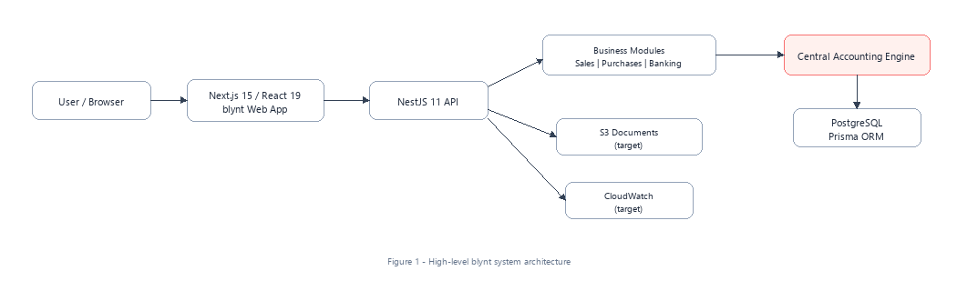
Figure 1 - High-level blynt system architecture
[ Next.js 15 Client (Turbopack) ]
│ (HTTP/REST via fetch with Bearer Token)
▼
[ NestJS 11 Application Gateway ]
├── Common Middleware (Correlation IDs: x-request-id)
├── Security Guards (AuthGuard -> RolesGuard -> OrgGuard)
├── Controllers (Routing, DTO transformation)
├── Domain Services (Accounting, Invoicing, Subledgers)
└── Central Posting Engine (Validation & Integrity Invariants)
│ (Prisma Client with Transaction Pool)
▼
[ PostgreSQL 16+ Engine ]
├── Composite Foreign Keys (Tenant Boundaries)
├── Temporal Exclusion (btree_gist Non-overlapping dates)
├── Check Constraints (debit >= 0, credit >= 0)
└── Triggers (Append-Only audit_logs immutability)

Execution Lifecycle of an Inbound Request:
1. Network Ingress & Reverse Proxy: Request enters port 4000. Middleware intercepts incoming HTTP headers, generating a unique x-request-id UUIDv4 if omitted, which is attached to the request context.
2. Global Validation Pipe: ValidationPipe parses and validates inbound request payloads against class-validator decorators, rejecting undeclared properties (whitelist: true) and transforming types.
3. Authentication Layer (`AuthGuard`): Extracts Authorization: Bearer <token>, validates session token against user_sessions in PostgreSQL, verifies token expiry, and resolves user context.
4. Tenant Verification & Role Authorisation (`RolesGuard`): Resolves active organizationId from URL route params (/organizations/:orgId/...) or headers, validates active membership in organization_members, and verifies the caller's role against @Roles(...) metadata.
5. Controller Dispatch: Invokes the corresponding NestJS controller method, providing typed DTOs and verified request actors.
6. Domain Service Execution & Database Transaction: Executes accounting domain logic. Critical financial writes execute within prisma.transaction(async (tx) => { ... }) with row-level locks.
7. Audit Logging & Response Interception: Structured audit records are saved directly into audit_logs. The response payload is wrapped into the standard API envelope.

2. Database Schema & Prisma ORM Deep-Dive (`schema.prisma`)
The database schema (apps/api/prisma/schema.prisma) serves as the authoritative financial contract.
2.1 Enums and Tenant Boundary Architecture
enum SystemRoleKey {
OWNER
ADMINISTRATOR
ACCOUNTANT
BOOKKEEPER
VIEWER
}
enum AccountType {
ASSET
LIABILITY
EQUITY
REVENUE
EXPENSE
}
enum BalanceType {
DEBIT
CREDIT
}
enum JournalStatus {
DRAFT
VALIDATED
POSTED
REVERSED
}
enum PeriodStatus {
OPEN
SOFT_LOCKED
HARD_LOCKED
}

- Tenant Boundary Contract: Child tables maintain composite unique references (organization_id, id) enabling composite foreign keys. A record in Organisation A cannot physically point to a foreign record in Organisation B.
2.2 Organizations & Membership Models
model Organization {
id String @id @default(cuid())
legalName String @map("legal_name")
slug String @unique
companyNumber String? @map("company_number")
vatNumber String? @map("vat_number")
baseCurrency String @default("GBP") @map("base_currency")
status OrganizationStatus @default(ACTIVE)
createdAt DateTime @default(now()) @map("created_at")
updatedAt DateTime @updatedAt @map("updated_at")
members OrganizationMember[]
accounts Account[]
journals JournalEntry[]
financialYears FinancialYear[]
contacts Contact[]
invoices Invoice[]
@@map("organizations")
}
model OrganizationMember {
id String @id @default(cuid())
organizationId String @map("organization_id")
userId String @map("user_id")
role SystemRoleKey @default(VIEWER)
joinedAt DateTime @default(now()) @map("joined_at")
organization Organization @relation(fields: [organizationId], references: [id], onDelete: Cascade)
user User @relation(fields: [userId], references: [id], onDelete: Cascade)
@@unique([organizationId, userId])
@@map("organization_members")
}

2.3 Chart of Accounts Nominal Model
model Account {
id String @id @default(cuid())
organizationId String @map("organization_id")
code String @db.VarChar(20)
name String @db.VarChar(255)
accountType AccountType @map("account_type")
accountSubtype AccountSubtype @map("account_subtype")
normalBalance BalanceType @map("normal_balance")
isControlAccount Boolean @default(false) @map("is_control_account")
allowManualPosting Boolean @default(true) @map("allow_manual_posting")
isActive Boolean @default(true) @map("is_active")
parentAccountId String? @map("parent_account_id")
organization Organization @relation(fields: [organizationId], references: [id], onDelete: Cascade)
parentAccount Account? @relation("AccountHierarchy", fields: [parentAccountId], references: [id])
childAccounts Account[] @relation("AccountHierarchy")
journalLines JournalLine[]
@@unique([organizationId, code])
@@unique([organizationId, id])
@@map("accounts")
}

2.4 Financial Years & Accounting Periods (btree_gist Constraints)
model FinancialYear {
id String @id @default(cuid())
organizationId String @map("organization_id")
name String
startDate DateTime @map("start_date") @db.Date
endDate DateTime @map("end_date") @db.Date
status FinancialYearStatus @default(OPEN)
periods AccountingPeriod[]
organization Organization @relation(fields: [organizationId], references: [id], onDelete: Cascade)
@@unique([organizationId, id])
@@map("financial_years")
}
model AccountingPeriod {
id String @id @default(cuid())
organizationId String @map("organization_id")
financialYearId String @map("financial_year_id")
periodNumber Int @map("period_number")
name String
startDate DateTime @map("start_date") @db.Date
endDate DateTime @map("end_date") @db.Date
status PeriodStatus @default(OPEN)
lockedAt DateTime? @map("locked_at")
lockedById String? @map("locked_by_id")
financialYear FinancialYear @relation(fields: [financialYearId], references: [id], onDelete: Cascade)
organization Organization @relation(fields: [organizationId], references: [id], onDelete: Cascade)
@@unique([organizationId, id])
@@map("accounting_periods")
}

- PostgreSQL Engine Constraint (`btree_gist`):
ALTER TABLE financial_years
ADD CONSTRAINT financial_years_no_overlap
EXCLUDE USING gist (
organization_id WITH =,
daterange(start_date, end_date, '[]') WITH &&
);

2.5 Double-Entry Journal Core & Database Constraints
model JournalEntry {
id String @id @default(cuid())
organizationId String @map("organization_id")
journalNumber String @map("journal_number")
postingDate DateTime @map("posting_date") @db.Date
status JournalStatus @default(DRAFT)
journalType JournalType @default(STANDARD) @map("journal_type")
sourceType JournalSourceType @default(MANUAL) @map("source_type")
sourceId String? @map("source_id")
narration String? @db.Text
reversedByJournalId String? @unique @map("reversed_by_journal_id")
lines JournalLine[]
reversedByJournal JournalEntry? @relation("JournalReversal", fields: [reversedByJournalId], references: [id])
reversingJournal JournalEntry? @relation("JournalReversal")
organization Organization @relation(fields: [organizationId], references: [id], onDelete: Cascade)
@@unique([organizationId, journalNumber])
@@unique([organizationId, id])
@@map("journal_entries")
}
model JournalLine {
id String @id @default(cuid())
organizationId String @map("organization_id")
journalEntryId String @map("journal_entry_id")
lineNumber Int @map("line_number")
accountId String @map("account_id")
contactId String? @map("contact_id")
debit Decimal @default(0) @db.Decimal(19, 4)
credit Decimal @default(0) @db.Decimal(19, 4)
description String? @db.Text
journalEntry JournalEntry @relation(fields: [journalEntryId], references: [id], onDelete: Cascade)
account Account @relation(fields: [organizationId, accountId], references: [organizationId, id])
contact Contact? @relation(fields: [organizationId, contactId], references: [organizationId, id])
@@index([organizationId, accountId])
@@index([organizationId, contactId])
@@map("journal_lines")
}

- Relational CHECK Constraints:
ALTER TABLE journal_lines
ADD CONSTRAINT chk_journal_lines_non_negative CHECK (debit >= 0 AND credit >= 0),
ADD CONSTRAINT chk_journal_lines_not_both_zero CHECK (NOT (debit = 0 AND credit = 0)),
ADD CONSTRAINT chk_journal_lines_not_both_positive CHECK (NOT (debit > 0 AND credit > 0));

2.6 Subledger Models: Contacts & Contact People
model Contact {
id String @id @default(cuid())
organizationId String @map("organization_id")
name String @db.VarChar(255)
contactType ContactType @map("contact_type")
companyName String? @map("company_name")
vatNumber String? @map("vat_number")
currency String @default("GBP")
paymentTermsDays Int @default(30) @map("payment_terms_days")
receivableAccountId String? @map("receivable_account_id")
payableAccountId String? @map("payable_account_id")
status ContactStatus @default(ACTIVE)
organization Organization @relation(fields: [organizationId], references: [id], onDelete: Cascade)
journalLines JournalLine[]
invoices Invoice[]
@@unique([organizationId, id])
@@map("contacts")
}

2.7 Invoices & Billing Models
model Invoice {
id String @id @default(cuid())
organizationId String @map("organization_id")
contactId String @map("contact_id")
invoiceNumber String @map("invoice_number")
issueDate DateTime @map("issue_date") @db.Date
dueDate DateTime @map("due_date") @db.Date
status InvoiceStatus @default(DRAFT)
currency String @default("GBP")
subtotal Decimal @db.Decimal(19, 4)
taxTotal Decimal @db.Decimal(19, 4)
totalAmount Decimal @db.Decimal(19, 4)
journalEntryId String? @unique @map("journal_entry_id")
contact Contact @relation(fields: [contactId], references: [id])
journalEntry JournalEntry? @relation(fields: [journalEntryId], references: [id])
lines InvoiceLine[]
@@unique([organizationId, invoiceNumber])
@@unique([organizationId, id])
@@map("invoices")
}
model InvoiceLine {
id String @id @default(cuid())
organizationId String @map("organization_id")
invoiceId String @map("invoice_id")
lineNumber Int @map("line_number")
accountId String @map("account_id")
description String @db.Text
quantity Decimal @db.Decimal(19, 4)
unitPrice Decimal @map("unit_price") @db.Decimal(19, 4)
taxRate Decimal @map("tax_rate") @db.Decimal(19, 4)
taxAmount Decimal @map("tax_amount") @db.Decimal(19, 4)
lineTotal Decimal @map("line_total") @db.Decimal(19, 4)
invoice Invoice @relation(fields: [invoiceId], references: [id], onDelete: Cascade)
account Account @relation(fields: [organizationId, accountId], references: [organizationId, id])
@@map("invoice_lines")
}

2.8 Append-Only Audit Logging & Database Trigger Functions
model AuditLog {
id String @id @default(cuid())
organizationId String @map("organization_id")
userId String? @map("user_id")
eventType String @map("event_type")
entityType String @map("entity_type")
entityId String @map("entity_id")
oldValues Json? @map("old_values")
newValues Json? @map("new_values")
ipAddress String? @map("ip_address")
requestId String? @map("request_id")
createdAt DateTime @default(now()) @map("created_at")
@@index([organizationId, entityType, entityId])
@@map("audit_logs")
}

- Statutory Immutability Trigger:
CREATE OR REPLACE FUNCTION prevent_audit_log_mutation()
RETURNS TRIGGER AS $$
BEGIN
RAISE EXCEPTION 'Statutory Compliance Violation: audit_logs are immutable and cannot be updated or deleted';
END;
$$ LANGUAGE plpgsql;
CREATE TRIGGER trg_audit_logs_immutable
BEFORE UPDATE OR DELETE ON audit_logs
FOR EACH ROW EXECUTE FUNCTION prevent_audit_log_mutation();

3. The Double-Entry Accounting Engine (`src/accounting-engine/`)
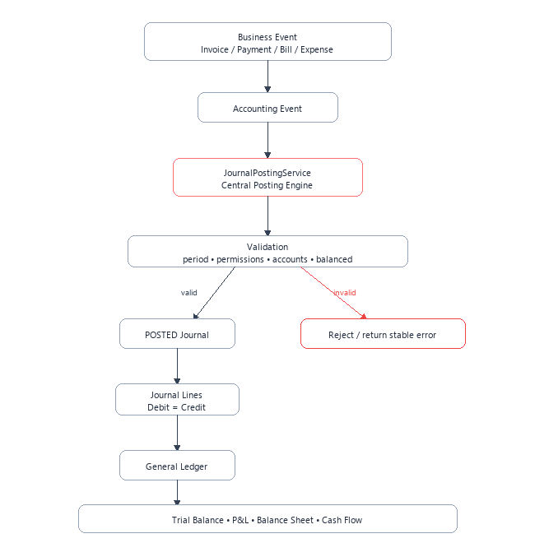
Figure 3 - Central accounting posting flow
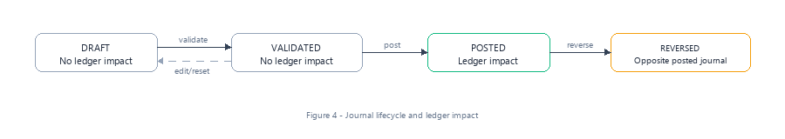
Figure 4 - Journal entry lifecycle state machine
3.1 `MoneyService`: Decimal.js and Zero-Drift Fixed-Point Math
JavaScript native floating-point calculations (0.1 + 0.2 = 0.30000000000000004) lead to balance sheet drift. MoneyService guarantees arbitrary precision fixed-point arithmetic configured to 4 decimal places matching PostgreSQL NUMERIC(19,4):
@Injectable()
export class MoneyService {
toDecimal(val: Decimal.Value | Prisma.Decimal): Decimal {
if (val instanceof Decimal) return val;
return new Decimal(val.toString());
}
isZero(val: Decimal.Value | Prisma.Decimal): boolean {
return this.toDecimal(val).isZero();
}
equals(a: Decimal.Value | Prisma.Decimal, b: Decimal.Value | Prisma.Decimal): boolean {
return this.toDecimal(a).equals(this.toDecimal(b));
}
plus(a: Decimal.Value | Prisma.Decimal, b: Decimal.Value | Prisma.Decimal): Decimal {
return this.toDecimal(a).plus(this.toDecimal(b));
}
minus(a: Decimal.Value | Prisma.Decimal, b: Decimal.Value | Prisma.Decimal): Decimal {
return this.toDecimal(a).minus(this.toDecimal(b));
}
round(val: Decimal.Value | Prisma.Decimal, places: number = 2): Decimal {
return this.toDecimal(val).toDecimalPlaces(places, Decimal.ROUND_HALF_UP);
}
}

3.2 `JournalValidationService`: Complete Walkthrough of the 15 Invariants
The JournalValidationService inspects candidate journals against 15 strict institutional accounting rules before permitting state transition:
@Injectable()
export class JournalValidationService {
constructor(
private readonly prisma: PrismaService,
private readonly money: MoneyService,
) {}
async validateJournalEntry(organizationId: string, journalId: string): Promise<void> {
const journal = await this.prisma.journalEntry.findUnique({
where: { id: journalId },
include: { lines: { include: { account: true } } },
});
if (!journal || journal.organizationId !== organizationId) {
throw new DomainException('ERR_JOURNAL_NOT_FOUND', 'Journal entry not found');
}
// Rule 1: Status must be DRAFT
if (journal.status !== 'DRAFT') {
throw new DomainException('ERR_JOURNAL_INVALID_STATUS', 'Only DRAFT journals can be validated');
}
// Rule 2: Minimum line count (at least 2 lines)
if (journal.lines.length < 2) {
throw new DomainException('ERR_JOURNAL_MINIMUM_LINES', 'Journal must have at least 2 lines');
}
let totalDebits = new Decimal(0);
let totalCredits = new Decimal(0);
for (const line of journal.lines) {
const debit = this.money.toDecimal(line.debit);
const credit = this.money.toDecimal(line.credit);
// Rule 8: Negative amounts prohibited
if (debit.isNegative() || credit.isNegative()) {
throw new DomainException('ERR_NEGATIVE_AMOUNT', 'Line amounts cannot be negative');
}
// Rule 6: Debit and credit cannot both be zero
if (debit.isZero() && credit.isZero()) {
throw new DomainException('ERR_ZERO_LINE', 'Line cannot have both debit and credit zero');
}
// Rule 7: Debit and credit cannot both be positive
if (!debit.isZero() && !credit.isZero()) {
throw new DomainException('ERR_DUAL_NON_ZERO', 'Line cannot have both debit and credit positive');
}
// Rule 4: Account active check
if (!line.account.isActive) {
throw new DomainException('ERR_ACCOUNT_INACTIVE', `Account ${line.account.code} is inactive`);
}
// Rule 5: Control account manual entry prohibition
if (journal.sourceType === 'MANUAL' && (line.account.isControlAccount || !line.account.allowManualPosting)) {
throw new DomainException('ERR_CONTROL_ACCOUNT_DIRECT_POSTING', `Direct manual posting to control account ${line.account.code} is forbidden`);
}
// Rule 12: Subledger contact requirement for AR/AP accounts
if (
(line.account.accountSubtype === 'ACCOUNTS_RECEIVABLE' || line.account.accountSubtype === 'ACCOUNTS_PAYABLE') &&
!line.contactId
) {
throw new DomainException('ERR_CONTACT_REQUIRED', `Contact ID is required for control line on account ${line.account.code}`);
}
totalDebits = totalDebits.plus(debit);
totalCredits = totalCredits.plus(credit);
}
// Rule 1: Total Debits == Total Credits
if (!totalDebits.equals(totalCredits)) {
const diff = totalDebits.minus(totalCredits).abs();
throw new DomainException('ERR_JOURNAL_UNBALANCED', `Debits (${totalDebits}) must equal credits (${totalCredits}). Difference: ${diff}`);
}
// Rule 9 & 10: Period resolution and hard-lock verification
const period = await this.resolvePeriod(organizationId, journal.postingDate);
if (!period) {
throw new DomainException('ERR_NO_PERIOD', 'No accounting period found covering posting date');
}
if (period.status === 'HARD_LOCKED') {
throw new DomainException('ERR_PERIOD_HARD_LOCKED', `Accounting period "${period.name}" is hard-locked`);
}
}
}

3.3 `JournalPostingService`: Atomic Sequences and State Transitions
Assigns the official sequence number JE-YYYY-XXXXXX inside a serializable database transaction:
@Injectable()
export class JournalPostingService {
async postJournal(organizationId: string, journalId: string, actor: Actor) {
return this.prisma.transaction(async (tx) => {
// 1. Lock journal row FOR UPDATE
await tx.$queryRaw`
SELECT id, status FROM journal_entries
WHERE id = ${journalId}::uuid AND organization_id = ${organizationId}::uuid
FOR UPDATE
`;
// 2. Execute validation inside transaction
await this.validator.validateJournalEntry(organizationId, journalId);
// 3. Generate sequential journal number
const sequenceNumber = await this.generateNextSequence(tx, organizationId);
// 4. Update status to POSTED
const posted = await tx.journalEntry.update({
where: { id: journalId },
data: {
status: 'POSTED',
journalNumber: sequenceNumber,
},
});
// 5. Emit immutable audit log
await this.audit.record(tx, actor, {
organizationId,
eventType: AuditEvents.JOURNAL_POSTED,
entityType: 'JOURNAL',
entityId: journalId,
newValues: { journalNumber: sequenceNumber, status: 'POSTED' },
});
return posted;
});
}
}

3.4 `JournalReversalService`: Non-Destructive GAAP Balancing Entries
Deletions of posted records are strictly prohibited under financial regulations. Reversals create an equal and opposite counter-entry:
@Injectable()
export class JournalReversalService {
async reverseJournal(organizationId: string, journalId: string, actor: Actor) {
return this.prisma.transaction(async (tx) => {
const original = await tx.journalEntry.findUnique({
where: { id: journalId },
include: { lines: true },
});
if (!original || original.status !== 'POSTED') {
throw new DomainException('ERR_CANNOT_REVERSE', 'Only posted journals can be reversed');
}
// Generate reversal sequence
const revNumber = await this.generateNextSequence(tx, organizationId);
// Create counter-entry with swapped debits and credits
const reversalJournal = await tx.journalEntry.create({
data: {
organizationId,
journalNumber: revNumber,
postingDate: new Date(),
status: 'POSTED',
journalType: 'REVERSAL',
sourceType: original.sourceType,
narration: `Reversal of ${original.journalNumber}: ${original.narration || ''}`,
lines: {
create: original.lines.map((l, idx) => ({
organizationId,
lineNumber: idx + 1,
accountId: l.accountId,
contactId: l.contactId,
debit: l.credit, // Inverted
credit: l.debit, // Inverted
description: `Reversal of line ${l.lineNumber}`,
})),
},
},
});
// Mark original journal as reversed and link counter-entry
await tx.journalEntry.update({
where: { id: journalId },
data: {
status: 'REVERSED',
reversedByJournalId: reversalJournal.id,
},
});
return reversalJournal;
});
}
}

3.5 `AccountingIntegrityService`: Automated Health Checks
The integrity service executes continuous verification queries across the database to detect potential anomalies:
@Injectable()
export class AccountingIntegrityService {
async checkIntegrity(organizationId: string) {
// 1. Verify global sum of debits == sum of credits
const aggregate = await this.prisma.journalLine.aggregate({
where: {
organizationId,
journalEntry: { status: 'POSTED' },
},
_sum: { debit: true, credit: true },
});
const totalDebit = this.money.toDecimal(aggregate._sum.debit || 0);
const totalCredit = this.money.toDecimal(aggregate._sum.credit || 0);
const difference = totalDebit.minus(totalCredit).abs();
const isBalanced = difference.isZero();
// 2. Check for unbalanced posted journals
const unbalancedJournals = await this.findUnbalancedJournals(organizationId);
// 3. Verify equation: Assets = Liabilities + Equity
const equationStatus = await this.verifyFundamentalEquation(organizationId);
return {
isBalanced,
totalDebit: totalDebit.toFixed(2),
totalCredit: totalCredit.toFixed(2),
difference: difference.toFixed(2),
unbalancedJournalsCount: unbalancedJournals.length,
fundamentalEquationBalanced: equationStatus.isBalanced,
};
}
}

4. Chart of Accounts & General Ledger (`src/accounts/` & `src/ledger/`)
4.1 Nominal Code Hierarchy (1000–8999) & Standard Seeding
The chart of accounts organizes nominal accounts into standardized institutional ranges:
Nominal Range | Account Type | Normal Balance | Purpose & Standard Accounts
1000 – 1999 | ASSET | DEBIT | 1000 Bank Operating, 1100 Accounts Receivable, 1200 Petty Cash
2000 – 2999 | LIABILITY | CREDIT | 2000 Accounts Payable, 2100 VAT Output / Input, 2200 PAYE / NIC
3000 – 3999 | EQUITY | CREDIT | 3000 Ordinary Share Capital, 3100 Retained Earnings
4000 – 4999 | REVENUE | CREDIT | 4000 Sales / Commercial Revenue, 4100 Consulting Fees
5000 – 5999 | EXPENSE (COS) | DEBIT | 5000 Cost of Goods Sold, 5100 Direct Subcontractors
6000 – 8999 | EXPENSE (OPEX) | DEBIT | 6000 Rent & Rates, 7000 Salaries, 8000 Software & Hosting

4.2 Control Account Protection Mechanics
Accounts flagged with isControlAccount: true (e.g., 1100 AR, 2000 AP, 2100 VAT) enforce subledger integrity:
- Manual journal entries targeting control accounts directly are rejected with ERR_CONTROL_ACCOUNT_DIRECT_POSTING.
- All postings to control accounts must originate from verified business subsystems (e.g. Invoicing, Payments, Bill Processing).
4.3 `AccountsService`: Hierarchical Trees & Validation
Manages creation, updates, and soft archiving:
- Duplicate Code Check: Rejects duplicate codes within the same organisation (DUPLICATE_ACCOUNT_CODE).
- Self-Parent Prevention: Throws ACCOUNT_INVALID_PARENT if an account is set as its own parent.
- Protected System Accounts: Built-in accounts (e.g., 1100, 2000, 3100) are flagged isSystemAccount: true and cannot be modified or deleted.
4.4 `LedgerService`: General Ledger Running Balances
Extracts chronological general ledger records, applying date range filters and calculating running balances:
- For DEBIT normal accounts: Running Balance = Running Balance + Debit - Credit.
- For CREDIT normal accounts: Running Balance = Running Balance - Debit + Credit.

5. Financial Periods & Year-End Closure (`src/financial-years/`, `src/accounting-periods/`)
5.1 Automated 12-Month Calendar Generation
When a financial year is created (e.g., 2026-04-01 to 2027-03-31), FinancialYearsService automatically generates 12 sequential monthly accounting periods:
- Month 1: April 2026 (2026-04-01 to 2026-04-30)
- Month 2: May 2026 (2026-05-01 to 2026-05-31)
- ...
- Month 12: March 2027 (2027-03-01 to 2027-03-31)
5.2 Three-Tier Period Lockdown State Machine
┌─────────┐ Lock Period ┌─────────────┐ Hard Close ┌─────────────┐
│ OPEN │ ────────────────────> │ SOFT_LOCKED │ ─────────────────> │ HARD_LOCKED │
└─────────┘ └─────────────┘ └─────────────┘
▲ │
└──────────── Unlock ───────────────┘

1. `OPEN`: Standard daily operations. All authorized roles may create and post journals.
2. `SOFT_LOCKED`: Month-end review mode. Standard bookkeepers cannot post. Senior accountants and administrators can post with audited override.
3. `HARD_LOCKED`: Statutory year-end close. Database triggers and application services reject any post attempts unconditionally (ERR_PERIOD_HARD_LOCKED).

6. Contacts & Commercial Subledgers (`src/contacts/`)
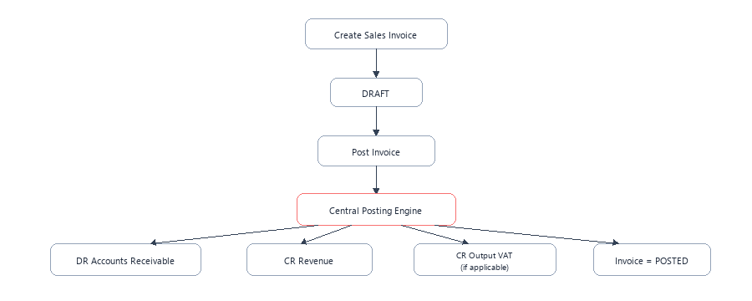
Figure 5 - Sales invoice accounting flow
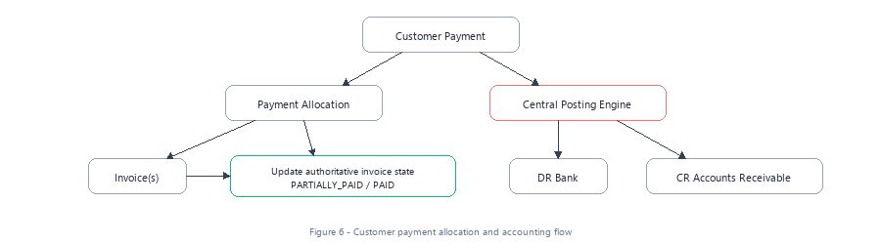
Figure 6 - Customer payment allocation and accounting flow
6.1 `ContactsService`: Customer/Supplier Directory & Master Data
Manages commercial trading entities:
- Classification: CUSTOMER, SUPPLIER, or BOTH.
- Company registration numbers and VAT identifiers.
- Contact People directory (ContactPerson) for invoicing email dispatch.
6.2 `ContactSubledgerService`: Dynamic AR/AP Derivation & Zero Cache Drift
Rather than maintaining a cached current_balance column that can drift out of sync with the General Ledger, customer and supplier balances are derived dynamically from posted journal lines:
$$ ext{Customer AR Balance} = \sum( ext{Debits to Accounts Receivable}) - \sum( ext{Credits to Accounts Receivable})$$
@Injectable()
export class ContactSubledgerService {
async getCustomerBalance(organizationId: string, contactId: string): Promise<Decimal> {
const lines = await this.prisma.journalLine.findMany({
where: {
organizationId,
contactId,
journalEntry: { status: 'POSTED' },
account: { accountSubtype: 'ACCOUNTS_RECEIVABLE' },
},
select: { debit: true, credit: true },
});
let balance = new Decimal(0);
for (const line of lines) {
balance = balance.plus(line.debit).minus(line.credit);
}
return balance;
}
}

6.3 Customer & Supplier Statement Generation
Generates structured statements for commercial counterparties:
- Opening balance calculation prior to start date.
- Itemized transaction list: Invoices, Credit Notes, and Payments.
- Running balance per transaction.
- Aging analysis breakdown: Current, 30 Days, 60 Days, 90+ Days.

7. Sales Invoicing & Commercial Billing (`src/invoices/`)
7.1 Invoice Creation, Line Pricing, and UK VAT Calculation
calculateInvoiceTotals(lines: CreateInvoiceLineDto[]) {
let subtotal = new Decimal(0);
let taxTotal = new Decimal(0);
const calculatedLines = lines.map((l) => {
const qty = this.money.toDecimal(l.quantity);
const price = this.money.toDecimal(l.unitPrice);
const taxRate = this.money.toDecimal(l.taxRate || 0);
const lineSubtotal = qty.times(price);
const lineTax = lineSubtotal.times(taxRate.dividedBy(100));
const lineTotal = lineSubtotal.plus(lineTax);
subtotal = subtotal.plus(lineSubtotal);
taxTotal = taxTotal.plus(lineTax);
return { ...l, taxAmount: lineTax, lineTotal };
});
return {
subtotal: this.money.round(subtotal, 2),
taxTotal: this.money.round(taxTotal, 2),
totalAmount: this.money.round(subtotal.plus(taxTotal), 2),
calculatedLines,
};
}

7.2 The Automated General Ledger Posting Pipeline (`postInvoice`)
When an invoice is approved and posted, InvoicesService.postInvoice atomically generates, validates, posts, and links a balanced double-entry journal entry:
async postInvoice(organizationId: string, invoiceId: string, orgContext: OrgContext, actor: Actor) {
this.postingService.checkPostingPermission(orgContext);
return this.prisma.transaction(async (tx) => {
// 1. Lock invoice row FOR UPDATE
await tx.$queryRaw`
SELECT id, status FROM invoices
WHERE id = ${invoiceId}::uuid AND organization_id = ${organizationId}::uuid
FOR UPDATE
`;
const invoice = await tx.invoice.findFirst({
where: { id: invoiceId, organizationId },
include: invoiceInclude,
});
if (invoice.status !== 'DRAFT') {
throw new DomainException('INVOICE_INVALID_STATE', 'Only DRAFT invoices can be posted');
}
// 2. Identify Accounts Receivable account (nominal 1100)
const arAccount = await this.resolveArAccount(tx, organizationId, invoice.contact);
// 3. Identify Tax Payable account (nominal 2100) if tax exists
const taxAccount = await this.resolveTaxAccount(tx, organizationId, invoice.taxTotal);
// 4. Construct Journal Lines:
// Debit AR (1100) with Total Amount
const journalLines = [
{
organizationId,
lineNumber: 1,
accountId: arAccount.id,
contactId: invoice.contactId,
debit: invoice.totalAmount,
credit: new Decimal(0),
description: `Invoice ${invoice.invoiceNumber} receivable`,
},
];
let lineNum = 2;
// Credit Revenue accounts per invoice line
for (const line of invoice.lines) {
journalLines.push({
organizationId,
lineNumber: lineNum++,
accountId: line.accountId,
contactId: invoice.contactId,
debit: new Decimal(0),
credit: line.lineTotal.minus(line.taxAmount),
description: line.description,
});
}
// Credit Tax Payable if tax > 0
if (this.money.toDecimal(invoice.taxTotal).greaterThan(0)) {
journalLines.push({
organizationId,
lineNumber: lineNum++,
accountId: taxAccount.id,
contactId: null,
debit: new Decimal(0),
credit: invoice.taxTotal,
description: `VAT output on invoice ${invoice.invoiceNumber}`,
});
}
// 5. Create Draft Journal Entry
const journal = await tx.journalEntry.create({
data: {
organizationId,
journalNumber: `TEMP-${invoice.invoiceNumber}`,
postingDate: invoice.issueDate,
status: 'DRAFT',
journalType: 'SALES_INVOICE',
sourceType: 'INVOICE',
sourceId: invoice.id,
narration: `Sales Invoice ${invoice.invoiceNumber}`,
lines: { create: journalLines },
},
});
// 6. Validate & Post via Accounting Engine
await this.validator.validateJournalEntry(organizationId, journal.id);
const postedJournal = await this.postingService.postJournal(organizationId, journal.id, actor);
// 7. Update Invoice status to POSTED and link journal ID
await tx.invoice.update({
where: { id: invoiceId },
data: {
status: 'POSTED',
journalEntryId: postedJournal.id,
},
});
return postedJournal;
});
}

7.3 Invoice Voiding and Reversal Alignment (`voidInvoice`)
Voiding an invoice that has been posted to the General Ledger executes an atomic reversal:
1. Locks the invoice row FOR UPDATE.
2. Locates the linked journal entry (invoice.journalEntryId).
3. Invokes JournalReversalService.reverseJournal, generating the GAAP counter-journal.
4. Updates the invoice status to VOIDED.
5. Emits AuditEvents.INVOICE_VOIDED audit log.

8. Financial Reporting Engine (`src/reports/`)
8.1 `TrialBalanceService`: Real-Time Nominal Aggregation
Generates the authoritative Trial Balance report directly from posted journal lines:
- Integrity Gate: Filters strictly by status: { in: ['POSTED', 'REVERSED'] }. Draft and validated journals are excluded.
- Balance Computation:
- For Asset/Expense accounts (DEBIT normal): Net Balance = Gross Debit - Gross Credit. If positive, placed in Debit column; if negative, placed in Credit column.
- For Liability/Equity/Revenue accounts (CREDIT normal): Net Balance = Gross Credit - Gross Debit. If positive, placed in Credit column; if negative, placed in Debit column.
- Equilibrium Check: Calculates diff = |totalDebits - totalCredits|. Sets isBalanced: diff.isZero().
- Export Capabilities: Supports both JSON and RFC-4180 compliant CSV formatting.
8.2 `ProfitAndLossService`: Revenue & Expense Classification
Generates the Income Statement over a specified date range:
- Turnover / Revenue: Sum of credit balances on nominal accounts 4000–4999.
- Cost of Sales: Sum of debit balances on nominal accounts 5000–5999.
- Gross Profit: $ ext{Gross Profit} = ext{Revenue} - ext{Cost of Sales}$.
- Operating Expenses (OPEX): Sum of debit balances on nominal accounts 6000–8999 (Rent, Salaries, Software).
- Operating Profit: $ ext{Operating Profit} = ext{Gross Profit} - ext{Operating Expenses}$.
- Net Profit / (Loss): Final net income transferred to Retained Earnings in the Balance Sheet.
8.3 `BalanceSheetService`: Assets, Liabilities, and Equity Verification
Verifies the foundational accounting equation at a specific date:
$$ ext{Assets} = ext{Liabilities} + ext{Equity}$$
- Current & Non-Current Assets: Cash at Bank (1000), Accounts Receivable (1100), Equipment (1500).
- Current & Non-Current Liabilities: Accounts Payable (2000), VAT Payable (2100), Bank Loans (2500).
- Equity: Share Capital (3000) + Prior Year Retained Earnings (3100) + Current Year Net Profit (derived from P&L).

9. Security, Authentication & Multi-Tenancy (`src/auth/`, `src/roles/`, `src/organizations/`, `src/audit/`)
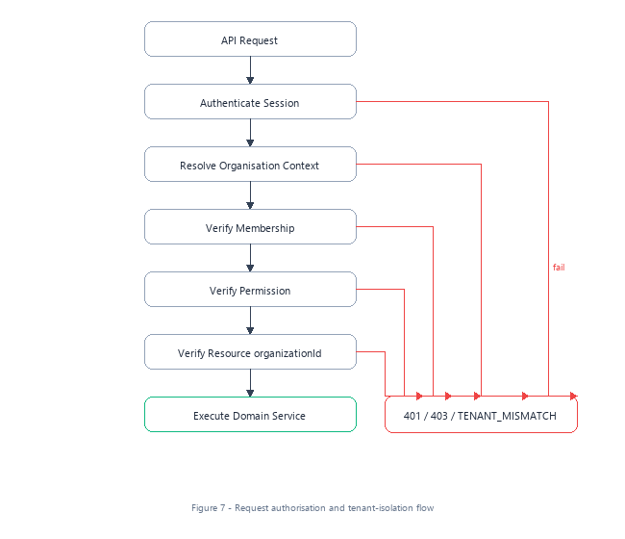
Figure 7 - Request authorisation and tenant-isolation flow
9.1 `PasswordService`: scrypt Hashing & Constant-Time Verification
@Injectable()
export class PasswordService {
async hash(password: string): Promise<string> {
const salt = crypto.randomBytes(16).toString('hex');
const derivedKey = (await promisify(crypto.scrypt)(password, salt, 64)) as Buffer;
return `${salt}:${derivedKey.toString('hex')}`;
}
async verify(password: string, storedHash: string): Promise<boolean> {
const [salt, key] = storedHash.split(':');
const keyBuffer = Buffer.from(key, 'hex');
const derivedKey = (await promisify(crypto.scrypt)(password, salt, 64)) as Buffer;
return crypto.timingSafeEqual(keyBuffer, derivedKey);
}
}

- Cryptographic Guarantees: 16-byte cryptographically secure random salt, 64-byte key length. crypto.timingSafeEqual prevents side-channel timing attacks during password verification.
9.2 `AuthGuard`: Bearer Token Extraction & Session Validation
@Injectable()
export class AuthGuard implements CanActivate {
async canActivate(context: ExecutionContext): Promise<boolean> {
const req = context.switchToHttp().getRequest();
const authHeader = req.headers['authorization'];
if (!authHeader || !authHeader.startsWith('Bearer ')) {
throw new UnauthorizedException('Authentication required');
}
const token = authHeader.substring(7);
const session = await this.prisma.userSession.findUnique({
where: { token },
include: { user: true },
});
if (!session || session.expiresAt < new Date()) {
throw new UnauthorizedException('Session expired or invalid');
}
req.user = session.user;
return true;
}
}

9.3 `RolesGuard`: Role-Based Access Control
Evaluates required role permissions declared via @Roles(...):
- Role Hierarchy:
- OWNER: Full tenant permissions, billing, organization deletion.
- ADMINISTRATOR: User management, financial configuration, periods.
- ACCOUNTANT: Journal creation, posting, period locks, reporting.
- BOOKKEEPER: Draft invoices, draft journals, customer records.
- VIEWER: Read-only reporting access.
9.4 `AuditService`: Structured Immutable Logging
Every mutating action generates an audit entry capturing actor, organization, entity ID, and state deltas (oldValues and newValues):
- Backed by PostgreSQL trg_audit_logs_immutable trigger preventing any update or deletion.

10. AI Document Intelligence & Safety Guardrails (`src/ai/`)
10.1 `AccountingClassificationService`: Document Code Mapping
Uses heuristic classification and LLM embeddings to suggest nominal accounts for inbound supplier bills and receipts:
- Extracts merchant name, line descriptions, VAT amounts.
- Maps recurring suppliers to standard OPEX accounts (e.g. AWS hosting -> 8000 Software & Hosting).
10.2 `TransactionDirectionService`: Debit/Credit Prediction
Determines transaction direction based on document semantics:
- Sales Invoices: Debit Accounts Receivable (1100), Credit Revenue (4000), Credit VAT Output (2100).
- Supplier Bills: Debit Expense (e.g. 8000), Debit VAT Input (2100), Credit Accounts Payable (2000).
10.3 `AccountingSafetyService`: Validation Guardrails
Prevents automated AI actions from compromising financial integrity:
- Prohibits autonomous posting to control accounts.
- Enforces confidence thresholds: predictions below 85% confidence are flagged for human review.
- Rejects any AI suggestion that violates double-entry balance constraints.

11. Common Infrastructure, Filters, Pipes & Logger (`src/common/`)
11.1 `AllExceptionsFilter`: Centralized Domain Error Envelope
Catches all thrown exceptions and formats them into a predictable, RFC-7807 compatible JSON structure:
{
"success": false,
"error": {
"code": "ERR_JOURNAL_UNBALANCED",
"message": "Debits (100.00) must equal credits (90.00)",
"timestamp": "2026-10-12T00:00:00.000Z",
"requestId": "9b1deb4d-3b7d-4bad-9bdd-2b0d7b3dcb6d"
}
}

11.2 `DomainException`: Standardized Error Structure
Enables strong error categorization across services with domain-specific error codes (e.g., ERR_PERIOD_HARD_LOCKED, ERR_CONTROL_ACCOUNT_DIRECT_POSTING).
11.3 `ValidationPipe`: Class-Validator Sanitization
Configured with whitelist: true, forbidNonWhitelisted: true, and transform: true to prevent parameter injection attacks.
11.4 `AppLogger`: Correlation IDs and Structured JSON Logging
Attaches x-request-id to every log line, producing structured JSON outputs ingested by AWS CloudWatch.

12. Web Client Architecture (`apps/web/src/`)
12.1 App Router Layout & Authentication Context
Built on Next.js 15 with React 19 and Turbopack:
- App router structure (apps/web/src/app/).
- Persistent authentication context (auth-context.tsx) managing session storage, active organisation state, and token refresh.
12.2 Tenant-Scoped API Client (`api.ts`)
The frontend API wrapper (apps/web/src/lib/api.ts) automatically resolves and prefixes tenant paths:
export function resolveEndpoint(endpoint: string, activeOrgId?: string | null): string {
let clean = endpoint.startsWith('/') ? endpoint : `/${endpoint}`;
if (activeOrgId && !clean.startsWith('/organizations') && !clean.startsWith('/auth')) {
if (clean.startsWith('/accounts') || clean.startsWith('/journals') || clean.startsWith('/invoices')) {
clean = `/organizations/${activeOrgId}${clean}`;
}
}
return clean;
}

12.3 Key User Interfaces & Components
- Dashboard: Displays real-time KPI cards for Cash at Bank, Accounts Receivable, Accounts Payable, and YTD Net Profit.
- Journal Entry Grid: Interactive multi-line journal editor with a sticky balance tally bar displaying live Debits, Credits, and Balance Difference in real-time.
- Invoice Editor & GL Post Button: Comprehensive invoice builder with automatic tax calculation and one-click General Ledger posting.
- Customer & Supplier Statements: Date-filterable statement viewer with instant PDF generation and email dispatch.
- Financial Reports Viewers: Interactive Trial Balance, Profit & Loss, and Balance Sheet viewers with CSV export.

13. Cloud Deployment & CI/CD Pipeline
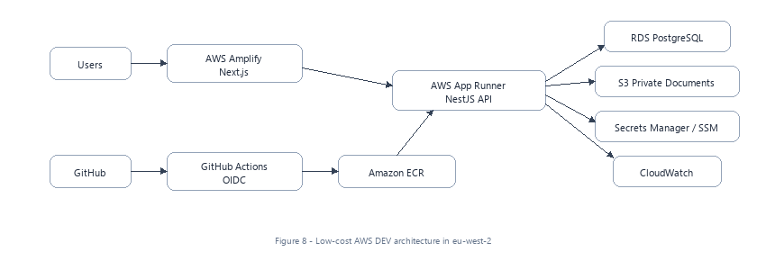
Figure 8 - Low-cost AWS DEV architecture in eu-west-2
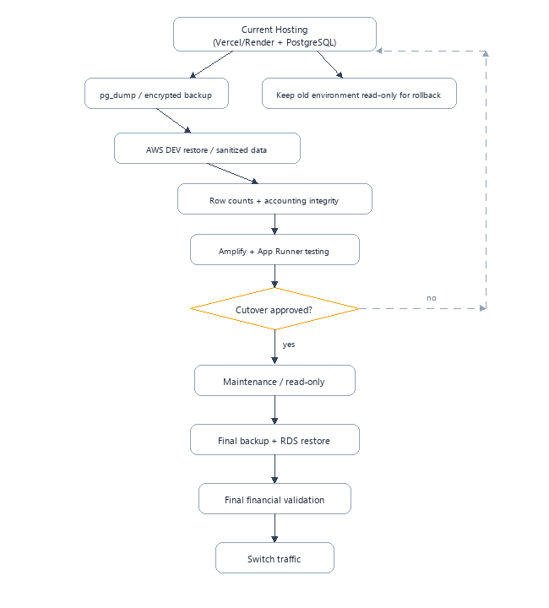
Figure 9 - Safe current-hosting to AWS migration and rollback path
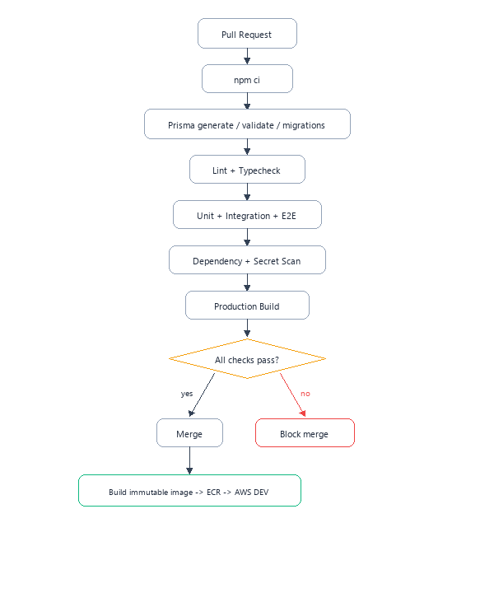
Figure 10 - Pull-request quality gate and AWS DEV deployment flow
13.1 AWS Dev Architecture (`eu-west-2` London)
- Frontend: AWS Amplify hosting Next.js 15 SSR build with automated edge caching.
- Backend: AWS App Runner running NestJS 11 containerized application with automatic horizontal scaling.
- Database: Amazon RDS PostgreSQL 16 Multi-AZ instance in private VPC subnets.
13.2 CI/CD Quality Gate
Every pull request triggers the automated GitHub Actions pipeline:
1. npm ci: Clean install across monorepo workspace.
2. prisma validate: Schema integrity and relation verification.
3. ESLint & TypeScript compilation checks.
4. Automated Unit & Service Tests: 26 test suites / 127 tests must PASS before merge approval.
5. Production container image build and push to Amazon ECR.

END OF BLYNT COMPLETE SOURCE CODE EXPLAINER

