This script will be run when ec2 instances are activated

Load Balancer

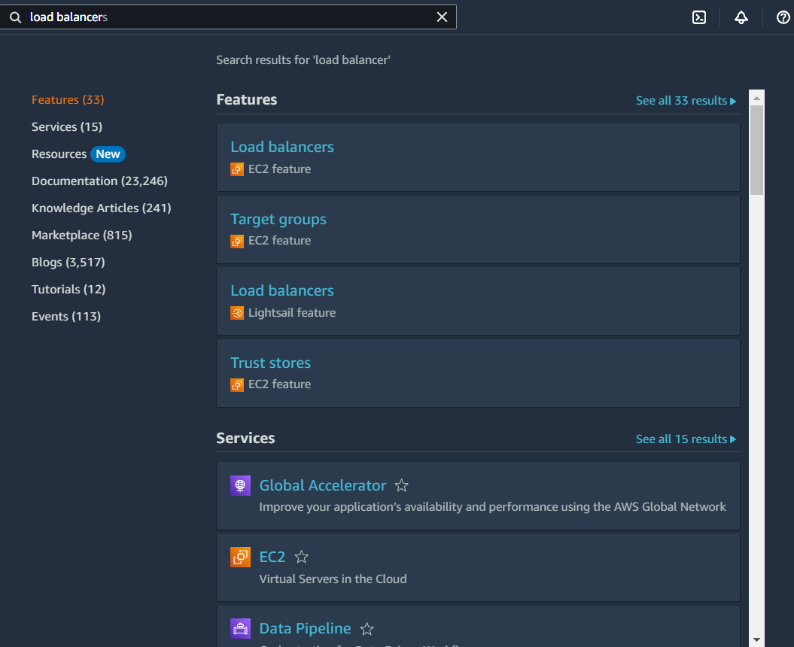

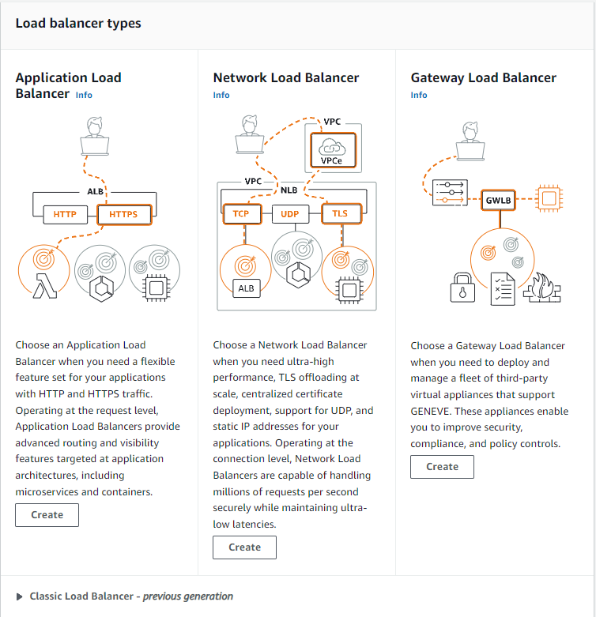

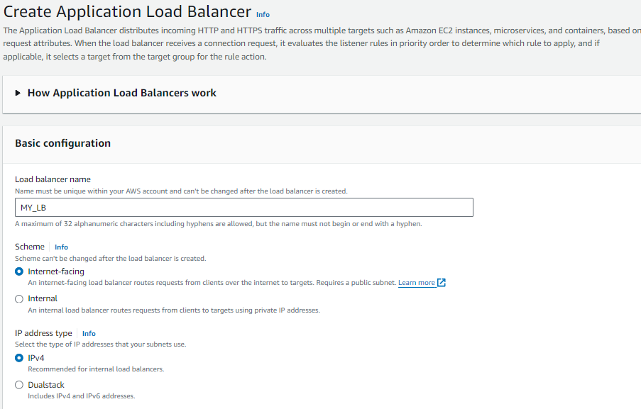

Creating a Target Group:

