1. Created S3 Buckets

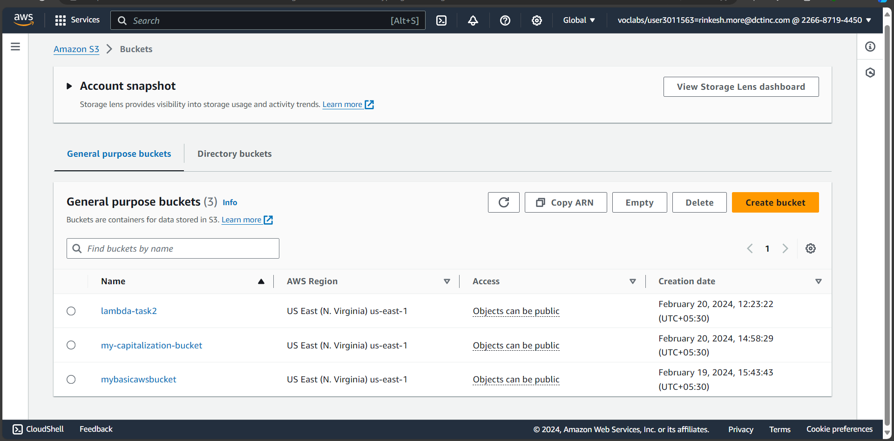

1. Making triggers in AWS-Lambda for two buckets- both with insertion triggers

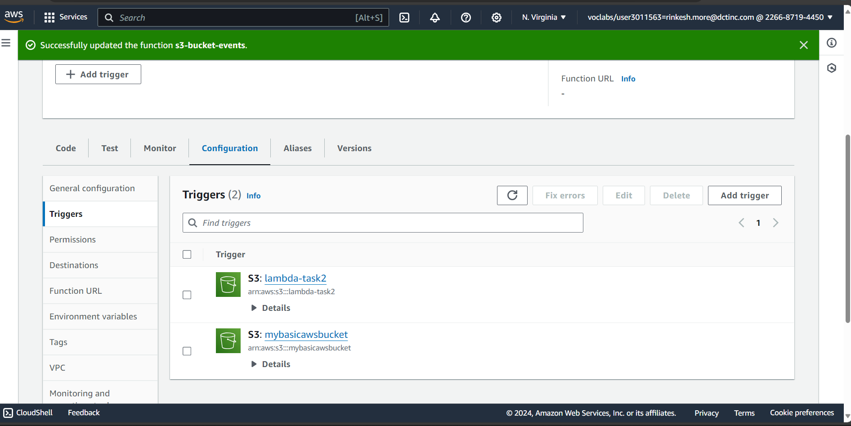

1. Inserted a file into a bucket named as – “lambda-task2”

1. Log of events as I have inserted file into the “lambda-task2” bucket

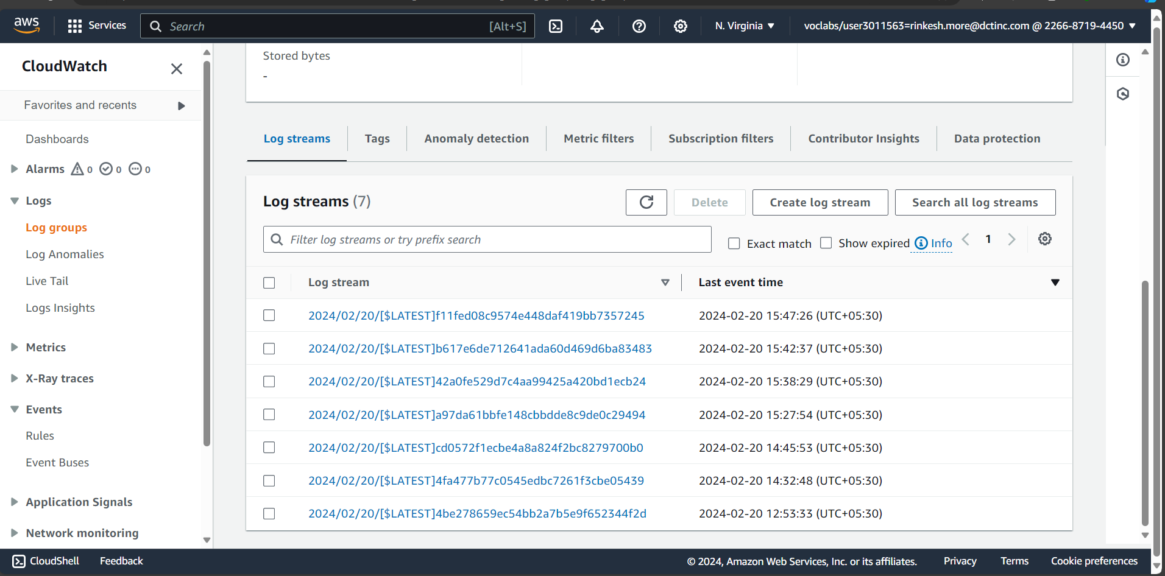

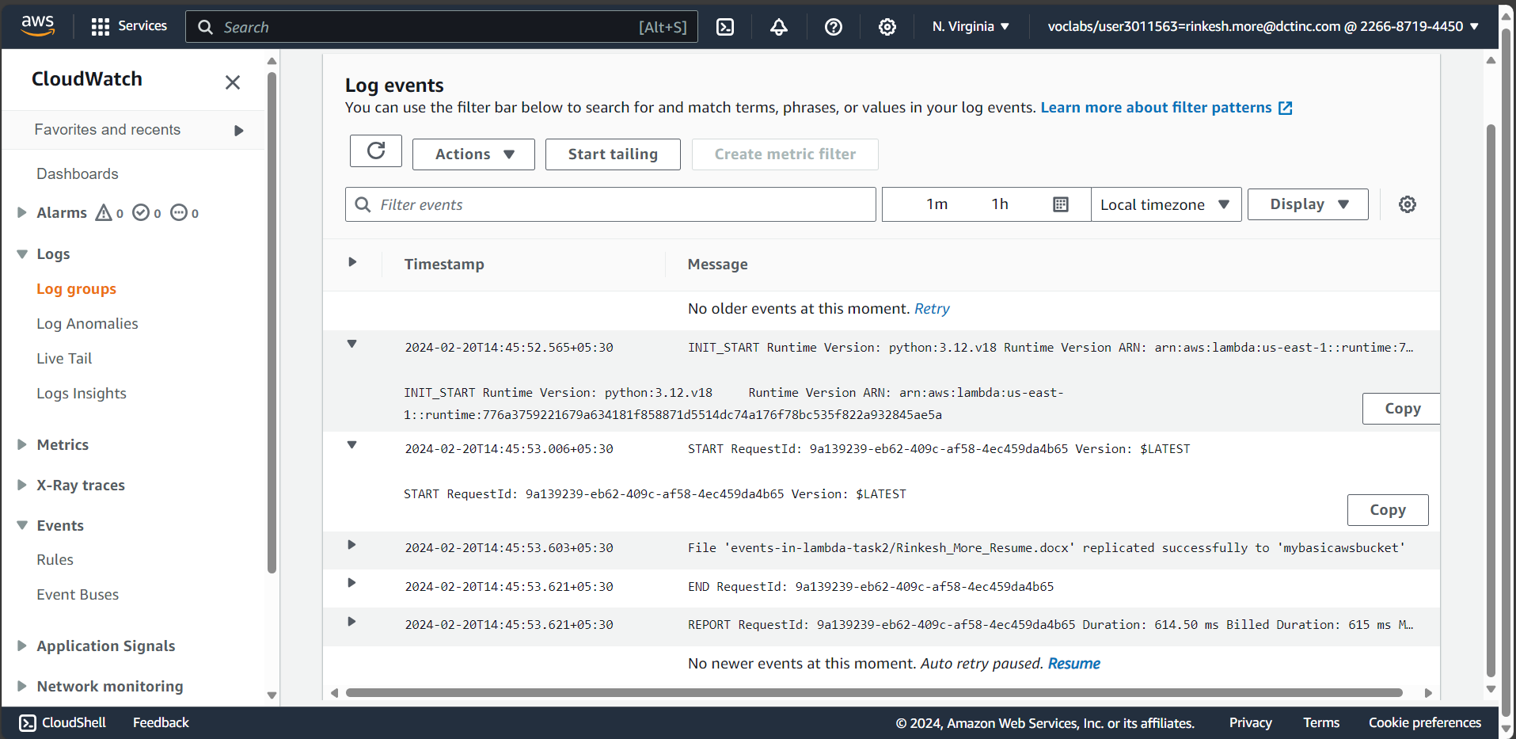

1. I have created a function in lambda which replicates a file that got inserted into “lambda-task2” bucket to another bucket named as “mybasicawsbucket”.

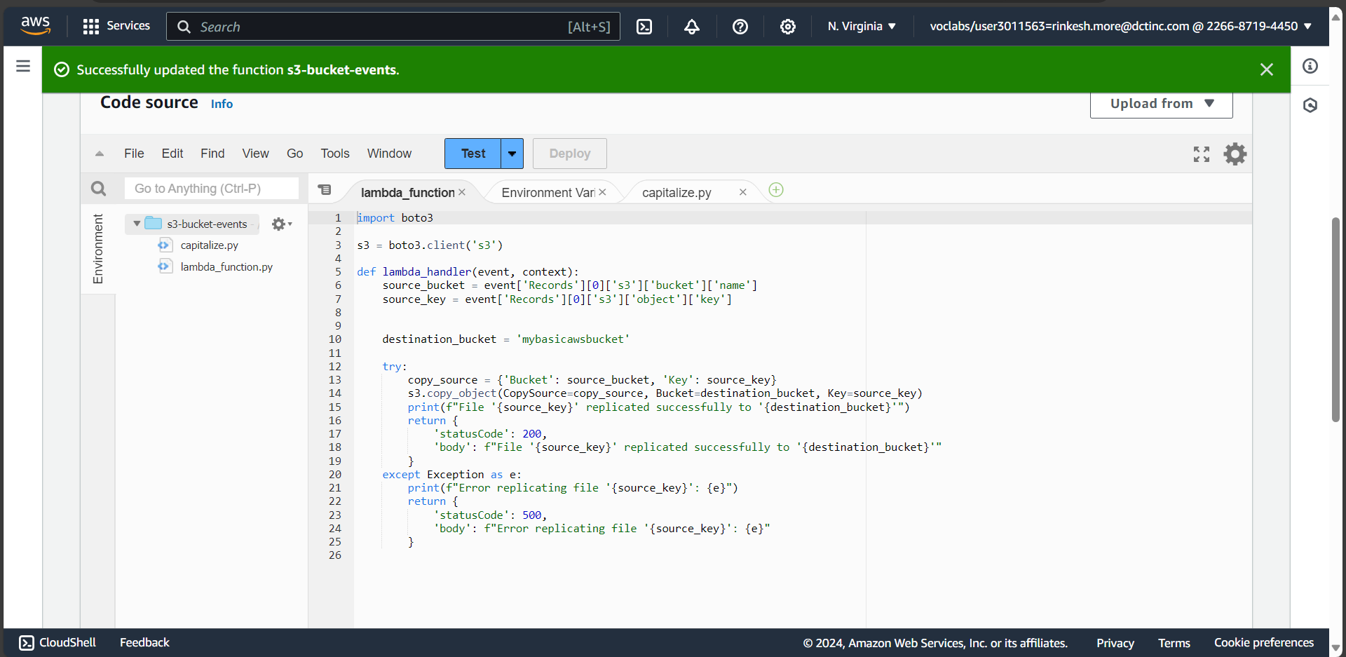

1. File got replicated into “mybasicawsbucket”.

1. Function to capitalize a text file that I have inserted into “mybasicawsbucket” and then replicate the same capitalize file into “[my-capitalization-bucket](https://us-east-1.console.aws.amazon.com/s3/buckets/my-capitalization-bucket?region=us-east-1&bucketType=general)”.

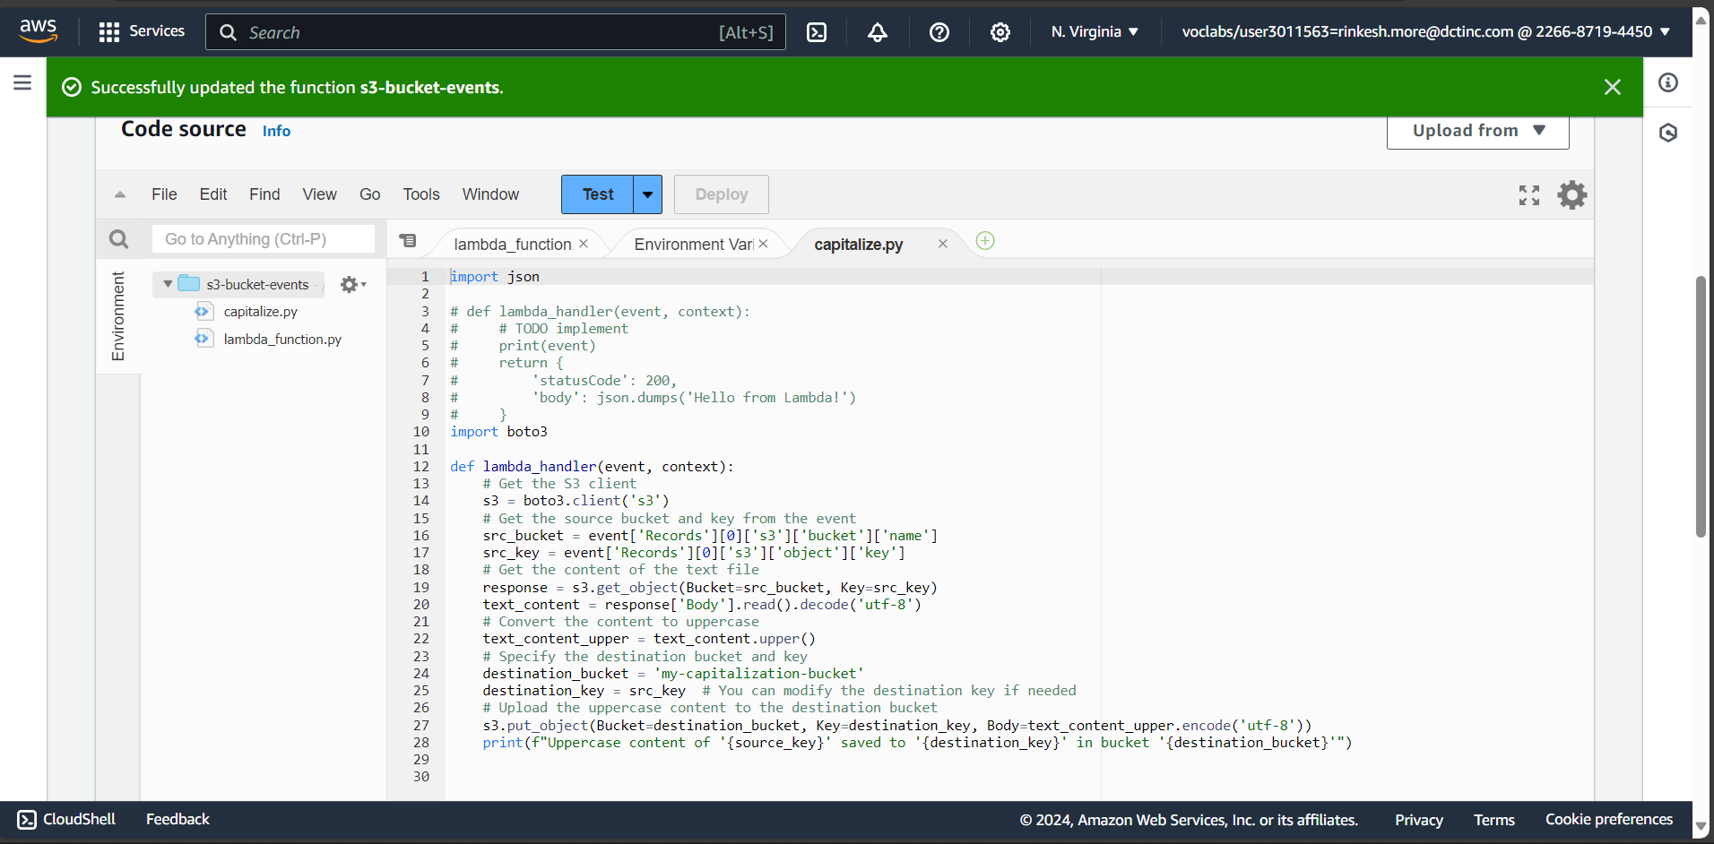

1. Inserted .txt file

1. The capitalized text file

