1)

Creating security group

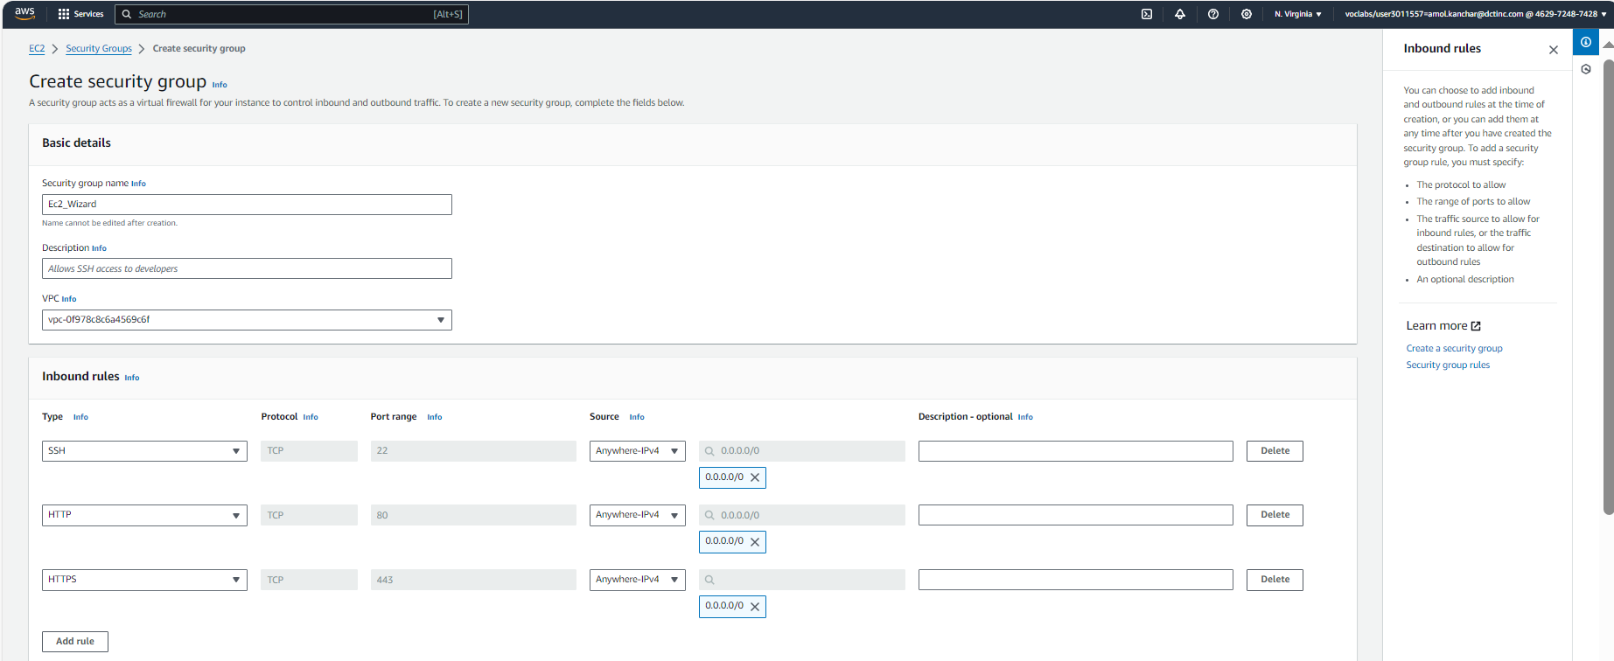

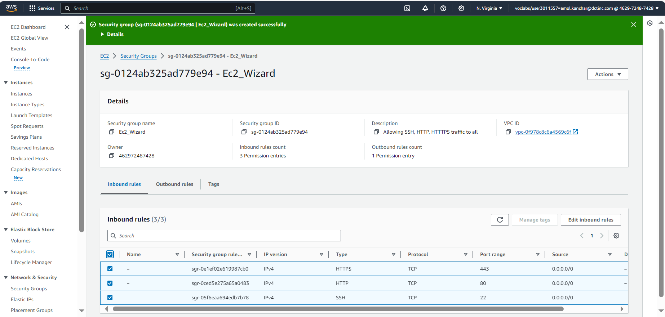

Allocating elastic IP Address

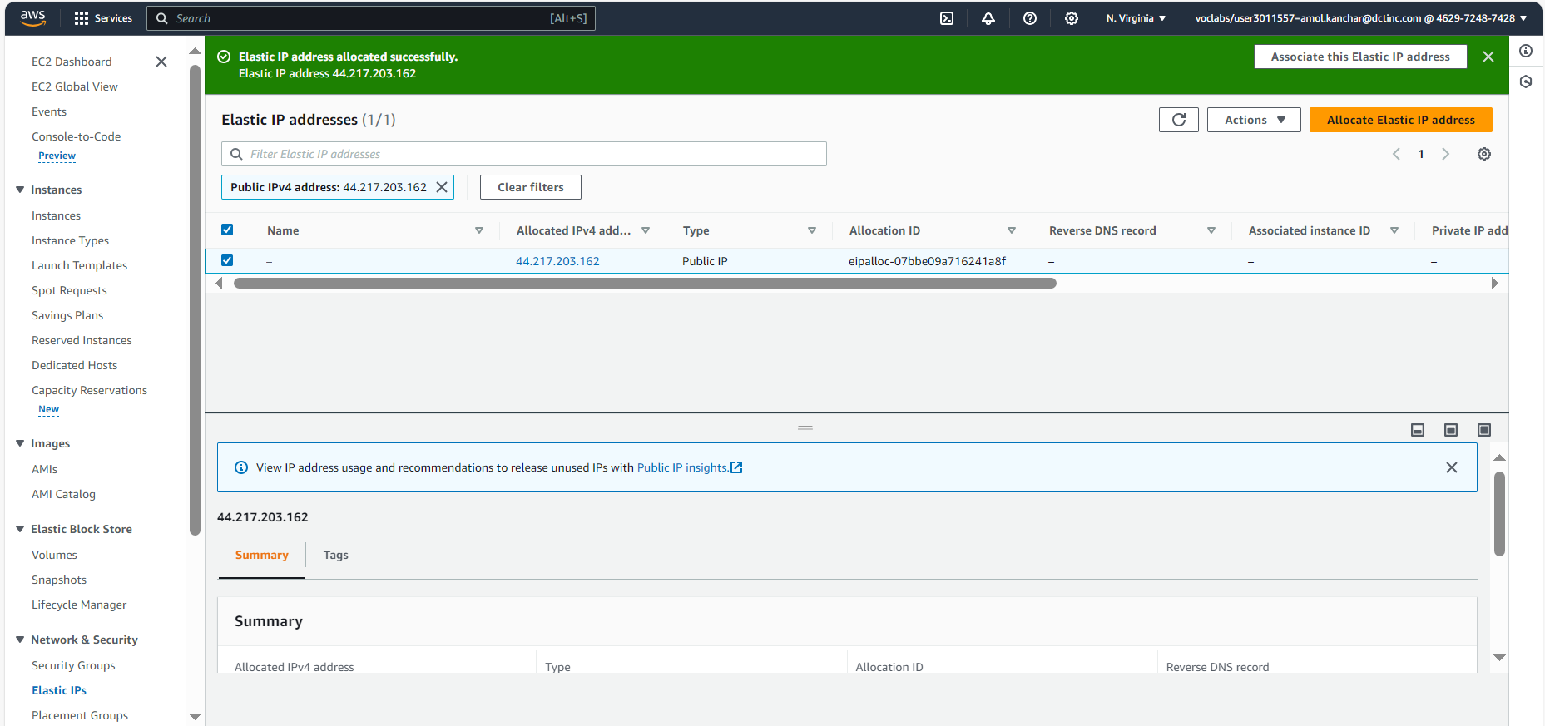

Creating Instance

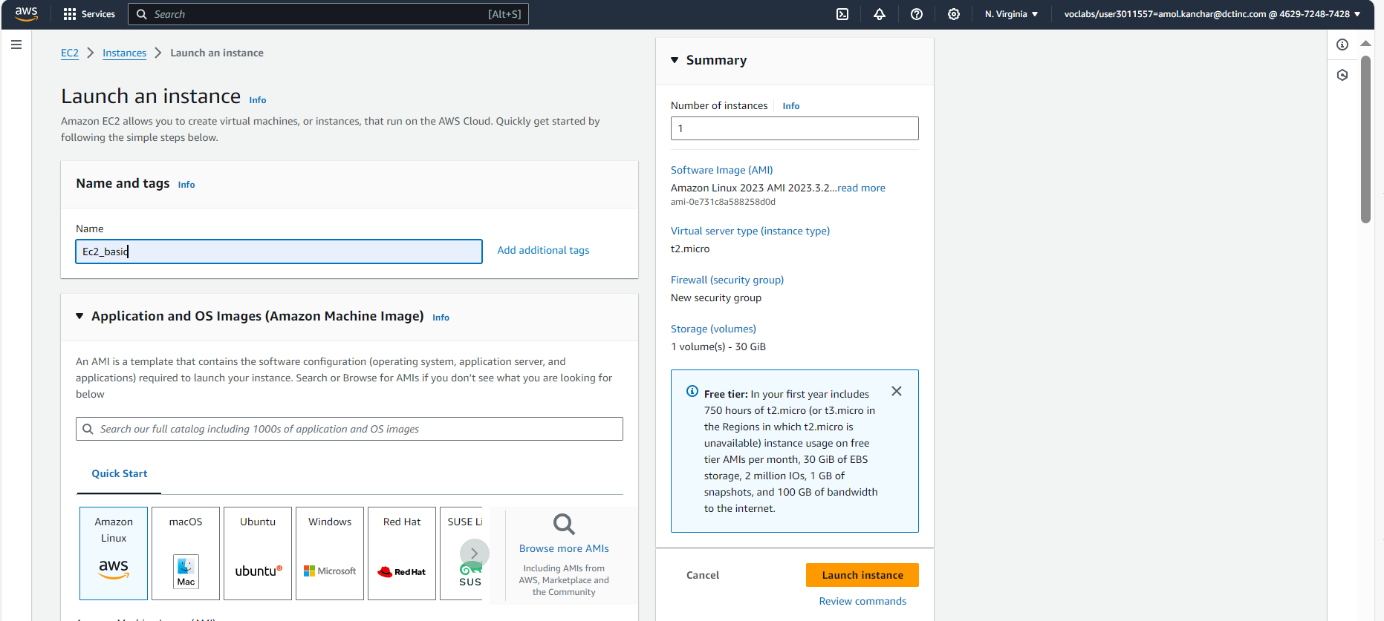

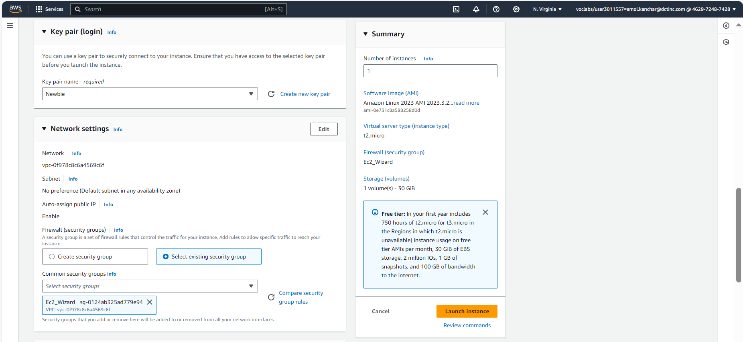

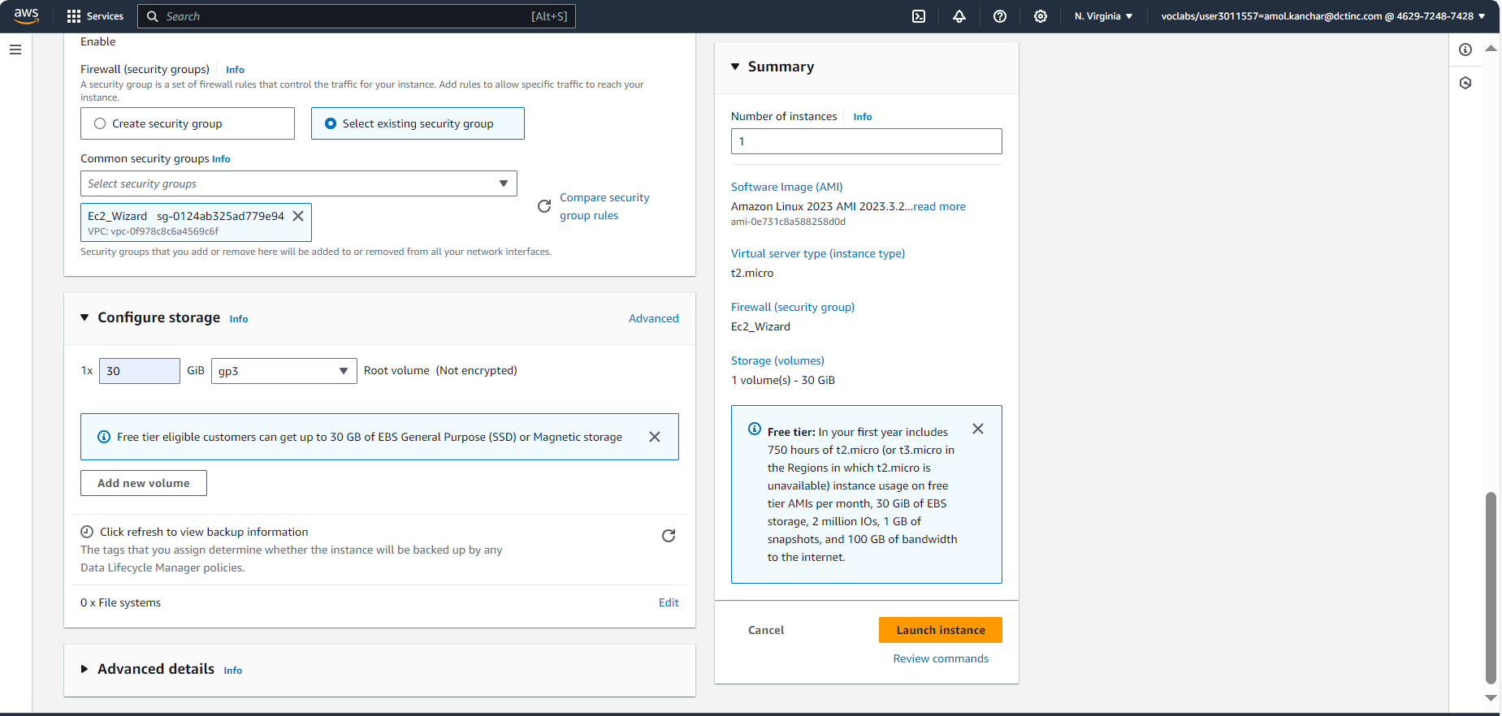

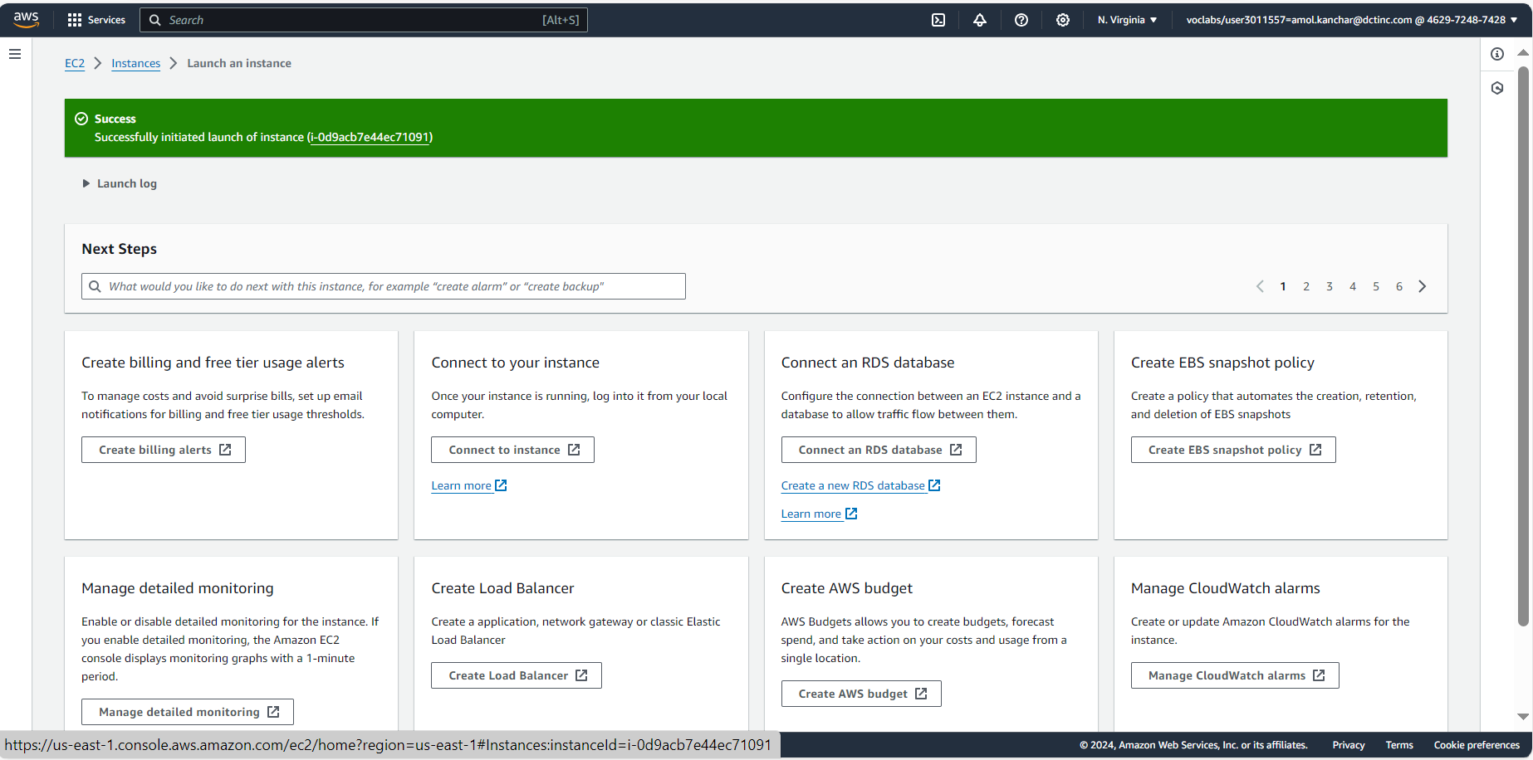

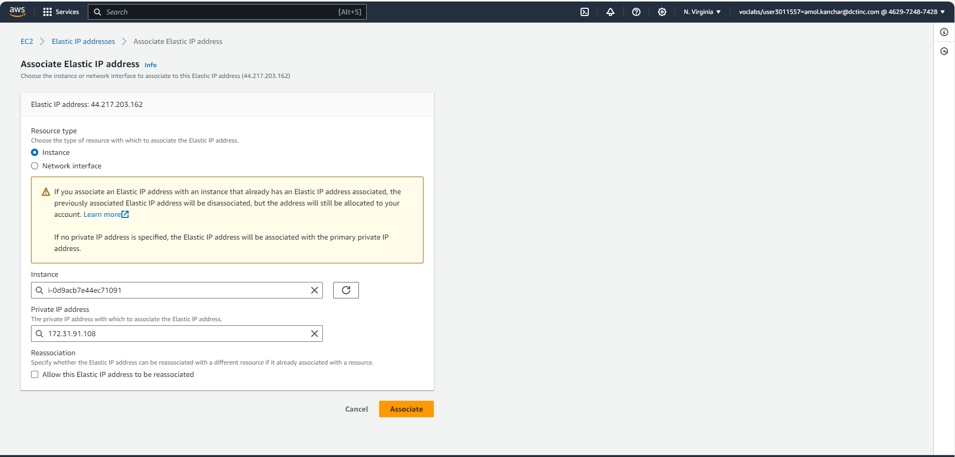

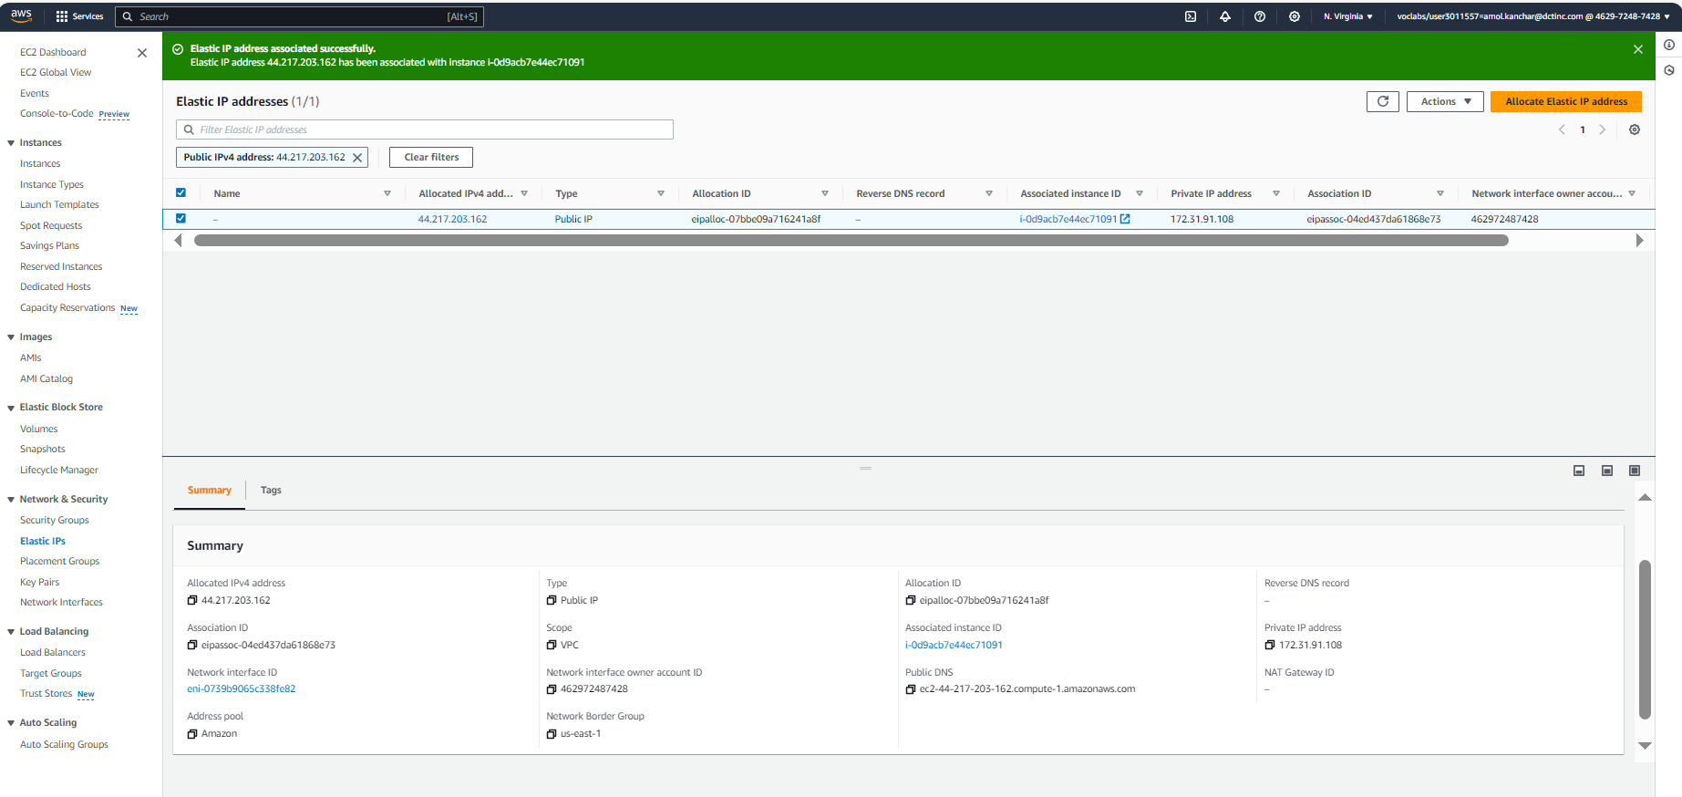

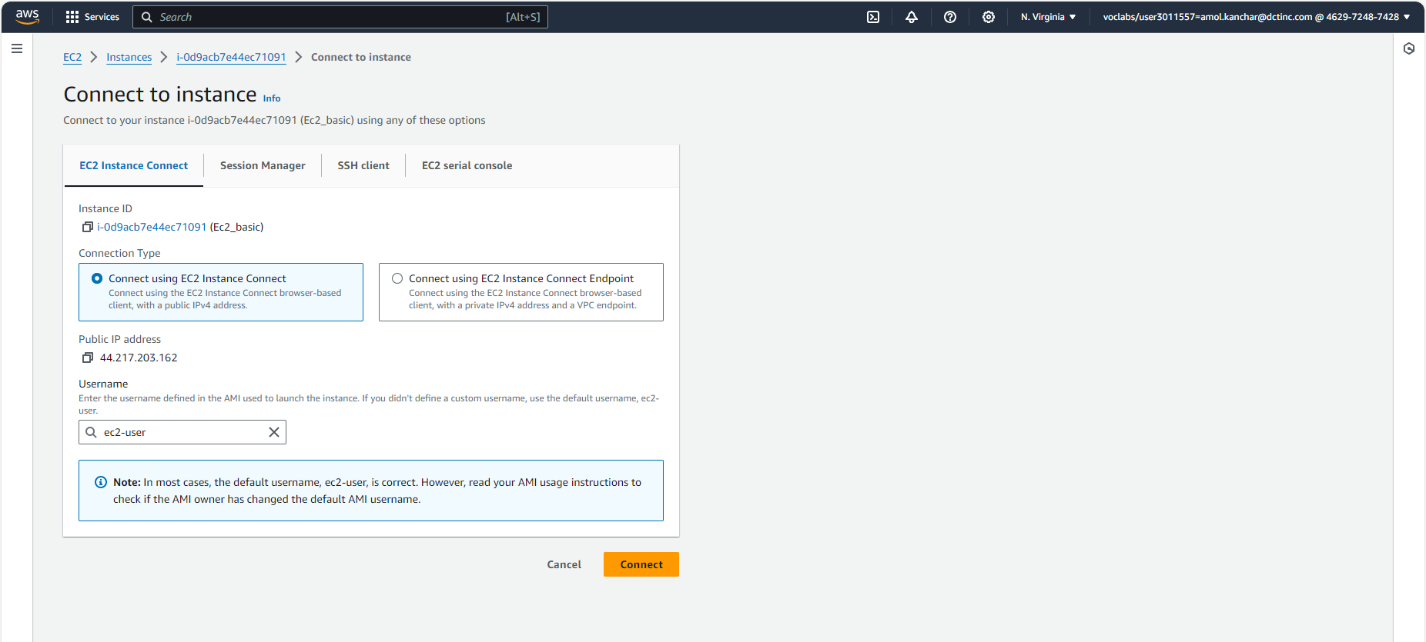

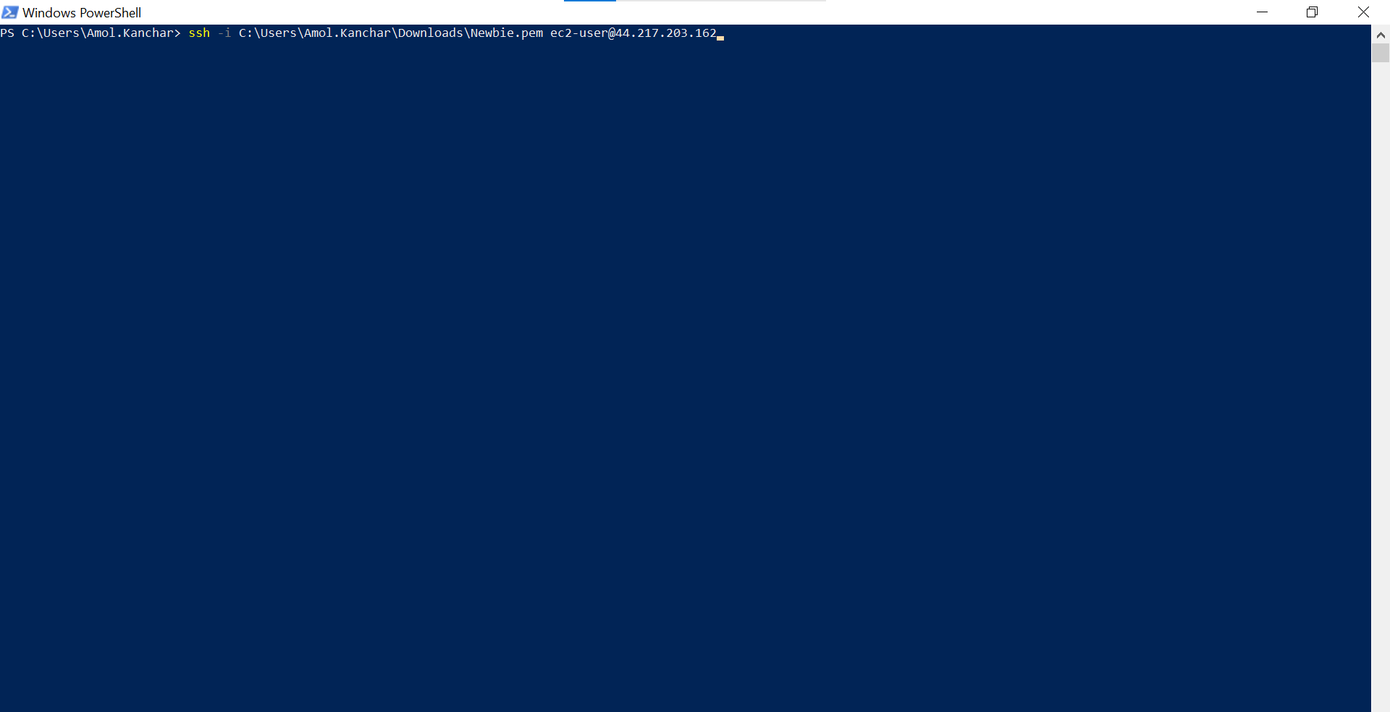

2)



