Creating tow S3 bracket:- 1)source ,2)destination

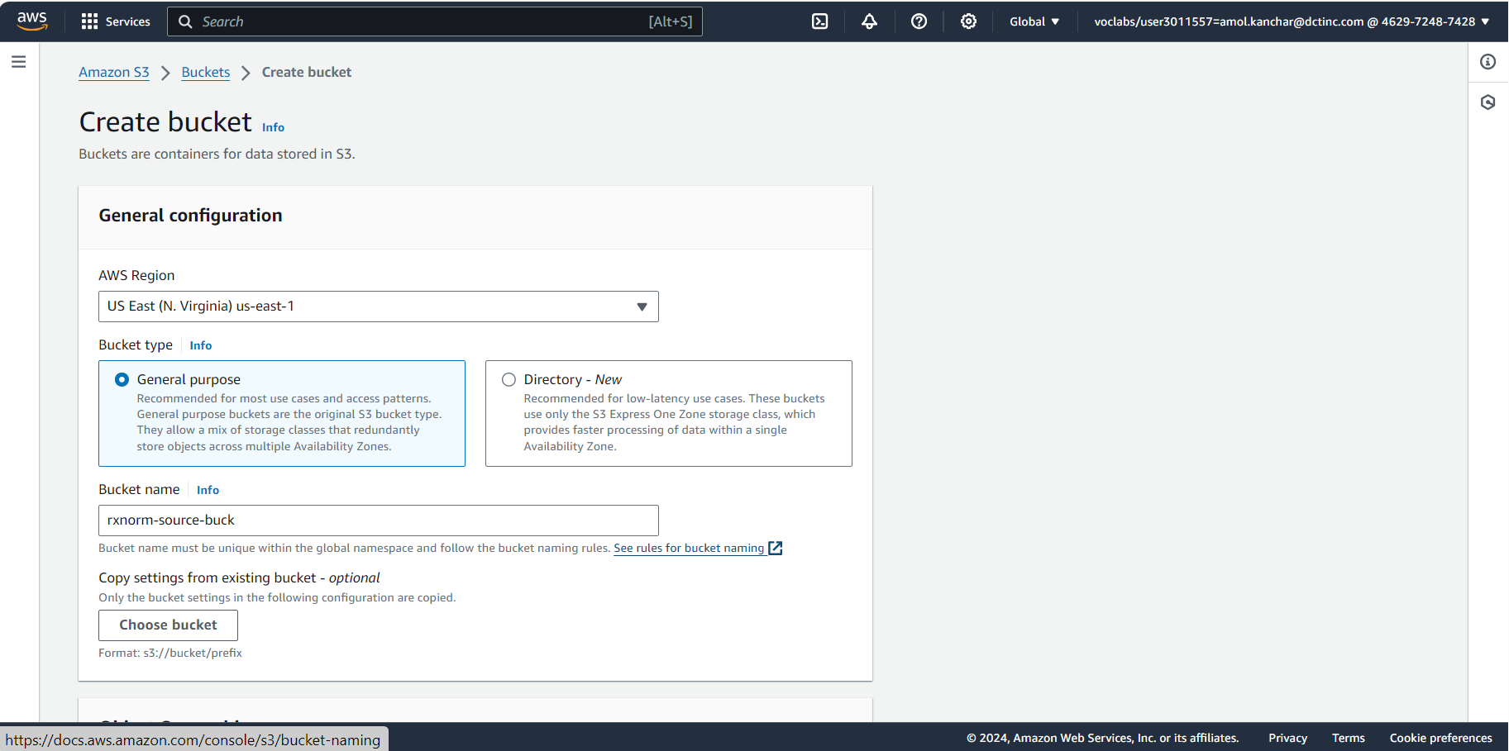

Creating folders in source bucket:-

Creating lambda function:-

Adding Trigger

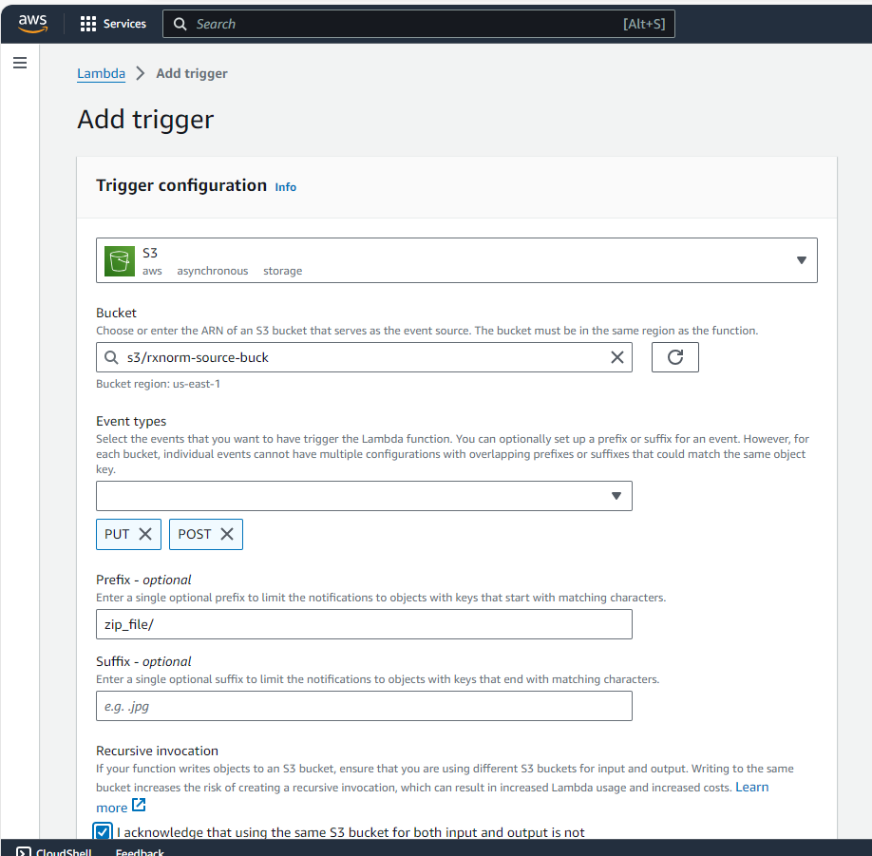

Adding pandas layer:-

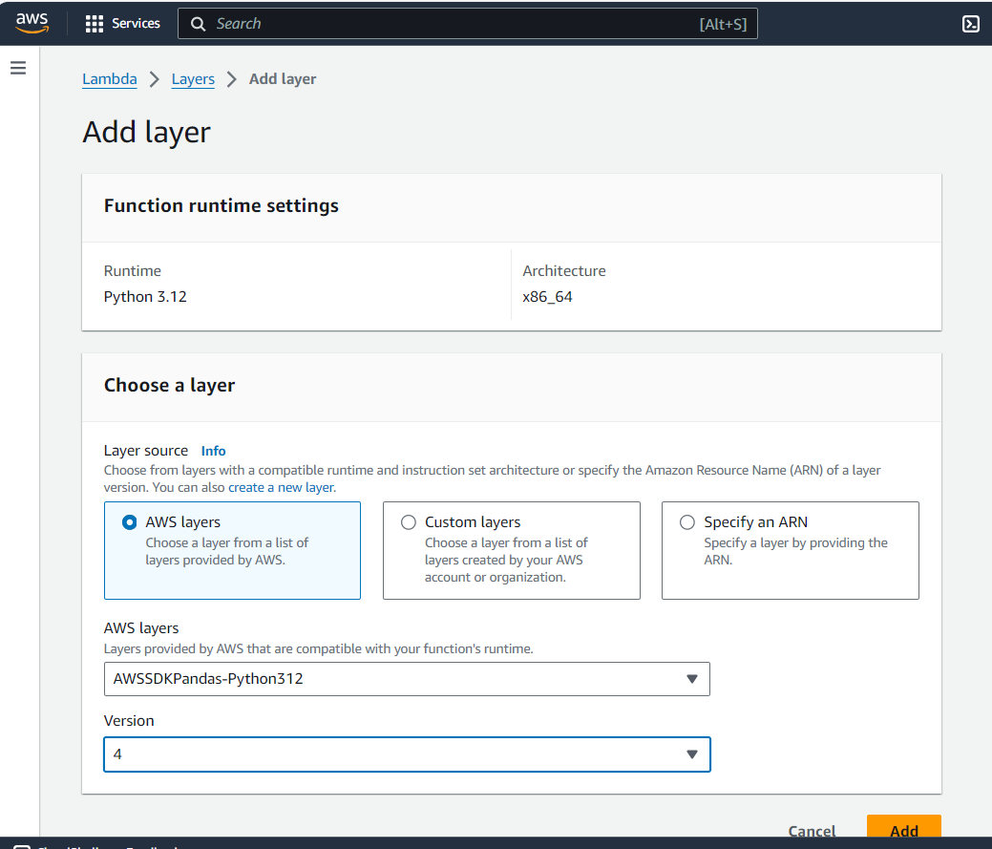

Changing Configuration Settings:-

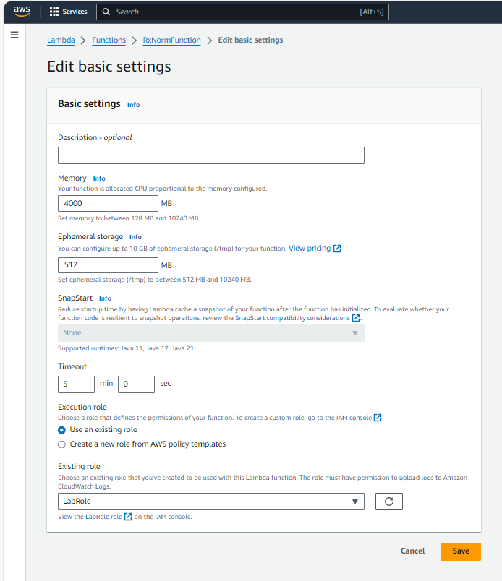

Code:-

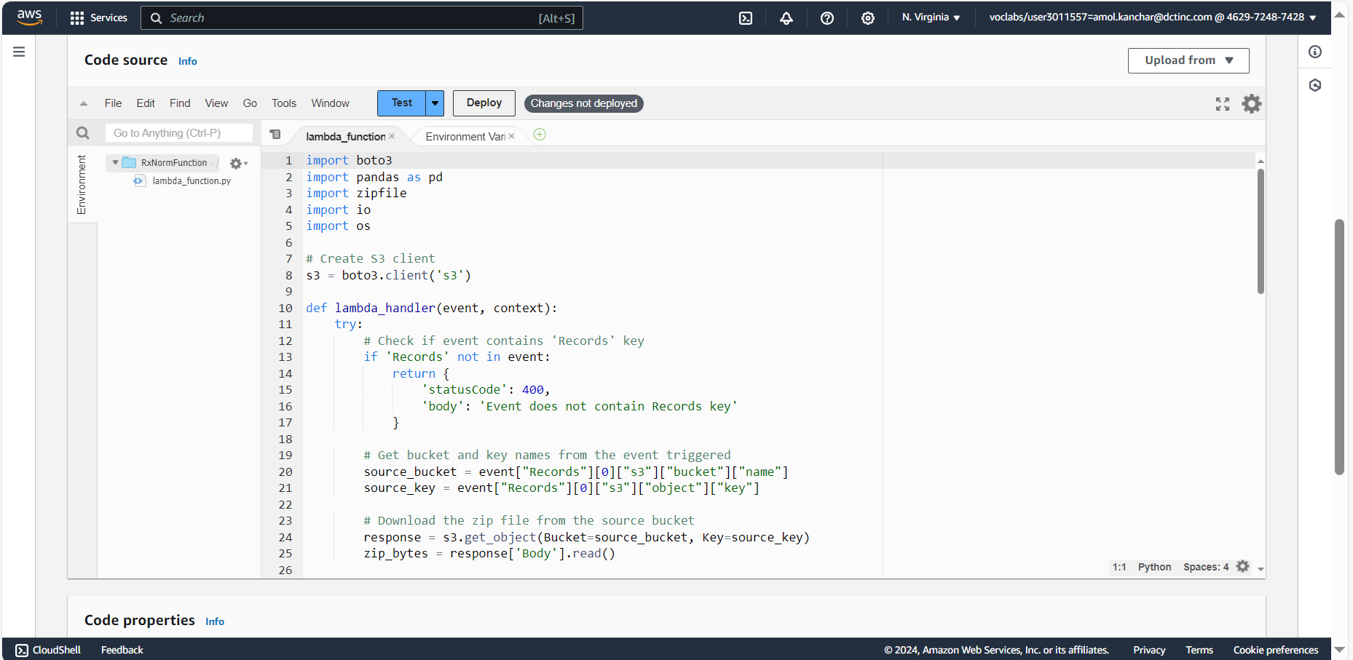

Adding zip file:-



