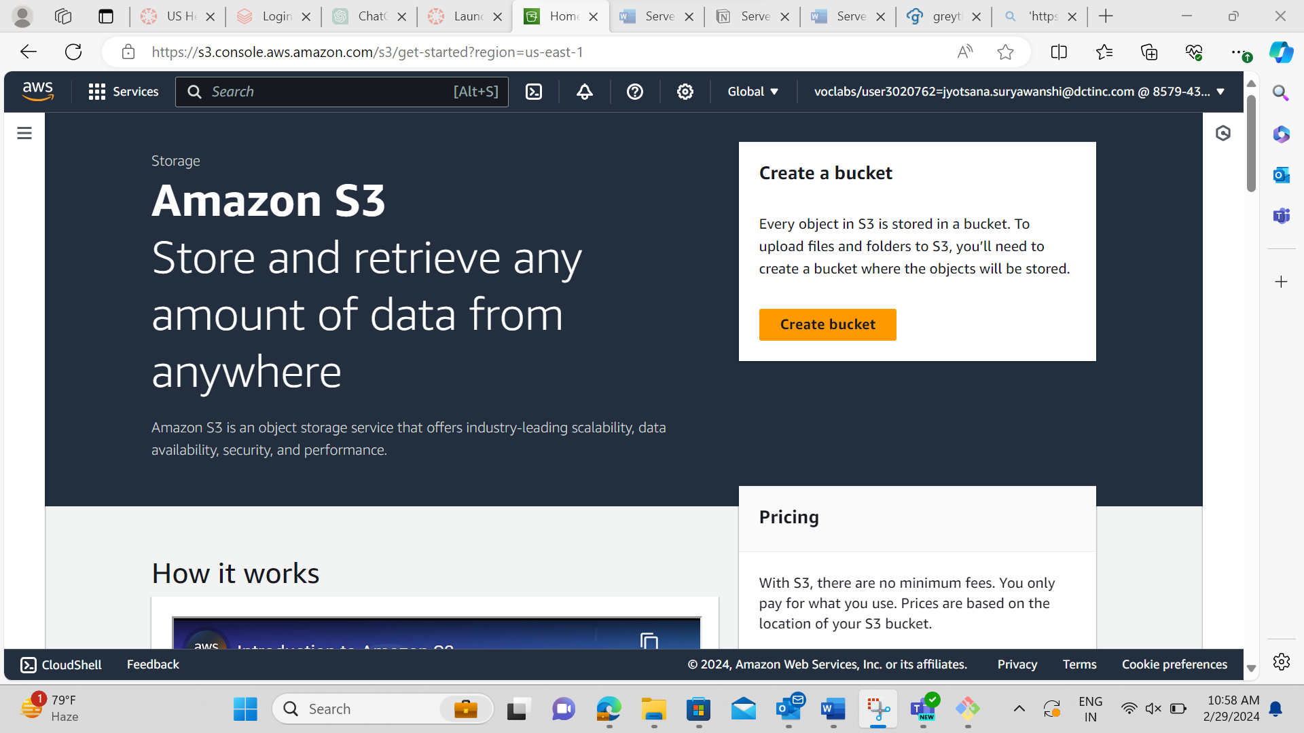

Two Buckets Created



