Hosting Static Portfolio Website On S3

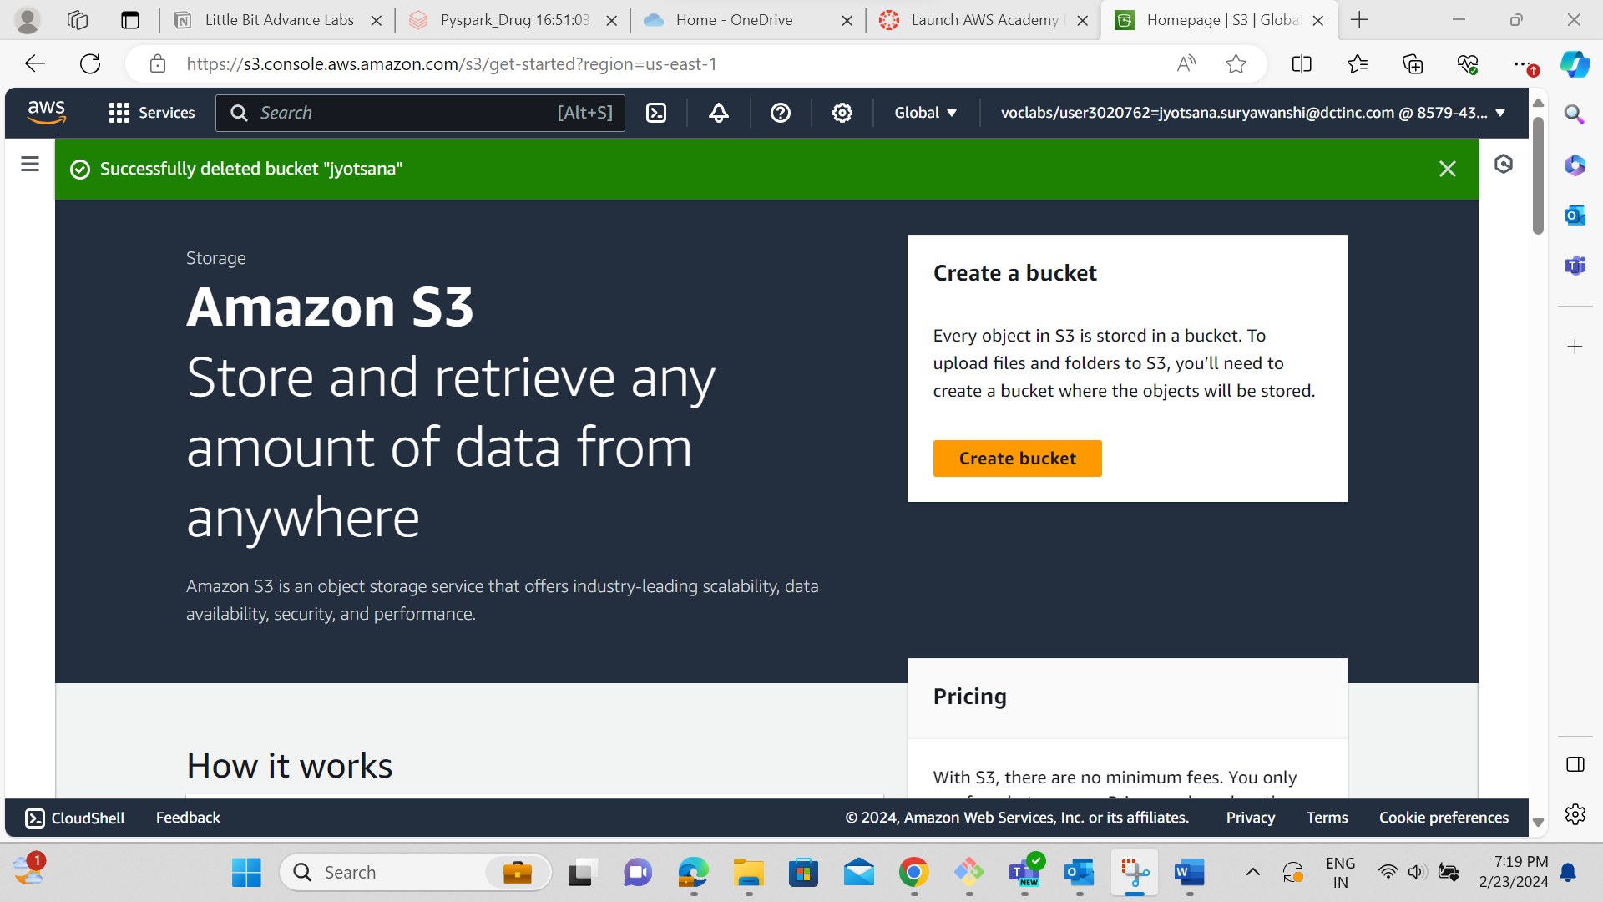

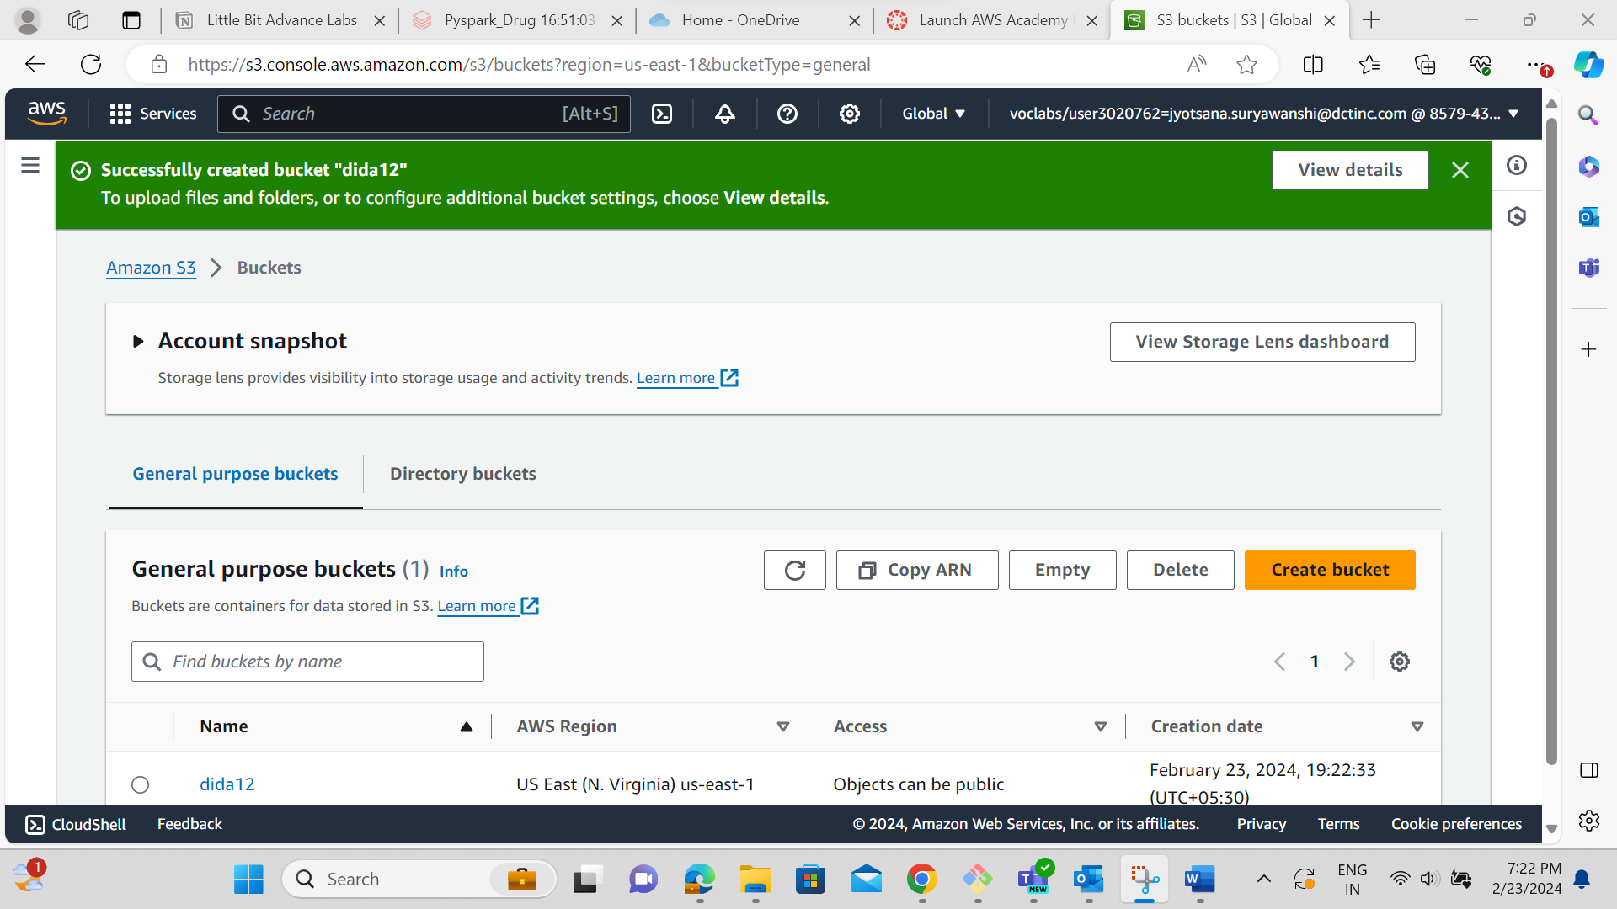

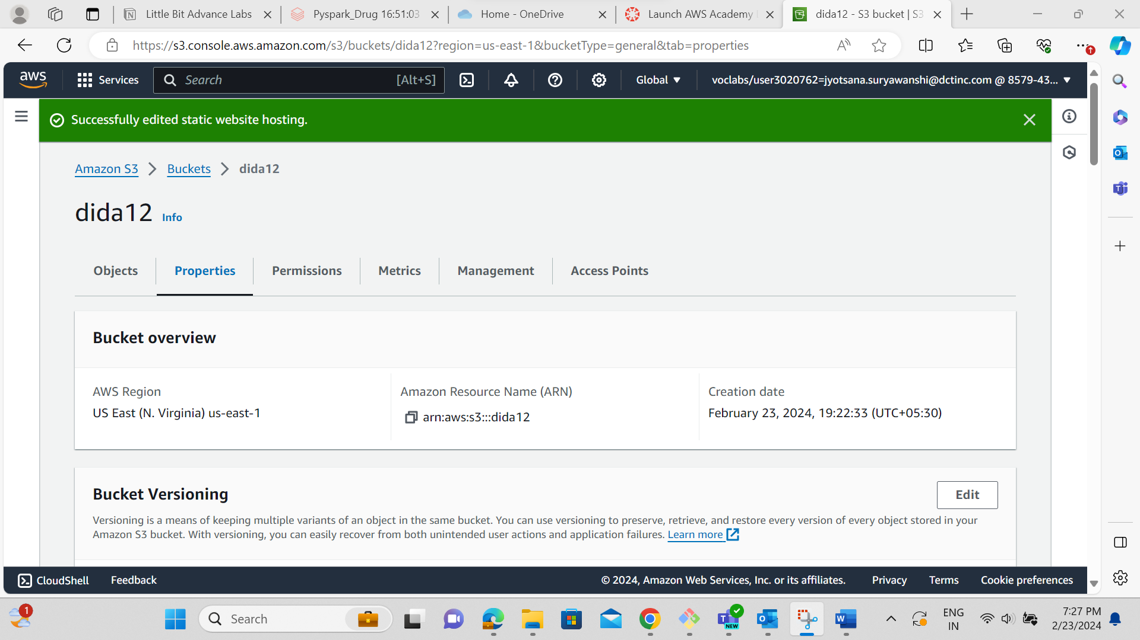

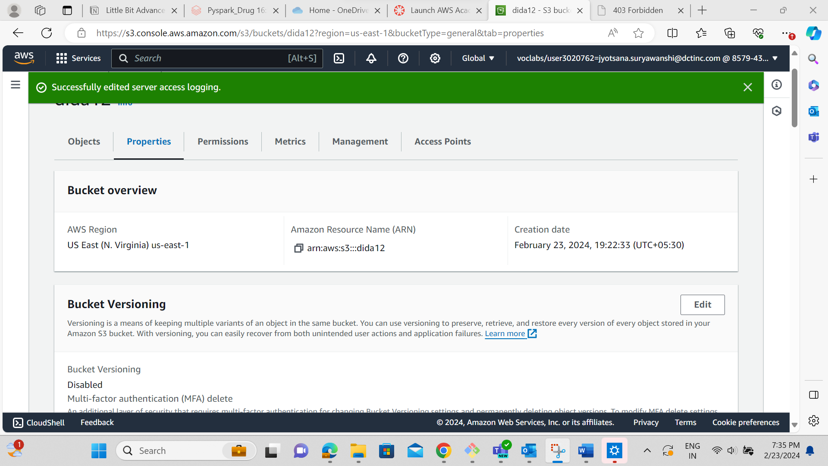

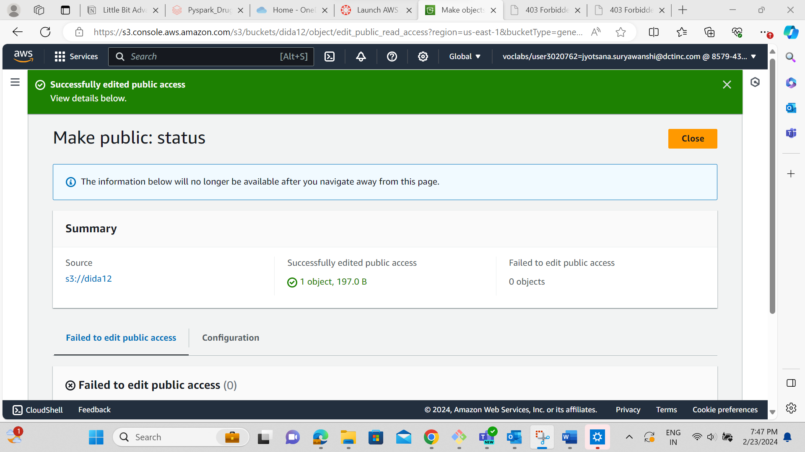

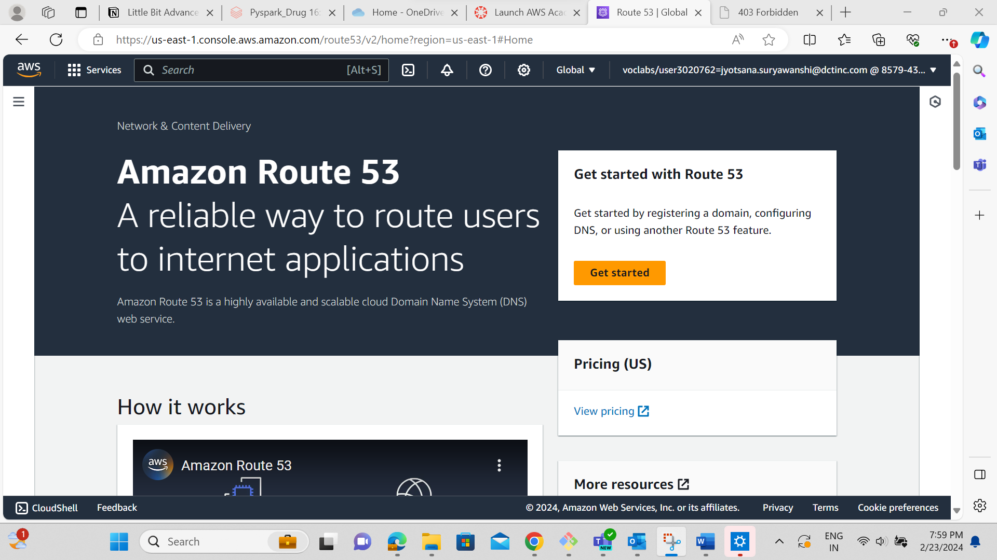  
“route53 services are not authorized”