Creating VPC.

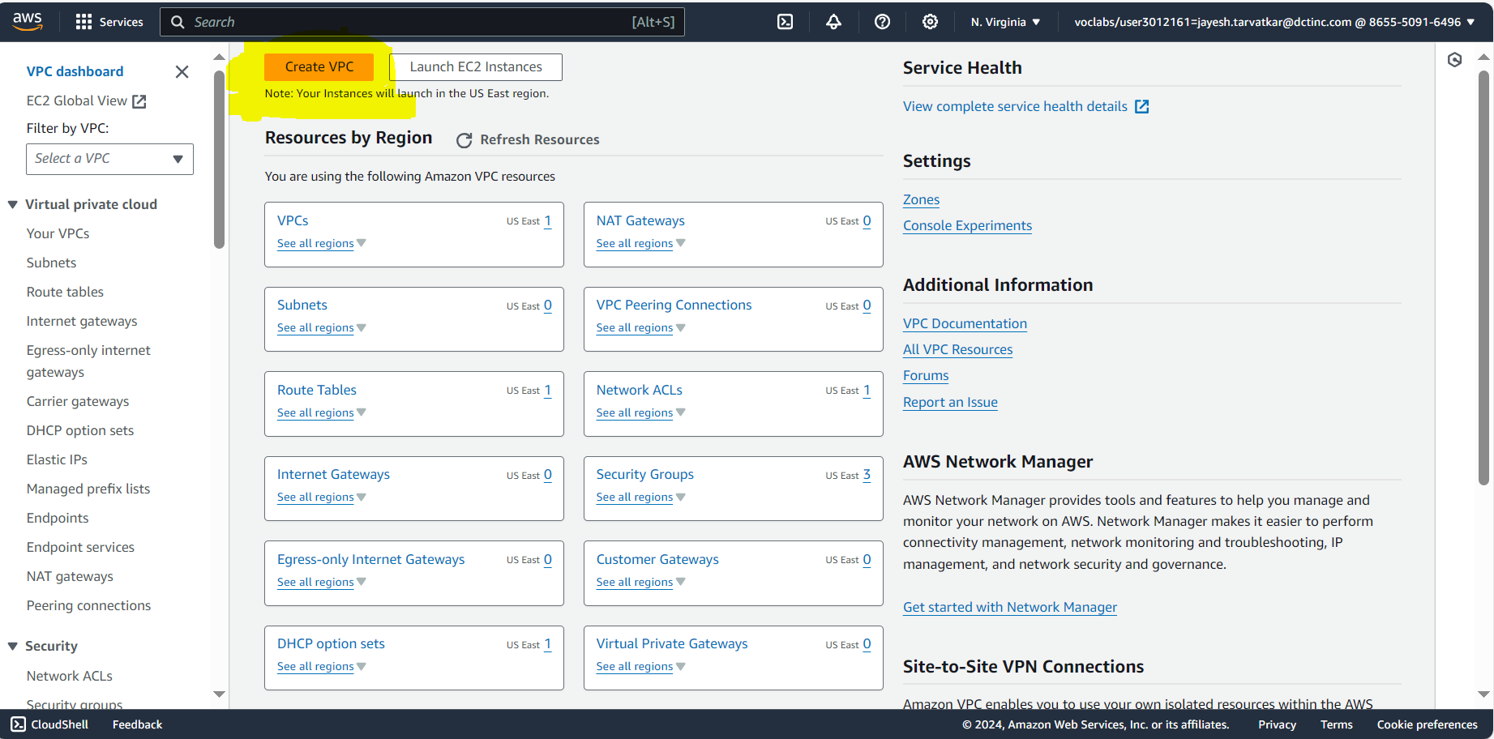

VPC Setting:

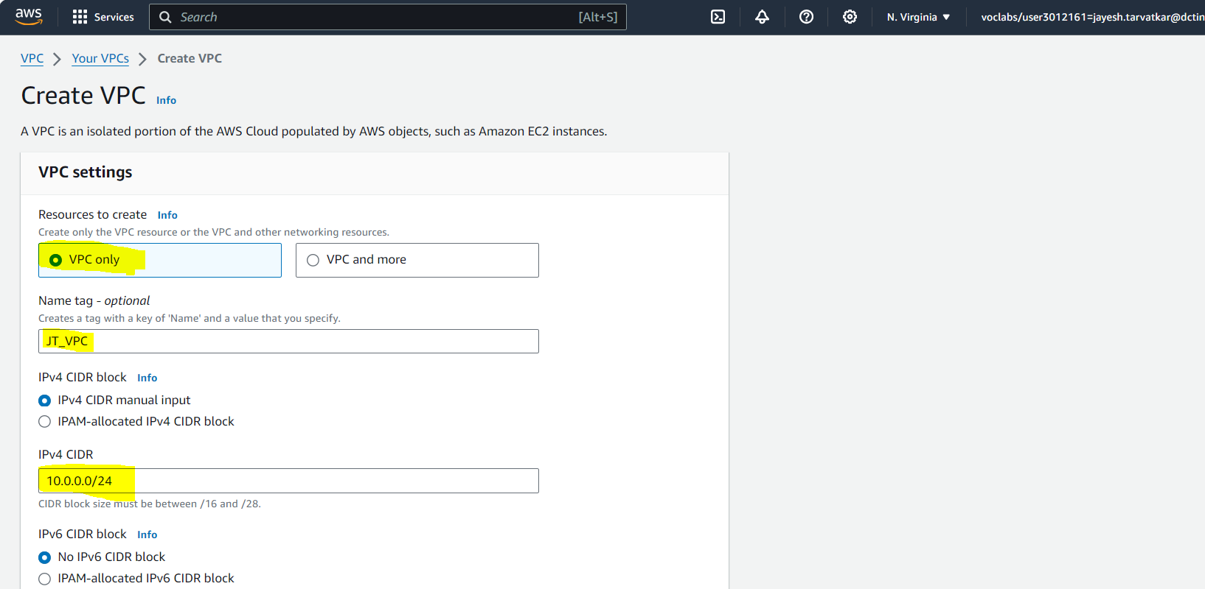

Created successfully: VPC id --: vpc-074b04771360eda08

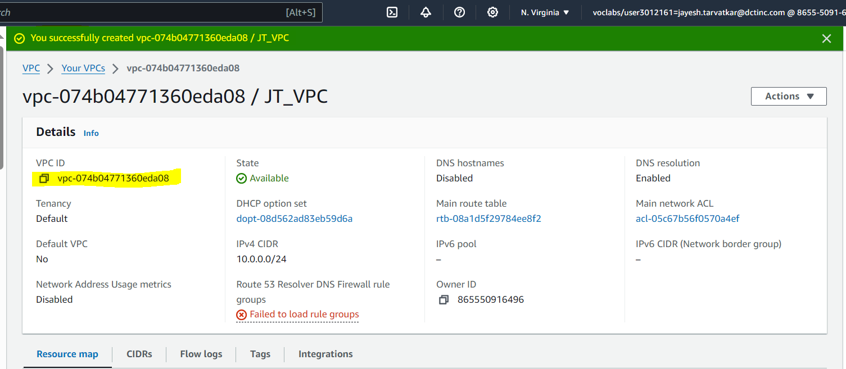

Now create , Subnet, Internet Gateways, Route Table Simultaneously.

Create Subnet:

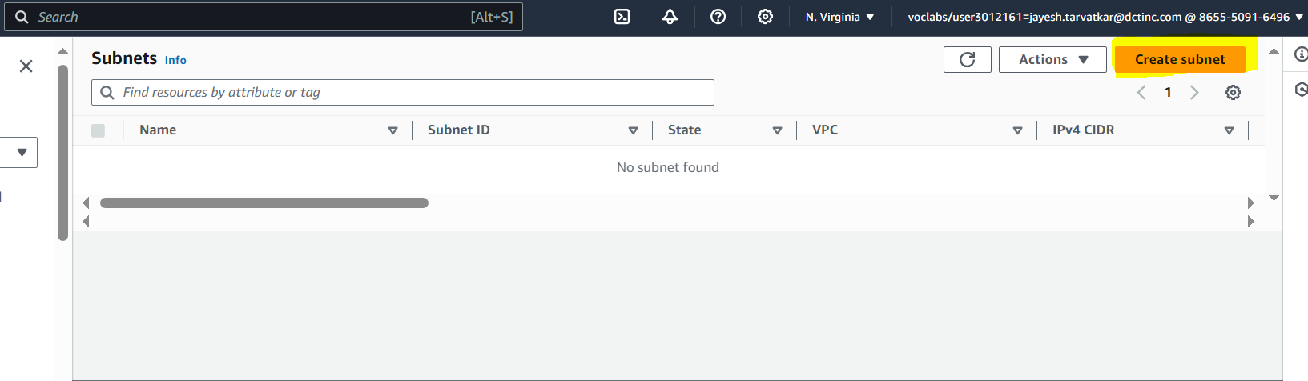

Adjust The subnet Setting. Create 1 public and 1private

Create Internet Gateways

Attach To VPC

Click on Subnet . Edit Subnet

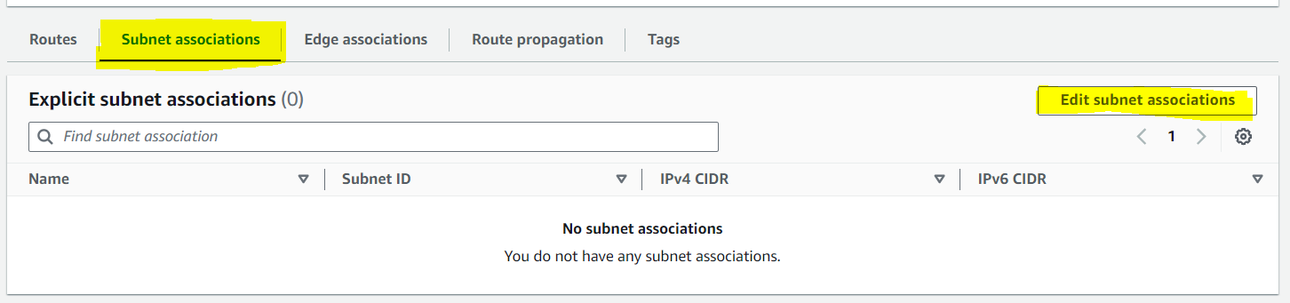

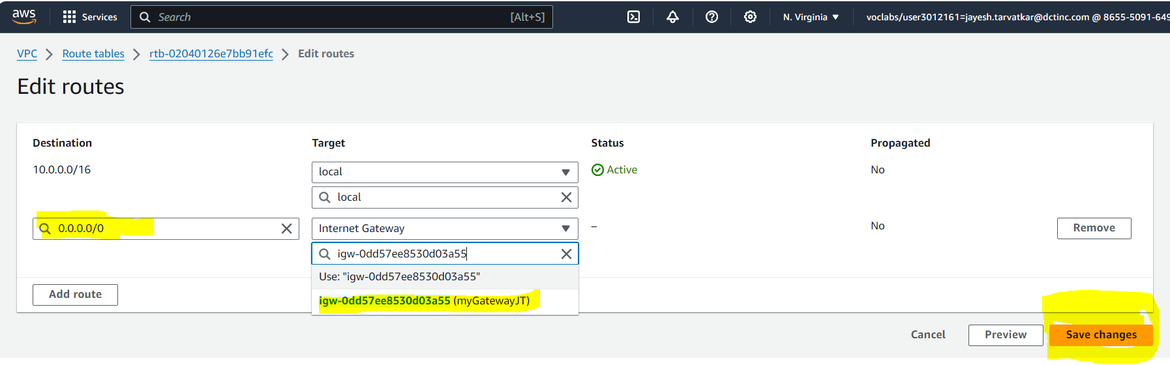

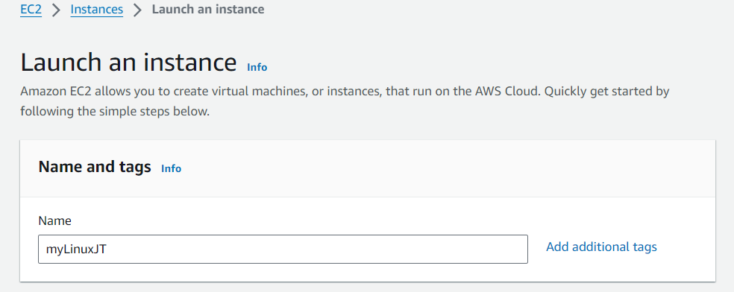

Launch EC2 and Edit Network Setting.

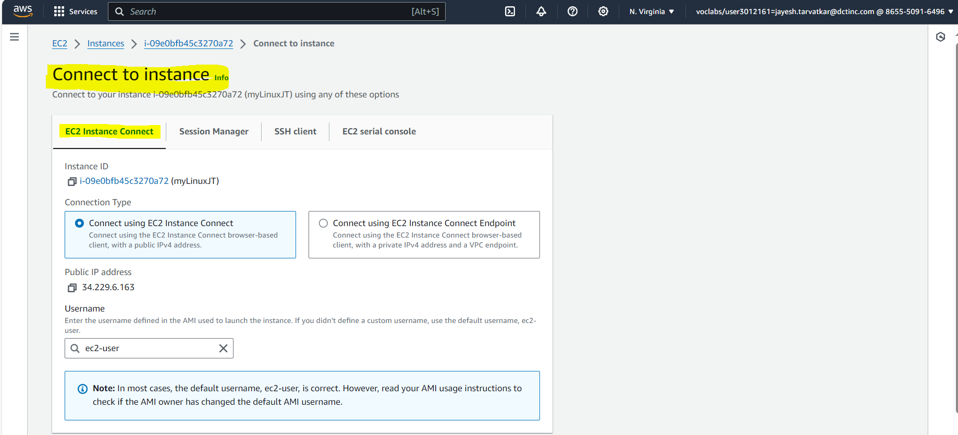



Uploaded the html file in ec2:

Now open the public IP;

Connection with windows picture:

