Task : Target Norm AWS

1. Create two s3 bucket for Source and Destination respectively.

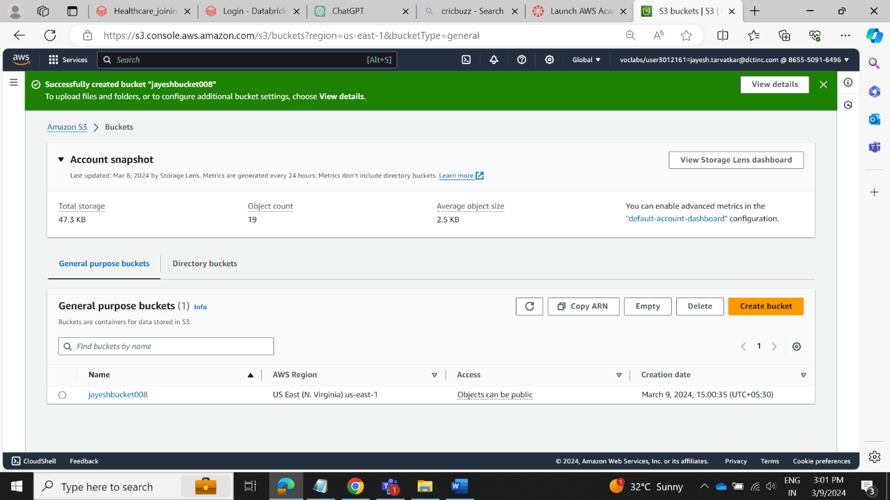

Create a Folder Named Excel, where our rxnorm file will be stored

Create a Function on Lambda and set the roles

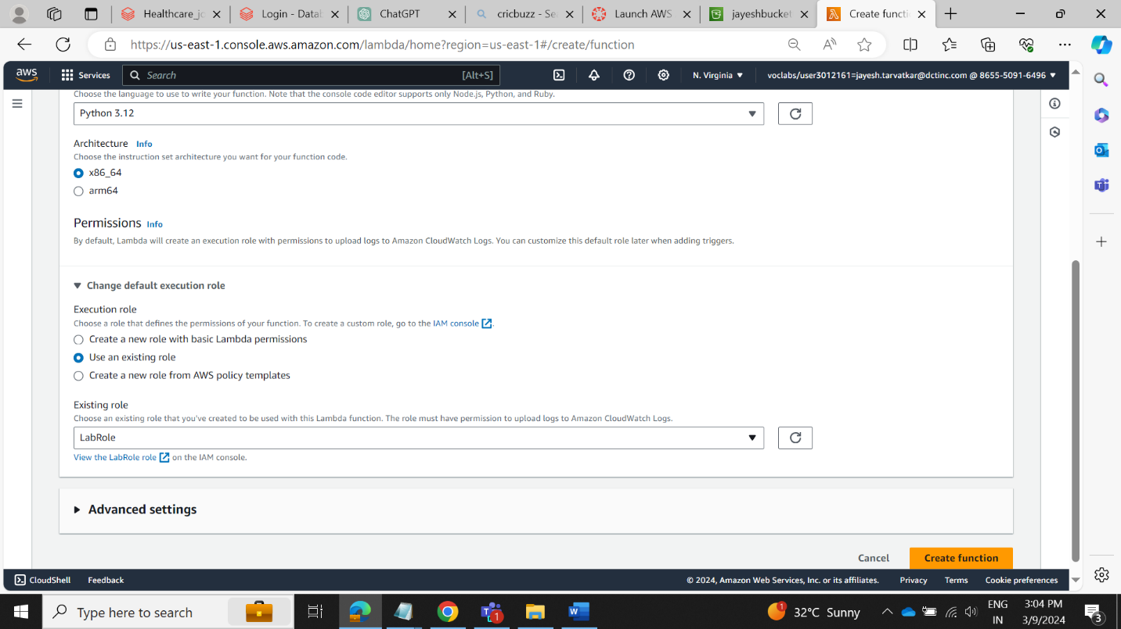

Add a custom layer on Lamda, as we are using pandas in our code

Add a trigger on s3

Add a test event

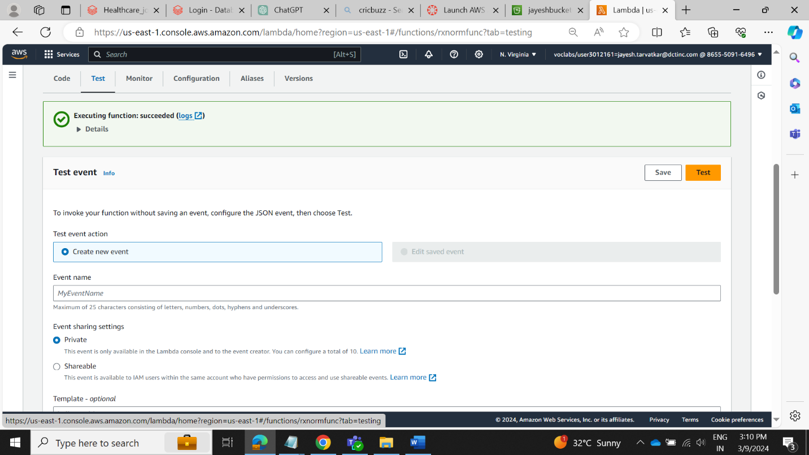

Update Compute resources

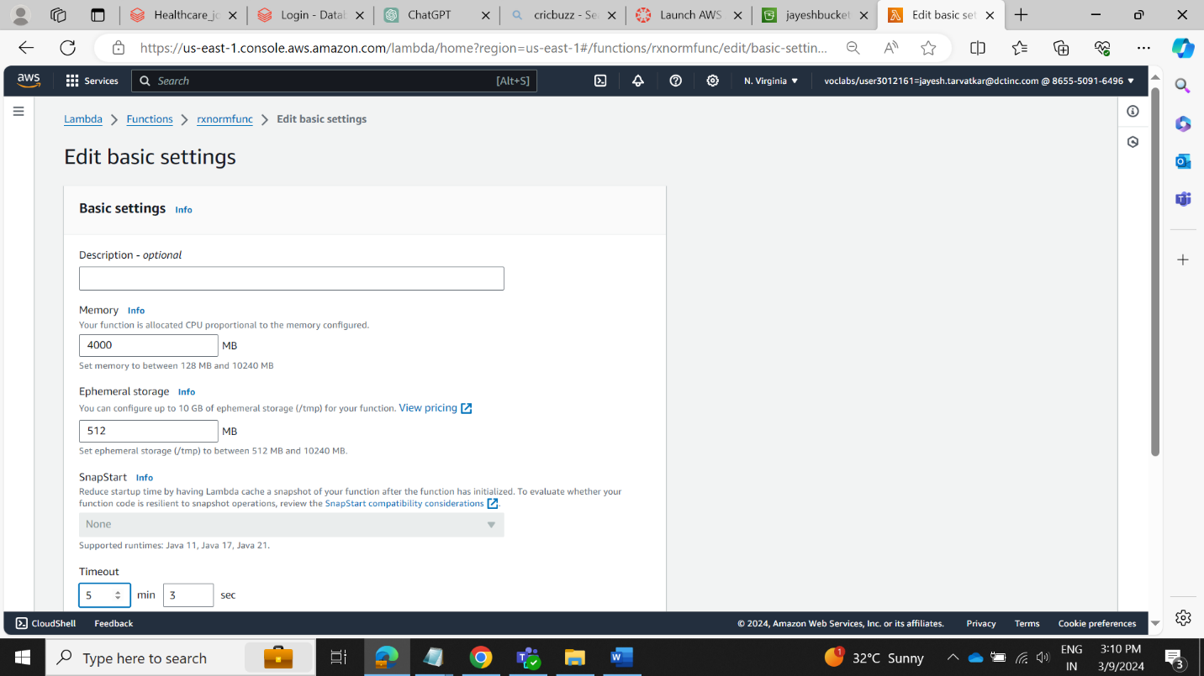

Df

Check the trigger status on cl0udwatch,

Now check the Destination Folder, Download one of the file, and check whether Header has been added

Here we can see , Headers are added also two columns CODE_SET and VERSION_MONTH are created

