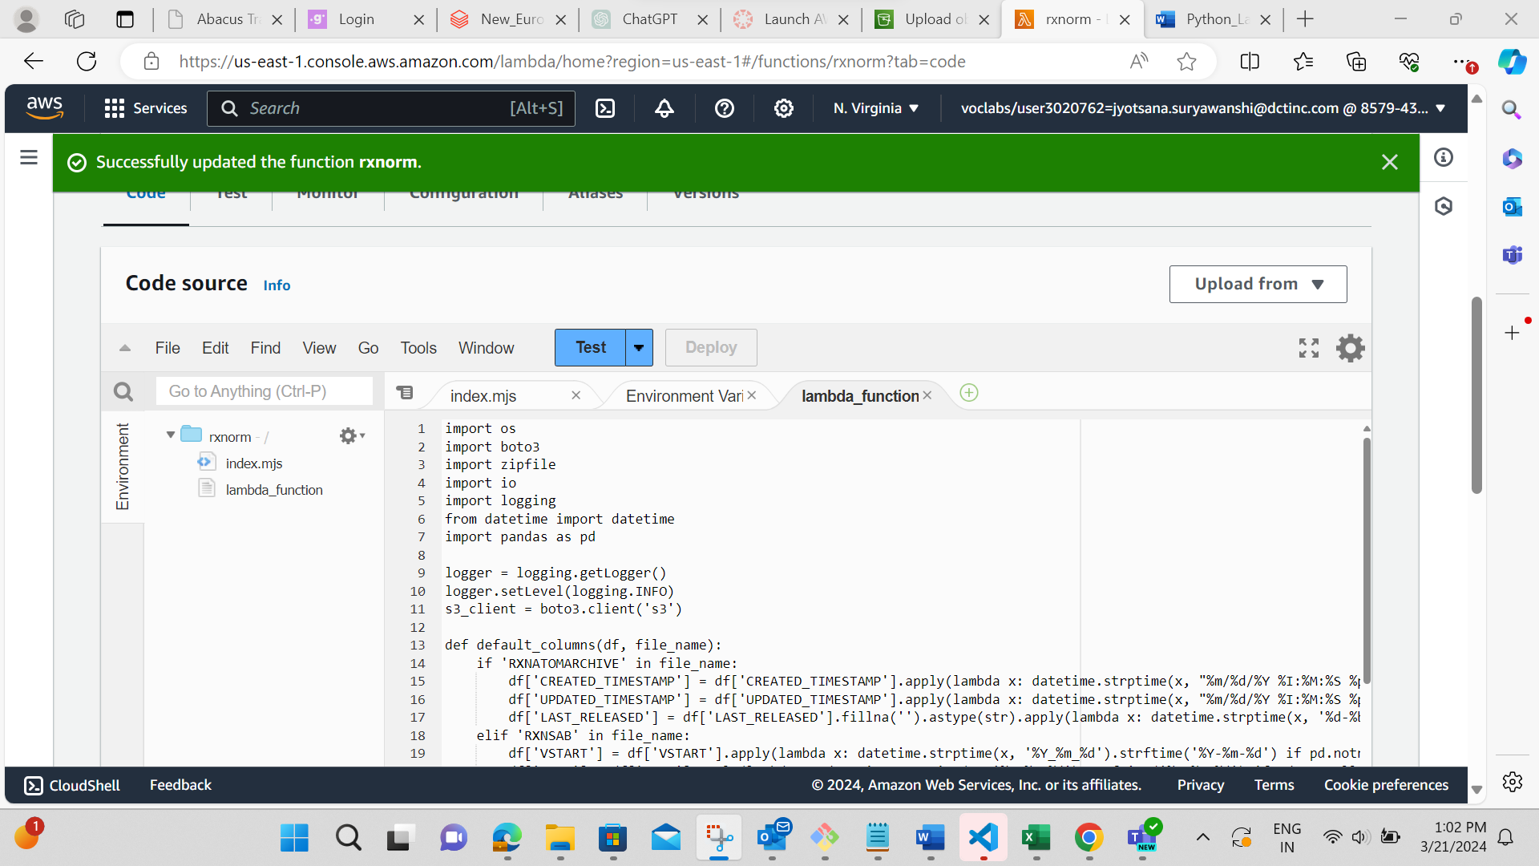

This is the complete code of lambda function which will help us to get the header added to the files.

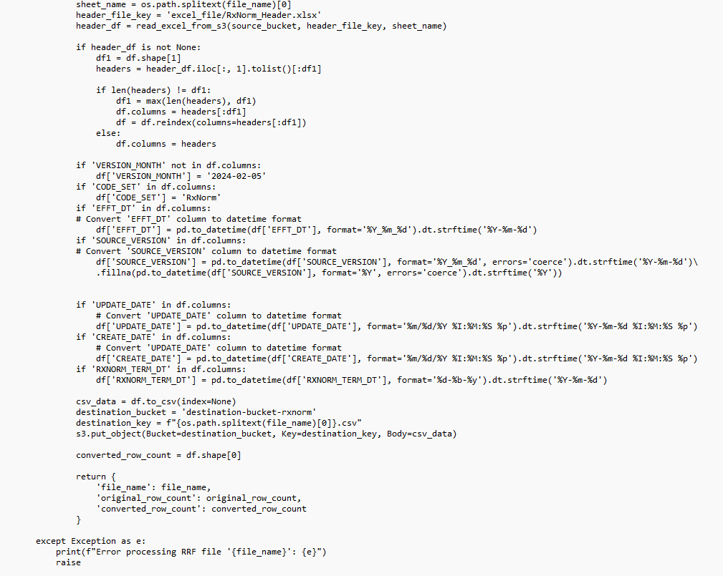

This is the “TEST” code to show if functions is working properly or not.

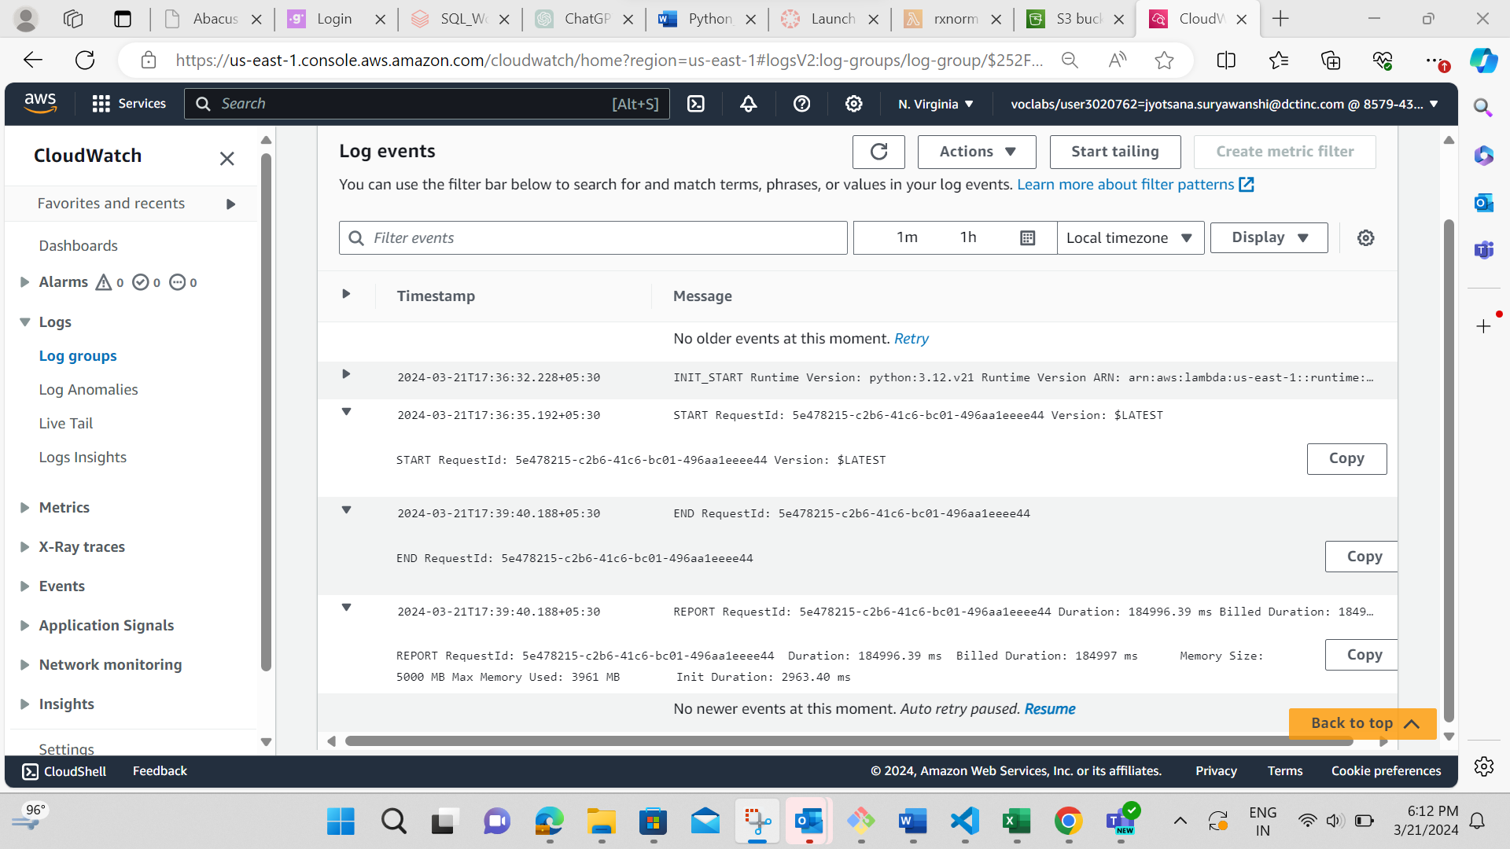

Loaded CSV files where we add the header.

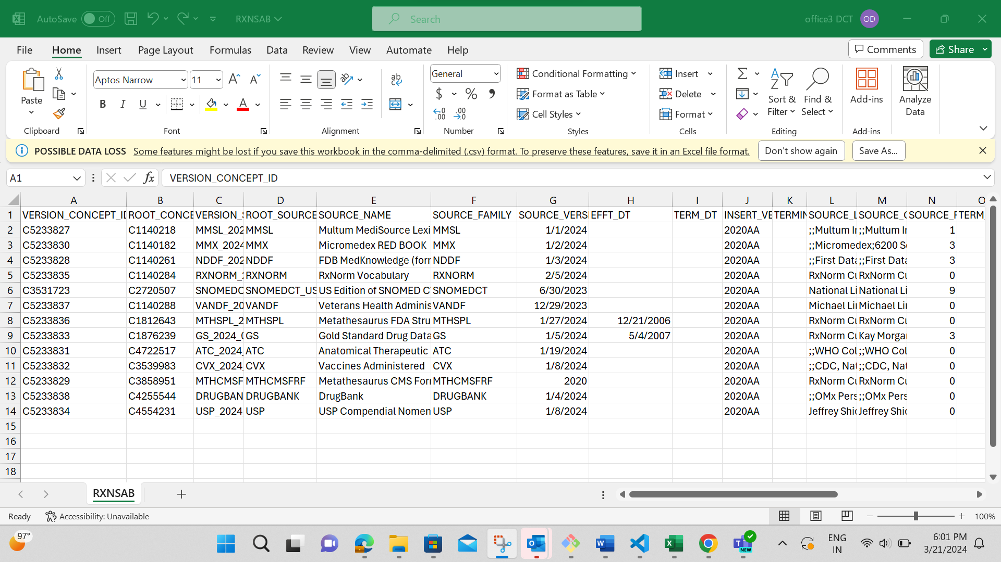

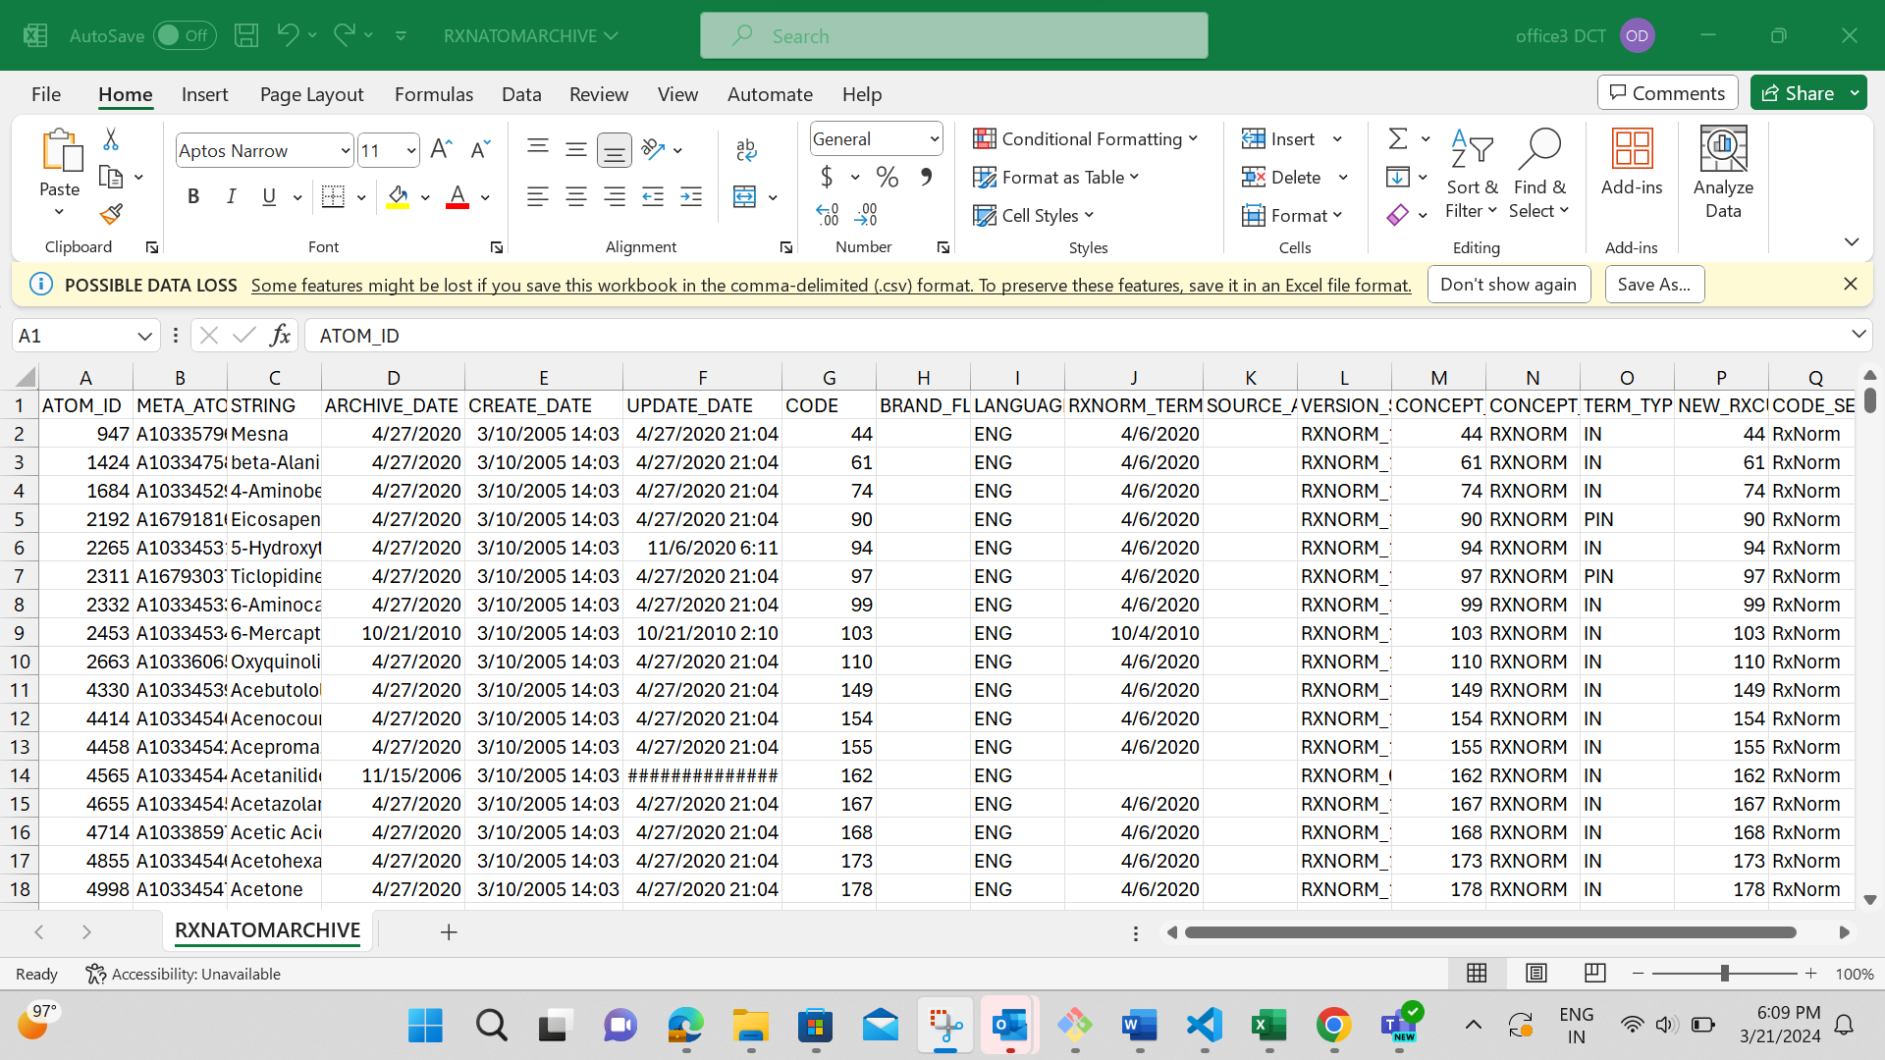

Above are some files where date form and header form is came right because of our code.

