AWS lambda and Python Task

Work with RXNORM file,  Add header into each rff from RXNORM.xlsx

Add CODE_SET & VERSION_MONTH column with default values RxNorm and version month from downloaded filename

Convert dates into YYYY-MM-DD

Save files as txt delimited by comma(,)

Validate row_count between original and converted files

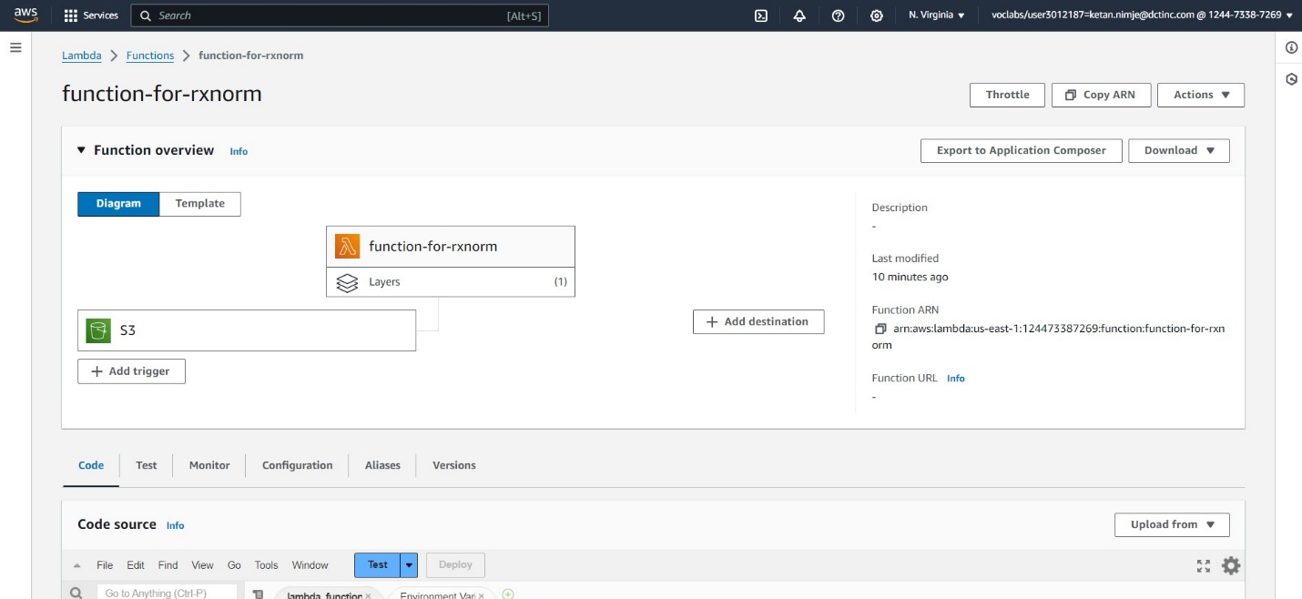

Create lambda function for the files

Created two buckets – one as a origin bucket for zip file and another as a destination bucket for getting the csv files

Adding a layer of pandas to be able to import pandas in lambda function

Configuring the lambda function by increasing its memory and timeout time to handle huge datasets. 5 GB for memory and 10 mins

This is the required output. All the files are in the destination bucket in csv format with the correct headers.

There are few changes in the start of the code as you can see in these 2 images. This is the lambda function code to provide solution for our problem statement.

Below are the result sheets.

