Created lambda function which triggers when we put zip files in source folder

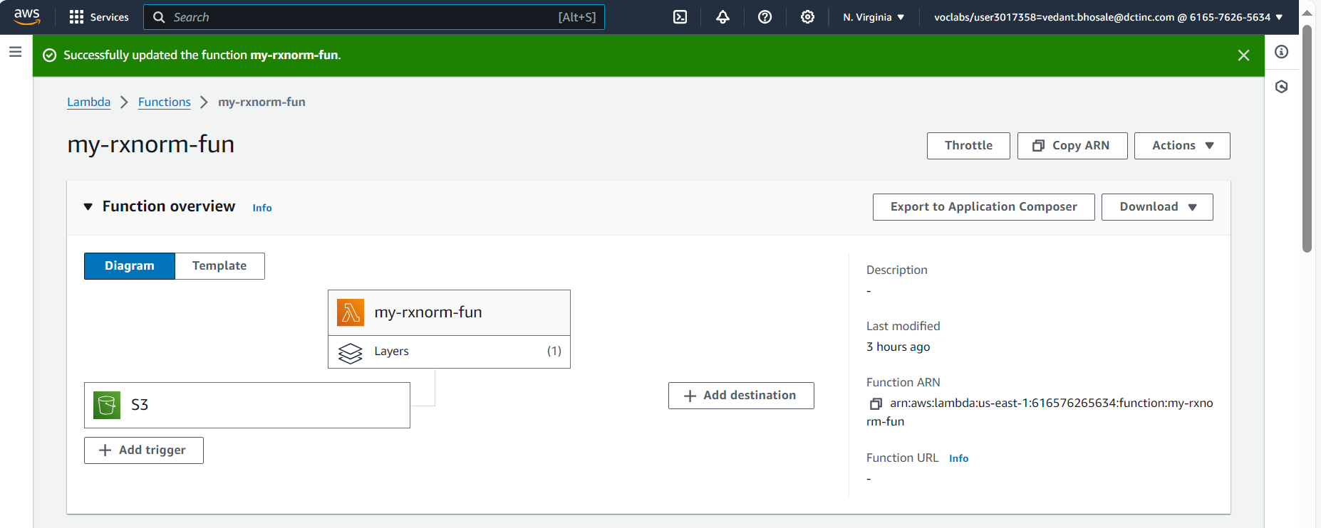

Created a pandas layer to create dataframes from files and assign them headers

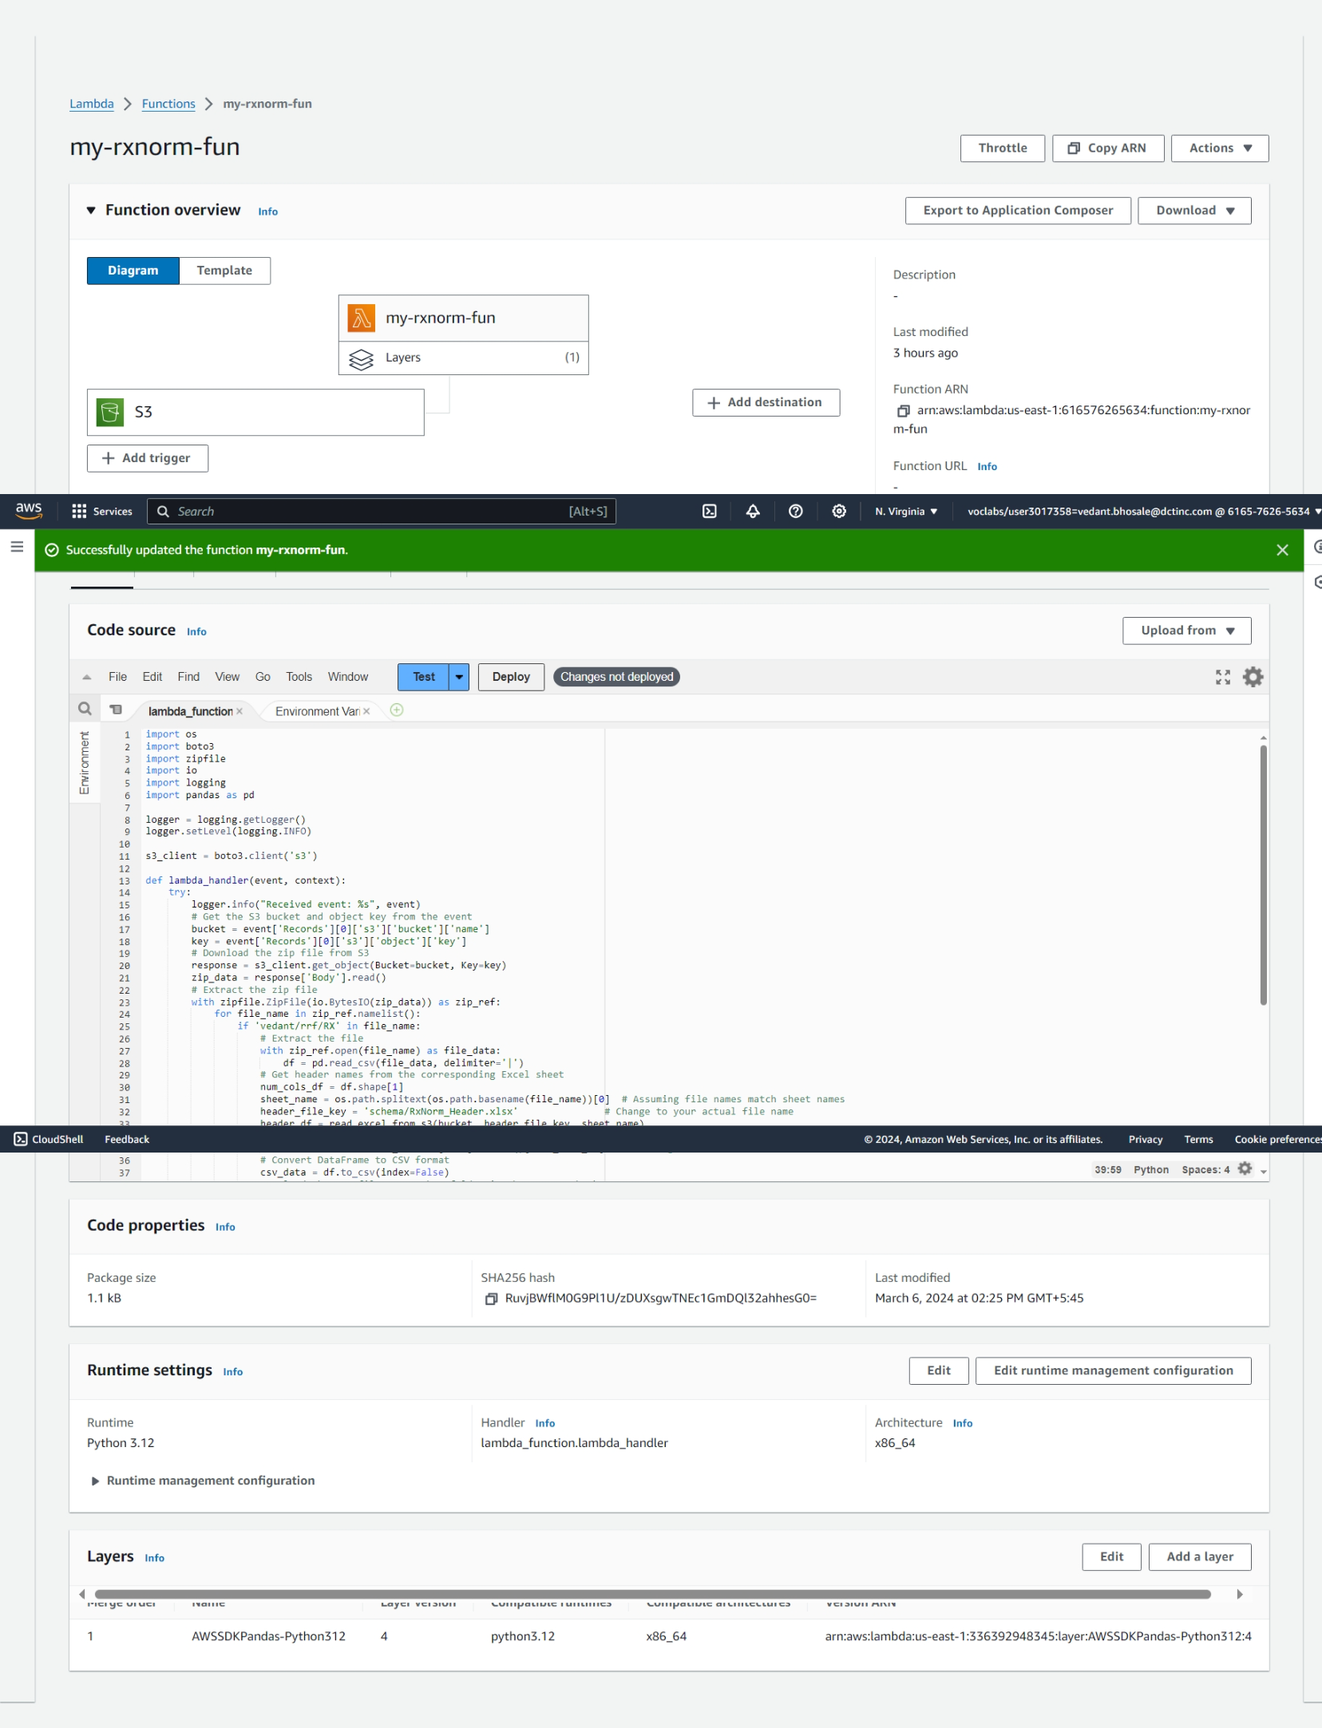

Bucket where zip file is uploaded in source_folder

Header excel file in schema

And converted files are stored in destination_folder

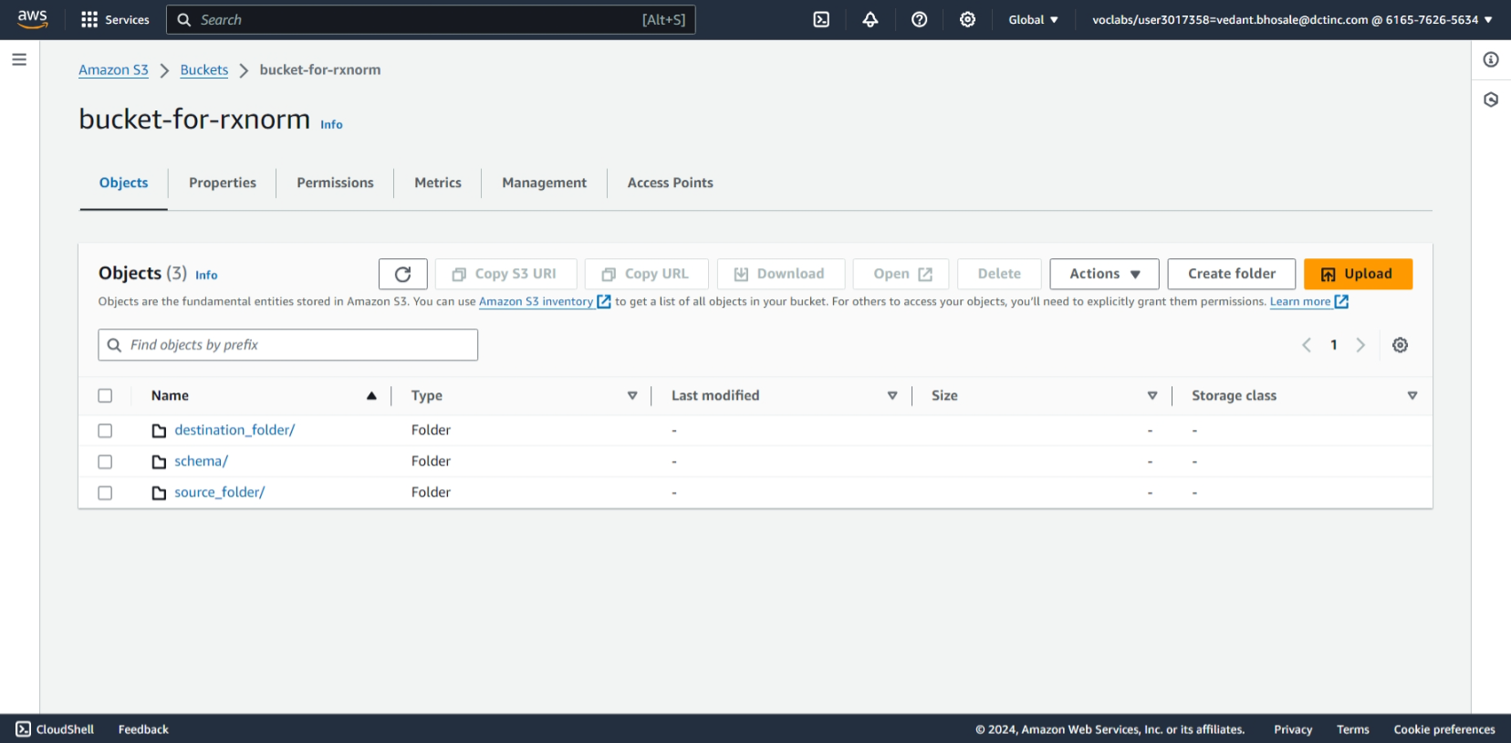

Lambda code to unzip the zipped files then assigning them headers from headers excel file and saving them in destination folder.

import os

import boto3

import zipfile

import io

import logging

import pandas as pd

logger = logging.getLogger()

logger.setLevel(logging.INFO)

s3_client = boto3.client('s3')

def lambda_handler(event, context):

    try:

        logger.info("Received event: %s", event)

        # Get the S3 bucket and object key from the event

        bucket = event['Records'][0]['s3']['bucket']['name']

        key = event['Records'][0]['s3']['object']['key']

        # Download the zip file from S3

        response = s3_client.get_object(Bucket=bucket, Key=key)

        zip_data = response['Body'].read()

        # Extract the zip file

        with zipfile.ZipFile(io.BytesIO(zip_data)) as zip_ref:

            for file_name in zip_ref.namelist():

                if 'vedant/rrf/RX' in file_name:

                    # Extract the file

                    with zip_ref.open(file_name) as file_data:

                        df = pd.read_csv(file_data, delimiter='|')

                    # Get header names from the corresponding Excel sheet

                    num_cols_df = df.shape[1]

                    sheet_name = os.path.splitext(os.path.basename(file_name))[0]  # Assuming file names match sheet names

                    header_file_key = 'schema/RxNorm_Header.xlsx'               # Change to your actual file name

                    header_df = read_excel_from_s3(bucket, header_file_key, sheet_name)

                    if header_df is not None:

                        df.columns = header_df.iloc[:, 0].tolist()[:num_cols_df]  # Assuming headers are in column B

                    # Convert DataFrame to CSV format

                    csv_data = df.to_csv(index=False)

                    # Upload the CSV file to another folder in the same S3 bucket

                    destination_key = f"destination_folder/{os.path.basename(file_name)}.csv"

                    s3_client.put_object(Bucket=bucket, Key=destination_key, Body=csv_data)

        return {

            'statusCode': 200,

            'body': 'Extraction and file upload completed'

        }

    except Exception as e:

        logger.error("Error: %s", e, exc_info=True)

        return {

            'statusCode': 500,

            'body': f'Error: {e}'

        }

def read_excel_from_s3(bucket, key, sheet_name):

    try:

        response = s3_client.get_object(Bucket=bucket, Key=key)

        excel_bytes = response['Body'].read()

        df = pd.read_excel(io.BytesIO(excel_bytes), sheet_name=sheet_name, header=None)

        return df

    except Exception as e:

        logger.error("Error reading Excel file: %s", e)

        return None

Modified files in destination folder

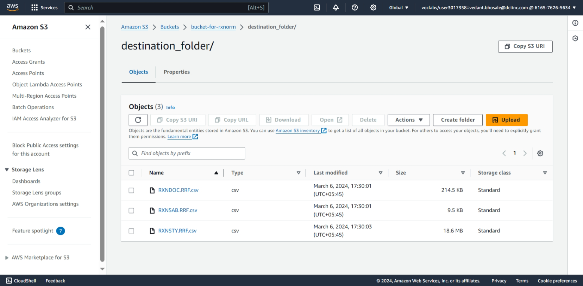

Files with headers assigned

