**CEZAR G. CARPIO BSIT 305 HCI**

**GAME TITLE:** Husky adventure

**TARGET:** 7 years’ old and above

**RATING**: 7+ Pegi E (everyone)

**GENRE:** adventure, Fantasy

**NUMBER OF PLAYED:** Single Player

**PLATFORM:** Smartphone Android

**GAMEPLAY:** 2d Scrolling

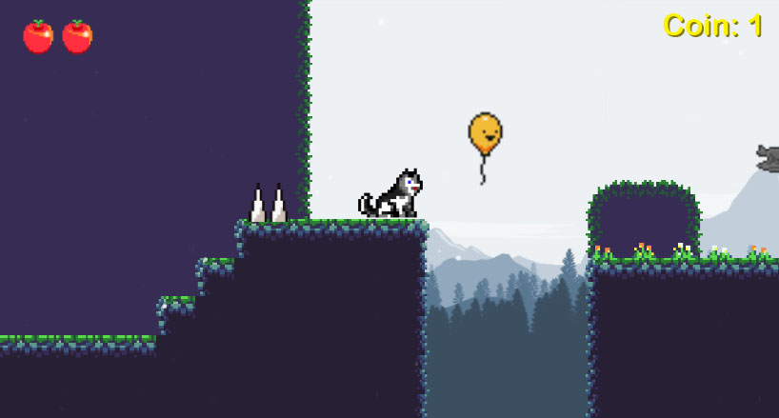

**STORY:** The adventure of husky that he will find his owner at the forest with dangerous enemy.

