**Introduction**

The purpose of this study was to test the interaction design of two webmail interfaces as to how well each facilitates users’ activities. We also conducted this study to see how well each interface conformed to their corresponding guidelines provided by the companies that designed them.

**Methods**

We created anonymous email accounts for both Yahoo! and Outlook with the address “ixdtest” that users would use to complete the tasks. We decided on three tasks that would allow users to interact with aspects of the interface that are considered to be used most often:

1.) Replying to an email - We populated the inboxes with emails that contained subject lines such as “Please reply to this email” and simple questions such as “What is your major?”, “What is your class year?”, and “What is 2 + 2?” that users would have to reply to. This was done prior to the study. Users were then asked to start from the inbox, bring up the original email message to the screen, and then reply to that email by answering the said questions and clicking “Send.”

2.) Recovering an email from the trash - A previously deleted email with a subject line of “Recover this email” or “Restore this email” would be in the trash before the users began the study. The users were then asked to navigate to the trash and find a way to move it to the inbox.

3.) Changing the theme - Users were asked to find the “theme” settings and change the background/wallpaper of the interface.

Only individuals who had never before used Yahoo! Mail or Outlook Mail (or at least not used them in a very long time) were asked to participate in the study. To collect data, facilitators used QuickTime Player for Mac or Screencast-O-Matic for PC to record screencasts as users completed the tasks. Audio was also recorded during the screencasts via these apps for qualitative data.

Our group agreed on a certain measuring scheme when extracting the time data from the screencasts: We started timing users from the moment they moved the mouse “toward the goal in mind” and stopped timing the users when *they* felt they had successfully completed the task. For example, some users would change the theme multiple times before deciding on one that they preferred. Our reasoning is that since this is a user-centered study, our data could have added value by reflecting user perceptions. Yes, the users objectively switched the background to a different theme for their first click, but if they did not prefer that theme, then in their minds they did not “successfully” change the theme. We believe that framing the data in this manner provides insight into how the interfaces facilitate usability.

**Data Collection**

There were two main phases to the study. The first phase involved having the users complete all three tasks for the first time without having seen the interfaces before. These recordings were used to extract data for Learnability metrics. The second phase involved having the users complete the same three tasks on each of the interfaces a second time. This second set of recordings was used to extract data for Efficiency metrics. Users were offered time after the first phase to practice the three tasks before entering the second phase of the study. During all times of the study, facilitators observed the users’ actions to take note if any Errors made at any time. We defined an Error as an event where the user clicks on something expecting one thing to happen but getting an unexpected result.

For qualitative data, users were asked to vocalize their thinking, frustrations, confusion, mastery, and so on, during the recording, and they were also interviewed after the two phases for them to explain how or why they utilized or reacted to the interface in certain ways. Post-phase interviews consisted of inquiries into how users perceived the interface: “Were there any aspects that you found confusing?”; “Were there any aspects that you found helpful?”; “Why did you ____ when you ____?”; “In general, how would you describe ____ ?”

Users were told which tasks to accomplish before the recording started, however, facilitators also guided users on which tasks needed to be completed and whether actions were valid or not *during* each recording.

**Results**

(The complete set of the data that is not averaged can be found in Appendix 1.)

A total of 10 individuals participated in the study. Two of those participants were also facilitators, but had never used Yahoo! or Outlook before or at least had not used either in the past 5 years. Our team of 4 facilitators was together when we recorded the screencasts of the 2 facilitators who were participants. The remaining 2 facilitators conducted the post-phase interviews for qualitative data and, at a later date and time, also extracted the time data from those screencasts.

Each survey with a participant averaged between 5 - 12 minutes to record the tasks for both phases of the study as well as interview that person about their experience and perceptions. According to the data, there was no outright “winner” as to which interface facilitated these specific tasks more effectively. The graphs below show the averaged times spent for each task by participants, where Task 1 is Replying to an Email, Task 2 is Recovering an Email from the Trash, and Task 3 is Changing the Theme of the interface.

From these visuals we can see that in terms of average Learnability, participants spent less time on Task 1 and 3 in Outlook than in Yahoo! but spent less time on Task 2 in Yahoo than in Outlook. It is also interesting to note the difference between the Learnability and Efficiency results and how the times for each task were reduced by about half for Task 1 and by several factors for Tasks 2 and 3. These averages have also not accounted for outliers in the data set.

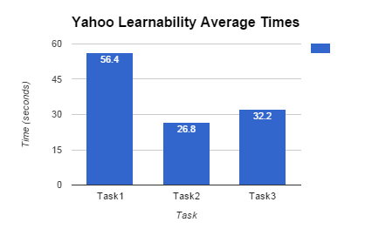

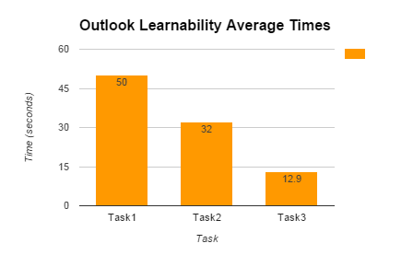

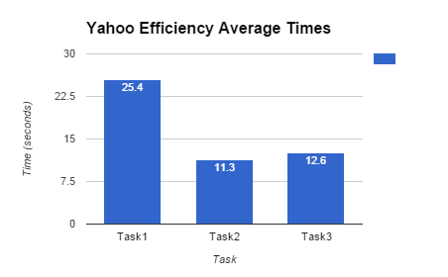

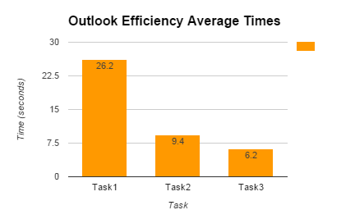

**Trends**

Just by looking at the more detailed graphs in Appendix 1, we can see that for Yahoo!, there was much more variability among participants than in Outlook. There were indeed some “repeat occurrences” between participants as they completed the tasks. For example, 6 of the 8 Errors associated with Yahoo! during both the Learnability and Efficiency phases were due to the settings gear icon on the top right of the screen.

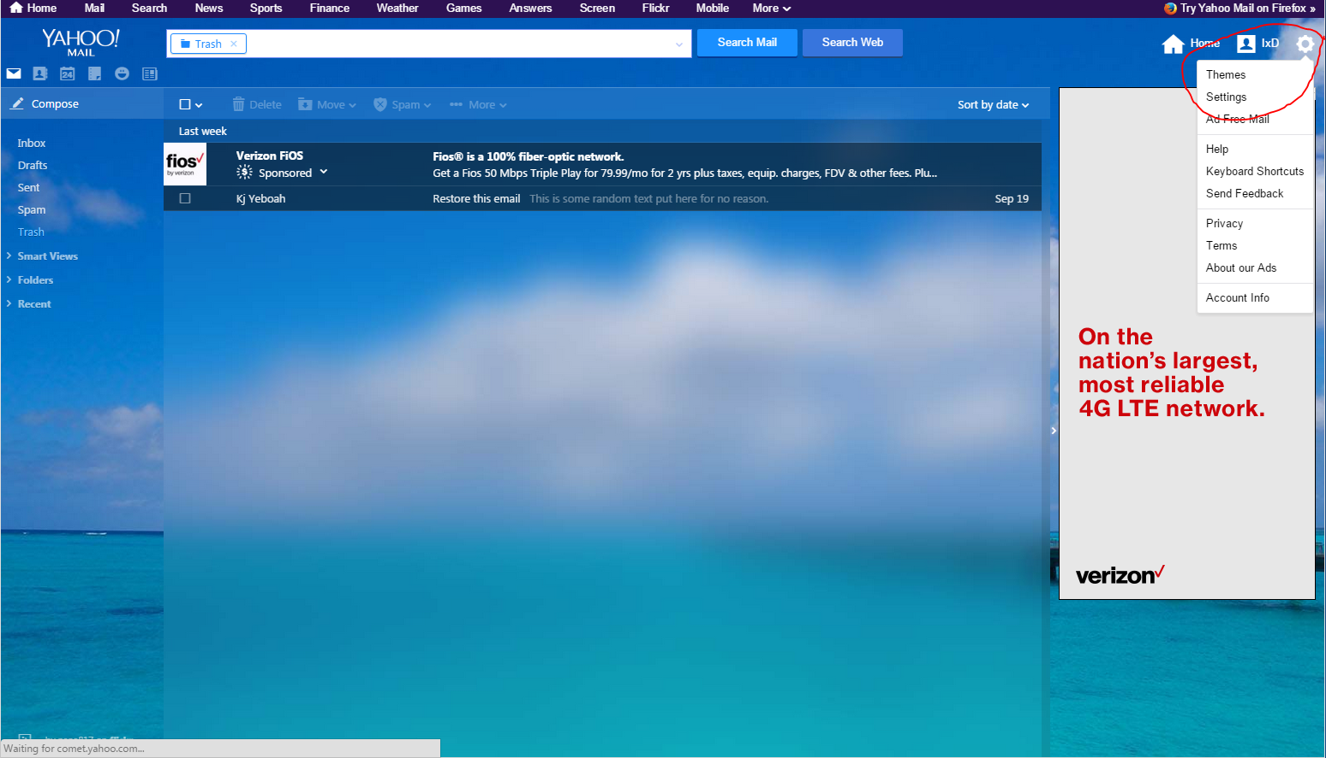

The gear icon is set so that the menu opens when the mouse hovers over it. Many users did not know this during the Learnability phase and had not adjusted to it even during the Efficiency phase. As a result, the participants would try to click on the gear icon, but the menu it reveals would appear and then immediately disappear. One participant had to click around 10 times just to access the menu. However, several participants also commented in the post-phase interview that the gear icon was crucial in helping them identify where the settings were because of its use in other interfaces such as Gmail.

Another note is that several participants also started looking through the small transparent icons on the top left of the screen as soon as they were instructed to change the theme during the Learnability phase. Two participants even clicked on them just to see what would happen. After 4 or more seconds, the participants in this subset eventually moved to the right side of the screen to look for the theme settings.

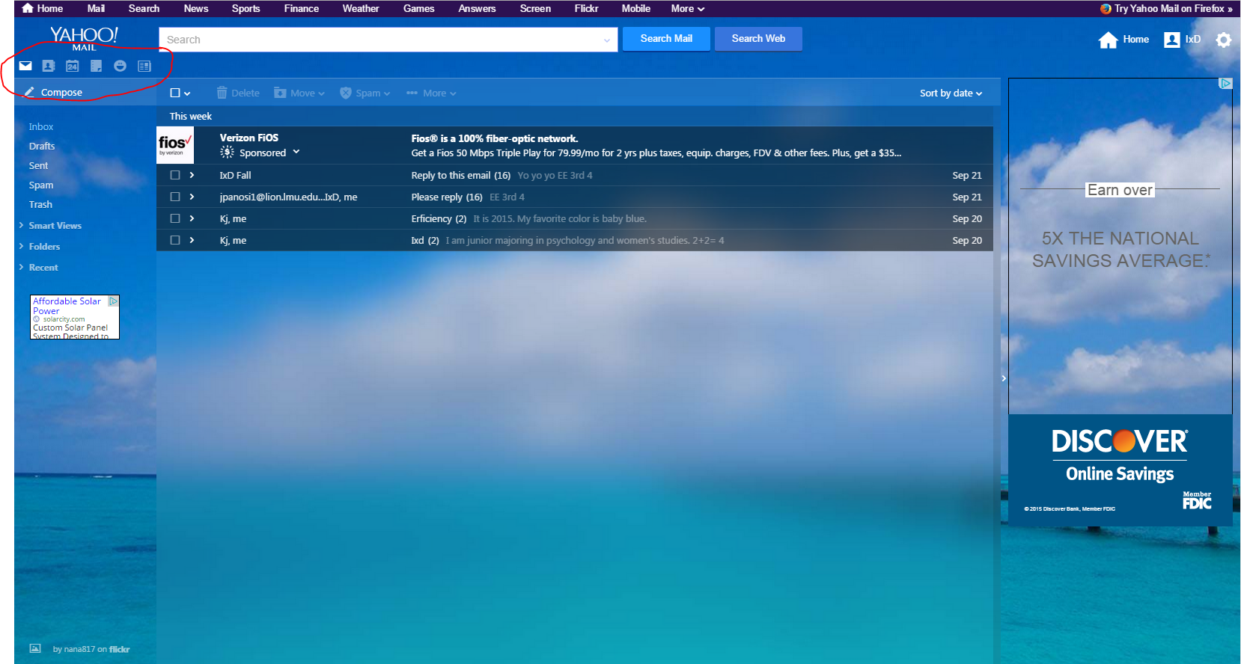

Outlook also had its caveats. For conversation threads in emails, Outlook utilizes an inverted thread feature, where the original message is displayed on the very bottom with consecutive replies being stacked above. Several participants stated this display was “weird” and threw them off because they expected the original message to be at the very top of the thread.

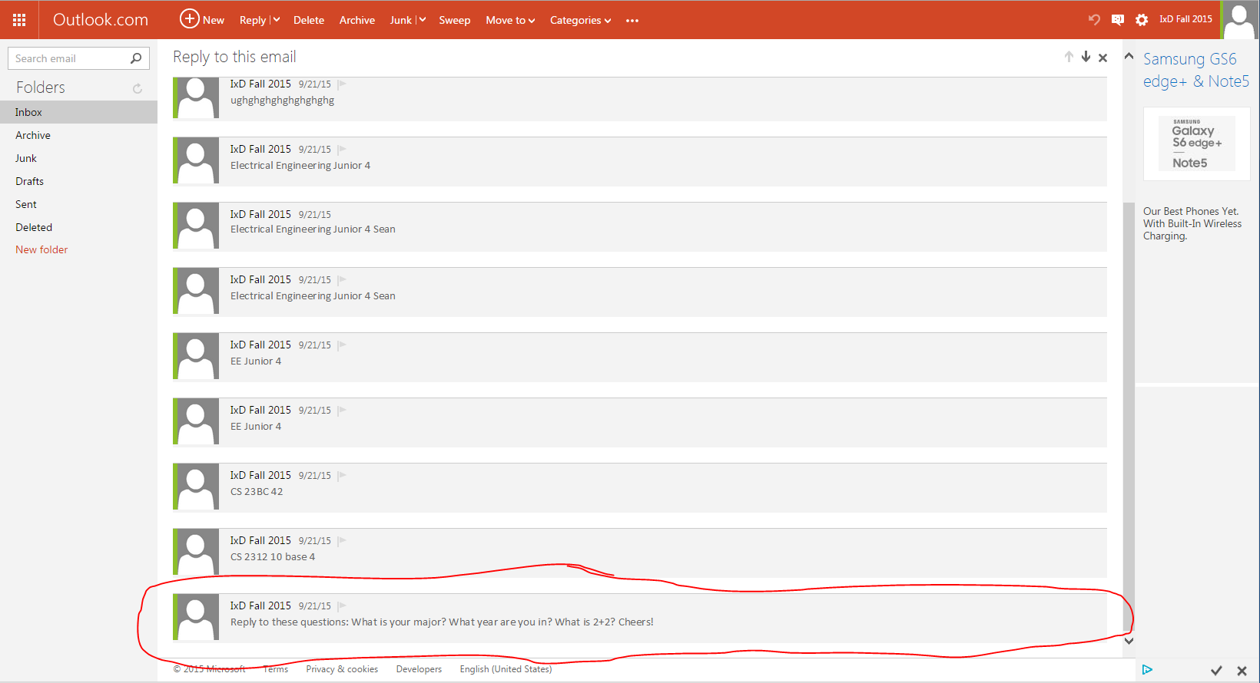

Another issue with this screen specifically that about half of the participants encountered was taking more than 3 seconds to find the “Reply” button. Notice that it is situated at the top of the screen, opposite to the original message at the very bottom. The only other alternative for users is to click “Actions” on the right after opening an email.

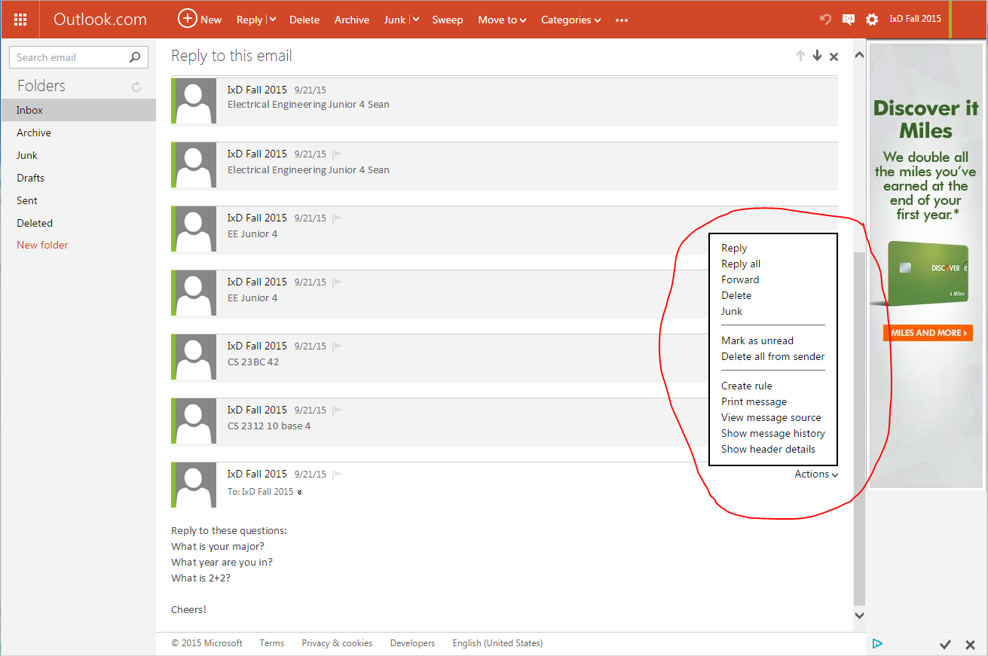

Yahoo, on the other hand, had embedded Reply and Reply All options in the email itself. Still, several participants did not immediately locate these embedded options but instead used other means of sending the email after 3 or more seconds of searching.

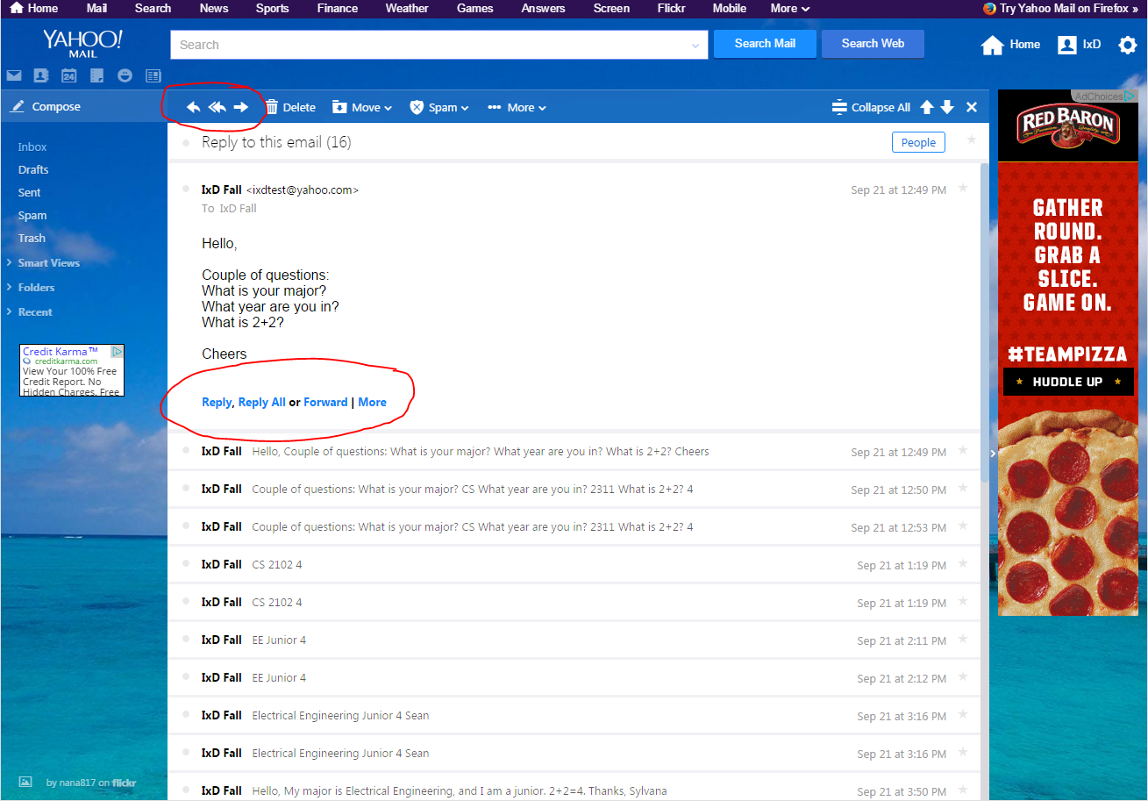

Outlook also differs from other interfaces in its naming conventions. Instead of the standard “spam” and “trash” options on the left of the screen, Outlook has “Junk” and “Deleted” options in their place. This change threw off several participants and even led to an Error in one of the Efficiency surveys.

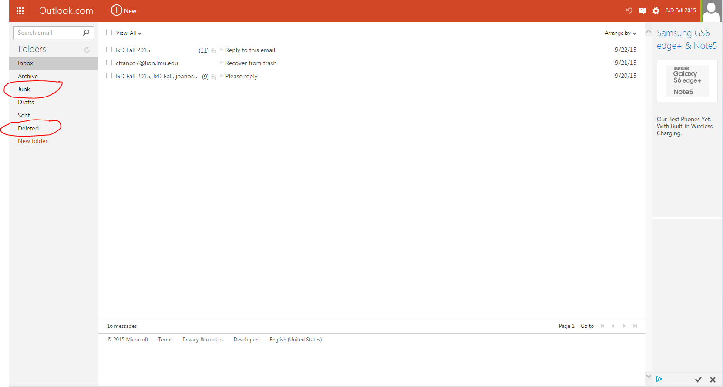

**Heuristic Evaluation**

We were able to find some form of interface guidelines for both Yahoo! and Outlook online:

Yahoo! - Yahoo Design Pattern Library

Outlook - Outlook VBA Reference (“for developing custom Outlook solutions.”)

[Guidelines discussion]

Perhaps, we can also enter into discussion about “Hidden Features,” as one of the participants put it. For example, only 2 participants in the study knew that they were able to drag an email from the Trash and drop it into the Inbox during the Learnability phase. One of those participants was a facilitator, and the second had accidentally been instructed by the facilitator to “drag the email into the inbox.” (The facilitator was supposed to use the more subtle language of “restore this email from the trash to the inbox,” which would have then required the user to explore different features.) The remaining 8 participants had all opened an email first and used the “Move” option at the top of the interface to move it to the Inbox.

**Limits of the study**

All of the individuals who participated in this study were tech-savvy college students. Also, majority of the participants were either Computer Science or Engineering majors. Given that this sample set is very small and extremely biased, it would be unwise to draw any far-reaching conclusions from this study about the effects of certain features of this interface.

Also, contrary to the expectations of the facilitators of this study, several of the participants stated that they do not usually restore emails from the trash and thus slightly invalidated our judgement of choosing tasks that are performed by a broad set of users.

**Appendix 1**

**Errors Metric**

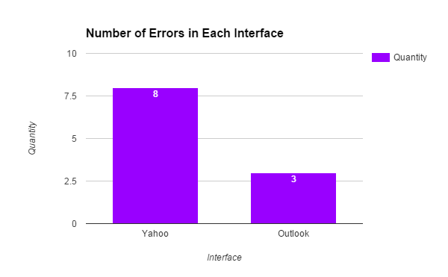

**Learnability Metric**

Replying to an Email

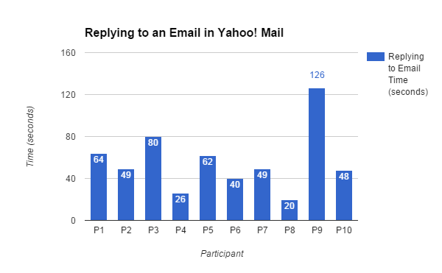

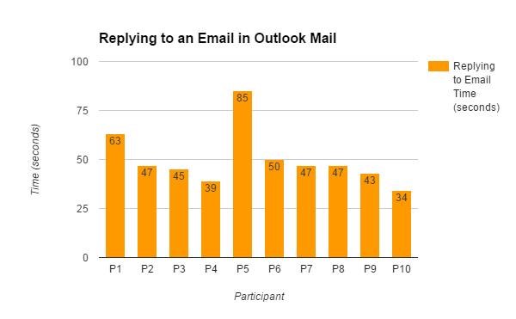

Recovering from Trash

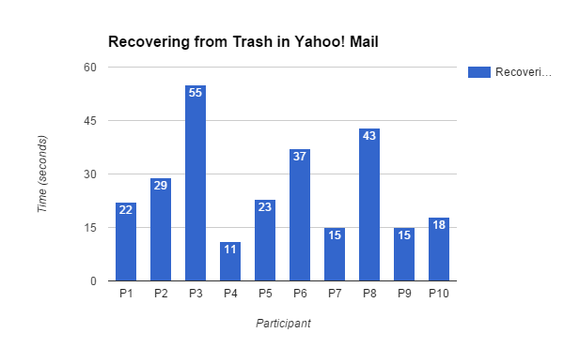

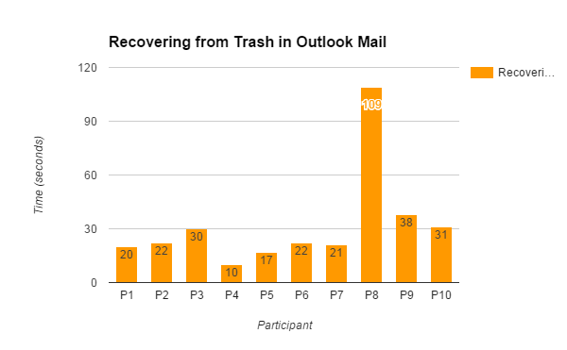

Changing Theme

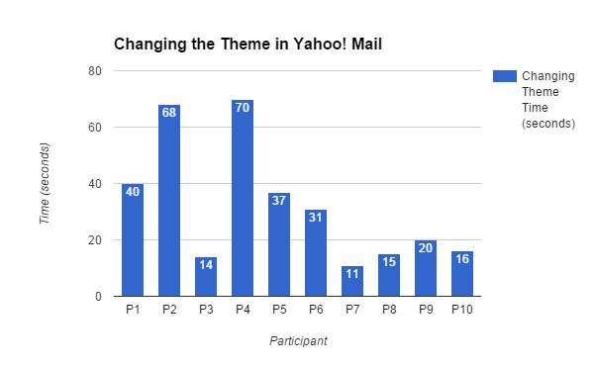

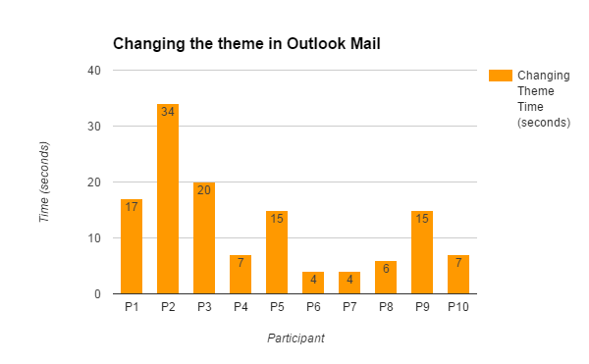

**Efficiency Metric**

Replying to an Email

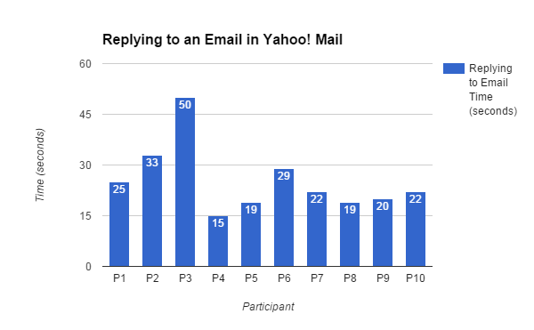

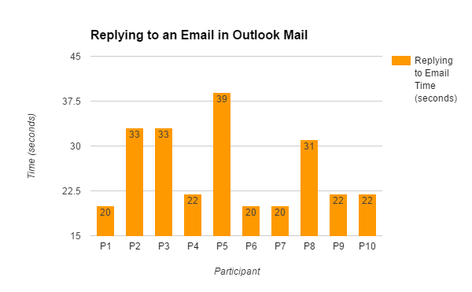

Recovering from Trash

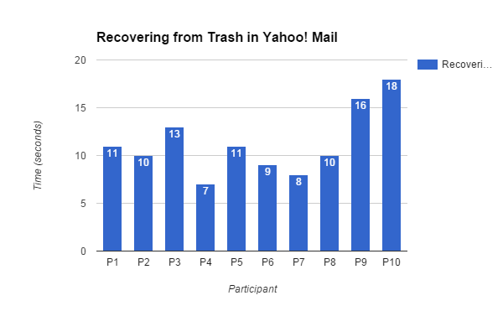

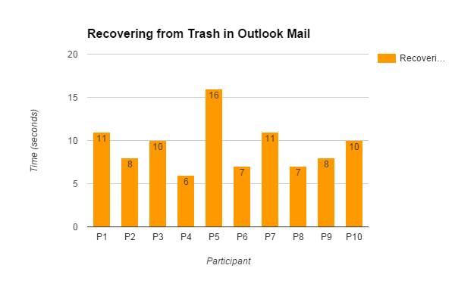

Changing Theme

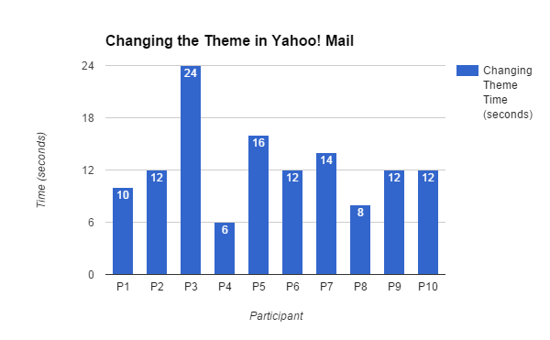

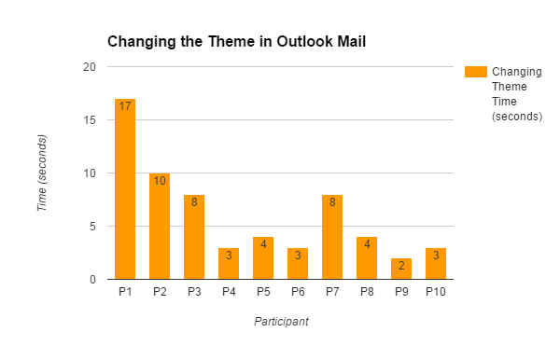

Paper

1. Yahoo
   1. trends
   2. apply guidelines
2. Outlook
   1. trends
   2. apply guidelines
3. Yahoo & Outlook
   1. data
4. Conclusions based on data and observations

Trends:

preconceived notions/expectations about interfaces based on other interfaces

Example: one participant going straight to settings and skipping over “themes” link when changing the theme during the Learnability test. the participant expected to find theme settings in settings, but they were separated in the menu. [photo]

**Yahoo**

Replying to an email

Questions left view when replying - 1

Hard time seeing “Reply” options in text of email - Kalia, Mattie, Maurice

Mental Model? - perceived options as part of email text?

Recovering from trash

Opened email - Andres, Josh, Kalia, Mattie, Maurice, Sean

Dragged email - Josh (Learnability) because facilitator accidentally said “drag”

Changing Theme

Started exploring on the top left - Andres, Josh, Kalia

Knew to look for the “gear” -

Hover feature disruptive (did not happen) - Andres, Kalia

**Outlook**

Replying to an email

More than 4 seconds finding “Send” -

Recovering from trash

Went to Junk first -

Screenshots

Original Email leaving view when replying