Twitter Dream-Design

1. Description of System

Twitter provides a social networking service in which the main form of communication between users is 140 character “tweets.” Users are able to follow each other to send and receive messages, and whoever is following a given user sees their tweets when they are posted. Networks of users can be even more creative with their posts by using hashtags (“#” with a word attached) to make any tweets in which it is contained indexed and easily searchable by followers and even users outside of that particular network (e.g. “#food”). The same can also be said for when users perform “mentions,” or tweets meant for other specific users, by typing the “@” with the other’s username attached (e.g. “@franco98765”). This is often used to direct a message that is still viewable to everyone in the network. The mention will appear in the other user’s feed as well. Of course, users can also send private direct messages to people they follow. Twitter also has an app, which helps it to be more effective in facilitating real-time communication and increasing access to a broader population, especially people in countries without widely-available desktop computers or laptops.

Compared to messaging applications like Slack, Twitter’s interface seems to be slightly more cluttered, with several different features being squeezed into small areas.

Twitter

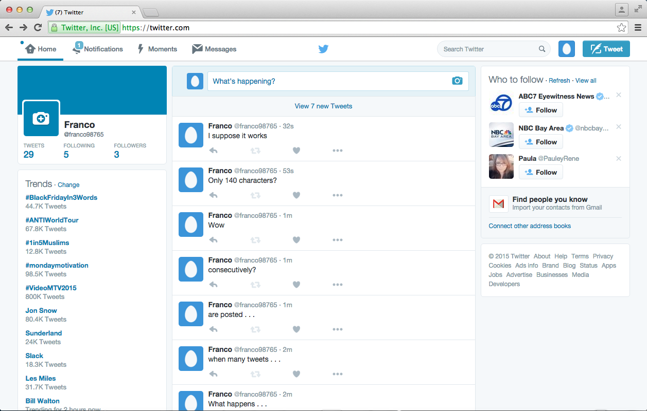

Slack

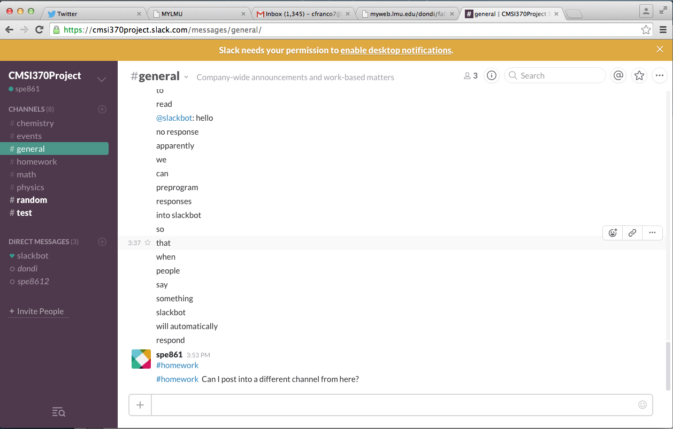

Given that this is my first time using Twitter in 1.5 years and that the last time I used it was only for a few minutes a week, it was interesting to explore and evaluate Twitter’s interface from a Learnability standpoint. For example, finding specific people to follow using the search bar was slightly difficult given that there are so many people with the same first and last name. However, there is a handy way to import your gmail contacts into twitter to instantly find people. It also took a few seconds to figure out where the *user settings* were. It turned out to be the egg icon next to the tweet button and was not the first place I looked.

Also, when first opening Twitter, it was slightly confusing to see random people and trends on the side menus as well as getting random tweets in the feed from people and organizations I had never contacted. This is mostly what adds to the clutter in my opinion.

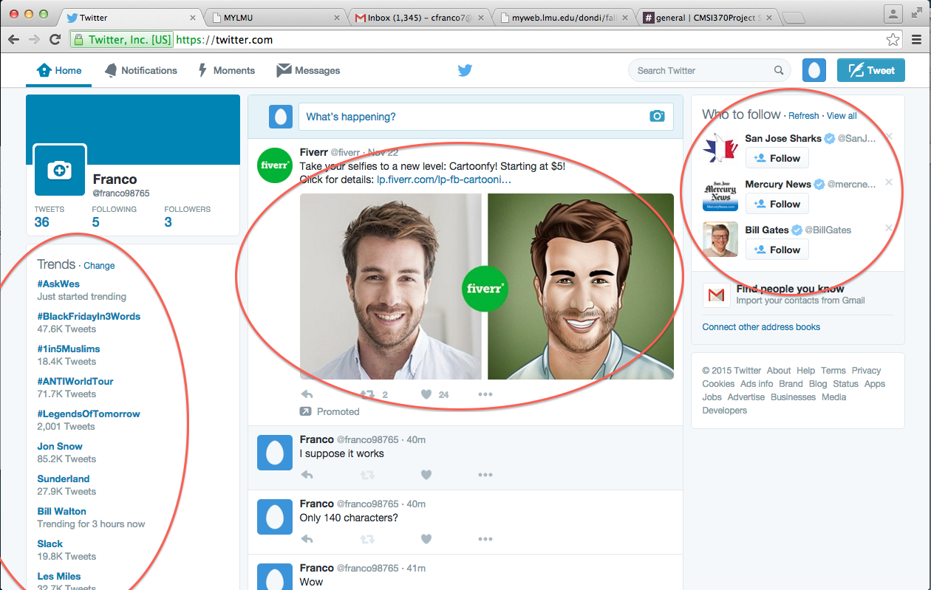

Another area for improvement is the actual display of the messags on Twitter. Although the 140 character limit may be an effective business strategy for bandwidth, creativity, efficiency, and the like, it can at times be difficult to decipher the meanings, contexts, and intentions of certain groups of messages. Often this is due to how people send messages, but there are also other times when the arrangement of the messages themselves adds time figuring out what is being said (as opposed to in Slack, where the use of empty space allows users to quickly locate and interpret elements of the page).

Lots going on here.

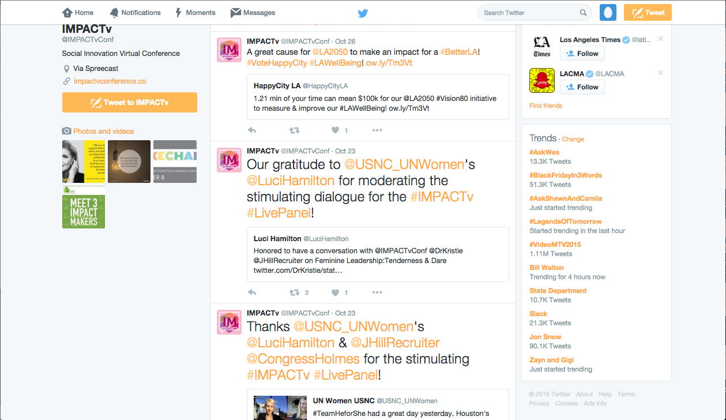

There are also some confusing aspects about replies to tweets. In the image below, the “Wow, it didn’t work” tweet refers to the “95 spaces” tweet (Twitter didn’t post a tweet with 95 spaces), yet when there are replies to the first, they extend below the original tweet and separate the two tweets from their temporal arrangement. That is, it no longer appears as though the “Wow, it didn’t work” tweet was posted immediately after the “95 spaces” tweet.

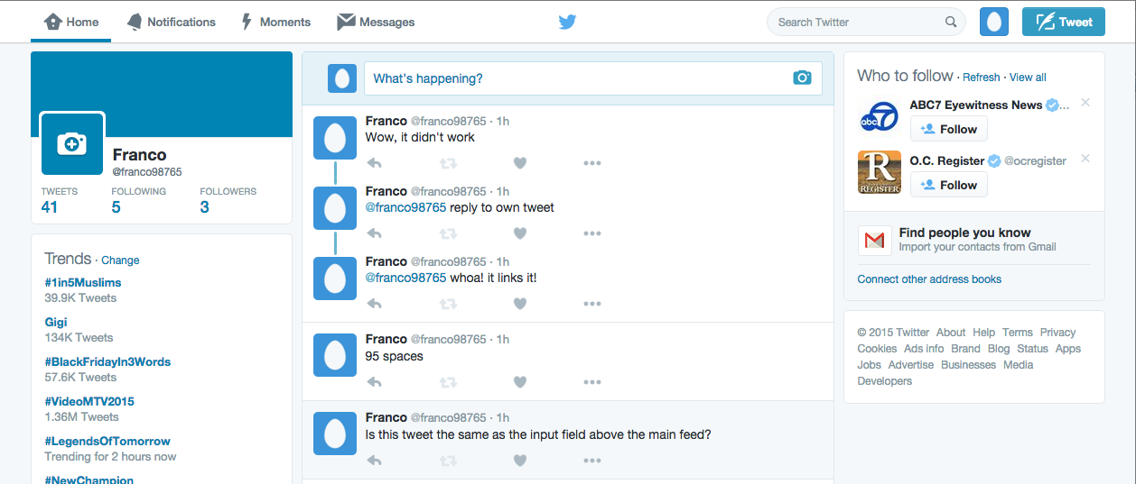

Other cases like the Followers page and Twitter’s Moments page have a mix of text and images that also make the interface pretty complex pretty quickly, thus adding more “reading time” for the user to locate specific information.

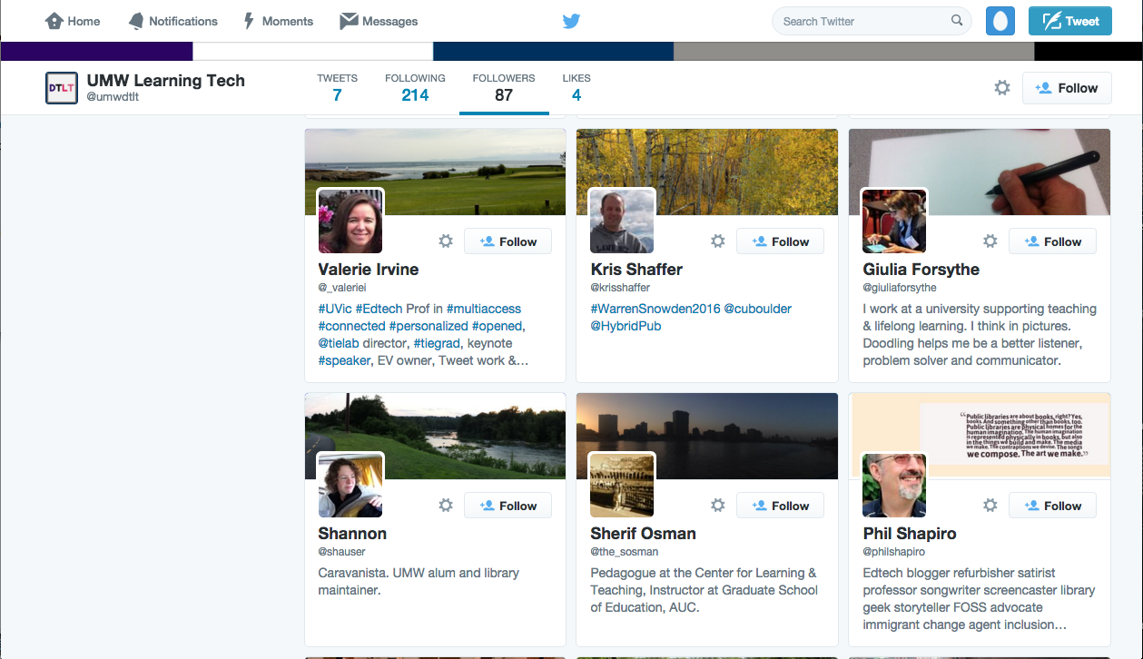

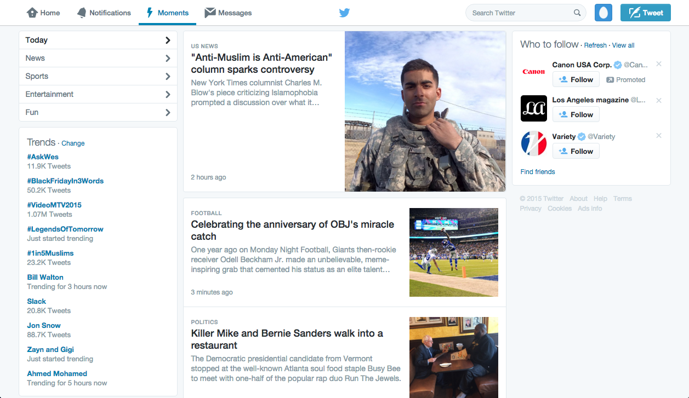

(From standstill images, this may look quite “readable,” but add a little motion and scrolling to these images and suddenly Twitter’s layout with the mix of photos and text becomes complex.)

Slack, on the hand, utilizes spacing to keep its interface uncluttered despite a mix of images and text.

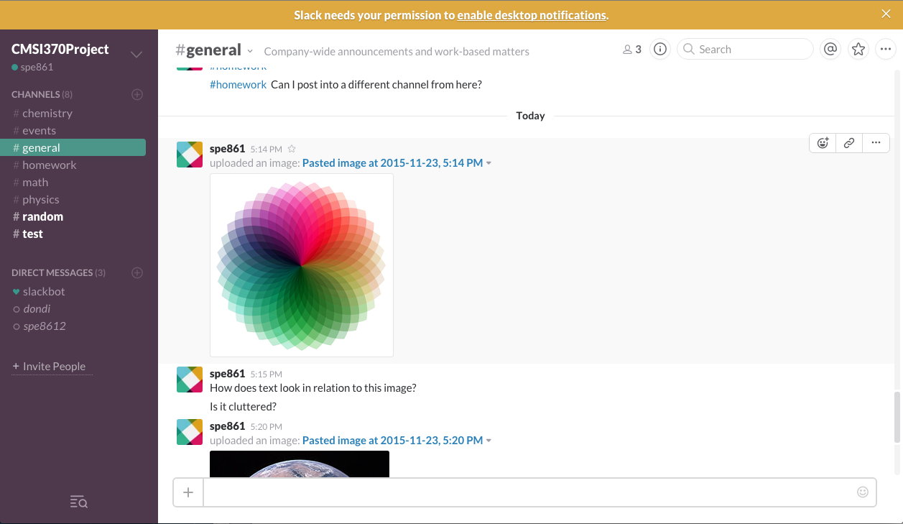

2. Top-Level Design/Layout

An alternative design may increase the “reading efficiency” of Twitter’s layout for human readers. I am proposing a new interface design that can not only accomplish this, but it can also help reveal further value in the network interactions and dynamics of Twitter data. This new interface would involve geospatial animations of 2.5D “graphs,” or mappings, of hashtag and user tweets.

Users would be able to fly to twitter feeds and see them being updated in real-time. It would be analagous to a combination of RealTimeBoard and Prezi’s 2.5D interfaces and the mappings from Eigenfactor.org (an organization that maps academic citations across and between disciplines).

Eigenfactor’s mapping of cross-disciplinary citations in the Sciences alone

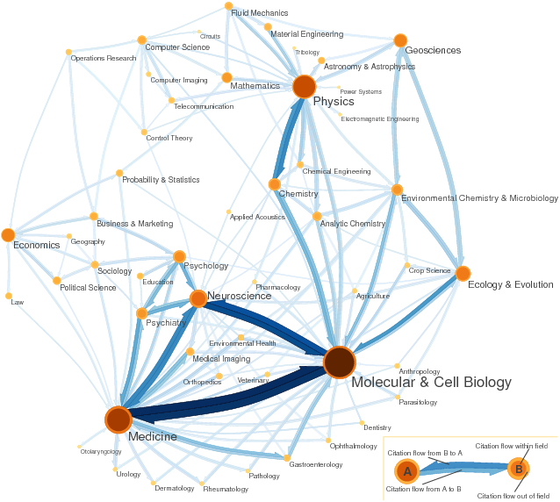

Eigenfactor’s Dynamic Map of citations between academic journals

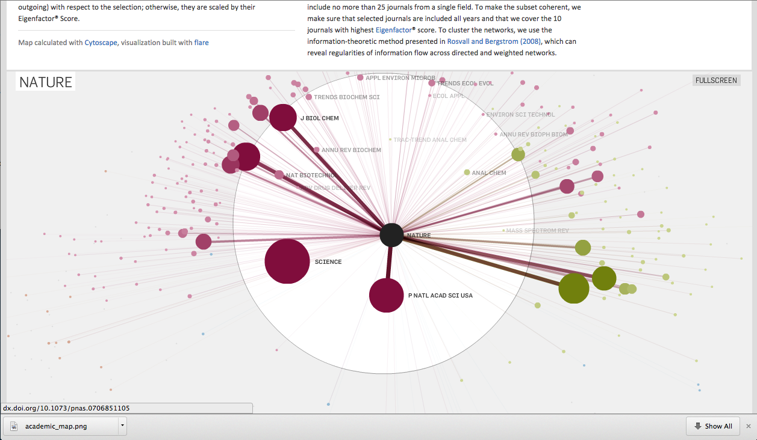

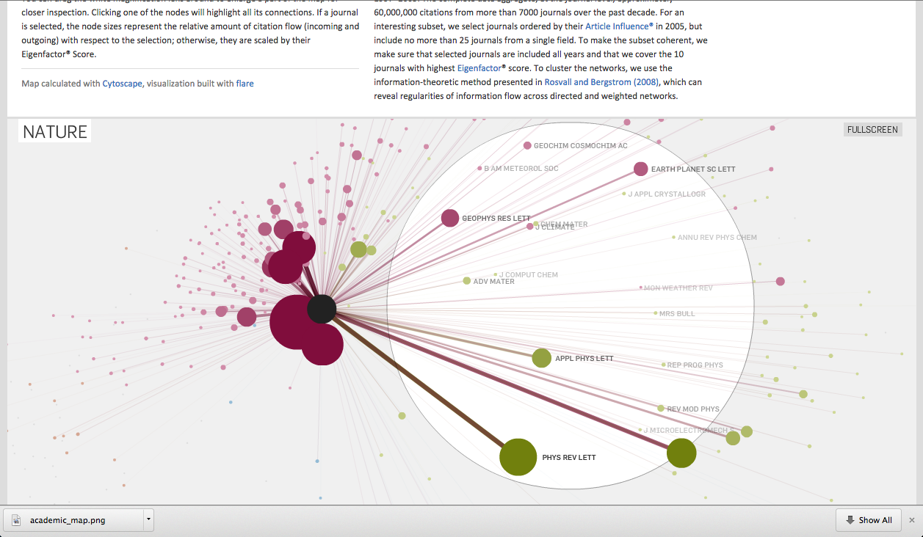

Attempt at illustrating the animated version of the interface

[photo of drawing]

* Graph/map constantly reshaping itself based on dynamics and interactions of networks
* Eliminates random trends and random people on sides of the feed that added clutter
* Keeps the important twitter feed that was in the center of the screen
* Isolates user info and settings from the same twitter feed page to reduce clutter
* User’s have the capability to see the big picture trends, but can also go to the micro-scale of viewing individual feeds
* Can see the connections between feeds
* Of course, users will be able to instantly fly to other feeds via search
* Now, structure provides new platform to add context to information
  + Color-coding based on retweets, on number of clicks or visits, on activity in general
* Users can filter the topics they see in macro and meso mode
  + Possible applications: humanitarian aid, have an “emergency” lens to see hashtags and keywords associated with emergencies

Twitter Display Requirements

<https://about.twitter.com/company/display-requirements>

3. Usage scenarios

* User uses hashtag in tweet, Twitter also lists number of connections to other posts, user can click “view connections”; Twitter takes user to meso view to see where connections lead (neighboring feeds connected to hashtag)